- Superstore Analysis Report Member 2

Executive summary
- Objective: Understand sales patterns to inform inventory planning and targeted promotions.
- Key insights: West and East have the highest transaction shares; Office Supplies dominate across regions, while Furniture and Technology vary. Outliers exist and warrant monitoring.
- Recommendations: Prioritize stock and promotions in West/East, tailor Furniture/Technology strategies by region and segment, and review discount policy drivers for outliers.
Introduction
- Context: This report analyzes the Superstore dataset to surface patterns across categories, segments, and regions.
- Scope: We evaluate correlations, identify outliers, and examine distributions and cross-tab relationships to guide operational decisions.
- Deliverables: Cleaned dataset, saved visuals, and actionable recommendations aligned with observed patterns.
Methods
- Data preparation: Loaded, cleaned, and exported the final dataset to the project Data folder for reuse and review.
- Correlation analysis: Computed and visualized numeric feature relationships to identify strong signals and potential risks.
- Outlier detection: Applied the IQR method and inspected boxplots to locate unusual values that may affect decisions.
- Distribution analysis: Measured counts and proportions for Category, Segment, and Region to understand concentration.
- Cross-tabs: Built heatmaps for Category × Segment and Category × Region to capture interaction effects.

Findings
- Correlation heatmap: Key relationships observed among numeric features; use them to focus monitoring and modeling efforts.
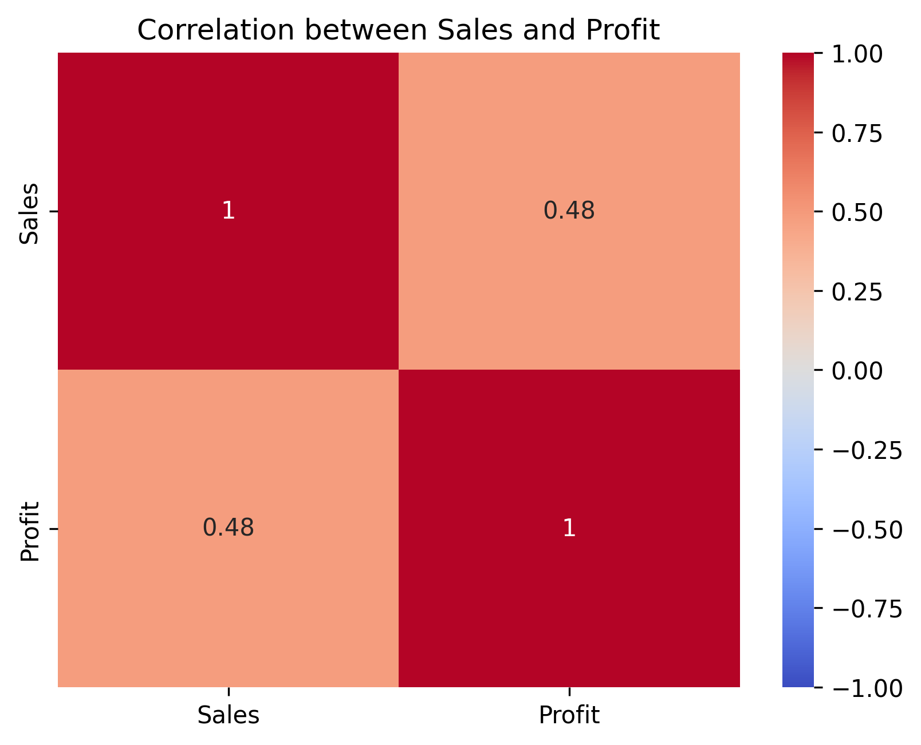
Figure 1: Correlation heatmap showing relationships among numeric features.
- Outliers boxplot: Notable outliers detected; these may reflect extreme discounts or high-value orders and need review.
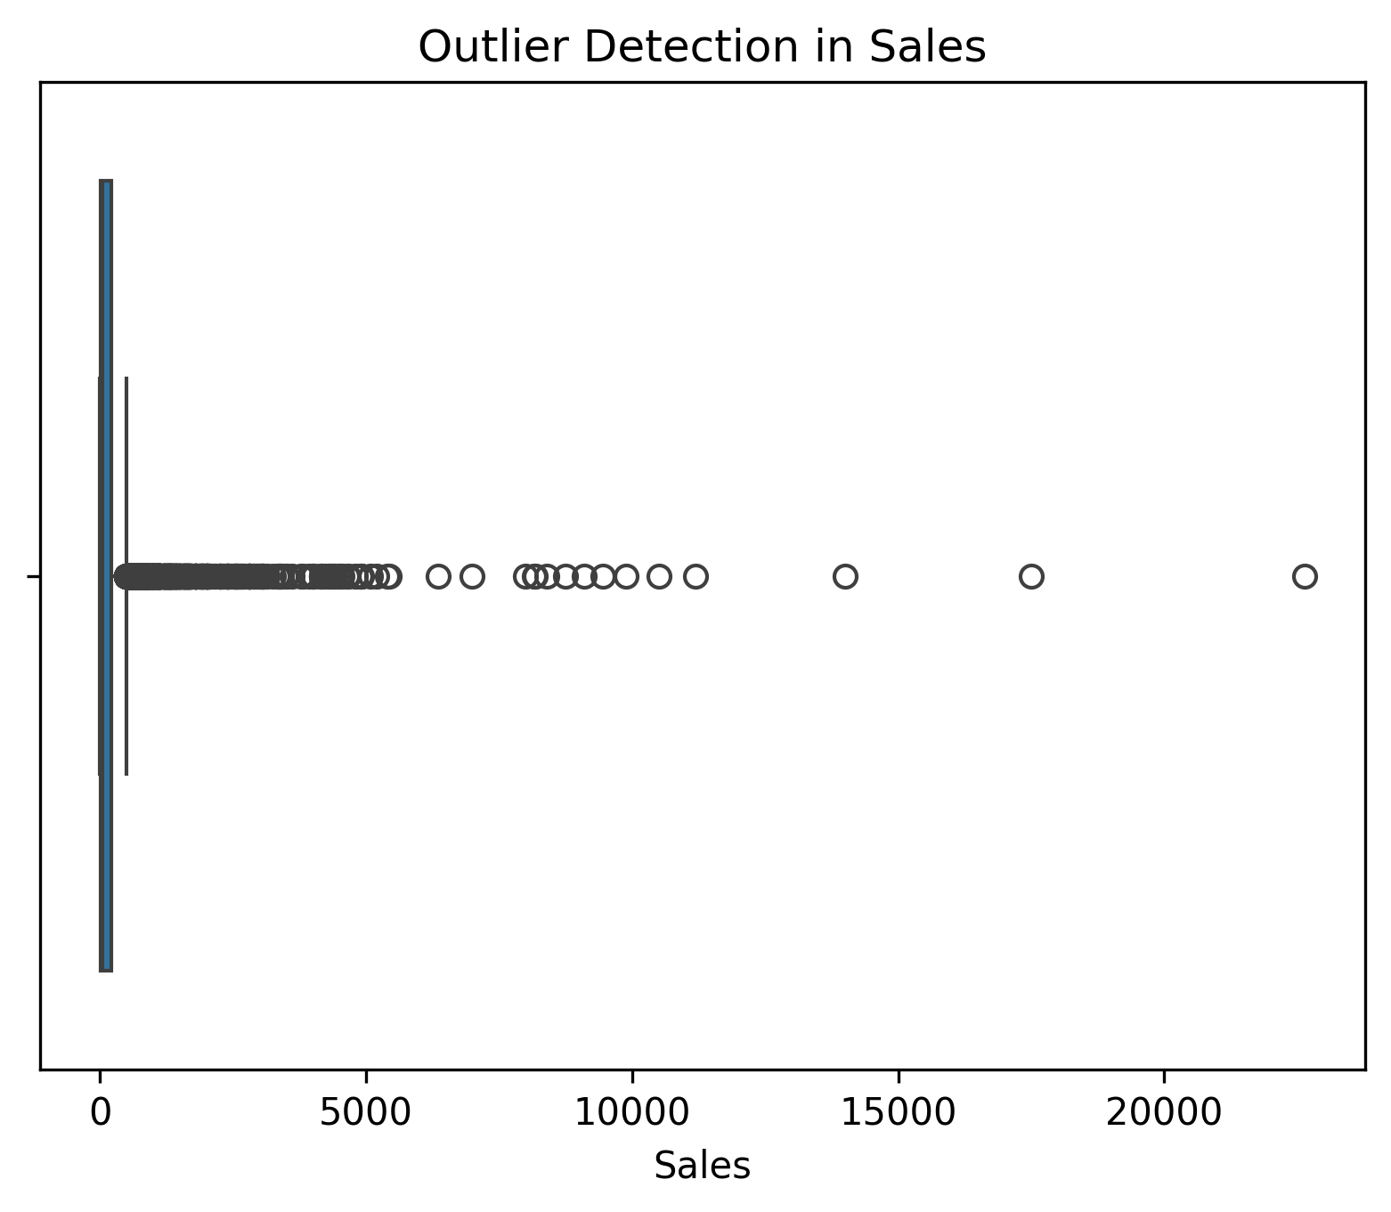
Figure 2: Boxplot highlighting outliers detected via IQR method.

- Category distribution: Office Supplies are most frequent; Furniture and Technology have smaller shares and greater variability.
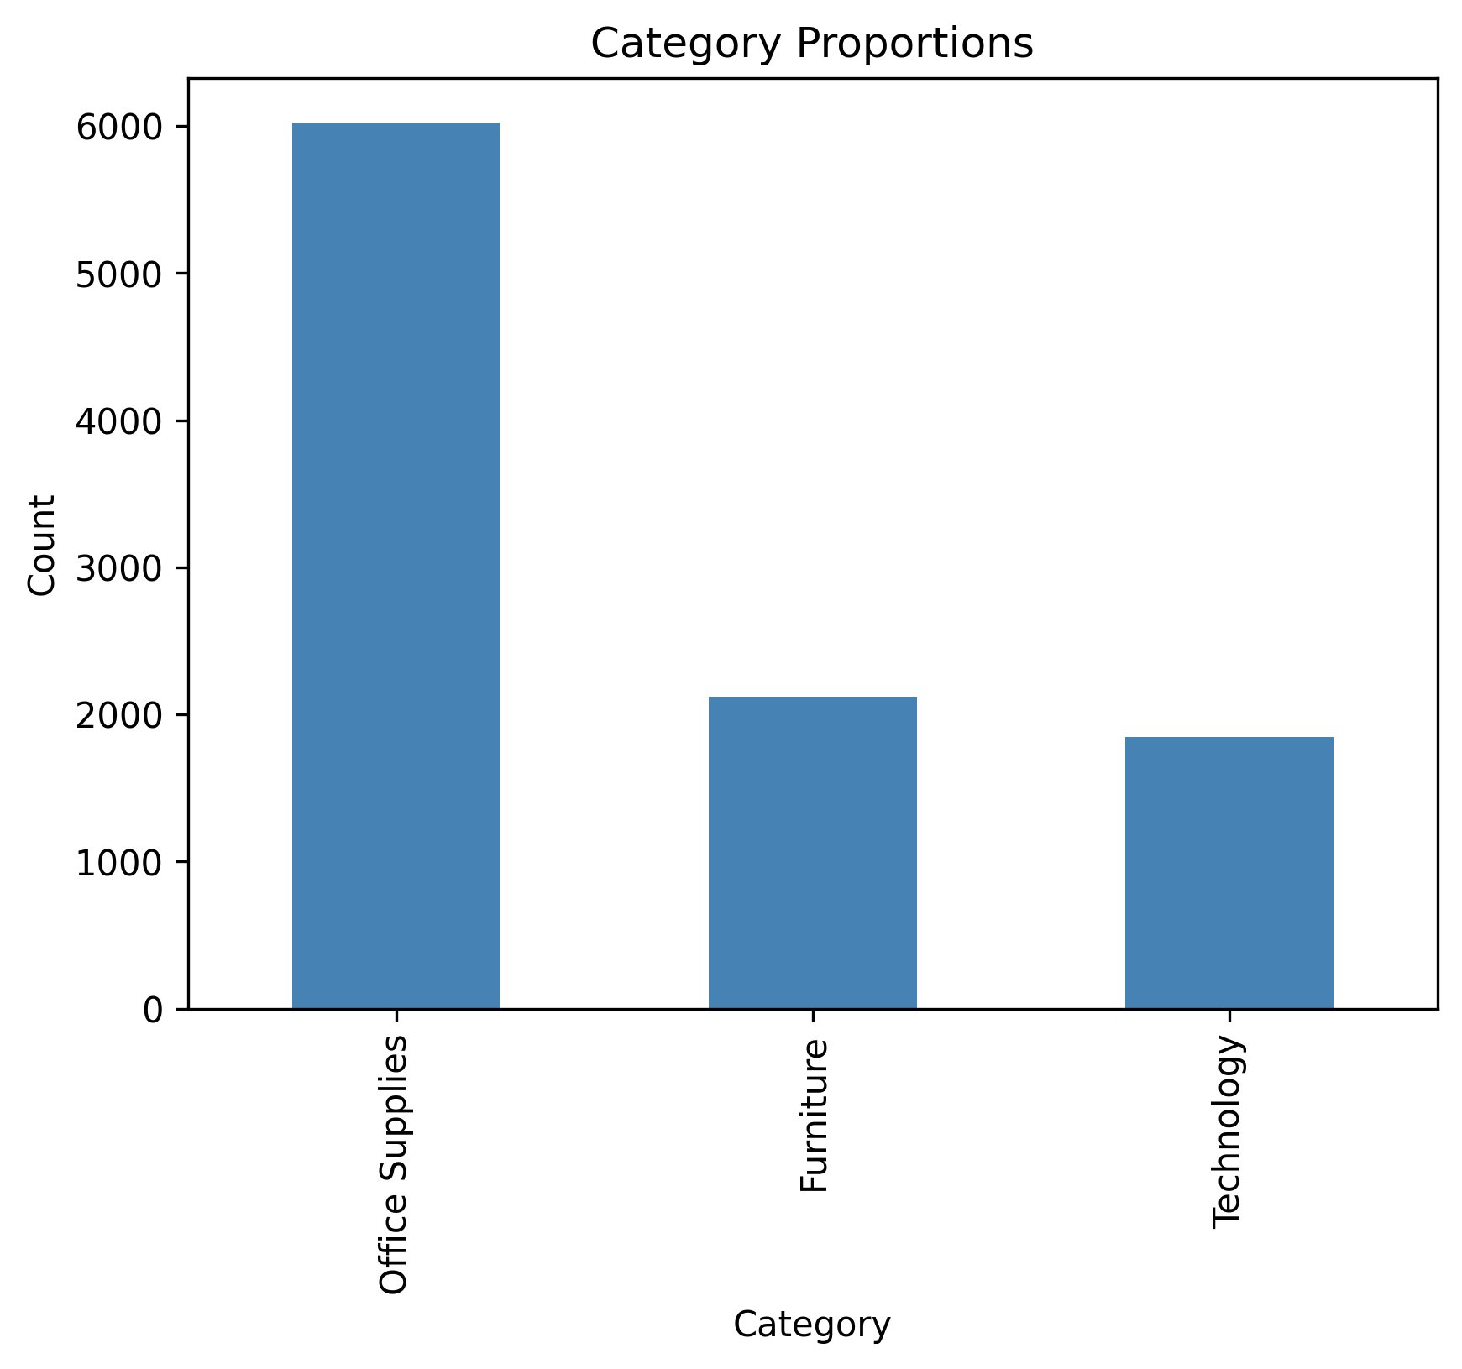
Figure 3: Bar chart showing distribution of product categories.

- Segment distribution: Consumer, Corporate, and Home Office exhibit distinct distribution patterns that affect targeting.
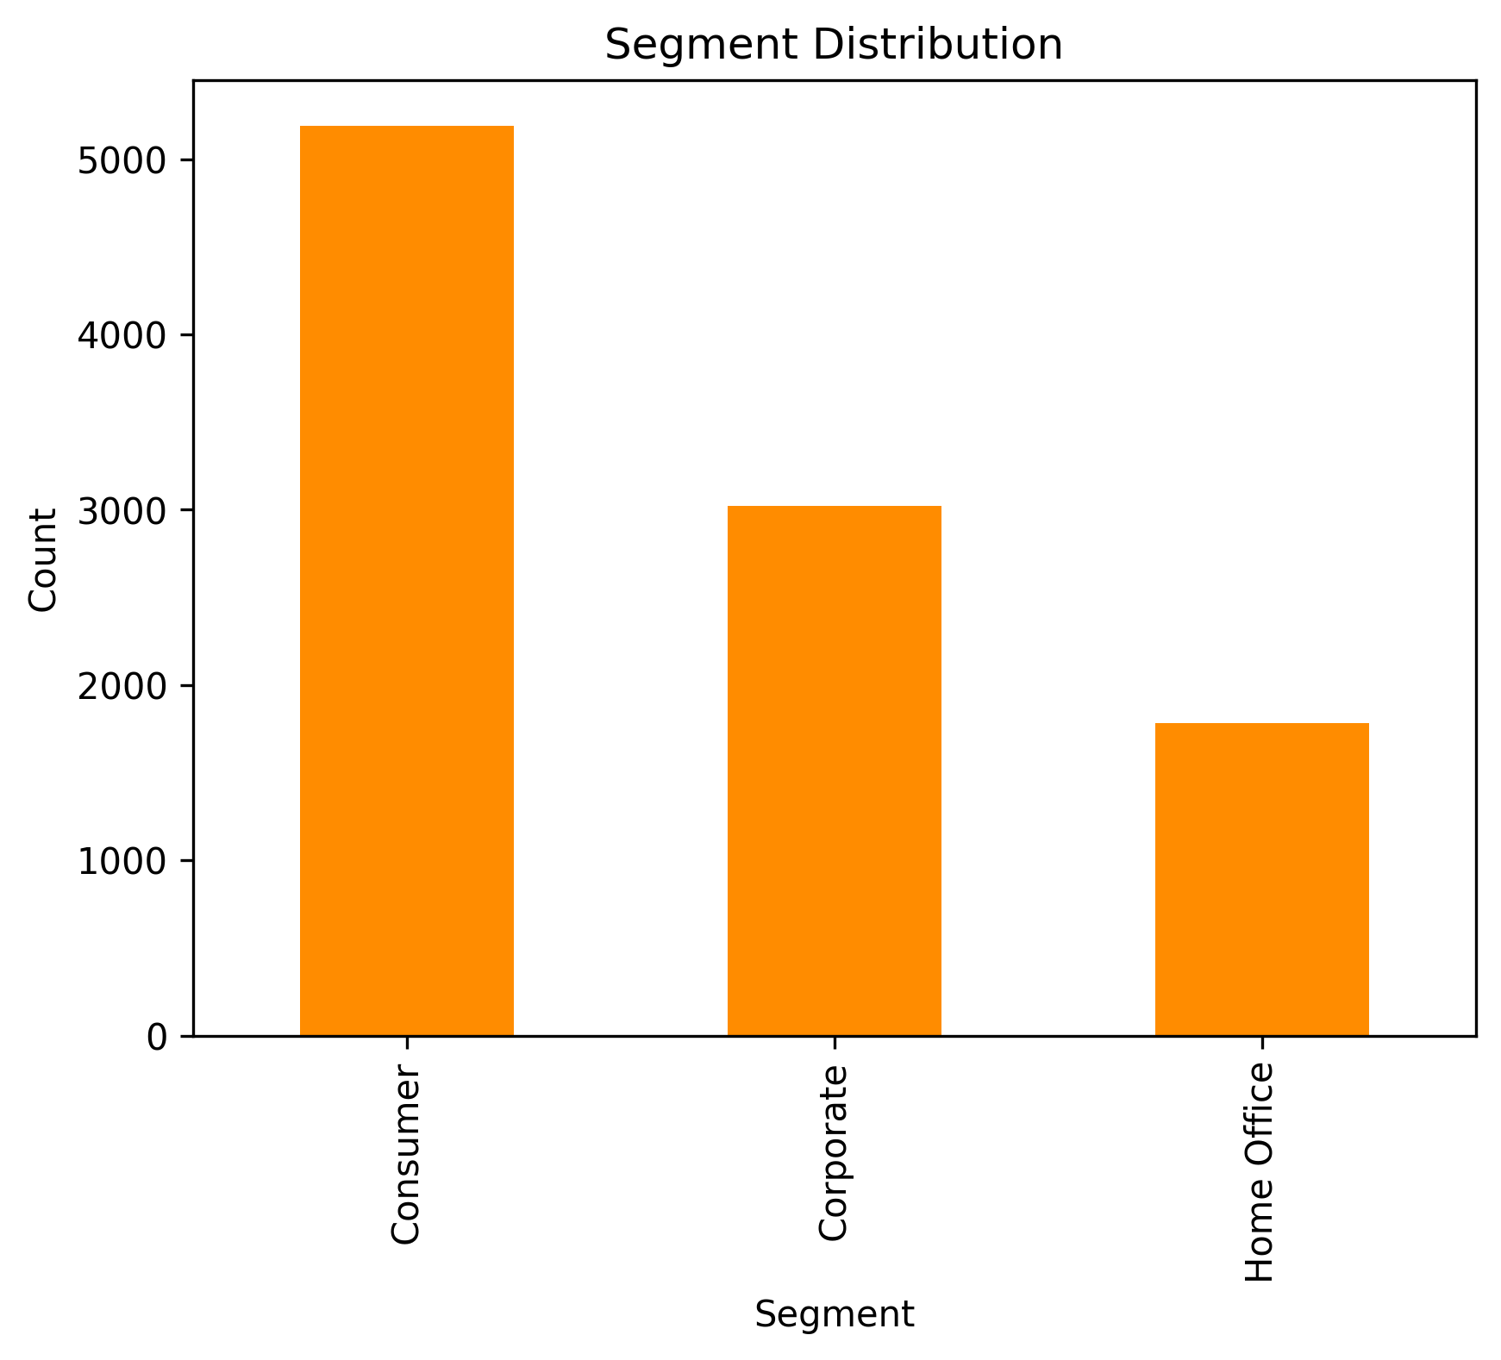
- Figure 4: Segment distribution across Consumer, Corporate, and Home Office.

- Category × Segment heatmap: Segment mix changes by category, indicating value in segment-specific offers per category.
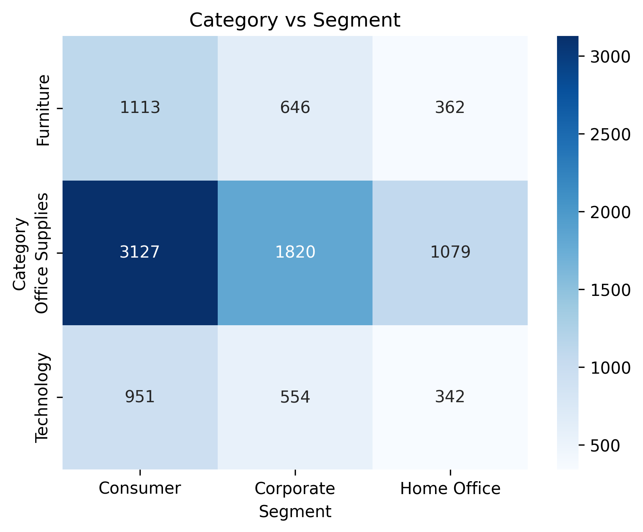
- Figure 5: Heatmap showing segment mix within each category.

- Region distribution: West and East dominate; South and Central show lower activity and may need different strategies.
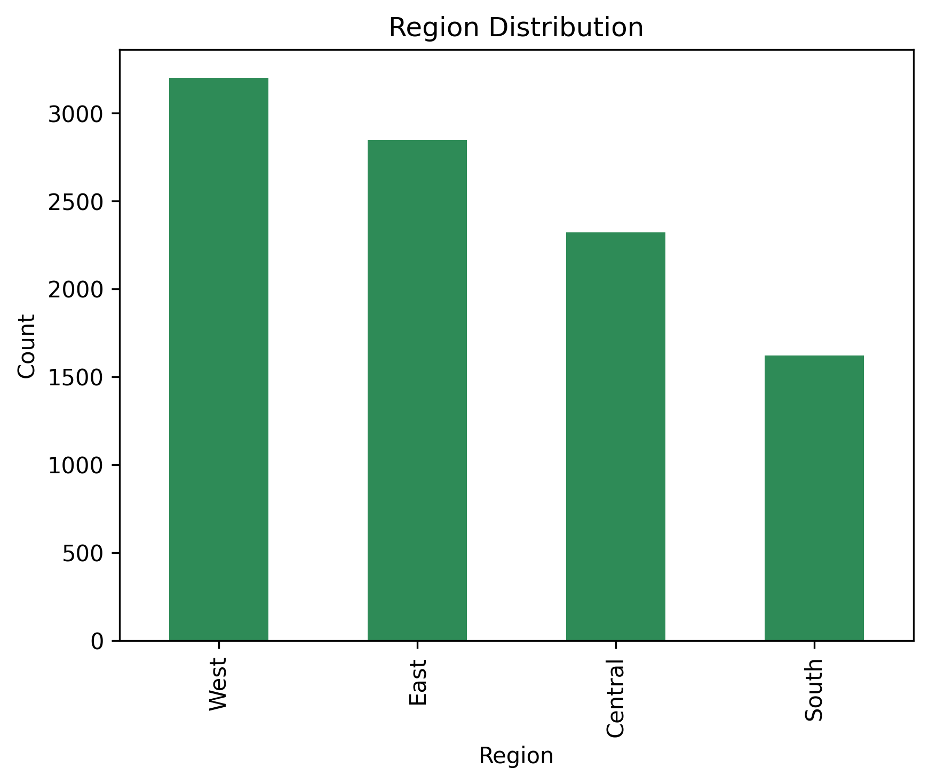
- Figure 6: Regional distribution of transactions across West, East, South, and Central.

- Category × Region heatmap: Office Supplies are consistently strong; Furniture and Technology vary by region, guiding localized actions.
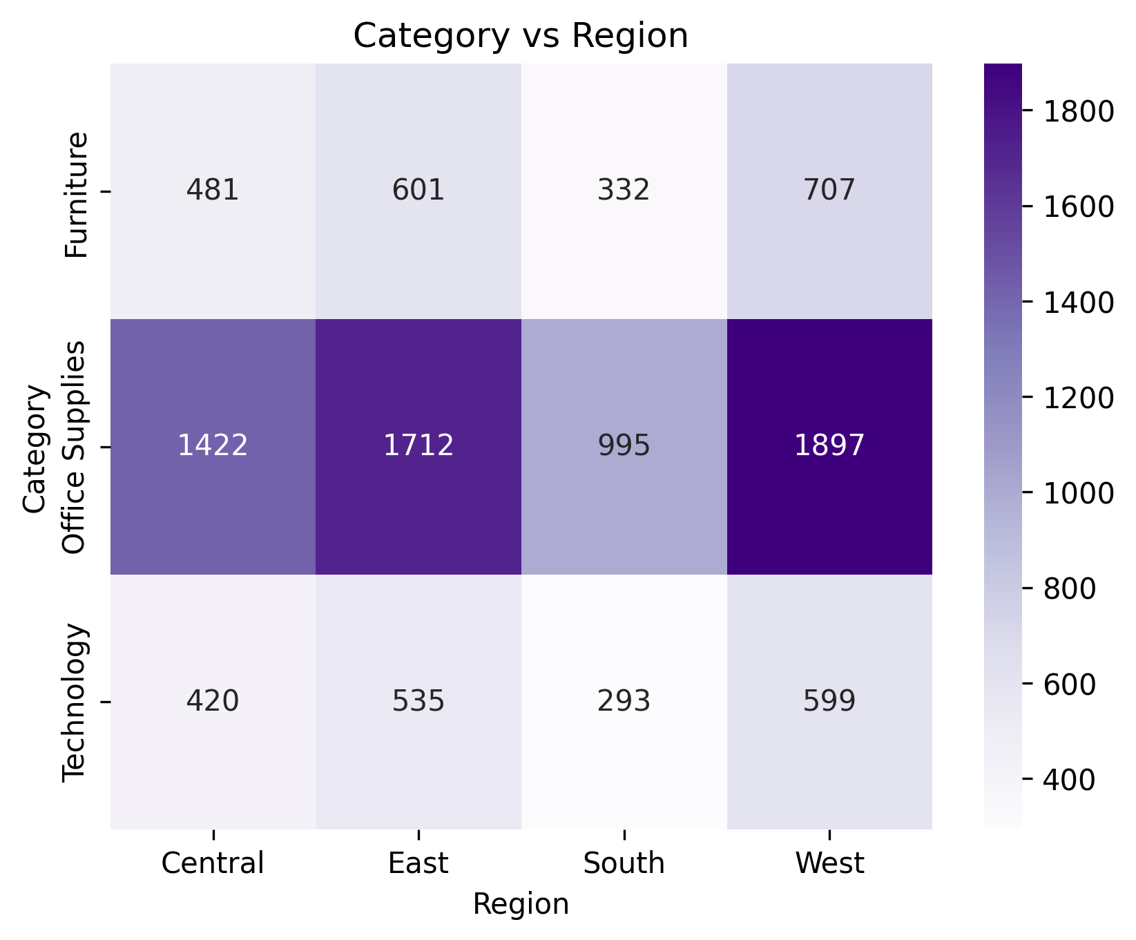
- Figure 7: Heatmap showing category distribution across regions.

Recommendations
- Inventory management: Increase availability in West/East and maintain higher reorder points for Office Supplies.
- Targeted promotions: Run region-specific campaigns for Furniture and Technology; align offers with segment behavior.
- Outlier governance: Review discount policies and high-variance orders to protect margins and ensure consistency.
- Reporting cadence: Refresh visuals monthly and track changes in segments and regions to catch trend shifts early.
Conclusion
- Takeaway: A region-aware and category-specific approach improves availability, targeting, and conversion while managing risk from outliers.
- Next steps: Validate findings with the latest sales data, A/B test regional offers, and integrate dashboards for ongoing monitoring.

