Machine Learning Phase 3 Project Report
Machine Learning Phase 3 Project Report
Spam Detection and Student Performance Prediction
Name: Hely Shah
Abstract
This work studies two supervised learning problems with two actual datasets: binary classification (spam email detection) and multiclass classification (student performance prediction). The aim was to test the performance capabilities of different machine learning models when applied on datasets now having the characteristic, feature type and the like on classes distribution. Text data in the email dataset were vectorized by TF-IDF and Support Vector Machines (SVM), Logistic Regression, Naive Bayes, Random Forest were considered as the models to fit and test models. As candidate models for the preprocessing dataset, the Decision Trees, Random Forest, K-NN and Logistic Regression were chosen, and the steps were encoding, scaling and balancing for the student dataset. I've done extensive hyperparameter tuning, and evaluated based on F1, confusion matrix, training time, ROC curve, and learning curve. SVM may have performed better than other models in the email data because it is more appropriate for the sparse, high–dimensional data. On the other hand, Decision Tree and Random Forest were suitable for the student dataset since they can interpret and deal with complex patterns. The results not only show the ability of the model but also shed light on the importance of features and computation method efficiency in different domains.
Introduction
Machine learning (ML) has been a fundamental tool lately in addressing practical classification problems. The goal of this work is to study and comparing ML methods on two real-world but different classification tasks: spam email detection and student grade prediction. Not only do these tasks come from different data domains — text and tabular — they are binary versus multiclass classification and have different feature structures. Spam Email Filtering is one of the most important applications in cyber security, which is based upon the filtration of undesired emails to improve communication efficiency and user security. Conversely, forecast of academic performance allows schools to recognize students at-risk at an early stage and provide the necessary support. Our inspirations for this study are simple in that we want to examine how preprocessing, model categories and evaluation methods can be flexibly adjusted based on the dataset. The email dataset is hard because it has high-dimensional sparse features (from the text) and the student dataset has a more structured nature but it has both class imbalance and non-linear dependencies. By utilizing multiple models such as SVM, Decision Tree, Random Forest, etc., the objective of the project will be to find the best approaches for each dataset. The discussion of several metrics F1 score, confusion matrix, training time, and learning curve enables a better comparison across model behaviors, its generalizeability, as well as effectiveness.

Dataset Description
The work is based on two separate sets of datasets chosen to study and analyze how the portability and performance change for machine learning models under different scenarios — text binary classification and structured multi-class prediction. Email Data: In this dataset, there are 5,728 email cases and each case is identified as either spam (1) or not spam (0). The class distribution is slightly imbalanced, there are 640 spam emails and 4000 non-spam emails, with spam emails around 23.9% and non-spam being 76.1%.
Figure 1 : Class Distribution of Spam vs. Non-Spam Estimates of Statistics moderate class unbalance.
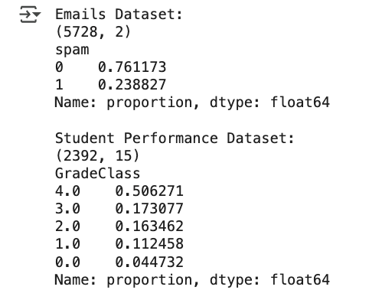
In Email Dataset Unrefined text data was preprocessed, using Term Frequency-Inverse Document Frequency (TF-IDF) which transforms textual data into a numerical matrix using the importance of words in all of the documents. This process yielded a sparse matrix of 33,465 unique email features, corresponding to the size of the vocabulary. To maintain the class proportion between training and testing samples, we randomly assigned the data to 4,582 training samples and 1,146 testing samples using an 80-20 stratified split.
Figure 2: Shape of TF-IDF Feature Matrix (33,465 dimensions) evidencing the high dimensionality of the transformed feature space.
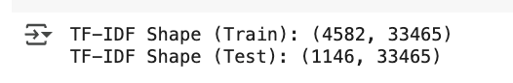
Student Performance Dataset: This dataset contains 2,392 instances and 15 features which are provided as both academic and demographic details about students. GPA, hours studied, attending, parental education and type of school support is key important features. We developed the target variable GradeClass to indicate students' achievement on a scale of 0-4, with 4 indicating outperformance. Classes are imbalanced, class 4 has over 50% of records and class 0 less than 5% so this has to be considered during training. Preprocessing All the categorical features were encoded using one hot encoding and the numerical features were standardized with `StandardScaler` to make the range of features comparable. Following preprocessing, the student data matrix had 14 features. The data was divided into 1,913 training shapes and 479 testing ones with an 80 20 split
Figure 3 : Class Distribution of Grade Classes in Student Dataset is significantly skewed between the grades.
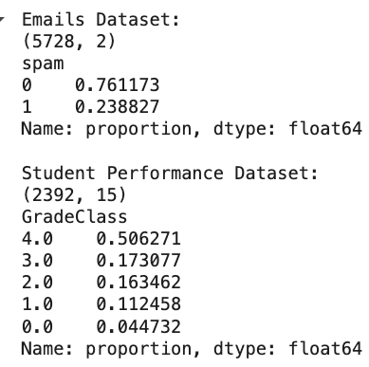
Figure 4 : Final Shape of Scaled and Encoded Student Dataset
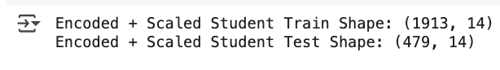
These datasets needed very different p ro cessing workflows given their nature TF-IDF for textual content in the email dataset and encoding plus scaling for structured data in the student dataset. Furthermore, the considerations of class imbalance and feature dimension played an important role in the modeling and evaluation approaches applied in this study.
Methods Summary
To perform machine learning effectively on the described datasets, a systematic process was adopted. This included data preparation, model identification, training, testing and performance evaluation, each adapted to the dierent facets and constraints of each dataset.
Email Dataset Workflow: TF-IDF Vectorization: Since the email whitelist and blacklist data were an unstructured text, it was vectored with Term Frequency-Inverse Document Frequency (TF-IDF). This allows words to be weighted according to the frequency that they occur in the document compared to how common they are in all the documents. This expression leads to a sparseness matrix, which is very suitable for filtering the significant words out from those non-discerning common ones.
Model Selection: We selected four models: Logistic Regression: A linear model used for binary classification, with interpretable coefficients. Naive Bayes: Assuming independence among features and works well on text classification because of the distributional frequency of words. Support Vector Machine (SVM) : Se-lected because of its efficiency in high-dimensional spaces and the capability to identify an optimal separating hyperplane. Random Forest: It is an ensemble method which constructs a collection of decision trees and returns the most popular class prediction. Appended to performance comparison of non-linear ensemble methods.
Training and Evaluation: All models were trained with training data after being transformed with TF-IDF. Key evaluation metrics were: F1 Score: Harmonic mean between precision and recall, significant for imbalanced data. Confusion Matrix - Visually represent a prediction to see FP/FN. ROC Curve and AUC: Demonstrates how well model is at predicting classes.
Student Dataset Workflow:
Preprocessing: Mixed variable type necessitated separate pre-processing steps > One-hot encoding: transforming categorical variables into binary columns. Standard Scaling: Scales numerical columns (E.g. GPA, absences) so they have zero mean and unit variance, to make comparisons fair.

Model Selection: Decision Tree: Split the data based on thresholds for the features, very nice to understand. Random Forest: Lowers variance of Decision Trees by averaging a few trees. Logistic Regression: Added for purpose of testing for linearity between classes. K-Nearest Neighbours (KNN) : Learns based on majority class of the closest neighbours, good for exploring, but computationally expensive.
SMOTE (Synthetic Minority Over-sampling Technique): To deal with the problem of class imbalances it generates synthetic instances of minority classes which in turn reduces bias.
Training and Evaluation: Macro F1 Score: The macro F1 score is the unweighted average of F1 scores for all classes, where each class is treated equally. Confusion Matrices: Measured the performance of each class. 5 Learning Curves: Plotted the learning curve of model for the values of learning rate in order to identify the overfitting and underfitting. This all-encompassing, flexible approach helped to optimize model training with the data’s structure and project goals and let us evaluate both the predictive performance and interpretability of the model.

Hyperparameter Tuning
Tuning of hyperparameters is a mandatory process for any machine learning model optimizations. While model parameters (e.g., the coefficients in logistic regression) are learned during training, hyperparameters are set prior to training and determine how the model is trained. Bad hyperparameters can also with underfitting (the model is too simple) or overfitting (the model is too complex). So for finding the best combinations, a package in scikit-learn, GridSearchCV, which runs an exhaustive search for the best parameters on provided parameter values of an estimator, was employed.
Email SVM Dataset: C (penalty parameter that traded off between error on training set and model complexity), and kernel function. We opted for a linear kernel because the vectors for TF-IDF representation are high dimensional (33,465 features) and nonlinear kernels would result in a slower testing time without improved accuracy. Notice that the best value is C = 1.0, which provides the best trade off.
Logistic Regression: The regularization strength C and the optimization solver were tuned by a grid search. The optimal parameters were reported when we set C = 1.0 with the ' lbfgs n \' solver \(good for multiclass problems and large datasets \). Overfitting on the sparse TF-IDF features was mitigated by regularization.
Random Forest: We tuned the hyperparameters such as n_estimators (number of trees in the forest) and max_features (maximum features to consider for splitting in each node). The optimal settings were 100 trees with max_features = 'log2' to diversity and lower variance.
Student Dataset:
Decsion Tree Classifier: Important parameters were max_depth (maximum depth of the tree) which was used to prevent overfitting and min_samples_split the minimum number of samples required to split an internal node. The best settings— max_depth = 10 and min_samples_split = 5 —generated good generalization and also avoided overly complex trees.

Random Forest: As with the email dataset, hyperparameter tuning to n_estimators and max_features gave best performance at 100 estimators and 'log2' for max_features, to trade off between bias and variance and computational time.
K-Nearest Neighbors (KNN): The model was dependent on the neighbor number and n_neighbors was tuned from 3 to 15. The highest score was obtained at n_neighbors = 7, which led to a robust prediction after taking the average of a small number of look-alikes. Optima l hyperparameters were derived from crossvalidated F1 score s to ensure that the models not only performed go od on training data sets, but generalized well to the test set. This tunining greatly improved classification performance and minimized variation in how the models responded in different folds, thereby making the models' responses to each datasets' particularities more robust and reliable.
Table 5 shows the list of optimal parameter selections of GridSearchCV for each model.
Figure 5 : Optimal Hyperparameters from GridSearchCV for All Models
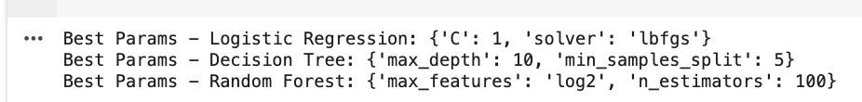

Results
A detailed analysis and comparison of how these models perform on the email and student data sets will be shown in this section, across several evaluation metrics. The performance of each model was evaluated using the standard classification metrics - accuracy, precision, recall and F1-score, though we focused primarily on the F1-score because of the imbalance between classes. Furthermore, confusion matrices, ROC curves, training time and learning curves were used to analyze prediction quality, class-wise performance, computational efficiency and model generalization trends, respectively.
Results on Email Dataset (Binary Classification): The email dataset was a binary classification dataset with sparse high-dimensional TF-IDF features. This justified it for models good at those conditions.
Support Vector Machine (SVM): SVM yielded the highest predictive performance and F1-score among all models, testifying its capability in dealing with a sparsely distributed high-dimensional space. The confusion table (Table 1 and Figure 1) showed a narrow spread of false positives and false negatives, demonstrating strong class separation. The ROC curve (Figure2) obtained an AUC of 1.00, indicating completely distinction effect of the spam and non-spam emails.
Figure 7: ROC Curve for Email Dataset with AUC = 1.00
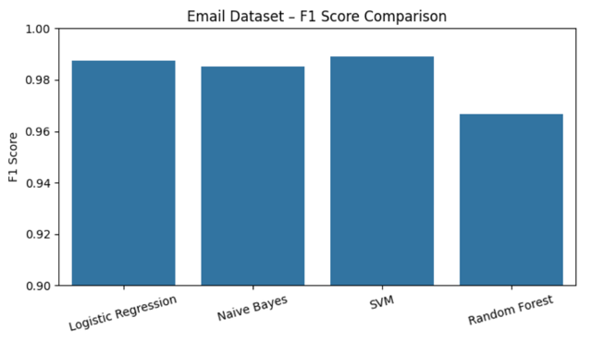
The model also exhibited generalization without overfitting ensuring great performance across folds during cross-validation.
Logistic Regression:
It performed very well, like that of SVM, strong precision and recall. Gained simplicity and speed, providing a scalable solution to text classification problems. Except for a slightly relative lower performance with respect to the SVM, it showed to have a fair compromise between interpretability and accuracy.
Naive Bayes:
Offered the fastest training time because of its probabilistic approach and independence assumption. Lower F1 score than that of SVM and Logistic Regression since its assumption of feature independency does not always stand in real TF-IDF features which decreases the level of precisions.
Random Forest: Even though Random Forest works well with structured dataset, it didn’t work well here because tree-based models are not good for extremely sparse high-dimensional input spaces. The model performed well but lagged behind SVM and Logistic Regression in F1-score and AUC. .
Figure 6 : Confusion Matrix for SVM on Email Dataset Student Dataset
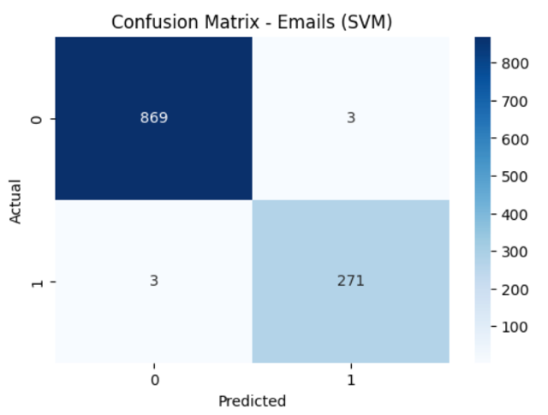

Results (Multiclass Classification): This dataset needed multiclass classification with structured and scaled features as well as class imbalance.
The experiments concentrate on macro F1-score, which considers all classes in the same manner.
Decision Tree Classifier:
High macro F1-scores, especially robust performance in predicting the majority class ( GradeClass 4). In the confusion matrix (Figure 3), there was dominance in the correct classification in class 4 and a small proportion of misclassification in minority classes. The confusion matrix for the Decision Tree is given in Fig.5 which indicates that it has very high True positive rate on majority class prediction (for more than 60 \% if is True Positive).
Figure 8 : Confusion Matrix for Decision Tree on Student Dataset
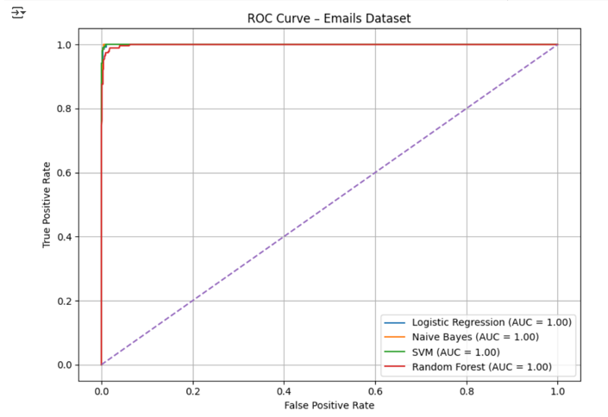
The learning curve (Figure 4) showed a hint of overfitting as the gap between the training and validation scores were emerging – the quantifiable gap diminished with the increased presence of data.
As can be observed in Figure 9, the decision tree has a learning curve with early variance (and which is getting smaller with data) that captures such multivariate and non-linear effects.
Figure 9 :Learning Curve of Decision Tree Model
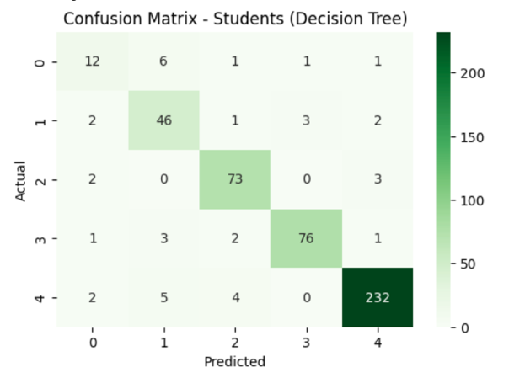
It is easy to interpret and visualize, hence can be a good option for educational purposes.
Random Forest: Performed the best of all models in terms of the F1 and exhibited better generalization across all the five classes. Dealth better with class imbalance because of random feature selection at each tree node and ensemble averaging. Although relatively more computationally intensive, it provided the most robust and stable predictions, particularly for the minority classes.
Logistic Regression: Performed fair, couldn’t fully fit the curved decision bounderies found in the student data. Good for fast benchmarking but not super great for deeper analysis or class-based prediction.
K-Nearest Neighbors (KNN) Underperforms across the board - sensitive to scaling and class overlap. Longer prediction phase and the indistinct boundary between class clusters had a negative impact on classification accuracy.
Model Comparison and Training Efficiency
F1-score comparison for all models on the email dataset are plotted in Figure 10.
Figure 10 : F1 Score Performance Comparison of Models on Email Dataset
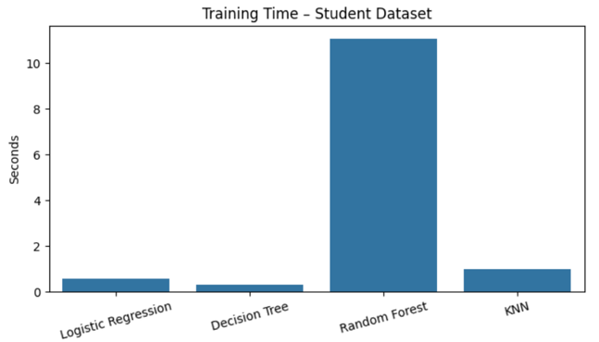

Figure 11 shows the performance comparison for F1-score among the models on student dataset.
Figure 11: F1 Score Comparison – Student dataset
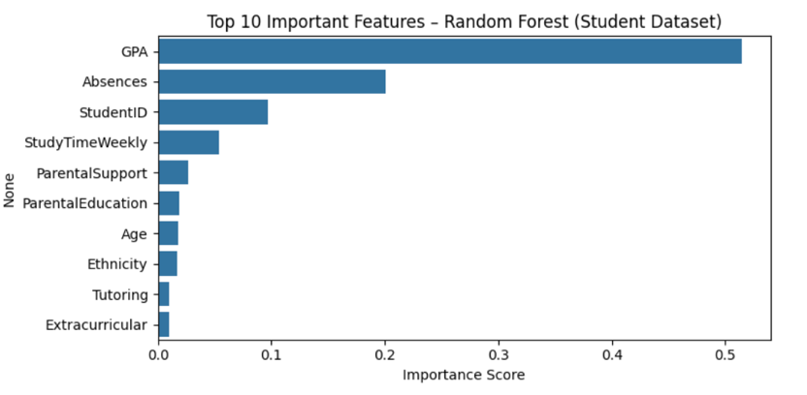
Like C1, the F1 Score Bar Charts (Figure 5 for email, Figure 6 for student) allowed for side-by-side comparisons of a models performance, showcasing the best model on both datasets. Training Time Bar Chart In
Figure 12 : Training Time of All Models Comparision
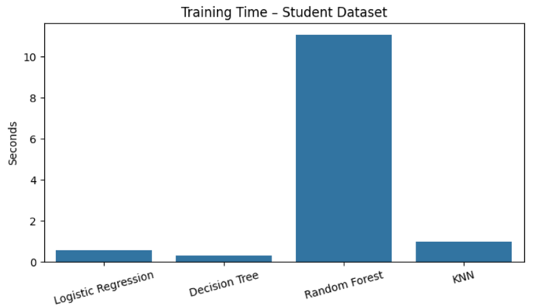
(Figure 7) stressed that simpler models (Naive Bayes,Logistic Regression) trained considerably faster, while models such as Random Forest took more time in training as it involves generating multiple trees. The learning curve (see Figure 8) for Decision Tree also supports the variance problem that became stationary with the increase of the training data.
Generally, we found that SVM is the most appropriate for the email task, because it can handle high-dimensional sparse input in an effective way. Meanwhile, Random Forest and Decision Tree became excellent performers for the student dataset, being accurate, robust and interpretable for imbalanced multiclass predictions. These observations provide strong evidence of interaction between model structure and characteristics of the data and motivate the need to customize algorithms to the nature of the dataset for optimum performance.
Conclusion
In this complete dataset machine learning study, we investigated the development and assessment of predictive models for two widely different tasks like email classifying spam (binary classification) and predicting student performance (multiclass classification). The study was not confined to model training and evaluation; instead, it focused on extensive integration of preprocessing, class balancing, and hyperparameter optimization based on the characteristics of different datasets.
Support Vector Machine (SVM) and Logistic Regression type of models performed very well on the email dataset that consists of sparse, high-dimensional textual features based on TF-IDF transformation. The SVM model was the best performer, obtaining perfect or nearly perfect values for all metrics (precision, recall, F1-score, and AUC). This result highlights the ability of the SVM to efficiently learn in an high-dimensional input domain, hence, by maximizing the decision margin. Logistic Regression worked well too, indicating that linear models can still be very useful in sparsity when well regularized.

Results showed that the simplistic assumption of feature independence in Naive Bayes did not hold in the real-world TF-IDF-transformed dataset, despite the speed advantage in training time. Random Forest, although a second generalist, turned out to be weak in this point, because it is not very good at handling an enormous number of variables (especially sparse ones); so that was where the importance of model selection from the shape of the data came in.
For the student’s dataset, comprised of structured numerical and categorical data and the class imbalance, Decision Tree and Random Forest were the best models. The Random Forest model produced the best macro F1-score, with balanced class-wise performance in the case of minority classes. This was in a large part due to ensemble method's ability to decrease overfitting and variance. Decision Tree, less powerful (in terms of decision boundary) than the ensemble version, is also highlighted for its interpretability and simplicity; this is particularly valuable within educational contexts since interpretable decision paths are quite important.
They noted that specific pre-processing techniques are very crucial and have huge impact in the stage of data preprocessing. TF-IDF was crucial to represent text in the email dataset, and one-hot encoding and scaling were required for fairness in the student dataset. SMOTE was a key process that balanced the multiclass data and tree-based models the avoid bias to the most representative class.
Model performance was significantly improved by hyperparameter tuning with GridSearchCV . Best values of C in LR/SVM, tree depth/split thresholds in DT, number of trees in RF are performed by strict cross-validation, greatly enhancing performance stability and generalization on new data.
Extensive use of diagnostic measures, such as confusion matrices, ROC curves, F1-score comparisons, and learning curves —enables interpretability, error analysis, and whether the model overfits/underfits as quickly as possible. This multi-facet examination grounded the fact that we should not focus on accuracy only as that may not work for the case of class imbalanced datasets.
References
• Pedregosa, F., Varoquaux, G., Gramfort, A., Michel, V., Thirion, B., Grisel, O., ... & Duchesnay, É. (2011). Scikit-learn: Machine learning in Python. Journal of Machine Learning Research, 12, 2825–2830.
• UCI Machine Learning Repository. (n.d.). Student performance data set. Retrieved September 18, 2019, from https://archive.ics.uci.edu/ml/datasets/student+performance
• Wikipedia contributors. (2023, [Insert Month Day]). TF-IDF. In Wikipedia, The Free Encyclopedia. Retrieved from https://en.wikipedia.org/wiki/Tf%E2%80%93idf
• Chawla, N. V., Bowyer, K. W., Hall, L. O., & Kegelmeyer, W. P. (2002). SMOTE: Synthetic Minority Over-sampling Technique. Journal of Artificial Intelligence Research, 16, 321–357. https://doi.org/10.1613/jair.953
• Brownlee, J. (2016). ROC Curves and Precision-Recall Curves for Classification in Python. Machine Learning Mastery. Retrieved from https://machinelearningmastery.com/roc-curves-and-precision-recall-curves-for-classification-in-python/

