Aegis Ascend website: how it works
Nov 13, 2026 · @Dhruvi

Overview
Aegis Ascend is the website and client workspace of a Mumbai advisory firm. It advises growing Indian businesses whether to raise debt, equity or a mix, then helps deliver the deal. The site has two halves:
- Public site: explains the services, fees and compliance stance, and lets visitors book an engagement or try a live debt-vs-equity model.
- Workspace: after sign-in, each of four roles (founder, investor, lender, advisor) gets its own dashboard.
It runs in two modes from the same front-end code:
Mode | Where data lives | Used for
Demo | The visitor's browser (localStorage), seeded with fictional companies | The shareable demo link; no server needed
Server | A Flask app with a SQLite database | Real use; the server enforces every rule
All companies and people in the demo are fictional and labelled as such on every workspace page.

Public site
The public site has nine pages, all black and gold, with smoked-glass panels over a New York skyline at night. It needs no login, and the "Ask Aegis" assistant is on every page.
Page | What it does
Home | 3D emblem scroll intro, a live debt-vs-equity example, the brand story, how reports are made, the tools, the founders, a call to action
Services | Debt vs equity advisory, equity raise and early exit (step by step), debt arranging, monitoring and loan transfers
For investors | Why fewer but checked companies, deal rooms, a tax table and an exit tax calculator; investing is free, with a 0.3–0.5% resale fee only when an investor sells
For lenders | Lender-side view, monitoring, loan transfers and a debt fee calculator
Pricing | Fee schedule (advisory from Rs 1 lakh; 2.5% equity success fee; 0.4% revenue share for 5 years; 2.5% debt success fee on loans we arrange; 0.3–0.5% resale fee from selling investors; lenders pay the arranging commission, monitoring and transfer fees; all plus 18% GST) and a "what one deal is worth" calculator
Trust & compliance | How each activity is structured legally, commitments, planned security controls, the release checklist
About | Founders (Hem Parekh, Yash Sharma, Vivan Shah), pilot target, comparison, four-phase roadmap
Contact | Enquiry form; submissions land on the advisor's Enquiries page
Sign in / Create account | Email sign-in, one-click demo roles, sign-up for founder, investor or lender; 5 wrong passwords lock the account for 15 minutes
The home intro. The page opens on a 3D gold emblem built from the logo's own outlines: two upright A's sharing a chevron, with a glowing diamond on top. It sways gently and leans toward the pointer. As you scroll, the camera flies in, the two A's part to the screen edges and a city of lit buildings rises behind the headline "Smarter Decisions. Stronger Futures.". Browsers without 3D graphics, and visitors who prefer reduced motion, get a layered 2D version.
The live example and whiteboard motion. A sample company needs Rs 12 crore; a split bar shows the recommended debt and equity shares, and each figure opens its working when clicked. Cursors labelled Advisor and Founder then circle the key numbers, draw arrows and stick gold notes beside them, and walk through the eight method steps.
Glass and skyline. Header, page headers, cards, the sign-in card, the contact form and the footer are glass panels. Text never sits directly on the skyline, so it stays readable. On phones the panels become near-solid instead of blurred.
The "Ask Aegis" assistant. A chat button on every page answers questions about services, fees and processes, and guides people around the site with links that suit the page they are on and their role. It gives general information only. On the server it answers with Claude once an API key is set; otherwise, and on the demo, it uses built-in quick answers.

Sign-in and the four workspaces
Each role signs in to its own workspace, a left menu plus a page area, and sees only its own data. The demo has one account per role, password demo1234.
Role | Demo account | Home page | Main screens
Founder | founder@demo.in (Priya Nair, Kalyan Polymers) | Overview: stage, advisor-approved mix, interested investors, report status, next-steps checklist | Fundraise tracker, Investors (Fit Score ranking, suggest to advisor), Deal room, Cap table with round calculator, Data room (8-item checklist), Revenue share, Loans & monitoring (apply through us, DSCR covenants), Fees with every invoice to the company, Company profile
Investor | investor@demo.in (Meera Iyer) | Portfolio, styled like a demat account: invested, value, gain, XIRR, holdings table | Holding detail with tax estimate, Sell request flow, Sell requests & exits (with the resale fee and invoices), Opportunities (private offers), Curated deals, Deal rooms with online NDA
Lender | lender@demo.in (Suresh Pillai, Harbour Bank) | Loan book: lent, outstanding, interest earned, next repayment, DSCR badges, and a Sell button on every loan | Loan detail with repayment schedule, Lender desk, Applications (sanction, disburse), Monitoring, Loan transfers (a seven-step guide and each sale's progress), Fees
Advisor | advisor@demo.in (CA Neha Joshi) | Today: everything needing attention, most urgent first | Company pipeline board, Company file, Investor directory (share offers), Deal rooms, Resale requests, Revaluation centre, Loan transfers, Review queue, Compliance, Revenue (including debt success and resale fees), Notes & tasks, Message templates, Admin
Advisor-only tools. Founders do not get the analysis tools. The advisor runs them and sends the founder the finished, reviewed report.
- Funding Twin: a live model of the company. It finds the best debt share in 5% steps, stress-tests it (sales −20%, rates +2 points), runs a 2,000-run simulation and produces the report the advisor submits.
- Equity vs Debt Optimizer: tests every mix from 0% to 100% equity in 1% steps and picks the best mix that can safely repay the loan, ranked by present value of founder wealth (the default), total cash, undiscounted wealth or present value of cash.
- CMA funding report: reads a bank CMA workbook in the browser, sizes debt on DSCR and exports a one-page PDF. Anyone else sees an "Advisors only" page.
- Readiness Score: debt and equity readiness out of 100, with a fix-it plan.
- Term Sheet Analyser: the true cost of a loan sanction letter, or the founder's stake and risky clauses in an equity term sheet.

Key processes, end to end
An equity raise passes between three people. The founder and investor decide access and interest; the advisor takes every step that has legal weight.
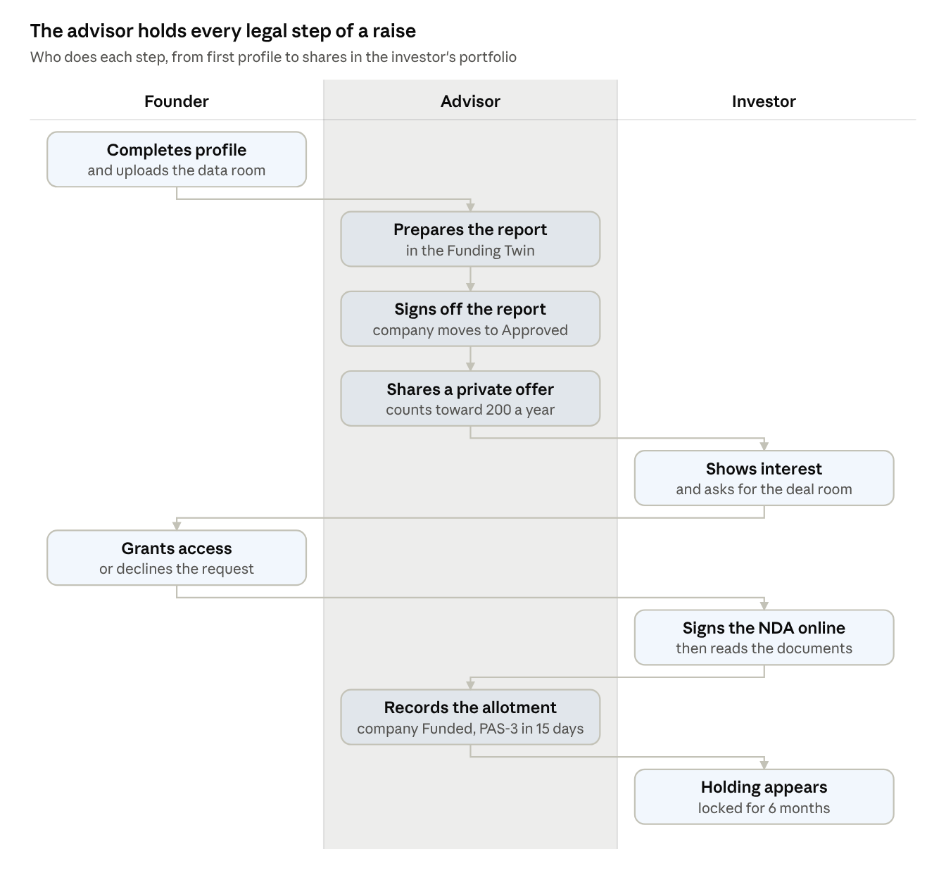
equity raise · 9 steps across founder, advisor and investor
The company's pipeline stage changes on its own: Under review when the report is submitted, Approved at sign-off, Offering at the first offer, Funded at the first allotment.
Early exit (resale)
- After 6 months, the investor requests a sale of the full stake or part of it.
- The advisor starts review, then a first-refusal window of 15–30 days.
- The advisor introduces one KYC-verified buyer who keeps the company within its limits.
- The advisor records the signed SPA, then completes the transfer, entering the resale fee (0.3–0.5% of the sale value). Both portfolios, the cap table and the member count update; the selling investor is invoiced the fee and the buyer pays nothing.
Loan
- The founder applies through Aegis Ascend to a chosen lender.
- The lender sanctions it, then marks it disbursed, which starts the repayment schedule and raises the company's 2.5% debt success fee invoice (plus GST, due in 15 days).
- The founder uploads quarterly accounts; DSCR is checked against covenants. Green is 1.5 or above, amber 1.25–1.5, red below 1.25.
- Lenders mark instalments received; overdue ones raise alerts.
Loan sale (transfer)
- The lender presses Sell on a loan in its loan book (or Sell a loan), choosing the amount and adding a note; the request goes to the advisor.
- The advisor checks eligibility (a regulated seller that has held the loan 3 or 6 months), then records borrower consent.
- The advisor introduces a regulated buyer, then records the signed deed and the ROC charge update.
- On completion the loan moves to the buyer's book and the selling lender is invoiced a 0.3–0.5% transfer fee. The lender follows each step on its Loan transfers page.
CMA funding report
- The advisor uploads the bank CMA workbook; it is read inside the browser and never uploaded.
- The advisor enters the project and financing details.
- The tool sizes debt on DSCR, with the promoter's contribution and a stress test, and exports a one-page PDF for lenders.

Fees and revenue
The firm earns from the company at several points, from investors only when they sell, and from lenders for arranging, monitoring and loan sales. All fees are plus 18% GST.
Fee | Rate | Paid by | When
Advisory engagement | From Rs 1 lakh | Company | At engagement
Equity success fee | 2.5% of amount raised | Company | At deal close
Revenue share | 0.4% of net revenue for 5 years | Company | Quarterly
Debt success fee | 2.5% of the loan amount | Company | At disbursal (invoiced automatically)
Resale fee | 0.3–0.5% of the sale value | Selling investor | When the transfer completes (invoiced automatically)
Debt arranging | Commission agreed per lender | Lender | At disbursal
Debt monitoring | 0.25–0.5% a year on the outstanding loan | Lender | Yearly
Loan transfer | 0.3–0.5% of the amount transferred | Selling lender | On completion (invoiced automatically)
Buying shares is free for investors. Worked example from the site's calculator: a Rs 10 crore equity raise at Rs 50 crore revenue earns Rs 1 lakh advisory, Rs 25 lakh success fee and Rs 100 lakh revenue share, about Rs 1.26 crore over 5 years before GST.

Compliance rules
The server checks these rules on every action, so no screen can get around them. The demo store copies the same checks.
Rule | What the system does
Direct holding | Investors hold shares in their own name; money never passes through the platform
Platform investors | At most 20 per company (changeable in advisor Settings)
Offer counter (Companies Act s.42) | One offer per investor, per company, per financial year and security type, including off-platform offers; warns at 150, blocks above 200
Member counter (s.2(68)) | Founders, existing holders and platform investors counted; warns at 180, blocks above 200
Minimum holding | 6 months from allotment; earlier only with the founder's recorded consent
Revaluation | Quarterly, by a registered valuer
Private resales | No listings or bidding; a 15–30 day first-refusal window and a one-to-one buyer introduction
Loan transfers | Only between regulated banks and NBFCs, after the minimum holding period (3 or 6 months)
KYC | Verified KYC needed before an offer or a buyer introduction
Deal rooms | Only for companies already offered; only the founder grants access; documents open after the NDA
Advisor-only actions | Reports, offers, allotments, valuations, resale and transfer steps
Data isolation | Each role sees only its own data
Audit log | Every change recorded with who, when, and before and after values

Architecture and code map
The front end is plain HTML, CSS and JavaScript with hand-drawn SVG charts and no framework; the home page's 3D emblem uses three.js. It talks to one data layer, window.GB_API. In the demo that is the browser store; on the server it is a thin adapter that calls the Flask API.
File | Lines | Role
site/shell.html | 855 | The page skeleton and all CSS, including glass, skyline, whiteboard motion and the assistant panel
site/calc.js | 312 | Calculation engine: best mix, stress tests, seeded simulation, fee calculators
site/optimizer.js | 249 | Browser port of the Equity vs Debt Optimizer
site/ui.js | 162 | Formatting, the click-any-number explain panel, small SVG charts
site/domain.js | 127 | Business arithmetic, a line-for-line mirror of server/domain.py
site/kit.js | 242 | Workspace components: tables, dialogs, toasts, timelines, kanban
site/src/hero3d.js | 266 | The 3D emblem scene; bundled with three.js into site/hero3d.js by site/tools/build-hero3d.sh
site/store.js | 1,042 | Demo data store: same actions, rules and automatic invoices as the server, kept in localStorage
site/api-server.js | 31 | Server adapter used when the Flask app serves the site
site/public.js | 354 | Public pages and the home scroll intro
site/motion.js | 190 | Whiteboard motion: cursors, hand-drawn ink and sticky notes
site/chat.js | 200 | The "Ask Aegis" assistant panel, quick answers and site guide
site/sitemap.json | 88 | The assistant's map of every page and workspace screen
site/portal.js | 585 | Sign-in, the workspace shell and the page router
site/ws-founder.js / ws-investor.js / ws-lender.js / ws-advisor.js | 165 / 216 / 207 / 523 | One file of screens per role
site/cma-lock.html | 38 | The "Advisors only" page for the CMA tool
site/build.py | 46 | Inlines everything into site/dist/index.html
site/tools/skyline.py | 155 | Draws the New York skyline SVG
server/app.py | 514 | Flask app: sign-in, sessions, API routes, the chat endpoint, uploads, page serving
server/actions.py | 806 | Every workspace action with its permission and rule checks, and automatic fee invoices
server/domain.py | 180 | Money, DSCR, schedules, XIRR and limits, in integer paise
server/seed.py | 263 | The fictional sample companies, people, loans and invoices
server/chat.py | 205 | The assistant: Claude answering from the site's facts and site map
How to run it
- Real app: pip install -r server/requirements.txt, then python -m server.app, and open http://127.0.0.1:8000. Set ANTHROPIC_API_KEY to turn on Claude answers in the assistant.
- Demo file: python site/build.py, then open site/dist/index.html. No server is needed.
- Tests: python -m pytest server/tests fundmix/tests and node site/tests/store.test.js. The parity tests check that browser and server give identical numbers, and a site-map test keeps the assistant in step with the menus.
Two standalone tools sit beside the site: the desktop Optimizer (optimizer/) and the local CMA report app (fundmix/).

Design system
The look follows the gold emblem on black. The full rules live in DESIGN.md.
Element | Value
Background | Obsidian #0D0E10 (public); stone #F2F1EE with white panels (workspace, light mode)
Gold | Emblem gold #C9A04F, light gold #E8C77B, deep gold ink #7B5C1F for text on white
Text | Ivory #F1ECE2 on dark; ink #16171A on light
Chart series | Debt blue #3F6EA6, equity gold #B8892F, mix green #1E8C68
Fonts | Cinzel for headings and the wordmark; Hanken Grotesk for body text and numbers; Caveat for handwritten sticky notes
Corners | 2–6px everywhere; 12px for glass panels only
Marker | A small rotated gold diamond for bullets, current page and chosen options
Glass | Tint rgba(20,19,16,.6), blur 14px, 1px gold edge at 22%, soft shadow
3D emblem | The logo's outlines extruded in metallic gold, always upright, with a glowing diamond (#D9A445) and a soft front light
Readability rules for glass
- Text never sits directly on the skyline: it is always on glass tinted at least 60%, or on a section ground of 90% or more.
- The header is tinted 80% (90% on phones), so gold content scrolling under it never washes out the menu.
- Phones get near-solid panels with no blur. Devices that ask for less transparency, and older browsers, get solid panels.
- In the workspace, data tables, number tiles and working panels stay solid. Only the left menu and page headers carry the skyline.
- Whiteboard notes and cursors never cover content or move the layout, and reduced-motion visitors see the finished annotations without cursors.

The single-file code bundle
All of the website's source is in one Markdown file, aegis-ascend-website-code.md: 33 files, 9,034 lines, about 790 KB. It opens with a contents list, then reproduces every file in full, in the order the page loads it. Regenerate it any time with python site/tools/bundle-code.py.
Part | Files
1. Page skeleton and styles | shell.html
2. Shared engine and helpers | calc.js, optimizer.js, ui.js, domain.js, kit.js
3. Home page 3D emblem | src/hero3d.js, tools/build-hero3d.sh
4. Data layer | store.js, api-server.js
5. Public website, motion and the assistant | public.js, motion.js, chat.js, sitemap.json
6. Sign-in and role workspaces | portal.js, ws-founder.js, ws-investor.js, ws-lender.js, ws-advisor.js
7. Standalone pages and build tools | cma-lock.html, build.py, tools/skyline.py, tools/bundle-code.py
8. Server (Flask) | app.py, actions.py, domain.py, seed.py, chat.py, requirements.txt
9. Tests | test_server.py, test_parity.py, test_demo_store.py, store.test.js
Each file has a heading with its path and a one-line description, followed by its full code in a fenced block.
Left out: the founder photos, the generated skyline.svg and hero3d.js (rebuilt by their tools), the built site/dist/ folder, and the standalone optimizer/ and fundmix/ tools.

