

**LIVERPOOL** **INTERNATIONAL COLLEGE**

**A Practical Report**

**on**

**Computer Science**

**Submitted By:**

Hem kumar pandey

S3

Roll number:12

**Submitted to:**

Department of Computer science

Liverpool International College

New Baneshwor,Kathmandu

In partial fulfillment of final examination of computer science.

**Under supervision of:**

Prabin Pathak

Feb 2024



LIVERPOOL INTERNATIONAL SS. COLLEGE

Kathmandu, Naya BANESHWOR

CERTIFICATE OF APPROVAL

This is to certify the Hem kumar pandey of class 12 at Liverpool college, has successfully completed the Computer Laboratory sessions and submitted the Project Report with diligence and proficienc. Hem kumar pandey has actively participated in various practical exercises, demonstrating a sound understanding of programming concepts, software applications, and problem-solving skills. The student's commitment to learning and enthusiasm in the computer laboratory have been commendable. This certificate is awarded as a testament to Hem kumar pandey successful completion of the Class 12 Computer Laboratory curriculum.

**Evaluation committee**



**Prabin Pathak External examiner**

|  |  |
| --- | --- |
|  |  |

ACKNOWLEDGEMENT

I would like to express my greatest appreciation to the all individuals who have helped and supported me throughout the project. I am thankful to my computer teacher for his ongoing support during the project, from initial advice, and encouragement, which led to the final report of this project. I would also like to thank Mr. Prabin Pathak who was always there in our computer lab for assistance. A special acknowledgement goes to my classmates who helped me in completing the project by exchanging interesting ideas and sharing their experience . I wish to thank my parents as well for their undivided support and interest who inspired me and encouraged me to go my own way, without whom I would be unable to complete my project .At the end, I want to thank my friends who displayed appreciation to my work and motivated me to continue my work.

Preface

C program is most useful for emended systems, or applications that requires the ability to be light-weight and have precise control over system resources. C programming lacking a lot that more contemporary languages feature, but remains a core tool for UNIXdevelopers. When set out a build an emended system, we should first consider using C programming. By learning C programming many programmers have understand the internal architecture of a computer, how computer stores and retrieves information. CSS is how we manage the look and feel of a webpage – so you will no longer be stuck with the default presentation of your browser. HTML provides the structure of HTML documents; CSS provides the appearance. AS always, as more you practice the better you get. HTML allows embedding text, image, multimedia and links to another document and web page. CSS can help to make web pages available for different media with the same mark-up page presented in different viewing styles.

JavaScript is a cross-platform, object-oriented scripting language used to make webpages interactive (e.g., having complex animations, clickable buttons, popup menus, etc.). There are also more advanced server-side versions of JavaScript such as Node.js, which allow you to add more functionality to a website than downloading files (such as real time collaboration between multiple computers). Inside a host environment (for example, a web browser), JavaScript can be connected to the objects of its environment to provide programmatic control over them.

JavaScript contains a standard library of objects, such as Array, Date, and Math, and a core set of language elements such as operators, control structures, and statements. Core JavaScript can be extended for a variety of purposes by supplementing it with additional objects.

LIST OF ABBREVIATIONT

* HTML – Hyper-text Markup Language
* CSS- Cascading Style Sheet
* JS- Java Script
* NF- Normalization Form
* DDL- Database Defination Language
* DML- Database Manupulation Language
* HTTP- Hyper Text Transfer Protocol
* SQL- Structured Query Language
* WWW- World Wide Web
* XML-Extensible Markup language
* UNIX-Uniplexed Information Computing System

Table Of Content

CHAPTER-1 8

DATABASE MANAGEMNT SYSTEM 8

1.1 Introduction 8

1.2Characteristics of DBMS 8

1.3Types of key 9

1.4 Advantages of Using DBMS 11

1.5 DDL and DML 12

1.6 Concept of Normalization: 1N,2NF,3NF 13

1.7 Data Security 14

1.8Some of the most important SQL commands 14

1.9 CREATING DATA BASE TABLE USING XAMP 15

2.1 Introduction of c-programming 18

2.2 Features of C-programming 18

2.3 ADVANTAGES AND DIS-ADVANTAGAGES OF C-PROGRAMMING 18

2.4 FUNCTION 19

2.5 Factorial 26

2.5.2 Algorithm of Factorial Program in C 26

2.6 Structure and unions 31

2.6.3How to Access Structure element 32

2.8 Pointers 42

2.9 Some programming using pointer. 43

Chapter 3 49

Web Technology 49

3.1Introduction 49

3.2Java script 50

3.3 Features of java script: 50

3.4 uses of java script 51

3.5 Form Validation: 51

3.6 Source Codes for Form validation: 52

Chapter-4 59

4.1 Introduction 59

4.2 Elements and tags 59

4.3 HTML PAGE AND STRUCTURE 60

4.4 features of html: 60

4.5 Some html program example 61

CHAPTER 5 64

5.1 Introduction 64

CSS key concepts: 64

5.2 some program related to css 65

Chapter 6 66

Gantt chart 78

References 79

# CHAPTER-1

# DATABASE MANAGEMNT SYSTEM

## 1.1 Introduction

Data: **data** is**a collection of discrete or continuous values that convey information, describing the quantity, quality, fact, statistics, other basic units of meaning, or simply sequences of symbols that may be further interpreted formally**

**Information:** It is **knowledge shared or obtained through study, instruction, investigation or news** and you share it through the act of communicating, whether verbally, nonverbally, visually, or through written word. Information has different names, including intelligence, message, data, signal or fact.

Database: **database**, also called **electronic database**, any collection of data, or [information](https://www.britannica.com/science/information-science), that is specially organized for rapid search and retrieval by a [computer](https://www.britannica.com/technology/computer). Databases are structured to [facilitate](https://www.merriam-webster.com/dictionary/facilitate) the storage, retrieval, modification, and deletion of data in conjunction with various data-processing operations.

**DBMS: Database Management System (DBMS)** is software for storing and retrieving users’ data while considering appropriate security measures. It consists of a group of programs that manipulate the database. The DBMS accepts the request for data from an application and instructs the operating system to provide the specific data. In large systems, a DBMS helps users and other third-party software store and retrieve data.

DBMS allows users to create their own databases as per their requirements. The term “DBMS” includes the user of the [database](https://www.guru99.com/introduction-to-database-sql.html) and other application programs. It provides an interface between the data and the software application.

## 1.2Characteristics of DBMS

* Here are the characteristics and properties of a Database Management System:
* Provides security and removes redundancy
* Self-describing nature of a database system
* Insulation between programs and data abstraction
* 1.2 Field, Records, primary key, alternate key, Candidate key

Field:- [A field in DBMS is a set of data values, of the same data type, in a table](https://www.bing.com/ck/a?!&&p=8539c1d0484eeb9dJmltdHM9MTY5MTEwNzIwMCZpZ3VpZD0wMjNmNDc1OS1lYTkzLTYwNTMtMjA1Yy01NDNiZWJmNzYxMjImaW5zaWQ9NTY0Ng&ptn=3&hsh=3&fclid=023f4759-ea93-6053-205c-543bebf76122&psq=explain+field+in+dbms&u=a1aHR0cHM6Ly93d3cuaW5ldHNvZnQuY29tL2luZm8vZGF0YWJhc2UtZmllbGRzLWFuZC10eXBlcy8&ntb=1)[1](https://www.bing.com/ck/a?!&&p=57e652e643524c91JmltdHM9MTY5MTEwNzIwMCZpZ3VpZD0wMjNmNDc1OS1lYTkzLTYwNTMtMjA1Yy01NDNiZWJmNzYxMjImaW5zaWQ9NTY0Nw&ptn=3&hsh=3&fclid=023f4759-ea93-6053-205c-543bebf76122&psq=explain+field+in+dbms&u=a1aHR0cHM6Ly93d3cuaW5ldHNvZnQuY29tL2luZm8vZGF0YWJhc2UtZmllbGRzLWFuZC10eXBlcy8&ntb=1). [A field can also be called a column or an attribute](https://www.bing.com/ck/a?!&&p=1bc10d7897fd28f4JmltdHM9MTY5MTEwNzIwMCZpZ3VpZD0wMjNmNDc1OS1lYTkzLTYwNTMtMjA1Yy01NDNiZWJmNzYxMjImaW5zaWQ9NTY0OQ&ptn=3&hsh=3&fclid=023f4759-ea93-6053-205c-543bebf76122&psq=explain+field+in+dbms&u=a1aHR0cHM6Ly93d3cuaW5ldHNvZnQuY29tL2luZm8vZGF0YWJhc2UtZmllbGRzLWFuZC10eXBlcy8&ntb=1)[1](https://www.bing.com/ck/a?!&&p=ba4a38c287db0488JmltdHM9MTY5MTEwNzIwMCZpZ3VpZD0wMjNmNDc1OS1lYTkzLTYwNTMtMjA1Yy01NDNiZWJmNzYxMjImaW5zaWQ9NTY1MA&ptn=3&hsh=3&fclid=023f4759-ea93-6053-205c-543bebf76122&psq=explain+field+in+dbms&u=a1aHR0cHM6Ly93d3cuaW5ldHNvZnQuY29tL2luZm8vZGF0YWJhc2UtZmllbGRzLWFuZC10eXBlcy8&ntb=1)[2](https://www.bing.com/ck/a?!&&p=d11997f1f8974f21JmltdHM9MTY5MTEwNzIwMCZpZ3VpZD0wMjNmNDc1OS1lYTkzLTYwNTMtMjA1Yy01NDNiZWJmNzYxMjImaW5zaWQ9NTY1MQ&ptn=3&hsh=3&fclid=023f4759-ea93-6053-205c-543bebf76122&psq=explain+field+in+dbms&u=a1aHR0cHM6Ly90ZWFjaGNvbXB1dGVyc2NpZW5jZS5jb20vZGF0YWJhc2UtZmllbGRzLw&ntb=1). [A field can hold simple or complex data, such as text, pictures, files, or movie clips](https://www.bing.com/ck/a?!&&p=4ae6fe97b2b2d992JmltdHM9MTY5MTEwNzIwMCZpZ3VpZD0wMjNmNDc1OS1lYTkzLTYwNTMtMjA1Yy01NDNiZWJmNzYxMjImaW5zaWQ9NTY1Mw&ptn=3&hsh=3&fclid=023f4759-ea93-6053-205c-543bebf76122&psq=explain+field+in+dbms&u=a1aHR0cHM6Ly93d3cuaW5ldHNvZnQuY29tL2luZm8vZGF0YWJhc2UtZmllbGRzLWFuZC10eXBlcy8&ntb=1)[1](https://www.bing.com/ck/a?!&&p=b6ce4bc90405447fJmltdHM9MTY5MTEwNzIwMCZpZ3VpZD0wMjNmNDc1OS1lYTkzLTYwNTMtMjA1Yy01NDNiZWJmNzYxMjImaW5zaWQ9NTY1NA&ptn=3&hsh=3&fclid=023f4759-ea93-6053-205c-543bebf76122&psq=explain+field+in+dbms&u=a1aHR0cHM6Ly93d3cuaW5ldHNvZnQuY29tL2luZm8vZGF0YWJhc2UtZmllbGRzLWFuZC10eXBlcy8&ntb=1)[2](https://www.bing.com/ck/a?!&&p=7f7f9d4741da4fefJmltdHM9MTY5MTEwNzIwMCZpZ3VpZD0wMjNmNDc1OS1lYTkzLTYwNTMtMjA1Yy01NDNiZWJmNzYxMjImaW5zaWQ9NTY1NQ&ptn=3&hsh=3&fclid=023f4759-ea93-6053-205c-543bebf76122&psq=explain+field+in+dbms&u=a1aHR0cHM6Ly90ZWFjaGNvbXB1dGVyc2NpZW5jZS5jb20vZGF0YWJhc2UtZmllbGRzLw&ntb=1). [A field can also refer to an individual cell or value within a row or column](https://www.bing.com/ck/a?!&&p=8a41091fbe95dd46JmltdHM9MTY5MTEwNzIwMCZpZ3VpZD0wMjNmNDc1OS1lYTkzLTYwNTMtMjA1Yy01NDNiZWJmNzYxMjImaW5zaWQ9NTY1Ng&ptn=3&hsh=3&fclid=023f4759-ea93-6053-205c-543bebf76122&psq=explain+field+in+dbms&u=a1aHR0cHM6Ly9kYXRhYmFzZS5ndWlkZS93aGF0LWlzLWEtZmllbGQv&ntb=1)[3](https://www.bing.com/ck/a?!&&p=83ce270f2bfbb31dJmltdHM9MTY5MTEwNzIwMCZpZ3VpZD0wMjNmNDc1OS1lYTkzLTYwNTMtMjA1Yy01NDNiZWJmNzYxMjImaW5zaWQ9NTY1Nw&ptn=3&hsh=3&fclid=023f4759-ea93-6053-205c-543bebf76122&psq=explain+field+in+dbms&u=a1aHR0cHM6Ly9kYXRhYmFzZS5ndWlkZS93aGF0LWlzLWEtZmllbGQv&ntb=1).

Records- The term record in DBMS refers to a collection of items or data organized within a table within a set of fields related to a particular topic or theme. As an example, student records are kept based on their grades and scores in college departments. Additional information often contained in student records includes the exam date, and section, as well as any fines or penalties imposed for malpractice. These record in DBMS are often stored in

## 1.3Types of key

Primary key- In the world of [databases](https://www.lifewire.com/what-is-a-database-1019737), the primary key of a relational table uniquely identifies each record in the table. Databases use keys to compare, sort, and store records, and to create relationships between records.

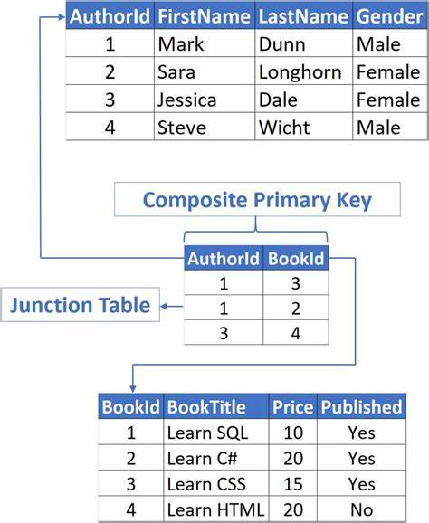

1

Alternate Key- [An alternate key is a**combination of one or more columns whose values are unique**](https://www.bing.com/ck/a?!&&p=cf446c2e0f87c175JmltdHM9MTY5MTEwNzIwMCZpZ3VpZD0wMjNmNDc1OS1lYTkzLTYwNTMtMjA1Yy01NDNiZWJmNzYxMjImaW5zaWQ9NTY0NA&ptn=3&hsh=3&fclid=023f4759-ea93-6053-205c-543bebf76122&psq=explain+alternate%5c+key&u=a1aHR0cHM6Ly93d3cuZWR1Y2JhLmNvbS9hbHRlcm5hdGUta2V5LWluLXNxbC8&ntb=1). [It is a candidate key that is not part of the primary key](https://www.bing.com/ck/a?!&&p=546dd8601f46475bJmltdHM9MTY5MTEwNzIwMCZpZ3VpZD0wMjNmNDc1OS1lYTkzLTYwNTMtMjA1Yy01NDNiZWJmNzYxMjImaW5zaWQ9NTY0OA&ptn=3&hsh=3&fclid=023f4759-ea93-6053-205c-543bebf76122&psq=explain+alternate%5c+key&u=a1aHR0cHM6Ly93d3cuZWR1Y2JhLmNvbS9hbHRlcm5hdGUta2V5LWluLXNxbC8&ntb=1).[A table consists of one or more candidate keys, in which one will be the primary key and the rest of the keys are called alternate keys](https://www.bing.com/ck/a?!&&p=796e07236950a828JmltdHM9MTY5MTEwNzIwMCZpZ3VpZD0wMjNmNDc1OS1lYTkzLTYwNTMtMjA1Yy01NDNiZWJmNzYxMjImaW5zaWQ9NTY1MQ&ptn=3&hsh=3&fclid=023f4759-ea93-6053-205c-543bebf76122&psq=explain+alternate%5c+key&u=a1aHR0cHM6Ly93d3cuZWR1Y2JhLmNvbS9hbHRlcm5hdGUta2V5LWluLXNxbC8&ntb=1). [The use of an alternate key is the same as that of a candidate key, i.e., to identify those columns in a table that can uniquely identify all the records of the table](https://www.bing.com/ck/a?!&&p=a6e92e435069639dJmltdHM9MTY5MTEwNzIwMCZpZ3VpZD0wMjNmNDc1OS1lYTkzLTYwNTMtMjA1Yy01NDNiZWJmNzYxMjImaW5zaWQ9NTY1Mw&ptn=3&hsh=3&fclid=023f4759-ea93-6053-205c-543bebf76122&psq=explain+alternate%5c+key&u=a1aHR0cHM6Ly93d3cuamF2YXRwb2ludC5jb20vYWx0ZXJuYXRlLWtleS1pbi1kYm1z&ntb=1).

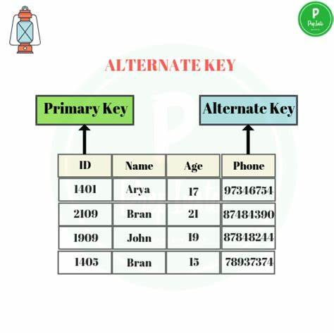

### Candidate key- A candidate key is a specific type of field in a relational database that can identify each unique record independently of any other data. Experts describe a candidate key of having "no redundant attributes" and being a "minimal representation of a tuple" in a relational database table.

### Candidate Key in DBMS » PREP INSTA

## 1.4 Advantages of Using DBMS

### Advantages of DBMS

1. Better Data Transferring: Database management creates a place where users have an advantage of more and better-managed data. Thus, making it possible for end-users to have a quick look and to respond fast to any changes made in their environment.
2. Better Data Security: The more accessible and usable the database, the more it is prone to security issues. As the number of users increases, the data transferring or data sharing rate also increases thus increasing the risk of data security. It is widely used in the corporate world where companies invest money, time, and effort in large amounts to ensure data is secure and is used properly. A Database Management System (DBMS) provides a better platform for data privacy and security policies thus, helping companies to improve Data Security.
3. Better data integration: Due to the Database Management System we have an access to well managed and synchronized form of data thus it makes data handling very easy and gives an integrated view of how a particular organization is working and also helps to keep a track of how one segment of the company affects another segment.
4. Better decision making: Due to DBMS Now we have Better managed data and Improved data access because of which we can generate better quality information hence on this basis better decisions can be made. Better Data quality improves accuracy, validity, and time it takes to read data. DBMS does not guarantee data quality, it provides a framework to make it easy to improve data qualities.

## 1.5 DDL and DML

DDL-Data Definition Language (DDL) is used to create and modify the structure of [objects](https://www.techtarget.com/searchapparchitecture/definition/object) in a [database](https://www.techtarget.com/searchdatamanagement/definition/database) using predefined [commands](https://www.techtarget.com/searchwindowsserver/definition/command) and a specific [syntax](https://www.techtarget.com/whatis/definition/syntax). These database objects include [tables](https://www.techtarget.com/whatis/definition/table), sequences, locations, [aliases](https://www.techtarget.com/whatis/definition/alias), [schemas](https://www.techtarget.com/searchdatamanagement/definition/schema) and indexes.

DDL statements –

* CREATE TABLE, which creates a table in the database.
* ALTER TABLE, which modifies the structure of an existing table.
* DROP TABLE, which deletes a table from the database.
* GRANT and REVOKE, which grant and revoke privileges to access objects in the database.
* TRUNCATE TABLE, which removes all rows from a table.

DML-

**Data Manipulation Language** (DML) is a computer programming language used for adding (inserting), deleting, and modifying (updating) data in a database. A DML is often a sublanguage of a broader database language such as SQL, with the DML comprising some of the operators in the language .

## 1.6 Concept of Normalization: 1N,2NF,3NF

Normalization is a **database design technique that reduces data redundancy** and eliminates undesirable characteristics like Insertion, Update and Deletion Anomalies. Normalization rules divides larger tables into smaller tables and links them using relationships.

### 1.6.1First Normal Form:

The first normal form simply says that each cell of a table should contain exactly one value.

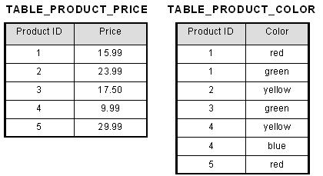

### 1.6.2 Second normal form 2nf

Second normal form (2NF) is the second step in normalizing a database. 2NF builds on the first normal form (1NF).

|  |  |
| --- | --- |
| Student name | Course code |
| Rahul | CS152 |
| Rajat | CS101 |
| Rahul | CS154 |
| Raman | CS101 |

|  |  |
| --- | --- |
| Student name | Enrolment number |
| Rahul | 1 |
| Rajat | 2 |

### 

### 1.6.3 Third Normal Form

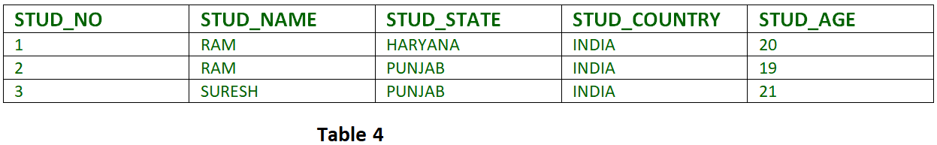It is in the Second Normal structure. Moreover, it doesn’t have a Transitive .

## 

## 1.7 Data Security

Data security is the process of safeguarding digital information throughout its entire life cycle to protect it from corruption, theft, or unauthorized access. It covers everything—hardware, software, storage devices, and user devices; access and administrative controls; and organizations’ policies and procedures.

## 1.8Some of the most important SQL commands

[Here are some of the most important SQL commands](https://www.bing.com/ck/a?!&&p=849c391dbf365aa8JmltdHM9MTY5MTI4MDAwMCZpZ3VpZD0wMjNmNDc1OS1lYTkzLTYwNTMtMjA1Yy01NDNiZWJmNzYxMjImaW5zaWQ9NTYzNA&ptn=3&hsh=3&fclid=023f4759-ea93-6053-205c-543bebf76122&psq=1.9%09Some+of+the+most+important+SQL+commands&u=a1aHR0cHM6Ly93d3cudzNzY2hvb2xzLmNvbS9zcWwvc3FsX3N5bnRheC5hc3A&ntb=1):

* SELECT – extracts data from a database
* UPDATE – updates data in a database
* DELETE – deletes data from a database
* INSERT INTO – inserts new data into a database
* CREATE DATABASE – creates a new database
* ALTER DATABASE – modifies a database
* CREATE TABLE – creates a new table
* ALTER TABLE – modifies a table

## 1.9 CREATING DATA BASE TABLE USING XAMP

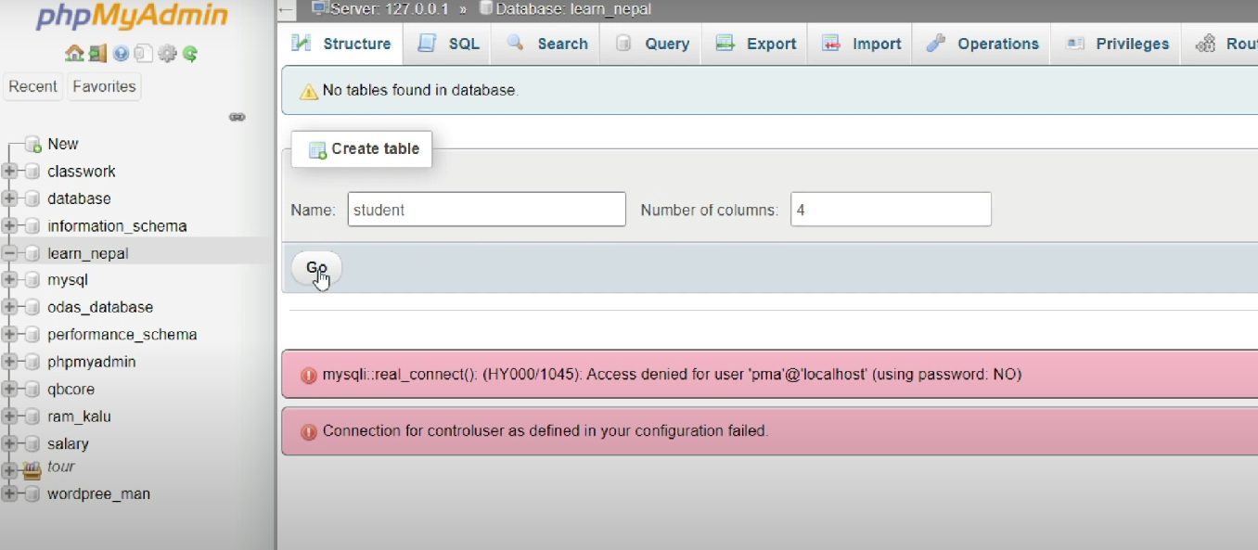Step 1­: Create table

Step 2 :- Insert data

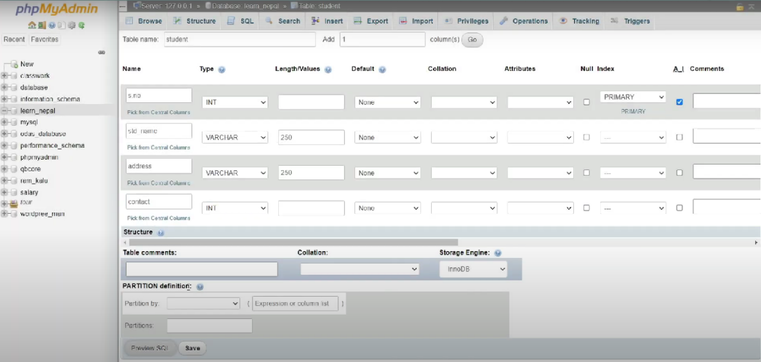

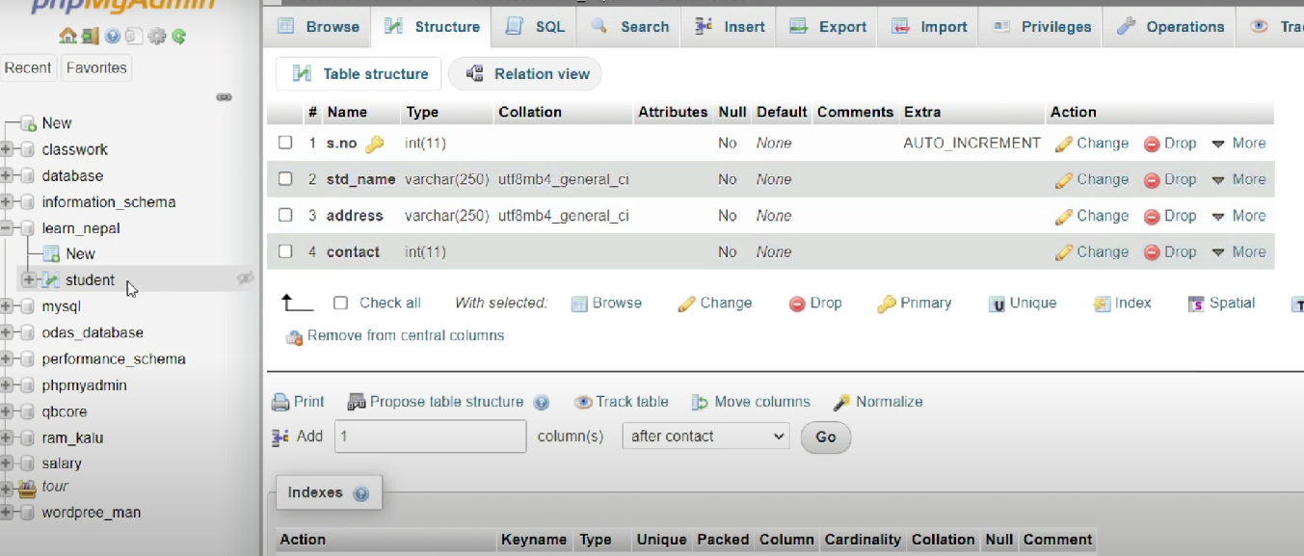Step 3: Retrieve data

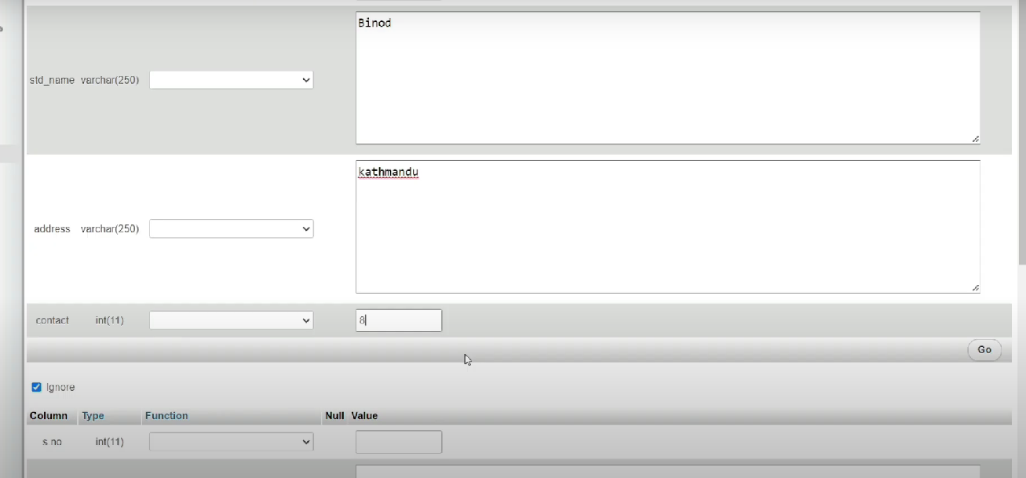Step 4 : import SQL file

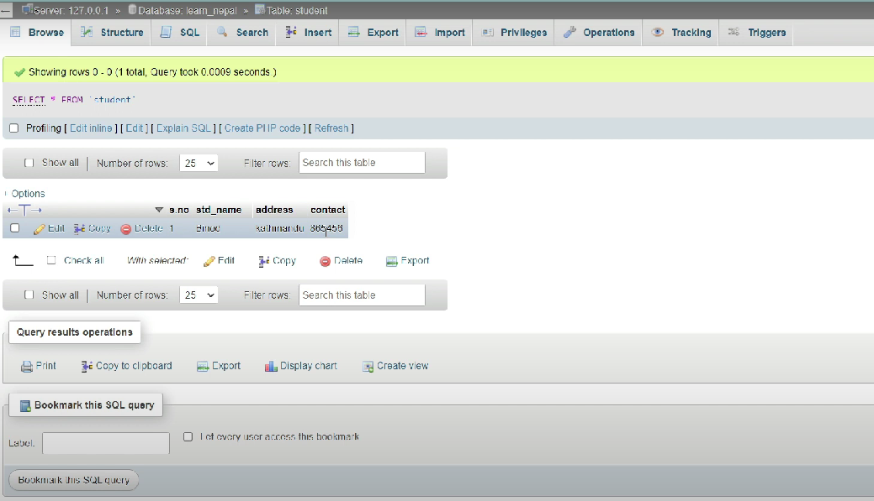Step 5; Export SQL file

Chapter 2

C-PROGRAMMING

## 2.1 Introduction of c-programming

**C** is a general-purpose programming language that is extremely popular, simple, and flexible to use. It is a structured programming language that is machine-independent and extensively used to write various applications, Operating Systems like Windows, and many other complex programs like Oracle database, Git, Python interpreter, and more.

## 2.2 Features of C-programming

* It is machine independent.
* It supports structured programming concept.
* General-Purpose Language
* Rich set of built-in Operators
* Libraries with Rich Functions

## 2.3 ADVANTAGES AND DIS-ADVANTAGAGES OF C-PROGRAMMING

* ADVANTAGE OF C-PROGR̥AMMING

1. As a middle-level language, C combines the features of both high-level and low-level languages. It can be used for low-level programming, such as scripting for drivers and kernels and it also supports functions of high-level programming languages, such as scripting for software applications etc.
2. C is a structured programming language which allows a complex program to be broken into simpler programs called functions. It also allows free movement of data across these functions.
3. Various features of C including direct access to machine level hardware APIs, the presence of C compilers, deterministic resource use and dynamic memory allocation make C language an optimum choice for scripting applications and drivers of embedded systems.
4. C language is case-sensitive which means lowercase and uppercase letters are treated differently.
5. C is a general-purpose programming language and can efficiently work on enterprise applications, games, graphics, and applications requiring calculations, etc.
6. C language has a rich library which provides a number of built-in functions. It also offers dynamic memory allocation.C implements algorithms and data structures swiftly, facilitating faster computations in programs.

DISADVANTAGES

1. It does not support Object Oriented Programming (OOP) features like Inheritance, Encapsulation, Polymorphism etc. It is a procedure oriented language.
2. It does not perform Run Time Type Checking. It only does compile time type checking.
3. It does not identify the variable type and does not exhibit namespace property.
4. It does not support the concept of constructors and destructors.
5. It has an insufficient level for data abstraction and lacks garbage collection.

## 

## 2.4 FUNCTION

A **function in C**is a set of statements that when called perform some specific task. It is the basic building block of a C program that provides modularity and code reusability.

* FEATURES OF FUNCTION
* A function may call itself, so recursion is supported.
* Function return values can be ignored, when not needed.
* Function and data pointers permit ad hoc run-time polymorphism.
* Functions may not be defined within the lexical scope of other functions.
* Variables may be defined within a function, with scope.

### Syntax

return_type **name_of_the_function** (parameter_1, parameter_2);

The parameter name is not mandatory while declaring functions. We can also declare the function without using the name of the data variables.

### Example

int **sum** (int *a*, int *b*);

int **sum** (int, int);

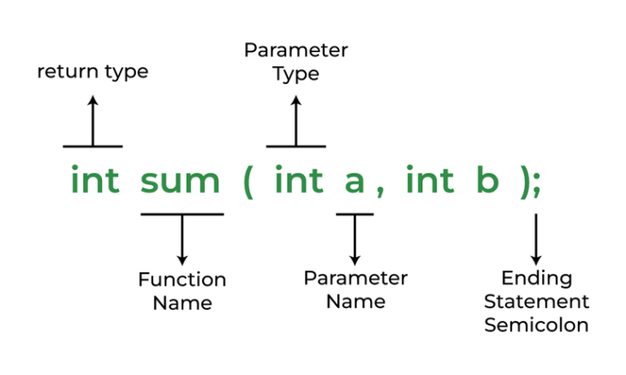

### 2.4.1 Some programming using function

1. Function with no arguments and return value.

#include <stdio.h>

void fun1(void)

{

int array[10]={1,2,3,4,5,6};

int i=0,sum=0;

for(i=0;i<6;i++)

{

sum = sum + array[i];

}

printf("\nThe sum of all array elements is : %d",sum);

}

int main()

{

fun1();

return 0;

}



Function with no agruments and no return value

#include<stdio.h>

void mul();

void main()

{

mul();

getch();

}

void mul()

{

int a,b,c;

printf("enter two number");

scanf("%d%d",&a,&b);

c=a*b;

printf("the multiplication is %d",c);

}

OUTPUT:

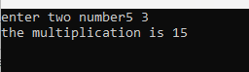

### 2.4.2 Function with arguments and no return values.

#include<stdio.h>

void mul(int,int);

void main()

{

int a,b;

printf("enter two number");

scanf("%d%d",&a,&b);

mul(a,b);

getch();

}

void mul(int a,int b)

{

int c;

c=a*b;

printf("the mul is %d",c);

}

Output

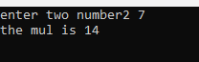

### 2.4.2 Call by reference

#include<stdio.h>

#include<conio.h>

void swap(int *a,int *b);

int main()

{

int x=11,y=33;

printf("values before swap x=%d and y=%d",x,y);

swap(&x,&y);

printf("values before swap x=%d and y=%d",x,y);

return 0;

}

void swap(int *a,int *b)

{

int temp;

temp=*a;

*a=*b;

*b=temp;

} Output:

Output:

### 2.4.3 Call by value

#include <stdio.h>

void swap(int x, int y);

int main ()

{

int a = 100;

int b = 200;

printf("Before swap, value of a : %d\n", a );

printf("Before swap, value of b : %d\n", b );

swap(a, b);

printf("After swap, value of a : %d\n", a );

printf("After swap, value of b : %d\n", b );

return 0;

}

void swap(int x, int y) {

int temp;

temp = x;

x = y;

y = temp;

return;

}

Output

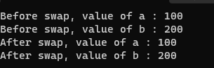

## 2.5 Factorial

 All positive descending integers are added together to determine the factor of n. Hence, n! is denoted as a Factorial of n. A factorial is denoted by "!". So, suppose, you want to find the factorial of the number n, then n! = n * (n-1) * (n-2) * (n-3) … *

2.5.1Algorithm to compute factorial of a number in C

* Start with n, decrease its value by 1 and multiply it to n that is n. (n – 1). ...
* Take n – 1, again decrease its value by 1 and multiply it to the last value of the variable fact that is fact. (n – 2) = n. ...
* Repeat the above steps till n becomes 1 that is n. (n – 1).

## 2.5.2 Algorithm of Factorial Program in C

The algorithm of a C program to find factorial of a number is:

* Start program
* Ask the user to enter an integer to find the factorial
* Read the integer and assign it to a variable
* From the value of the integer up to 1, multiply each digit and update the final value
* The final value at the end of all the multiplication till 1 is the factorial
* End program

### 2.5.3Some program using factorial

1.Wap to find the sum of N integers num using function

#include<stdio.h>

#include<conio.h>

int sum(int);

int main()

{

int n,result;

printf("enter nth term");

scanf("%d",&n);

result=sum(n);

printf("The sum of number upto nth term is=%d",result);

getch();

}

int sum(int n)

{

int a=0;

if(n==0)

return a;

else

return(n+sum(n-1));

}

Output:

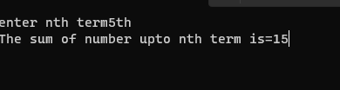

2.Wap in c to find the factorial of a number using function

#include<stdio.h>

#include<conio.h>

int fun(int n);

void main()

{

int n,x;

printf("enter any number");

scanf("%d",&n);

x=fun(n);

printf("The factorial of %d is %d.",n,x);

getch();

}

int fun(int n)

{

int fact=1;

while(n!=0)

{

fact=fact*n;

n=n-1;

}

return(fact);

}

Output-

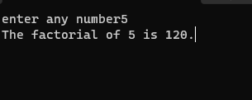

3.Wap to display the fabonacial series up to the nth term using resurcive function.

#include<stdio.h>

int fibo(int n);

int main()

{

int n,i;

printf("enter value of n");

scanf("%d",&n);

for(i=0;i<n;i++)

{

printf("%d",fibo(i));

}

return 0;

}

int fibo(int n)

{

if(n==0)

{

return 0;

}

else if (n==1)

{

return 1;

}

else

{

return fibo(n-1)+fibo(n-2);

}

}

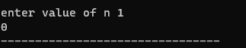Output:

## 2.6 Structure and unions

### 2.6.1stucture

Structure in C is a user-defined data type. It is used to bind two or more similar or different data types or data structures together into a single type. The structure is created using the struct keyword, and a structure variable is created using the struct keyword and the structure tag name.

### 2.6.2Features of structure

* The code should be in modular nature.
* There should be single entry and single exit for each module( i.e. no unconditional gates).
* At least one construct each for sequence, condition and iteration.

## 

## 2.6.3How to Access Structure element

### Syntax

structVariable.structMember

### Example

The following example illustrates how to access the members of a structure and modify them in C.

#include <stdio.h>

#include <string.h>

struct cube

{

data members

   char P_name[10];

   int P_age;

   char P_gender;

};

int main()

{

   struct cube p1, p2;

   strcpy(p1.P_name, "XYZ");

   p1.P_age = 25;

   p1.P_gender = 'M';

   strcpy(p2.P_name, "ABC");

   p2.P_age = 50;

   p2.P_gender = 'F';

     printf("The name of the 1st patient is: %s\n", p1.P_name);

   printf("The age of the 1st patient is: %d\n", p1.P_age);

   if (p1.P_gender == 'M')

   {

      printf("The gender of the 1st patient is: Male\n");

   }

   else

   {

      printf("The gender of the 1st patient is: Female\n");

   }

   printf("\n");

   // patient 2

   printf("The name of the 2nd patient is: %s\n", p2.P_name);

   printf("The age of the 2nd patient is: %d\n", p2.P_age);

   if (p2.P_gender == 'M')

   {

      printf("The gender of the 2nd patient is: Male\n");

   }

   else

   {

      printf("The gender of the 2nd patient is: Female\n");

   }

   return 0;

}

Syntax of structure

* struct tag_name {
* type member1;
* type member2;
* ……………………………………….
* ……………………………………..
* };

*How to declare?

typedef struct tag_name

{

type member1;

type member2;

struct_alias;

}

2.6.4 Some programming using structures.

* 1. Wap to print name, roll no, and address by nested structure

#include<stdio.h>

struct student

{char name[50];

char address[50];

int roll;

}

int main()

{

printf("enter the name, address and roll number of a student");

scanf("%s%s%d",s.name,s.address,&s.roll);

printf("the name is %s and address is %s and roll is %d",s.name,s.address,s.roll);

return 0;

}

Output-

2.Wap to print name, roll no, marks,age and address by nested structure.

#include<stdio.h>

int main()

{

union student

{

char name[20];

char add[25];

int age;

float marks;

} ;

union student e;

printf("enter name");

scanf("%s",& e.name);

printf("%s",e.name);

printf("enter address");

scanf("`%s",&e.add);

printf("%s",e.add);

printf("enter age");

scanf("`%d",&e.age);

printf("%d",e.age);

printf("enter marks");

scanf("`%f",&e.marks);

printf("%f",e.marks);

return 0;

}

Output

program to input roll num, name, adress and age of student then display tghe records in stored order (ascending).

#include <stdio.h>

struct student

{

char name[50];

int roll;

float marks;

} s;

int main() {

printf("Enter information:\n");

printf("Enter name: ");

fgets(s.name, sizeof(s.name), stdin);

printf("Enter roll number: ");

scanf("%d", &s.roll);

printf("Enter marks: ");

scanf("%f", &s.marks);

printf("Displaying Information:\n");

printf("Name: ");

printf("%s", s.name);

printf("Roll number: %d\n", s.roll);

printf("Marks: %.1f\n", s.marks);

return 0;

}

Output:

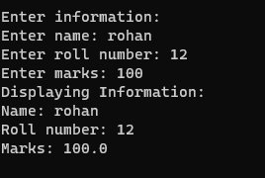

2.7 unions

Union in C is a special data type available in C that allows storing different data types in the same memory location. You can define a union with many members, but only one member can contain a value at any given time. Unions provide an efficient way of using the same memory location for multiple purposes.

### 2.7.1 Features of unions

1. Safeguard the workers' rights and privileges from management encroachment.
2. Ensure a healthy and sound working environment.
3. Fight for the performance-linked bonus for workers.
4. Negotiate for insurance, housing, healthcare, education, and cooperative societies for the workers from the management.

* Syntax for declaring a c Union

union union_name

{

datatype field_name;

datatype field_name;

……………………………

…………………………..

}

### 2.7.2 Some programming using unions

1.program to input employee id name, and salery of an employee

#include<stdio.h>

struct employee

{

int id,age,salary;

char name[25];

}

emp[10];

void main()

{

int i,n;

printf("Enter the no of employees\n");

scanf("%d",&n);

printf("Enter employee info as id , name , age , salary\n");

for(i=0;i<n;i++)

{

scanf("%d %s %d %d",&emp[i].id,emp[i].name,&emp[i].age,&emp[i].salary);

}

printf("\nEMP_NAME\tEMP_NAME\tEMP_AGE\t\tEMP_SAL\n");

for(i=0;i<n;i++)

{

printf("%d\t\t%s\t\t%d\t\t%d\n",emp[i].id,emp[i].name,emp[i].age,emp[i].salary);

}

}

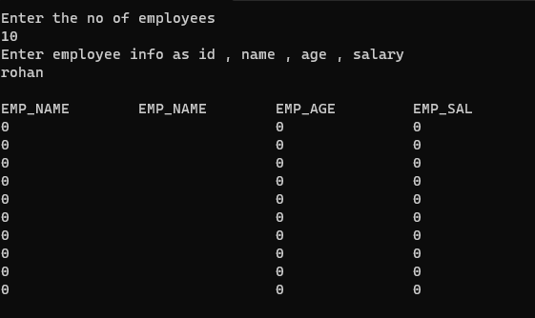Output;

Program to find size of union members

#include <stdio.h>

void main()

{

union sample

{

int m;

float n;

char ch;

};

union sample u;

printf("The size of union = %d\n", sizeof(u));

u.m = 25;

printf("%d %f %c\n", u.m, u.n, u.ch);

u.n = 0.2;

printf("%d %f %c\n", u.m, u.n, u.ch);

u.ch = 'p';

printf("%d %f %c\n", u.m, u.n, u.ch);

}

Output:

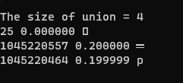

## 2.8 Pointers

### 2.8.1 Introduction of pointer

Pointers are one of the core components of the C programming language. A pointer can be used to store the memory address of other variables, functions, or even other pointers. The use of pointers allows low-level memory access, dynamic memory allocation, and many other functionality in C.

### 2.8.2 Features of pointers

* The execution time of a pointer is faster because it directly accesses to memory location.
* The memory is accessed efficiently with the help of a pointer.
* Memory is allocated and deallocated dynamically.
* Pointers Pointer saves the memory space.
* are used with data structures.

2.8.3 Benefits of Pointers

• Pointers allow you to reference a large data structure in a compact way.

• Pointers facilitate sharing data between different parts of a program. – Call-by-Reference

• Dynamic memory allocation: Pointers make it possible to reserve new memory during program execution.

2.8.4 More Topics on Pointers

1) Pointer to Pointer – A pointer can point to another pointer (which means it can store the address of another pointer), such pointers are known as double pointer OR pointer to pointer.

2) Passing pointers to function – Pointers can also be passed as an argument to a function, using this feature a function can be called by reference as well as an array can be passed to a function while calling.

3) Function pointers – A function pointer is just like another pointer, it is used for storing the address of a function. Function pointer can also be used for calling a function in C program

## 2.9 Some programming using pointer.

1.WAP to add two numbers using piointers.

#include <stdio.h>

int main()

{

int first, second, *p, *q, sum;

printf("Enter two integers to add\n");

scanf("%d%d", &first, &second);

p = &first;

q = &second;

sum = *p + *q;

printf("Sum of the numbers = %d\n", sum);

return 0;

}

Output

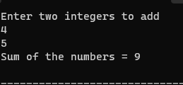

2)Passing pointer to function

#include <stdio.h>

void swap(int a, int b)

{

int temp = a;

a = b;

b = temp;

}

int main()

{

int a = 10, b = 20;

swap(a, b);

printf("Values after swap function are: %d, %d",

a, b);

return 0;

}

Output



3)find a difference between two Numbers Using Pointer

#include <stdio.h>

void swap(int a, int b)

{

int temp = a;

a = b;

b = temp;

}

int main()

{

int a = 10, b = 20;

swap(a, b);

printf("Values after swap function are: %d, %d",a, b);

return 0;

}

Output:

4)Call by value concept

#include <stdio.h>

void add10(int);

int main(void)

{

int num = 10;

printf("Value of num before function call: %d\n", num);

add10(num);

printf("Value of num after function call: %d\n", num);

return 0;

}

void add10(int n) {

n = n + 10;

printf("Inside add10(): Value %d\n", n);

}

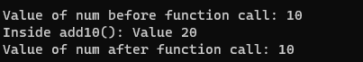

Chapter 3

# Web Technology

## 3.1Introduction

Web technology refers to the means by which computers communicate with each other using markup languages and multimedia packages. It gives us a way to interact with hosted information, like websites. Web technology involves the use of hypertext markup language (HTML) and cascading style sheets (CSS).

Web Technology can be Classified into the Following Sections:

* [**World Wide Web (WWW):**](https://www.geeksforgeeks.org/world-wide-web-www/) The World Wide Web is based on several different technologies: Web browsers, Hypertext Markup Language (HTML), and Hypertext Transfer Protocol (HTTP).
* [**Web Browser:**](https://www.geeksforgeeks.org/web-browser-a-complete-overview/) The web browser is an application software to explore www (World Wide Web). It provides an interface between the server and the client and requests to the server for web documents and services.
* [**Web Server:**](https://www.geeksforgeeks.org/web-server-and-its-type/) Web server is a program which processes the network requests of the users and serves them with files that create web pages. This exchange takes place using Hypertext Transfer Protocol (HTTP).
* [**Web Pages:**](https://www.geeksforgeeks.org/web-pages/) A webpage is a digital document that is linked to the World Wide Web and viewable by anyone connected to the internet has a web browser.
* [**Web Development:**](https://www.geeksforgeeks.org/web-development/) Web development refers to the building, creating, and maintaining of websites. It includes aspects such as web design, web publishing, web programming, and database management. It is the creation of an application that works over the internet i.e. websites.

## 3.2Java script

JavaScript (JS) is a lightweight interpreted (or just-in-time compiled) programming language with first-class functions. While it is most well-known as the scripting language for Web pages, many non-browser environments also use it, such as Node.js, Apache CouchDB and Adobe Acrobat.

## 3.3 Features of java script:

#### 1. Object-Centered Script Language

Object Centered Language features built in the object as Java Script has a window object. Some Common Examples of Object Centered languages are Java Script and Visual Basic etc. The object-centered languages are mostly used for features like Polymorphism which is a quality of taking an object in many forms.

2. Client Edge Technology

The client is basically a term used for Web Browser in respective of User. The data on the server gets uploaded by a client which later used by a user in the rendered form. The user gets access to the client through a web browser for surfing and interacting through websites. The client edge technology in Java Script allows the client to have full control over the content which is being updated in servers.

3.Else and IF Statement

IF and Else Statements are used to perform logical operations.

4. Interpreter Centered

Java Script is built with Interpreter Centered which allows the user to get the output without the use of Compiler. That means the input performed by the user gets rendered directly without the compiling of codes.

### 

## 3.4 uses of java script

* Client-side validation
* Dynamic drop-down menus
* Displaying date and time
* Displaying pop-up windows and dialog boxes
* Displaying clock

Adding JavaScript to HTML

There are typically three ways to add JavaScript to a web page:

• Embedding the JavaScript code between a pair of &lt;SCRIPT&gt; and &lt;/SCRIPT&gt; tag.

• Creating an external JavaScript file with the .js extension and then load it within the page

through the src attribute of the &lt;SCRIPT&gt; tag.

## 3.5 Form Validation:

* Ensuring your password is between 8 to 30 characters or making sure your password is mixed between letters, numbers, and asterisks.
* Or ensure you include the @ for the email input field by popping messages like "Please enter a valid email address".
* "This field is required" (You can't leave this field blank)

This is called Validation. When you enter your details on a form website, the browser and/or the web server will check to see that the data is in the correct format and within the constraints set by the application.

Form validation is the process of verifying that the data entered into an HTML form is accurate, complete, and meets the specified criteria before it is submitted to the server.

## 3.6 Source Codes for Form validation:

* Form.html

<!DOCTYPE html>

<html lang="en">

<head>

<meta charset="UTF-8">

<title>Validated Login Form</title>

<link rel="stylesheet" href="style.css">

</head>

<body>

<div class="container">

<h1 class="label">User Login</h1>

<form class="login_form" action="home.html" method="post" name="form" onsubmit="return validated()">

<div class="font">Email or Phone</div>

<input autocomplete="off" type="text" name="email">

<div id="email_error">Please fill up your password</div>

<input type="password" name="password">

<button type="submit">Login</button>

</form>

</div>

<script src="valid.js"></script>

</body>

</html>

* **Style css**

*{

padding: 0;

margin: 0;

}

body{

background: url(bg_img.jpg) no-repeat;

background-size: cover;

align-items: center;

justify-content: center;

display: flex;

font-family: sans-serif;

}

.container{

position: relative;

margin-top: 100px;

width: 450px;

height: auto;

background: #dedede;

border-radius: 5px;

}

.label{

padding: 20px 130px;

font-size: 35px;

font-weight: bold;

color: #130f40;

}

.login_form{

padding: 20px 40px;

}

.login_form .font{

font-size: 18px;

color: #130f40;

margin: 5px 0;

}

.login_form input{

height: 40px;

width: 350px;

padding: 0 5px;

font-size: 18px;

outline: none;

border: 1px solid silver;

}

.login_form .font2{

margin-top: 30px;

}

.login_form button{

margin: 45px 0 30px 0;

height: 45px;

width: 365px;

font-size: 20px;

color: white;

outline: none;

cursor: pointer;

font-weight: bold;

background: #1A237E;

border-radius: 3px;

border: 1px solid #3949AB;

transition: .5s;

}

.login_form button:hover{

background: #151c6a;

}

.login_form #email_error,

.login_form #pass_error{

margin-top: 5px;

width: 345px;

font-size: 18px;

color: #C62828;

background: rgba(255,0,0,0.1);

text-align: center;

padding: 5px 8px;

border-radius: 3px;

border: 1px solid #EF9A9A;

display: none;

}

**Output**

* **When form wasn’t filled**

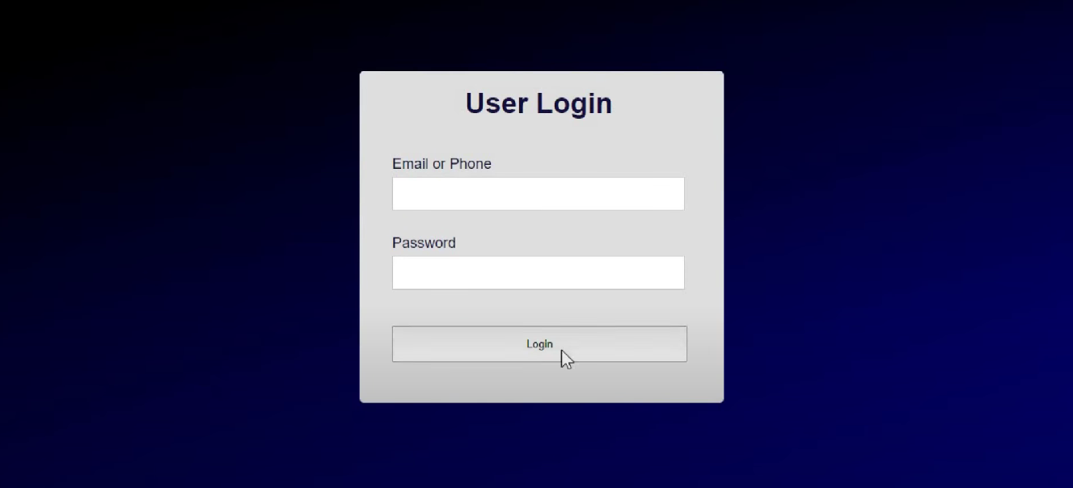

* **When form was filled**

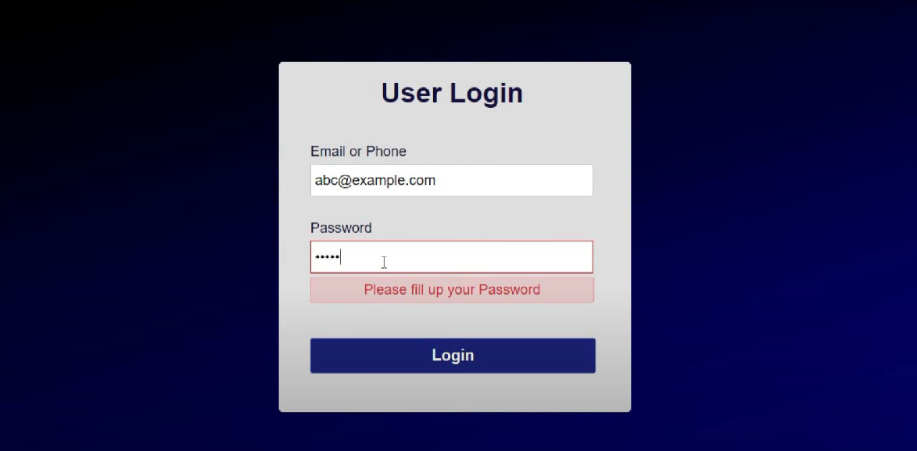

**After filling up email&password**

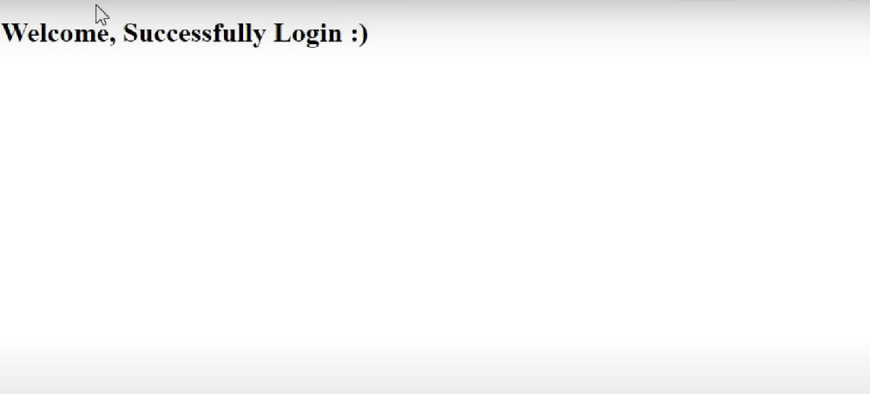

# Chapter-4

HTML (HPYER TEXT MARK UP LANGUAGE)

## 4.1 Introduction

HTML is a markup language that defines the structure of your content. HTML consists of a series of [elements](https://developer.mozilla.org/en-US/docs/Glossary/Element), which you use to enclose, or wrap, different parts of the content to make it appear a certain way, or act a certain way. The enclosing [tags](https://developer.mozilla.org/en-US/docs/Glossary/Tag) can make a word or image hyperlink to somewhere else, can italicize words, can make the font bigger or smaller, and so on.

## 4.2 Elements and tags

* tag elements

The <html> element is the root element and it defines the whole HTML document. It has a start tag <html> and an end tag </html> . The <body> element defines the document's body. It has a start tag <body> and an end tag </body> .

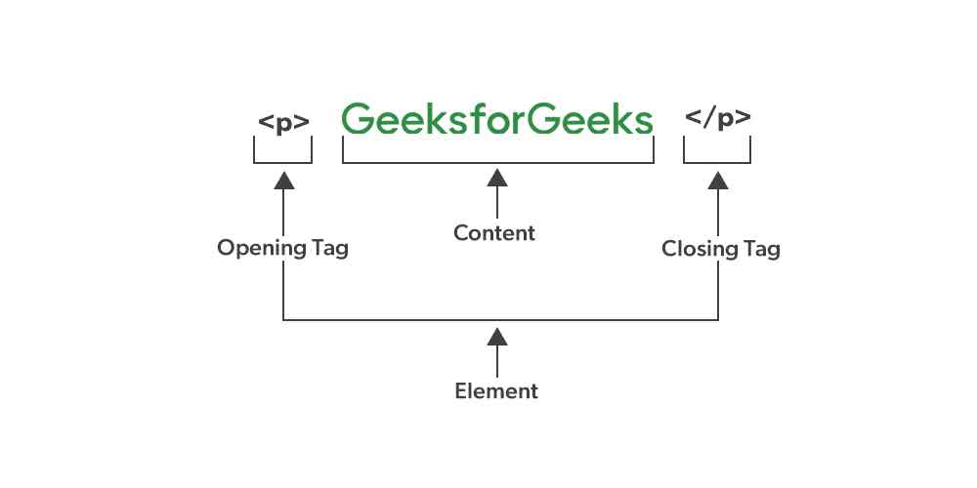

## 4.3 HTML PAGE AND STRUCTURE

Within a web page, some HTML tags are required for the page to be displayed correctly. These tags are <html> , <head> , <title> and <body> . The <html> tags must begin and end the document and the <head> tags must appear before the <body> tags. Also, the <title> tags must be within the <head> tags.

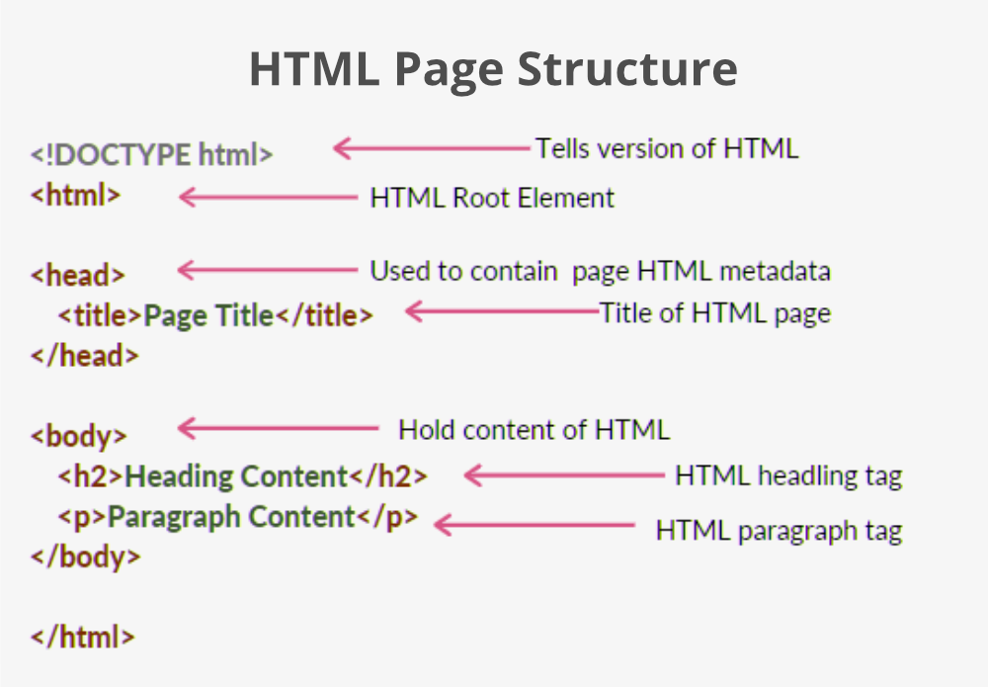

## 4.4 features of html:

1. Simple and user-friendly

2. Semantic Structure

3. SEO - Search Engine Optimisation

4. Local Storage & IndexedDB - Client-Side Data Storage

5. Offline Capabilities (PWA) with Cache API & Service Workers

6. Canvas for Game Development

## 4.5 Some html program example

* Html program to change background color.

<!DOCTYPE html>

<html>

<body style="background-color:powderblue;">

<h1>This is a heading</h1>

<p>This is a paragraph.</p>

</body>

</html>

* Output



* Html program to write paragraph

<!DOCTYPE html>

<html>

<body>

<p>This is a paragraph.</p>

<p>This is a paragraph.</p>

<p>This is a paragraph.</p>

</body>

</html>

* Output



* HTML form

<!DOCTYPE html>

<html>

<body>

<h2>HTML Forms</h2>

<form action="/action_page.php">

<label for="fname">First name:</label><br>

<input type="text" id="fname" name="fname" value="rohan"><br>

<label for="lname">Last name:</label><br>

<input type="text" id="lname" name="lname" value="sah"><br><br>

<input type="submit" value="Submit">

</form>

<p>If you click the "Submit" button, the form-data will be sent to a page called "/action_page.php".</p>

</

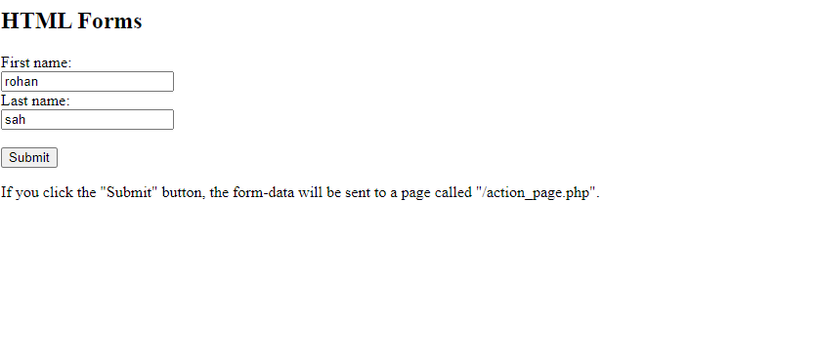

Hem

Hem

# 

# CHAPTER 5

CSS

## 5.1 Introduction

Cascading Style Sheets (CSS) is a stylesheet language used to describe the presentation of a document written in HTML or XML (including XML dialects such as SVG, MathML or XHTML). CSS describes how elements should be rendered on screen, on paper, in speech, or on other media.CSS is among the core languages of the **open web** and is standardized across Web browsers according to [W3C specifications](https://www.w3.org/Style/CSS/#specs). Previously, the development of various parts of CSS specification was done synchronously, which allowed the versioning of the latest recommendations. You might have heard about CSS1, CSS2.1, or even CSS3. There will never be a CSS3 or a CSS4; rather, everything is now CSS without a version number.

## CSS key concepts:

* + The [syntax and forms of the language](https://developer.mozilla.org/en-US/docs/Web/CSS/Syntax)
  + [Specificity](https://developer.mozilla.org/en-US/docs/Web/CSS/Specificity), [inheritance](https://developer.mozilla.org/en-US/docs/Web/CSS/Inheritance), and [the Cascade](https://developer.mozilla.org/en-US/docs/Web/CSS/Cascade)
  + [CSS units and values](https://developer.mozilla.org/en-US/docs/Web/CSS/CSS_Values_and_Units) and [functional notations](https://developer.mozilla.org/en-US/docs/Web/CSS/CSS_Functions)
  + [Box model](https://developer.mozilla.org/en-US/docs/Web/CSS/CSS_box_model/Introduction_to_the_CSS_box_model) and [margin collapse](https://developer.mozilla.org/en-US/docs/Web/CSS/CSS_box_model/Mastering_margin_collapsing)
  + The [containing block](https://developer.mozilla.org/en-US/docs/Web/CSS/Containing_block)
  + [Stacking](https://developer.mozilla.org/en-US/docs/Web/CSS/CSS_positioned_layout/Understanding_z-index/Stacking_context) and [block-formatting](https://developer.mozilla.org/en-US/docs/Web/CSS/CSS_display/Block_formatting_context) contexts
  + [Initial](https://developer.mozilla.org/en-US/docs/Web/CSS/initial_value), [computed](https://developer.mozilla.org/en-US/docs/Web/CSS/computed_value), [used](https://developer.mozilla.org/en-US/docs/Web/CSS/used_value), and [actual](https://developer.mozilla.org/en-US/docs/Web/CSS/actual_value) values
  + [CSS shorthand properties](https://developer.mozilla.org/en-US/docs/Web/CSS/Shorthand_properties)
  + [CSS Flexible Box Layout](https://developer.mozilla.org/en-US/docs/Web/CSS/CSS_flexible_box_layout)
  + [CSS Grid Layout](https://developer.mozilla.org/en-US/docs/Web/CSS/CSS_grid_layout)
  + [CSS selectors](https://developer.mozilla.org/en-US/docs/Web/CSS/CSS_selectors)
  + [Media queries](https://developer.mozilla.org/en-US/docs/Web/CSS/CSS_media_queries)

## 5.2 some program related to css

<!DOCTYPE html>

<html lang="en">

<head>

<title>CSS Template</title>

<meta charset="utf-8">

<meta name="viewport" content="width=device-width, initial-scale=1">

<style>

* {

box-sizing: border-box;

}

body {

font-family: Arial, Helvetica, sans-serif;

}

/* Style the header * output;

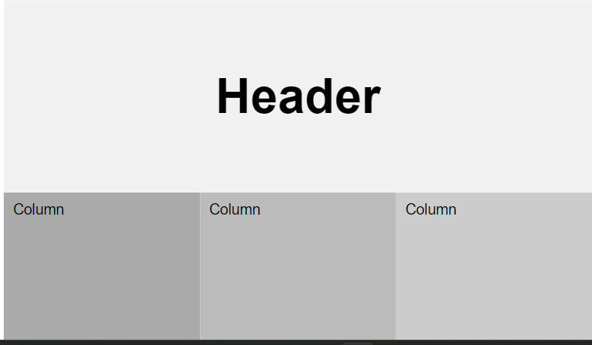 background-color: #f1f1f1;

padding: 30px;

text-align: center;

font-size: 35px;

}

# Chapter 6

Website html

|  |
| --- |
| <!DOCTYPE html> |
|  | <html> |
|  | <head> |
|  | <title></title> |
|  | <link rel="stylesheet" type="text/css" href="css/style.css"> |
|  | <link href="https://fonts.googleapis.com/css?family=Josefin+Sans&display=swap" rel="stylesheet"> |
|  | <link rel="stylesheet" href="https://cdnjs.cloudflare.com/ajax/libs/animate.css/3.7.2/animate.min.css"> |
|  | </head> |
|  | <body> |
|  |  |
|  | <header> |
|  |  |
|  | <nav> |
|  | <div class="logo"> <h1 style="font-size: 20px;"> Mera bharat </h1> </div> |
|  | <div class="menu"> |
|  | <a href="#" style="font-size: ">Home</a> |
|  | <a href="#">gallery</a> |
|  | <a href="https://www.youtube.com/channel/UCwfaAHy4zQUb2APNOGXUCCA" target="_blank">about</a> |
|  | <a href="#">contact</a> |
|  | </div> |
|  | </nav> |
|  |  |
|  | <main> |
|  | <section> |
|  | <h3>Welcome To India</h3> |
|  | <h1>DO COME & VISIT <span class="change_content"> </span> <span style="margin-top: -10px;"> | </span> </h1> |
|  | <p>"India once is not enough"</p> |
|  | <a href="#" class="btnone">learn more</a> |
|  | <a href="#" class="btntwo">signup here</a> |
|  | </section> |
|  | </main> |
|  |  |
|  |  |
|  | </header> |
|  |  |
|  | </body> |
|  | </html> |

Using css website

|  |
| --- |
| * { |
|  | margin: 0; |
|  | padding: 0; |
|  | box-sizing: border-box; |
|  | font-family: "Josefin Sans", sans-serif; |
|  | } |
|  |  |
|  | header { |
|  | width: 100%; |
|  | height: 100vh; |
|  | background-image: linear-gradient(rgba(0, 0, 0, 0.3), rgba(0, 0, 0, 0.15)), |
|  | url("../images/taj.jpg"); |
|  | background-repeat: no-repeat; |
|  | background-size: cover; |
|  | } |
|  |  |
|  | nav { |
|  | width: 100%; |
|  | height: 15vh; |
|  | background: rgba(0, 0, 0, 0.2); |
|  | color: white; |
|  | display: flex; |
|  | justify-content: space-between; |
|  | align-items: center; |
|  | text-transform: uppercase; |
|  | } |
|  |  |
|  | nav .logo { |
|  | width: 25%; |
|  | text-align: center; |
|  | /*background: red;*/ |
|  | } |
|  |  |
|  | nav .menu { |
|  | width: 40%; |
|  | display: flex; |
|  | justify-content: space-around; |
|  | } |
|  |  |
|  | nav .menu a { |
|  | width: 25%; |
|  | text-decoration: none; |
|  | color: white; |
|  | font-weight: bold; |
|  | } |
|  |  |
|  | nav .menu a:first-child { |
|  | color: #00b894; |
|  | } |
|  |  |
|  | main { |
|  | width: 100%; |
|  | height: 85vh; |
|  | display: flex; |
|  | justify-content: center; |
|  | align-items: center; |
|  | text-align: center; |
|  | color: white; |
|  | } |
|  |  |
|  | section h3 { |
|  | font-size: 35px; |
|  | font-weight: 200; |
|  | letter-spacing: 3px; |
|  | text-shadow: 1px 1px 2px black; |
|  | } |
|  |  |
|  | section h1 { |
|  | margin: 30px 0 20px 0; |
|  | font-size: 55px; |
|  | font-weight: 700; |
|  | text-shadow: 2px 1px 5px black; |
|  | text-transform: uppercase; |
|  | } |
|  |  |
|  | section p { |
|  | font-size: 25px; |
|  | word-spacing: 2px; |
|  | margin-bottom: 25px; |
|  | text-shadow: 1px 1px 1px black; |
|  | } |
|  |  |
|  | section a { |
|  | padding: 12px 30px; |
|  | border-radius: 4px; |
|  | outline: none; |
|  | text-transform: uppercase; |
|  | font-size: 13px; |
|  | font-weight: 500; |
|  | text-decoration: none; |
|  | letter-spacing: 1px; |
|  | transition: all 0.5s ease; |
|  | } |
|  |  |
|  | section .btnone { |
|  | /*background: #00b894;*/ |
|  | background: #fff; |
|  | color: #000; |
|  | } |
|  |  |
|  | .btnone:hover { |
|  | background: #00b894; |
|  | color: white; |
|  | } |
|  |  |
|  | section .btntwo { |
|  | background: #00b894; |
|  | color: white; |
|  | } |
|  |  |
|  | .btntwo:hover { |
|  | background: #fff; |
|  | color: #000; |
|  | } |
|  |  |
|  | .change_content:after { |
|  | content: ""; |
|  | animation: changetext 10s infinite linear; |
|  | color: #00b894; |
|  | } |
|  |  |
|  | @keyframes changetext { |
|  | 0% { |
|  | content: "Darjeeling"; |
|  | } |
|  | 20% { |
|  | content: "Agra"; |
|  | } |
|  | 35% { |
|  | content: "Jaipur"; |
|  | } |
|  | 60% { |
|  | content: "kerala"; |
|  | } |
|  | 80% { |
|  | content: "delhi"; |
|  | } |
|  | 100% { |
|  | content: "Mumbai"; |
|  | } |
|  | }  Output |

# 



Conclusion

HTML and CSS are two of the major core interfaces that help build webpages which can be used by anyone with a simple method to use. Many of the webpages we see today have been developed with the help of HTML and CSS. They have provided common people with the opportunity to build their own webpages. Job opportunities have also been created with their help for people with excellent web designing skills. Thus, they have played a significant role in today’s technological society and the internet. Therefore learning such skills can makes ones perfect in computer related field.

BIBLIOGRAPHY

-Balaguruswamy, e.programming in ANSI C, tata McGRAW Hill.

-Barkakati,N., Microsoft C Bible, SAMS.

-Sinha, P.K., computer fundamentals, BPP publication

-Donald Knuth ,The Art Of Computer Programming

-Brian Kernighan, The C Programming language

-Dennis Ritchie,The C Programming Language (with Brian Kernighan)

-Douglas C. Schmidt,C++ Network Programming

# Gantt chart

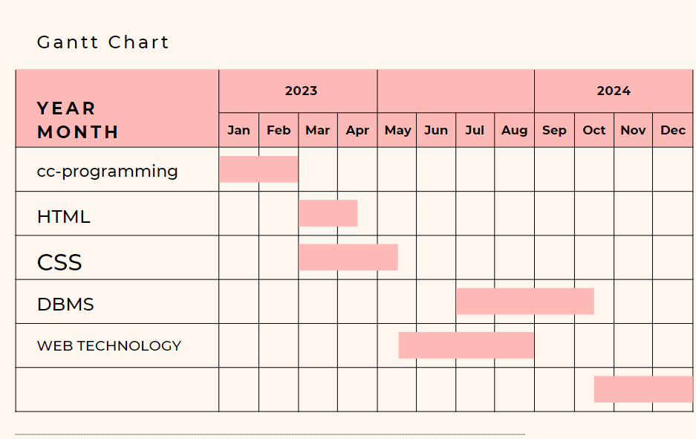

# References

JavaScript:

• Book: Flanagan, D. (2011). "JavaScript: The Definitive Guide". O'Reilly Media.

• Online resource: Mozilla Developer Network (MDN). (n.d.). JavaScript. Retrieved from https://developer.mozilla.org/en-US/docs/Web/JavaScript

HTML (Hypertext Markup Language):

• Book: Duckett, J. (2014). "HTML and CSS: Design and Build Websites". John Wiley & Sons.

• Online resource: W3Schools. (n.d.). HTML Tutorial. Retrieved from https://www.w3schools.com/html/

CSS (Cascading Style Sheets):

• Book: McFarland, D. (2015). "CSS: The Missing Manual". O'Reilly Media.

• Online resource: MDN Web Docs. (n.d.). CSS. Retrieved from https://developer.mozilla.org/en-US/docs/Web/CSS

Database (General):

• Book: Elmasri, R., & Navathe, S. B. (2015). "Fundamentals of Database Systems". Pearson.

• Online resource: W3Schools. (n.d.). SQL Tutorial. Retrieved from https://www.w3schools.com/sql/

C Programming Language:

• Book: Kernighan, B. W., & Ritchie, D. M. (1978). "The C Programming Language". Prentice Hall.