1. **What is Hypervisor?**

* A**hypervisor**, also known as a virtual machine monitor or VMM, is software that creates and runs virtual machines (VMs).
* A hypervisor allows one host computer to support multiple guest VMs by virtually sharing its resources, such as memory and processing.

**Types of Hypervisor:**

There are two main hypervisor types, such as “Type 1” and “Type 2” Hypervisor.

* **Type 1 Hypervisor (or bare metal):** A type 1 hypervisor acts like a lightweight operating system and runs directly on the host’s hardware.
* **Type 2 Hyper visor**: A type 2 hypervisor runs as a software layer on an operating system, like other computer programs.

1. **What is virtualization?**

* [Virtualization](https://www.redhat.com/en/topics/virtualization) is technology that lets you create useful IT services using resources that are traditionally bound to hardware.
* It allows you to use a physical machine’s full capacity by distributing its capabilities among many users or environments.
* Virtualization is the process of creating a software-based, virtual version of something (compute storage, servers, application, etc). These virtual versions or environments are created from single physical hardware system.

1. **What is containerization?**

* Containerization is the packaging together of software code with all it’s necessary components like libraries, frameworks, and other dependencies so that they are isolated in their own "[container](https://www.redhat.com/en/topics/containers/whats-a-linux-container)."
* This is so that the software or [application](https://www.redhat.com/en/topics/cloud-native-apps/what-are-cloud-applications) within the container can be moved and run consistently in any environment and on any infrastructure, independent of that environment or infrastructure’s operating system.
* The container acts as a kind of bubble or a computing environment surrounding the application and keeping it independent of its surroundings.
* So basically an application that is being developed and deployed is bundled and wrapped together with all its configuration files and dependencies. The bundle is called container.

1. **What is the difference between virtualization and containerization?**
2. **What is Docker?**

* Docker is an open platform for developing, shipping, and running applications. Docker enables you to separate your applications from your infrastructure so you can deliver software quickly.
* With Docker, you can manage your infrastructure in the same ways you manage your applications.
* By taking advantage of Docker’s methodologies for shipping, testing, and deploying code quickly, you can significantly reduce the delay between writing code and running it in production.

1. **What is Docker container?**

* Docker containers include the application and all of its dependencies.
* It shares the kernel with other containers, running as isolated processes in user space on the host operating system.
* A container is defined by its image as well as any configuration options you provide to it when you create or start it. When a container is removed, any changes to its state that are not stored in persistent storage disappear.

1. **What are Docker Images?**

* A Docker image contains application code, libraries, tools, dependencies and other files needed to make an application run.
* When a user runs an image, it can become one of many instances of a container.

You can create a Docker image by using one or two methods.

* **Interactive:** By running container from an existing Docker image, manually changing that container environment through a series of live steps, and saving the resulting state as a new image.
* **Dockerfile**: By constructing a plain-text file, known as a **Dockerfile**, which provides the specifications for creating a Docker image.

1. **What is Docker Hub?**

* Docker images create Docker containers. There has to be a registry where these Docker images live. The Registry is Docker Hub.
* [Docker Hub](https://hub.docker.com/) is a service provided by Docker for finding and sharing container images with your team.

1. **Explain Docker Architecture**

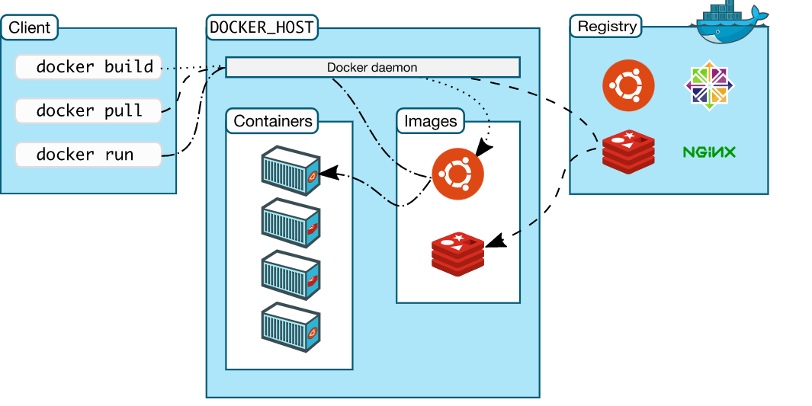

* Docker uses a **client-server** architecture.
* The Docker ***client***  talks to the **Docker *daemon***, which does the heavy lifting of building, running, and distributing your Docker containers.
* The Docker client and daemon *can* run on the same system, or you can connect a Docker client to a remote Docker daemon.
* In the above architecture, there 3 major components. 1. Docker daemon, 2. The Docker client, 3. Docker registries.

**Docker Daemon:**

* The Docker daemon (dockerd) listens for Docker API requests and manages Docker objects such as images, containers, networks, and volumes.
* A daemon can also communicate with other daemons to manage Docker services.

**The Docker Client:**

* The Docker client (docker) is the primary way that many Docker users interact with Docker.
* When you use commands such as docker run, the client sends these commands to dockerd, which carries them out.
* The docker command uses the Docker API. The Docker client can communicate with more than one daemon.

**Docker Registries:**

* A Docker *registry* stores Docker images.
* Docker Hub is a public registry that anyone can use, and Docker is configured to look for images on Docker Hub by default.
* When you use the docker pull or docker run commands, the required images are pulled from your configured registry.
* When you use the docker push command, your image is pushed to your configured registry.

1. **What is Dockerfile?**

* A Dockerfile is a text document that contains all the commands a user could call on the command line to assemble an image.
* Using docker build users can create an automated build that executes several command-line instructions in succession.
* Docker can build images automatically by reading the instructions from a Dockerfile.

1. **Tell us something about Docker Compose**

* Docker compose is a YAML file which contains details about the services, networks, and volumes for setting up the Docker application

1. **What is Docker Swarm?**

* Docker Swarm is an orchestration management tool that runs on Docker applications.
* It helps end-users in creating and deploying a cluster of Docker nodes.
* Each node of a Docker Swarm is a Docker daemon, and all Docker daemons interact using the Docker API.
* Each container within the Swarm can be deployed and accessed by nodes of the same cluster.
* Docker Swarm is native clustering for Docker. It turns a pool of Docker hosts into a single, virtual Docker host,

1. **What is a Docker Namespace?**

* A namespace is one of the Linux features and an important concept of containers.
* Namespace add a layer of isolation in containers.
* Docker uses a technology called namespaces to provide the isolated workspace called the *container*. When you run a container, Docker creates a set of *namespaces* for that container.

1. **What is the lifecycle of a Docker container?**

* The complete lifecycle of a docker container revolves around five phases.

1. Create phase
2. Running phase
3. Paused phase/unpause phase
4. Stopped phase
5. Killed Phase

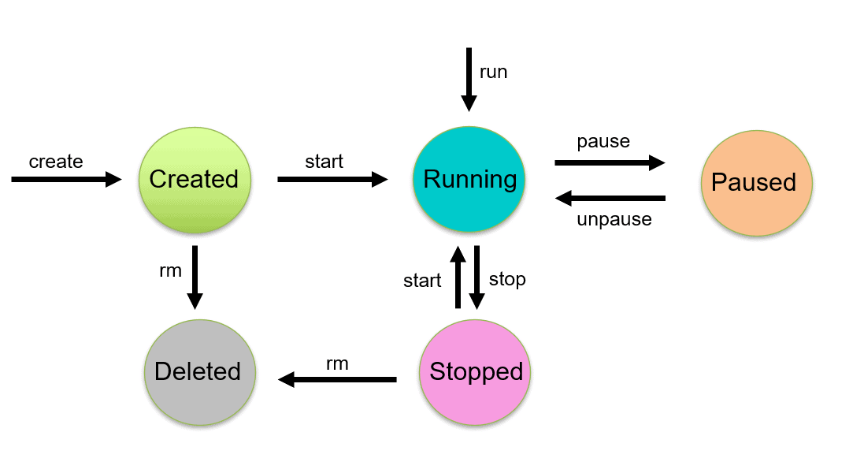

* **Create containers:** $ docker create - - name <container name> <image name>
* **Start container:** $ docker start <container id/ container name>
* **Run container:** $ docker run –it - - name <container name> <image name>
* **Pause container:** $ docker pause <container name>

**To unpause :** $ docker unpause <container name>

* **Stop container: $ docker stop <container name>**

**To stop running container:** $ docker stop $(docker container ls –aq)

* **Delete container:** $ docker rm <container name>

**We can delete all stop container:** $ docker rm $(docker ps –aq)

* **Kill container**: $ docker kill <container name>

1. **What is docker Machine?**

* Docker machine is a tool that lets you install Docker Engine on virtual hosts.
* **Docker Machine** is a tool for provisioning and managing your Dockerized hosts (hosts with Docker Engine on them).
* Docker Machine has its own command line client **docker-machine** and the**Docker Engine client, docker.**

1. **How to check for Docker Client and Docker Server version?**

* The following command gives you information about Docker Client Server versions.

$ docker version

* Using this you can check all the versions present in docker engine

1. **How do you get the number of containers running, paused and stopped?**

* You can use the following command to get detailed information about the docker installed on your system.

$ docker info

1. **If you vaguely remember the command and you’d like to confirm it, how will you get on that particular command?**

* The following command is very useful as its gives you help on how to use a command, the syntax, etc.

$ docker – help

e.g. $ docker - - run help

1. **How to login into docker repository?**

* You can use the following command to login into hub.docker.com:

$docker login

* After type above command you will fill the username and password of docker hub for login into it.

1. **If you wish to use base image and make modifications or personalize it, how do you do that?**

* It’s one simple command to pull an image from docker hub:
* $ docker pull <image name>
* To get the list of image go to hub.docker.com website and pull the image by taking the image name
* E.g. $ docker pull Ubuntu:latest – In this command we pull the Ubuntu image form docker hub

1. **How to create a docker container from an image?**

* Use the following command:
* $ docker run –it – d <image name>
* E.g. $ docker run – it – d Ubuntu:latest

1. **How do you list all the running containers?**

* The following command lists down all the running containers:

$ docker ps

$ docker container ls

1. **How do you access a running container?**

* The following command let us access a running container:
* $ docker exec –it <container id > bash
* E.g. $ docker exec – it c6f bash

1. **How to start, stop and kill a container?**

* Here are below commands

$ docker start <container id>

$ docker stop <container id>

$ docker kill <container id>

1. **Can you use a container, edit it, and update it?**

* Here the command syntax:
* $ docker commit <container id> <username/imagename>
* $ docker commit c6f80324d ubuntu

1. **Once you have worked with an image, how do you push it to docker hub?**

* The following command as below
* $ docker push <username/image name>

1. **How to delete a stopped container?**

* Here the below command:
* $ docker rm <container id>

1. **How to delete an image from the local storage system?**

* Here the below command:
* $ docker rmi <image id>

1. **How to build a Dockerfile?**

* Once you have written a Dockerfile, you need to build it to create an image with those specifications. Use the following command to build a Dockerfile.
* $ docker build <path to docker file>

1. **Do you know why docker system prune is used? What does it do?**

* The basic usage of the command docker system prune is Remove unused data.
* Removes all unused containers, networks, images (both dangling and unreferenced), and optionally, volumes.
* $ docker system prune
* **Refer link:** https://docs.docker.com/engine/reference/commandline/system_prune/

1. **Will you lose your data, when a docker container exists?**

* NO, you won’t lose any data when Docker container exists. Any data that your application writes to the container gets preserved.
* You have to explicitly delete the data

1. **Where all do you think Docker is being used?**

Docker is being used in the following area.

* **Simplifying configuration:** Docker lets you put your environment and configuration into code and deploy it.
* **Code Pipeline Management:** There are different systems used for development and production. As the code travels from development to testing to production, it goes through a difference in the environment. Docker helps in maintaining the code pipeline consistency.
* **Developer Productivity**: Using Docker for development gives us two things – We’re closer to production and development environment is built faster.
* **Application Isolation:** As containers are applications wrapped together with all dependencies, your apps are isolated. They can work by themselves on any hardware that supports Docker.
* **Debugging Capabilities:** Docker supports various debugging tools that are not specific to containers but work well with containers.
* **Multi-tenancy:** Docker lets you have multi-tenant applications avoiding redundancy in your codes and deployments.
* **Rapid Deployment:** Docker eliminates the need to boost an entire OS from scratch, reducing the deployment time.

1. **How is Docker different from other containerization methods?**

There are some differences between Docker and other container technologies or Docker alternatives. Here I'm sharing some of them.

* **Different configuration:** In the simple context, Docker is easy and its system configuration isn’t enriched like other container technologies like Lxc, runc, podman, etc. So from this aspect, you can identify the differences.
* Docker containers very easy to deploy.
* **Working Capacity:** Docker performs differently than other container-based management tools. Because some container management technologies work combinedly. But, docker works for isolated tasks.
* **Productivity:** Basically, Docker alternatives could be a wise decision for container-based applications. Because Docker’s productivity is not efficient and effective like others.
* Overall, Docker is a simple and different tool from others.

1. **How have you used Docker in your previous position?**

* This answer depend on your experience on Docker

1. **How far do Docker containers scale? Are there any requirements for the same?**

* Containers can be scaled to hundreds of thousands or even millions of them running in parallel.
* Talking about requirements, containers require the memory and the OS at all the times and a way to use this memory efficiently when scaled.
* Refer link for know about docker service scale : https://docs.docker.com/engine/reference/commandline/service_scale/

1. **What platforms does docker run on?**

Docker runs on various Linux flavors:

* + - Ubuntu
    - RHEL
    - CENTOS 6 +
    - ArchLinux

**Refer links:** https://docs.docker.com/engine/faq/

1. **Is there a way to identify the status of a Docker container?**

* Using docker commands identify the status of Docker container.
* Such commands are : $ docker ps and $docker ps -a

1. **Can you remove a paused container from Docker?**

* No, Best idea to remove container is first stop it and then remove the container

1. **Can a container restart by itself?**
2. **Is it better to directly remove the container using the rm command or stop the container followed by remove container?**

* It is better to stop the container and then remove it using remove command.

*$ docker stop <container id>*

*$ docker rm <container id>*

1. **Will cloud overtake the use of containerization?**
2. **How many containers can run per host?**

* Depend on your hardware of your system and containers need like storage space, CPU and memory, we can run the containers.
* It can be multiple numbers of containers or depends on your application requirement.

1. **Is it good practice to run stateful applications on Docker?**
2. **How will you monitor Docker in Production?**
3. **Have you used Kubernetes? If you have which one would you prefer amongst Docker and Kubernetes?**
4. **Are you aware of load balancing across containers and hosts? How does it work?**