**9. Develop neural network-based time series forecasting model**

|  |  |
| --- | --- |
| **EX.N0 : 9** | **Develop neural network-based time series forecasting model** |
| **DATE : 012/04/2025** |

**AIM:**

To Develop neural network-based time series forecasting model

**PROGRAM:**

import numpy as np

import pandas as pd

import matplotlib.pyplot as plt

from sklearn.preprocessing import MinMaxScaler

from tensorflow.keras.models import Sequential

from tensorflow.keras.layers import Dense, LSTM

# ----- Step 1: Create Dataset -----

# Population data (you can replace with real data if needed)

population = np.array([

689000, 705000, 720000, 735000, 752000, 768000, 784000, 801000, 819000, 837000,

855000, 873000, 892000, 911000, 931000, 951000, 972000, 993000, 1015000, 1037000,

1060000, 1083000, 1106000, 1129000, 1153000, 1177000, 1201000, 1225000, 1250000,

1275000, 1300000

])

years = np.arange(1980, 1980 + len(population))

# Create DataFrame

df = pd.DataFrame({'Year': years, 'Population': population})

# ----- Step 2: Normalize the Data -----

scaler = MinMaxScaler()

scaled_data = scaler.fit_transform(df[['Population']])

# ----- Step 3: Create Time Series Dataset -----

def create_dataset(data, time_step=3):

X, y = [], []

for i in range(len(data) - time_step):

X.append(data[i:i + time_step])

y.append(data[i + time_step])

return np.array(X), np.array(y)

time_step = 3

X, y = create_dataset(scaled_data, time_step)

# Reshape input to [samples, time steps, features]

X = X.reshape(X.shape[0], X.shape[1], 1)

# ----- Step 4: Build the LSTM Model -----

model = Sequential()

model.add(LSTM(64, return_sequences=True, input_shape=(time_step, 1)))

model.add(LSTM(32))

model.add(Dense(1))

model.compile(optimizer='adam', loss='mean_squared_error')

# ----- Step 5: Train the Model -----

model.fit(X, y, epochs=100, batch_size=1, verbose=1)

# ----- Step 6: Predict the Next Population Value -----

last_input = scaled_data[-time_step:]

last_input = last_input.reshape(1, time_step, 1)

predicted_scaled = model.predict(last_input)

predicted = scaler.inverse_transform(predicted_scaled)

print(f"\n📈 Predicted next year's population: {predicted[0][0]:,.0f}")

# ----- Step 7: Plot the Results -----

train_predict = model.predict(X)

train_predict_plot = scaler.inverse_transform(train_predict)

actual_plot = df['Population'].values[time_step:]

plt.figure(figsize=(10, 6))

plt.plot(df['Year'][time_step:], actual_plot, label='Actual Population', linewidth=2)

plt.plot(df['Year'][time_step:], train_predict_plot, label='Predicted Population', linestyle='--')

plt.axvline(df['Year'].iloc[-1], color='gray', linestyle=':', alpha=0.6)

plt.title("📊 Population Forecasting using Neural Network (LSTM)")

plt.xlabel("Year")

plt.ylabel("Population")

plt.legend()

plt.grid(True)

plt.tight_layout()

plt.show()

**OUTPUT:**

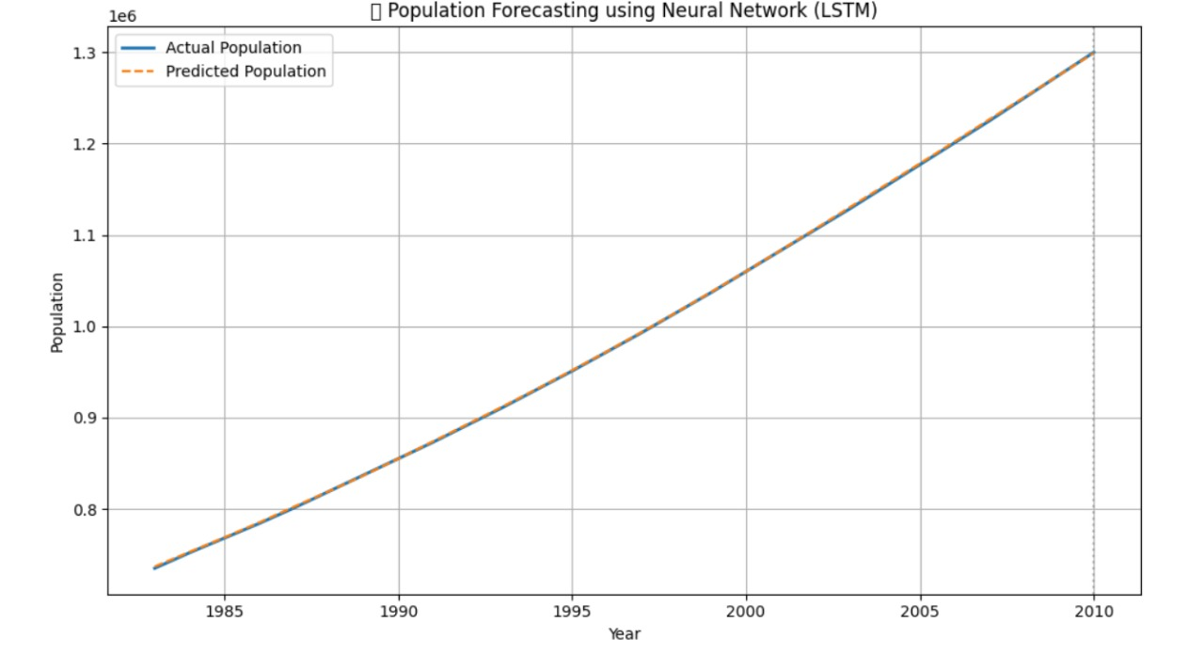

**RESULT:**

Thus, the program for Create an ARIMA model for time series forecasting is executed successfully.