**10. Develop vector auto regression model for multivariate time series data forecasting.**

|  |  |
| --- | --- |
| **EX.N0 : 10** | **Develop vector auto regression model for multivariate time series data forecasting.** |
| **DATE : 12/04/2025** |

**AIM:**

To Develop vector auto regression model for multivariate time series data forecasting.

**PROGRAM:**

import pandas as pd

import numpy as np

import matplotlib.pyplot as plt

from statsmodels.tsa.api import VAR

from statsmodels.tsa.stattools import adfuller

# Step 1: Simulate multivariate population dataset with variability

years = np.arange(1990, 2021)

np.random.seed(42)

population = np.linspace(700000, 1300000, len(years)) + np.random.normal(0, 5000, len(years))

birth_rate = np.linspace(30, 18, len(years)) + np.random.normal(0, 0.3, len(years))

death_rate = np.linspace(12, 8, len(years)) + np.random.normal(0, 0.2, len(years))

df = pd.DataFrame({

'Year': years,

'Population': population,

'BirthRate': birth_rate,

'DeathRate': death_rate

})

df.set_index('Year', inplace=True)

# Step 2: Make data stationary (Differencing)

def make_stationary(data):

df_diff = data.copy()

for col in df_diff.columns:

result = adfuller(df_diff[col])

if result[1] > 0.05: # Not stationary

df_diff[col] = df_diff[col].diff()

return df_diff.dropna()

df_stationary = make_stationary(df)

# Step 3: Fit VAR model

model = VAR(df_stationary)

results = model.fit(maxlags=4, ic='aic')

# Step 4: Forecast next 5 years

forecast_steps = 5

forecast_input = df_stationary.values[-results.k_ar:]

forecast = results.forecast(y=forecast_input, steps=forecast_steps)

# Step 5: Prepare forecast DataFrame

forecast_index = np.arange(df.index[-1] + 1, df.index[-1] + 1 + forecast_steps)

forecast_df = pd.DataFrame(forecast, index=forecast_index, columns=df.columns)

# Step 6: Revert differencing

last_values = df.iloc[-1]

forecast_df_cumsum = forecast_df.cumsum()

forecast_df_final = forecast_df_cumsum.add(last_values)

# Step 7: Plot historical and forecast data

plt.figure(figsize=(12, 6))

for col in df.columns:

plt.plot(df[col], label=f'Historical {col}')

plt.plot(forecast_df_final[col], '--', label=f'Forecast {col}')

plt.title("VAR Forecast for Population Dataset")

plt.xlabel("Year")

plt.ylabel("Values")

plt.legend()

plt.grid(True)

plt.tight_layout()

plt.show()

# Step 8: Display forecasted values

print("\nForecasted Data (2021–2025):")

print(forecast_df_final)

**OUTPUT:**

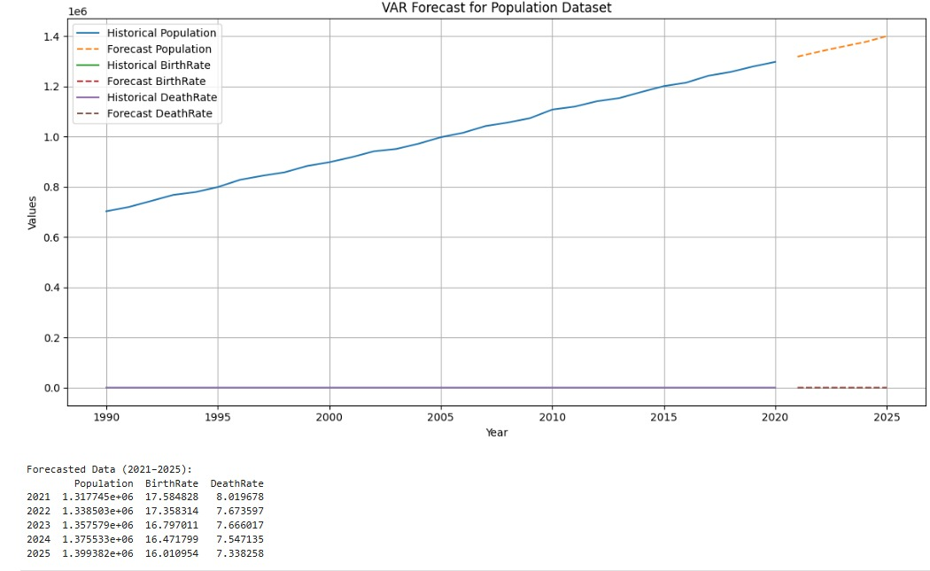

**RESULT:**

Thus, Development vector auto regression model for multivariate time series data forecasting.

is executed successfully.