**TRACEROUTE , PING , IFCONFIG , IPCONFIG(WINDOWS), AND NETSAT COMMAND**

**EXP NO :4**

**Aim:**

Using TraceRoute, ping, ifconfig(LINUX), ipconfig(WINDOWS), and netstat Command.

Procedure:

Step 1: Open windows command prompt and Type tracert command and tracert

[www.saveetha.com](http://www.saveetha.com/) -> “Enter”

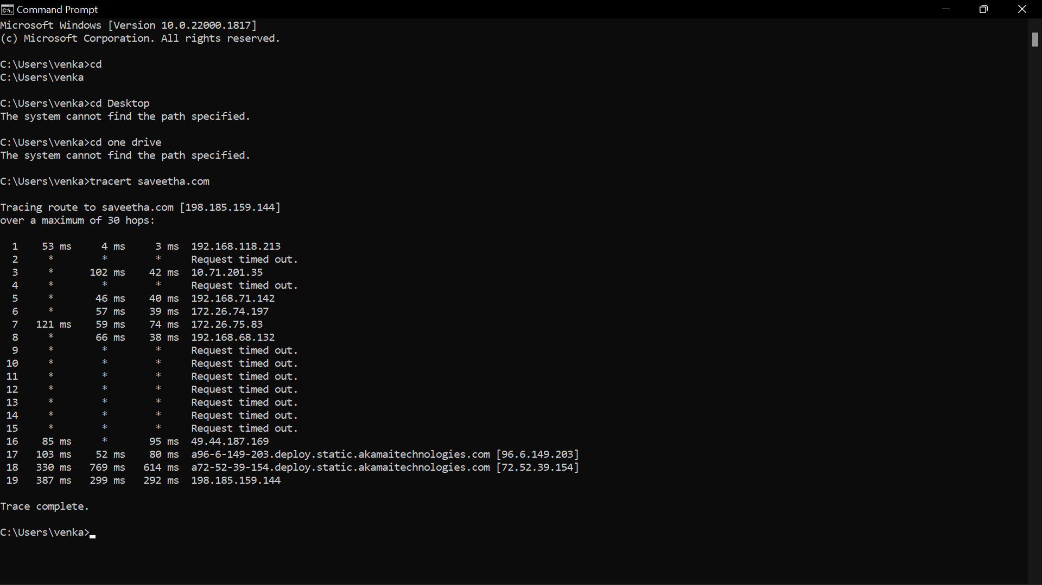

Step 2: Type ping command and type IP address press “Enter”.

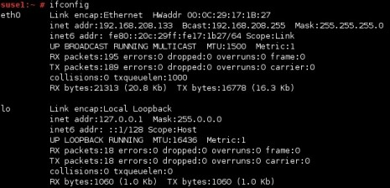Step 3: Type ifconfig command

Step 4:Type netset command

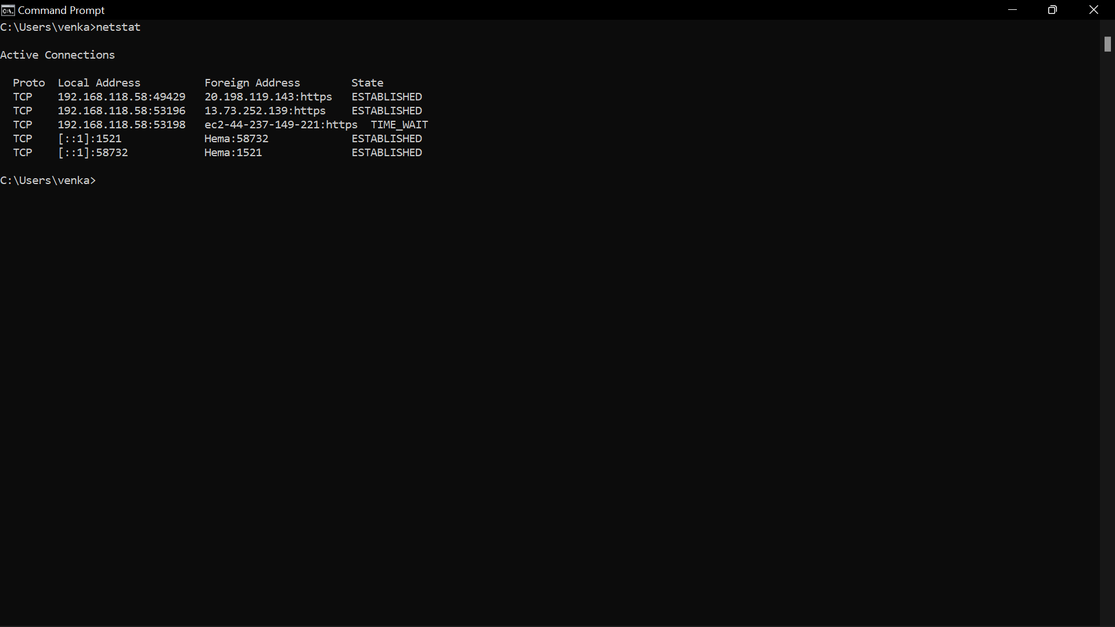

**RESULT:**

Hence we have successfully used the commands traceroute,ping,ifconfig.