HANDWRITTEN SIGNATURE VERIFICATION USING CONVOLUTIONARY
NEURAL NETWORKS

Dheeraj Avadhanula Hema Varshini Danda
dheerajavadhanula@my.unt.edu hemavarshinidanda@my.unt.edu

ABSTRACT
Researchers studying image processing have been working on the problem of handwritten signature verification for decades. It is the responsibility of a signature verification system to ascertain if a particular signature is genuine (made by the claimed individual) or fake (generated by an impostor). In offline (static) environments without access to dynamic information about the signing process, using images of scanned signatures, this has proven to be a difficult problem. Among the various improvements that have been proposed in the literature over the past 5 to 10 years is the use of Artificial Neural Networks (ANN) approaches to train feature representations from signature images. Artificial neural networks are used to categorize photos and identify items in them. This essay examines the problem's historical handling, current advancements, and potential directions for future research.
Keywords: Forgery, Handwritten Recognition, Image Processing, Artificial Neural Networks
1. INTRODUCTION
The aim of the project is to normalize the signature image and system checks whether the signature matches with original signature image applies preprocessing steps.
Signature verification is basically to verify the signature whether the signature is original or forgery. The use of signatures for personal identification and verification is very common. Verifying signatures is necessary for many documents, including legal transactions and bank checks. It takes a lot of time and effort to verify several papers using signatures.
Identification and signature verification are crucial for authentication purposes. Here, we proposed a system that normalizes the signature picture and verifies that it corresponds to the original signature. The system employs picture pre-processing techniques. The system will display the outcome in that manner.
  - Why signature Verification?
This method's main contribution is to identify and lessen fraud, particularly in the banking sector. In the future, the justice system and legal papers might both employ signature verification.
Personal verification frequently involves signature verification. However, it will inevitably be used for forgery, so a system for automatically identifying and verifying signatures is needed. Verification can be carried via using an offline or online program. Offline systems utilize a signature's scanned image for operation. Online systems utilize dynamic data from a signature at the moment it is made, such as pressure, speed, etc.
  - FORGERIES
There are numerous methods to fake something. Some are simpler to spot than others. Identifications using handwriting and hand printing have been carried out since the late 1800s.
It is possible to determine who penned a certain word, set of initials, signature, or piece of writing since everyone has a different style of handwriting and hand printing. There are a few established, undisputed standards that must be used in order to compare handwriting, hand printing, or signatures accurately. In order to ensure that the writings are consistent, filled with recognizable handwriting patterns, and distinguishable from one another, they are then compared to the accepted criteria. If all three conditions are met and the writing in issue is contemporaneous to the recognized criteria that are given, authorship or non-authorship may usually be positively determined.
The most crucial information is that the questioned signature must appear on the original document in order for the document examiner to accurately assess it, and that the second element needed to prove authorship is known signatures from the putative author. The dates of the known signatures are closest to the date of the questioned signature the more pertinent the investigation.
    - Types of Forgery
There are four main types of Forgery:
1. Blind Forgery - In which the intended recipient of the falsified signature is unaware of its appearance. Since it rarely closely resembles a real signature, this kind of forgery is the easiest to spot. By examining the forged signature's handwriting patterns, an examiner may occasionally be able to determine who performed the forgery. In order to match the handwriting habits in the questioned signature to the habits in the known cursive writing, an examiner needs known cursive writing samples of the suspected forger in order to do this type of study.
2. Simulation - where the person doing the forging has a sample of the fake signature. The level of skill and accuracy required to successfully simulate a signature relies on how much experience the forger gets before trying the actual forgery. When examining the original document or even a copy, a trained document examiner can typically spot this type of forgery with ease. The forger's personal handwriting habits are concealed because they are being used to mimic someone else's writing style. As a result, it is frequently impossible to determine who faked a simulation.
3. Tracing - Holding the model document and the questioned document up to the light, you can do this by tracing the model signature's lines onto the questioned document using a pen. The model signature can also be traced by making an impression of the questioned document using a blunt stylus and then erasing it. The model's signature is then supposedly created by filling in this imprint with a pen. This style of forgery can occasionally be challenging to identify from a photocopy if the model signature the forger used is not discovered.
4. Optional Transfer - which involves using a photocopier, scanner, facsimile machine, or photography to transfer a real signature to a document. Without the Original for comparison, an examiner cannot conclusively determine whether a signature is authentic with this kind of fake. On a copy of the disputed document, there are frequently but not always indications of this kind of fraud. Anyone, especially the legal system, should exercise extreme caution when determining the validity of documents and signatures in the absence of an original.

  - THEORY
A process when a real signature is reproduced on a document using a photocopier, scanner, facsimile machine, or photography. Without the Original to compare it to, an examiner working with this kind of counterfeit cannot conclusively determine whether a signature is authentic. A copy of the questioned document frequently, but not always, shows signs of this kind of fake. Everyone, but notably the judicial system, should use utmost caution when establishing the veracity of documents and signatures when no original can be produced.
    - Theories used in Research
A computer stores images as a collection of pixel data. In order to determine whether two or more photographs are comparable, they must be analyzed and compared pixel by pixel. The suggested system can recognize signatures and identify signatories with speed and accuracy thanks to the use of CNNs in signature recognition. It is potentially feasible to contrast a user signature with earlier signatures previously kept in the host database by utilizing deep learning and image recognition. Either learning-based systems or template-based methods can be used to identify signatures. Template-based approaches compare input document images with template images of the signature being searched for.
Signature models are trained in learning-based systems using supervised learning.
  - ARTIFICIAL NEURAL NETWORKS(ANNs)
A neural network is described as "...a computing system made up of several simple, highly interconnected processing elements, which process information by their dynamic state response to external inputs" by Dr. Robert Hecht-Nielsen, the creator of the first neurocomputer.
    - Basic Structure of ANNs:
The concept behind ANNs is based on the premise that by forming the appropriate connections, silicon and wires may be used to simulate the real neurons and dendrites found in the human brain.
86 billion neurons, or nerve cells, make up the human brain. Axons connect them to a million additional cells. Dendrites absorb input from sensory organs as well as stimuli from the outside environment. Electric impulses are produced by these inputs and quickly pass through the neural network. A neuron has the option to either forward the message to another neuron for handling or to stop doing so.
Numerous nodes make up ANNs, which mimic the biological neurons found in the human brain. The links that connect the neurons allow them to communicate with one another. The nodes have the ability to take input data and apply straightforward operations to it. Other neurons get the outcome of these operations. Each node's output is known as its activation or node value. Weight is connected to each link. ANNs have the ability to learn, which happens through changing the weight values.
    - Types of Artificial Neural Networks:
Feedforward and Feedback are the two topologies of artificial neural networks.
Information flows in a single direction in a feedforward ANN. A unit communicates with another unit it does not get information from. No feedback loops exist. They assist in the creation, recognition, and classification of patterns. Their inputs and outputs are fixed.
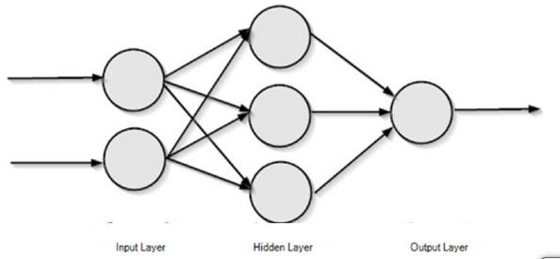
Fig1.1. Feed Forward ANN
Feedback ANN: Feedback loops are permitted here. In content addressable memories, they are employed.
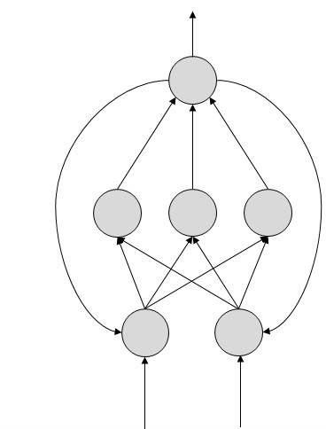 Fig 1.2. Feedback ANN
  - CONVOLUTIONAL NEURAL NETWORKS
A Convolutional Neural Network (ConvNet/CNN) is a Deep Learning method that can take in an input image, give various elements and objects in the image importance (learnable weights and biases), and be able to distinguish between them. Comparatively speaking, a ConvNet requires substantially less pre-processing than other classification techniques. ConvNets can learn these filters/characteristics with adequate training, whereas with primitive approaches filters are hand-engineered.
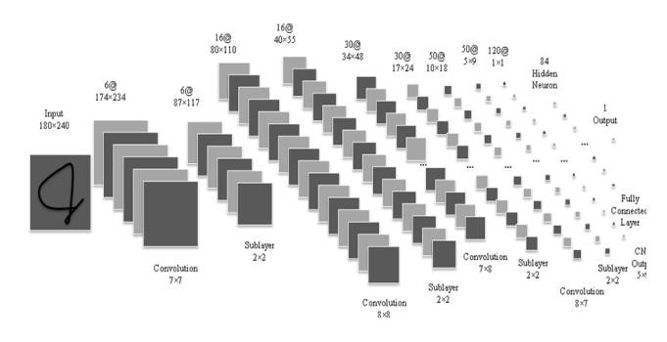
Fig 1.3. Convolutional Neural Networks
A ConvNet's architecture was influenced by how the Visual Cortex is organized and is similar to the connectivity network of neurons in the human brain. Only in this constrained area of the visual field, known as the Receptive Field, do individual neurons react to stimuli. The entire visual field is covered by a series of such fields that overlap.
    - Design
An input layer, an output layer, and numerous hidden layers make up a convolutional neural network. Convolutional layers, RELU layers, or activation functions, pooling layers, fully connected layers, and normalizing layers are frequently found in a CNN's hidden layers. By convention, the process is described
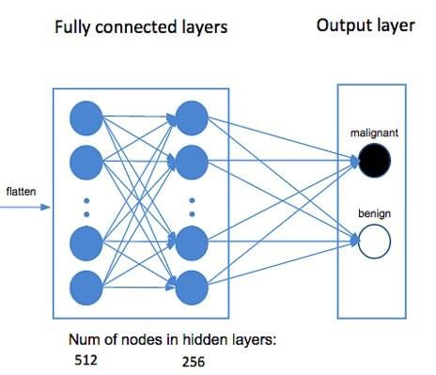
as a convolution in neural networks. Although cross-correlation is a related operation, mathematically speaking, it is a cross-correlation rather than a convolution. This only matters in terms of the matrix's indices and, consequently, which weights are assigned to which index.
    - Convolutional Layers
Convolutional layers manipulate an input image by moving a variety of tiny filters over every conceivable region before producing the dot product of the filter and the image at each location. Instead of allowing them to learn independently, all filter weights are constrained, and only inputs from a small area are linked to the outputs. The weights of each filter and one bias value make up the learnable parameters for a convolutional layer. Convolutional layers naturally lend themselves to the comprehension of pictures, as we frequently seek to extract features by looking at discrete sections of an image while not caring precisely where the feature is situated in the image. Our architecture employs 3x3 filters, with the number of filters rising with network depth.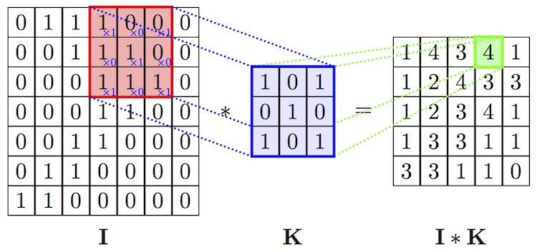
Fig 1.4. Convolutional Layers
    - Fully Connected Layer
Transformation is applied to inputs by fully linked layers. The weight matrix W, a learnable parameter, determines how each output in a fully-connected layer relates to each input.

Fig1.5. Fully Connected Layers
    - SoftMax Nonlinearity
There isn't any learnable configuration for it. In the final layer of the neural network, a phenomenon known as SoftMax nonlinearity calculates final class scores that are input into the loss function or output during testing. Using SoftMax to determine class scores is a preferable alternative due to how easy it is to read.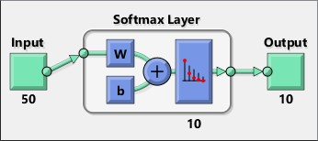
Fig 1.6. SoftMax Nonlinearity
    - Dropout Layer
In neural networks, dropout layers are used to take input from various sources and set each input's value to 0 with a probability of p. The dropout esteem p serves as the system's programmable hyperparameter during testing. Dropout is a type of regularization since it makes the system employ several methods to identify the right response, preventing it from becoming unduly reliant on any one relationship.
Fig 1.7. Drop out Layers
    - Max Pooling Layer
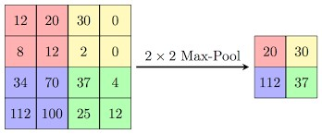
Max pooling layers reduce image size by combining two 2x2 contribution areas into one output value. The output value is effectively the greatest estimation of those 4 input pixels for each 2x2 informational region. This is comparable to handling the image with a higher level of consideration, where highlights are compared to a larger area of the information picture.
Fig 1.8 Max Pooling
    - Rectified Linear Unit Nonlinearity
ReLU Layers serve as the activation functions for the completely linked layers, hence they do not require any activation functions of their own. These layers' gradient values are extremely high, never tend to zero, and adjust to the ongoing neuronal learning process. Only negative numbers supplied to these layers will cause them to return zero.
  - WORKING OF ANNs
The information flow path is denoted by each arrow in the topology diagrams, which shows a connection between two neurons. Each link's weight, which is an integer number, governs the signal between the two neurons. If the network yields a "good or desired" output, there is no need to adjust the weights. To improve subsequent results, the system updates the weights if the network generates a "poor or undesirable" output or an error.
  - VGG ARCHITECTURE
The Very Deep Convolutional Networks for Large Scale Image Recognition article by Simonyan and Zisserman from 2014 is when the VGG network concept was originally introduced. In this network, there is only one convolutional layer, 33, and it is stacked on top of itself in increasing layers of complexity. Volume size may be minimized via max pooling. Following two fully connected layers with a combined total of 4,096 nodes each, a softmax classifier is used to further refine the results. The networks in this design were thought to be extraordinarily deep. Pretraining is the method by which the smaller networks converged and were then utilized as initializations for the bigger, deeper networks. Pre-training, while logical, is a time-consuming, tedious job that necessitates training a complete network before it can act as an initialization for a deeper network.
    - AlexNet vs VGG
Alex Krizhevsky and colleagues created AlexNet in 2012 to participate in the ImageNet competition. Although this model is much larger than LeNet-5, the general architecture is very similar. Many members of the computer vision community were persuaded to seriously consider deep learning for computer vision tasks as a result of the success of this model, which won the 2012 ImageNet competition.
The convolutional structures outlined above have a deeper yet simpler variant, the VGG network, which was introduced in 2014. This model was quite complex at the time it was first introduced.
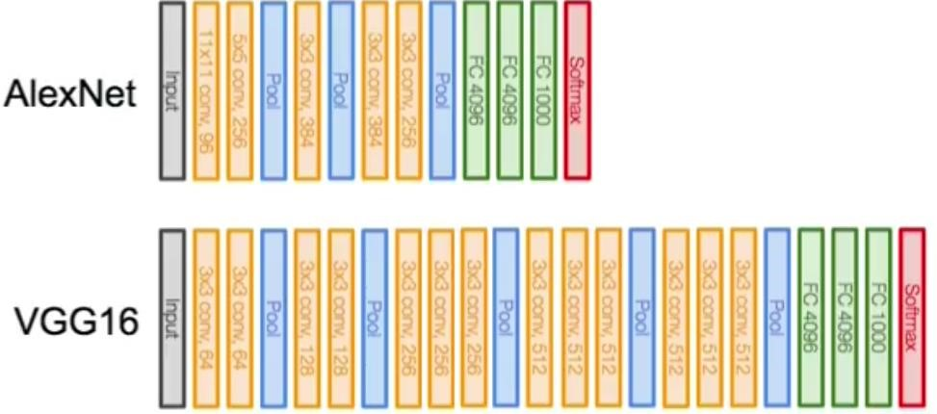
Fig 1.9 AlexNet vs VGG16
2. RELATED WORK
Review of Literature:
A biometric method of person authentication is signature verification. Systems for handwritten signature identification and verification have been the subject of decades' worth of research.
Mohsen EbrahimiMoghaddama and Samaneh Ghandali[1] A approach based on Image Registration, DWT (Discrete Wavelet Transform), and Image Fusion is suggested for the identification and verification of off-line Persian signatures. To solve the shift and scale challenge, each person's training signatures are registered. In order to extract features, DWT is first utilized to obtain the signature's data. The suggested method is based on the Euclidean distance between each pattern in the test picture and each sub-band during the classification phase. The classification stage makes use of high frequency information to further separate a real signature from a fake. The classifier is based on the Euclidian distance between each sub-band's learned and tested patterns during the identification and verification stages. The training signatures of each individual are recorded in order to tackle the shift and scale issue. DWT is first used to acquire the signature's data before characteristics are extracted. Only Persian signatures, nevertheless, may be read using this technique.
Taking into account several forgery forms in an HMM framework, Edson J. R. Justino, Flavio Bortolozzi, and Robert Sabourin[2] announce their contribution to signature verification. According to the experiments, there is relatively little difference in the error rates of simple and random forgery signatures. This reflects actual applications where straightforward forgeries are the main fraudulent scenario. Additionally, the experiments demonstrate encouraging outcomes in the verification of skilled forgery using straightforward static and fictitious dynamic features.
Three different approaches of tracking the variances are suggested in this research.
1. Random Forgery - Typically, a signature sample from a different writer of the signature model is used to represent it.
2. Simple Forgery - It is represented with a signature example that mimics the genuine writer's name in terms of shape.
3. Skilled Forgery - A appropriate copy of the real signature model serves as its representation.
The combination of pixel density, pixel distribution, and axial slant features was done using a multiple codebook technique. The benefit of grid-segmentation techniques has frequently been demonstrated. These works also show how the stability of the signature's components is taken into account while adapting a grid method to them. In, we discussed a set of graphometric features used in the grid segmentation method. Depending on the feature being used, each column of cells is transformed into a characteristic vector, each of which has one or more representative integer values. Three features—two static and one pseudo dynamic—were utilized for this work. In order to account for the number of pixels in each cell (pixel density feature), we included a signature binary image into the grid. The Extended-Shadow-Code (ESC) pixel distribution function that Sabourin used was also used by us. Results for identifying random forgeries have been encouraging.
Using a NN architecture, Alan McCabe, Jarrod Trevathan, and Wayne Read[3] offer a technique for authenticating handwritten signatures. The NN is trained using a variety of static and dynamic signature features, such as height, slant, velocity, pen tip pressure, etc. The accuracy of a number of network topologies is evaluated and compared. An overall error rate of 3.3% is indicated as the best case performance of the resulting system.
The HSV experimentation was made easier with the creation of a signature database. A database must have a large sample size, a variety of samples, and no arbitrary exclusions in order to be effective.
The training set can be produced using this strategy in the following ways: a) Using the full database to train one
network.
b) Using the complete database to train a single network with many outputs
c) Individual networks for each signer should be trained, along with negative network training examples.
A brand-new technique for identifying handwritten signatures based on rotating complex wavelet filters is put forth by M.S. Shirdhonkar and Manesh Kokare[4]. We have suggested combining the rotated complex wavelet filters (RCWF) and dual tree complex wavelet transform (DTCWT) to create an extraction method for signature features that gathers data from twelve different angles. Canberra distance measurement is utilized during the identification step. The discrete wavelet transform (DWT) is contrasted with the proposed approach. According to experimental findings, the proposed method's signature identification rate is higher than DWT's.
Using rotated complex wavelet filters and dual tree complex wavelet transform, this research suggests an off-line technique for recognizing handwritten signatures. For measuring the separation between two points in a multidimensional space, the Canberra distance metric was employed. The signatures were scribbled in either black or blue ink on A4 paper, eight to a page, and no consideration was given to the brand of the pen used to write them. The photos were taken as 256 × 256 pixel rectangles.
In 2005, Chen and Srihari [7] described a method for defining a pseudo-writing route by obtaining the image's outside contour. Dynamic temporal warping (DTW) approach has been used to segment signatures into curves in order to match two signatures. Additionally, some Zernike moment-based features have been extracted. Last but not least, a harmonic distance has been used to assess signature similarity. This technique performs better when used in conjunction with a word shape-based strategy.
A method for Chinese offline signature verification was developed in 2002 by Shen, Qiang, and Pan [8] based on the fusion of many types of geometric global and local features. These writers have taken into account the cross-count feature, the size of embedded white space, the distance between the vectors of the center of gravities, the center of gravity of sub-regions, and the envelope of the signature.
Judstino, et al. [9] employed an HMM-based learning approach with straightforward characteristics in 2000 to verify signatures. By applying a cross-validation process for each author, the goal of this strategy was to obtain the most representative signature model possible. To accept genuine signatures and reject fake ones, they offered an automatic threshold detection approach.
A approach that uses a closed-contour tracing algorithm to extract both static and dynamic curvature information as well as a wavelet transform to retrieve stable features was proposed by Peter Shaohua et al. [10]. To find expert forgeries, they applied a dynamic thresholding approach based on optimization.
3. PROPOSED METHOD
3.1 PROCESSS
In our proposed solution, we have 3 steps to be done
- Preprocessing
- Network Training
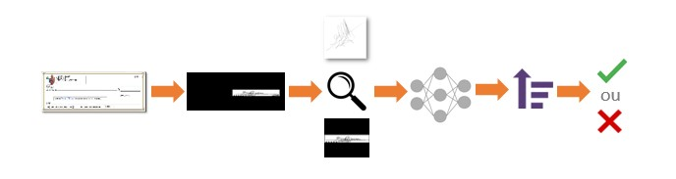
- Signature Verification
Fig.3.1: Flow of Proposed Solution
In the first step, the signature images must be verified if noise removal is done or not. Then the signatures dataset must be divided into genuine and forged one. Finally based on the count of images in the training set and the test dataset are divided
The training dataset must contain both forged and genuine signature. Then based on the count of signatures in each category we add the sample weight to each dataset.
After the preprocessing is done the network has to be trained such that when the test data is sent it must verify if the signature is genuine or not.
So, the training data set is shuffled and sent to the network, as the no of times we pass the network the highest would be the accuracy.
Coming to the verification, the test dataset is sent to the network based on the features in the network the signature could be verified.
In both training and testing we have used VGG architecture which has 16 layers through the image is passed. The layers which we are using are Convolutional Layer, Max Pool Layer, Activation Layer and Relu Layer.
The flow chart representation is,
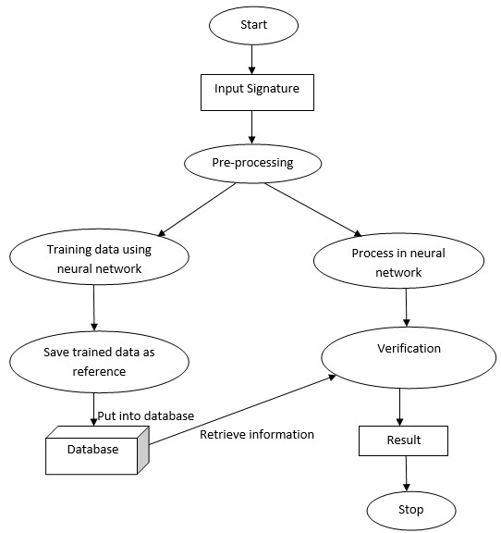
Fig 3.2: Flow Chart
1. Once Tensorflow has been imported, we can start preparing our data, modeling it, and finally training it.
2. Then we imported keras and numpy as the methods in that packages are used
3. The images would be in RGB format which is represented in a 3D matrix which would results in complexity for further calculations, so we need to convert it into a 1D array
4. At first, we import the images by assigned the file path to a variable
5. Then the categorization of the datasets into Genuine & Forged.
6. After categorizing the data, all images are sent into a single array called training _data.
7. So, an empty array is declared, in that
array at first, we load the images using the functions imread () and resize () functions, one to read the images into array and the resize the image to the required size.
8. Then the resized array is appended to the training_data array with category value for example the category value for forgery is 0 and for the genuine one is 1
9. The dataset contains large number of files so every time adding them to the training set would be difficult so pickle the datasets i.e., serializing the python object.
10. By pickling we can eliminate the back-and-forth movements repeatedly. By pickling we can save both time and space
11. We can get the pickled data in another file by using the functions,
12. Before pickling is done features and labels must be identified. But in ConvNet the network itself identifies the features. So, for pickling we have selected 2 arrays one for the features(X) and the other for labels(y)
13. After the pickled data is obtained, we have passed the arrays to the layers, these layers are in VGG architecture.
14. Before the layers are defined, we
selected sequential model and then pass
X and y to the layers.
15. At first, we pass the X to the convolution layer where the features are extracted.
16. Then we use activation function to perform max pooling. The activation function used here is ReLU (Rectified Linear Unit)
16. Then max pooling is performed to find the required region with required matrix size.
17. Then after multiple convolution and max pooling layers we have flatten and dense layer which are used to convert into 1D vector and for connecting to the output layers respectively.
18. After the layers we activate the sigmoid function to find whether a signature is forged (0) or genuine (1) and then we compile it.
4. EXPERIMENTS
4.1 Dataset
Dataset: ICDAR 2011 Signature Verification Competition (SigComp2011) -Training Dataset
4.1.1 Software
Programming Languages – Spyder, Numpy, TensorFlow, Keras.
IDE – Visual Studio Code, Anaconda, Jupyter Notebook, Rstudio, Qt Console.
4.1.2 Hardware
Windows – 8 or newer 11
Linux – Ubuntu
MAC – OS X v10.7 or higher
5. RESULTS AND DISCUSSION
The network can determine the specific properties of the signature photos after putting the training set through it repeatedly depending on the datasets in question.
The primary goal is to determine if a signature is authentic or false. Therefore, this can be found using acceptance rate. The acceptance rate is determined by the enumerated elements. The first parameter is the sum of all comparisons (Total), and the second is the positive count (PC). The signature is genuine if the ratio of PC to Total above the cutoff limit; else, it is counterfeit. Value = Positive Count / Total
We are able to distinguish between the signatures based on the value acquired. The network has been run numerous times with training datasets to get the best accurate results.
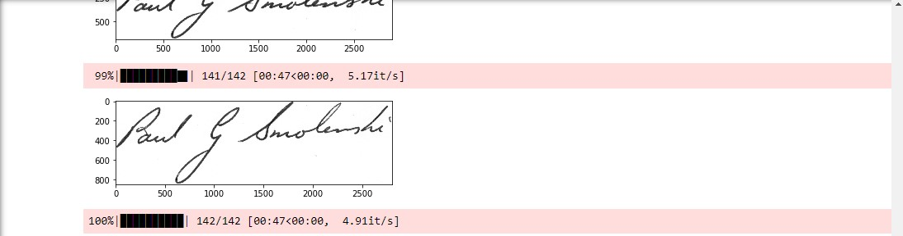
5.1 (a) Training the Dataset
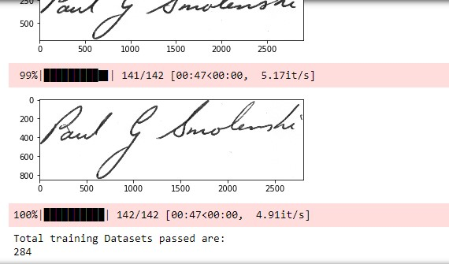
(b)
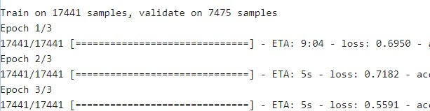
(c)
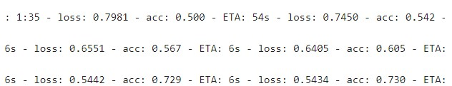
(d)
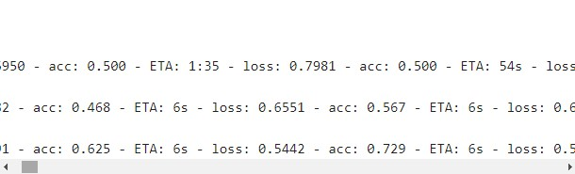
(e)
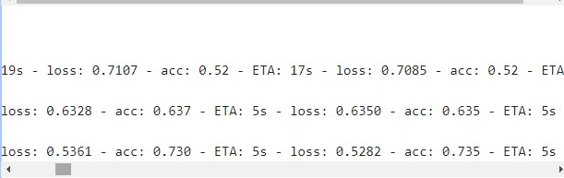
(f)
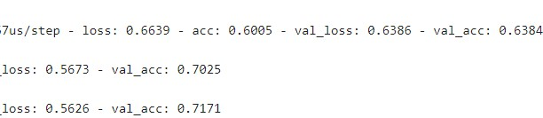
(g)
6. CONCLUSIONS
We tested a number of different tasks for signature verification. We demonstrated that convolutional neural networks perform very well at validating signatures when given access to instances of real and fake signatures from the same individuals whose signatures are viewed during testing. Due to the task's inherent complexity, we next conducted an experiment in which we evaluated our network on the signatures of fresh people, whose signatures had not been exposed to any training data. Last but not least, we proposed a special architecture for signature comparison that holds promise for future work in signature verification, particularly in circumstances when a possibly forged signature may be compared to known genuine signatures of a certain signer.
When provided access to verified and fraudulent signatures, convolutional neural networks perform well at checking signatures. Analysis, however, revealed that performance was only slightly superior to a gullible gauge. The presentation of a novel engineering technique for signature correlation ensures future progress in signature check, particularly in situations where a possibly manufactured signature can be compared to real signatures.
The authors propose two areas for further study: increasing the amount of resources available, training on a larger dataset with more signature samples per person, and training a larger network for longer epochs. It is challenging to find high-quality datasets of publicly accessible signatures since the sample was rather small, consisting of just a few tens of thousands of instances. The Writer Dependent Comparison Task, which represents an actual-world scenario where signature verification would be used, appears to be a promising subject for additional research. Although we weren't able to get high grades on this assignment, the research on signature verification suggests that our method is promising. We could train our algorithms if we had access to more data and computing capacity.
7. ACKNOWLEDGEMENTS
Convolutional neural networks (CNNs) were utilized to create a deep learning-based system for signature verification utilizing the SigComp2011 dataset of offline signatures. In comparison to other cutting-edge techniques, the authors claimed that their CNN-based system outperformed them all in terms of high accuracy and resilience when determining the veracity of signatures. The SigComp2011 dataset was utilized by the authors to illustrate the efficacy of their methodology on a vast and varied collection of signature photos and to compare their findings to those of other research that also used the dataset. Overall, the SigComp2011 dataset served as an invaluable resource for the development and assessment of the CNN-based signature verification system described in this study, advancing the state-of-the-art in the field of signature verification using deep learning methods.
8. CONTRIBUTIONS
Hema Varshini Danda – Introduction, Implementation, Code Execution, Results and Discussion,
Dheeraj Avadhanula – Related Work, Proposed Method, Code Execution, Results, Acknowledgements, References.
9. REFERENCES
1. S. Ghandali and M. Ebrahimi Moghaddam,
Off-Line Persian Signature Identification and Verification based on Image Registration and Fusion, In: Journal of Multimedia, volume 2009, pages: 137-144.
2. E. J. R. Justino , F Bortolozzi and R. sabourin , Off-line signature verification Using HMM for random, simple and skilled forgeries, ICDAR 2001, International Conference on document Analysis and Recognition, vol. 1 pp. 105-110. 2001.
3. Alan McCabe, Jarrod Trevathan and Wayne Read, Neural Network-based Handwritten Signature Verification, Journal of computers,vol. 3, no. 8, August 2008.
4. B.Fang, C.H Leung, Y.Y. Tang, K.W. Tse, P.C.K. Kwok, and Y.K.Wong, Off-line signature verification by the tracking of feature and stroke positions, Pattern Recognition, vol. 36, pp. 91-101, 2003.
5. Larkins, R. Mayo, M., “Adaptive Feature Thresholding for Off-Line Signature Verification”, In: Image and vision computing New Zealand, 2008, pages: 1-6.
6. Chen. S., Srihari. S., “Use of Exterior Contours and Shape Features in Off-line Signature Verification”, In: Eighth International Conference Document Analysis and Recognition, 2005, page(s): 1280 – 1284.
7. Yaqian Shen, Qinghua Qianq, Jingui Pan, “Off-line signature verification using geometric features specific to Chinese handwriting”, In: 24th International Conference Information Technology Interfaces, 2002, page(s): 229 - 235 vol.1.
8. Edson J. R. Justino, Yacoubi. A., Bortolozzi. F., Sabourin. R., “An Off-Line Signature Verification System Using Hidden Markov Model and Cross-Validation”, In: 13th Brazilian Symposium on Computer Graphics and Image Processing, 2000, page(s): 105 – 112.
9. Peter Shaohua Deng, Hong-Yuan Mark Liao, “Wavelet-Based Off-Line Handwritten Signature Verification”, In: Computer Vision and Image Understanding, 1999, page(s) 173-190.
10. Kovari, B. Kertesz, Z. and Major, a., Off-Line Signature Verification Based on Feature
11. Matching: In: Intelligent Engineering Systems, 2007, pages 93-97.
49

12. Wei Tian, YizhengQiao and Zhiqiang Ma, A New Scheme for Off-line Signature Verification Using DWT and Fuzzy Net”, 8th ACIS International Conference on Software Engineering, Artificial Intelligence, Networking, and parallel/Distributed Computing.
13. Ian W. McKeague, A Statistical model for signature verification, Journal of the American Statistical Association, 2005, vol. 100, pages231-241.
14. Peter Shaohua Deng, Hong-Yuan Mark Liao, “Wavelet-Based Off-Line Handwritten Signature Verification”, In: Computer Vision and Image Understanding, 1999, page(s) 173-190
15. J. Elms, "The Representation and Recognition of Text Using Hidden Markov Models", PhD Theses Doctor, University of Surrey, U.K. (1996), 239p.
16. G. Rigoll, A. Kosmala, "A Systematic Comparison Between On-Line and Off-Line Methods for Signature Verification with Hidden Markov Models", 14th International Conference on Pattern Recognition - vol. II, Australia (1998), 1755-1757.
17. Drouhard, J.P., R. Sabourin, and M. Godbout, “A neural network approach to off-line signature verification using directional PDF”, Pattern Recognition, vol. 29, no. 3, (1996),415-424.
18. Q. Yingyong, B. R. Hunt, "Signature Verification Using Global and Grid Features", Pattern Recognition – vol. 22, no. 12, Great Britain (1994), 1621--1629.
19. Sabourin, R. and Genest, G., “An Extended -Shadow-Code Based Approach for Off-Line Signature Verification: Part –I – Evaluation of the Bar Mask Definition”, 12th IAPR International Conference on Pattern Recognition - Jerusalem, Israel, October 9-13 - IEEE 1051-4651/94, (1994), 450--455.
20. Yinggyong Qi, Bobby R Hunt, “A Multiresolution Approach to Computer Verification of Handwritten Sigantures”, IEEE Transactions on Image Processing, vol. 4, no. 6, june (1995), pp 870-874.
21. L. S. Oliveira, E. Justino, C. Freitas, and R. Sabourin, The graphology applied to signature
verification, in 12th Conference of the International Graphonomics Society, 2005, pp. 286 290
22. R. Sabourin and G. Genest, An extended-shadow-code based approach for off-line signature verification. I. Evaluation of the bar mask definition, in Conference on Pattern Recognition, 1994. Vol. 2 - Conference B:

Computer Vision amp; Image 50 Processing., Proceedings of the 12th IAPR International, vol. 2, Oct. 1994, pp. 450453 vol.2.
23. N. A. Murshed, R. Sabourin, and F. Bortolozzi, A cognitive approach to off-line signature verification, International Journal of Pattern Recognition and Artificial Intelligence, vol. 11, no.05, pp. 801825, 1997.
24. E. zgndz, T. entrk, and M. E. Karslgil, Off-line signature verification and recognition by support vector machine, in European signal processing conference, EUSIPCO, 2005.
25. J. Vargas, M. Ferrer, C. Travieso, and J. Alonso, Off-line Handwritten Signature GPDS-960 Corpus, in Ninth International Conference on Document Analysis and Recognition, 2007. ICDAR 2007, vol. 2, Sep. 2007, pp. 764768

