Date | 07/06/26
Team ID | SWTID-2026-9649
Project Name | Sports Hall Booking System by Service Portal(ServiceNow)
Maximum Marks | 2 Marks
Assignment - 1

- Bar Chart

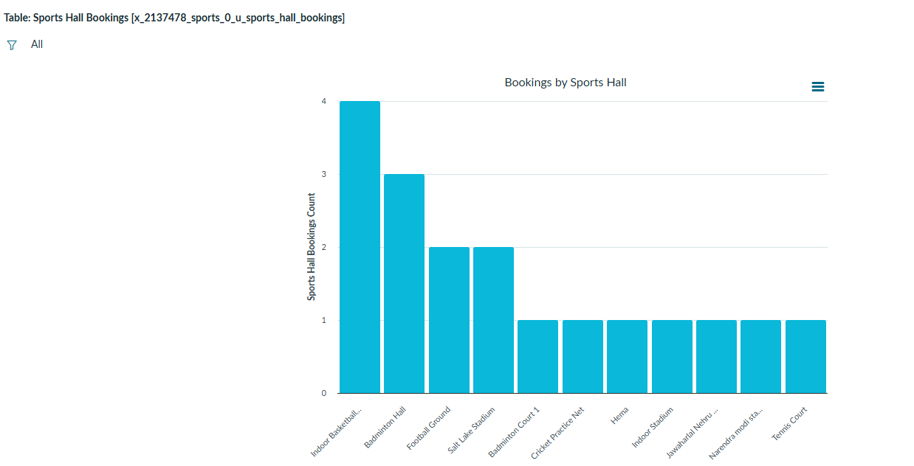

- Pie Chart

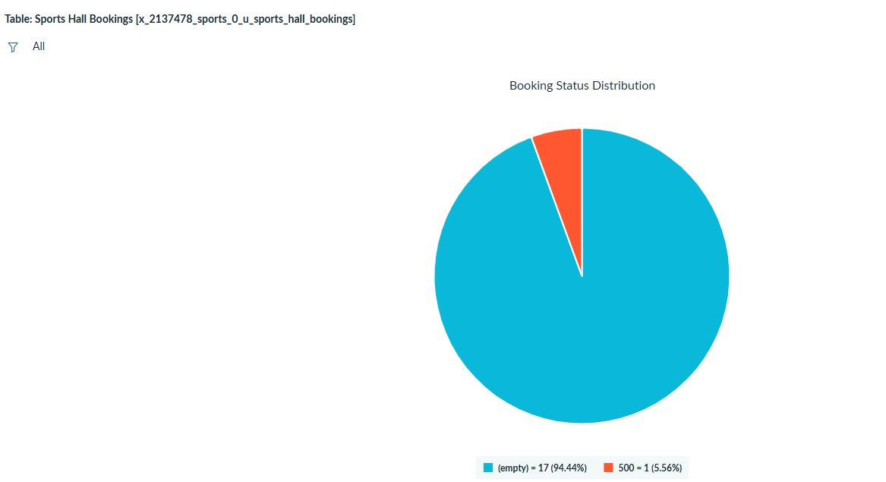

- Line Chart

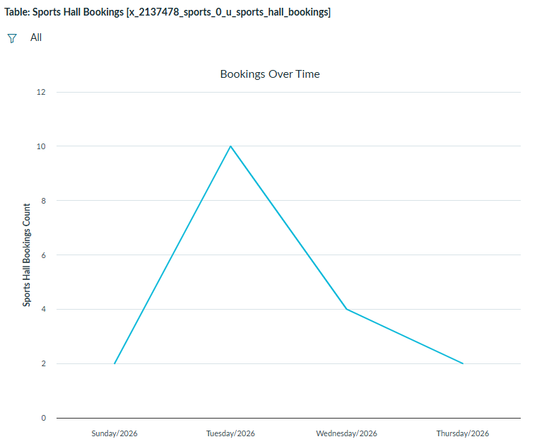

- Bubble Chart

