# Logging using SLF4J

Exercise 1: Logging Error Messages and Warning Levels

LoggingExample .java

package com.example.LoggingExample;

import org.slf4j.Logger;

import org.slf4j.LoggerFactory;

public class LoggingExample {

private static flnal Logger ***looftofter*** = LoggerFactory.*getLogger*(LoggingExample.class);

public static void main(String[] args) { ***looftofter***.error("This is an error message"); ***looftofter***.warn("This is a warning message");

}

}

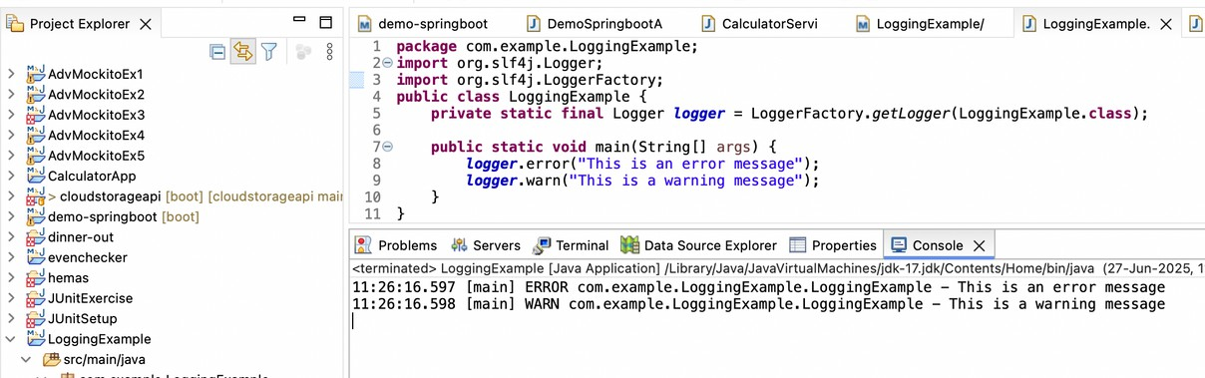output

Exercise 2: Parameterized Logging

## ParameterizedLoggingExample.java

package com.example.LoggingExample2;

import org.slf4j.Logger;

import org.slf4j.LoggerFactory;

public class ParameterizedLoggingExample {

private static flnal Logger ***looftofter*** =

LoggerFactory.*getLogger*(ParameterizedLoggingExample.class);

public static void main(String[] args) { String user = "Alice";

int age = 30;

// Parameterized logging with placeholders {} ***looftofter***.info("User {} has logged in.", user); ***looftofter***.debug("User's age is {}", age);

// Multiple parameters

***looftofter***.warn("Warning: User {} with age {} has some issue.", user, age);

// Parameterized error message

try {

int result = 10 / 0;

} catch (ArithmeticException e) {

***looftofter***.error("Error occurred while dividing: {}", e.toString());

}

}

}

# output

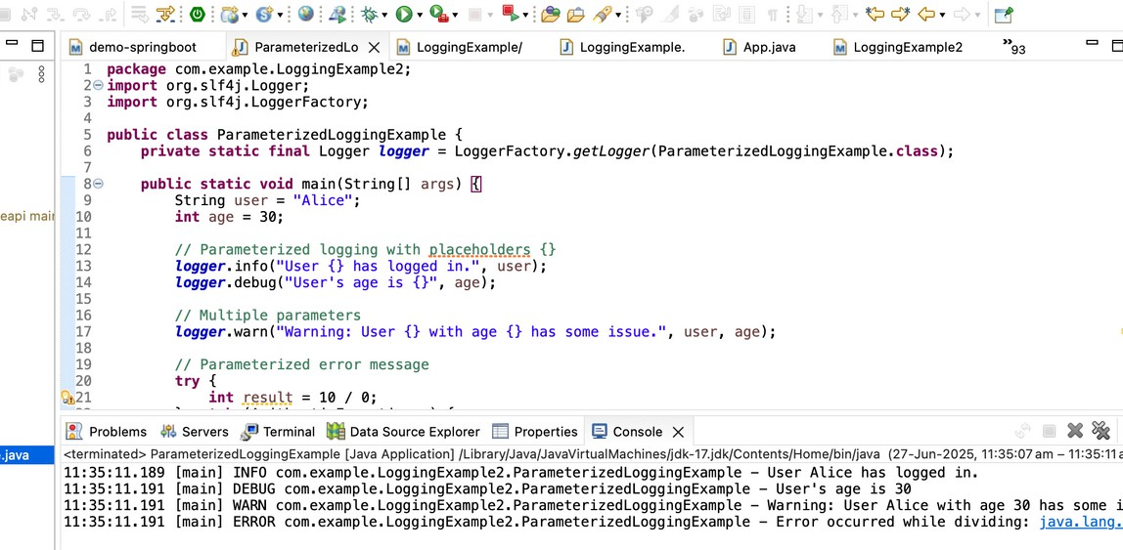

Exercise 3: Using Different Appenders

## AppenderExample.java

package com.example.LoggingExample3;

import org.slf4j.Logger;

import org.slf4j.LoggerFactory;

public class AppenderExample {

private static flnal Logger ***looftofter*** = LoggerFactory.*getLogger*(AppenderExample.class);

public static void main(String[] args) {

***looftofter***.debug("Debug message"); ***looftofter***.info("Info message"); ***looftofter***.warn("Warning message"); ***looftofter***.error("Error message");

}

}

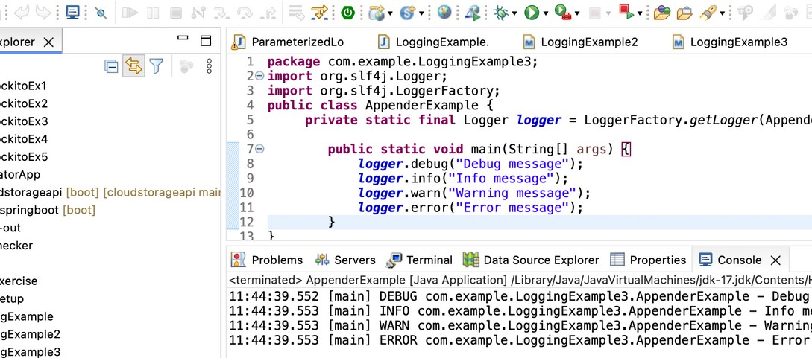output