**WEEK 7 REACT**

**EX 10 OFFICERENTALAPP**

**App.js**

import React from 'react';

function App() {

const office = {

name: 'Indigo Workspace',

rent: 55000,

address: '123 Tech Park, Bengaluru',

image: 'https://via.placeholder.com/400x200.png?text=Office+Space'

};

const officeList = [

{

name: 'Indigo Workspace',

rent: 55000,

address: '123 Tech Park, Bengaluru',

},

{

name: 'GreenHub Office',

rent: 72000,

address: '45 Startup Lane, Chennai',

},

{

name: 'SkyView Workspaces',

rent: 60000,

address: '88 Business Bay, Hyderabad',

}

];

const getRentStyle = (rent) => {

return {

color: rent > 60000 ? 'green' : 'red',

fontWeight: 'bold'

};

};

return (

<div style={{ padding: '20px', fontFamily: 'Arial' }}>

<h1>Office Space Rental App</h1>

<img src={office.image} alt="Office Space" style={{ width: '400px', height: '200px' }} />

<h2>{office.name}</h2>

<p style={getRentStyle(office.rent)}>Rent: ₹{office.rent}</p>

<p>Address: {office.address}</p>

<hr />

<h2>Available Office Spaces:</h2>

{officeList.map((item, index) => (

<div key={index} style={{ marginBottom: '20px' }}>

<h3>{item.name}</h3>

<p style={getRentStyle(item.rent)}>Rent: ₹{item.rent}</p>

<p>Address: {item.address}</p>

</div>

))}

</div>

);

}

export default App;

**OUTPUT**

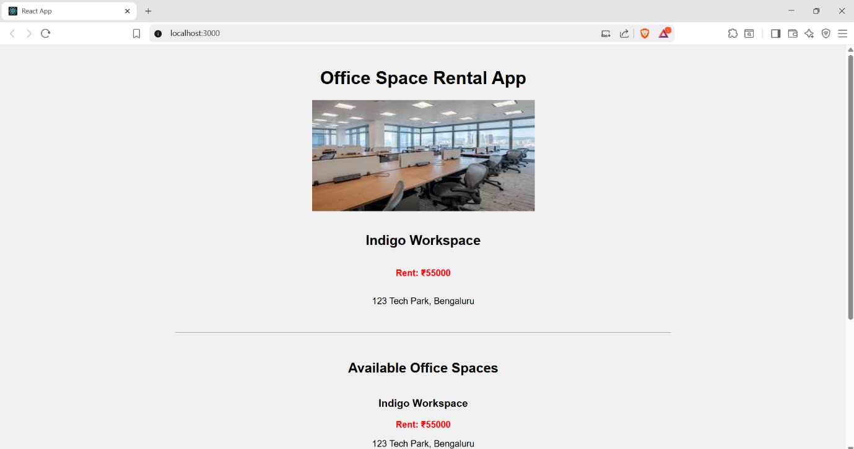

**EX 11 EVENTEXAMPLESAPP**

**App.js**

import React, { Component } from "react";

import CurrencyConvertor from "./CurrencyConvertor";

class App extends Component {

constructor(props) {

super(props);

this.state = {

counter: 0,

};

// Binding this manually for class method

this.handleDecrement = this.handleDecrement.bind(this);

}

// Increment with multiple methods

handleIncrement = () => {

this.incrementValue();

this.sayHello();

};

incrementValue = () => {

this.setState((prevState) => ({

counter: prevState.counter + 1,

}));

};

sayHello = () => {

console.log("Hello! Counter is increasing.");

};

handleDecrement() {

this.setState((prevState) => ({

counter: prevState.counter - 1,

}));

}

// Welcome message function

sayWelcome = (message) => {

alert(message);

};

// Synthetic Event Handler

handleClick = (event) => {

alert("I was clicked");

console.log("Synthetic Event: ", event);

};

render() {

return (

<div style={{ textAlign: "center", marginTop: "50px" }}>

<h1>React Event Handling Examples</h1>

<h2>Counter: {this.state.counter}</h2>

<button onClick={this.handleIncrement}>Increment</button>&nbsp;

<button onClick={this.handleDecrement}>Decrement</button>

<hr style={{ margin: "30px 0" }} />

<button onClick={() => this.sayWelcome("Welcome to React Events!")}>

Say Welcome

</button>

<hr style={{ margin: "30px 0" }} />

<button onClick={this.handleClick}>Click Me (Synthetic Event)</button>

<hr style={{ margin: "30px 0" }} />

<CurrencyConvertor />

</div>

);

}

}

export default App;

**CurrencyConvertor.js**

import React, { useState } from "react";

function CurrencyConvertor() {

const [rupees, setRupees] = useState("");

const [euro, setEuro] = useState("");

const handleSubmit = (e) => {

e.preventDefault();

const euroValue = (parseFloat(rupees) / 90).toFixed(2);

setEuro(euroValue);

};

return (

<div>

<h2>Currency Converter (INR → Euro)</h2>

<form onSubmit={handleSubmit}>

<input

type="number"

placeholder="Enter amount in INR"

value={rupees}

onChange={(e) => setRupees(e.target.value)}

/>

&nbsp;

<button type="submit">Convert</button>

</form>

{euro && (

<p>

€ {euro} EUR (from ₹{rupees})

</p>

)}

</div>

);

}

export default CurrencyConvertor;

**OUTPUT**

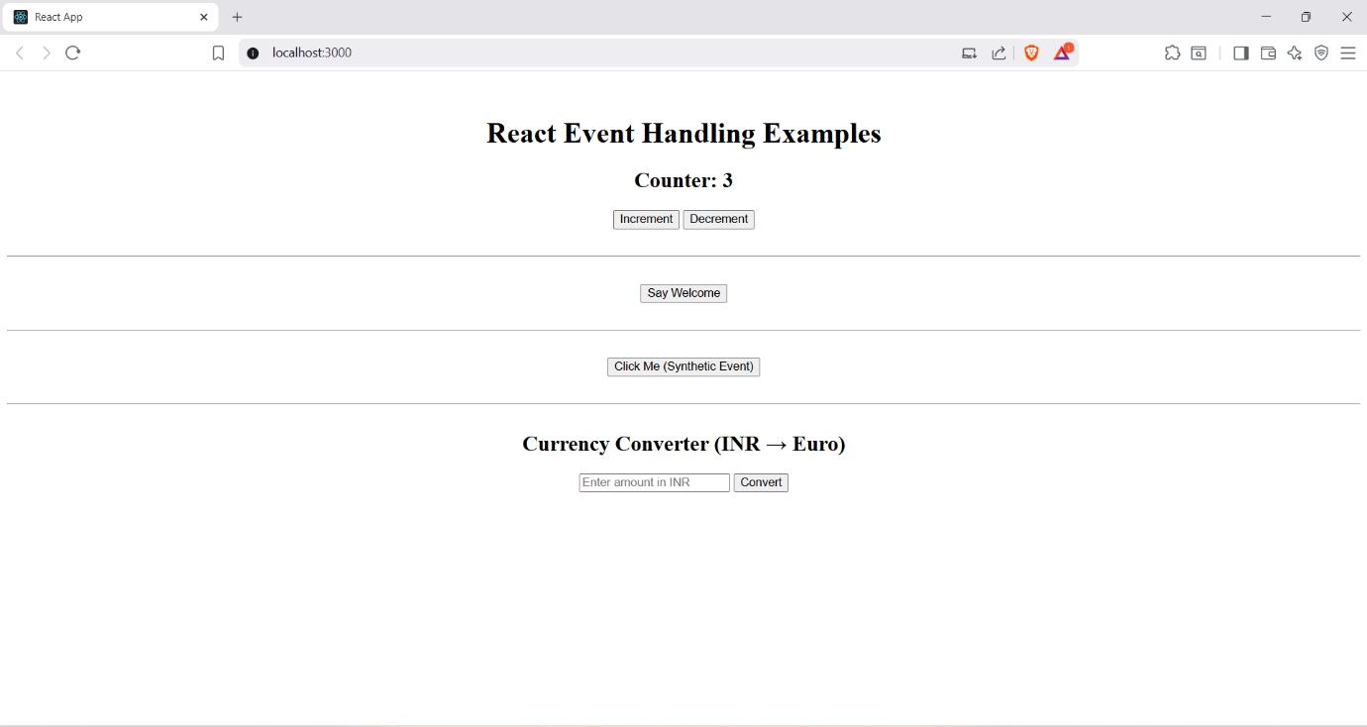

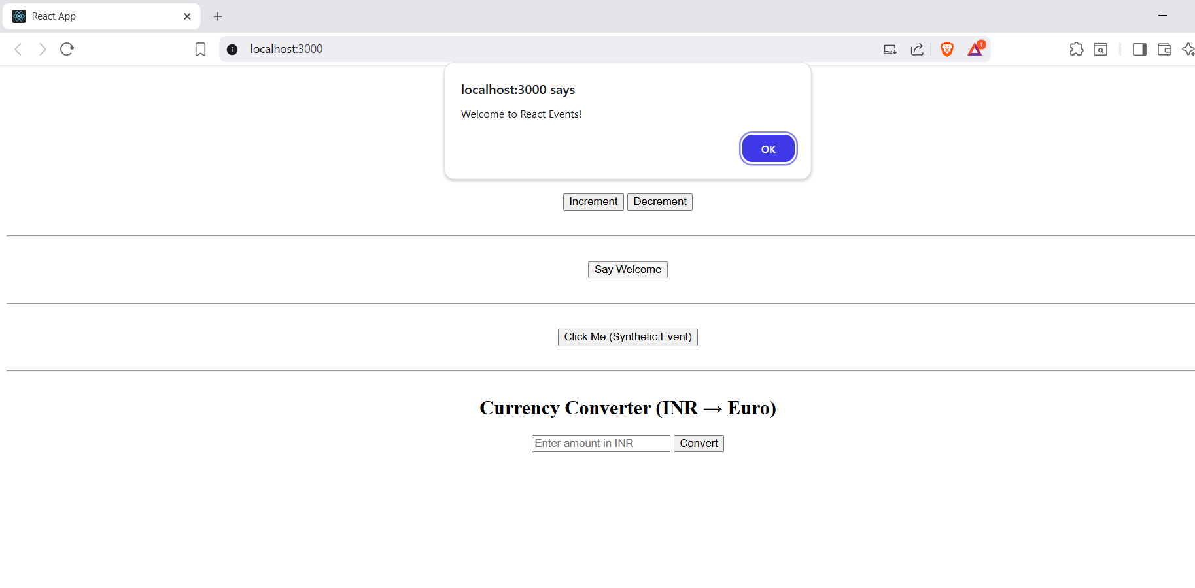

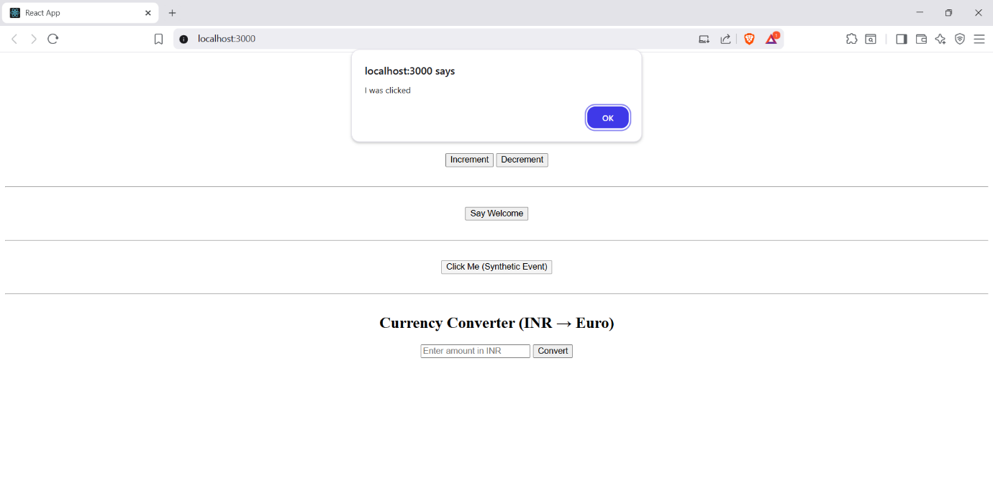

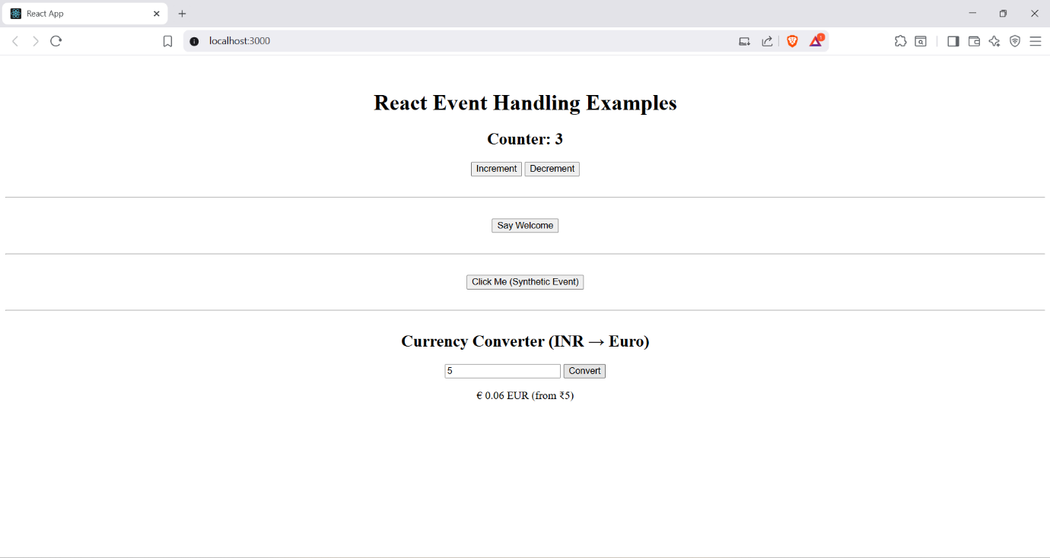

**EX 12 TICKETBOOKINGAPP**

**Guest.js**

import React from 'react';

const Guest = () => {

return (

<div style={styles.container}>

<h2>Welcome, Guest!</h2>

<p>You can browse flight details here, but booking requires login.</p>

</div>

);

};

const styles = {

container: {

textAlign: 'center',

marginTop: '50px',

},

};

export default Guest;

**User.js**

import React from 'react';

const User = () => {

return (

<div style={styles.container}>

<h2>Welcome, User!</h2>

<p>You can now book your flight tickets.</p>

</div>

);

};

const styles = {

container: {

textAlign: 'center',

marginTop: '50px',

},

};

export default User;

**App.js**

import React, { useState } from 'react';

import Guest from './components/Guest';

import User from './components/User';

function App() {

const [isLoggedIn, setIsLoggedIn] = useState(false);

const handleLoginToggle = () => {

setIsLoggedIn(prev => !prev);

};

const buttonStyle = {

marginTop: '20px',

padding: '10px 20px',

backgroundColor: isLoggedIn ? 'tomato' : 'green',

color: 'white',

border: 'none',

cursor: 'pointer',

borderRadius: '8px'

};

return (

<div style={{ textAlign: 'center' }}>

<h1>Ticket Booking App</h1>

{isLoggedIn ? <User /> : <Guest />}

<button style={buttonStyle} onClick={handleLoginToggle}>

{isLoggedIn ? 'Logout' : 'Login'}

</button>

</div>

);

}

export default App**;**

**OUTPUT**

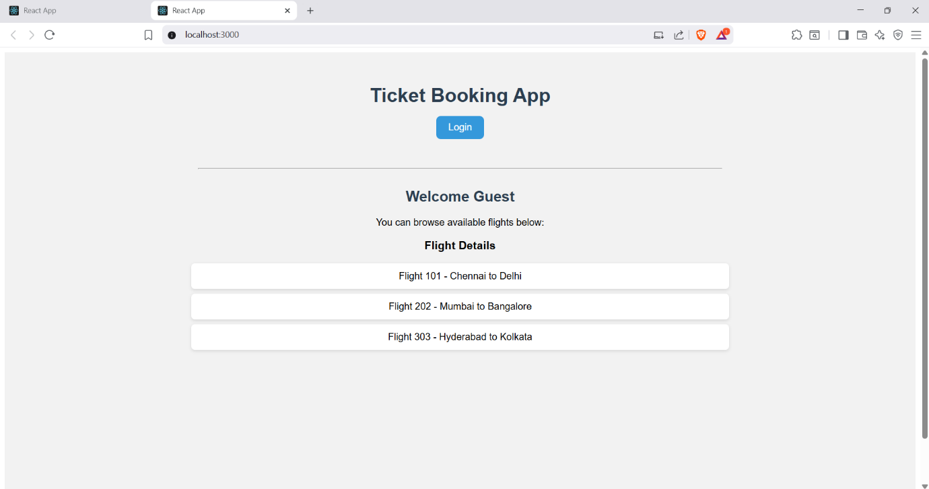

**EX 13 BLOGAPP**

**BlogDetails.js**

import React from 'react';

const BlogDetails = ({ blogs }) => {

  return (

    <div>

      <h2>Blog Posts</h2>

      <ul>

        {blogs.map((blog) => (

          <li key={blog.id}>

            <strong>{blog.title}</strong> - {blog.content}

          </li>

        ))}

      </ul>

    </div>

  );

};

export default BlogDetails;

**BookDetails.js**

import React from 'react';

const BookDetails = ({ books }) => {

  return (

    <div>

      <h2>Books List</h2>

      <ul>

        {books.map((book, index) => (

          <li key={book.id}>

            <strong>{book.title}</strong> by {book.author}

          </li>

        ))}

      </ul>

    </div>

  );

};

export default BookDetails;

**CourseDetails.js**

import React from 'react';

const CourseDetails = ({ courses }) => {

  return (

    <div>

      <h2>Courses</h2>

      <ul>

        {courses.map((course) => (

          <li key={course.id}>

            <strong>{course.name}</strong> - {course.instructor}

          </li>

        ))}

      </ul>

    </div>

  );

};

export default CourseDetails;

**App.js**

import React, { useState } from 'react';

import BookDetails from './BookDetails';

import BlogDetails from './BlogDetails';

import CourseDetails from './CourseDetails';

import './App.css';

function App() {

  const [view, setView] = useState('books');

  const books = [

    { id: 1, title: 'React Explained', author: 'Zac Gordon' },

    { id: 2, title: 'Learning JavaScript', author: 'Ethan Brown' }

  ];

  const blogs = [

    { id: 1, title: 'React Tips', content: 'Use hooks wisely' },

    { id: 2, title: 'JavaScript Trends', content: 'ES2025 is here!' }

  ];

  const courses = [

    { id: 1, name: 'React Basics', instructor: 'Alice' },

    { id: 2, name: 'Advanced JS', instructor: 'Bob' }

  ];

  let content;

  if (view === 'books') {

    content = <BookDetails books={books} />;

  } else if (view === 'blogs') {

    content = <BlogDetails blogs={blogs} />;

  } else {

    content = <CourseDetails courses={courses} />;

  }

  return (

    <div className="App">

      <h1>Blogger App</h1>

      <div className="nav">

        <button onClick={() => setView('books')}>Books</button>

        <button onClick={() => setView('blogs')}>Blogs</button>

        <button onClick={() => setView('courses')}>Courses</button>

      </div>

      <hr />

      {content}

      {/* {view === 'books' ? <BookDetails books={books} /> : view === 'blogs' ? <BlogDetails blogs={blogs} /> : <CourseDetails courses={courses} />} */}

      {/* {view === 'books' && <BookDetails books={books} />}

      {view === 'blogs' && <BlogDetails blogs={blogs} />}

      {view === 'courses' && <CourseDetails courses={courses} />} */}

    </div>

  );

}

export default App;

**OUTPUT**

