Assignment 1

This is to be done AFTER you have read through the chapters and played around with some of those concepts! You will be creating a folder called Lastname_Firstname_HTML. In that folder you will be creating a file named: HTML1_Lastname_Firstname.htm

- Create a folder called: Lastname_Firstname_HTML
- Open Notepad (click on Start/All Programs/Accessories/Notepad).
- Enter the following text in your Notepad window. Punctuation (syntax) is KEY. Make sure you use all the correction punctuation. Note: make sure and tell me a little about yourself in the paragraph where it says “Tell me a little about yourself here”.

<HTML>

<HEAD>
<TITLE>My First Web Page</TITLE>
</HEAD>

<BODY>
<H1>My First Web Page</H1>
<H2>My Name is (enter your first and last name)</H2>
<P>Hello. Tell me a little about yourself here.</P>
</BODY>

</HTML>

- Save this document in the HTML folder you created above, with the filename of: HTML1_Lastname_Firstname.htm
- Find this file on your computer, and double click the file to open it in your explorer window. As soon as you double click on the file name, the PC will know it’s a web page due to the .htm extension at the end of the name. The PC will bring this file up in a browser window.
- Your web page should look identical to the figure below, except for the paragraph about yourself, and your name. Notice the name in the blue Title bar below.

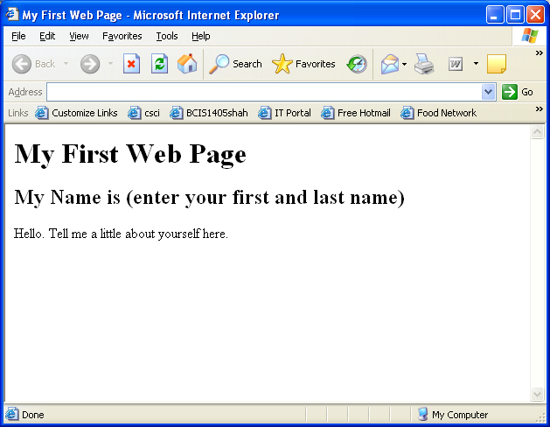

- Your instructor will inform you on how he/she would like you to turn in the assignment.

