Installation:

Steps to be followed:

1)Install Java Version 8 or 11– Jenkins is a Java based application, hence Java is a must.
2)Install Apache Tomcat Version 9-Tomact is required to deploy jenkins war file.
Extract the downloaded zip in some location.
Go to bin folder and find STARTUP BATCH file. Open and run
To ensure tomcat is working properly
-> go to chrome and type http://localhost:8080 then the tomcat dashboard will be displayed.
- Download jenkins War file-This war is required to install jenkins
Now copy this war file to the folder->(tomcat location)-webapps
- open the command prompt and run jenkins on different port.
Java -jar jenkins.war --httpPort=<some port number other than 8080>
- once jenkins is running,, open chrome and type http://localhost:<portno>
Then the jenkins page is displayed asking username and password
Username:admin(by default)
Password:(find Jenkins.war in the webapp folder of Tomcat and start Tomcat, initial admin password gets generated in the path)
- And in tomcat tab type http://localhost:8080/jenkins
(‘jenkins’ file name in webapps folder) it will ask the same credentials(username and password).
- Install Suggested Plugins – Install a list of plugins suggested by Jenkins.

Note:
to start tomcat run->startup.bat
To stop tomcat run->catalina.bat stop

Captured screens:

Tomcat dashboard:
URL:http://localhost:8080

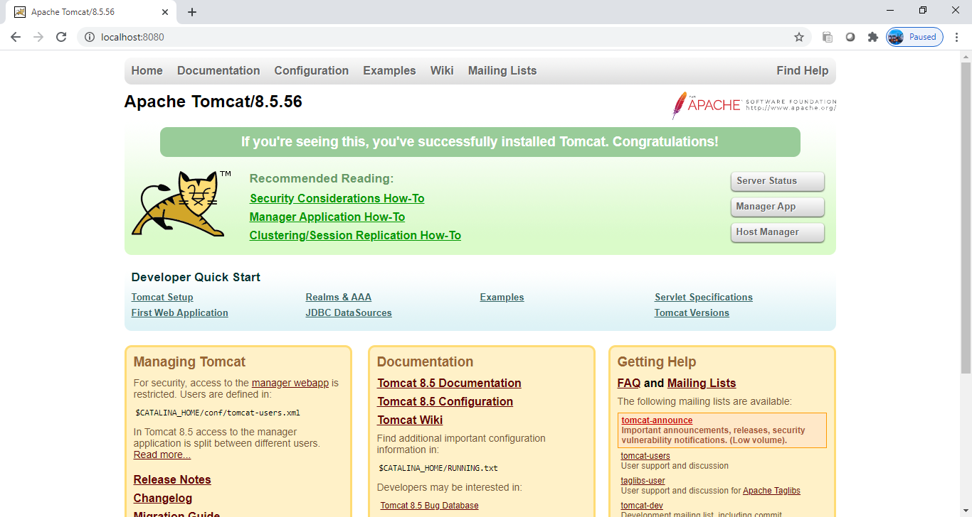

Jenkins tab:
URL:http://localhost:8080/jenkins
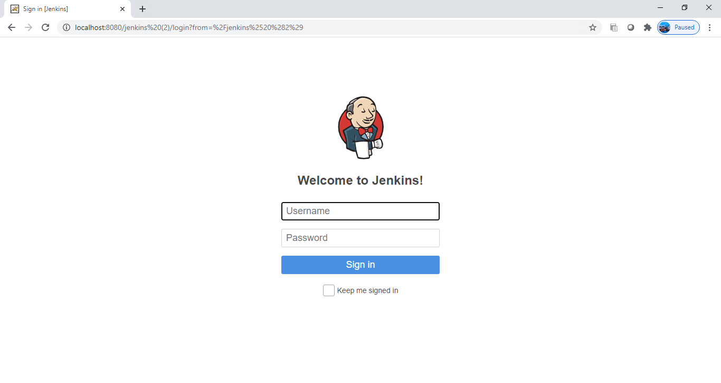

After providing credentials it asks for installing plugins.
After successful installations redirected to jenkins dashboard:

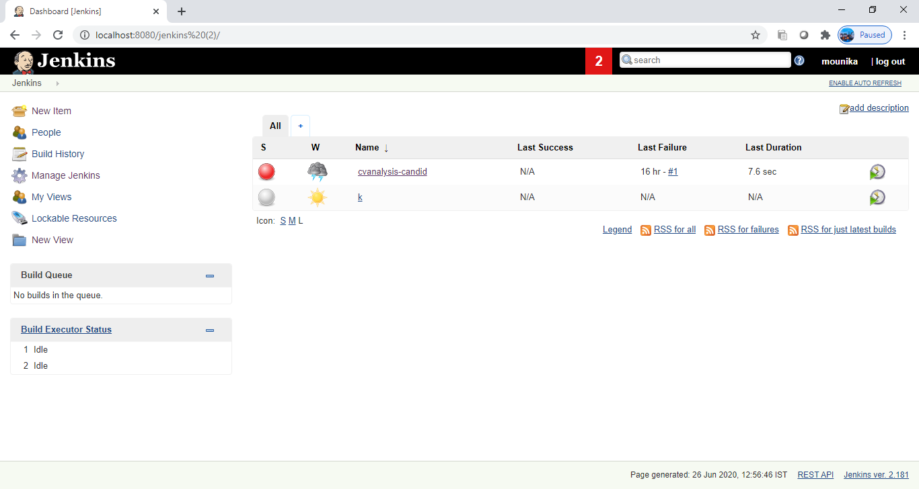

For running the local code on jenkins we need to create a project and should choose which type :
