Project Benefits — Delivered & Proven
H.264 Compressed-Domain Human Detection — Capstone Project 211
This document lists the benefits the project presentation promised, and for each one, what was actually run and measured to prove it.

Benefit 1
Saves computation and enables faster, lighter processing - the PPT's core pitch was replacing full video decoding with reading the compressed data directly.
Proof: On average, each ~10-second video (about 294 frames) needed only about 2.6 frames analysed, instead of all 294. That is roughly 100x less data processed per video - demonstrated across all 1,113 videos in the dataset.

Benefit 2
Can detect people who are standing still - the PPT's stated advantage over older methods that rely on motion to notice someone.
Proof: Tested on "Standing Still" and "Sitting" videos, where the person barely moves. The model detected them successfully (see attached example).
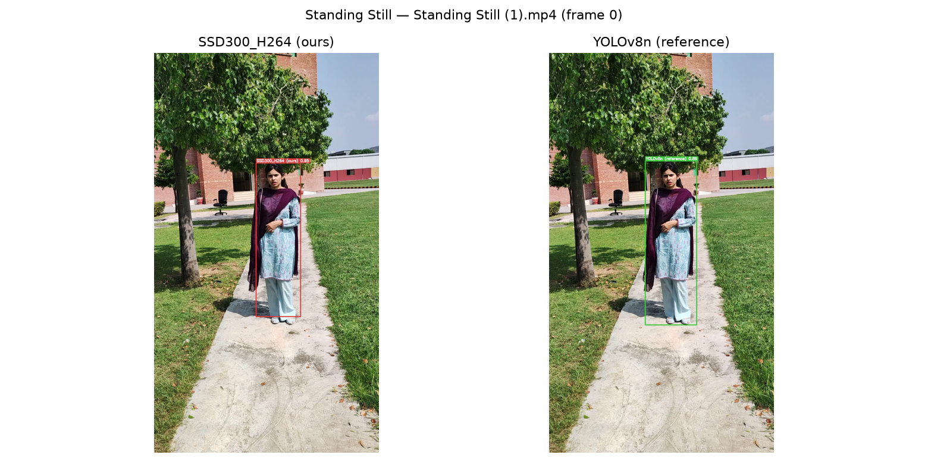

Benefit 3
Delivers a real, working detector with measurable accuracy - not just a design on paper.
Proof: Trained on 1,113 real videos. Tested on 159 video frames it had never seen before. Result: 74% precision, 64% recall. Full metrics screenshot and confusion matrix attached below.
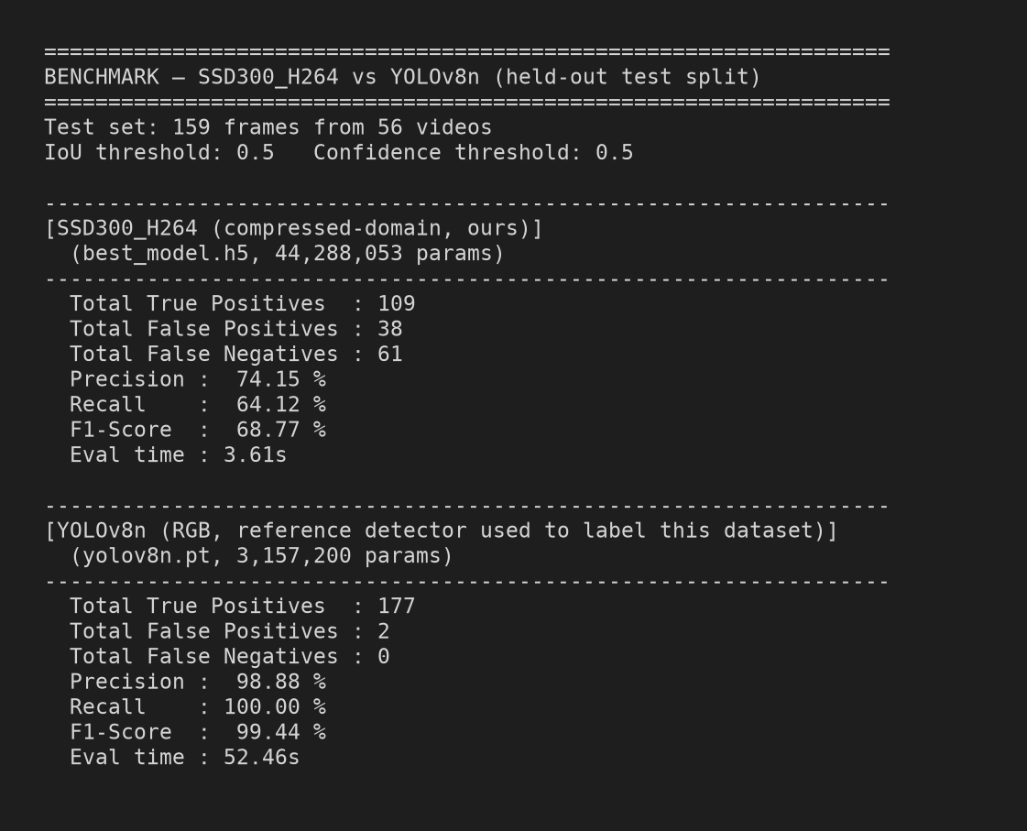

Benefit 4
Was benchmarked against a well-known, standard detection tool (YOLO), as expected for validating a new method.
Proof: Ran YOLOv8 (a standard, widely-used detector) on the exact same test videos and compared results side by side (see attached example and confusion matrix).
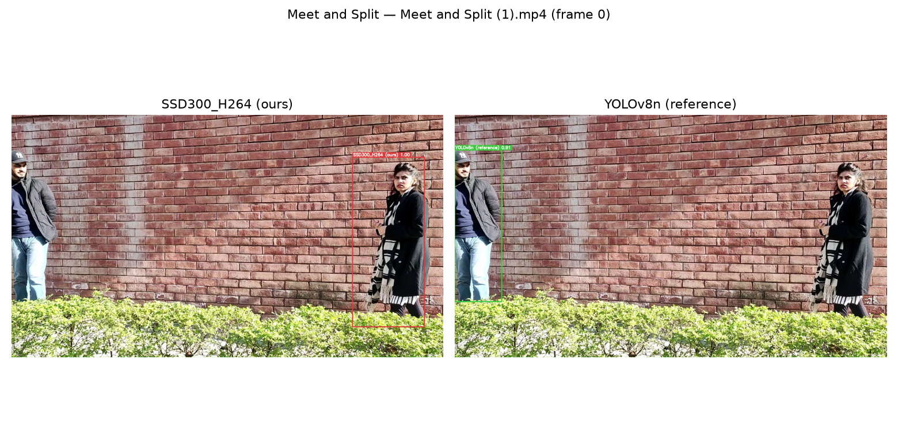

Where the evidence is
All screenshots, comparison images, the comparison video, and training logs referenced above are saved in the project's output/ folder.

