**LEARNHUB:YOUR CENTER FOR SKILL ENHANCEMENT**

**Team ID :**LTVIP2025TMID53018

**Team Leader :**M Hema Venkata Bhavani

**Team member :**Lakshmi Pavani Kommina

**Team member :**Kurma Naga Syam Laya Sri

**Team member :**Lankapalli Sampath Kumar

**Functional Requirements:**

Following are the functional requirements of the proposed solution.

**Functional Requirements – Music Streaming App**

|  |  |  |
| --- | --- | --- |
| **FR No.** | **Functional Requirement (Epic)** | **Sub Requirement (Story / Sub-Task)** |
| **FR-1** | User Authentication | Sign up, Login, Password Reset   |  | | --- | |  | |
|  |  | |  | | --- | |  |  |  | | --- | | OAuth login using Google / GitHub | |
| **FR-2** | **Appointment Booking** | Search doctors by specialty, location, and availability |
|  |  | Book, reschedule, and cancel appointments |
| **FR-3** | **Calendar & Schedule Management** | Freelancers apply to jobs |
|  |  | View upcoming and past appointments |
| **FR-4** | **Notifications & Reminders** | Automated SMS/email reminders for upcoming appointments |

**Non-functional Requirements:**

Following are the non-functional requirements of the proposed solution.

|  |  |  |
| --- | --- | --- |
| **NFR No.** | **Non-Functional Requirement** | **Description** |
| **NFR-1** | **Usability** | |  | | --- | | The platform should provide a simple, clean UI for all users, including patients and healthcare providers. | |
| **NFR-2** | **Security** | |  | | --- | | All patient and appointment data must be encrypted. Implement role-based access and secure authentication | |
| **NFR-3** | **Reliability** | |  |  | | --- | --- | | |  | | --- | | Appointment booking, notifications, and telehealth services must be available and dependable at all times. | | |
| **NFR-4** | **Performance** | Pages and booking actions should load within 2 seconds; reminders and notifications should be timely. |
| **NFR-5** | **Availability** | |  | | --- | | The system should ensure 99.9% uptime with minimal downtime. | |
| **NFR-6** | **Scalability** | |  | | --- | | Support a growing number of users, providers, and concurrent bookings without degradation. | |

**Data Flow Diagrams:**

A **Data Flow Diagram (DFD)** illustrates how data moves within the Freelance Finder platform. It captures how users (freelancers and clients) interact with the system, how information flows between different components, and where the data is stored.

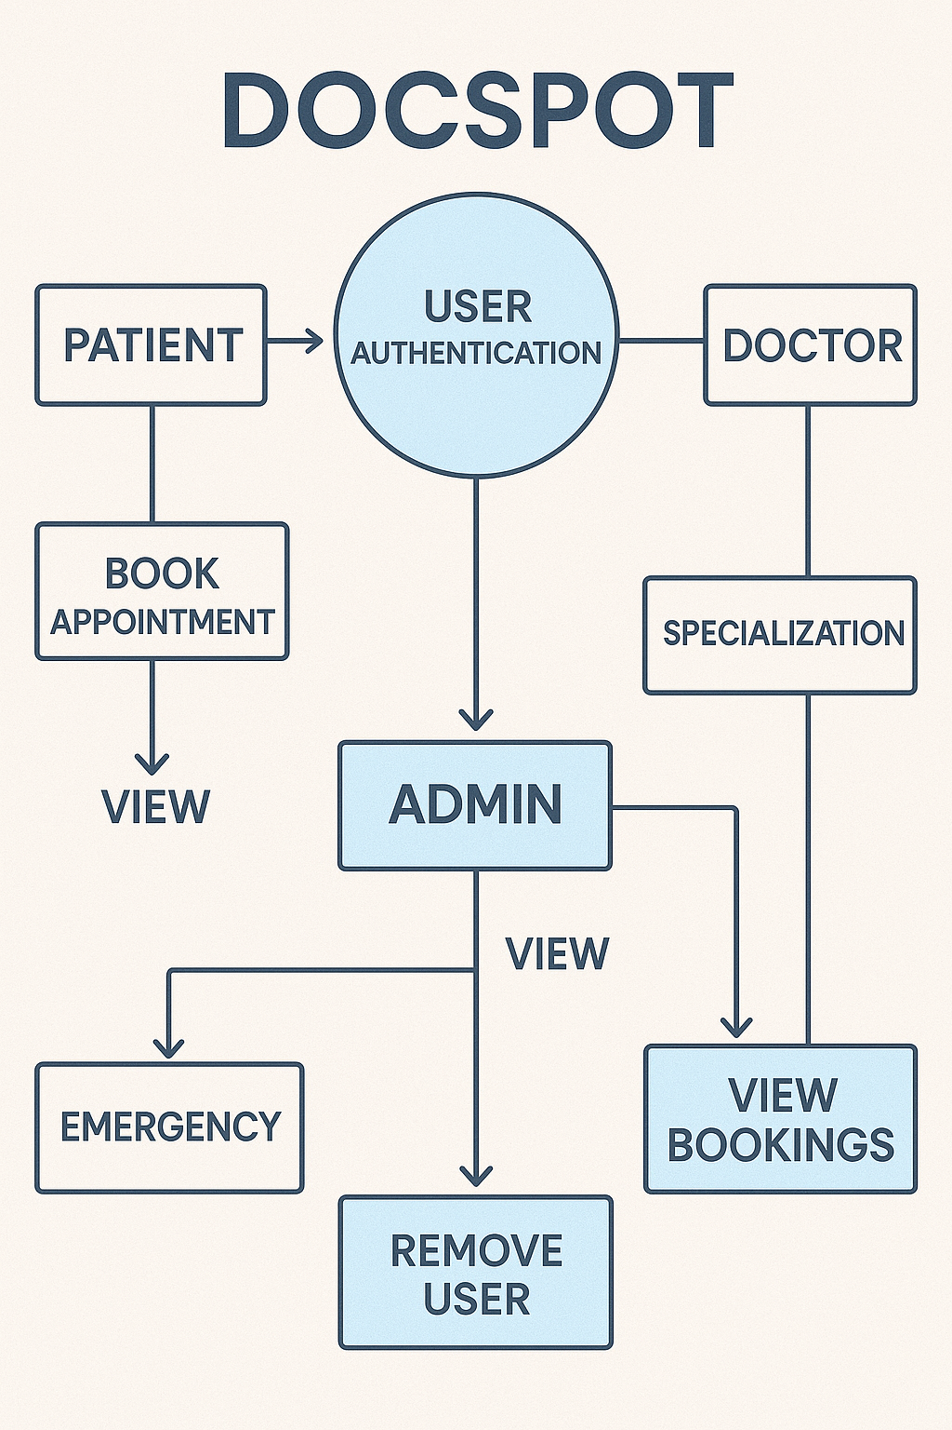

**User Stories**

**User Story Table – DocSpot**

|  |  |  |  |  |  |
| --- | --- | --- | --- | --- | --- |
| **User Type** | **Functional Requirement (Epic)** | **User Story / Task** | **Acceptance Criteria** | **Priority** | **Release** |
| |  | | --- | | **Patient** |  |  | | --- | |  | | |  | | --- | | Appointment Booking | | As a patient, I can search for doctors by specialty and location. | Search results return relevant doctors. | High | Sprint-1 |
|  |  | As a patient, I can book, reschedule, or cancel appointments. | |  | | --- | | Appointment status updates accordingly. |  |  | | --- | |  | | Medium | Sprint-2 |
| |  | | --- | | **Healthcare Provider** |  |  | | --- | |  | | |  | | --- | | Schedule Management |  |  | | --- | |  | | |  |  |  | | --- | --- | --- | | |  | | --- | | As a provider, I can manage my availability calendar. |  |  | | --- | |  | | | |  | | --- | | Changes reflect immediately in patient booking system. |  |  | | --- | |  | | High | Sprint-1 |
| **User** | Messaging | As a user, I can chat with the other party in real-time. | Messages appear instantly. | Medium | Sprint-2 |
| **Admin** | Profile Management | As a Admin, I can update my profile. | Changes are saved successfully. | High | Sprint-2 |
| **Client** | Payment Processing | As a client, I can make secure payments after job completion. | Payment recorded and shown in transaction history. | High | Sprint-2 |
| **user** | |  | | --- | |  |  |  | | --- | | Review System | | As a user, I can leave a review after project closure. | Review appears on profile. | Medium | Sprint-2 |
| **Admin** | User Moderation | As an admin, I can review reported users and take action. | Reports and actions logged. | High | Sprint-1 |

**Technical Architecture:**

**DocSpot** is designed with a scalable 3-tier architecture consisting of:

**1.Presentation Layer (Frontend):** User-friendly interface for patients and healthcare providers to book and manage appointments.

2.**Business Logic Layer (Backend):** Handles appointment scheduling, notifications, user management, and telehealth integration.  
  
3.**Data Storage Layer:** Secure storage of user profiles, appointment records, and healthcare provider details.  
  
The platform integrates with third-party APIs for notifications (SMS/email) and telehealth services to enhance usability.

**Table-1 : Components & Technologies:**

| **S.No** | **Component** | **Description** | **Technology** |
| --- | --- | --- | --- |
|  | User Interface | Web and mobile-friendly interface for patients and providers | HTML, CSS, JavaScript  / React Js etc. |
|  | Application Logic-1 | Appointment booking, calendar management, reminders | Node.js, Express.js |
|  | Application Logic-2 | |  | | --- | | Admin panel, provider management, reporting | | React js, Node js |
|  | Database | Stores user profiles, appointments, provider datas | MongoDB |

**Table-2: Application Characteristics:**

| **S.No** | **Characteristics** | **Description** | **Technology** |
| --- | --- | --- | --- |
|  | Open-Source Frameworks | Frontend frameworks | React.js, Node.js, BootStrap, Tailwind CSS |
|  | Scalable Architecture | 3-tier architecture with RESTful APIs | Microservices |

**Brainstorm & Idea Prioritization Template:**Brainstorming provides a free and open environment that encourages everyone within a team to participate in the creative thinking process that leads to problem solving. Prioritizing volume over value, out-of-the-box ideas are welcome and built upon, and all participants are encouraged to collaborate, helping each other develop a rich amount of creative solutions.

Use this template in your own brainstorming sessions so your team can unleash their imagination and start shaping concepts even if you're not sitting in the same room.

Reference: <https://www.mural.co/templates/brainstorm-and-idea-prioritization>

**Step-1: Team Gathering, Collaboration and Select the Problem Statement**

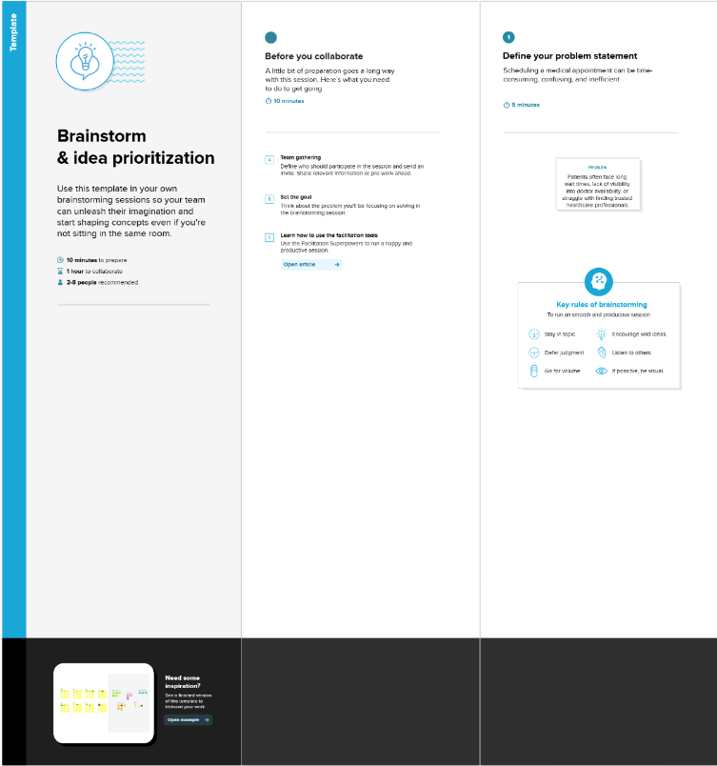

**Step-2: Brainstorm, Idea Listing and Grouping**

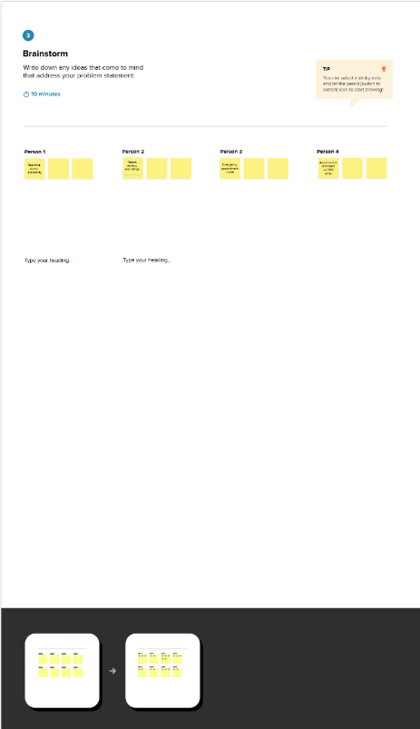

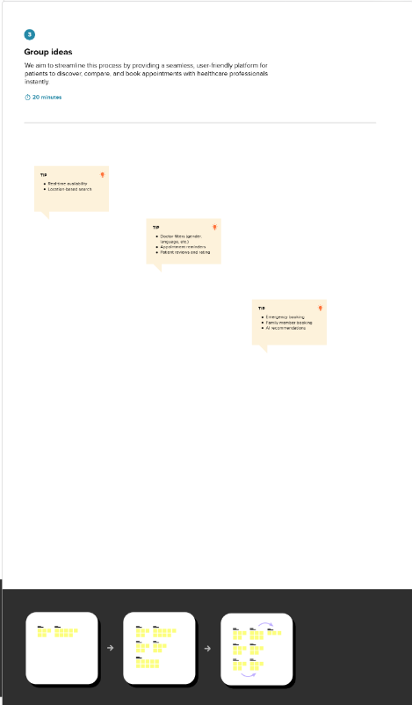

**Step-3: Idea Prioritization**

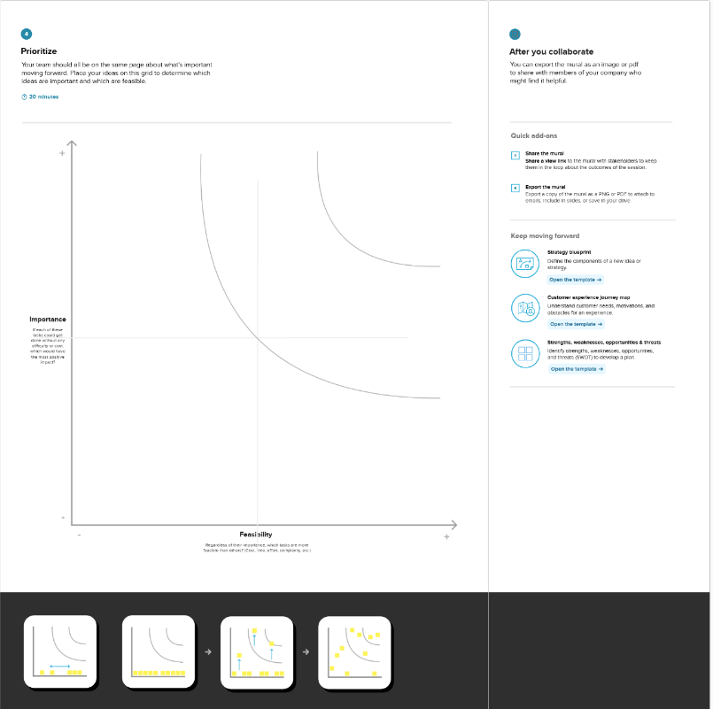

**Customer Problem Statement Template:**

 To define the core problems freelancers face while searching for jobs online, and use those insights to guide the development of Freelance Finder.

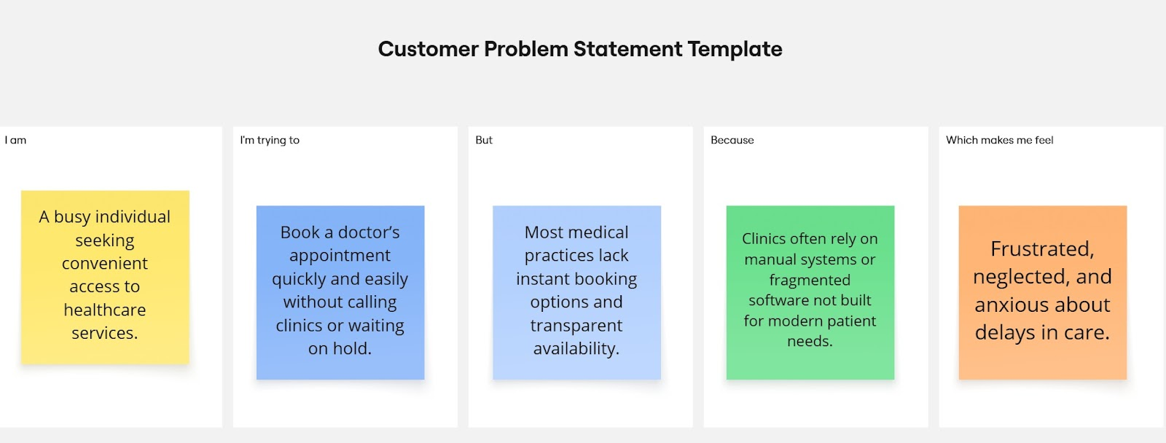

Reference: <https://miro.com/templates/customer-problem-statement/>

|  |  |  |  |  |  |
| --- | --- | --- | --- | --- | --- |
| **Problem Statement (PS)** | **I am (Customer)** | **I’m trying to** | **But** | **Because** | **Which makes me feel** |
| PS-1 | a working professional with a tight schedule | book a doctor’s appointment quickly without phone calls or long wait times. | most clinics don’t have real-time booking systems or clear availability info | their systems are outdated or fragmented | frustrated and anxious about my health getting worse while waiting. |
| PS-2 | a general physician running a small clinic. | manage patient bookings efficiently and reduce no-shows. | my current tools are manual or not tailored to healthcare workflows. | I can’t afford or understand complex clinic management systems. | stressed and underpaid despite my busy schedule. |

**Empathy Map Canvas:**

An empathy map is a simple, easy-to-digest visual that captures knowledge about a user’s behaviours and attitudes.

It is a useful tool to helps teams better understand their users.

Creating an effective solution requires understanding the true problem and the person who is experiencing it. The exercise of creating the map helps participants consider things from the user’s perspective along with his or her goals and challenges.

**Example:**

Reference: <https://www.mural.co/templates/empathy-map-canvas>

**Example: LearnHub**

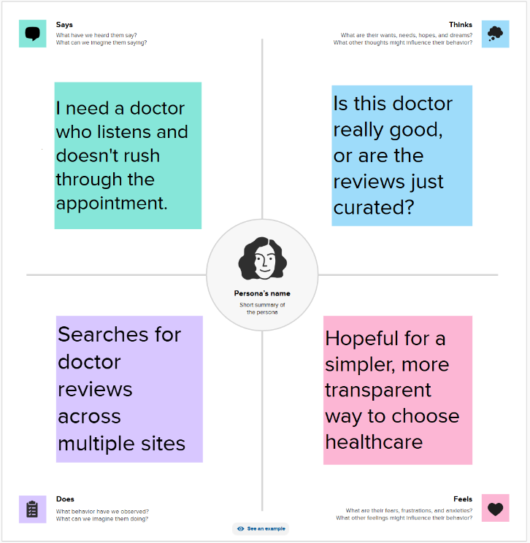

**Project Overview:**

Project Name: DocSpot

Project Description:A user-friendly platform that allows patients to book, reschedule, and manage medical appointments with healthcare professionals. Features include doctor search, real-time availability, appointment booking, video consultation, digital prescriptions, and calendar integration.

Project Version:v1.0.0

Testing Period:  2025-05-26 to 2025-06-02

**Testing Scope:**

* Patient registration and login
* Doctor profile creation and calendar setup
* Search and filter for doctors
* Real-time appointment bookin
* Reschedule and cancel appointments
* Video consultation module
* Digital prescriptions
* Appointment reminders (SMS/email)
* Payment integration
* Review and rating system

**Requirements to be Tested:**

* As a patient, I want to easily search and book appointments with available doctors.
* As a doctor, I want to manage my availability and bookings.
* As a user, I want secure login, video consultations, and payments.
* As an admin, I want to manage users and handle disputes or feedback.

**Testing Environment:**

**Testing Environment**

**URL:** https://docspot.example.com

**Credentials:**

* **Patient:** test.patient@example.com / patient123
* **Doctor:** test.doctor@example.com / doctor123
* **Admin:** admin@docspot.com / adminpass

**Test Cases:**

|  |  |  |  |  |  |
| --- | --- | --- | --- | --- | --- |
| **Test Case ID** | **Test Scenario** | **Test Steps** | **Expected Result** | **Actual Result** | **Pass/Fail** |
| TC-001 | User Registration | 1. Visit site  2. Click "Sign Up"  3. Fill & submit form | Profile saved | Account created, redirected to dashboard | [Pass/Fail] |
| TC-002 | Doctor Profile Creation | 1. Login as doctor  2. Fill bio & availability  3. Save | Profile saved, listed in search results | Account created, redirected to dashboard | [Pass/Fail] |
| TC-003 | Book Appointment | 1. Search doctor  2. Select time  3. Confirm booking | Booking confirmed and shown in user dashboard | Appointmeet will br booked | [Pass/Fail] |

**Bug Tracking:**

|  |  |  |  |  |  |
| --- | --- | --- | --- | --- | --- |
| **Bug ID** | **Bug Description** | **Steps to reproduce** | **Severity** | **Status** | **Additional feedback** |
| BG-001 | |  | | --- | |  |  |  | | --- | | Filter not working properly | | 1. Search with location + specialty | Medium | Open | Only partial results shown |
| ... | ... | ... | ... | ... | ... |

**Sign-off:**

Tester Name: Sidhartha

Date: 26-05-2025

Signature:Sidhartha

**Notes:**

Test across **multiple devices and browsers**.

Cover **positive and negative** cases (e.g., invalid input, empty search, etc.).  
  
Track all bugs with reproduction steps and severity.  
  
Sign-off is required from the **project manager** and **product owner** before release.

**Problem – Solution Fit Overview:**

The Problem–Solution Fit ensures that DocSpot effectively tackles the challenges in appointment booking faced by both patients and healthcare providers. This validation is essential before expanding the platform.

**Purpose:**

* Simplify and streamline the appointment booking process.
* Provide a centralized platform for schedule management to avoid conflicts and delays.
* Enhance patient access to timely healthcare services through smart search and booking.
* Improve communication via reminders to reduce no-shows and cancellations.

**Problem Statement:**

**Patients and healthcare providers face challenges such as:**

Complex and time-consuming appointment booking.

Lack of centralized scheduling causing overlaps and missed appointments.  
Poor communication and reminder systems leading to high no-show rates.  
 Difficulty in quickly finding available doctors or specialists.

Managing appointments across multiple platforms or clinics is inconvenient.  
  
**Solution:**

**DocSpot offers a seamless appointment booking platform with:**

Easy search and booking using filters like specialty, location, and availability.  
Real-time calendar management for providers to optimize schedules.  
Automated reminders and notifications to reduce no-shows.  
Secure patient profiles with appointment history and preferences.  
Telehealth integration for virtual consultations.  
Admin controls for managing providers, appointments, and report**ing.**

**Solution Architecture:**

To provide a user-friendly, secure, and scalable healthcare appointment booking system that bridges the gap between patients and healthcare providers.

* Effortless Appointment Booking
* End-to-End Patient Management
* Scalable user authentication and authorization
* Secure and trackable payment transactions
* Reliable real-time chat and notifications

**Example - Solution Architecture Diagram:**

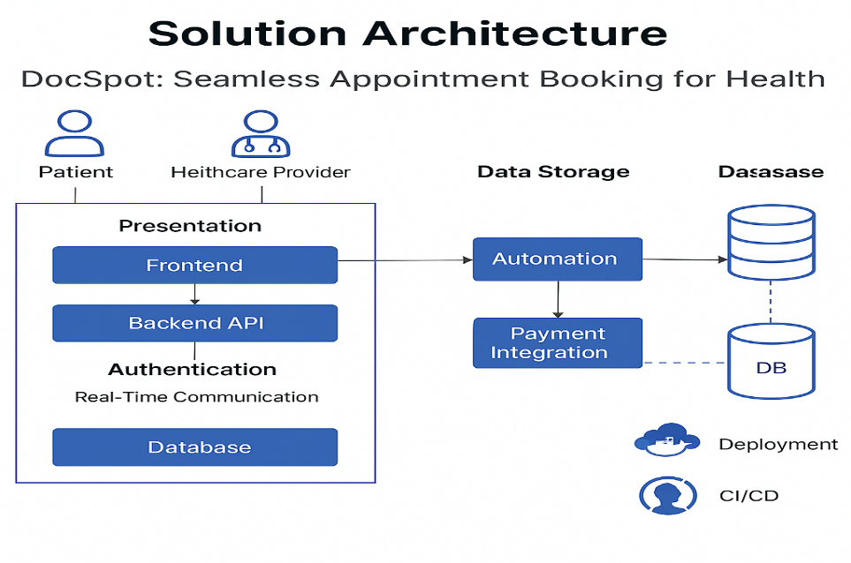

**Proposed Solution for DocSpot App**

|  |  |  |
| --- | --- | --- |
| **S. No.** | **Parameter** | **Description** |
| **1** | **Problem Statement** (Problem to be solved) | Patients often face long wait times, inconvenient appointment scheduling, and poor communication with healthcare providers. On the provider side, managing slots, follow-ups, and patient data remains inefficient. |
| **2** | **Idea / Solution Description** | DocSpot is a full-stack healthcare appointment booking platform that connects patients with healthcare providers. It features real-time availability, secure appointment scheduling, digital payments, and reminders. Admin tools help manage users and service quality. |
| **3** | **Novelty / Uniqueness** | - Real-time appointment availability  - Role-based access for patients/doctors/admins  - Secure payment integration  - SMS/email reminders  - Option for teleconsultation (video call integration) |
| **4** | **Social Impact / Customer Satisfaction** | - Reduces patient wait times and no-shows  - Empowers rural or remote access to care via telehealth  - Enhances patient-provider communication  - Digitally transforms outdated booking systems |
| **5** | **Business Model (Revenue Model)** | -Freemium model for clinics with basic features  - Subscription for advanced features (analytics, teleconsultation, branded portal)  - Transaction fee on payments (optional)  - White-label B2B partnerships with hospitals |
| **6** | **Scalability of the Solution** | Designed for clinics, hospitals, and telehealth startups  - Global-ready with multi-language, multi-timezone, and multi-currency support  - Mobile-first UX with future React Native or Flutter app  - Modular microservices-based backend for flexibility |

**Product Backlog, Sprint Schedule, and Estimation (4 Marks)**

**Product Backlog & Sprint Schedule**

|  |  |  |  |  |  |  |
| --- | --- | --- | --- | --- | --- | --- |
| **Sprint** | **Functional Requirement (Epic)** | **User Story Number** | **User Story / Task** | **Story Points** | **Priority** | **Team Members** |
| **Sprint-1** | |  | | --- | | **User Authentication** | | USN-1 | As a user, I can sign up and log in securely. | 3 | High |  |
|  |  | USN-2 | |  | | --- | | As a user, I can reset my password. | | 2 | Medium |  |
| **Sprint-2** | **Doctor Discovery & Booking** | USN-3 | As a patient, I can search and filter doctors by location/speciality. | 2 | High |  |
| **Sprint-3** | **Profile Management** | USN-4 | As a doctor, I can set up and update my profile and availability. | 3 | High |  |
|  |  | USN-5 | As a user, I can update my profile information. | 2 | High |  |
|  |  | USN-6 | As a user, I can send/receive messages. | 2 | Medium |  |
| **Sprint-4** | **Payment Integration & Reviews** | USN-7 | As a client, I can pay freelancers securely. | 3 | High |  |
|  |  | USN-8 | |  | | --- | |  |  |  | | --- | | As a user, I can leave a review after project completion. | | 2 | Medium |  |
|  |  | USN-9 | As a user, I can change my password. | 2 | Medium |  |
|  |  |  |  |  |  |  |