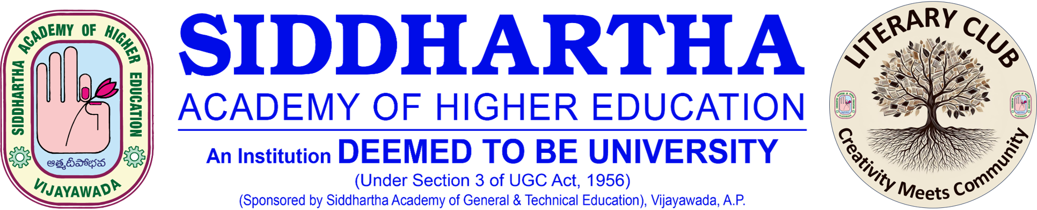

poetry slam
Date: 11 April 2026

