1. Title
AI-Powered Code Reviewer and Quality Assistant

2. Project Statement
Modern codebases suffer from inconsistent quality due to time-intensive manual reviews, variable reviewer expertise, and lack of automated validation—leading to technical debt and delayed development cycles. This AI-assisted code review tool addresses these challenges by automatically analyzing Python code for documentation quality, style compliance, and structural patterns using AST parsing, LLMs, and intelligent analysis.
The tool parses Python files to identify missing or incomplete docstrings and generates high-quality documentation in multiple standard formats (Google, NumPy, reStructuredText). Developers interact through a Streamlit dashboard or CLI with Accept/Reject controls for manual oversight. By providing real-time coverage tracking, PEP 257 validation, and complexity analysis, it reduces documentation time by 80% while ensuring consistent standards across teams—serving as a foundation for comprehensive code review capabilities.

3. Outcomes
Primary Deliverables
- Interactive Web Dashboard: Professional Streamlit-based UI with dark theme, real-time metrics visualization, and intuitive navigation for enhanced developer experience
- AI-Powered Documentation Generation: Context-aware docstring generation using Large Language Models with support for Google, NumPy, and reStructuredText formats
- Human-in-the-Loop Workflow: Accept/Reject mechanism allowing developers to review AI-generated docstrings before applying changes to source code
- Comprehensive Analysis Engine: AST-based parser extracting code structure, complexity metrics, and documentation coverage with ≥95% accuracy
Key Features
- Automated Code Scanning: Recursively analyzes Python projects to identify functions, methods, and classes requiring documentation
- Multi-Style Support: Generates docstrings conforming to PEP 257 standards in three popular documentation styles
- Real-time Coverage Tracking: Monitors documentation coverage percentage with target of ≥90% on sample repositories
- PEP 257 Validation: Integrated pydocstyle checks for enhanced documentation quality validation with clear error reporting
- Advanced Filtering & Search: Smart filtering system by documentation status (All, Documented, Missing) with case-insensitive search across entire codebase
- Test Integration: Built-in pytest runner with live output display, test results grouping by file, and visual pass/fail charts
- Export Capabilities: Comprehensive JSON and CSV export functionality for documentation reports, enabling CI/CD integration and external analysis
- Safe Code Updates: Accepted docstrings inserted directly into source files while preserving indentation and code structure
Quality Metrics
- Generated docstrings conform to PEP 257 standards for consistency
- Documentation coverage ≥90% on sample repositories
- Validation errors clearly reported for quick resolution
- Complexity analysis with cyclomatic complexity calculation for all functions
- Automated reporting with actionable insights for development teams

4. Modules Implemented
1. Code Parsing & Analysis
Purpose: Extract and analyze Python code structure using Abstract Syntax Trees
Components:
- AST-based parser for Python files (core/parser/python_parser.py)
- Extract structure: imports, classes, functions, methods, and decorators
- Identify code elements: function signatures, parameters, return types, and complexity
- Detect documentation gaps: missing or incomplete docstrings
- Calculate cyclomatic complexity metrics using radon library
- Recursive project scanning with file system traversal

2. AI Review Engine
Purpose: Generate intelligent, context-aware docstrings using Large Language Models
Components:
- LLM integration via Groq API (core/docstring_engine/generator.py)
- Prompt engineering for context-aware documentation generation
- Style-specific generation templates (Google, NumPy, reST)
- Function signature analysis and parameter extraction
- Class documentation with attributes and usage patterns
- Structured output formatting with proper sections (Args, Returns, Raises, Examples)

3. Validation & Metrics
Purpose: Ensure documentation quality and provide comprehensive reporting
Components:
- PEP 257 validation using pydocstyle (core/validator/validator.py)
- Documentation coverage calculation (core/reporter/coverage_reporter.py)
- Complexity metrics and maintainability index
- Violation detection and categorization by severity
- Coverage reports with file-level and project-level statistics
- Export functionality (JSON, CSV) for CI/CD integration

4. CLI & Configuration
Purpose: Provide command-line interface for automated workflows
Components:
- Command structure: scan, review, validate, report (cli/commands.py)
- Configuration support via environment variables
- Batch processing for large codebases
- Report generation and storage in storage/reports/
- Review log tracking in storage/review_logs.json

5. Review Web UI
Purpose: Interactive dashboard for visualizing and managing documentation
Components:
- Streamlit-based web interface (dashboard.py, main_app.py)
- Dark theme with modern UI design
- Side-by-side docstring comparison view
- Real-time metrics visualization with metric cards
- Advanced filtering by documentation status
- Search functionality across codebase
- Accept/Reject workflow controls
- Test integration with pytest runner
- Export capabilities for reports
- Interactive help documentation with style references

5. Week-wise Module Implementation & High-Level Requirements
Milestone 1 (Weeks 1–2) – Parsing & Baseline Generation
Objective: Establish foundational code analysis and basic docstring generation capabilities
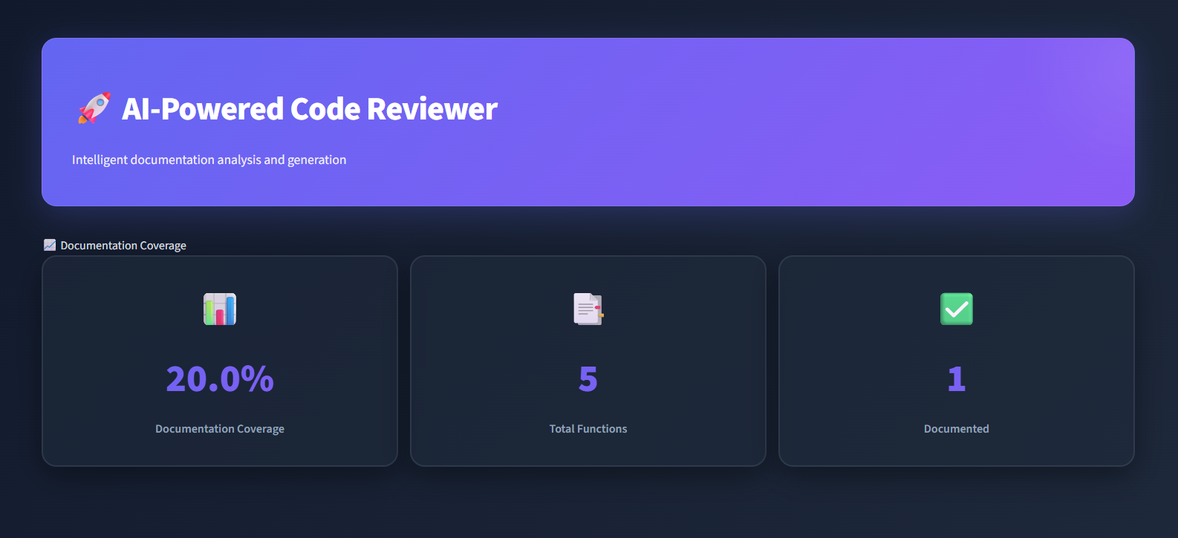
Implementation Tasks:
- Implement AST-based extractor for functions, classes, and modules
- Build recursive file scanner for Python projects
- Extract code structure: function signatures, parameters, classes
- Generate baseline docstrings in Google style format
- Calculate initial documentation coverage metrics
- Produce docstring coverage report with file-level statistics

Milestone 2 (Weeks 3–4) – Synthesis & Validation
Objective: Enhance documentation generation and add quality validation
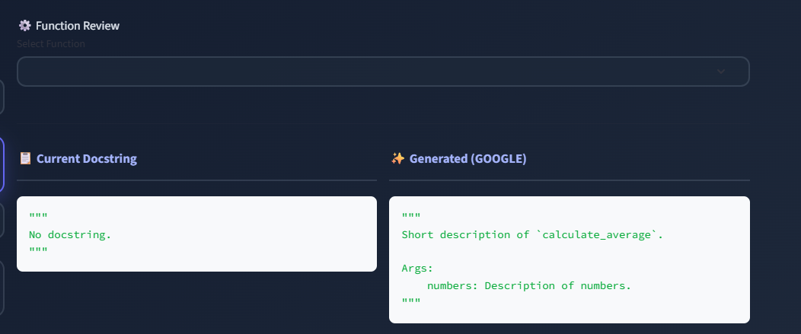
Implementation Tasks:
- Add support for NumPy and reStructuredText (reST) docstring styles
- Extend docstring sections to include Parameters, Returns, Raises, and Attributes
- Improve generation with comprehensive section coverage (Yields, Examples, Notes)
- Integrate pydocstyle for PEP 257 compliance checking
- Implement style-specific validation rules
- Generate enhanced coverage reports with violation tracking
- Add docstring comparison functionality

Milestone 3 (Weeks 5–6) – LLM Integration & Human-in-the-Loop Workflow
Objective: Integrate AI-powered generation with developer control mechanisms
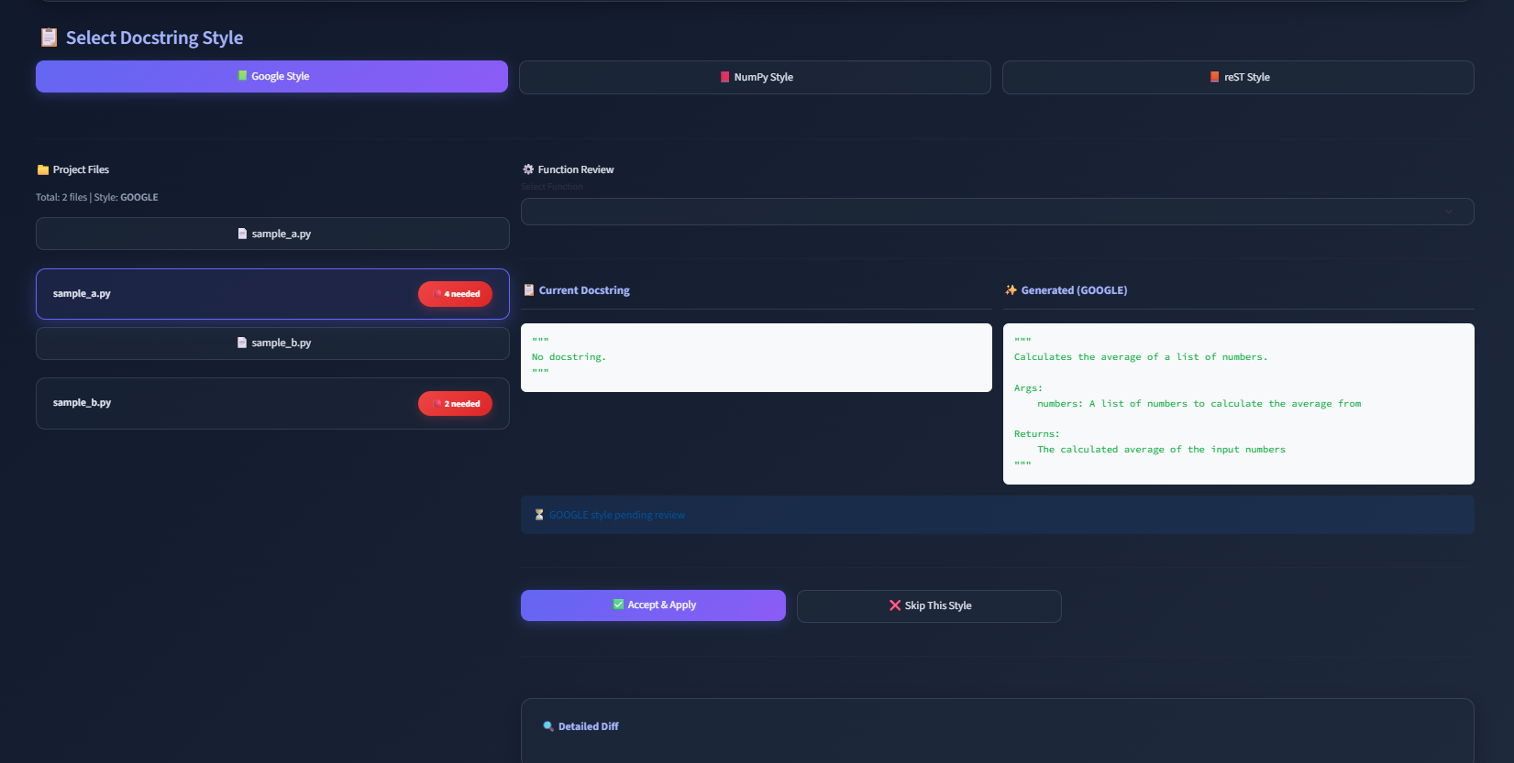
Implementation Tasks:
- Integrate Groq LLM API for intelligent docstring generation
- Implement context-aware prompts using function signatures and code structure
- Generate docstrings in multiple styles (Google, NumPy, reST) during analysis
- Build Accept/Reject workflow for developer review
- Implement safe file modification with indentation preservation
- Add review logging and tracking system
- Create Streamlit prototype for interactive review

Milestone 4 (Weeks 7–8) – Professional Dashboard & Advanced Features
Objective: Build production-ready interface with comprehensive features
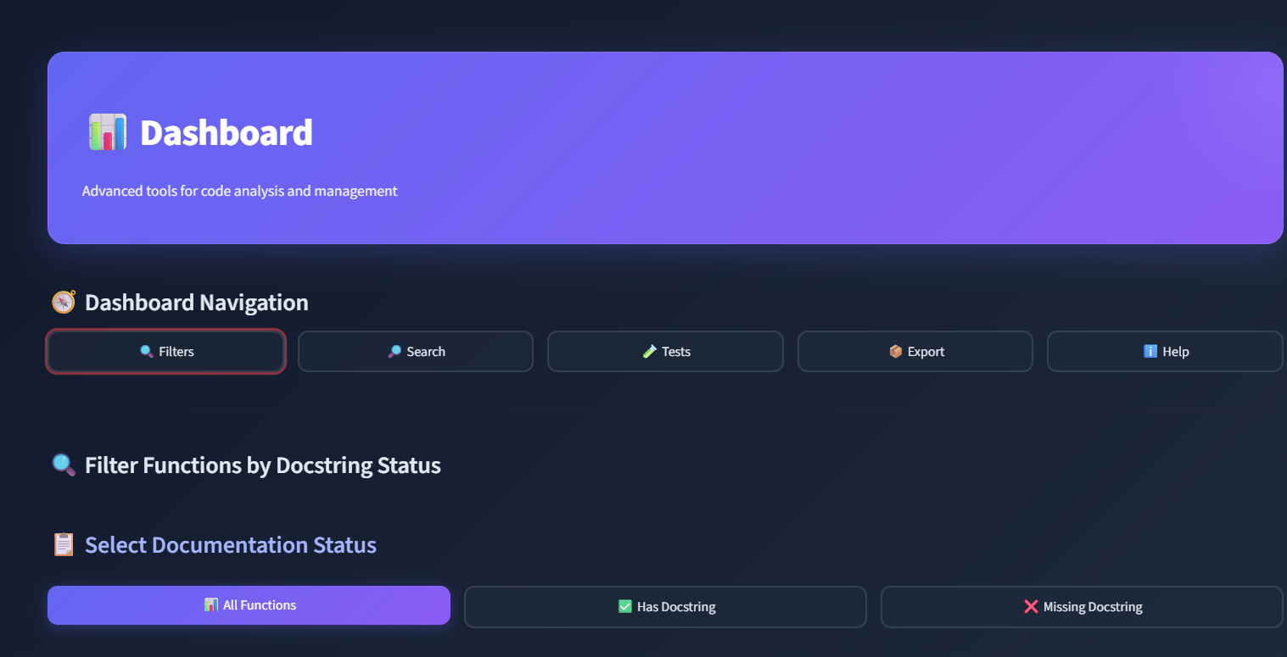
Implementation Tasks:
- Develop professional Streamlit-based dashboard with dark theme
- Add real-time metrics visualization (coverage, complexity, validation status)
- Build advanced filtering system (All, Documented, Missing)
- Implement case-insensitive search across entire codebase
- Integrate pytest runner with live output display
- Add test results grouping by file with visual charts
- Implement JSON and CSV export functionality
- Create comprehensive help documentation within dashboard

6.WorkFlow Diagram
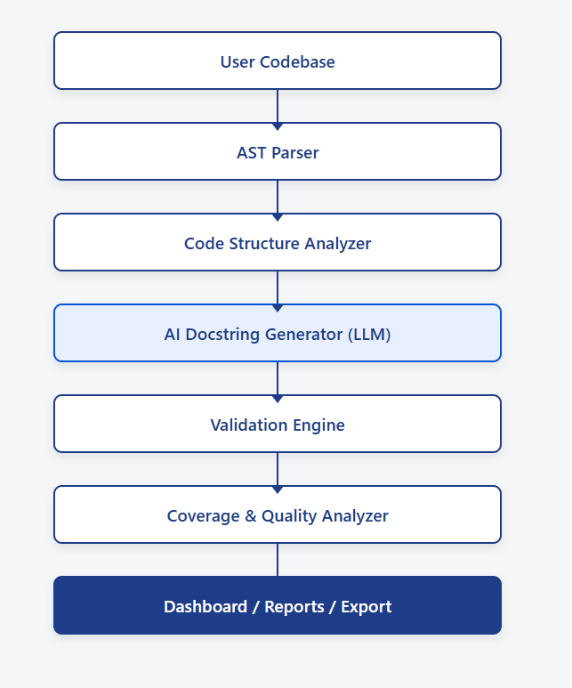

7.Architecture Diagram
