**Star Schema Implementation**

**-- Dimension Tables**

CREATE TABLE audience( audience_id INT PRIMARY KEY, age INT, gender VARCHAR(10), preferred_genre VARCHAR(10));

CREATE TABLE genre( genre_id INT PRIMARY KEY, sub_genre VARCHAR(10), genre_name VARCHAR(10), marketshare_percentage INT);

CREATE TABLE region( region_id INT PRIMARY KEY, country VARCHAR(10), language VARCHAR(10), market_size INT);

CREATE TABLE time( time_id INT PRIMARY KEY, month VARCHAR(10), quarter INT, year INT);

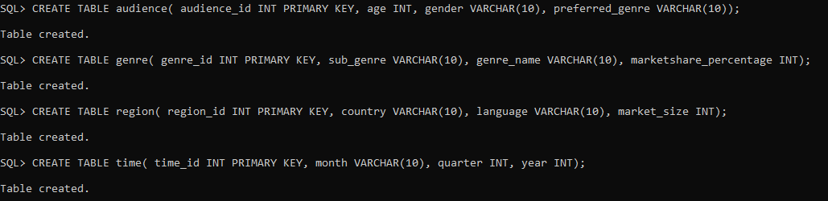

**-- Fact Table:**

CREATE TABLE movie_performance ( movie_id INT PRIMARY KEY, audience_id INT, genre_id INT, region_id INT, time_id INT, revenue INT, rating INT, FOREIGN KEY (audience_id) REFERENCES audience(audience_id), FOREIGN KEY (genre_id) REFERENCES genre(genre_id), FOREIGN KEY (region_id) REFERENCES region(region_id), FOREIGN KEY (time_id) REFERENCES time(time_id));



**Insertion:**

INSERT INTO audience (audience_id, age, gender, preferred_genre) VALUES (1, 21, 'Male', 'mystery');

INSERT INTO audience (audience_id, age, gender, preferred_genre) VALUES (2, 25, 'Male', 'action');

INSERT INTO audience (audience_id, age, gender, preferred_genre) VALUES (3, 19, 'Female', 'thriller');

INSERT INTO audience (audience_id, age, gender, preferred_genre) VALUES (4, 20, 'Female', 'horror');

INSERT INTO audience (audience_id, age, gender, preferred_genre) VALUES (5, 30, 'Female', 'drama');

INSERT INTO audience (audience_id, age, gender, preferred_genre) VALUES (6, 35, 'Male', 'action');

INSERT INTO audience (audience_id, age, gender, preferred_genre) VALUES (7, 21, 'Female', 'fantasy');

INSERT INTO audience (audience_id, age, gender, preferred_genre) VALUES (8, 16, 'Male', 'thriller');

INSERT INTO audience (audience_id, age, gender, preferred_genre) VALUES (9, 24, 'Male', 'horror');

INSERT INTO audience (audience_id, age, gender, preferred_genre) VALUES (10, 28, 'Female', 'romance');

**TABLES:**

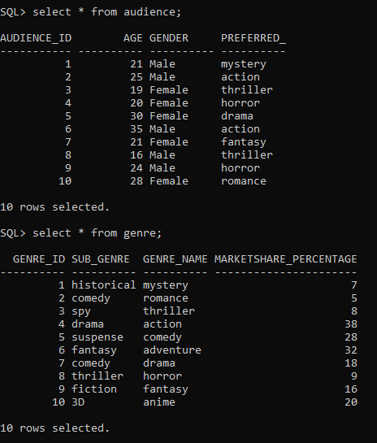

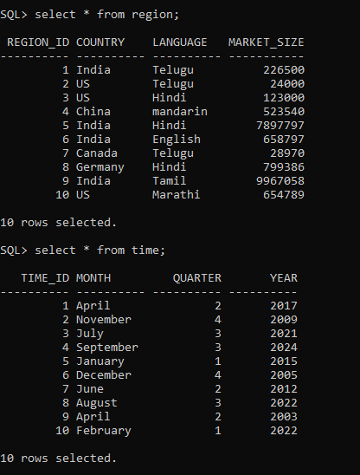

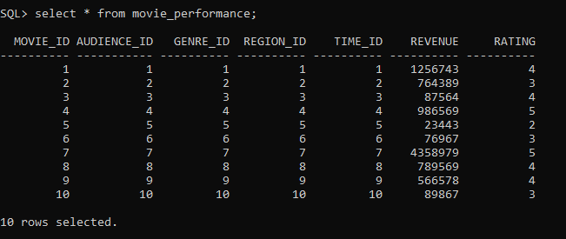

**OLAP Queries Using SQL**

Here are some practical SQL queries to analyse multidimensional data:

1. **Aggregate Revenue by Genre**

SELECT g.GENRE_NAME, SUM(mp.REVENUE) AS Total_Revenue FROM movie_performance mp JOIN genre g ON mp.GENRE_ID = g.GENRE_ID GROUP BY g.GENRE_NAME;

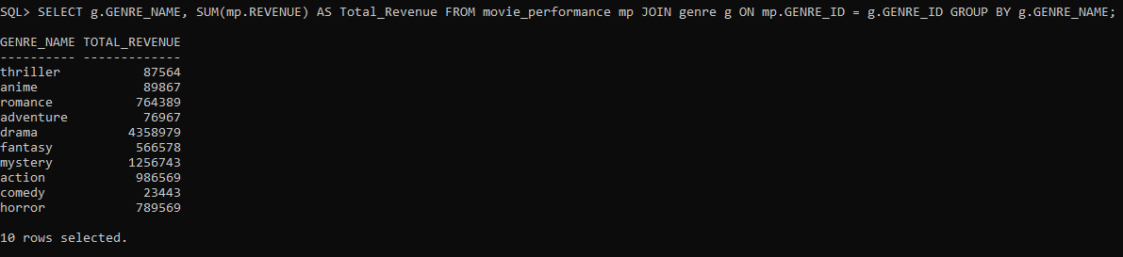

1. **Top 2 movies by Revenue in a Specific Year**

SELECT mp.MOVIE_ID, g.GENRE_NAME, r.COUNTRY, t.YEAR, mp.REVENUE FROM movie_performance mp JOIN genre g ON mp.GENRE_ID = g.GENRE_ID JOIN region r ON mp.REGION_ID = r.REGION_ID JOIN time t ON mp.TIME_ID = t.TIME_ID WHERE t.year = 2022 ORDER BY mp.REVENUE DESC;

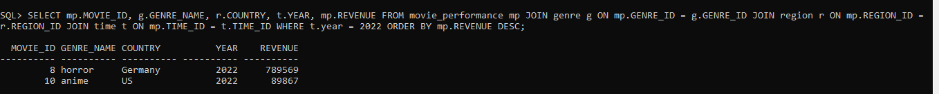

1. **Count of Movies by Language**

SELECT r.LANGUAGE, COUNT(mp.MOVIE_ID) AS Movie_Count FROM movie_performance mp JOIN region r ON mp.REGION_ID = r.REGION_ID GROUP BY r.LANGUAGE;

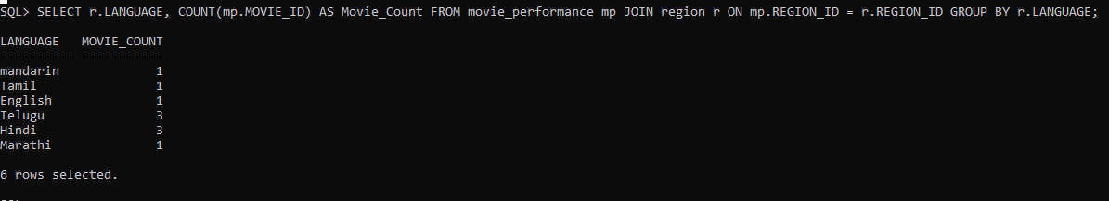

1. **Movies with Above Average Revenue**

SELECT mp.MOVIE_ID, g.GENRE_NAME, r.COUNTRY, mp.REVENUE FROM movie_performance mp JOIN genre g ON mp.GENRE_ID = g.GENRE_ID JOIN region r ON mp.REGION_ID = r.REGION_ID WHERE mp.REVENUE > (SELECT AVG(REVENUE) FROM movie_performance);

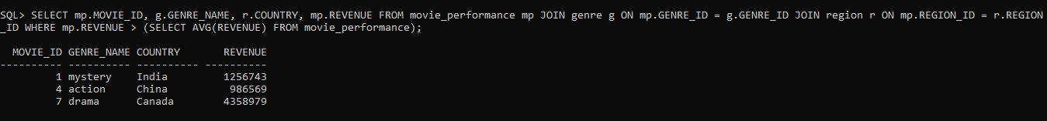

1. **Total Revenue by Country**

SELECT r.COUNTRY, SUM(mp.REVENUE) AS Total_Revenue FROM movie_performance mp JOIN region r ON mp.REGION_ID = r.REGION_ID GROUP BY r.COUNTRY;

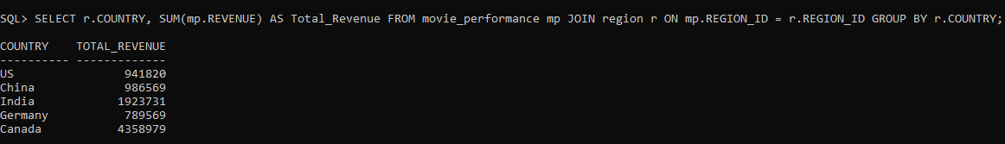

**Using ROLLUP (Hierarchical Aggregation)**

SELECT t.YEAR, t.MONTH, SUM(mp.REVENUE) AS Total_Revenue FROM movie_performance mp JOIN time t ON mp.TIME_ID = t.TIME_ID GROUP BY ROLLUP(t.YEAR, t.MONTH) ORDER BY t.YEAR, t.MONTH;

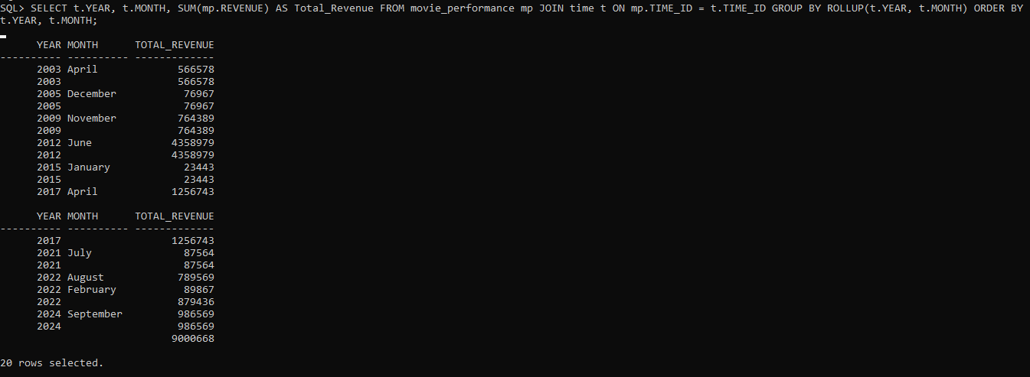

**Using CUBE (Multidimensional Aggregation)**

SELECT r.COUNTRY, g.GENRE_NAME, SUM(mp.REVENUE) AS Total_Revenue FROM movie_performance mp JOIN region r ON mp.REGION_ID = r.REGION_ID JOIN genre g ON mp.GENRE_ID = g.GENRE_ID GROUP BY CUBE(r.COUNTRY, g.GENRE_NAME) ORDER BY r.COUNTRY, g.GENRE_NAME;

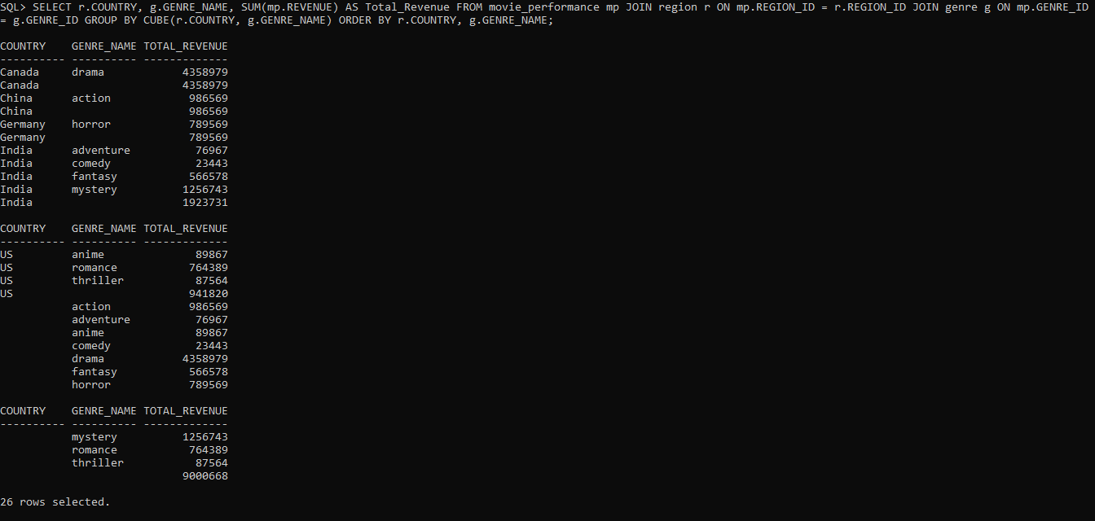

**Using GROUPING SETS (Custom Aggregation)**

SELECT g.GENRE_NAME, r.COUNTRY, SUM(mp.REVENUE) AS Total_Revenue FROM movie_performance mp JOIN genre g ON mp.GENRE_ID = g.GENRE_ID JOIN region r ON mp.REGION_ID = r.REGION_ID GROUP BY GROUPING SETS ((g.GENRE_NAME, r.COUNTRY), (g.GENRE_NAME), (r.COUNTRY), ()) ORDER BY g.GENRE_NAME, r.COUNTRY;

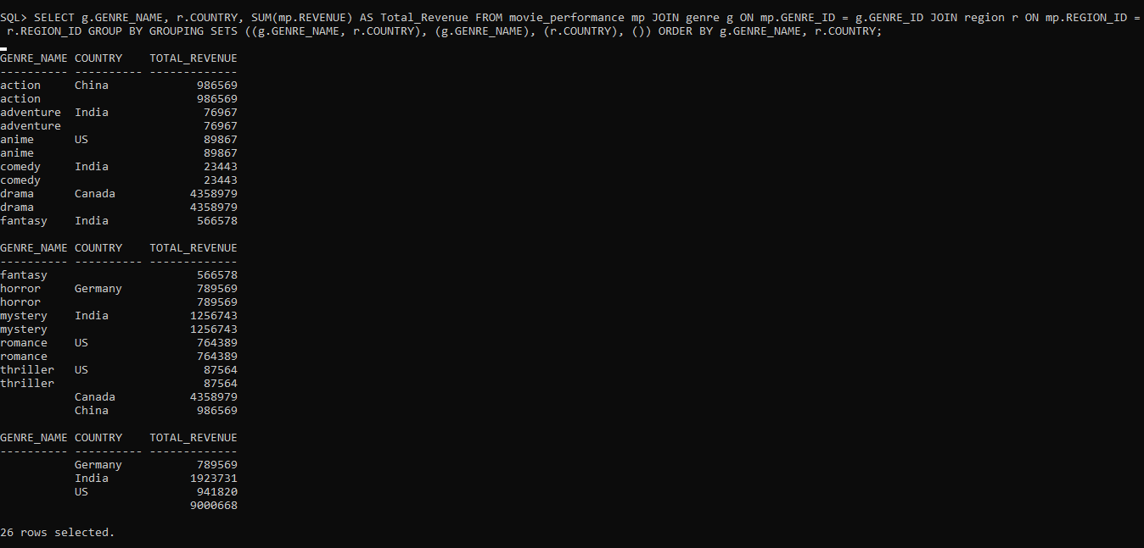

**Total Revenue by Age**

SELECT a.AGE as Age, SUM(mp.REVENUE) AS Total_Revenue FROM movie_performance mp JOIN audience a ON mp.AUDIENCE_ID = a.AUDIENCE_ID GROUP BY Age ORDER BY Total_Revenue DESC;

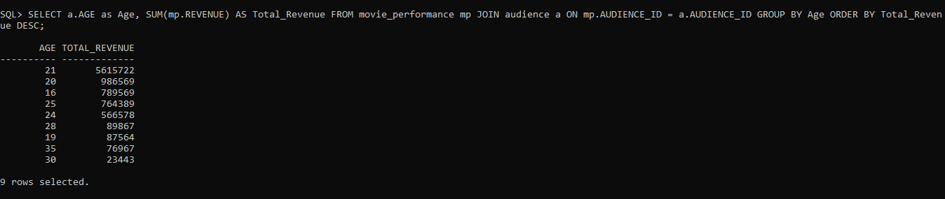

**Total Revenue across all regions (Grand total)**

SELECT SUM(mp.REVENUE) AS Total_Revenue FROM movie_performance mp;

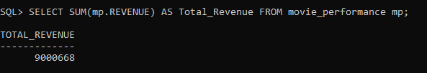

**Creating Indexes for Performance Optimization**

CREATE INDEX idx_movie_time ON movie_performance(TIME_ID);

CREATE INDEX idx_movie_genre ON movie_performance(GENRE_ID);

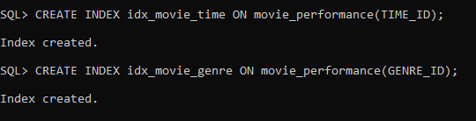

SELECT * FROM movie_performance WHERE TIME_ID=3;

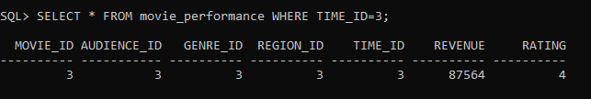

SELECT GENRE_ID, RATING FROM movie_performance WHERE GENRE_ID=6;

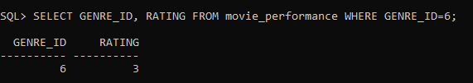

**Creating a View for Summary data**

CREATE VIEW movie_summary AS SELECT t.YEAR,t.MONTH,g.GENRE_NAME,SUM(mp.REVENUE) AS Total_Revenue FROM movie_performance mp JOIN time t ON mp.TIME_ID = t.TIME_ID JOIN genre g ON mp.GENRE_ID = g.GENRE_ID GROUP BY t.YEAR, t.MONTH, g.GENRE_NAME;



select * from movie_summary;

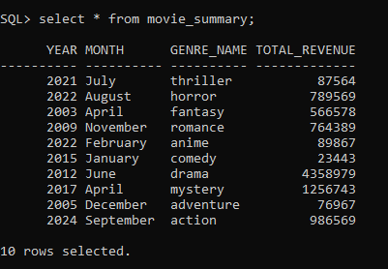

**Dynamic Queries with Parameters**

-- Declare and assign the variable

VARIABLE genre_name VARCHAR2(50);

EXEC :genre_name := 'action';

-- Use the bind variable in your query

SELECT mp.MOVIE_ID, g.GENRE_NAME, r.COUNTRY, mp.REVENUE FROM movie_performance mp JOIN genre g ON mp.GENRE_ID = g.GENRE_ID JOIN region r ON mp.REGION_ID = r.REGION_ID WHERE g.GENRE_NAME = :genre_name;

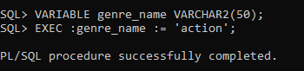



**Generate a Pivot Table Using CASE**

SELECT t.YEAR, SUM(CASE WHEN g.GENRE_NAME = 'action' THEN mp.REVENUE ELSE 0 END) AS Action_Revenue, SUM(CASE WHEN g.GENRE_NAME = 'comedy' THEN mp.REVENUE ELSE 0 END) AS Comedy_Revenue, SUM(CASE WHEN g.GENRE_NAME = 'drama' THEN mp.REVENUE ELSE 0 END) AS Drama_Revenue FROM movie_performance mp JOIN time t ON mp.TIME_ID = t.TIME_ID JOIN genre g ON mp.GENRE_ID = g.GENRE_ID GROUP BY t.YEAR ORDER BY t.YEAR;

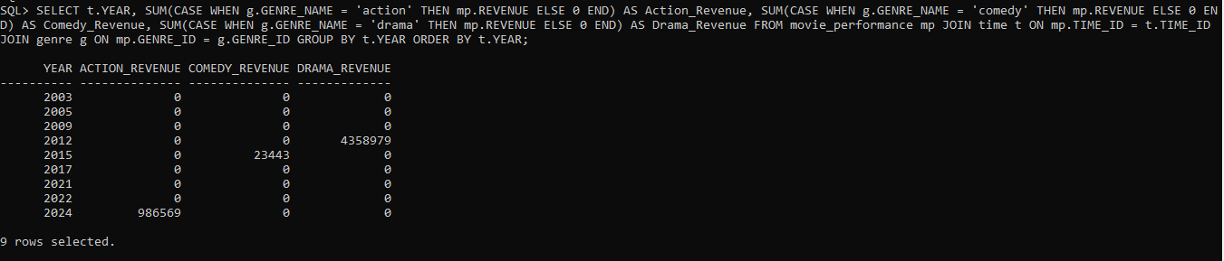

**Generate a Dynamic Monthly Revenue Report**

SELECT t.YEAR, t.MONTH, SUM(mp.REVENUE) AS Total_Revenue FROM movie_performance mp JOIN time t ON mp.TIME_ID = t.TIME_ID GROUP BY t.YEAR, t.MONTH ORDER BY t.YEAR, t.MONTH;

