HEMACHANDIRAN A
240701188
Forms Design Using Zoho Creator
AIM
To create and manage vehicle service forms using Zoho Creator for storing customer, vehicle, service booking, and billing information.
PROCEDURE
- Create a new application named Vehicle Service in Zoho Creator.
- Create the following four forms:
  - Customer Details – to store customer information such as Customer ID, Name, Phone Number, Email, and Address.
  - Vehicle Details – to store vehicle information such as Customer ID, Vehicle Type, Brand, Model, Registration Number, and Year of Manufacture.
  - Service Booking – to store booking details such as Customer ID, Registration
Number, Service Type, Booking Date, Preferred Time Slot, and Service Status.
  - Service Billing – to store billing details such as Booking ID, Service Charges, Spare Parts Cost, Total Amount, Payment Mode, and Payment Status.
- Add suitable field types such as Single Line, Number, Email, Phone, Date, Time, Dropdown, Radio, and Decimal fields.
- Configure the required fields and arrange the fields appropriately in each form.
- Enter sample customer and vehicle service records into each form.
- Preview and verify all the forms and their reports to ensure that the data is entered and stored correctly.
OUTPUT
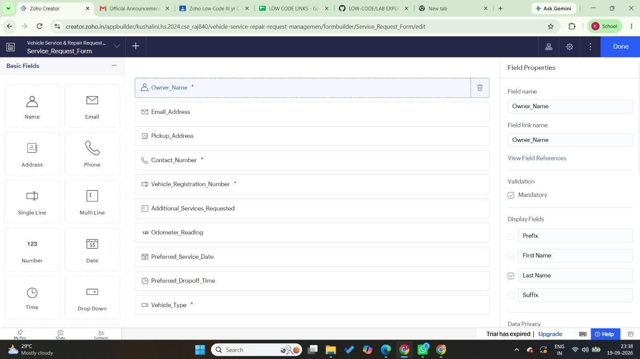

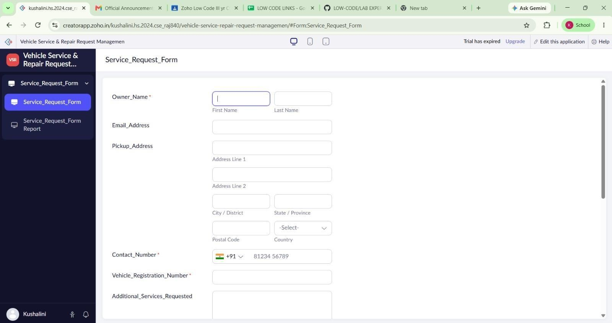

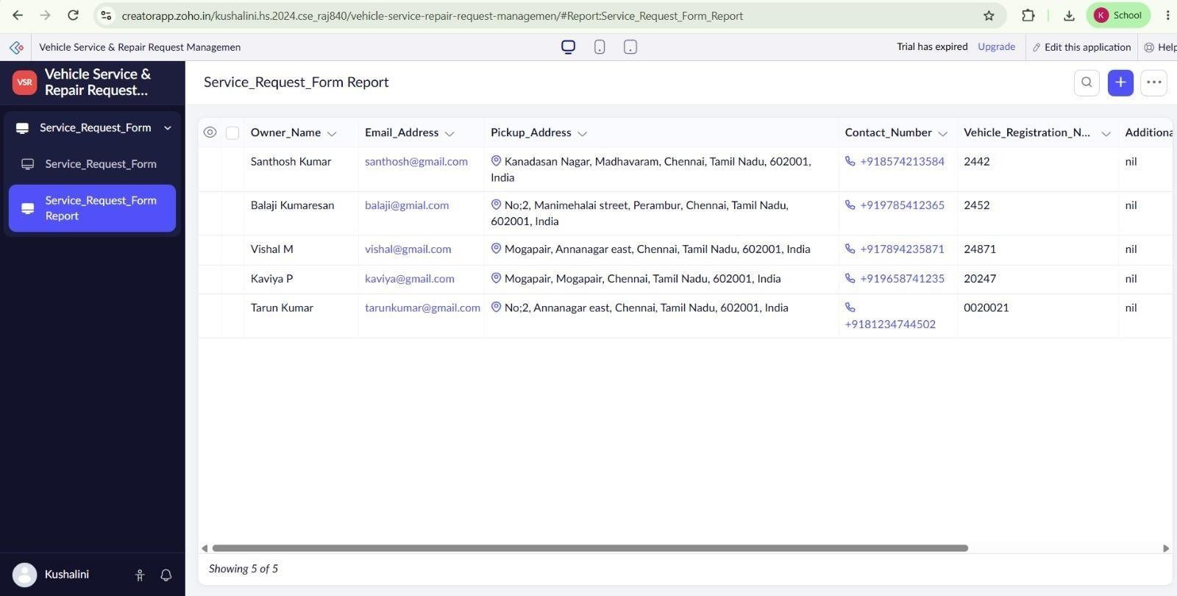

RESULT
Thus, the required Customer Details, Vehicle Details, Service Booking, and Service Billing forms were successfully created in Zoho Creator and sample vehicle service data was stored successfully.

