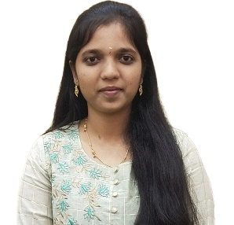

HEMADHARSHINI S

CSD Intern

[hemadharshini.s@cognizant.com](mailto:hemadharshini.s@cognizant.com)

8883869976

**_______________________________________________________________________________________________**  
**Career Objective**

I would like to be part of an organization where I could use my skills and enhance my knowledge and talent for the development of both the organization and me. I am open-minded to learn new things and experiences.

**Work Experience**

**GenC-CSD Intern| 1’Dec’2023 – Present**

Currently undergoing a training program on SQL, Java including,

Problem solving and Data analysis. Gaining technical knowledge

and improving my programming skills. Learning and

developing my skills in JAVA and SQL.

**Academic Qualification**

* **P.S.N.A College of Engineering and Technology, Dindigul**

B.E., Computer Science and Engineering | August 2019 – April 2023 | CGPA – 8.30

* **St. Joseph’s Matric Higher Secondary School, Dindigul**

HSC Computer Science stream| 2017 – 2019 | 69.5%

* **St. Joseph’s Matric Higher Secondary School, Dindigul**

Class 10TH SSC | 2016 – 2017 | 90.6%

**Technical Skills**

* Programming Languages : Java, SQL.

**Soft Skills**

* Team Player
* Adaptability
* Creativity
* Problem Solving

**Project Works**

**Data Leakage Detection**

* Technologies: HTML, CSS, JS, Flask, SQL, Python.
* It is a software program used to identify data leakage in stored datasets. Additionally, it detects malware within the dataset and classifies it according to its types.
* The administrator stores the data in encrypted form, and when a user wants to access the data, the admin sends the decryption key to the user via email, allowing them to decrypt the data.

**AI Based - Assisted Search For missing Person**

* Technologies: HTML, Python, Bootstrap, AI, AWS.
* It is a web application used to find the missing person with the help of AWS Facial Recognition Technique.
* The data collected from the admin and the users will be recognized to find a match if there was any match an alert mail will be sent to the respective guardian.

**Fertilizers Recommendation System for Disease Prediction**

* Technologies: Artificial Intelligence, Machine Learning, Deep Learning, HTML, SQL.
* It is a web Application in which the user can upload a picture from their folder and have to choose which type of plant when it is submitted it will predict the disease and it will suggest treatment for that plant will be recommended.

**Certifications**

* Certified with course completion in Java by SoloLearn.
* Certified with course completion in Database Management System by Oracle
* Certified with course completion in SQL by Sololearn.
* Certified with project completion in IBM Developer Skills Network by ICTAcademy.

**Personal Details**

* Languages known : English, Tamil.
* Area of Interests : Database Management.
* Hobbies : Drawing, Painting, Craft Work