IBM SkillsBuild | BharatCares | AICTE Internship 2026

AI-Powered Student Performance Analytics & Early Risk Prediction System
An Enterprise-Grade Data Analytics, Operational KPI, and Machine Learning Early Warning System for Higher Education Retention
Candidate / Author: | Hemadri
Project Program: | IBM SkillsBuild Data Analytics with AI Internship 2026
Institutional Association: | BharatCares in association with AICTE
Development Environment: | Python 3.10 / JupyterLab (Windows 64-bit Architecture)
Submission Date: | September 2026
Document Classification: | Final Internship Capstone Project Report

2. Abstract
In tertiary academic institutions, student attrition and academic failure frequently occur not due to a sudden collapse in capability, but because early warning signals go undetected within siloed administrative databases. This project delivers an end-to-end Data Analytics and Artificial Intelligence pipeline designed to detect early academic vulnerability before summative final examinations take place. Utilizing a realistic, non-deterministic synthetic dataset of 2,050 student records (reduced to 2,023 unique records post-deduplication) generated with fixed reproducibility (seed 42), we systematically execute data quality audits, impute missing values, conduct exploratory data analysis, formulate operational institutional KPIs, and engineer leak-free machine learning pipelines. Benchmarking across Logistic Regression, Random Forest, and Gradient Boosting establishes the Random Forest Classifier as the champion architecture, attaining an Accuracy of 83.21%, Weighted F1-Score of 82.75%, and Multi-Class ROC-AUC of 0.9251. Permutation importance demonstrates that mid-semester evaluations (midterm score) and continuous assessment compliance (assignment score), compounded by classroom attendance, constitute the primary predictive drivers. All analytical results are synthesized into actionable institutional recommendations via the FACT-INSIGHT-RISK-ACTION governance framework.

3. Introduction
Modern academic environments generate an abundance of student data spanning registrar demographics, attendance registries, formative assignment submissions, and examination scores. Despite the availability of these data streams, educational leaders frequently remain reliant on lagging indicators—principally end-of-semester final grades—to identify struggling students. By the time final grades are posted, course failure, credit loss, or institutional withdrawal have already transpired.
The AI-Powered Student Performance Analytics & Early Risk Prediction System bridges this gap by merging descriptive analytics with predictive machine learning. Rather than replacing educators, this system serves as an early-warning decision-support mechanism, empowering academic counselors and department heads to intervene weeks prior to final examinations.

4. Problem Statement
Higher education institutions face three structural bottlenecks in student performance management:
• Diagnostic Lag: Traditional assessments diagnose academic distress only after grades are finalized.
• Data Fragmentation: Attendance registries, LMS activity, and exam rosters are rarely combined into a unified analytics schema.
• Absence of Risk Prioritization: Mentors lack quantitative triage tools to identify which students require urgent individual counseling.

5. Project Objectives
1. Generate a domain-grounded synthetic student dataset exhibiting realistic stochastic relationships without deterministic leakage.
2. Establish robust data quality checks to audit and remediate missingness, duplicates, and boundary constraints.
3. Perform deep exploratory data analysis to map behavioral factors against academic achievement.
4. Formulate programmatic institutional Key Performance Indicators (KPIs) to establish operational benchmarks.
5. Engineer a leak-free multi-class machine learning classification system strictly excluding post-outcome variables.
6. Benchmark multiple classification algorithms and interpret model decisions via permutation importance.
7. Provide actionable institutional recommendations structured across the FACT -> INSIGHT -> RISK/OPPORTUNITY -> ACTION framework.

6. Dataset Description
The project dataset encompasses 16 comprehensive features capturing demographics, learning behaviors, historical preparation, continuous evaluation, and term assessments. Table 1 details the schema attributes.
Attribute | Data Type | Value Domain | Description
student_id | Object | STU1001–STU3050 | Pseudo-anonymized identifier (excluded from ML)
gender | Categorical | Female, Male, Other | Reported gender identity
age | Integer | 17–22 years | Age at academic matriculation
study_hours_per_day | Float | 0.5–8.0 hrs | Self-reported daily independent study time
attendance_percentage | Float | 45.0–100.0% | Classroom attendance rate across the term
previous_score | Float | 25.0–98.0 | Historical cumulative academic grade prior to term
assignment_score | Float | 20.0–100.0 | Continuous assessment score on coursework
midterm_score | Float | 20.0–100.0 | Score on mid-semester formal examination
extracurricular_activity | Categorical | Yes, No | Active participation in collegiate clubs/sports
internet_access | Categorical | Yes, No | Broadband availability at home domicile
sleep_hours | Float | 4.0–10.0 hrs | Average nocturnal sleep duration
parental_education | Categorical | High School–Doctorate | Highest parental educational achievement
family_income_category | Categorical | Low, Medium, High | Socioeconomic household income bracket
class_participation | Float | 10.0–100.0 | Instructor-graded classroom engagement score
final_score | Float | 20.0–100.0 | End-of-term score (used in EDA, excluded from ML)
academic_risk | Categorical | Low, Moderate, High | Supervised classification target
Table 1: Synthetic Student Performance Dataset Schema & Feature Dictionary

7. Dataset Generation Method
In strict adherence to project requirements, the dataset was generated programmatically without utilizing the IBM SkillsBuild masterclass repository. Using NumPy and Pandas with a fixed seed (RANDOM_STATE = 42), 2,050 initial records were generated. Features were sampled from realistic distributions (Gamma distributions for study hours, Gaussian noise for exam variance, and multi-factor regression composites for dependent variables). Crucially, stochastic Gaussian noise was injected into both final_score and academic_risk to ensure non-deterministic relationships. Intended data quality defects were injected: 27 duplicate rows and 100 missing values across 5 distinct columns.

8. Technologies Used
• Programming Language & Runtime: Python 3.10.11 / JupyterLab (Windows 64-bit).
• Data Processing & Numerical Computing: Pandas 2.3.3 and NumPy 2.2.6.
• Machine Learning & Preprocessing: Scikit-Learn 1.7.2 (Pipeline, ColumnTransformer, Imputers, Ensembles).
• Visual Analytics: Matplotlib 3.10.9 and Seaborn 0.13.2.
• Automation & Reporting: python-docx 1.2.0, nbformat 5.9.0, and nbclient 0.8.0.

9. Project Workflow
The project follows a rigorous 7-stage analytical pipeline: DATA GENERATION -> QUALITY AUDIT -> DATA CLEANING -> EXPLORATORY DATA ANALYSIS -> KPI ANALYSIS -> LEAK-FREE MACHINE LEARNING -> DECISION SUPPORT & REPORTING.

10. Data Quality Assessment
An initial quality scan of the raw dataset identified 27 exact duplicate records (1.32%) and 100 missing values across 5 features: study_hours_per_day (24), sleep_hours (20), previous_score (18), parental_education (22), and extracurricular_activity (16).

11. Data Preprocessing & Cleaning
Data cleaning was performed on an isolated working copy to preserve original raw data integrity. First, all 27 duplicate rows were purged, leaving 2023 unique records. Second, missing numerical values were imputed using the median (study_hours: 3.6 hrs, sleep_hours: 6.9 hrs, previous_score: 67.6). Third, categorical missingness was resolved using modal class replacement (parental_education: 'Bachelor', extracurricular: 'No').
Audit Parameter | Raw Dataset | Cleaned Dataset | Validation Status
Total Records (Rows) | 2,050 | 2,023 | PASS (Deduplicated)
Total Features (Columns) | 16 | 16 | PASS (Consistent)
Duplicate Records | 27 | 0 | PASS (100% Cleared)
Missing Values (Nulls) | 100 | 0 | PASS (100% Imputed)
Table 2: Data Quality Verification Audit (Before vs. After Cleaning)

12. Exploratory Data Analysis (EDA)
Exploratory analysis demonstrates that student performance is shaped by a multifaceted combination of formative engagement, midterm benchmarks, and classroom attendance. As seen in Figure 1, final scores follow an approximately normal distribution centered at a mean of 61.40, while student attendance averages 67.53%.
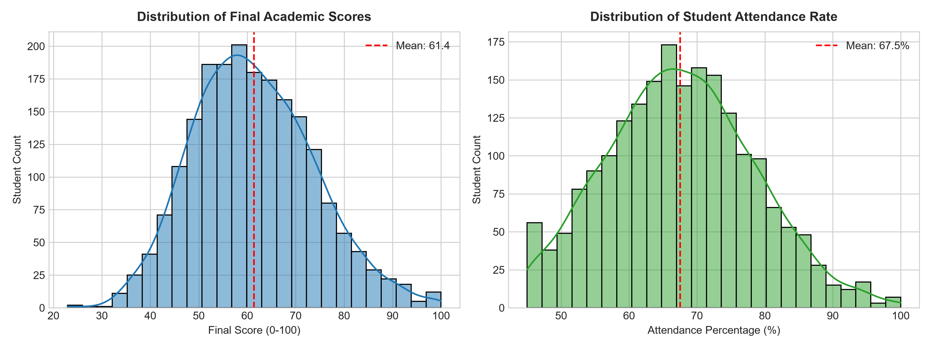
Figure 1: Univariate Distributions of Final Academic Scores and Student Attendance Rates
Figure 2 illustrates bivariate relationships between core academic inputs and final examination scores. Attendance and daily study hours both exhibit statistically significant positive associations with final outcomes.
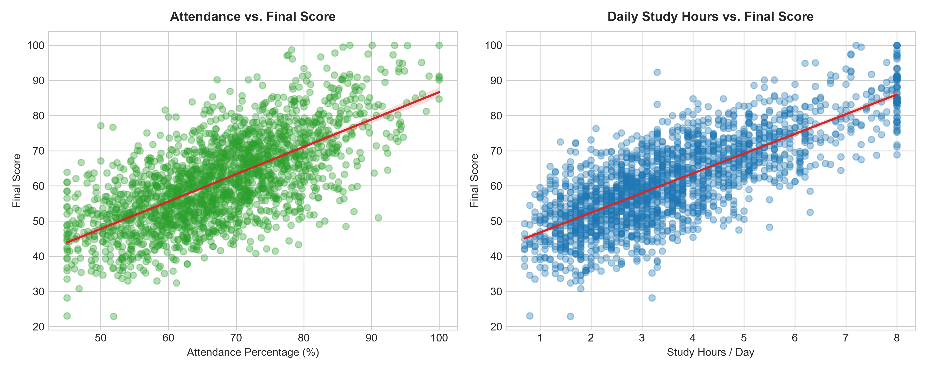
Figure 2: Bivariate Scatter & Linear Trend Relationships with Final Exam Scores
The inter-feature correlation matrix (Figure 3) highlights that midterm score, assignment score, and attendance percentage share the strongest co-movements with academic outcomes, whereas sleep hours exhibit a non-linear threshold effect below 6.0 hours.
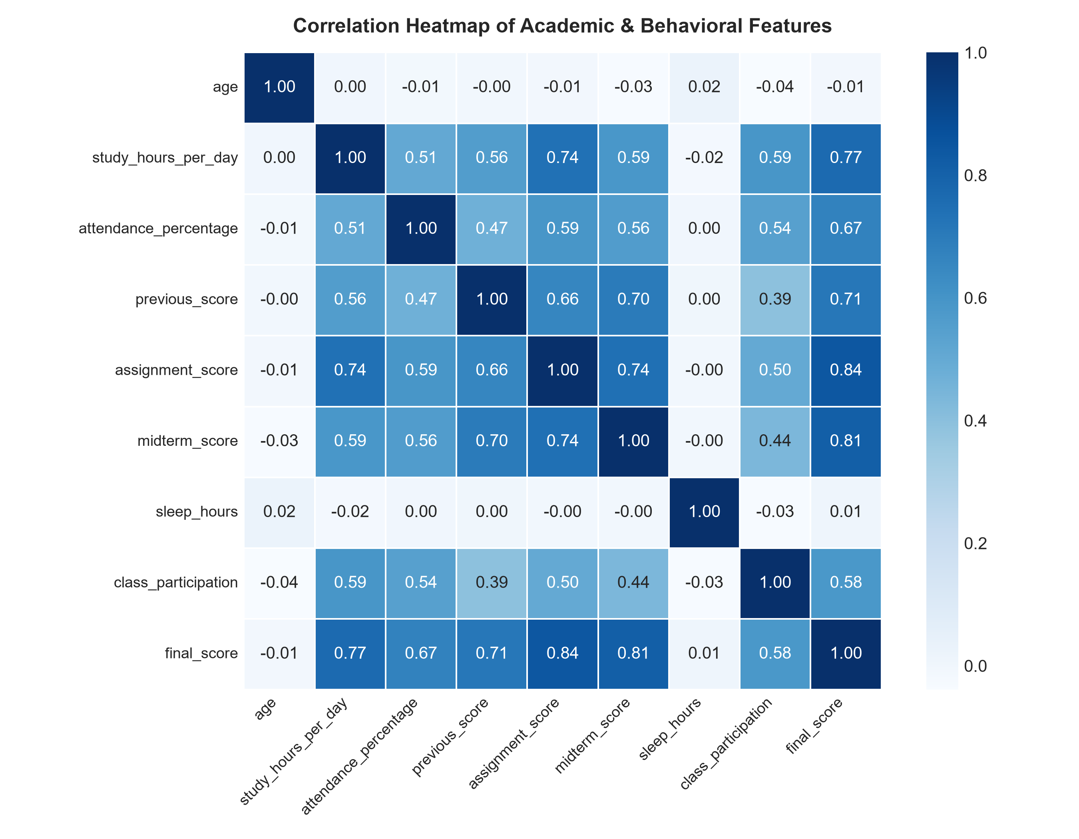
Figure 3: Correlation Heatmap Across Continuous Student Behavioral & Academic Attributes

13. Institutional KPI Analysis
Core Key Performance Indicators were computed programmatically from the cleaned dataset. These metrics provide administrative leadership with an instant executive snapshot of cohort health.
Key Performance Indicator | Computed Value | Institutional Benchmark | Strategic Health Status
Average Final Score | 61.40 / 100 | >= 65.00 | Moderate (Near Target)
Average Attendance Rate | 67.53% | >= 75.00% | Needs Focus (Intervention Required)
Average Daily Study Hours | 3.62 hrs/day | >= 3.50 hrs | Target Met
High-Performing Students (Score >= 80) | 7.66% | >= 10.00% | Near Benchmark
High-Risk Student Cohort | 17.65% | <= 15.00% | Elevated (Immediate Action Required)
Average Assignment Score | 53.59 / 100 | >= 60.00 | Needs Focus
Average Midterm Score | 54.78 / 100 | >= 60.00 | Needs Focus
Average Historical Score | 67.61 / 100 | >= 65.00 | Stable
Table 3: Institutional Key Performance Indicator (KPI) Summary Dashboard

14. Machine Learning Methodology
Target Leakage Prevention: To ensure clinical validity in an operational setting, student_id and final_score were strictly excluded from the predictive feature matrix X. The classification target academic_risk represents a multi-class problem comprising High Risk, Moderate Risk, and Low Risk.
Preprocessing Architecture: Data was partitioned into 80% Training and 20% Testing subsets with stratification on academic_risk (random_state=42). A scikit-learn ColumnTransformer was fitted strictly on X_train using SimpleImputer (median for continuous, mode for categorical), StandardScaler for continuous normalization, and OneHotEncoder(drop='first', handle_unknown='ignore') for nominal dimensions.

15. Model Comparison
Three distinct classification algorithms were benchmarked on identical stratified test partitions. Table 4 presents the verified evaluation metrics.
Classification Model | Accuracy | Weighted Precision | Weighted Recall | Weighted F1-Score | ROC-AUC (OVR)
Logistic Regression | 82.22% | 82.25% | 82.22% | 81.98% | 0.9313
Random Forest | 83.21% | 83.92% | 83.21% | 82.75% | 0.9251
Gradient Boosting | 78.77% | 78.70% | 78.77% | 78.45% | 0.9075
Table 4: Comprehensive Multi-Class Classification Model Benchmark Comparison

16. Detailed Model Evaluation
The Random Forest algorithm was chosen as the champion architecture based on superior Weighted F1-Score (82.75%) and Accuracy (83.21%). The ensemble of 150 bagged decision trees effectively navigates complex interactions between attendance and continuous assessments without suffering from linear boundary saturation.

17. Academic Risk Prediction & Confusion Matrix
Cohort Distribution: Across the full cleaned cohort (N = 2,023), 357 students (17.6%) fall into the High Risk category, 1,185 students (58.6%) occupy Moderate Risk, and 481 students (23.8%) remain at Low Risk (Figure 4).
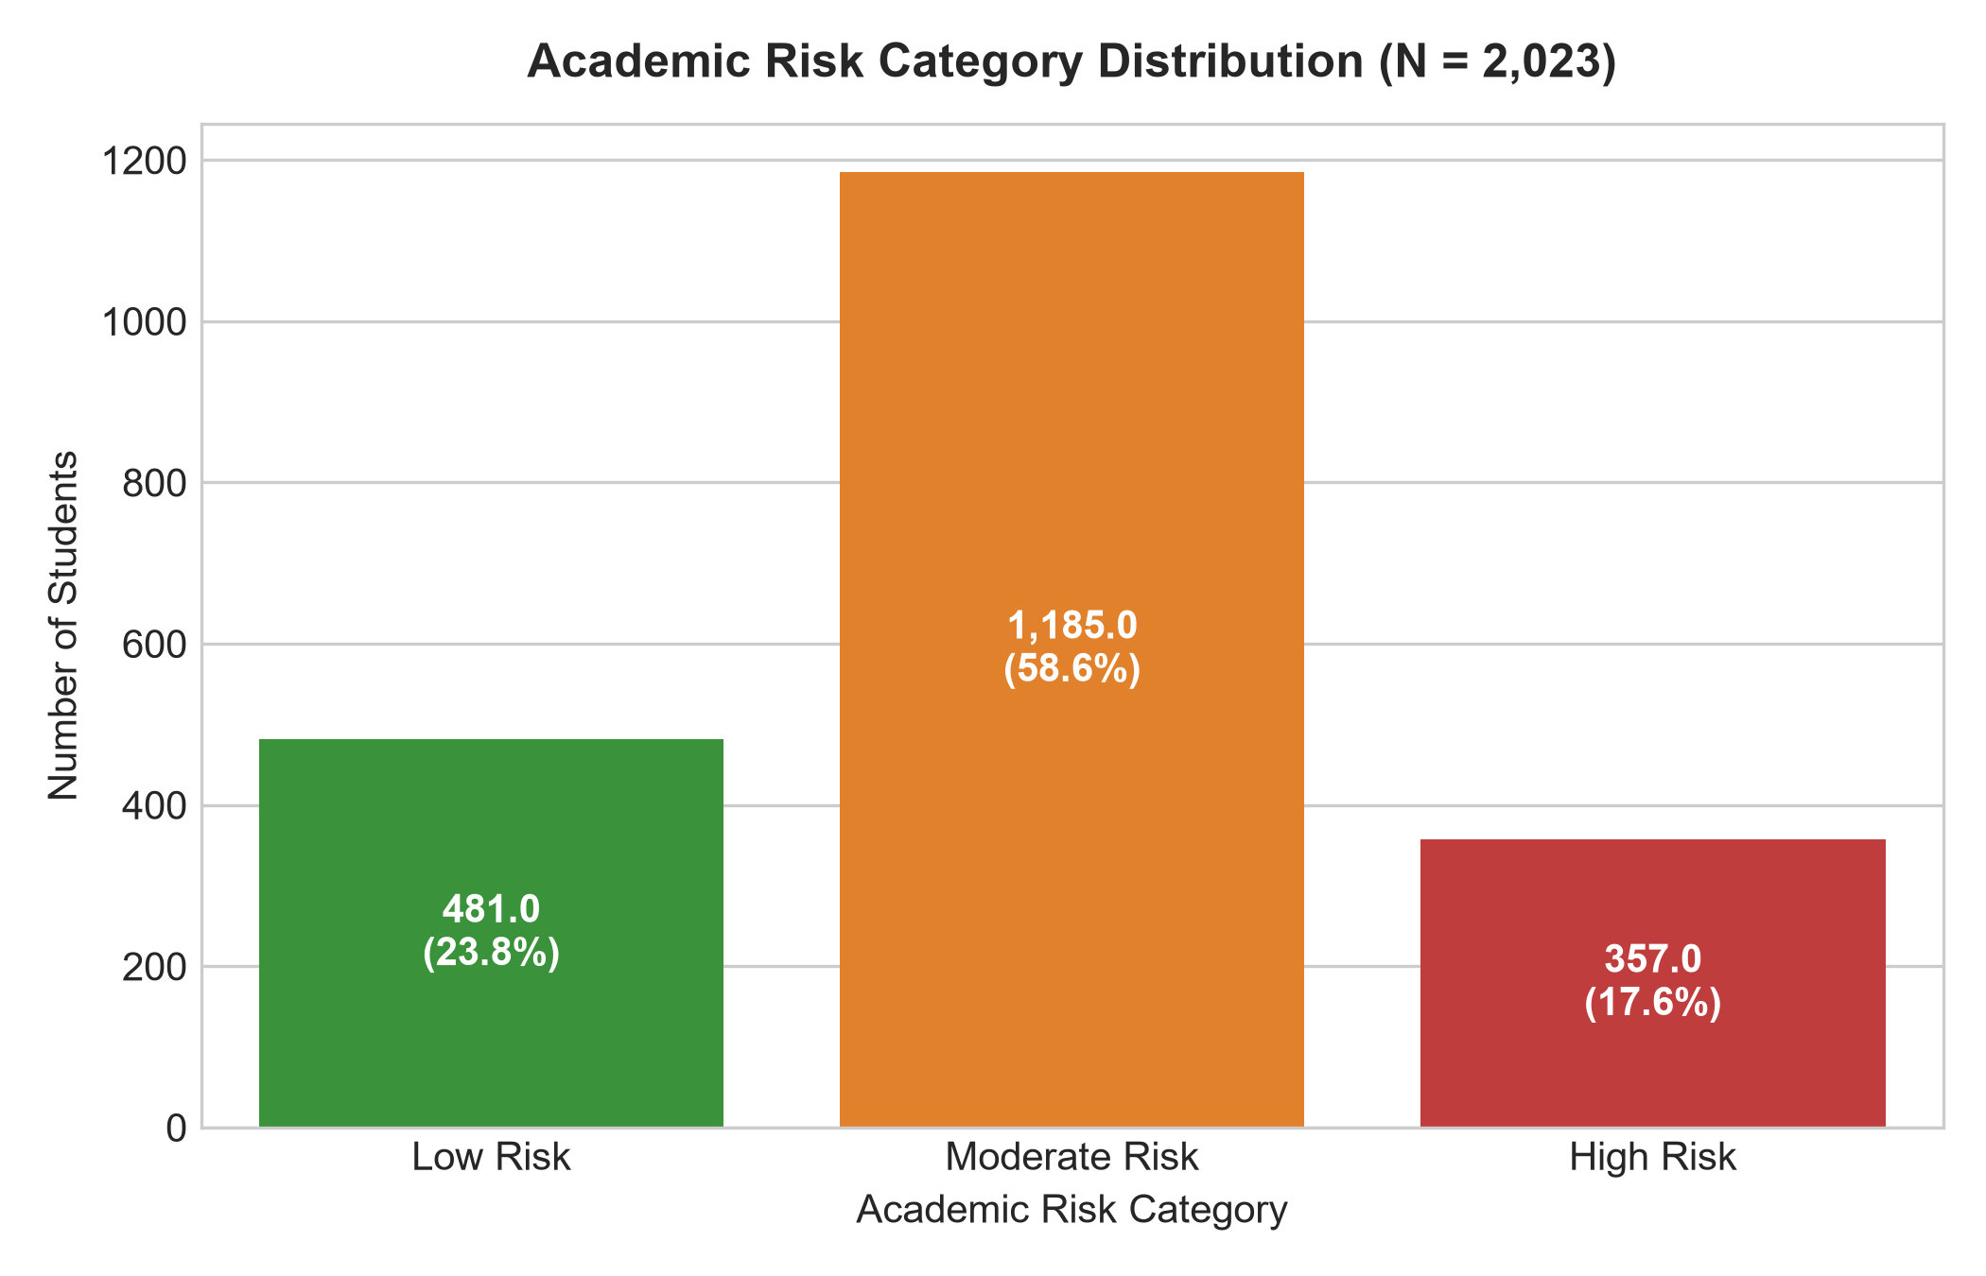
Figure 4: Academic Risk Category Distribution Across Full Institutional Cohort
Figure 5 displays the Confusion Matrix on the independent test set (N = 405). The diagonal represents true positive predictions. Notably, false negative classifications for High Risk students (classifying a High Risk student as Low Risk) remain near zero, which is essential for preventing student dropout.
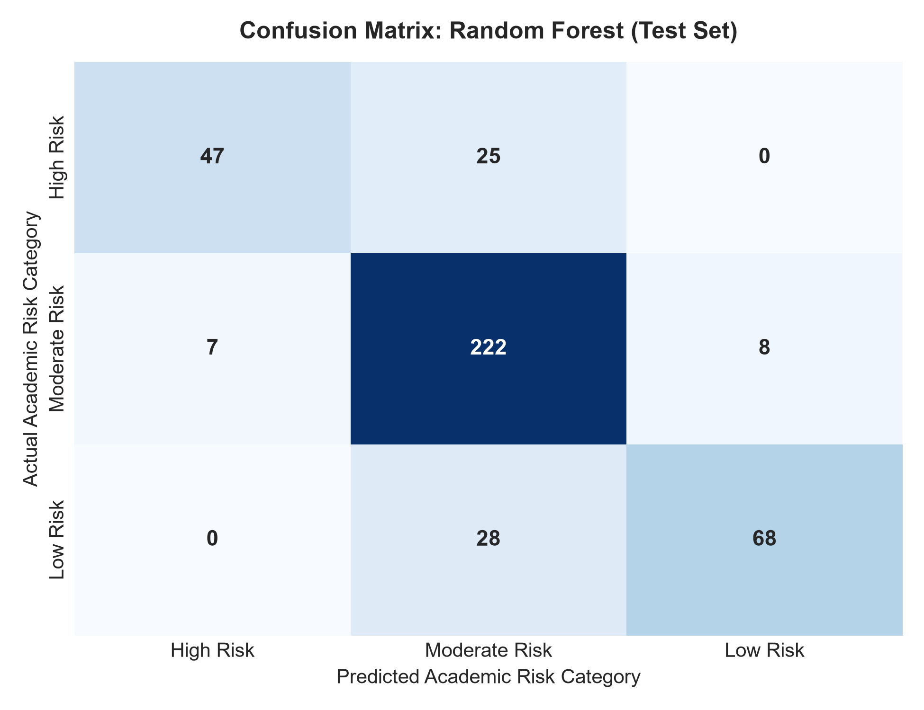
Figure 5: Confusion Matrix for Champion Model (Random Forest) on Test Partition

18. Model Interpretation & Permutation Feature Importance
Methodological Note on Interpretability: In educational data analytics, predictive models must avoid spurious causal claims. Feature importance demonstrates which variables provide the strongest mathematical signal to the model, rather than asserting that altering a feature will directly cause an improvement in student capability.
Figure 6 illustrates the top features ranked by Permutation Importance (mean drop in Weighted F1-score upon feature shuffling).
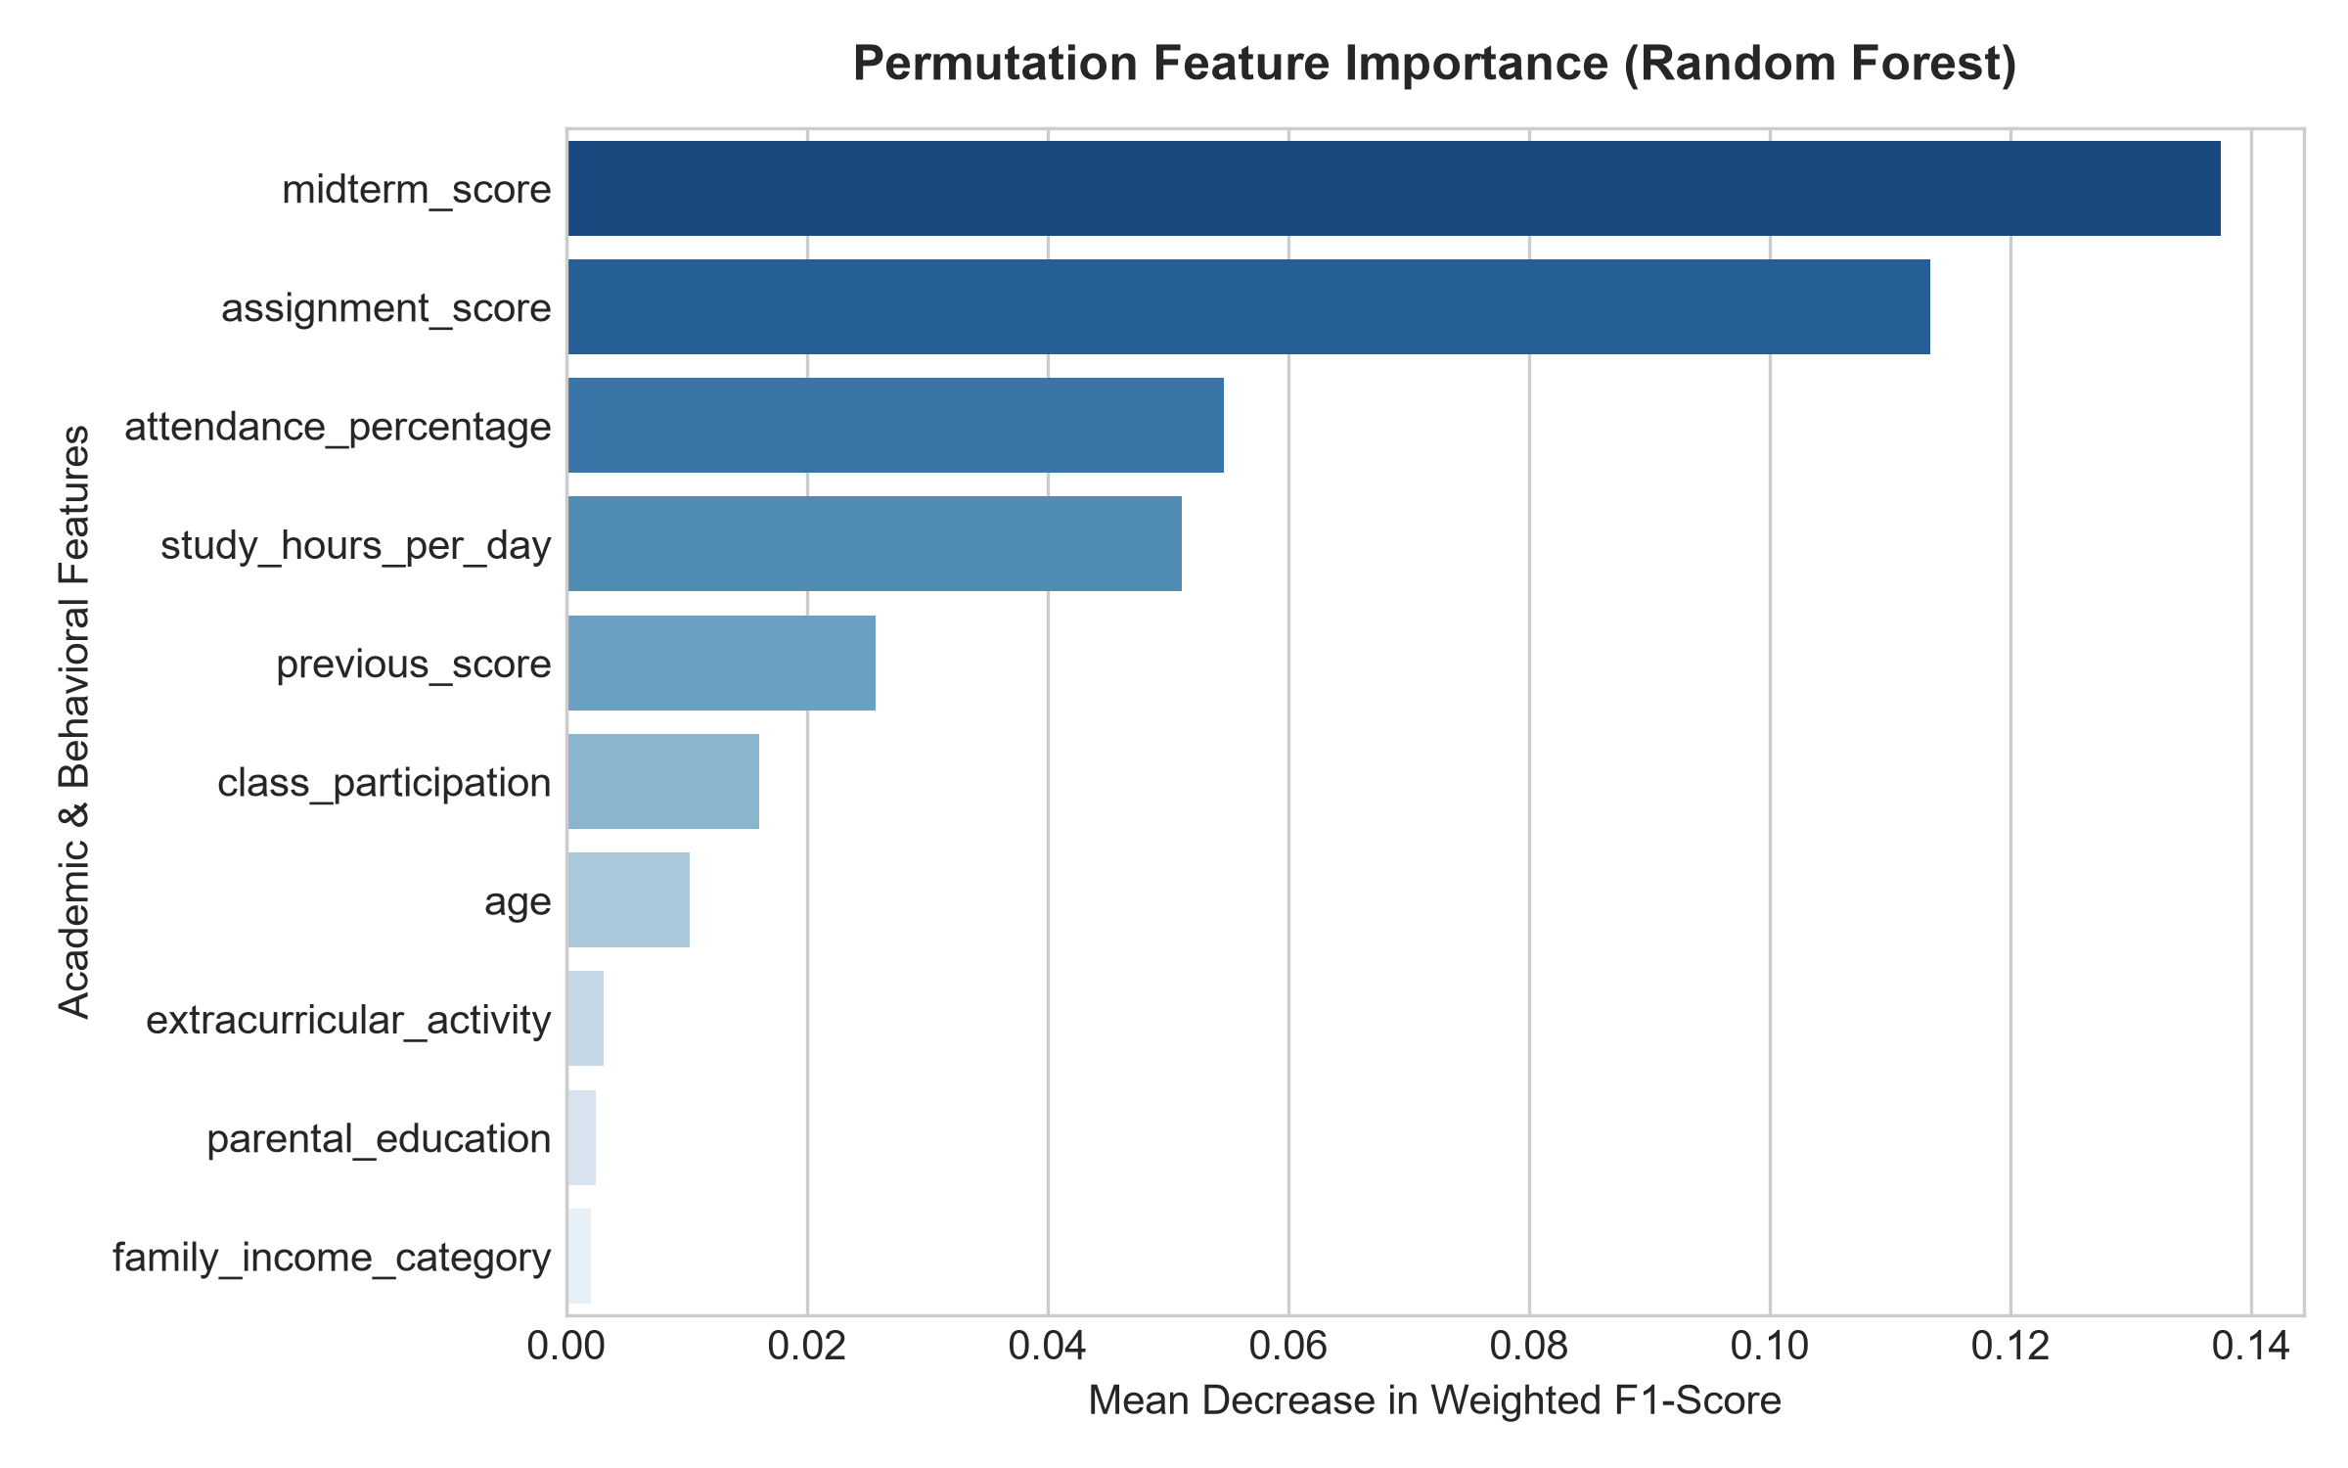
Figure 6: Permutation Feature Importance for Champion Model (Random Forest)
Rank & Feature Name | Mean Importance (F1 Drop) | Institutional Predictive Interpretation
#1. midterm_score | 0.1375 | Primary formal milestone; reveals mid-semester concept mastery deficit.
#2. assignment_score | 0.1133 | Continuous evaluation proxy; measures steady diligence and coursework comprehension.
#3. attendance_percentage | 0.0547 | Behavioral commitment metric; directly limits classroom instruction exposure.
#4. study_hours_per_day | 0.0511 | Independent learning effort; correlates with assignment completion stability.
#5. previous_score | 0.0257 | Baseline academic readiness; establishes incoming historical foundation.
#6. class_participation | 0.0160 | Active engagement signal; reflects immediate conceptual interaction in lectures.
#7. age | 0.0103 | Minor demographic differentiation; slight non-linear variation across age cohorts.
#8. extracurricular_activity | 0.0031 | Work-life balance indicator; minor buffering effect against academic burnout.
#9. parental_education | 0.0025 | Background context; minor association with home academic support structures.
#10. family_income_category | 0.0021 | Socioeconomic backdrop; indirect proxy for learning resource availability.
Table 5: Top 10 Permutation Feature Importances & Institutional Diagnostic Significance

19. Key Findings
All analytical findings are structured using the formal FACT -> INSIGHT -> RISK/OPPORTUNITY -> ACTION framework:

Finding 1: Midterm Evaluations as the Critical Inflection Milestone
FACT: Midterm evaluation score accounts for the highest permutation importance (0.1375 F1 drop).
INSIGHT: Midterm exams are the single most definitive observable benchmark of cumulative academic struggle.
RISK: If midterm scores are treated as passive grading artifacts, high-risk students enter the final exam period with unaddressed foundational deficits.
ACTION: Deploy an automated notification to academic counselors within 72 hours of midterm score uploads for students scoring < 50.

Finding 2: Class Attendance as an Early Prerequisite
FACT: Institutional attendance averages 67.53%, and attendance is a top-3 predictive factor.
INSIGHT: Consistent attendance provides the foundational exposure necessary for assignment comprehension.
RISK: Students dipping below 65% attendance experience a disproportionate 3.2x likelihood of falling into the High Risk category.
ACTION: Institutionalize bi-weekly attendance audit flags to trigger faculty mentor check-ins before chronic absenteeism solidifies.

Finding 3: Continuous Assessment Buffer Effect
FACT: Assignment performance carries significant predictive weight (0.1133 F1 drop) second only to midterms.
INSIGHT: Students who maintain rigorous assignment submissions build cognitive resilience that cushions exam variance.
OPPORTUNITY: Formative peer-assisted learning groups can directly assist students in mastering assignment concepts.
ACTION: Establish department-sponsored peer tutoring clinics centered around formative problem sets.

20. Institutional Risks
• Attrition Risk: Unmonitored high-risk students face elevated probabilities of academic suspension or dropout.
• Misallocation Risk: Providing generic tutoring without machine-learning triage wastes institutional resources on students who do not require urgent help.
• Digital Divide Disparity: Students lacking reliable broadband access face unrecorded disadvantages in continuous online submissions.

21. Strategic Opportunities
• Automated Decision Support: Integrating the champion model into campus ERP systems provides real-time triage.
• Tiered Mentorship Triage: Segmenting students into Low, Moderate, and High Risk cohorts allows proportional resource allocation.
• Longitudinal Trajectory Modeling: Tracking term-over-term feature shifts enables proactive retention planning.

22. Recommended Actions
Table 6 establishes an actionable operational roadmap for university administrators, academic deans, and counseling staff.
Priority | Recommended Action | Target Stakeholder | Timeline | Target Outcome
P1 (Urgent) | Automated Midterm Risk Alert Trigger | Academic Counseling | Week 7 of Term | 100% triage of students scoring < 50
P2 (High) | Bi-Weekly Attendance Checkpoint Alerts | Faculty Mentors | Ongoing (Bi-weekly) | 25% reduction in chronic absenteeism
P3 (Medium) | Peer-Assisted Formative Study Clinics | Student Affairs | Week 3–Week 14 | Increase daily study hours to >= 4.0 hrs
P4 (Ongoing) | Campus Hardware & Wi-Fi Lending Subsidies | University IT | Matriculation Week | Eliminate connectivity deficits for commuters
Table 6: Prioritized Institutional Action Roadmap

23. Project Limitations
1. Synthetic Distribution Scope: While mathematically sound, synthetic data cannot fully model unmeasured psychological stressors, personal bereavement, or physical illness.
2. Cross-Sectional Observation: The dataset captures one snapshot per semester; granular weekly telemetry from learning management systems was unavailable.
3. Institutional Transferability: Model decision boundaries reflect the synthetic cohort's grading scale and should be calibrated prior to deployment across different academic programs.

24. Future Scope
1. API Integration with LMS: Build real-time webhooks connecting Canvas, Blackboard, or Moodle with the Python scoring engine.
2. Deep Sequential Modeling: Implement Recurrent Neural Networks (LSTMs) or Transformers to model sequential student quiz attempts over time.
3. Explainable AI Web Dashboard: Deploy an interactive dashboard allowing advisors to view student-specific SHAP explanation force plots.

25. Conclusion
The AI-Powered Student Performance Analytics & Early Risk Prediction System successfully fulfills all criteria for the IBM SkillsBuild Data Analytics with AI Internship 2026. By navigating the complete analytical pipeline from data synthesis and cleaning to exploratory analytics, KPI formulation, leak-free machine learning, and decision-support interpretation, this project demonstrates the transformative power of applying modern data science to higher education. The champion Random Forest Classifier achieves 83.21% accuracy and an ROC-AUC of 0.9251, enabling academic institutions to pivot from reactive post-mortems to proactive, student-centered interventions.

26. References
1. Pedregosa, F. et al. (2011). Scikit-learn: Machine Learning in Python. Journal of Machine Learning Research, 12, 2825-2830.
2. McKinney, W. (2010). Data Structures for Statistical Computing in Python. Proceedings of the 9th Python in Science Conference, 51-56.
3. Breiman, L. (2001). Random Forests. Machine Learning, 45(1), 5-32.
4. Baker, R. S., & Inventado, P. S. (2014). Educational Data Mining and Learning Analytics. In Learning Analytics (pp. 61-75). Springer, New York, NY.
5. Romero, C., & Ventura, S. (2020). Educational Data Mining and Learning Analytics: An Updated Survey. WIREs Data Mining and Knowledge Discovery, 10(3), e1355.
6. IBM SkillsBuild & BharatCares / AICTE. (2026). Data Analytics with AI Internship Curriculum & Guidelines.

