Program-2: Write a JavaScript that calculates the squares and cubes of the numbers

Html

<!DOCTYPE html>
<html>
<head>
<style>
table{
border: 5px solid;
background-color:#C8FE2E;
margin: auto;
}
.blink{
margin:30px;
background-color: #F5A9BC;
padding: 25px;
text-align: center;
line-height: 100px;
}
span{
font-size: 25px;
color: lightblue;
animation: blink 1s linear infinite;
}
@keyframes blink{
0%{opacity: 0;}
70%{opacity: .5;}
100%{opacity: 1;}
}
</style>
<title>Squares and Cubes</title>
</head>
<body>
<table border="2" align="center">
<tr>
<td colspan="3"><center>Squares and cubes</center></td>
</tr>
<tr>
<td>. Number .</td>
<td>. Square values .</td>
<td>. Cubes .</td>
</tr>
<script type="text/javascript">
for(var i=0; i<=10; i=i+1)
{
document.write("<tr align='center'><td>" + i + "</td><td>" + i*i +"</td><td>" + i*i*i + "</td></tr>")
}
</script>
</table>
<center><div= class="blink"><span>Challenge 2 completed!!</span></div></center>
</body>
</html

Test no | Input values | Output images
1. | i=0 to 10,  increment of i+1 | 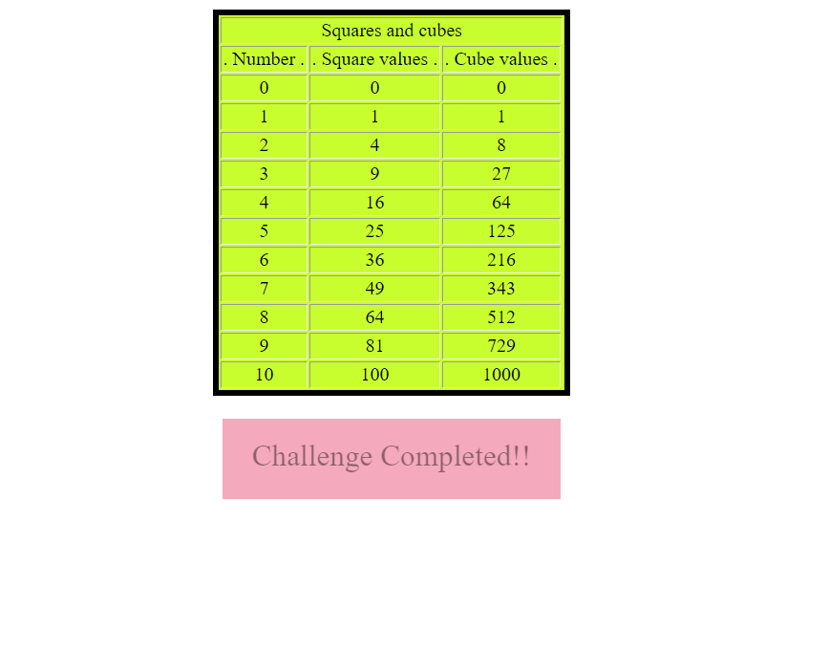
2. | i=10 to 100,  increment of i+10 | 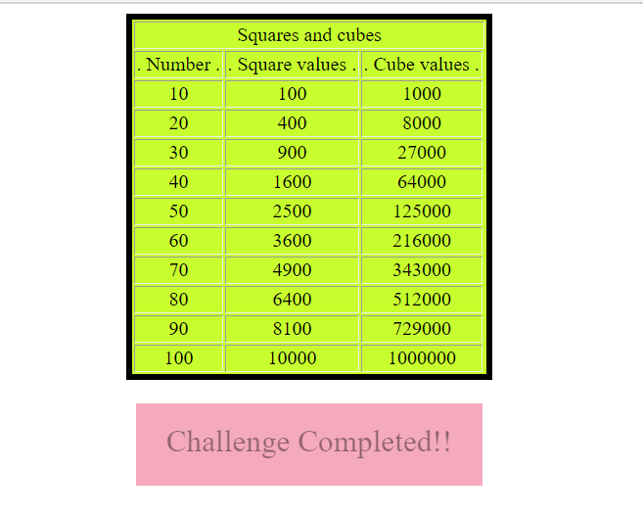
3. | i=100 to 1000,  increment of i+100 | 