1. **Launching an EC2/VM in azure and aws. Connect using ssh through Powershell/Git Bash/Terminal/MobaXterm.**

In powershell

Create an ec2 instance and copy the ssh id.go to powershell and copy the path,enter yes & then click enter.

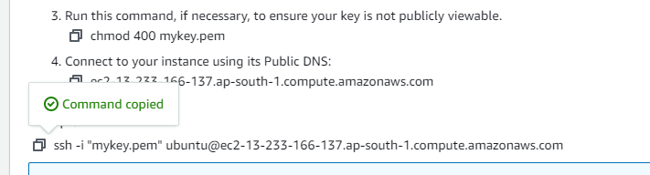

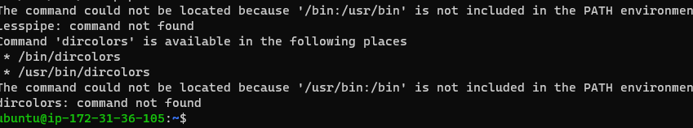

In Gitbash

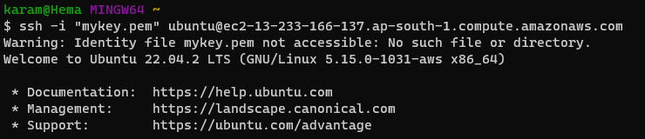

1. **Installing softwares using chocolatey**

First install chocolatey in windows

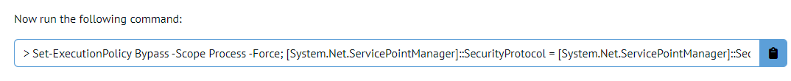

Execute the above command in terminal to install chocolatey

Choco is packaging manager in windows

By using choco we can install necessary softwares in windows

Check whether choco is installed or not by running this command

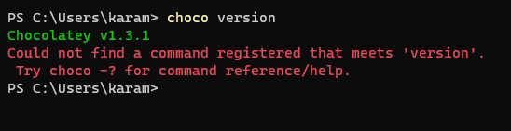

🡪winscp



🡪notepadplusplus



🡪gitbash



🡪MobaXterm



🡪Beyondcompare



1. **Create a keypair in AWS**

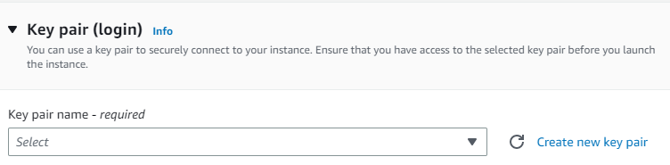

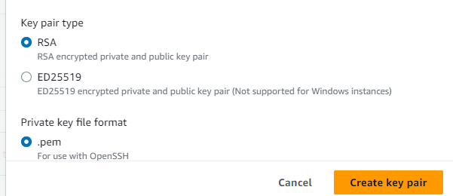

1. **Create a Security Group/NSG in AWS/Azure and assign 22,80 and 443 ports.**

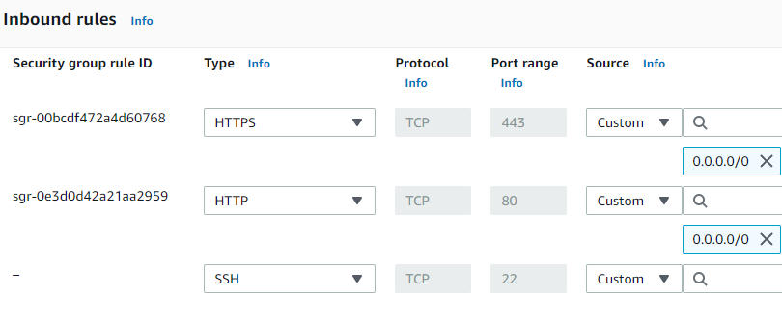

1. **Create users using adduser/useradd/deleteuser/deletegroup/removeuserfrom group and assign passwords and group creation and add the existing user to the group.**

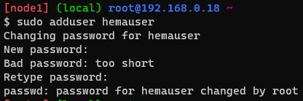

1. **Find the location of users,passwords and groups.**





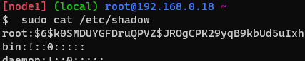

1. **Upload files into a remote repository using SFTP from a local machine.**

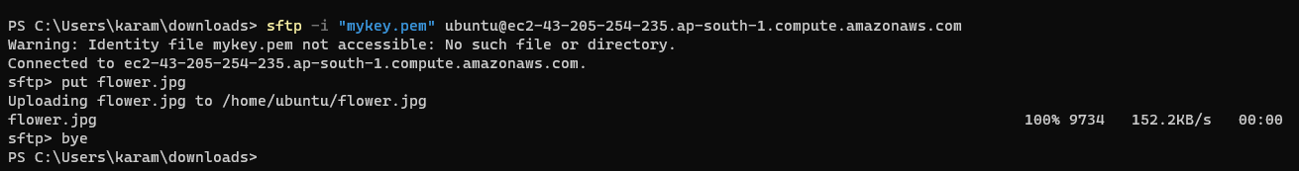

**connect ec2 to gitbash/terminal**

install any html image(apache2)

cd /var/🡪ls🡪cd www🡪ls🡪cd html/🡪ls🡪cd🡪sudo cp (our image name) /var/www/html

(copying image from source to destination)

Open browser ip address/image name

1. **Hands-on file permissions and change ownerships**

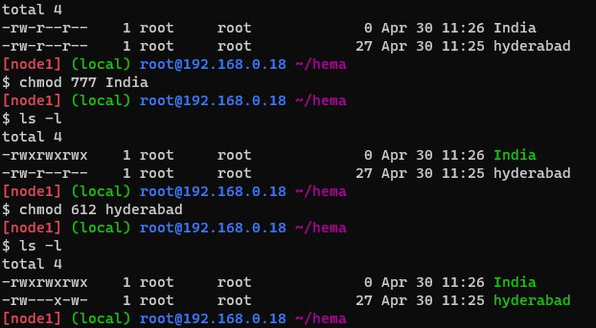

1. **Import key pair/ Ssh keypair concepts on AWS/Azure cloud.**

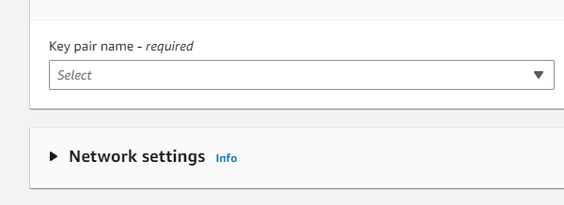

1. **cp and mv rm and rmdir and wc /Head/Cut/Sort/Grep/Uniq and process ....etc commands usage.**

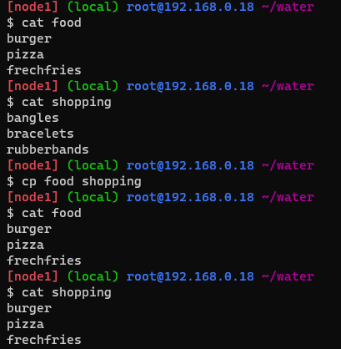

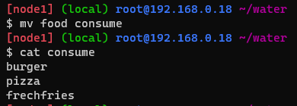

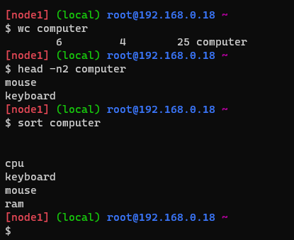

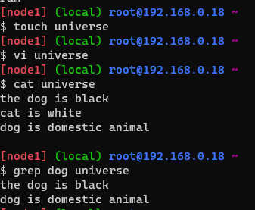

1. **Download and Install java using tar file and set environment variable for java**

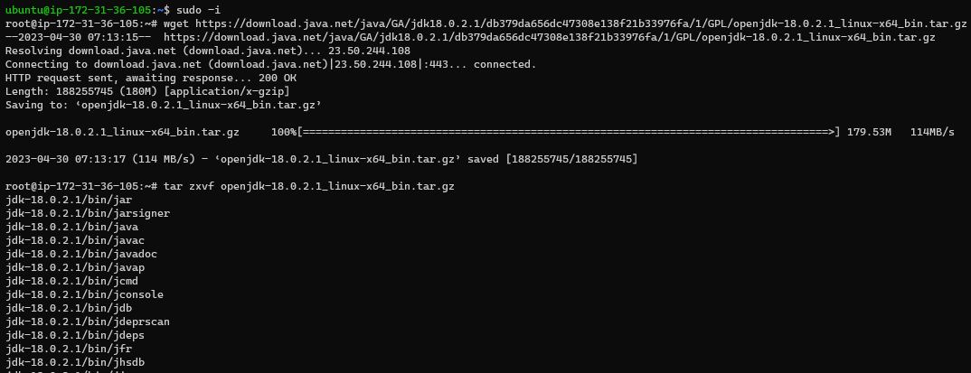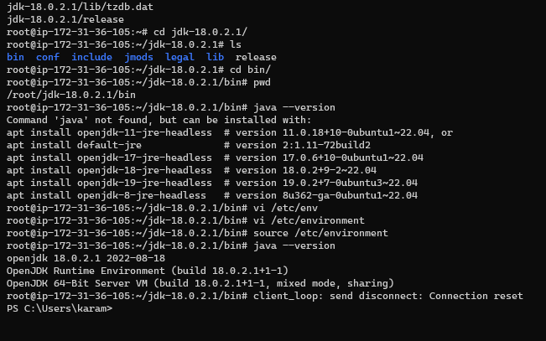

1. **Generate ssh and Connect 2 linux machines using ssh-copy-id**

