**Instructions to execute the code:**

1. Compile the source code in terminal using below command

$ gcc -o movie MovieShowTimes.c

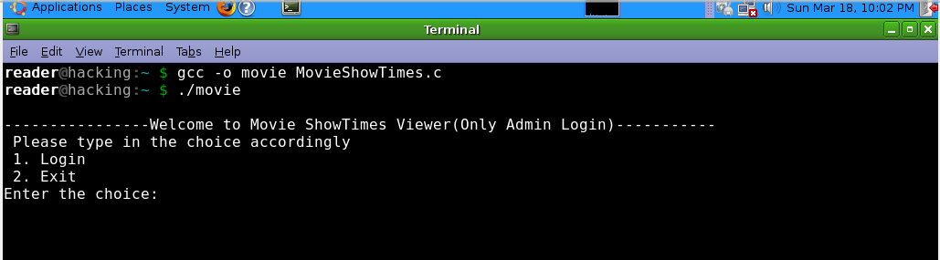

1. Then run the executable file like below:

$ ./movie

1. Then type 1 to proceed into application
2. Type in the username “root” and password ”root” to proceed.
3. Select the choice as 1 to view the movie and show timings.

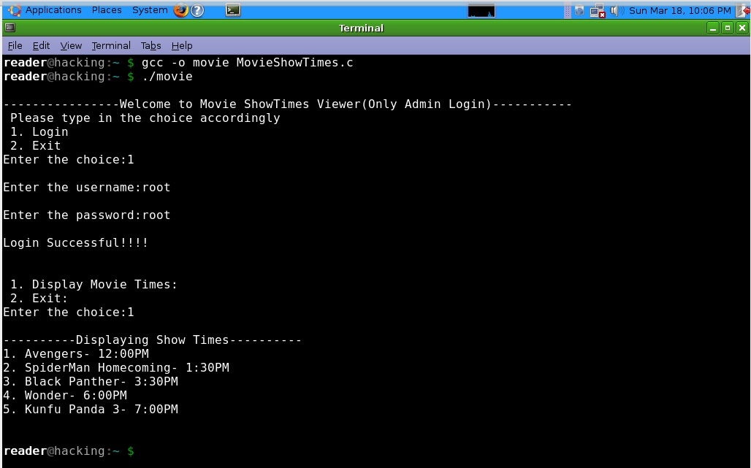

**How to exploit the application:**

1. Compile the source code in terminal using below command

$ gcc -o movie MovieShowTimes.c



1. Then run the executable file like below:

$ ./movie

1. Then type 1 to proceed into application
2. **Type any username having 35 characters and above, type in any password.**

