Project Understanding Document

Table of Contents
Executive Summary
1. Project Overview
1.1 Problem Statement
1.2 Objectives
1.3 Key Stakeholders
2. Stakeholder RACI
3. Primary Use Cases
4. Scope
5. Target Architecture
6. Tools
7. Data Sources & Ingestion
8. Data Model
9. Pipelines & Orchestration
10. Dashboards & KPIs
11. Data Governance & Security
12. SDLC & DevOps
13. Data Population & Backfill
14. Modules & Timeline
15. Risks, Assumptions & Dependencies
16. Success Metrics & ROI
17. Glossary

Executive Summary
This project establishes a centralized manufacturing analytics platform for Tata Motors Pune Plant. Currently, production, maintenance, quality, inventory, and telemetry data exist in silos across spreadsheets and systems, leading to manual reconciliation, delayed KPIs, and missed early indicators of machine failures. The proposed lakehouse-based solution integrates all data into a governed, scalable Azure platform. Phase 1 focuses on descriptive and diagnostic analytics with automated KPIs and alerts, while Phase 2 enables predictive maintenance and ML-driven optimization.

1. Project Overview
1.1 Problem Statement
The Tata Motors Pune Plant faces operational challenges due to fragmented data across production, maintenance, inventory, quality, and machine telemetry systems. Daily manual consolidation delays KPI reporting by 1–2 days. Limited spare parts visibility leads to unplanned downtime impacting production output by approximately 5–7% monthly.
1.2 Objectives
- Create a single source of truth for manufacturing data
- Automate KPI calculations (OEE, MTTR, MTBF, scrap, downtime Pareto)
- Enable historical trend analysis with threshold-based alerts
- Provide role-based dashboards for Operations, Maintenance, Quality, Stores, and Management
- Establish governance (catalog, lineage, RBAC, data quality)
- Ensure Phase 2 readiness for predictive maintenance
1.3 Key Stakeholders
Sponsor (Plant Head), Product Owner (Manufacturing Excellence), Data Owners (Production, Maintenance, Quality, Stores), Data Engineering Lead, BI Lead, Security Lead, Business Users.

2. Stakeholder RACI
R = Responsible, A = Accountable, C = Consulted, I = Informed
Activity | Sponsor | Product Owner | Data Owners | Data Eng | BI Team | Security
Project approval & funding | A | I | I | I | I | I
Requirements & KPI definition | I | A/R | C | C | C | I
Source data ownership | I | C | A/R | I | I | I
Data ingestion & processing | I | C | C | A/R | I | I
Data modeling & KPIs | I | C | C | A/R | C | I
Dashboard development | I | C | C | C | A/R | I
Data quality validation | I | C | A | R | C | I
Security & access control | I | I | I | C | C | A/R
UAT & business sign-off | I | A/R | C | I | I | I
Production release | I | A | I | R | R | C

3. Primary Use Cases
- Analyse repeat machine failures and overheating events to plan preventive maintenance proactively.
- Monitor OEE by line and shift to identify performance losses.
- Track scrap trends by model and station to reduce defects and improve quality.
- View real-time inventory and spare-parts availability to prevent stockouts.
- Receive daily and weekly KPI summaries to support faster decision-making.

4. Scope
Current Phase Scope:
- Ingestion of production, maintenance, telemetry, quality, inventory, and shift data
- Bronze/Silver/Gold data layers
- Fact and dimension modeling
- KPI automation and dashboards
- Data governance and security
Out of Scope:
- Real-time streaming ingestion
- Machine learning model deployment (Phase 2)

5. Target Architecture
Data flows from source systems into Bronze (raw), Silver (cleaned and standardized), and Gold (analytics-ready) layers using Azure Data Factory and Databricks/Synapse Spark. Gold-layer data is served through Azure Synapse SQL to Power BI dashboards with role-based access control.
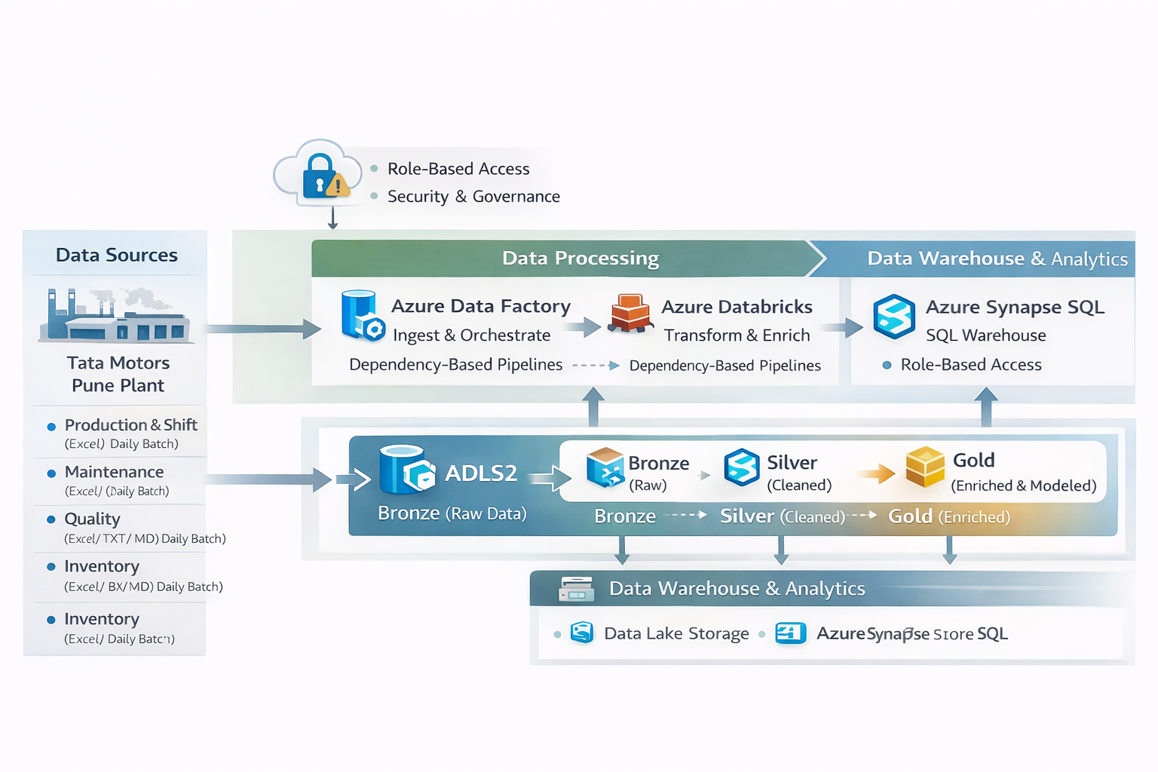

6. Tools
Azure Data Lake Storage Gen2
Azure Data Factory
Azure Databricks
Azure Synapse SQL
Power BI
Microsoft Purview
Azure Key Vault
Azure DevOps

7. Data Sources & Ingestion
Production & Shift Data – Excel, daily batch
Maintenance & Repairs – Excel, daily batch
Machine Telemetry – JSONL, micro-batch (5–10 minutes)
Quality & Scrap – Excel/TXT/MD, daily batch
Inventory & Spares – Excel, daily batch

8. Data Model
Dimensions: dim_machine, dim_line, dim_plant, dim_employee, dim_part, dim_supplier, dim_vehicle_model, dim_date
Facts & Grain:
fact_production – per machine per shift per day
fact_downtime – per downtime event
fact_repairs – per repair activity
fact_spare_usage – per part usage event
fact_inventory – per part per day
fact_telemetry – per machine per timestamp

9. Pipelines & Orchestration
Bronze Layer: Raw ingestion with metadata, source tracking, and hash validation
Silver Layer: Schema enforcement, deduplication, SCD Type 2 handling, JSON/YAML parsing
Gold Layer: KPI computation, threshold breach flags, semantic modeling
Error Handling: Schema drift detection, quarantine of bad records, replay and reprocessing support
Orchestration: Dependency-based ADF pipelines with retries and alerts

10. Dashboards & KPIs
Dashboards: OEE Overview, Downtime Pareto, MTTR/MTBF Trends, Scrap Analysis, Inventory Health, Telemetry Alerts
Key KPIs:
OEE = Availability × Performance × Quality
MTTR = Total Repair Time / Number of Repairs
MTBF = Total Uptime / Number of Failures
Scrap Rate = Scrap Units / Total Units

11. Data Governance & Security
Data ownership defined by domain
Business and technical metadata cataloged in Purview
End-to-end lineage from source to dashboard
RBAC with Azure AD
PII masking for operator data
Change control board for schema and KPI changes

12. SDLC & DevOps
Environments: Dev, Test, Prod
Feature-branch development with PR reviews
CI/CD for ADF, Spark, SQL, and Power BI
Rollback using Git tags and backups
Monitoring of pipeline failures, data freshness, and cost
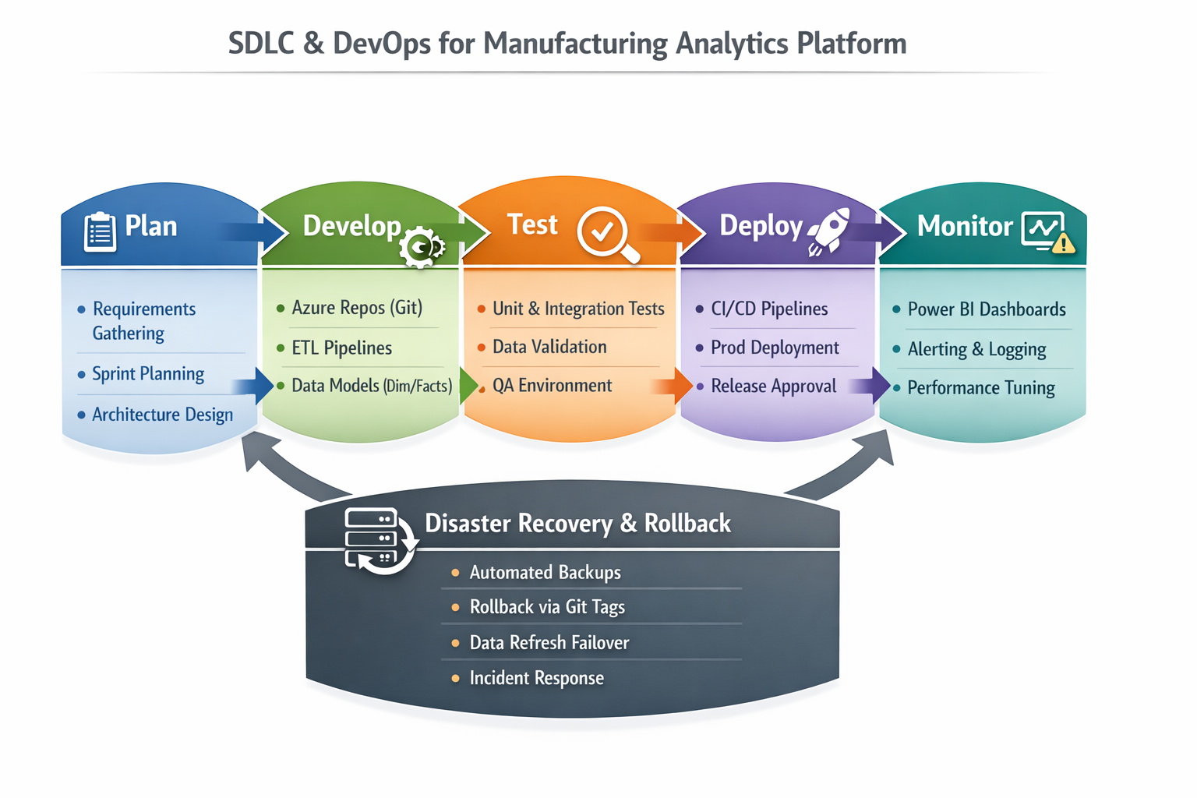

13. Data Population & Backfill
Initial backfill of 6–12 months historical data
Daily incremental loads with watermarking
Late-arriving data handling and reconciliation checks
SCD Type 2 for machines, lines, and employees

14. Modules & Timeline
Weeks 1–2: Foundations and environment setup
Weeks 3–5: Source ingestion to Bronze
Weeks 6–8: Silver transformations and dimensions
Weeks 9–11: Gold facts and KPI logic
Weeks 12–14: Dashboards and UAT
Weeks 15–16: Go-live and training

15. Risks, Assumptions & Dependencies
Risks: Missing historical data, schema drift, access delays, telemetry spikes, user adoption
Mitigations: Source audits, schema registry, early approvals, autoscaling, training
Assumptions: SME availability, Power BI tenant access, budget approval
Dependencies: Plant IT support, vendor coordination, shared drive/API access

16. Success Metrics & ROI
60% reduction in manual reporting effort
Same-day KPI availability
Reduced unplanned downtime through early alerts
Improved inventory planning and reduced stockouts

17. Glossary
OEE – Overall Equipment Effectiveness
MTTR – Mean Time To Repair
MTBF – Mean Time Between Failures
SCD – Slowly Changing Dimension
ADF – Azure Data Factory

