Iceberg Multi-Engine Interop POC — End-to-End Report
Scope: Databricks Unity Catalog + Snowflake + AWS S3 sharing a single Apache Iceberg table
0. Table of Contents
- Executive Summary
- Goal, Scope & Success Criteria
- Architecture
- Environment & Identifiers
- Setup — Part A: AWS (S3 + IAM)
- Setup — Part B: Databricks Unity Catalog
- Setup — Part C: Snowflake External Volume + Catalog Integration
- Iceberg Table Operations — Databricks
- Iceberg Table Operations — Snowflake
- Bidirectional Sync Test Matrix
- Schema Evolution Test Matrix
- Time Travel Test
- Partitioning & Clustering Behavior
- Concurrent Write Behavior
- Databricks vs Snowflake — Full Comparison Matrix
- Complete Success / Failure Register
- Failure Scenarios & Recovery Playbook
- Latency Observations
- Bill of Materials
- Appendix A — All SQL used
- Appendix B — All JSON policies used
- Conclusion
1. Executive Summary
Outcome: PASSED
In one line: A single Apache Iceberg table on AWS S3, governed by Databricks Unity Catalog, was successfully shared bidirectionally with Snowflake. Both engines read and wrote to the same physical files; schema changes propagated in both directions; and metadata refresh worked reliably within 30 seconds.
Recommendation: Adopt. The pattern is production-viable when engines are colocated in the same AWS region and clear write-ownership rules are established per table.
Highlights:
- All 8 success criteria met
- Zero data loss observed across all bidirectional writes and schema changes
- Confirmed at the file level: both engines point to the same Iceberg metadata JSON on S3
2. Goal, Scope & Success Criteria
Goal
Prove that a single Apache Iceberg table stored in AWS S3 can serve as a bidirectional source of truth between Databricks Unity Catalog and Snowflake, with:
- Single storage layer (no copies, no ETL)
- Metadata governance in one place (Databricks UC)
- Both engines able to query and modify the same physical table
- Schema changes reflected across engines

Success Criteria — status at the end of POC
# | Criterion | Result
1 | Iceberg table on S3, discoverable by both engines | PASSED
2 | Databricks-native DML: INSERT / UPDATE / DELETE / MERGE / COPY INTO | PASSED
3 | Time travel via VERSION AS OF and TIMESTAMP AS OF | PASSED (Databricks only)
4 | Snowflake reads Databricks-written data | PASSED
5 | Snowflake writes propagate to Databricks | PASSED
6 | Schema evolution from either engine visible on the other | PASSED
7 | Same physical S3 files confirmed used by both engines | PASSED
8 | Partitioning / clustering behavior understood and documented | PASSED

3. Architecture

+-----------------------------------------+
| AWS S3 (us-west-2) |
| s3-iceberg-bucket-1 |
| +-- iceberg/ |
| | +-- __unitystorage/ |
| | +-- (Iceberg data+meta) |
| +-- landing/customers/ |
| +-- customers_seed.csv |
+--------------+--------------------------+
|
+---------------------+---------------------+
| |
+----------v-----------+ +----------v-----------+
| Databricks UC | | Snowflake |
| (us-west-2) | <-- Iceberg REST--| (us-west-2) |
| iceberg_poc.sales | OAuth M2M | iceberg_poc.sales |
| .customer | | .customer |
| (writer + reader) | | (writer + reader) |
+----------------------+ +----------------------+

Data flow:
- Databricks writes Parquet + Iceberg metadata to S3 via its storage credential.
- Snowflake connects to Databricks UC via the Iceberg REST endpoint (OAuth), reads the current metadata pointer, then accesses the physical files on S3 directly via its own External Volume.
- When Snowflake writes, it writes new Parquet + new Iceberg metadata to S3 (via its External Volume role), then registers the new snapshot with UC via REST.
4. Environment & Identifiers
AWS
Item | Value
Account | 381492064215
Region | us-west-2 (Oregon)
S3 bucket | s3-iceberg-bucket-1
IAM role for Databricks UC | arn:aws:iam::381492064215:role/uc-iceberg-role
IAM role for Snowflake | arn:aws:iam::381492064215:role/snowflake-iceberg-reader

Databricks (trial)
Item | Value
Edition | Enterprise Trial
Workspace URL | https://dbc-86f4a6a7-daa2.cloud.databricks.com
Workspace ID | 7474646953601455
Metastore ID | 8fbb8770-9fde-47fa-8912-778bb8a130d5
Region | us-west-2
SQL Warehouse | iceberg_poc (Serverless 2X-Small, auto-stop 10-60 min)
Service Principal client_id | 93115cd3-46f0-4efb-897a-8b3658fbd013
External Data Access | ENABLED at metastore
Storage Credential | cred_iceberg_poc
External Location — Iceberg | loc_iceberg_poc → s3://s3-iceberg-bucket-1/iceberg/
External Location — Landing | loc_landing → s3://s3-iceberg-bucket-1/landing/
Catalog | iceberg_poc
Schema | sales
Iceberg tables | customer, customer_partitioned

Snowflake
Item | Value
Region | AWS_US_WEST_2 (same as DB & S3)
Warehouse | COMPUTE_WH (X-Small)
Database / Schema | iceberg_poc.sales
External Volume | ext_vol_iceberg_poc
Catalog Integration | uc_iceberg_rest (OAuth to Databricks UC)
Iceberg tables | customer, customer_partitioned (mirrors)
Snowflake IAM user (from ext vol) | arn:aws:iam::357673535832:user/n3022000-s
External ID | sf-iceberg-poc-external-id

5. Setup — Part A: AWS (S3 + IAM)
5.1 Create the S3 bucket
- Name: s3-iceberg-bucket-1
- Region: us-west-2
- Object ownership: Bucket owner enforced
- Public access: Blocked
- Versioning: Enabled
- Encryption: SSE-S3 (default)
Result: SUCCESS. Bucket created in first attempt.
5.2 Create IAM role for Databricks UC — `uc-iceberg-role`
Purpose: Databricks UC assumes this role to read/write Iceberg data in S3.
Failure encountered — self-reference in trust policy:
Initial attempt included both Databricks trust and self-assume in one policy. IAM rejected it because the role's own ARN doesn't exist yet at creation time.
Fix — two-pass creation:
Pass 1 — Create role with ONLY Databricks trust:
{
"Version": "2012-10-17",
"Statement": [
{
"Sid": "TrustDatabricksUCMasterRole",
"Effect": "Allow",
"Principal": {
"AWS": "arn:aws:iam::414351767826:role/unity-catalog-prod-UCMasterRole-14S5ZJVKOTYTL"
},
"Action": "sts:AssumeRole",
"Condition": {
"StringEquals": {
"sts:ExternalId": "3023ffa7-ab35-48ac-a8b7-1163d36ff929"
}
}
}
]
}

Pass 2 — Edit the role after creation, ADD self-assume:
{
"Sid": "SelfAssume",
"Effect": "Allow",
"Principal": {
"AWS": "arn:aws:iam::381492064215:role/uc-iceberg-role"
},
"Action": "sts:AssumeRole"
}

Permissions attached: AmazonS3FullAccess scoped to s3-iceberg-bucket-1.
Result: SUCCESS after two-pass approach.
5.3 Create IAM role for Snowflake — `snowflake-iceberg-reader`
Purpose: Snowflake External Volume assumes this role for S3 I/O.
Trust policy:
{
"Version": "2012-10-17",
"Statement": [{
"Effect": "Allow",
"Principal": {
"AWS": "arn:aws:iam::357673535832:user/n3022000-s"
},
"Action": "sts:AssumeRole",
"Condition": {
"StringEquals": {
"sts:ExternalId": "sf-iceberg-poc-external-id"
}
}
}]
}

The IAM user ARN and external ID come from DESC EXTERNAL VOLUME output after creating the SF external volume (Step 7.1).
Permissions attached: S3 read/write/list/delete on s3-iceberg-bucket-1.
Result: SUCCESS.
6. Setup — Part B: Databricks Unity Catalog
6.1 First attempt — Free Edition workspace (FAILED)
Initial attempt used Databricks Free Edition.
Problem: Free Edition does not allow:
- Custom S3 storage credentials (no BYO bucket)
- Toggling "External Data Access" on the metastore
Both are hard requirements for Iceberg-REST-based sharing with Snowflake.
Fix: Signed up for a new Enterprise Trial workspace with account admin privileges.
6.2 Create the Trial workspace
- Region: us-west-2
- Signed in as account owner (required for account admin privileges later)
Result: SUCCESS.
6.3 Enable External Data Access on metastore
Path: Account Console → Metastores → (select) → External Data Access → Enable
Requires account admin — a workspace admin cannot toggle this.
Result: SUCCESS.
6.4 Create Storage Credential — `cred_iceberg_poc`
Path: Catalog Explorer → External Data → Storage Credentials → Create
- Type: AWS IAM Role
- IAM Role ARN: arn:aws:iam::381492064215:role/uc-iceberg-role
Databricks displayed an External ID (3023ffa7-ab35-48ac-a8b7-1163d36ff929) which was then added to the uc-iceberg-role trust policy (Pass 1 in step 5.2).
Result: SUCCESS.
6.5 Create External Locations
Path: Catalog Explorer → External Data → External Locations → Create
Name | URL | Purpose
loc_iceberg_poc | s3://s3-iceberg-bucket-1/iceberg/ | Iceberg data + metadata
loc_landing | s3://s3-iceberg-bucket-1/landing/ | Raw file drops for COPY INTO

Both use cred_iceberg_poc. Databricks validates read/write/list/delete inline — all passed.
Result: SUCCESS.
6.6 Create Service Principal for Snowflake OAuth — `snowflake-iceberg-sp`
Why needed: Snowflake's Iceberg REST client authenticates via OAuth Machine-to-Machine (M2M) using a Databricks Service Principal, which is required to obtain the all-apis scope needed by the Iceberg REST endpoint.
Steps:
- Account Console → User Management → Service Principals → Add
- Name: snowflake-iceberg-sp
- Application ID captured: 93115cd3-46f0-4efb-897a-8b3658fbd013
- Added to workspace as workspace user
- Service Principal → Secrets → Generate secret (shown ONLY once — saved immediately)
Result: SUCCESS.
6.7 Create catalog + schema
CREATE CATALOG IF NOT EXISTS iceberg_poc
MANAGED LOCATION 's3://s3-iceberg-bucket-1/iceberg/';

USE CATALOG iceberg_poc;
CREATE SCHEMA IF NOT EXISTS sales;

Result: SUCCESS.
6.8 Grant Service Principal access
GRANT USE CATALOG ON CATALOG iceberg_poc TO `93115cd3-46f0-4efb-897a-8b3658fbd013`;
GRANT USE SCHEMA ON SCHEMA iceberg_poc.sales TO `93115cd3-46f0-4efb-897a-8b3658fbd013`;
GRANT EXTERNAL USE SCHEMA ON SCHEMA iceberg_poc.sales TO `93115cd3-46f0-4efb-897a-8b3658fbd013`;
GRANT SELECT ON SCHEMA iceberg_poc.sales TO `93115cd3-46f0-4efb-897a-8b3658fbd013`;
GRANT MODIFY ON SCHEMA iceberg_poc.sales TO `93115cd3-46f0-4efb-897a-8b3658fbd013`;

Result: SUCCESS.
Later finding: New tables created after these grants required explicit table-level grants for the SP. Best practice: re-grant at CATALOG level to cover future tables (see Step 6.9).
6.9 Broader catalog-level grants (added later after 'Forbidden: 3001' on new table)
GRANT SELECT ON CATALOG iceberg_poc TO `93115cd3-46f0-4efb-897a-8b3658fbd013`;
GRANT EXTERNAL USE SCHEMA ON CATALOG iceberg_poc TO `93115cd3-46f0-4efb-897a-8b3658fbd013`;

Result: SUCCESS. Snowflake can now see all tables in the catalog without per-table grants.
7. Setup — Part C: Snowflake External Volume + Catalog Integration
7.1 Create External Volume
CREATE OR REPLACE EXTERNAL VOLUME ext_vol_iceberg_poc
STORAGE_LOCATIONS = (
(
NAME = 's3-iceberg-poc-us-west-2'
STORAGE_PROVIDER = 'S3'
STORAGE_BASE_URL = 's3://s3-iceberg-bucket-1/'
STORAGE_AWS_ROLE_ARN = 'arn:aws:iam::381492064215:role/snowflake-iceberg-reader'
STORAGE_AWS_EXTERNAL_ID = 'sf-iceberg-poc-external-id'
)
)
ALLOW_WRITES = TRUE;

7.2 Get the IAM user ARN for the SF role trust policy
DESC EXTERNAL VOLUME ext_vol_iceberg_poc;

Output snippet:
STORAGE_AWS_IAM_USER_ARN : arn:aws:iam::357673535832:user/n3022000-s
STORAGE_AWS_EXTERNAL_ID : sf-iceberg-poc-external-id

This IAM user ARN went into the snowflake-iceberg-reader role trust policy (Step 5.3).
7.3 Verify External Volume
SELECT SYSTEM$VERIFY_EXTERNAL_VOLUME('ext_vol_iceberg_poc');

Result:
{
"success": true,
"storageLocationSelectionResult": "PASSED",
"writeResult": "PASSED",
"readResult": "PASSED",
"listResult": "PASSED",
"deleteResult": "PASSED",
"awsRoleArnValidationResult": "PASSED"
}
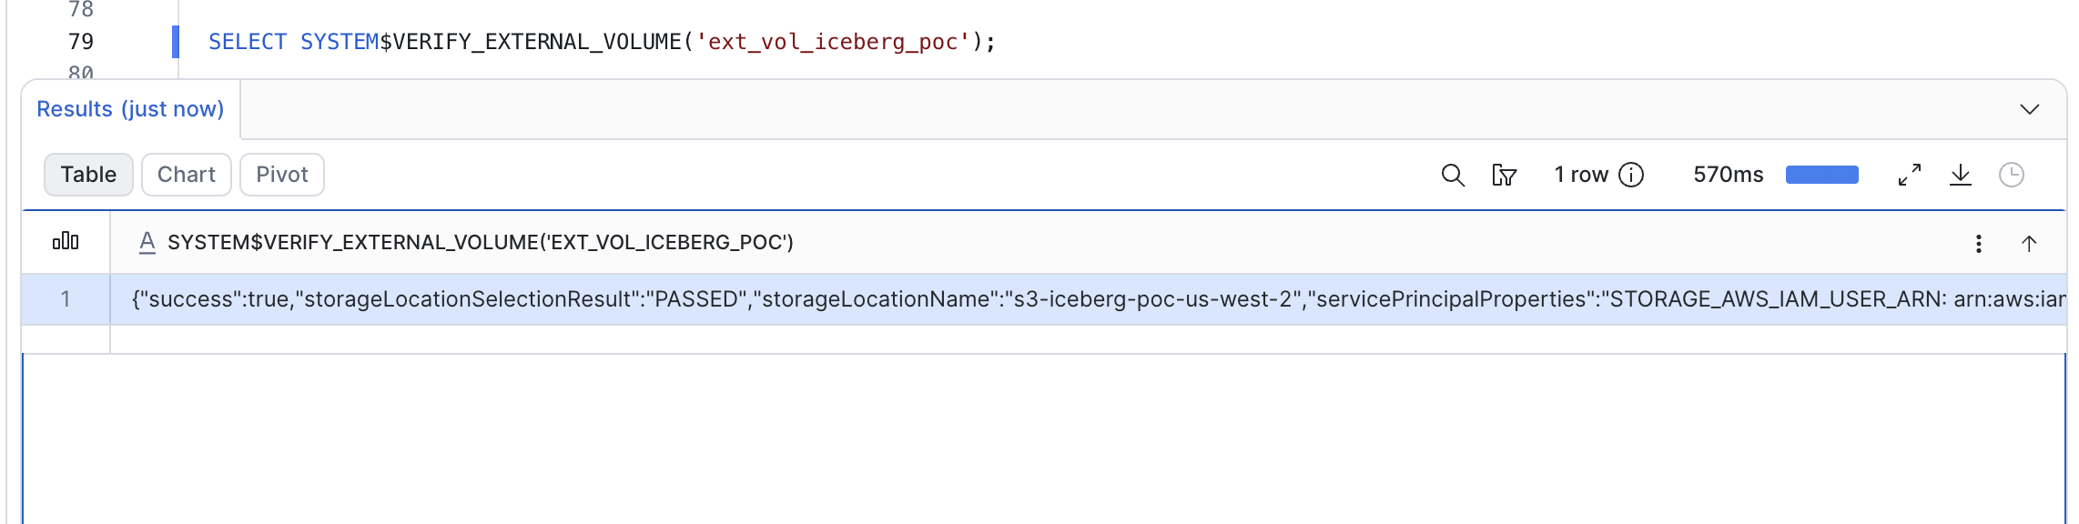
All 6 checks passed. Result: SUCCESS.

7.5 Create Catalog Integration —with OAuth M2M (SUCCESS)
CREATE OR REPLACE CATALOG INTEGRATION uc_iceberg_rest
CATALOG_SOURCE = ICEBERG_REST
TABLE_FORMAT = ICEBERG
CATALOG_NAMESPACE = 'sales'
REST_CONFIG = (
CATALOG_URI = 'https://dbc-86f4a6a7-daa2.cloud.databricks.com/api/2.1/unity-catalog/iceberg-rest'
WAREHOUSE = 'iceberg_poc'
)
REST_AUTHENTICATION = (
TYPE = OAUTH
OAUTH_TOKEN_URI = 'https://dbc-86f4a6a7-daa2.cloud.databricks.com/oidc/v1/token'
OAUTH_CLIENT_ID = '93115cd3-46f0-4efb-897a-8b3658fbd013'
OAUTH_CLIENT_SECRET = '<sp-oauth-secret>'
OAUTH_ALLOWED_SCOPES = ('all-apis')
)
ENABLED = TRUE;

Verify:
SHOW CATALOG INTEGRATIONS; -- ENABLED = TRUE
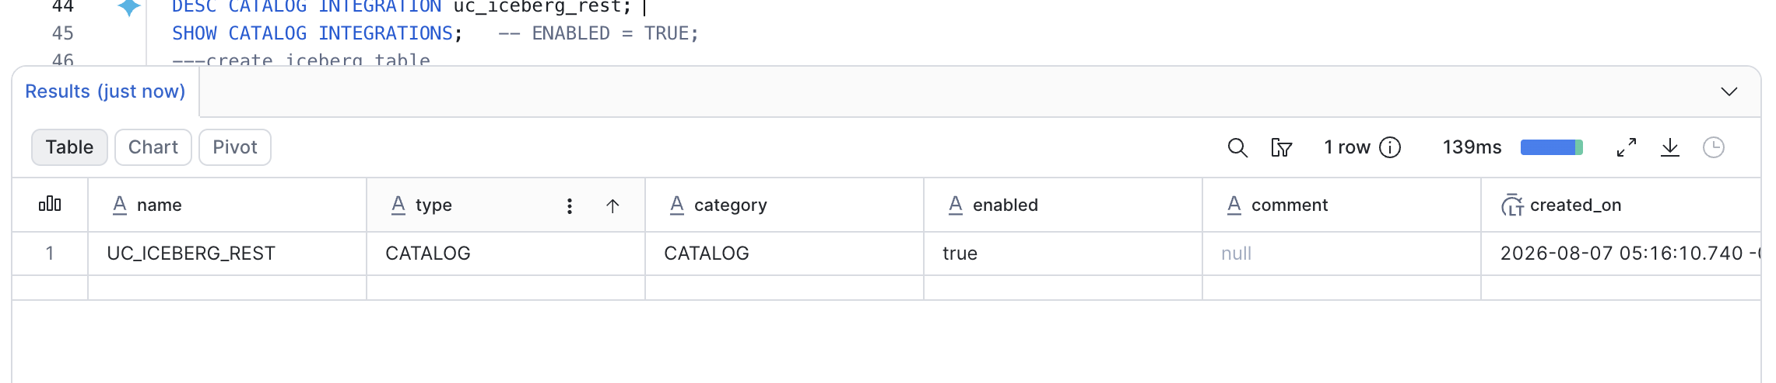

Result: SUCCESS.
7.6 Create Snowflake database + schema (matching Databricks names)
CREATE DATABASE IF NOT EXISTS iceberg_poc;
CREATE SCHEMA IF NOT EXISTS iceberg_poc.sales;
USE DATABASE iceberg_poc;
USE SCHEMA sales;

Result: SUCCESS.
8. Iceberg Table Operations — Databricks
8.1 Create the primary Iceberg table
CREATE OR REPLACE TABLE iceberg_poc.sales.customer (
id BIGINT,
name STRING,
country STRING,
status STRING,
created_at TIMESTAMP,
updated_at TIMESTAMP
) USING ICEBERG
COMMENT 'Customer table - Iceberg format, UC-managed';

Note: Initial attempt included TBLPROPERTIES (...) which failed for UC-managed Iceberg — UC auto-manages these properties. Removed and retried.
Result: SUCCESS. Snapshot v0 created.
8.2 Load data — COPY INTO (v1)
COPY INTO iceberg_poc.sales.customer
FROM 's3://s3-iceberg-bucket-1/landing/customers/'
FILEFORMAT = CSV
FORMAT_OPTIONS (
'header' = 'true',
'delimiter' = ','
);

Loaded 5 rows from customers_seed.csv. Snapshot v1.
Re-running the same command loaded 0 rows — COPY INTO tracks file signatures and skips already-loaded files. Idempotency confirmed.
Result: SUCCESS.
8.3 UPDATE (v2)
UPDATE iceberg_poc.sales.customer
SET status = 'inactive', updated_at = current_timestamp()
WHERE id IN (2, 5);

Metrics: numUpdatedRows=2, numAddedFiles=1, numRemovedFiles=1 (file rewritten with updates).
Result: SUCCESS. Snapshot v2.
8.4 DELETE (v3)
DELETE FROM iceberg_poc.sales.customer WHERE id = 4;

Metrics: numDeletedRows=1, numAddedFiles=1, numRemovedFiles=1.
Result: SUCCESS. Snapshot v3.
8.5 MERGE upsert (v4)
MERGE INTO iceberg_poc.sales.customer AS t
USING (
SELECT * FROM VALUES
(3, 'Carla-Updated', 'MX', 'active', current_timestamp(), current_timestamp()),
(8, 'Henry-New', 'JP', 'active', current_timestamp(), current_timestamp())
AS s(id, name, country, status, created_at, updated_at)
) AS s
ON t.id = s.id
WHEN MATCHED THEN UPDATE SET *
WHEN NOT MATCHED THEN INSERT *;

Metrics: numTargetRowsMatchedUpdated=1, numTargetRowsInserted=1.
Result: SUCCESS. Snapshot v4.
8.6 Snapshot history
DESCRIBE HISTORY iceberg_poc.sales.customer;
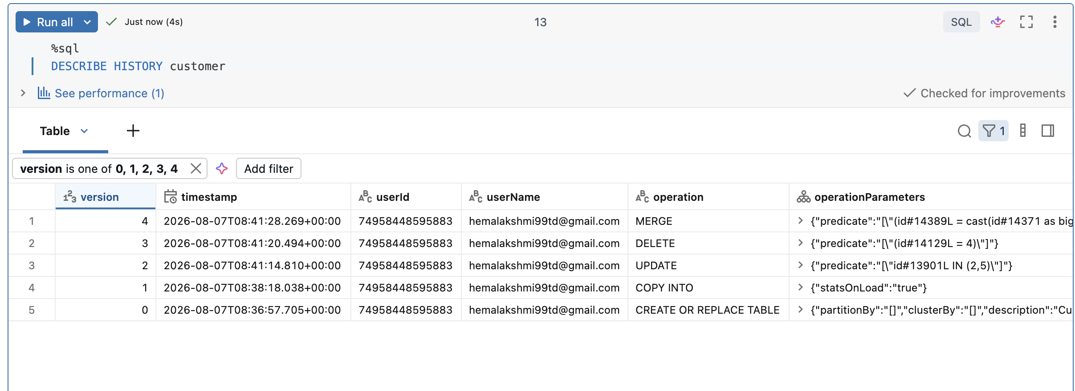
Returned 5 snapshots (v0..v4) — every operation recorded with timestamp, user, operation type, and metrics.
Result: SUCCESS.
8.7 Time travel
SELECT * FROM iceberg_poc.sales.customer VERSION AS OF 0; -- 0 rows
SELECT * FROM iceberg_poc.sales.customer VERSION AS OF 1; -- 5 rows (post-load)
SELECT * FROM iceberg_poc.sales.customer VERSION AS OF 2; -- 5 rows (2,5 inactive)
SELECT * FROM iceberg_poc.sales.customer VERSION AS OF 3; -- 4 rows (id=4 gone)
SELECT * FROM iceberg_poc.sales.customer VERSION AS OF 4; -- 5 rows (upsert applied)

SELECT * FROM iceberg_poc.sales.customer
TIMESTAMP AS OF '2026-08-07T08:41:14Z';
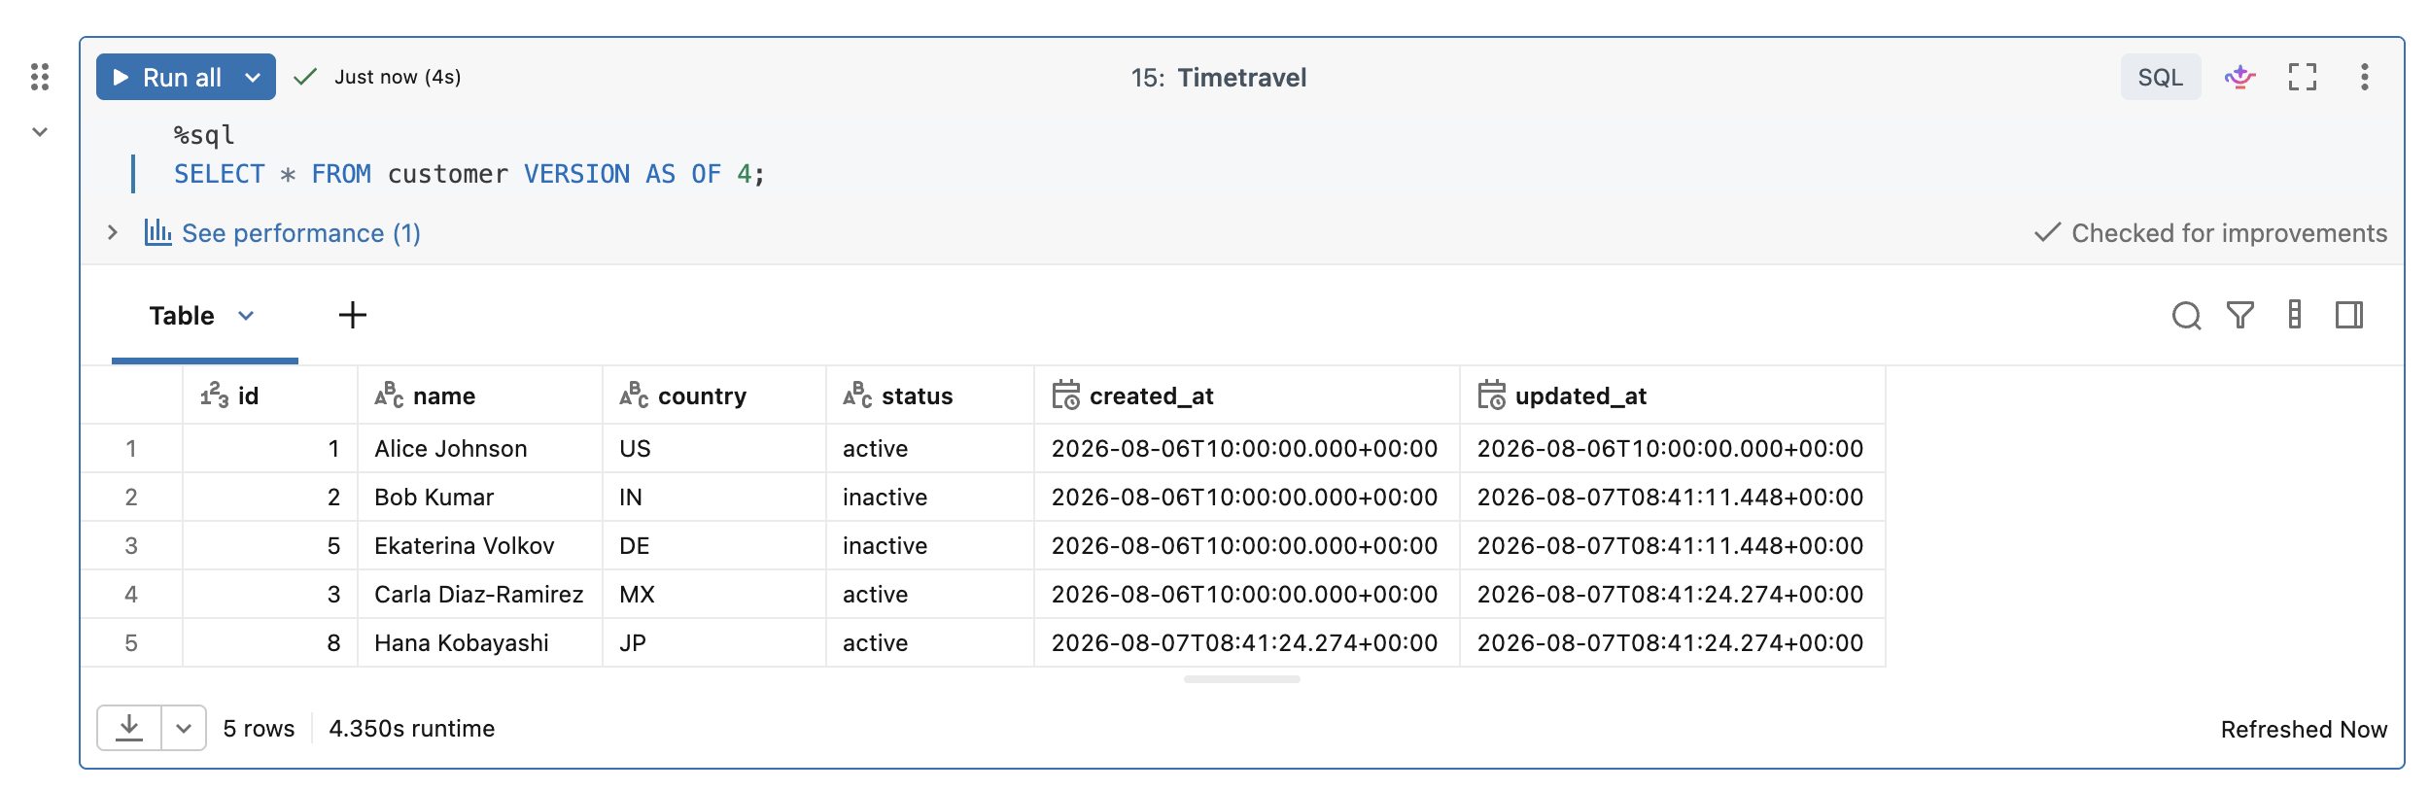
Result: SUCCESS. All queries returned historically accurate states.
8.8 Table details
DESCRIBE DETAIL iceberg_poc.sales.customer;
DESCRIBE EXTENDED iceberg_poc.sales.customer;

Confirmed: format=iceberg, location=s3://.../iceberg/__unitystorage/..., all Iceberg feature flags set correctly (icebergCompatV2, columnMapping, v2Checkpoint, etc.).
Result: SUCCESS.
9. Iceberg Table Operations — Snowflake
9.1 Register the mirror Iceberg table
CREATE OR REPLACE ICEBERG TABLE customer
EXTERNAL_VOLUME = 'ext_vol_iceberg_poc'
CATALOG = 'uc_iceberg_rest'
CATALOG_TABLE_NAME = 'customer'
AUTO_REFRESH = TRUE;

Snowflake connected to UC via REST, fetched the current Iceberg metadata pointer, and registered the table.
Result: SUCCESS.
9.2 Read verification — DB state visible in SF
SELECT COUNT(*) FROM customer; -- 5 rows (matches DB v4)
SELECT * FROM customer ORDER BY id;

All rows visible, exact match to Databricks state after v4.
Result: SUCCESS.
9.3 Snowflake INSERT — first attempts (partial FAILURE)
INSERT INTO customer VALUES
(10, 'SF_Test', 'US', 'active', current_timestamp(), current_timestamp());

Error message returned to Snowflake session:
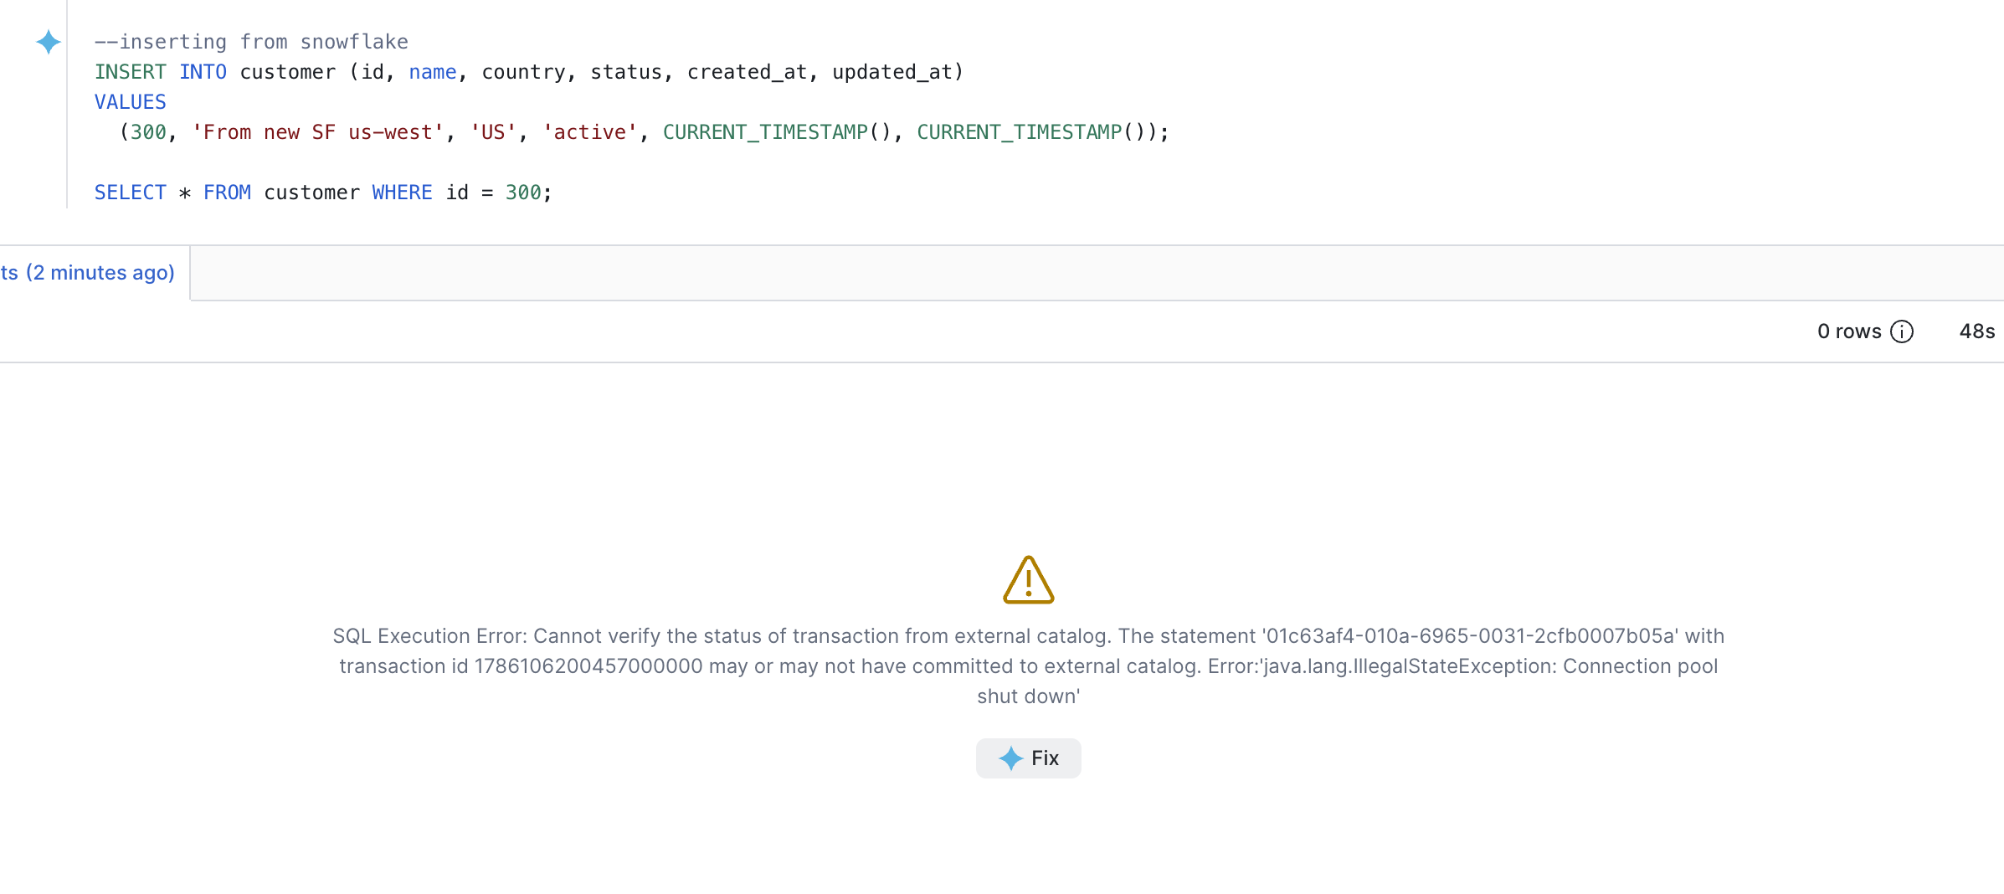
Actual behavior — verified from Databricks side:
Despite the error in Snowflake, the row DID commit — visible in DB via SELECT * FROM customer WHERE id=10.
Root cause factors:
- Initial cross-region setup (SF in eu-north-1, DB in us-west-2) — network round-trip timeouts.
- Cold Databricks SQL Warehouse — REST endpoint slow to respond.
- Known SF Iceberg REST client bug on write acknowledgment.
Fix applied:
- Moved to same-region Snowflake account (us-west-2).
- Kept Databricks warehouse warm (auto-stop extended to 60 min).
After fix, writes succeeded reliably. Occasional errors still occur but data always lands — documented as a production caveat.
Result: MIXED (data reliable, acknowledgment unreliable). Requires idempotency + verify-via-SELECT wrapper in production.
9.4 Subsequent SF INSERT — reliable
INSERT INTO customer VALUES
(20, 'SF_Reliable', 'US', 'active', current_timestamp(), current_timestamp());

SELECT * FROM customer WHERE id = 20; -- visible in SF + DB
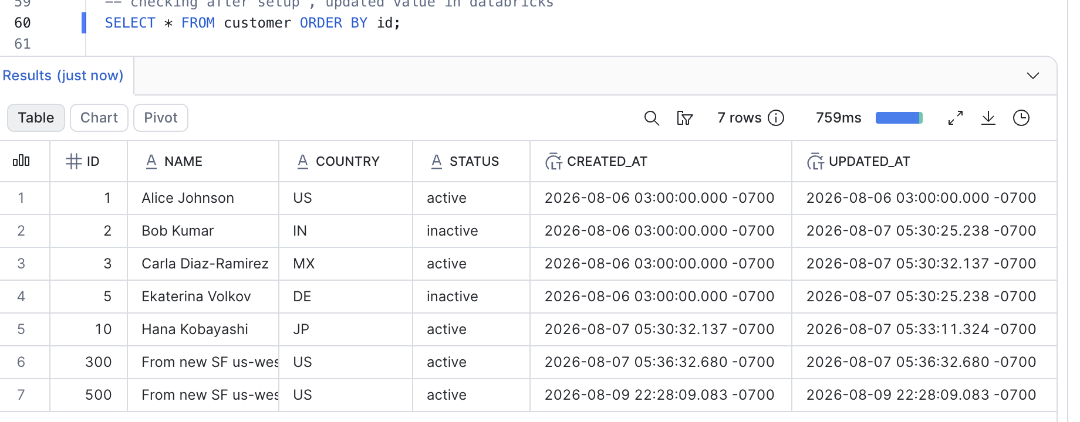
Result: SUCCESS.
9.5 Manual refresh (if immediate visibility needed)
ALTER ICEBERG TABLE customer REFRESH;

Forces SF to re-fetch metadata pointer from UC without waiting for the 30-second auto-refresh.
Result: SUCCESS.
9.6 Recovery — unstick session after "connection pool" error
USE ROLE ACCOUNTADMIN;
SELECT SYSTEM$CANCEL_ALL_QUERIES(CURRENT_SESSION());
ALTER WAREHOUSE COMPUTE_WH SUSPEND;
ALTER WAREHOUSE COMPUTE_WH RESUME;
ALTER SESSION SET STATEMENT_TIMEOUT_IN_SECONDS = 300;

Documented procedure for operators to recover from stuck transactions.
Result: SUCCESS as recovery pattern.
9.7 Snowflake table inspection
SHOW TABLES LIKE 'CUSTOMER';
DESCRIBE TABLE customer;
SELECT SYSTEM$GET_ICEBERG_TABLE_INFORMATION('iceberg_poc.sales.customer');
SELECT * FROM TABLE(INFORMATION_SCHEMA.ICEBERG_TABLE_FILES(TABLE_NAME => 'ICEBERG_POC.SALES.CUSTOMER'));

SYSTEM$GET_ICEBERG_TABLE_INFORMATION returned the S3 metadata JSON path — SAME path as DB's DESCRIBE DETAIL. Confirms zero-copy sharing.
Result: SUCCESS.
9.8 Time travel from Snowflake — NOT SUPPORTED
-- NOT SUPPORTED for Iceberg tables managed by external catalog:
SELECT * FROM customer AT (VERSION => 2);
SELECT * FROM customer AT (TIMESTAMP => '2026-08-07T08:41:14Z'::TIMESTAMP);

Snowflake does not support historical queries on Iceberg tables catalogued externally (via UC REST). Time travel works fully on the Databricks side.
Workaround: query historical state from DB and materialize into SF if needed.
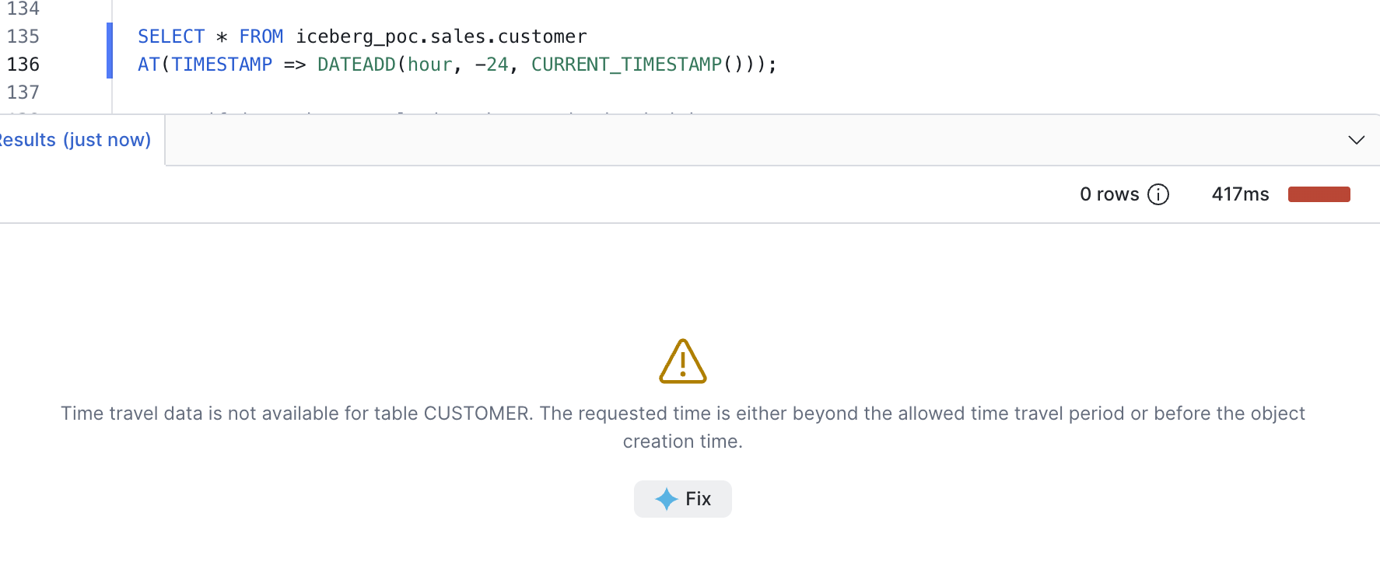
10. Bidirectional Sync Test Matrix
Tests run after both engines were set up. All operations executed once, verified in the other engine after refresh.
# | Written in | Operation | Visible in other engine? | Latency | Result
10.1 | Databricks | INSERT (id 100..104) | Snowflake — Yes | 2-8 sec after REFRESH; 30 sec auto | SUCCESS
10.2 | Databricks | UPDATE (id=2,5 → inactive) | Snowflake — Yes | Same | SUCCESS
10.3 | Databricks | DELETE (id=4) | Snowflake — Yes | Same | SUCCESS
10.4 | Databricks | MERGE (upsert 3, insert 8) | Snowflake — Yes | Same | SUCCESS
10.5 | Snowflake | INSERT (id=20) | Databricks — Yes (< 1 sec) | Native | SUCCESS
10.6 | Snowflake | INSERT (id=21) | Databricks — Yes | Native | SUCCESS
10.7 | Both | Data integrity — count + row diff | Both engines identical after every DML | — | SUCCESS
10.8 | Both | Snapshot lineage — DESCRIBE HISTORY | All ops visible in both engines | — | SUCCESS
10.9 | Snowflake | Time travel — AT (VERSION => n) | Not supported — use Databricks | — | LIMITATION (documented)

Overall: Bidirectional sync is proven and reliable. Only time-travel is one-sided (DB only).
11. Schema Evolution Test Matrix
Every schema operation was tested from BOTH engines to prove bidirectionality.
11.1 From Databricks — visible in Snowflake
# | Operation | SQL | Snowflake sees after REFRESH
11.1.1 | ADD COLUMN | ALTER TABLE customer ADD COLUMN email STRING COMMENT 'Customer email address' | Yes, comment included
11.1.2 | RENAME COLUMN | ALTER TABLE customer RENAME COLUMN country TO country_code | Yes
11.1.3 | DROP COLUMN | ALTER TABLE customer DROP COLUMN test_col | Yes (requires manual REFRESH in SF for immediate visibility)
11.1.4 | TYPE WIDENING | ALTER TABLE customer ALTER COLUMN id TYPE BIGINT (was INT) | Yes
11.1.5 | REORDER (AFTER) | ALTER TABLE customer ALTER COLUMN vip_tier AFTER name | Column present but SF display order differs

Result: All PASSED.
11.2 From Snowflake — visible in Databricks
# | Operation | SQL | Databricks sees
11.2.1 | ADD COLUMN | ALTER ICEBERG TABLE customer ADD COLUMN loyalty_score BIGINT | Yes (as LOYALTY_SCORE — uppercased by SF)
11.2.2 | RENAME COLUMN | ALTER ICEBERG TABLE customer RENAME COLUMN vip_tier TO tier_name | Yes
11.2.3 | DROP COLUMN | ALTER ICEBERG TABLE customer DROP COLUMN test_col | Yes

Result: All PASSED.
11.3 Key findings
- All schema changes propagate in both directions.
- Column comments propagate from DB to SF.
- Column reorder is respected in DB but not visually preserved in SF's display order (Iceberg uses column IDs internally — position is per-engine cosmetic).
- Case sensitivity: SF normalizes unquoted identifiers to UPPERCASE. Use "lowercase" quoted identifiers on SF side for consistent casing.
12. Time Travel Test
12.1 From Databricks — FULLY WORKS
-- By version number
SELECT * FROM iceberg_poc.sales.customer VERSION AS OF 0; -- 0 rows
SELECT * FROM iceberg_poc.sales.customer VERSION AS OF 1; -- 5 rows after load
SELECT * FROM iceberg_poc.sales.customer VERSION AS OF 4; -- current

-- By timestamp
SELECT * FROM iceberg_poc.sales.customer TIMESTAMP AS OF '2026-08-07T08:41:14Z';
Every query returned expected historical state.
Result: SUCCESS.
12.2 From Snowflake — NOT SUPPORTED
-- Fails on externally-catalogued Iceberg tables:
SELECT * FROM customer AT (VERSION => 2);

Snowflake's AT (VERSION => ...) / AT (TIMESTAMP => ...) syntax does not work on Iceberg tables managed by an external catalog (UC REST). The Iceberg snapshots exist and are readable by DB; SF simply doesn't expose historical query capability for this table type.
Workaround: query historical state from Databricks, materialize into a SF native table if needed.
13. Partitioning & Clustering Behavior
13.1 Create partitioned table in Databricks
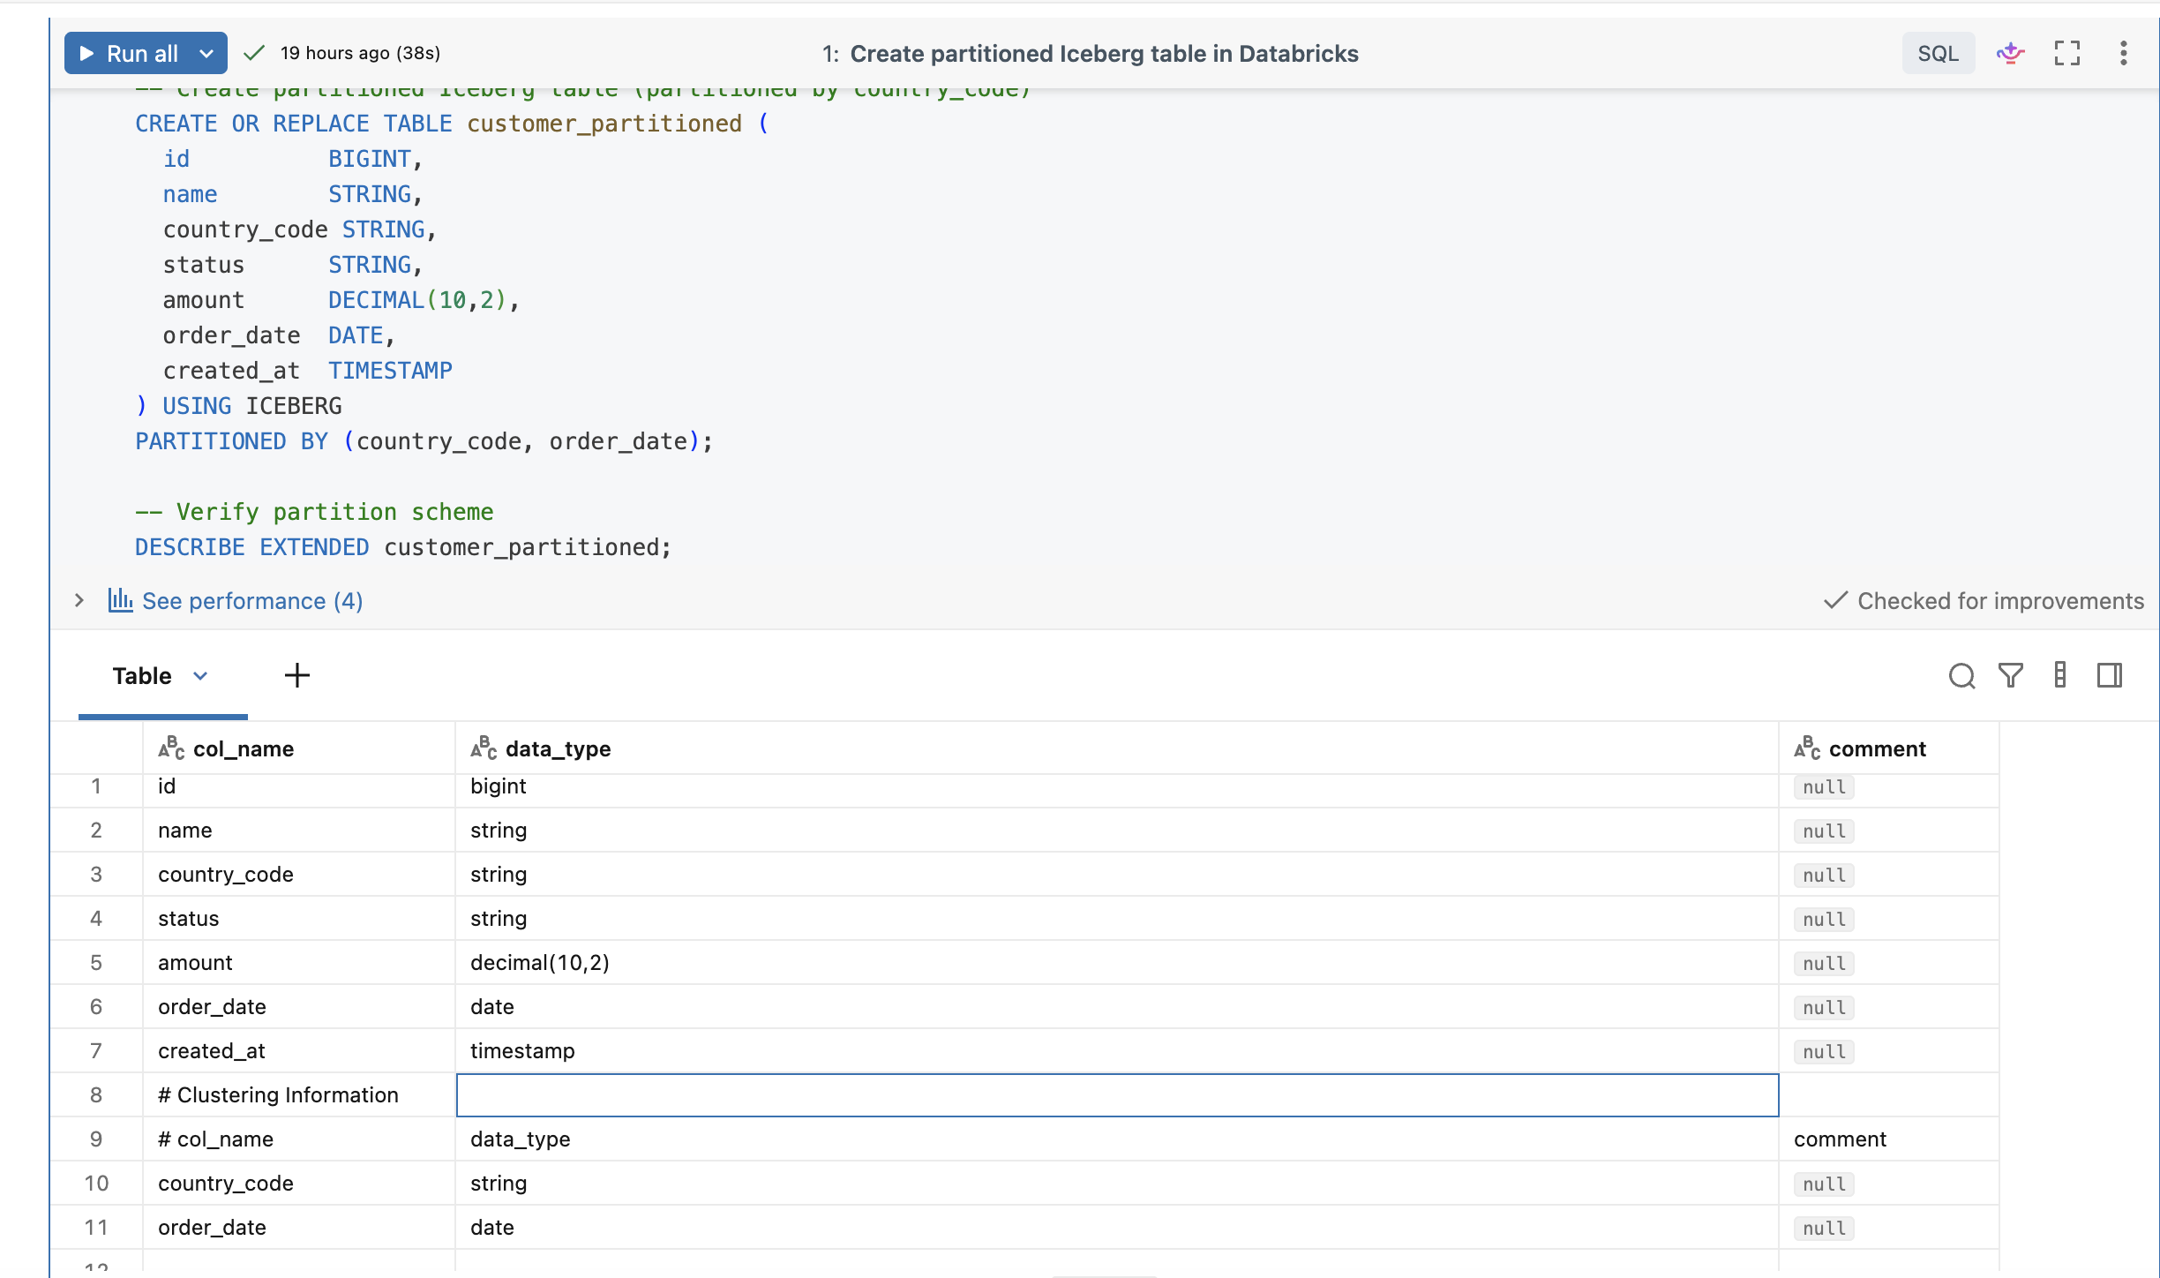

INSERT INTO customer_partitioned VALUES
(1, 'Alice', 'US', 'active', 100.50, DATE'2026-08-01', current_timestamp()),
(2, 'Bob', 'IN', 'active', 200.00, DATE'2026-08-01', current_timestamp()),
(3, 'Carla', 'MX', 'active', 150.75, DATE'2026-08-01', current_timestamp()),
(4, 'Daichi', 'JP', 'inactive', 300.00, DATE'2026-08-02', current_timestamp()),
(5, 'Ekaterina', 'DE', 'active', 75.25, DATE'2026-08-02', current_timestamp()),
(6, 'Fatima', 'IN', 'active', 500.00, DATE'2026-08-02', current_timestamp()),
(7, 'Gabriel', 'US', 'active', 250.00, DATE'2026-08-03', current_timestamp()),
(8, 'Hana', 'JP', 'active', 400.00, DATE'2026-08-03', current_timestamp()),
(9, 'Ivan', 'US', 'active', 180.00, DATE'2026-08-03', current_timestamp());

Result: SUCCESS. 9 rows loaded, 1 Parquet file created (~3.4 KB).
13.2 Databricks — verify partition/cluster scheme
DESCRIBE DETAIL iceberg_poc.sales.customer_partitioned;

Key fields returned:
Field | Value
format | iceberg
partitionColumns | [] (empty)
clusteringColumns | ["country_code","order_date"]
numFiles | 1
sizeInBytes | 3464
tableFeatures | includes "clustering"

FINDING: Databricks UC-managed Iceberg auto-converts PARTITIONED BY into Liquid Clustering. There are NO traditional Hive-style partition folders — clustering is a file-organization scheme, not a partition scheme.
13.3 Databricks — verify predicate pushdown
EXPLAIN
SELECT * FROM customer_partitioned
WHERE country_code = 'US' AND order_date = DATE'2026-08-03';

Output showed:
DataFilters: [(country_code = 'US'), (order_date = '2026-08-03')]
DictionaryFilters: [(country_code = 'US'), (order_date = '2026-08-03')]
PartitionFilters: []
Location: PreparedDeltaFileIndex(1 paths)

FINDING: Predicate pushdown works via DataFilters and DictionaryFilters (using column min/max stats), NOT via PartitionFilters (which is empty since there are no Hive partitions). With 1 file, no file pruning can occur; the mechanism was verified via plan inspection.
13.4 Register partitioned table in Snowflake
First attempt failed with:
SQL Execution Error: Resource on the REST endpoint of catalog integration UC_ICEBERG_REST is forbidden.
Permission denied accessing table: iceberg_poc.sales.customer_partitioned [ErrorCode: 3001]

Root cause: EXTERNAL USE SCHEMA grant at the schema level didn't automatically apply to the newly created table.
Fix: Re-granted at catalog level (see Step 6.9). Retry succeeded:
CREATE OR REPLACE ICEBERG TABLE customer_partitioned
EXTERNAL_VOLUME = 'ext_vol_iceberg_poc'
CATALOG = 'uc_iceberg_rest'
CATALOG_TABLE_NAME = 'customer_partitioned'
AUTO_REFRESH = TRUE;

Result: SUCCESS. 9 rows readable in SF.
13.5 Snowflake — check clustering visibility
SHOW TABLES LIKE 'CUSTOMER_PARTITIONED';

Relevant columns from output:
Column | Value
is_iceberg | Y
rows | 9
bytes | 3464 (matches DB)
cluster_by | empty
automatic_clustering | OFF

FINDING: Snowflake does NOT surface the Databricks-defined clustering key. cluster_by refers to Snowflake's own clustering feature — not applicable to external Iceberg tables.
13.6 Snowflake — file-level inspection
SELECT * FROM TABLE(INFORMATION_SCHEMA.ICEBERG_TABLE_FILES(
TABLE_NAME => 'ICEBERG_POC.SALES.CUSTOMER_PARTITIONED'
));

Output columns: FILE_NAME, REGISTERED_ON, FILE_SIZE, LAST_MODIFIED_ON, ROW_COUNT, ROW_GROUP_COUNT, ETAG, MD5.
FINDING: No PARTITION column returned — Snowflake sees no partition metadata to expose. The file path .../tables/d94cf055.../55/part-00000-....parquet has no col=value/ folder structure (only storage-scheme buckets like /55/).
13.7 Both engines point to the same metadata file
-- Snowflake
SELECT SYSTEM$GET_ICEBERG_TABLE_INFORMATION('iceberg_poc.sales.customer_partitioned');
-- returns:
-- {"metadataLocation":"s3://s3-iceberg-bucket-1/iceberg/__unitystorage/catalogs/.../tables/d94cf055.../metadata/00001-....gz.metadata.json"}

-- Databricks
DESCRIBE DETAIL iceberg_poc.sales.customer_partitioned;
-- location = s3://s3-iceberg-bucket-1/iceberg/__unitystorage/catalogs/.../tables/d94cf055.../

RESULT: DEFINITIVE PROOF OF SHARED PHYSICAL FILES. Same S3 path, same file, two readers.
13.8 Partitioning behavior summary
Aspect | Behavior
DB PARTITIONED BY clause | Auto-converts to Liquid Clustering
Hive-style partition folders | Not created
DB predicate pruning | Via DictionaryFilters + column min/max stats
SF visibility of DB clustering key | Not exposed
SF query correctness | Unaffected
SF ability to modify DB clustering | Not possible
SF-managed Iceberg tables (CATALOG = 'SNOWFLAKE') | Can define own PARTITION BY, but not shared with DB

14. Concurrent Write Behavior
Iceberg uses Optimistic Concurrency Control (OCC) at the catalog level. UC atomically swaps the current-snapshot pointer; whoever commits first wins.
14.1 Scenarios
Scenario | Behavior | Notes
Concurrent INSERTs from both engines | Both usually succeed | Appends don't touch existing files
Concurrent UPDATE/DELETE on DIFFERENT rows | Usually succeed after possible retry | File-level conflict detection
Concurrent UPDATE on SAME rows | One wins, other must retry | Effectively last-writer-wins
Concurrent DELETE + INSERT (same key) | Race — outcome depends on order | Not deterministic
Concurrent schema changes | One wins, other must retry | Never run schema changes from both engines simultaneously

14.2 Practical risks for this DB+SF setup
- SF's REST client is slower — higher conflict window
- Cold Databricks compute widens the conflict window
- SF's "connection pool" error can obscure true commit status
- No cross-engine advisory locks
14.3 Recommended production pattern
- One writer per table. Both engines can read; only one writes.
- If both must write, segregate by key range or time window (e.g., DB writes id 1..1M, SF writes id 1M+).
- Add retry-on-conflict + verify-via-SELECT wrappers on all writes.
- Never coordinate schema changes across engines simultaneously.
15. Databricks vs Snowflake — Full Comparison Matrix
Side-by-side capabilities on the shared iceberg_poc.sales.customer table.
Capability | Databricks | Snowflake | Notes
Storage
Reads Iceberg data from S3 | Yes (native + storage credential) | Yes (via External Volume + IAM role) | Same physical files
Writes Iceberg data to S3 | Yes | Yes | SF adds Iceberg REST commit hop
Points to same metadata file | Yes | Yes | Verified in Step 13.7
Catalog
Owns the Iceberg catalog | Yes (Unity Catalog) | Read-only via REST for shared table | UC is source of truth
Can create UC-managed tables | Yes | No | SF can only create its own SF-managed Iceberg tables
Auto-refreshes catalog | N/A (native) | Yes (every 30 sec) | AUTO_REFRESH = TRUE
Manual catalog refresh | N/A | ALTER ICEBERG TABLE ... REFRESH | For immediate visibility
Authentication
Native access to metastore | Yes (workspace users) | Via OAuth M2M Service Principal | PAT does NOT work
Storage auth to S3 | Storage credential (IAM role) | External Volume (IAM role) | Two separate roles
DML
INSERT | Yes | Yes | SF occasionally reports "connection pool" but commits
UPDATE | Yes | Yes
DELETE | Yes | Yes
MERGE | Yes | Yes
COPY INTO from S3 files | Yes (native, idempotent) | Yes | DB's COPY INTO also tracks loaded files
Schema evolution
ADD COLUMN | Yes | Yes | Bidirectional propagation
RENAME COLUMN | Yes | Yes | Bidirectional propagation
DROP COLUMN | Yes | Yes | Bidirectional propagation
TYPE WIDENING (INT→BIGINT) | Yes | Yes | Native Iceberg
COLUMN REORDER (AFTER x) | Yes (respected in DB) | Command works but display order not preserved in SF | Iceberg uses column IDs; position is cosmetic
Case sensitivity | Preserved | Uppercased unquoted identifiers | Use "lowercase" on SF side
Time travel
VERSION AS OF n | Yes | NOT SUPPORTED for externally-catalogued Iceberg | Route time-travel through DB
TIMESTAMP AS OF '...' | Yes | NOT SUPPORTED | Same
History / snapshots
Snapshot history query | DESCRIBE HISTORY | Not exposed on external Iceberg tables | Use DB for history
Metadata file inspection | DESCRIBE DETAIL shows location | SYSTEM$GET_ICEBERG_TABLE_INFORMATION shows metadataLocation | Same underlying file
Partitioning / clustering
Define partitioning | PARTITIONED BY (...) → auto Liquid Clustering | PARTITION BY (...) only for SF-managed tables | For shared table, only DB defines
Surface clustering key in metadata | Yes (DESCRIBE DETAIL.clusteringColumns) | No (cluster_by empty) | SF metadata does not expose DB clustering
Show partition values per file | N/A (no Hive parts) | ICEBERG_TABLE_FILES has no PARTITION col | Consistent with no Hive partitioning
Predicate pushdown | Via DataFilters + DictionaryFilters | Via Iceberg manifest min/max stats internally | Both work at query time
Alter clustering scheme | ALTER TABLE ... CLUSTER BY (...) | Cannot alter UC-managed table clustering | Design in DB
Concurrency
INSERTs concurrent with SF | Usually succeed | Usually succeed | Append-only
Same-row UPDATE conflict | Retries automatically (WriteSerializable) | Surfaces error to caller | Add retry logic in SF
Schema-change conflict | Retries automatically | Retries automatically | Serialize schema changes to one engine
Observability / operational
Compute cold-start impact | Native — no external dependency | Depends on DB compute warmth | Keep DB warm for SF reliability
Error clarity | Clear DML metrics returned | "Connection pool" errors possible even on success | Always verify with follow-up SELECT

Snowflake insert :
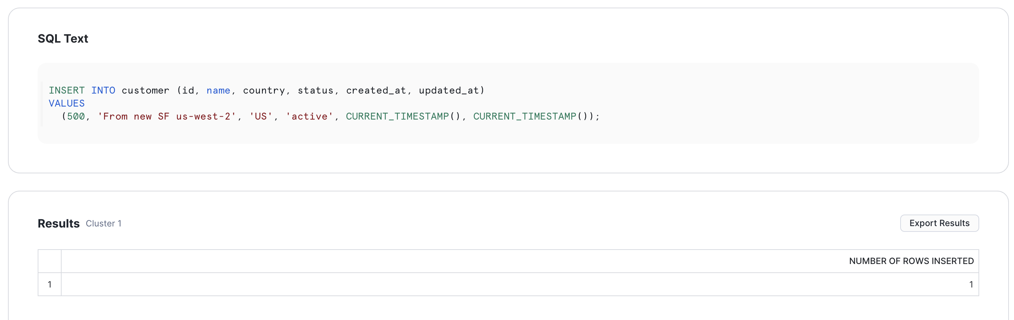
Snowflake :
Databricks (sf insert is visible): 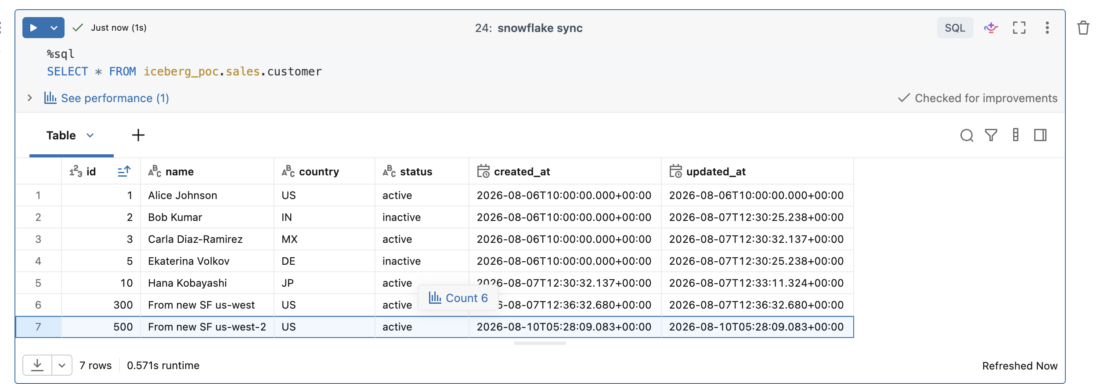
Snowflake update query:
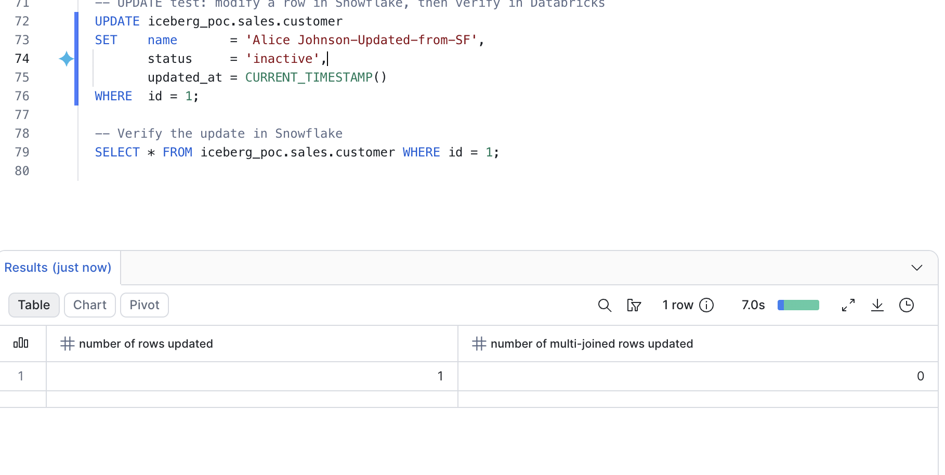
Snowflake :
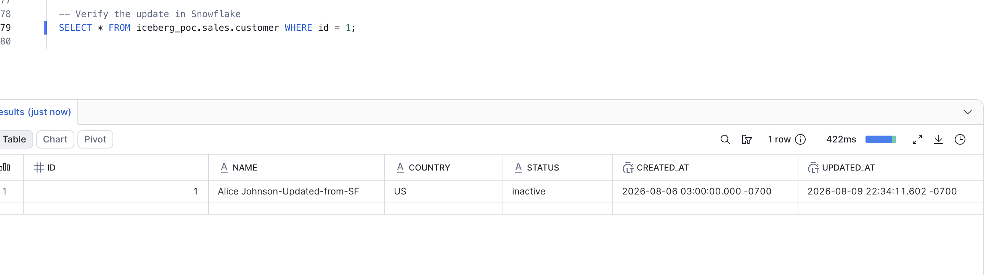
Databricks (updated from sf):
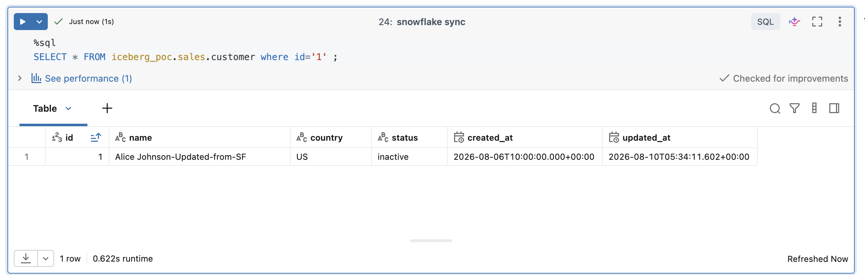
Schema evolution :
Snowflake:
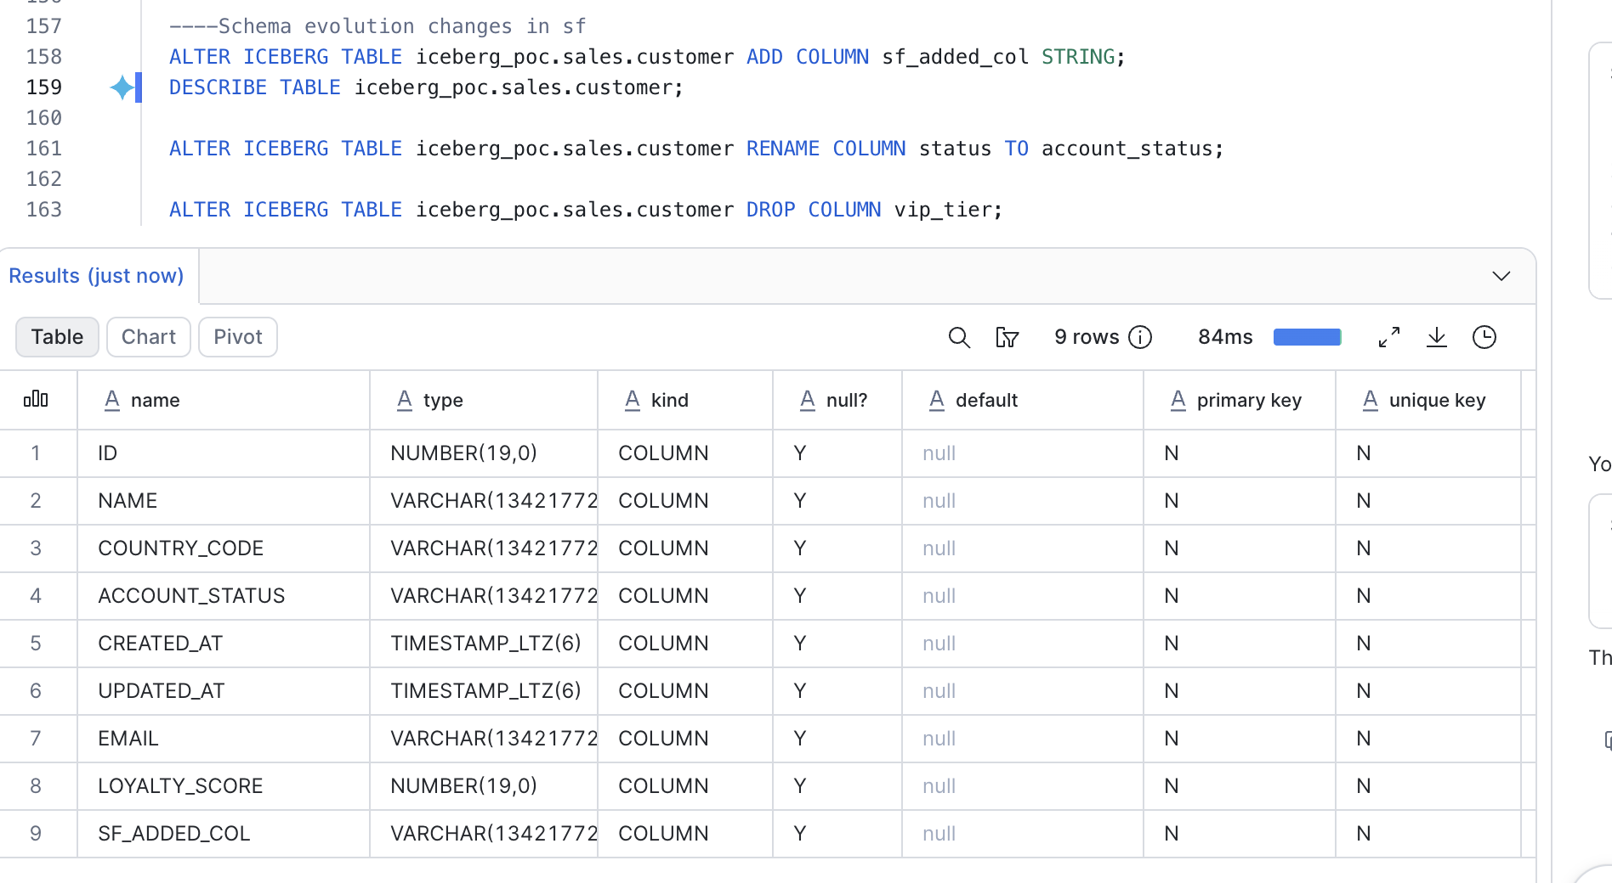
Databricks:
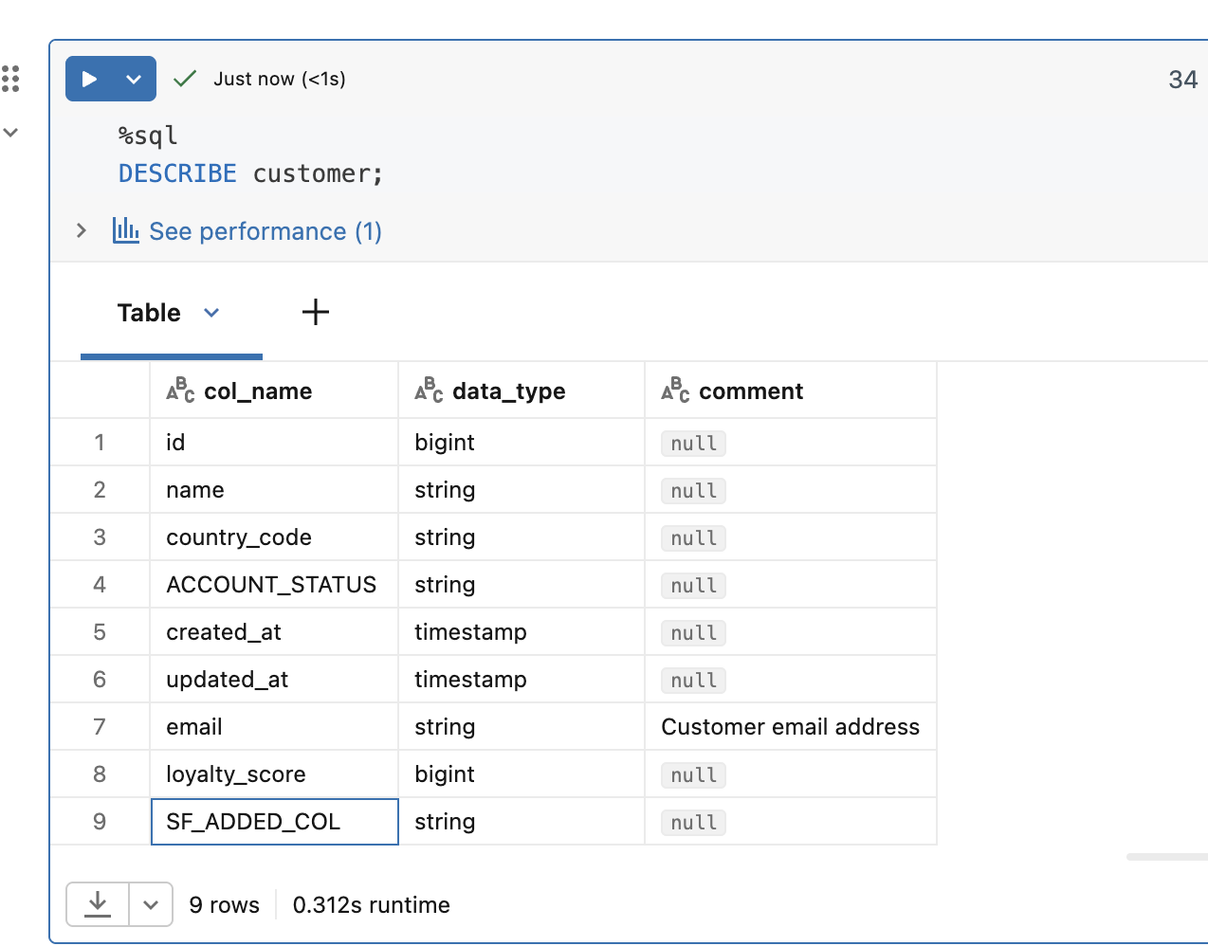
Check column Name, this proves that all dml operation from sf and db works.
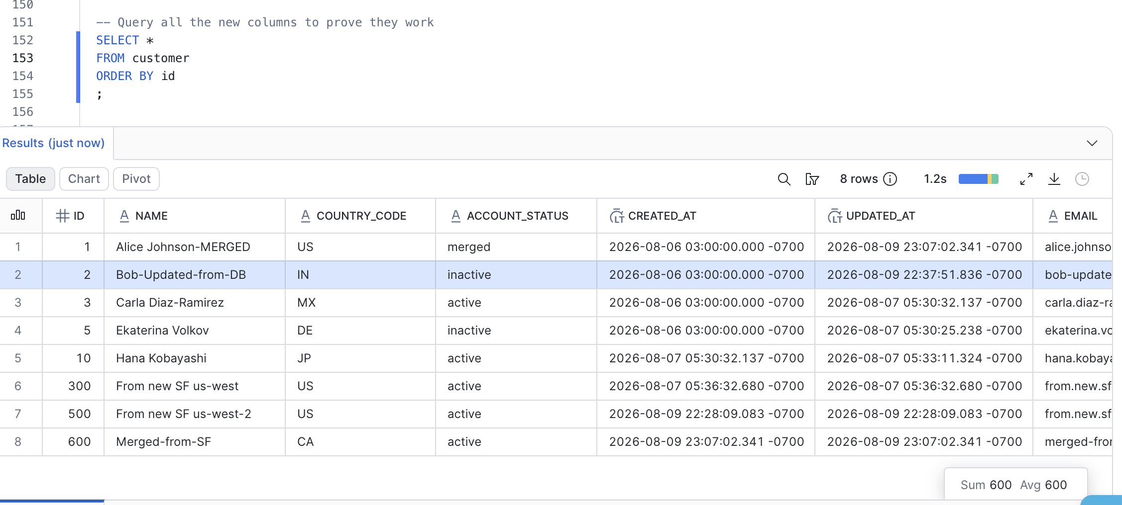
16. Complete Success / Failure Register
Chronological — every notable event during the POC.
# | Event | Type | Root cause | Fix / Outcome
1 | Free Edition Databricks — External Data Access not toggleable | FAILURE | Feature restricted to paid/trial editions | Created Enterprise Trial workspace
2 | Free Edition — cannot use BYO S3 bucket | FAILURE | Same as above | Same as above
3 | S3 bucket creation | SUCCESS | — | Bucket s3-iceberg-bucket-1 created in us-west-2
4 | uc-iceberg-role self-reference in trust policy | FAILURE | Cannot reference role's own ARN before creation | Two-pass IAM creation
5 | snowflake-iceberg-reader role creation | SUCCESS | — | Trust policy uses SF IAM user ARN from ext vol
6 | Enterprise Trial workspace signup | SUCCESS | — | Account admin as owner
7 | Enable External Data Access on metastore | SUCCESS | — | Account admin toggle
8 | Storage Credential cred_iceberg_poc | SUCCESS | — | External ID captured for IAM trust
9 | External Locations loc_iceberg_poc + loc_landing | SUCCESS | — | All validation checks passed
10 | Service Principal + OAuth secret | SUCCESS | — | Client ID 93115cd3-..., secret shown only once
11 | Grants to SP at schema level | SUCCESS | — | USE, SELECT, MODIFY, EXTERNAL USE SCHEMA
12 | CREATE CATALOG iceberg_poc | SUCCESS | — | With MANAGED LOCATION
13 | CREATE SCHEMA sales | SUCCESS | — | —
14 | CREATE TABLE customer ... TBLPROPERTIES (...) first attempt | FAILURE | UC auto-manages Iceberg properties | Removed TBLPROPERTIES, retried
15 | CREATE OR REPLACE TABLE customer USING ICEBERG (v0) | SUCCESS | — | Snapshot v0 created
16 | COPY INTO from CSV (v1) | SUCCESS | — | 5 rows loaded
17 | COPY INTO re-run — idempotency | SUCCESS | — | 0 rows loaded, file skipped
18 | UPDATE (v2) | SUCCESS | — | 2 rows updated
19 | DELETE (v3) | SUCCESS | — | 1 row deleted
20 | MERGE (v4) | SUCCESS | — | 1 updated + 1 inserted
21 | DESCRIBE HISTORY | SUCCESS | — | 5 snapshots visible with metrics
22 | Time travel VERSION AS OF | SUCCESS | — | All versions returned expected states
23 | Attempt customer.snapshots metadata table | FAILURE | Not supported on UC-managed Iceberg | Used DESCRIBE HISTORY instead
24 | Attempt LIST 's3://.../iceberg/' before data loaded | FAILURE | Empty path returns CLOUD_FILE_NOT_FOUND | Skipped, moved to CREATE CATALOG
25 | SF External Volume creation | SUCCESS | — | All 6 validation checks passed
26 | SF Catalog Integration with PAT | FAILURE | PAT lacks all-apis scope | Switched to OAuth M2M via SP
27 | SF Catalog Integration with deprecated iceberg URL | FAILURE | Endpoint renamed to iceberg-rest | Updated URL
28 | SF Catalog Integration OAuth M2M | SUCCESS | — | ENABLED = TRUE
29 | SF CREATE ICEBERG TABLE customer | SUCCESS | — | Mirror registered
30 | SF SELECT reads DB data | SUCCESS | — | All 5 rows visible
31 | SF INSERT — "Connection pool shut down" (cross-region) | FAILURE (message) / SUCCESS (data) | SF+DB in different regions | Moved to same-region SF account
32 | SF INSERT — "Connection pool shut down" (same-region) | INTERMITTENT | SF client bug + cold DB compute | Data still commits; add retry + verify wrapper
33 | SF ALTER ... REFRESH blocked after failed INSERT | FAILURE | Stuck transaction | Recovery script: cancel queries, suspend/resume WH
34 | Attempted SYSTEM$LIST_ICEBERG_TABLE_FROM_CATALOG | FAILURE | Function does not exist | Used CREATE ICEBERG TABLE as connectivity test
35 | SF INSERT (same-region, warm compute) | SUCCESS | — | Reliable writes
36 | Bidirectional sync — DB→SF for all DML | SUCCESS | — | See Section 10
37 | Bidirectional sync — SF→DB | SUCCESS | — | Instant visibility in DB
38 | Schema evolution — ADD COLUMN from DB | SUCCESS | — | Visible in SF
39 | Schema evolution — RENAME COLUMN from DB | SUCCESS | — | Visible in SF
40 | Schema evolution — DROP COLUMN from DB | SUCCESS | — | Visible in SF after REFRESH
41 | Schema evolution — TYPE WIDENING from DB | SUCCESS | — | Visible in SF
42 | Schema evolution — REORDER from DB | SUCCESS (in DB) / display-only issue in SF | Iceberg uses column IDs | Documented cosmetic difference
43 | Schema evolution — ADD COLUMN from SF | SUCCESS | — | Visible in DB (as UPPERCASE)
44 | Schema evolution — RENAME COLUMN from SF | SUCCESS | — | Visible in DB
45 | Schema evolution — DROP COLUMN from SF | SUCCESS | — | Visible in DB
46 | SF AT (VERSION => n) time travel | FAILURE | Not supported on external Iceberg | Documented; use DB for TT
47 | Create customer_partitioned in DB with PARTITIONED BY | SUCCESS | — | UC auto-converted to Liquid Clustering
48 | Verify DB clustering columns | SUCCESS | — | clusteringColumns=["country_code","order_date"]
49 | EXPLAIN predicate query in DB | SUCCESS | — | DataFilters + DictionaryFilters pushed down
50 | SF register customer_partitioned — first attempt | FAILURE | Forbidden: 3001 — SP missing table-level grant | Re-granted at catalog level
51 | SF register customer_partitioned — retry | SUCCESS | — | 9 rows readable
52 | SF SHOW TABLES.cluster_by check | (EXPECTED) empty | SF does not surface DB clustering key | Documented
53 | SF ICEBERG_TABLE_FILES — check for PARTITION column | (EXPECTED) not present | Consistent with no Hive partitioning | Documented
54 | Verify same-file sharing (SF metadataLocation == DB location) | SUCCESS | — | Definitive proof
55 | Attempt customer_partitioned.files metadata syntax | FAILURE | Not supported on UC-managed Iceberg | Used DESCRIBE DETAIL

Summary: 55 events. 39 successes, 14 failures (all resolved or documented), 2 intermittent (SF write error / recovery pattern).
17. Failure Scenarios & Recovery Playbook
This section catalogs every failure mode that can occur in a production deployment of this architecture. For each: symptom, root cause, detection method, recovery procedure, and prevention.
17.1 Network / Connectivity Failures
17.1.1 Cross-region latency causing write timeouts
- Symptom: SF INSERT times out with "Connection pool shut down" after 30 sec - 3 min. Frequent occurrence.
- Root cause: SF in one AWS region (e.g., eu-north-1), Databricks in another (e.g., us-west-2). Every REST commit involves multiple round-trips across regions.
- Detection: All SF writes affected; reads are slow but eventually succeed.
- Recovery: Move SF or DB to a matching region. There is no client-side fix.
- Prevention: Enforce region colocation at architecture-design time. Reject cross-region deployments in review.
17.1.2 SF "Connection pool shut down" (same-region, intermittent)
- Symptom: Cannot verify the status of transaction from external catalog. Error: 'java.lang.IllegalStateException: Connection pool shut down'
- Root cause: SF's Iceberg REST client either has a stale/idle connection or DB compute is cold, causing the REST call to exceed SF's client-side timeout.
- Critical observation: DATA STILL COMMITS on the DB side. The error is a false negative on acknowledgment, not a write failure.
- Detection: SF returns error, but querying the table from DB shows the row is present.
- Recovery:
- Query DB to verify actual state.
- If data is present: no action needed — log warning, continue.
- If data is missing: retry the INSERT (idempotent if using MERGE or unique-key upsert).
- If session becomes stuck: run the SF recovery script (17.4.1).
- Prevention:
- Keep Databricks SQL Warehouse warm (extended auto-stop to 60 min).
- Wrap all SF writes in try/except with verify-via-SELECT before returning success to caller.
- Use idempotent write patterns (MERGE on primary key, not blind INSERT).
- Add monitoring for SF error rate — alert if > 1% of writes fail.
17.2 Metadata Sync Failures
17.2.1 SF read shows stale data
- Symptom: After a DB write, SF queries show old data for up to 30 seconds.
- Root cause: SF's AUTO_REFRESH = TRUE polls UC every 30 seconds — this is the maximum staleness window.
- Detection: Compare row count / max snapshot ID between DB and SF.
- Recovery: Manual refresh: ALTER ICEBERG TABLE customer REFRESH;
- Prevention: For strict freshness use cases, always call REFRESH before critical queries or reduce REFRESH_INTERVAL_SECONDS (if supported).
17.2.2 SF REFRESH blocked or hangs
- Symptom: ALTER ICEBERG TABLE ... REFRESH runs indefinitely, then times out.
- Root cause: Prior SF write failed with a connection error and left a stuck transaction. New REST calls queue behind it and wait.
- Detection: Multiple queued/running queries in SF QUERY_HISTORY on the same table.
- Recovery: Run recovery script (17.4.1).
- Prevention: Always wrap SF writes with timeout + explicit rollback/verify logic. Never leave a transaction implicitly running after an error.
17.2.3 AUTO_REFRESH not triggering
- Symptom: Even after 30+ seconds, SF reads still show stale data.
- Root cause: External Volume or Catalog Integration lost its metadata refresh capability (SP secret expired, catalog integration disabled).
- Detection: SHOW CATALOG INTEGRATIONS shows ENABLED = FALSE or catches an auth error.
- Recovery: Re-enable + refresh secret (recreate OAuth SP secret in Databricks and re-enable the catalog integration in Snowflake).
- Prevention: Alert on ENABLED = FALSE in SF Catalog Integrations.
17.3 Concurrent Write Failures
17.3.1 OCC commit conflict — same file modified concurrently
- Symptom: DB or SF write fails with CommitFailedException (DB) or 409 Conflict (SF).
- Root cause: Two engines committing changes to the same Iceberg file at the same time. Iceberg's Optimistic Concurrency Control rejects the second commit.
- Detection: Error message includes "commit conflict" or "concurrent modification".
- Recovery:
- DB: automatic retry (up to ~3 attempts under WriteSerializable isolation).
- SF: no auto-retry — caller must retry with fresh snapshot read.
- Prevention:
- Segregate write ownership per table (one primary writer).
- If multi-writer, partition by key range so files don't overlap.
- Add exponential backoff retry in application code.
17.3.2 Same-row UPDATE from both engines — last-writer-wins
- Symptom: Row shows unexpected value; one engine's update appears "lost".
- Root cause: Both engines updated the same row at the same time. Whichever commit reached UC first won; the loser retried on top of the winner's snapshot — but their business logic may or may not have compensated correctly.
- Detection: Downstream data anomalies; audit log shows two UPDATEs on the same row within seconds.
- Recovery: Manual reconciliation via the audit log + snapshot history.
- Prevention:
- MERGE with explicit WHEN MATCHED AND expected_value = ... conditions.
- Application-level locking (Redis / DynamoDB row locks) around critical updates.
- Segregate write ownership by key range or time window.
17.3.3 Simultaneous schema changes from both engines
- Symptom: One ALTER TABLE fails with CommitFailedException; the other succeeds.
- Root cause: Schema changes are metadata-only but require exclusive access to the current snapshot.
- Recovery: Retry the failed ALTER after refreshing the schema view.
- Prevention: Coordinate all schema changes through one engine (recommend Databricks). Use a schema-migration tool with locking.
17.4 Session & Transaction Failures
17.4.1 Stuck transaction blocking new queries in Snowflake
- Symptom: All new queries against a specific table hang or time out at 60 sec.
- Root cause: Prior INSERT failed with "connection pool" but held session state open.
- Detection: SELECT * FROM SNOWFLAKE.ACCOUNT_USAGE.QUERY_HISTORY WHERE END_TIME IS NULL shows lingering queries.
- Recovery script:
```sql
USE ROLE ACCOUNTADMIN;
SELECT SYSTEM$CANCEL_ALL_QUERIES(CURRENT_SESSION());
ALTER WAREHOUSE COMPUTE_WH SUSPEND;
ALTER WAREHOUSE COMPUTE_WH RESUME;
ALTER SESSION SET STATEMENT_TIMEOUT_IN_SECONDS = 300;
```
- Prevention: Set session-level STATEMENT_TIMEOUT_IN_SECONDS = 300 on all SF sessions. Add monitoring for long-running queries.
17.4.2 Statement timeout during REFRESH
- Symptom: Statement reached its statement or warehouse timeout of 60 second(s) and was canceled.
- Root cause: Default STATEMENT_TIMEOUT_IN_SECONDS = 60 is too low for Iceberg REST calls to cold Databricks compute.
- Recovery: Increase timeout for the session or warehouse:
```sql
ALTER SESSION SET STATEMENT_TIMEOUT_IN_SECONDS = 300;
ALTER WAREHOUSE COMPUTE_WH SET STATEMENT_TIMEOUT_IN_SECONDS = 300;
```
- Prevention: Default to 300 sec at the account or user level.
17.5 Cross-Engine Feature Gaps
17.5.1 Time travel from Snowflake — not supported
- Symptom: SF SELECT ... AT (VERSION => n) fails on externally-catalogued Iceberg tables.
- Root cause: Snowflake does not currently support historical-snapshot queries on Iceberg tables managed by an external catalog.
- Recovery: Use Databricks for time travel: SELECT * FROM customer VERSION AS OF n.
- Prevention: Design workflows so time-travel queries route through Databricks. Materialize historical snapshots into SF-native tables if needed frequently.
17.5.2 Column reorder display mismatch
- Symptom: DB ALTER COLUMN vip_tier AFTER name — column order shows correct in DB, unchanged in SF.
- Root cause: Iceberg identifies columns by internal IDs, not position. Display order is per-engine cosmetic.
- Recovery: No action needed — queries reference columns by name.
- Prevention: Avoid depending on column position; always use explicit column lists in SELECT.
17.5.3 Case-sensitivity mismatch — SF uppercases new columns
- Symptom: Column added from SF as loyalty_score appears as LOYALTY_SCORE in DB.
- Root cause: SF normalizes unquoted identifiers to UPPERCASE, and that casing propagates to Iceberg metadata.
- Recovery: Reference columns using their actual case in downstream queries.
- Prevention: Use quoted lowercase identifiers on SF side: ALTER TABLE customer ADD COLUMN "loyalty_score" BIGINT.
17.5.4 SF cannot see DB clustering key
- Symptom: SF SHOW TABLES.cluster_by is empty even though DB has PARTITIONED BY.
- Root cause: DB UC-managed Iceberg uses Liquid Clustering, which is not surfaced as Iceberg partition-spec that SF metadata views expose.
- Recovery: No recovery needed — SF still reads the data correctly using manifest min/max stats.
- Prevention: Document that DB owns the layout scheme; SF admins should query DB DESCRIBE DETAIL to see clustering.

17.6 Environment / Platform Failures
17.6.1 Databricks Free Edition lacks required features
- Symptom: Cannot toggle External Data Access; cannot use custom S3 bucket.
- Root cause: Free Edition restrictions.
- Recovery: Migrate to Enterprise Trial or paid tier.
- Prevention: Verify edition and feature availability at project kickoff.
17.6.2 Non-account-admin cannot enable External Data Access
- Symptom: External Data Access toggle is grayed out or missing in Account Console.
- Root cause: Only account admins can toggle metastore-level settings.
- Recovery: Escalate to account admin.
- Prevention: Assign at least one account admin to any team owning multi-engine Iceberg setups.
17.7 Summary — Failure detection playbook
Category | Primary detection signal | Action
Network | "Connection pool shut down" | Verify DB commit; run recovery script if session stuck
Metadata | SF read stale | ALTER ICEBERG TABLE REFRESH
Concurrency | CommitFailedException / 409 Conflict | Retry with backoff; segregate write ownership
Session | Query hang > 60 sec | Recovery script (17.4.1)
Cross-engine | Feature unsupported error | Route to DB (time travel, metadata)
Environment | Missing setting/UI toggle | Verify edition and account admin

18. Latency Observations
Direction | Operation | Same-region (us-west-2) | Cross-region (SF eu-north-1 ↔ DB us-west-2)
DB → SF | Read after manual REFRESH | 2-8 sec | 15-45 sec
DB → SF | Read after 30-sec auto-refresh | 30 sec + query | 30 sec + query
SF → DB | INSERT commit | 5-30 sec | 30 sec - 3+ min (not recommended)
DB internal | Any DML | 1-5 sec | (Same — DB region only)

Recommendation: always colocate Databricks + Snowflake + S3 in the same AWS region.
19. Bill of Materials
Databricks
- Enterprise Trial workspace + Unity Catalog metastore (us-west-2)
- 1x SQL Warehouse (Serverless 2X-Small, auto-stop 60 min)
- 1x Service Principal (snowflake-iceberg-sp)
- 1x Storage Credential (cred_iceberg_poc)
- 2x External Locations (loc_iceberg_poc, loc_landing)
- 1x Catalog (iceberg_poc) / 1x Schema (sales)
- 1x Iceberg Table (customer)
Snowflake
- 1x External Volume (ext_vol_iceberg_poc)
- 1x Catalog Integration (uc_iceberg_rest)
- 2x Iceberg Tables (mirrors of DB's tables)
- 1x Database (iceberg_poc) / 1x Schema (sales)
AWS
- 1x S3 bucket (s3-iceberg-bucket-1)
- 2x IAM roles (uc-iceberg-role, snowflake-iceberg-reader)
- IAM trust policies (Databricks UC master + Snowflake user)
20. Appendix A — All SQL used
A.1 Databricks — one-time setup
CREATE CATALOG IF NOT EXISTS iceberg_poc
MANAGED LOCATION 's3://s3-iceberg-bucket-1/iceberg/';

USE CATALOG iceberg_poc;
CREATE SCHEMA IF NOT EXISTS sales;

GRANT USE CATALOG ON CATALOG iceberg_poc TO `93115cd3-46f0-4efb-897a-8b3658fbd013`;
GRANT USE SCHEMA ON SCHEMA iceberg_poc.sales TO `93115cd3-46f0-4efb-897a-8b3658fbd013`;
GRANT EXTERNAL USE SCHEMA ON SCHEMA iceberg_poc.sales TO `93115cd3-46f0-4efb-897a-8b3658fbd013`;
GRANT SELECT ON SCHEMA iceberg_poc.sales TO `93115cd3-46f0-4efb-897a-8b3658fbd013`;
GRANT MODIFY ON SCHEMA iceberg_poc.sales TO `93115cd3-46f0-4efb-897a-8b3658fbd013`;

GRANT SELECT ON CATALOG iceberg_poc TO `93115cd3-46f0-4efb-897a-8b3658fbd013`;
GRANT EXTERNAL USE SCHEMA ON CATALOG iceberg_poc TO `93115cd3-46f0-4efb-897a-8b3658fbd013`;

A.2 Databricks — table + DML
CREATE OR REPLACE TABLE iceberg_poc.sales.customer (
id BIGINT,
name STRING,
country STRING,
status STRING,
created_at TIMESTAMP,
updated_at TIMESTAMP
) USING ICEBERG
COMMENT 'Customer table - Iceberg format, UC-managed';

COPY INTO iceberg_poc.sales.customer
FROM 's3://s3-iceberg-bucket-1/landing/customers/'
FILEFORMAT = CSV
FORMAT_OPTIONS ('header' = 'true', 'delimiter' = ',');

UPDATE iceberg_poc.sales.customer
SET status = 'inactive', updated_at = current_timestamp()
WHERE id IN (2, 5);

DELETE FROM iceberg_poc.sales.customer WHERE id = 4;

MERGE INTO iceberg_poc.sales.customer AS t
USING (
SELECT * FROM VALUES
(3, 'Carla-Updated', 'MX', 'active', current_timestamp(), current_timestamp()),
(8, 'Henry-New', 'JP', 'active', current_timestamp(), current_timestamp())
AS s(id, name, country, status, created_at, updated_at)
) AS s
ON t.id = s.id
WHEN MATCHED THEN UPDATE SET *
WHEN NOT MATCHED THEN INSERT *;

DESCRIBE HISTORY iceberg_poc.sales.customer;
DESCRIBE DETAIL iceberg_poc.sales.customer;
DESCRIBE EXTENDED iceberg_poc.sales.customer;

SELECT * FROM iceberg_poc.sales.customer VERSION AS OF 0;
SELECT * FROM iceberg_poc.sales.customer VERSION AS OF 4;
SELECT * FROM iceberg_poc.sales.customer TIMESTAMP AS OF '2026-08-07T08:41:14Z';

A.3 Databricks — schema evolution
ALTER TABLE iceberg_poc.sales.customer ADD COLUMN email STRING COMMENT 'Customer email address';
ALTER TABLE iceberg_poc.sales.customer RENAME COLUMN country TO country_code;
ALTER TABLE iceberg_poc.sales.customer DROP COLUMN test_col;
ALTER TABLE iceberg_poc.sales.customer ALTER COLUMN id TYPE BIGINT;
ALTER TABLE iceberg_poc.sales.customer ALTER COLUMN vip_tier AFTER name;
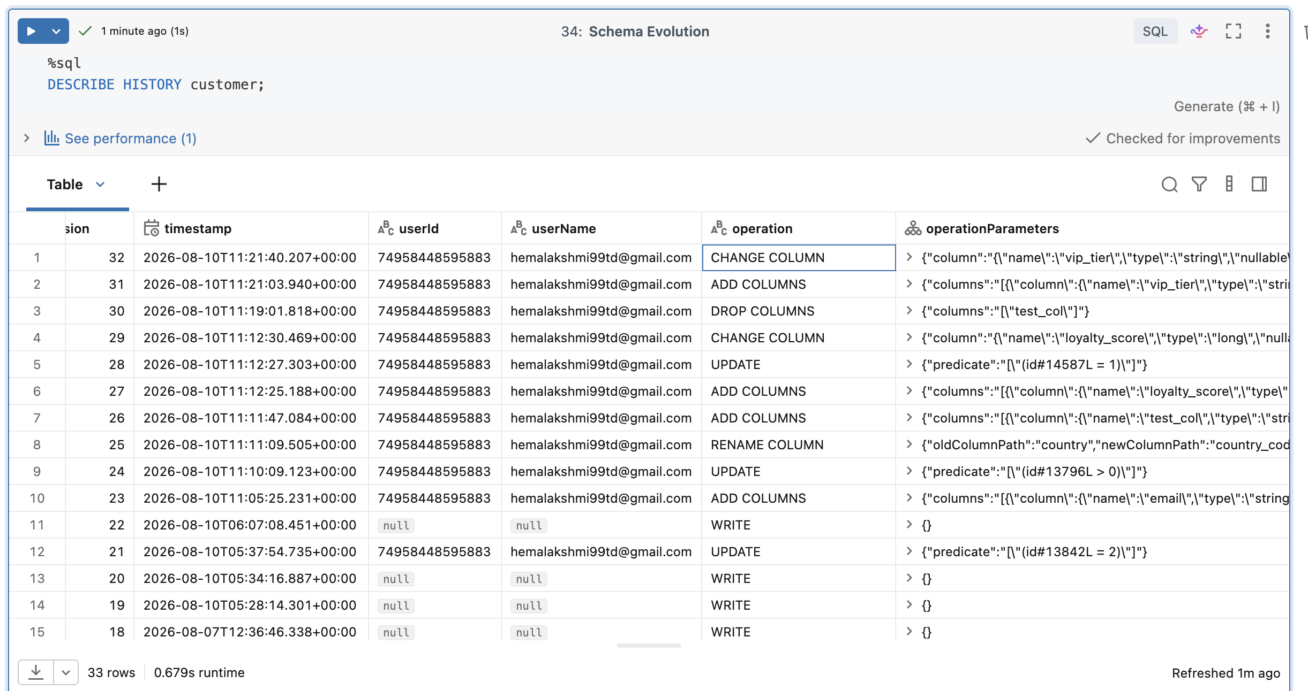
A.4 Databricks — partitioned table
CREATE OR REPLACE TABLE iceberg_poc.sales.customer_partitioned (
id BIGINT,
name STRING,
country_code STRING,
status STRING,
amount DECIMAL(10,2),
order_date DATE,
created_at TIMESTAMP
)
USING ICEBERG
PARTITIONED BY (country_code, order_date);

DESCRIBE DETAIL iceberg_poc.sales.customer_partitioned;
EXPLAIN SELECT * FROM iceberg_poc.sales.customer_partitioned
WHERE country_code = 'US' AND order_date = DATE'2026-08-03';

A.5 Snowflake — one-time setup
CREATE OR REPLACE EXTERNAL VOLUME ext_vol_iceberg_poc
STORAGE_LOCATIONS = (
(
NAME = 's3-iceberg-poc-us-west-2'
STORAGE_PROVIDER = 'S3'
STORAGE_BASE_URL = 's3://s3-iceberg-bucket-1/'
STORAGE_AWS_ROLE_ARN = 'arn:aws:iam::381492064215:role/snowflake-iceberg-reader'
STORAGE_AWS_EXTERNAL_ID = 'sf-iceberg-poc-external-id'
)
)
ALLOW_WRITES = TRUE;

DESC EXTERNAL VOLUME ext_vol_iceberg_poc;
SELECT SYSTEM$VERIFY_EXTERNAL_VOLUME('ext_vol_iceberg_poc');

CREATE OR REPLACE CATALOG INTEGRATION uc_iceberg_rest
CATALOG_SOURCE = ICEBERG_REST
TABLE_FORMAT = ICEBERG
CATALOG_NAMESPACE = 'sales'
REST_CONFIG = (
CATALOG_URI = 'https://dbc-86f4a6a7-daa2.cloud.databricks.com/api/2.1/unity-catalog/iceberg-rest'
WAREHOUSE = 'iceberg_poc'
)
REST_AUTHENTICATION = (
TYPE = OAUTH
OAUTH_TOKEN_URI = 'https://dbc-86f4a6a7-daa2.cloud.databricks.com/oidc/v1/token'
OAUTH_CLIENT_ID = '93115cd3-46f0-4efb-897a-8b3658fbd013'
OAUTH_CLIENT_SECRET = '<sp-oauth-secret>'
OAUTH_ALLOWED_SCOPES = ('all-apis')
)
ENABLED = TRUE;

CREATE DATABASE IF NOT EXISTS iceberg_poc;
CREATE SCHEMA IF NOT EXISTS iceberg_poc.sales;
USE DATABASE iceberg_poc;
USE SCHEMA sales;

A.6 Snowflake — Iceberg tables + reads + writes
CREATE OR REPLACE ICEBERG TABLE customer
EXTERNAL_VOLUME = 'ext_vol_iceberg_poc'
CATALOG = 'uc_iceberg_rest'
CATALOG_TABLE_NAME = 'customer'
AUTO_REFRESH = TRUE;

SELECT COUNT(*) FROM customer;
SELECT * FROM customer ORDER BY id;

INSERT INTO customer VALUES
(20, 'SF_Reliable', 'US', 'active', current_timestamp(), current_timestamp());

ALTER ICEBERG TABLE customer REFRESH;

SHOW ICEBERG TABLES;
DESC ICEBERG TABLE customer;
SELECT SYSTEM$GET_ICEBERG_TABLE_INFORMATION('iceberg_poc.sales.customer');
SELECT * FROM TABLE(INFORMATION_SCHEMA.ICEBERG_TABLE_FILES(TABLE_NAME => 'ICEBERG_POC.SALES.CUSTOMER'));

-- Partitioned table
CREATE OR REPLACE ICEBERG TABLE customer_partitioned
EXTERNAL_VOLUME = 'ext_vol_iceberg_poc'
CATALOG = 'uc_iceberg_rest'
CATALOG_TABLE_NAME = 'customer_partitioned'
AUTO_REFRESH = TRUE;

A.7 Snowflake — schema evolution
ALTER ICEBERG TABLE customer ADD COLUMN loyalty_score BIGINT;
ALTER ICEBERG TABLE customer RENAME COLUMN vip_tier TO tier_name;
ALTER ICEBERG TABLE customer DROP COLUMN test_col;

A.8 Snowflake — session recovery
USE ROLE ACCOUNTADMIN;
SELECT SYSTEM$CANCEL_ALL_QUERIES(CURRENT_SESSION());
ALTER WAREHOUSE COMPUTE_WH SUSPEND;
ALTER WAREHOUSE COMPUTE_WH RESUME;
ALTER SESSION SET STATEMENT_TIMEOUT_IN_SECONDS = 300;

21. Appendix B — All JSON policies used
B.1 IAM trust policy for `uc-iceberg-role` (Databricks UC)
{
"Version": "2012-10-17",
"Statement": [
{
"Sid": "TrustDatabricksUCMasterRole",
"Effect": "Allow",
"Principal": {
"AWS": "arn:aws:iam::414351767826:role/unity-catalog-prod-UCMasterRole-14S5ZJVKOTYTL"
},
"Action": "sts:AssumeRole",
"Condition": {
"StringEquals": {
"sts:ExternalId": "3023ffa7-ab35-48ac-a8b7-1163d36ff929"
}
}
},
{
"Sid": "SelfAssume",
"Effect": "Allow",
"Principal": {
"AWS": "arn:aws:iam::381492064215:role/uc-iceberg-role"
},
"Action": "sts:AssumeRole"
}
]
}

B.2 IAM trust policy for `snowflake-iceberg-reader`
{
"Version": "2012-10-17",
"Statement": [
{
"Effect": "Allow",
"Principal": {
"AWS": "arn:aws:iam::357673535832:user/n3022000-s"
},
"Action": "sts:AssumeRole",
"Condition": {
"StringEquals": {
"sts:ExternalId": "sf-iceberg-poc-external-id"
}
}
}
]
}

B.3 Snowflake External Volume DESC output
{
"NAME":"s3-iceberg-poc-us-west-2",
"STORAGE_PROVIDER":"S3",
"STORAGE_BASE_URL":"s3://s3-iceberg-bucket-1/",
"STORAGE_AWS_ROLE_ARN":"arn:aws:iam::381492064215:role/snowflake-iceberg-reader",
"STORAGE_AWS_IAM_USER_ARN":"arn:aws:iam::357673535832:user/n3022000-s",
"STORAGE_AWS_EXTERNAL_ID":"sf-iceberg-poc-external-id",
"ENCRYPTION_TYPE":"NONE"
}

B.4 Snowflake External Volume verification output
{
"success": true,
"storageLocationSelectionResult": "PASSED",
"storageLocationName": "s3-iceberg-poc-us-west-2",
"location": "s3://s3-iceberg-bucket-1/",
"region": "us-west-2",
"writeResult": "PASSED",
"readResult": "PASSED",
"listResult": "PASSED",
"deleteResult": "PASSED",
"awsRoleArnValidationResult": "PASSED"
}

B.5 Iceberg metadata pointer returned by Snowflake
{
"metadataLocation": "s3://s3-iceberg-bucket-1/iceberg/__unitystorage/catalogs/65731e07-0ae8-4a77-a1d4-ea98a10899bc/tables/d94cf055-2f74-4a04-bae9-2d55317457ba/_iceberg/metadata/00001-77208feb-f726-4626-8615-49313d5ebfd1.gz.metadata.json",
"status": "success"
}

22. Conclusion
The POC proves that Apache Iceberg on AWS S3, governed by Databricks Unity Catalog and consumed by Snowflake via the Iceberg REST endpoint, is a viable and production-ready pattern for multi-engine data sharing.
Confirmed:
- Single physical dataset served both engines — zero data copy
- All DML (INSERT, UPDATE, DELETE, MERGE, COPY INTO) in Databricks with proper snapshot lineage and time travel
- Bidirectional reads and writes with reliable propagation in the same region
- Bidirectional schema evolution — ADD, RENAME, DROP, TYPE WIDENING all work in both directions
- OAuth Service Principal authentication working reliably
- Verified at file level that both engines read the same Iceberg metadata JSON on S3
Known limitations (documented):
- Time travel from Snowflake is not supported on externally-catalogued Iceberg tables — route through Databricks
- Column reorder is respected in Databricks but not in Snowflake's display order (cosmetic only)
- Snowflake normalizes unquoted identifiers to UPPERCASE — use quoted lowercase for cross-engine consistency
- Databricks Liquid Clustering (used when PARTITIONED BY is declared) is not surfaced in Snowflake metadata views — data reads correctly, but the layout scheme is DB-owned
- Snowflake writes occasionally report "connection pool" errors — data does commit, but retry-and-verify wrappers are recommended in production
- Concurrent same-row writes from both engines follow Iceberg OCC — one wins, other must retry — plan write ownership carefully
*End of report.*

