Iceberg Table Cross-Platform POV
AWS Glue Catalog as Source of Truth - Accessed via Snowflake, Databricks, and Athena - Proof of Value Documentation

1. Objective
This is an internal exploration, not a specific client requirement. The goal is to understand, hands-on, how a single Apache Iceberg table - created and cataloged once in AWS Glue - can be accessed consistently from multiple analytics platforms, and whether changes made on one platform stay in sync when read from the others.
AWS Glue Data Catalog is used as the single shared catalog (source of truth). Three platforms will connect to it and read/write the same underlying Iceberg table:
- - Snowflake (via a Glue catalog integration)
- - Databricks (via Glue as external metastore/catalog)
- - Amazon Athena (native Glue integration)
What we want to learn:
- - Can all three platforms read the same Iceberg table registered in Glue without any data duplication or separate load step?
- - When an INSERT is run from one platform, how quickly and reliably does it appear when queried from the other two?
- - Same question for UPDATE and DELETE operations - do all platforms see a consistent row-level state after the change, or is there staleness/conflict?
- - Which platforms can only read vs. which can also write to the Glue-cataloged table?
- - Where does synchronization break down, if anywhere - metadata refresh delays, caching, permissions, or format-level limitations?
Scope of this POV:
- - Storage: Amazon S3 (single region) holding the Iceberg data/metadata files
- - Catalog: AWS Glue Data Catalog (single shared catalog for all three platforms)
- - Platforms under test: Snowflake, Databricks, Amazon Athena
- - Sample dataset only (not production data or volumes)
- - Internal exploration - findings will inform whether/how this pattern gets proposed to a client later
Success criteria (what "done" looks like for this POV):
- - A single Iceberg table, cataloged once in Glue, is queried successfully from Snowflake, Databricks, and Athena
- - Insert, update, and delete operations performed on one platform are confirmed (with evidence/screenshots) as visible on the other two
- - Any sync delay, conflict, or inconsistency observed is documented with the exact steps to reproduce it
- - A clear internal recommendation on viability, plus any platform-specific limitations found (e.g. read-only vs. read-write support)

2. Architecture Overview
AWS S3 — Storage layer
AWS Glue — Catalog
Data Platform — Snowflake, Databricks and Athena

3. Storage Setup (Amazon S3)
Step 3.1: Create S3 Bucket
Bucket Name | ta-icebreg-poc
Region | eu-north-1
Versioning | Enabled
Encryption | SSE-S3
Block Public Access | True( All 4 settings)
Screenshot Reference:
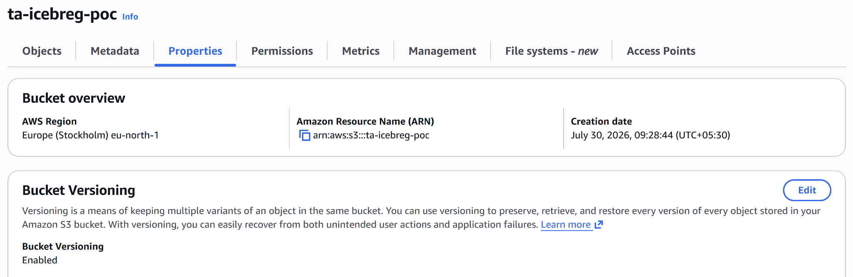

Step 3.2: Define Base Iceberg Path
Base Path (s3://...) | s3://ta-icebreg-poc/warehouse/poc_db/orders_iceberg/
Warehouse Folder | warehouse/
Database Namespace | poc_db

Step 3.3: Create IAM Role & Policy
Role Name | iceberg-role
Permissions Policy Summary | Glue(Read, Write) and S3(List,Read, Write)
Trust Policy Summary | Added Snowflake IAM and Databrick IAM

Screenshot Reference :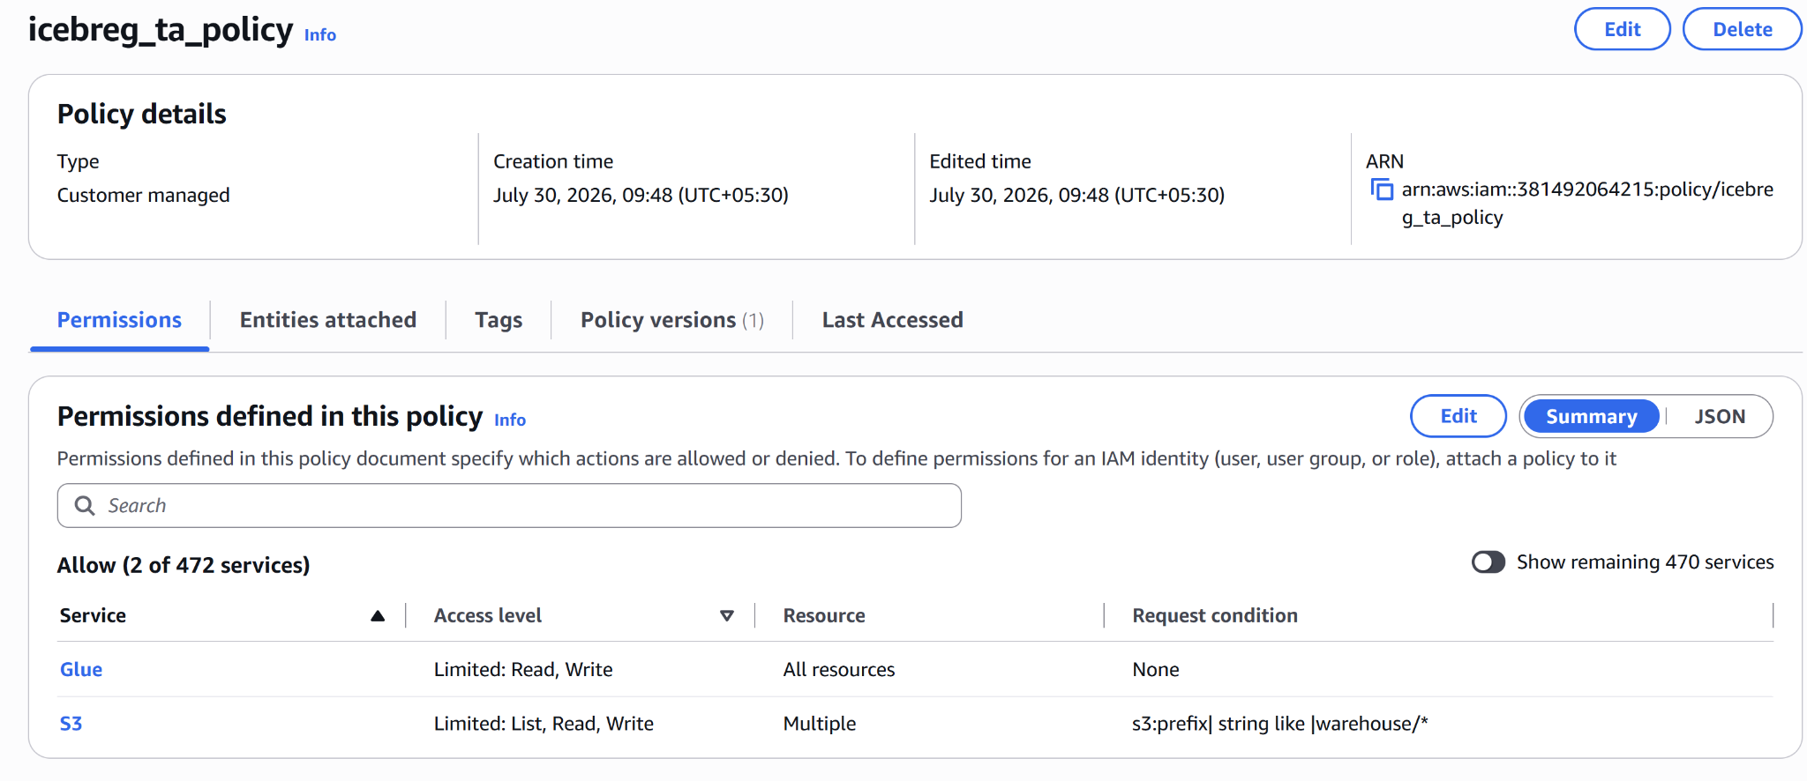
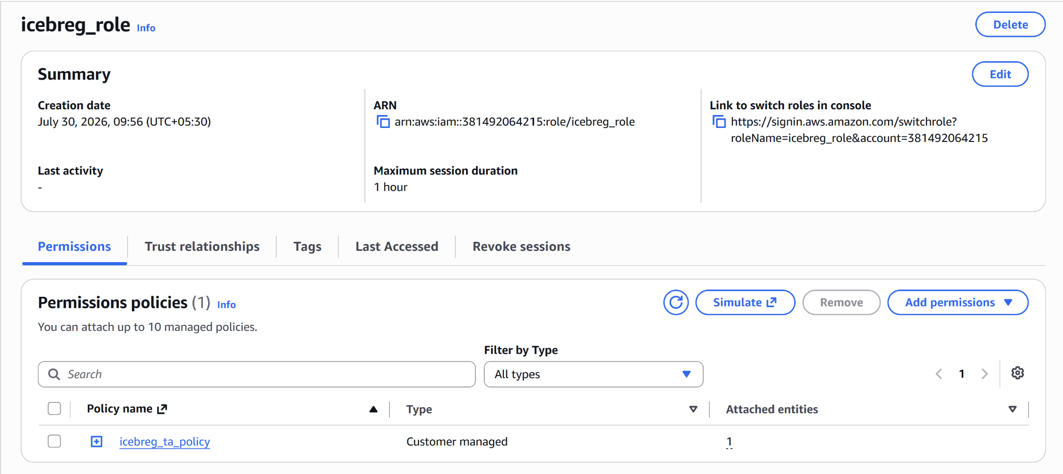

4. Catalog Setup (AWS Glue - Single Shared Catalog)
Step 4.1: Create Glue Database (Namespace)
Glue Database Name | poc_db
Location URI | s3://ta-icebreg-poc/warehouse/poc_db

Screenshot Reference:
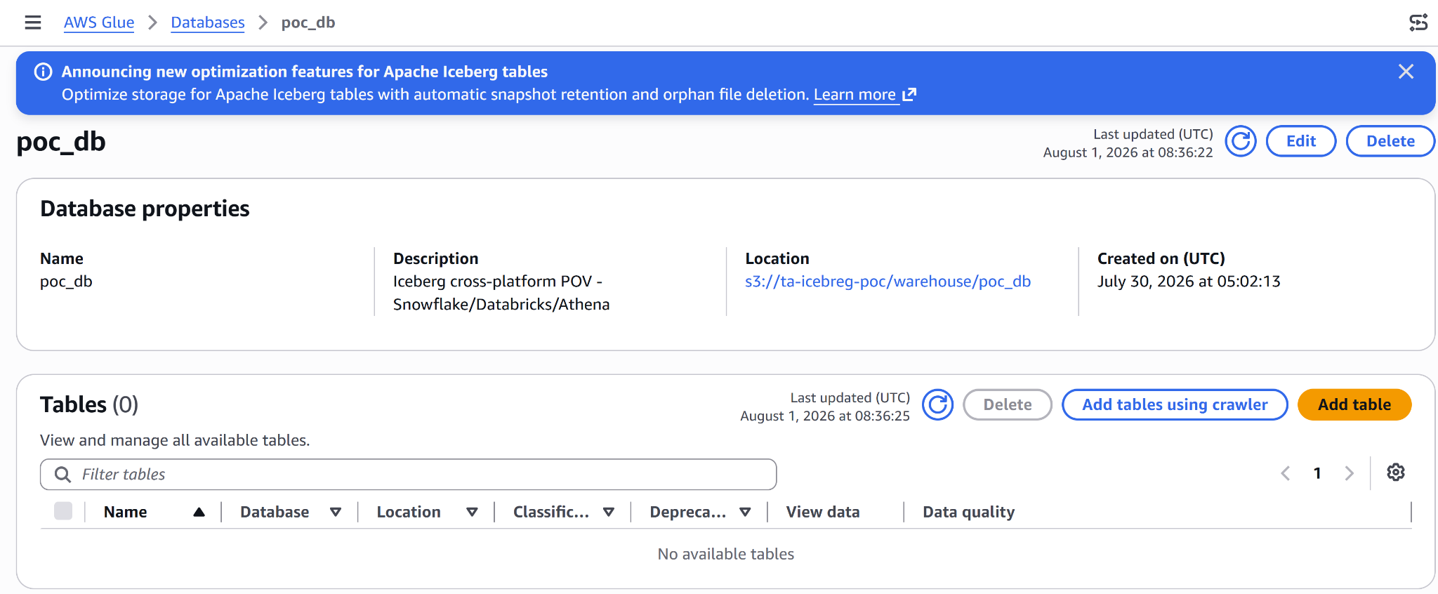

Step 4.2: Configure Glue Permissions
IAM Role Used | iceberg-poc-access-role
Lake Formation Settings (if applicable) | Lake Formation present but running in default IAM_ALLOWED_PRINCIPALS mode (no active admins configured) - access is governed entirely by IAM policy

Command Used: aws lakeformation get-data-lake-settings in AWS Cloud shell

Screenshot Reference :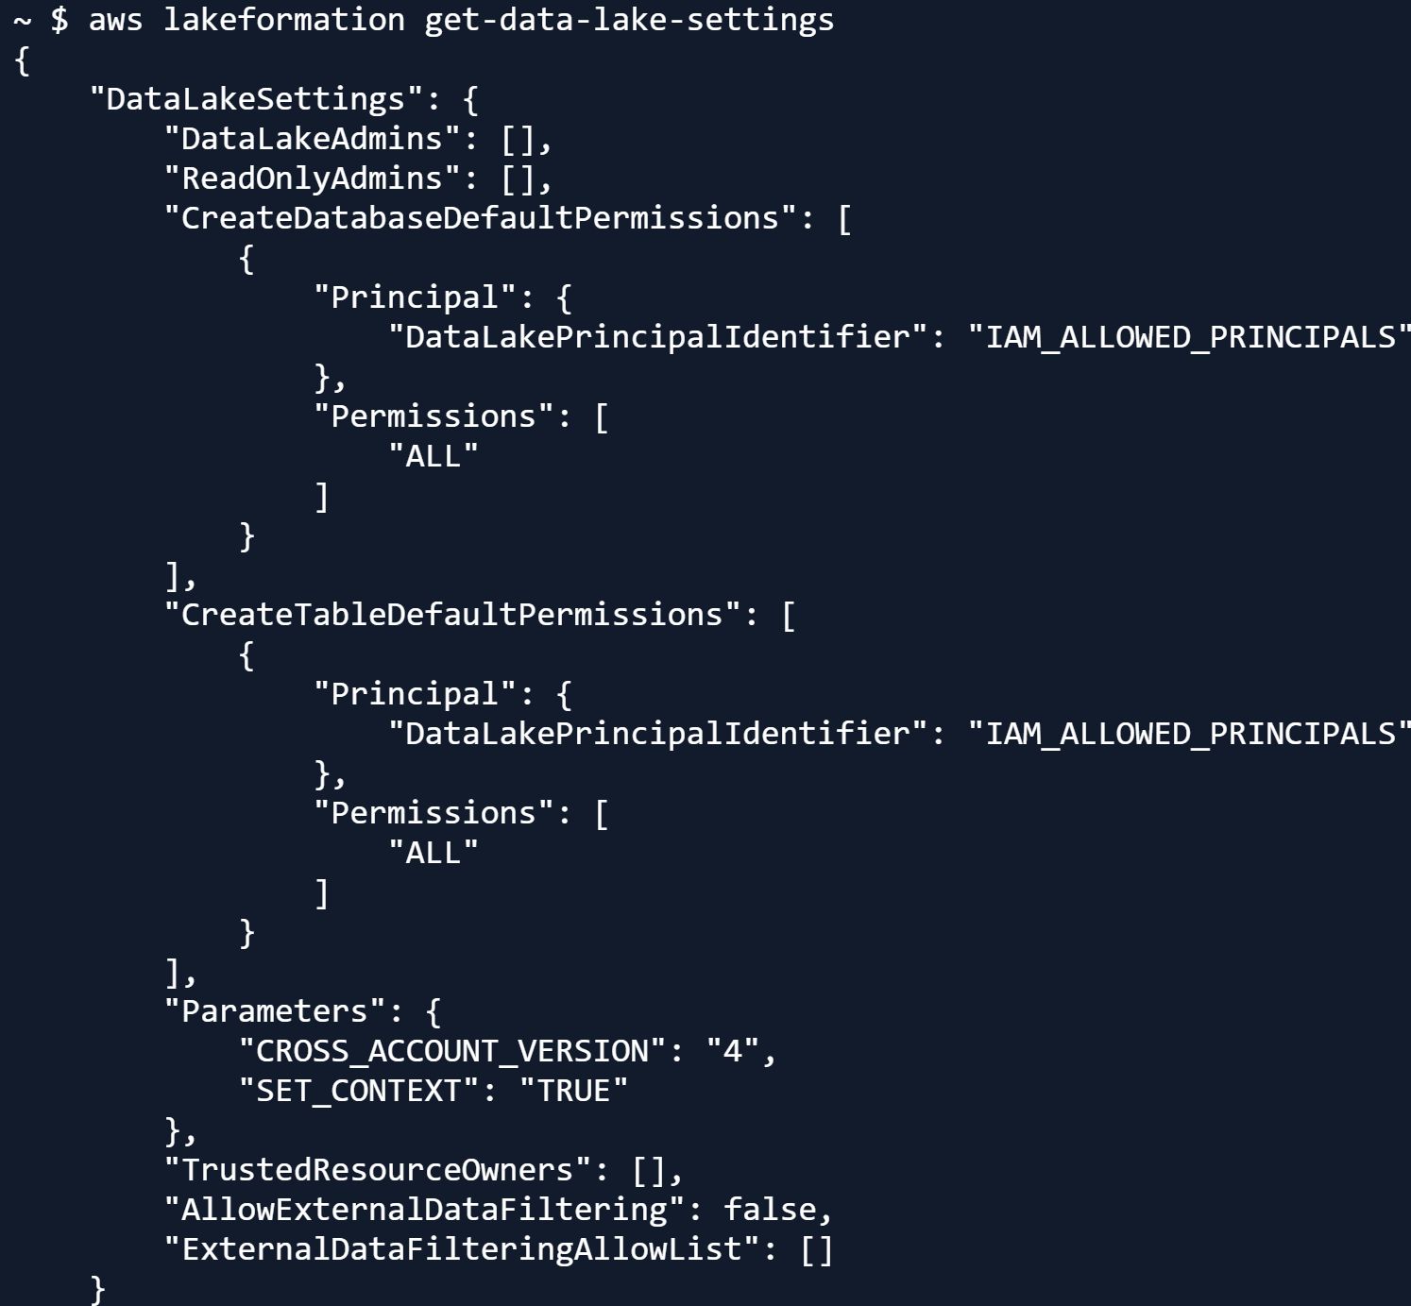

5. Iceberg Table Creation
Step 5.1: Create Iceberg Table (registered in Glue)
Table Name | orders_iceberg
Schema Summary | order_id (int), customer_name (string), order_date (date), amount (double), status (string)
Created Via (Engine) | Athena
Partitioning | None
Command Used:
CREATE TABLE poc_db.orders_iceberg (
order_id int,
customer_name string,
order_date date,
amount double,
status string
)
LOCATION 's3://ta-iceberg-poc/warehouse/poc_db/orders_iceberg/'
TBLPROPERTIES (
'table_type' = 'ICEBERG',
'format' = 'parquet'
);

Screenshot Reference :
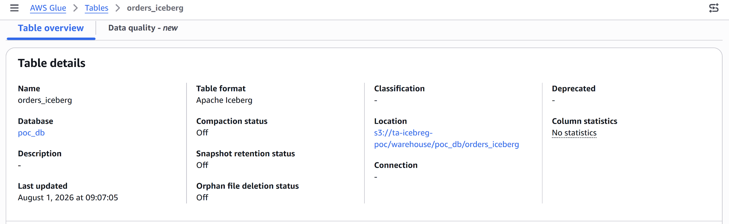

Step 5.2: Load Sample Data
Record Count | 5
Source of Sample Data | Manually inserted sample order records via Athena SQL
Command / Config Used:
INSERT INTO poc_db.orders_iceberg VALUES
(1, 'Alice', DATE '2026-07-01', 120.50, 'pending'),
(2, 'Bob', DATE '2026-07-02', 89.99, 'shipped'),
(3, 'Charlie', DATE '2026-07-03', 45.00, 'pending'),
(4, 'Dana', DATE '2026-07-04', 210.75, 'delivered'),
(5, 'Evan', DATE '2026-07-05', 15.20, 'pending');

Screenshot Reference :
Data present in table
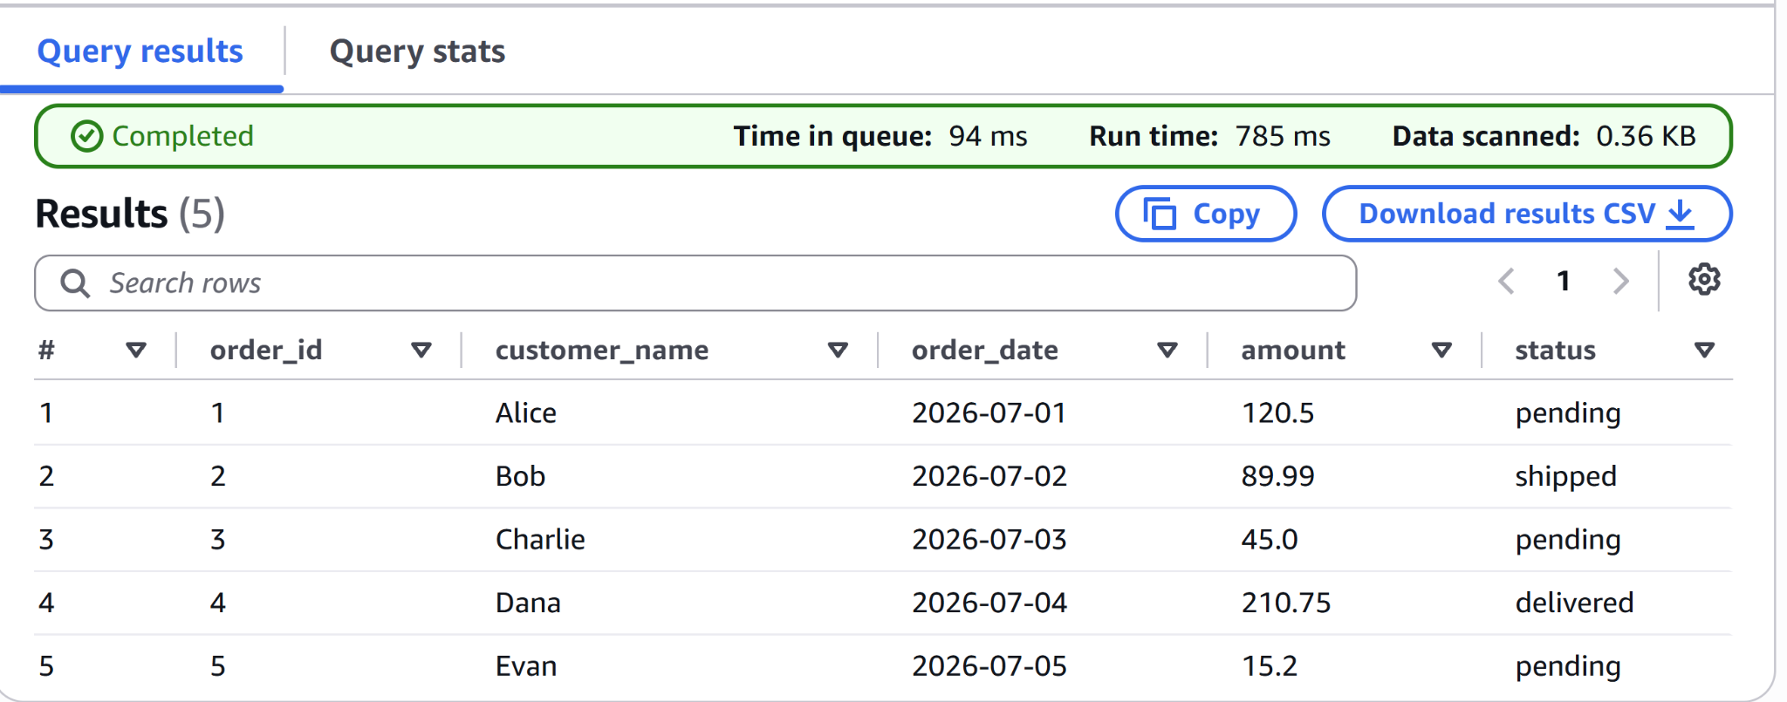
Snapshot created

File created in S3 bucket
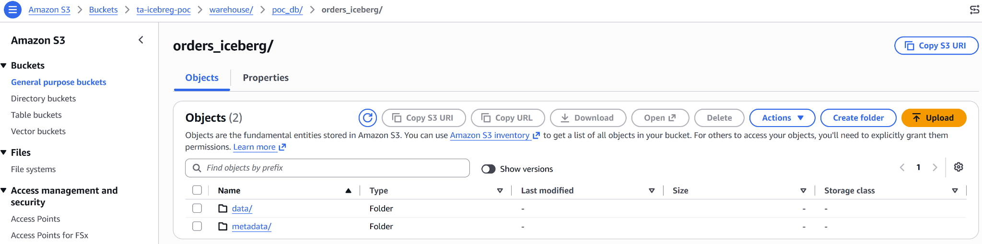

6. Platform Connections

Step 6.1: Snowflake

Snowflake Trial Account | User Name | Password
Icebreg Trial Account | Tiger | Tiger123456789
Step 6.1.1 a: Create External Volume
External Volume Name | iceberg_poc_vol
STORAGE_AWS_IAM_USER_ARN | arn:aws:iam::008349342067:user/j5kw1000-s
STORAGE_AWS_EXTERNAL_ID | iceberg_poc_ext_id
STORAGE_AWS_ROLE_ARN | arn:aws:iam::381492064215:role/icebreg_role
Command Used:
CREATE OR REPLACE EXTERNAL VOLUME iceberg_poc_vol
STORAGE_LOCATIONS = (
(
NAME = 'ta-icebreg-poc-s3'
STORAGE_PROVIDER = 'S3'
STORAGE_BASE_URL = 's3://ta-icebreg-poc/warehouse/poc_db/'
STORAGE_AWS_ROLE_ARN = 'arn:aws:iam::381492064215:role/icebreg_role'
STORAGE_AWS_EXTERNAL_ID = 'iceberg_poc_ext_id'
)
)ALLOW_WRITES = TRUE;
DESC EXTERNAL VOLUME iceberg_poc_vol;
SELECT SYSTEM$VERIFY_EXTERNAL_VOLUME('iceberg_poc_vol');

Step 6.1.1 b: Update Trust Policy
Locate the STORAGE_LOCATION_1 row in the command output. Inside its JSON payload, copy the values for STORAGE_AWS_IAM_USER_ARN and STORAGE_AWS_EXTERNAL_ID. Return to AWS IAM, open iceberg-poc-access-role, and update the trust policy.

Screenshot Reference :
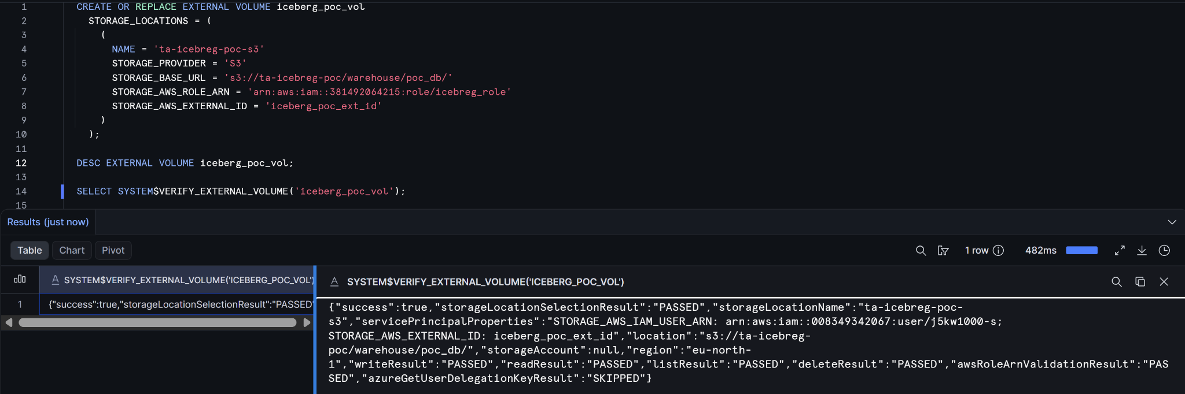

Notes / Issues Encountered:
Initial SYSTEM$VERIFY_EXTERNAL_VOLUME failed with AccessDenied on s3:DeleteObject — IAM policy on icebreg_role was missing delete permission on the warehouse/* prefix.
Fixed by adding s3:DeleteObject to the policy; verification passed after update.

Step 6.1.2: Create Catalog Integration (CATALOG_SOURCE = ICEBREG_REST)
Integration Name | glue_rest_catalog_int
Catalog Source | Icebreg REST
Glue Catalog ID | 381492064215
Glue Region | eu-north-1
Glue AWS Role ARN | arn:aws:iam::381492064215:role/icebreg_role
Table Format | Iceberg
Command Used:
CREATE OR REPLACE CATALOG INTEGRATION glue_rest_catalog_int
CATALOG_SOURCE = ICEBERG_REST
TABLE_FORMAT = ICEBERG
CATALOG_NAMESPACE = 'poc_db'
REST_CONFIG = (
CATALOG_URI = 'https://glue.eu-north-1.amazonaws.com/iceberg'
CATALOG_API_TYPE = AWS_GLUE
CATALOG_NAME = '381492064215'
)
REST_AUTHENTICATION = (
TYPE = SIGV4
SIGV4_IAM_ROLE = 'arn:aws:iam::381492064215:role/icebreg_role'
SIGV4_SIGNING_REGION = 'eu-north-1'
)
ENABLED = TRUE;
DESC CATALOG INTEGRATION glue_catalog_int;
SELECT SYSTEM$VERIFY_CATALOG_INTEGRATION('glue_rest_catalog_int');

Screenshot Reference :
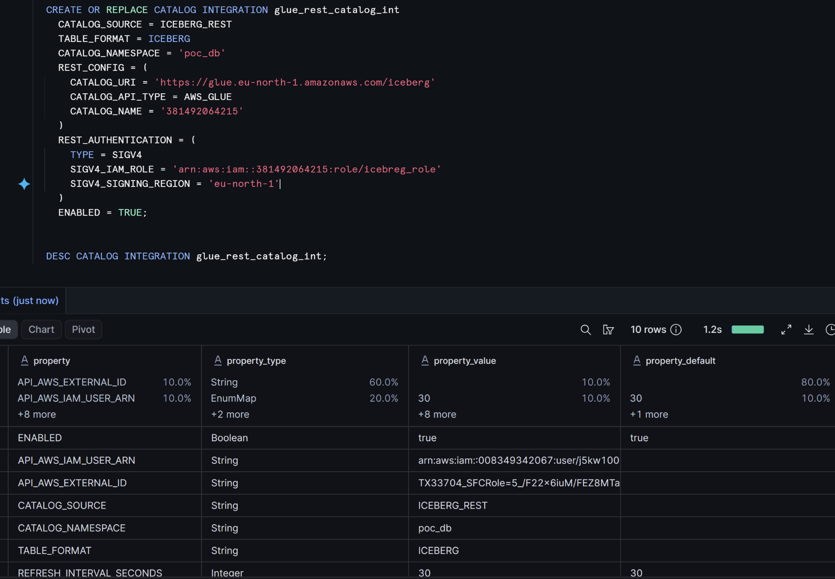

Notes / Issues Encountered:
- Catalog integration uses a separate IAM principal from the external volume — required a second Statement block in icebreg_role's trust policy (initial AssumeRole: 403 error until this was added).
- SYSTEM$VERIFY_CATALOG_INTEGRATION is not supported for GLUE catalog type (errorCode 004186) — this is expected behavior, not a config error. Verification was instead done by directly querying the registered table (see 6.1.3).

Step 6.1.3: Query Table from Snowflake
Query Used | CREATE ICEBERG TABLE POC_DB.DEV.orders_iceberg  EXTERNAL_VOLUME = 'iceberg_poc_vol'  CATALOG = 'glue_rest_catalog_int'  CATALOG_TABLE_NAME = 'orders_iceberg'  AUTO_REFRESH = TRUE;  SELECT * FROM orders_iceberg;
Result Summary | All 5 rows originally inserted via Athena are visible and match exactly — confirms Snowflake can read a Glue-cataloged Iceberg table with no data duplication
Read or Read-Write? | Confirmed read;  Write capability to be confirmed in Section 7 (INSERT sync test)

Screenshot Reference :
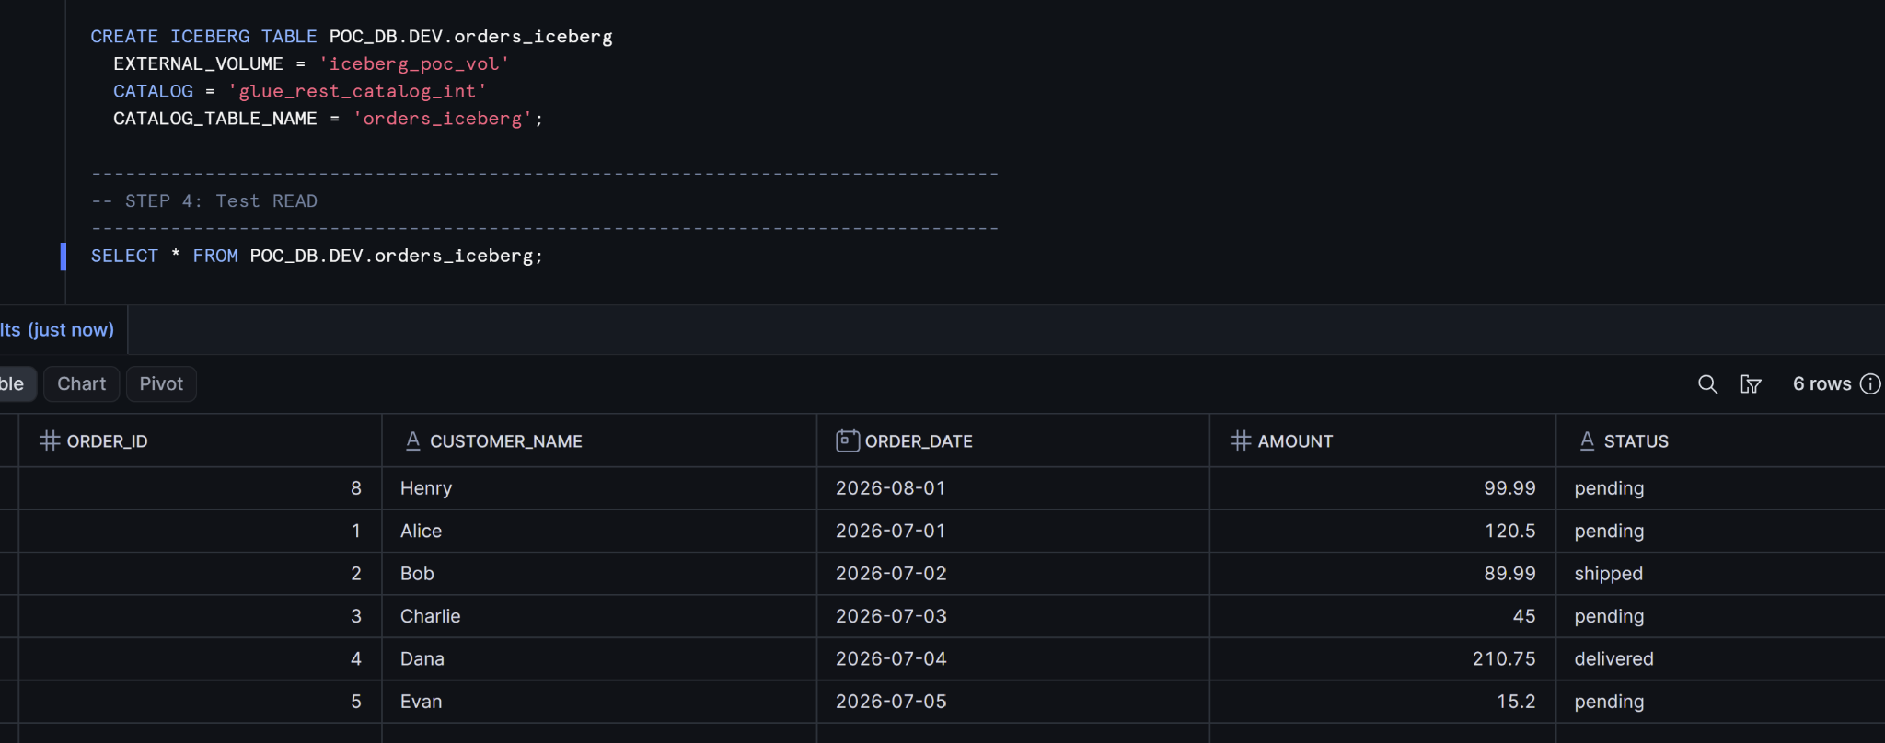

Step 6.2: Databricks
Step 6.2.1: Configure Glue as OSS on Cluster
Approach Used | Used Open Source Software om Cluster
IAM Role | icebreg_role
AWS Region | eu-north-1
Catalog Name | glue_catalog

Cluster Setup Prerequisites
- Standard classic cluster required — serverless instances do not support the necessary custom Spark catalog configurations or external JAR files.
- Valid AWS IAM credentials for a principal with full Glue (Get/Create/Update/Delete) and S3 (List/Read/Write on the warehouse bucket) access.
- Glue environment details: Account 381492064215, Region eu-north-1, Catalog DB poc_db, Table orders_iceberg, Base Path s3://ta-icebreg-poc/warehouse/.

Step 6.2.1: Cluster Configuration
Databricks Runtime | 15.4 LTS (Spark 3.5, Scala 2.12)
Photon Engine | Disabled (Standard Spark execution)
Access Mode | Single user / No isolation

Step 6.2.2: Java 17 JVM Setup
Navigate to Advanced options &to; Spark &to; Environment variables and insert the following key:
Variable Definition:
JNAME=zulu17-ca-amd64
Iceberg 1.10 necessitates Java 11 or higher. Since DBR 15.4 defaults to Java 8 if `zulu11` is used, explicit selection of Java 17 is required for compatibility.

Step 6.2.3: AWS Credential Management (Secret Scopes)
Persist AWS access keys securely utilizing the Databricks CLI before cluster attachment:
CLI Commands:
databricks secrets create-scope aws-glue
databricks secrets put-secret aws-glue aws_access_key_id
databricks secrets put-secret aws-glue aws_secret_access_key
Map these secrets to Environment variables within the cluster configuration:
AWS_ACCESS_KEY_ID={{secrets/aws-glue/aws_access_key_id}}
AWS_SECRET_ACCESS_KEY={{secrets/aws-glue/aws_secret_access_key}}
AWS_REGION=eu-north-1
Notes / Issues Encountered:
Naming Convention: Ensure variable names match AWS SDK requirements precisely (e.g., AWS_ACCESS_KEY_ID rather than AWS_ACCESS_KEY).

Step 6.2.4: Spark Catalog Configuration
In Advanced options &to; Spark &to; Spark config, define the Glue catalog implementation:
spark.sql.extensions org.apache.iceberg.spark.extensions.IcebergSparkSessionExtensions
spark.sql.catalog.glue_catalog org.apache.iceberg.spark.SparkCatalog
spark.sql.catalog.glue_catalog.catalog-impl org.apache.iceberg.aws.glue.GlueCatalog
spark.sql.catalog.glue_catalog.io-impl org.apache.iceberg.aws.s3.S3FileIO
spark.sql.catalog.glue_catalog.warehouse s3://ta-icebreg-poc/warehouse/
spark.sql.catalog.glue_catalog.client.region eu-north-1
spark.sql.iceberg.vectorization.enabled false
Configuration Note:
vectorization.enabled=false is mandatory to prevent read failures on Parquet files utilizing DELTA_LENGTH_BYTE_ARRAY encoding.

Step 6.2.5: Maven Library Installation
Install the following dependencies via Libraries &to; Install new &to; Maven (ensure version parity):
org.apache.iceberg:iceberg-spark-runtime-3.5_2.12:1.10.0
org.apache.iceberg:iceberg-aws-bundle:1.10.0

Step 6.2.6: Connectivity Verification
Execute the following diagnostics in a Databricks notebook to confirm environment state and catalog visibility:
# Java Version Check
print(spark._jvm.System.getProperty("java.version"))
-- Catalog &amp; Data Validation
SHOW DATABASES IN glue_catalog;
SELECT * FROM glue_catalog.poc_db.orders_iceberg LIMIT 10;

Screenshot Reference :

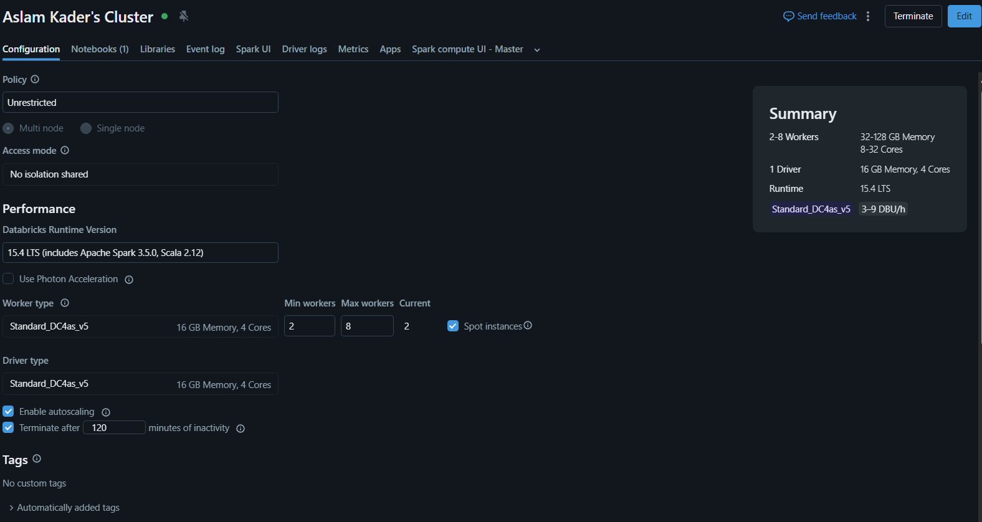
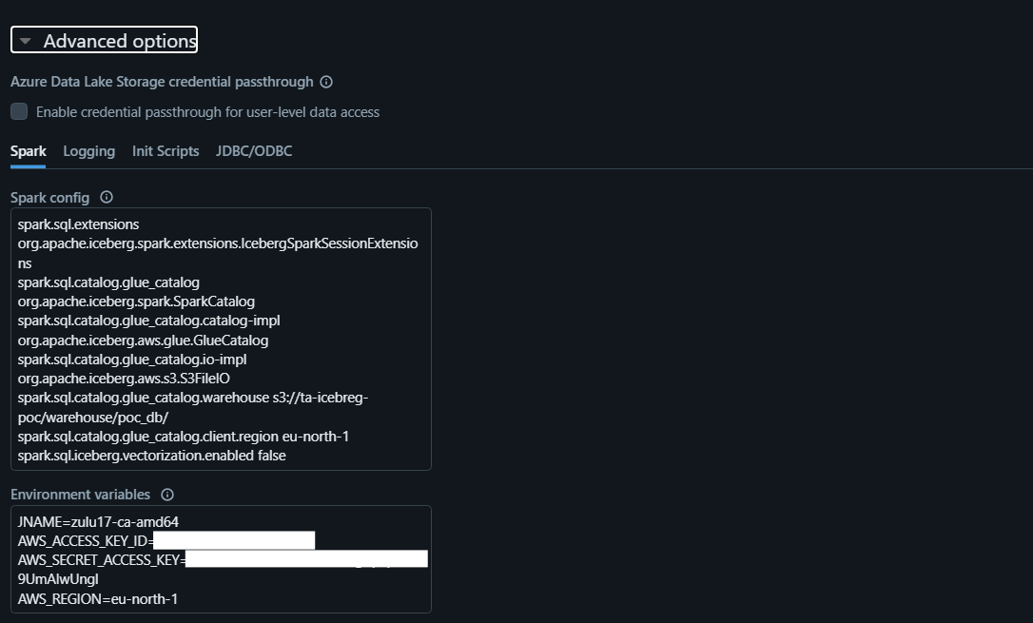
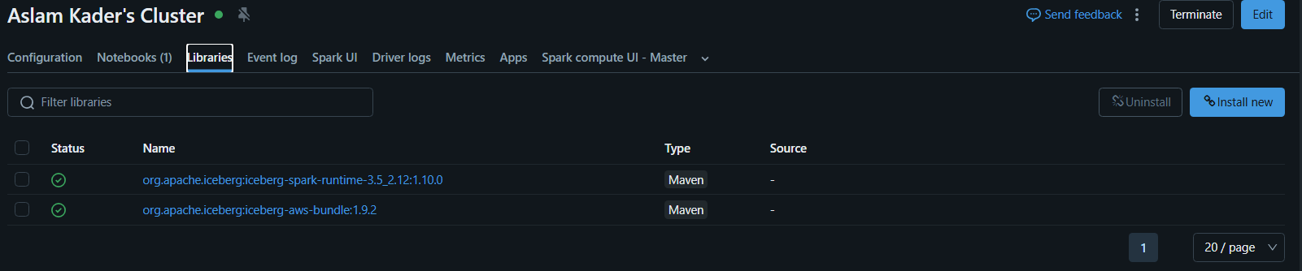
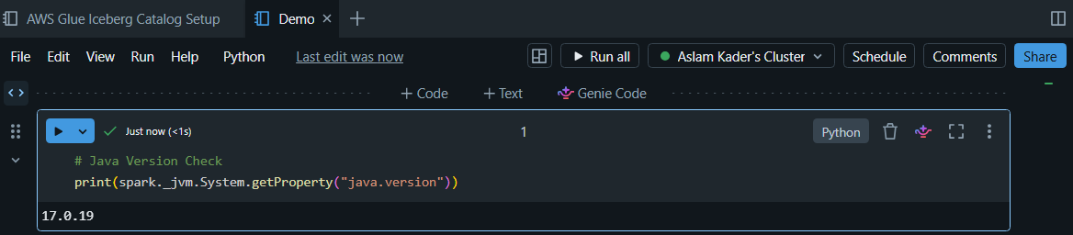

Notes / Issues Encountered:
- Workspace is serverless-only (trial) — no cluster/compute option available, so pivoted from the originally planned Spark-config approach to Unity Catalog's native Glue Foreign Catalog feature.
- Initial catalog creation failed with UC_IAM_ROLE_NON_SELF_ASSUMING — the storage credential's IAM role needs a trust statement allowing it to assume itself (an AWS-wide requirement since June 2023). Fixed by adding a self-referencing trust statement.

Step 6.2.2: Query Table from Databricks
Query Used | SHOW TABLES IN glue_catalog..poc_db;  SELECT * FROM glue_catalog.poc_db.orders_iceberg;
Result Summary | all 5 rows visible / matches Athena & Snowflake exactly
Read or Read-Write? | Confirmed read; write capability to be tested in Section 7

Screenshot Reference :
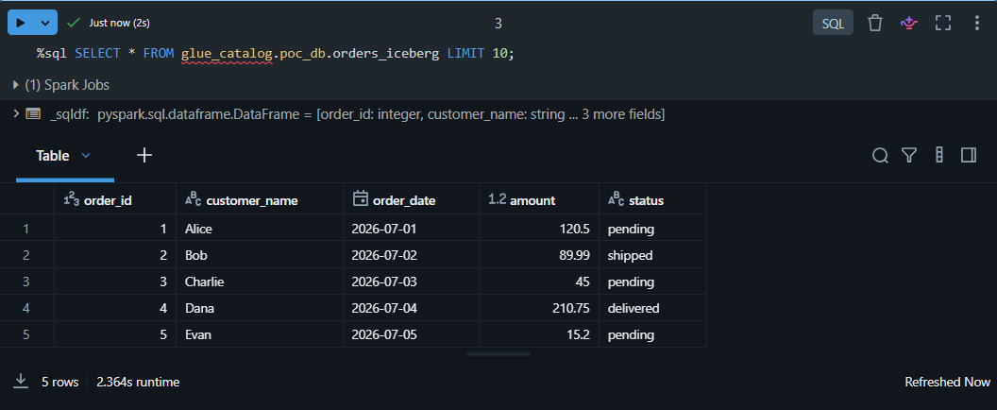

Step 6.3: Amazon Athena
Step 6.3.1: Confirm Glue Database Visible in Athena
Workgroup Used | Primary
Query Engine Version | Athena engine version 3
Query Used | SELECT * FROM poc_db.orders_iceberg;
Result Summary | All 5 rows visible — same as originally loaded; confirms baseline before cross-platform sync tests begin
Read or Read-Write? | Confirmed read-write

Screenshot Reference :

Notes / Issues Encountered:
Initial setup required configuring a query result output location (s3://ta-icebreg-poc-athena-results/) — Athena requires this separately from the Iceberg warehouse path itself, since it stores query metadata/logs there rather than table data.

7. Cross-Platform Sync Proof Tests
For each test, run the operation on the "Source" platform, then immediately query from the other two platforms and record what each one sees. Note any delay before the change becomes visible.

Step 7.1: INSERT Sync Test
Step 7.1.1: Insert from Snowflake -> Verify in Databricks & Athena
Rows Inserted | 1
Visible in Databricks? (Y/N + delay) | Yes
Visible in Athena? (Y/N + delay) | Yes
Command / Config Used:
INSERT INTO POC_DB.DEV.orders_iceberg VALUES
(6, 'Fiona', DATE '2026-08-01', 75.00, 'pending', null);

Output / Confirmation:
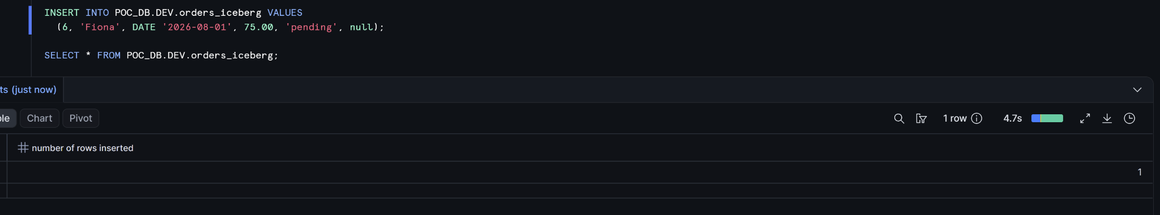

Screenshot Reference:
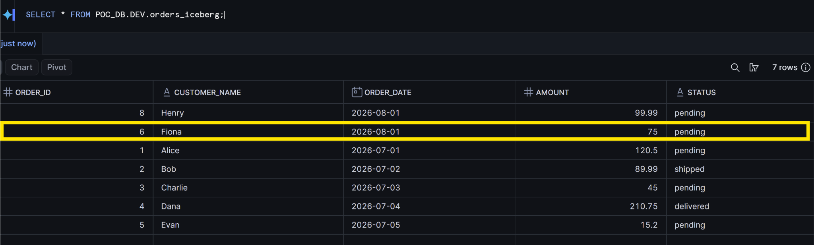
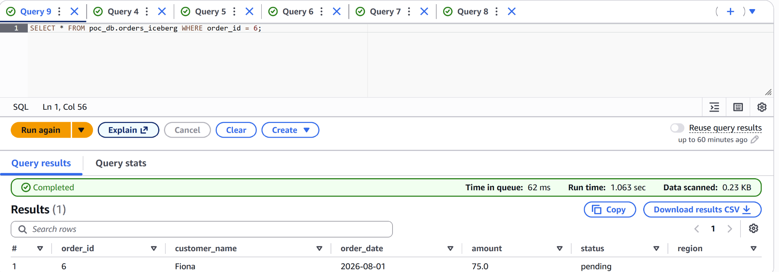

Step 7.1.2: Insert from Databrics-> Verify in Snowflake & Athea
Rows Inserted | 1
Visible in Snowflake? (Y/N + delay) | Yes
Visible in Databricks? (Y/N + delay) | Yes
Command / Config Used:

INSERT INTO poc_db.orders_iceberg VALUES
(7, 'Aslam', DATE '2026-08-01', 199.99, 'pending', 'EU');

Output / Confirmation:
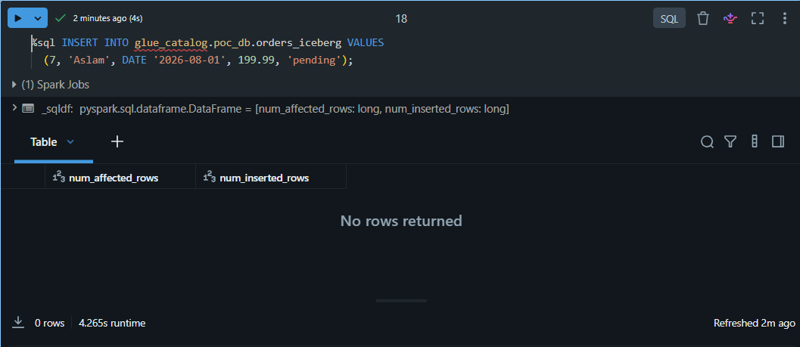

Screenshot Reference :
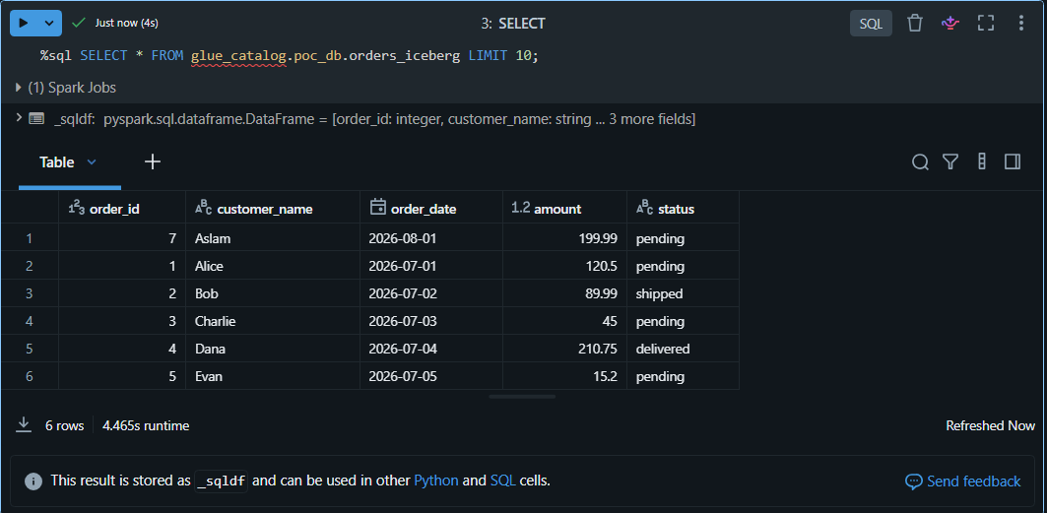
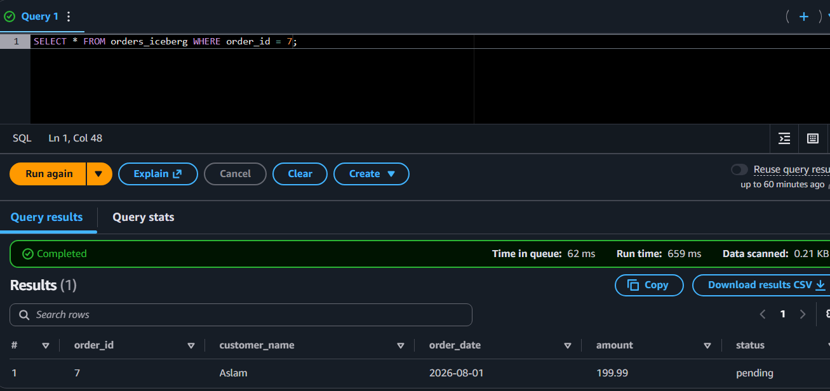
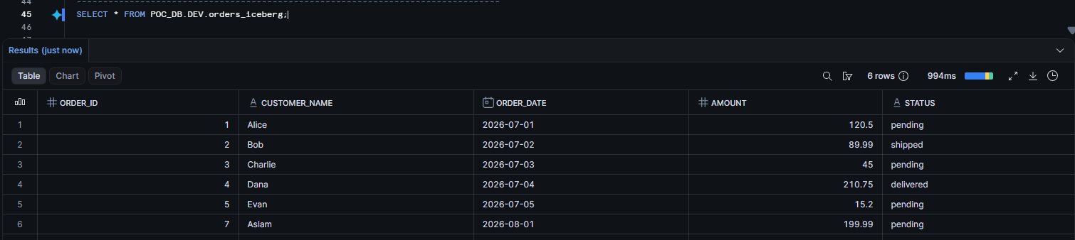

Step 7.1.3: Insert from Athena -> Verify in Snowflake & Databricks
Rows Inserted | 1
Visible in Snowflake? (Y/N + delay) | Yes
Visible in Databricks? (Y/N + delay) | Yes
Command / Config Used:

INSERT INTO poc_db.orders_iceberg VALUES
(8, 'Henry', DATE '2026-08-01', 99.99, 'pending', 'EU');

Output / Confirmation:
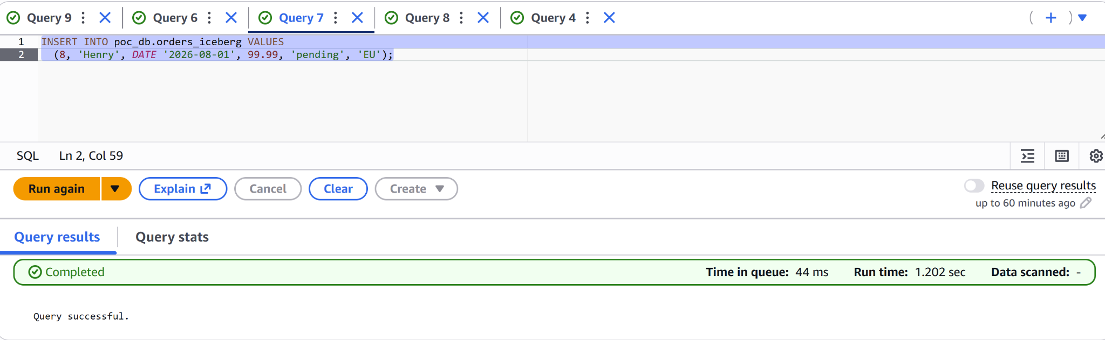
Screenshot Reference :
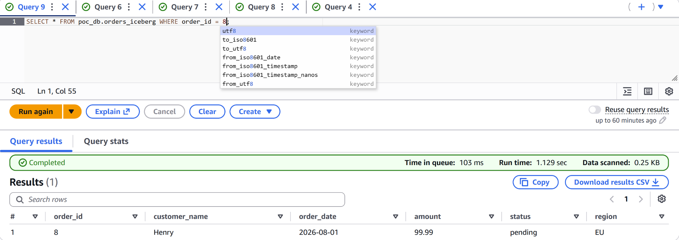
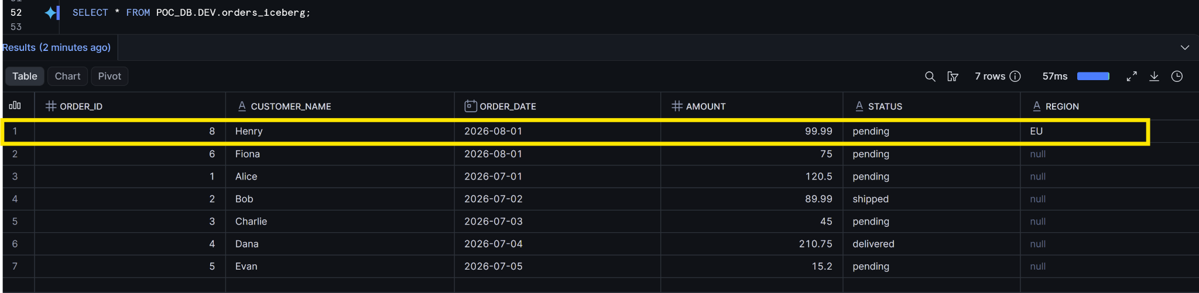

Step 7.2: UPDATE Sync Test
Step 7.2.1: Update from Snowflake -> Verify in Databricks & Athena
Rows Updated | 1
Visible in Databricks? (Y/N + delay) | Yes
Visible in Athena? (Y/N + delay) | Yes
Command / Config Used:
UPDATE POC_DB.DEV.orders_iceberg
SET status = 'shipped', amount = 80.00
WHERE order_id = 6;

Output / Confirmation:
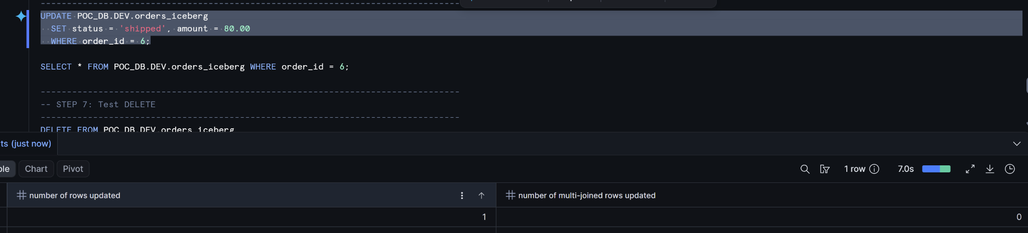

Screenshot Reference:
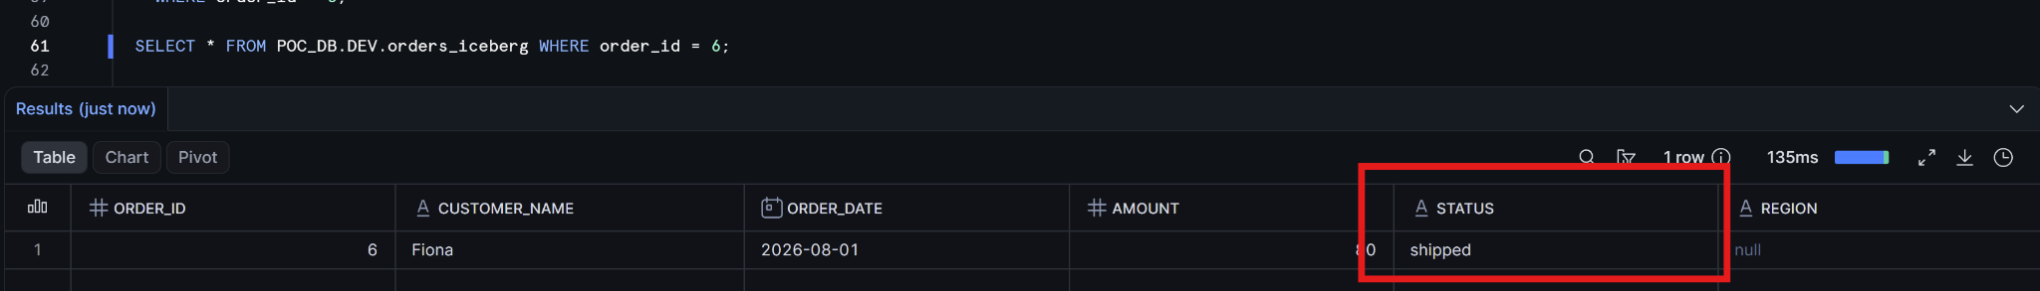
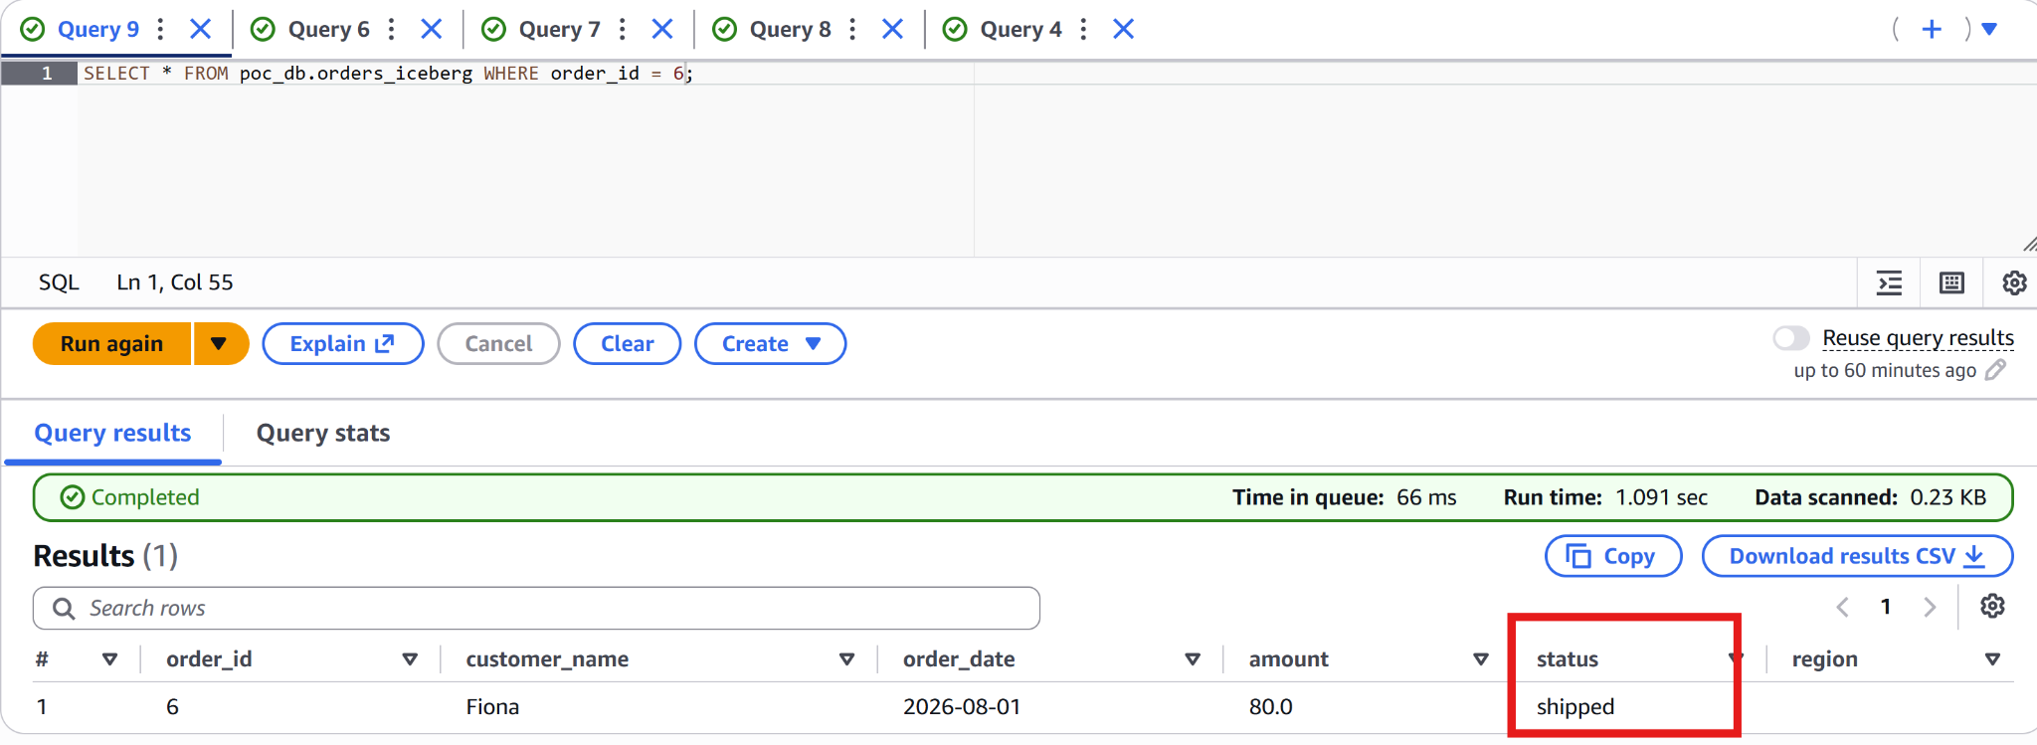

Step 7.2.3: Update from Athena -> Verify in Snowflake & Databricks
Rows Updated | 1
Visible in Snowflake? (Y/N + delay) | Yes (delay ~30s)
Visible in Databricks? (Y/N + delay) | Yes
Command / Config Used:
UPDATE poc_db.orders_iceberg
SET status = 'shipped'
WHERE order_id = 8;

Output / Confirmation:
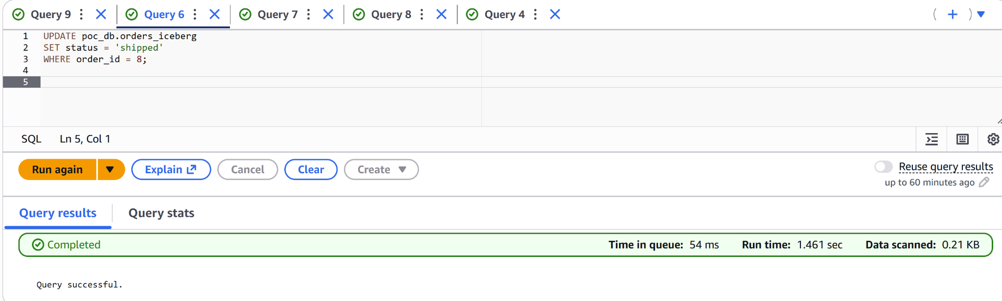

Screenshot Reference :
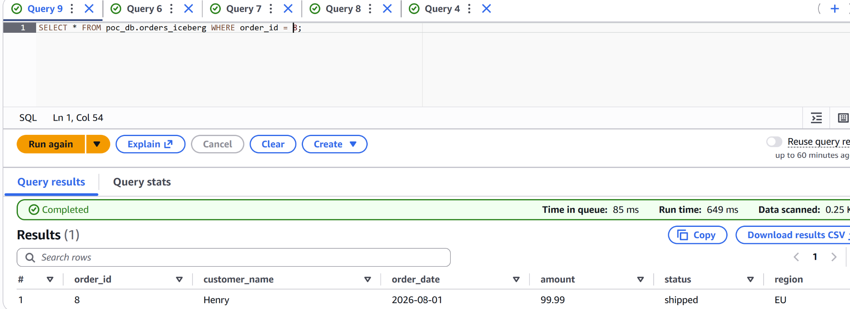
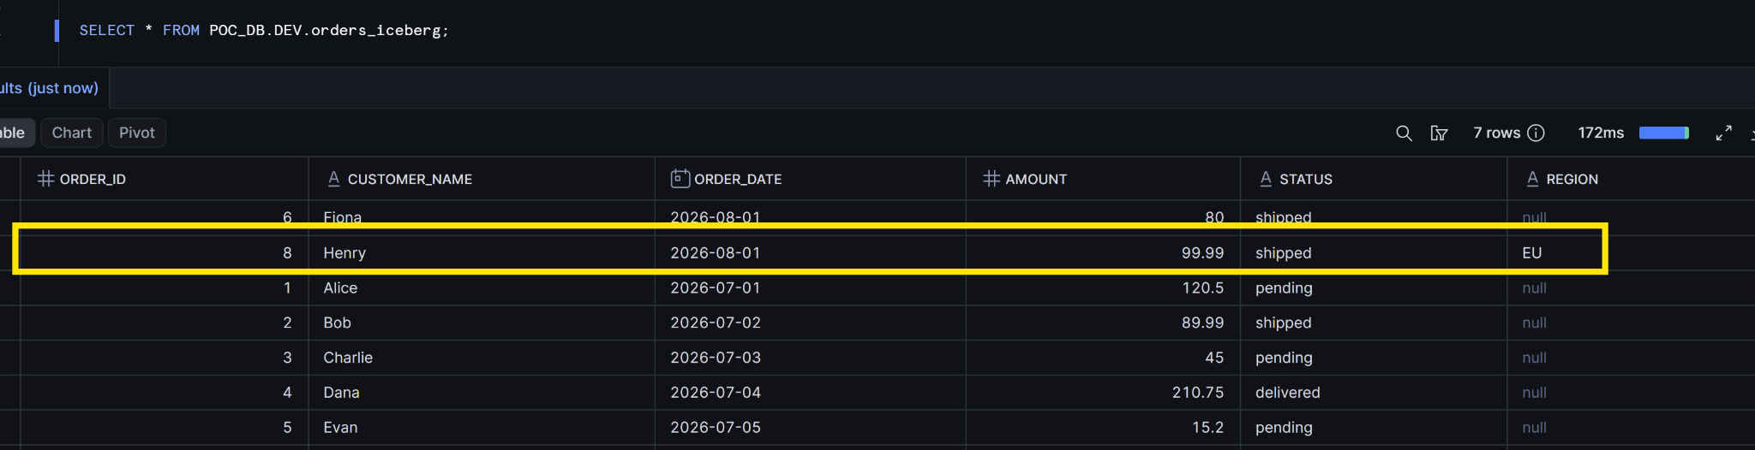

Notes / Issues Encountered:
Table uses the Glue Iceberg REST catalog integration, it should auto-refresh within ~30 seconds.

Step 7.3: DELETE Sync Test
Step 7.3.1: Delete from Snowflake -> Verify in Databricks & Athena
Rows Deleted | 1
Visible in Databricks? (Y/N + delay) | Yes
Visible in Athena? (Y/N + delay) | Yes
Command / Config Used:
DELETE FROM POC_DB.DEV.orders_iceberg
WHERE order_id = 6;

Output / Confirmation:
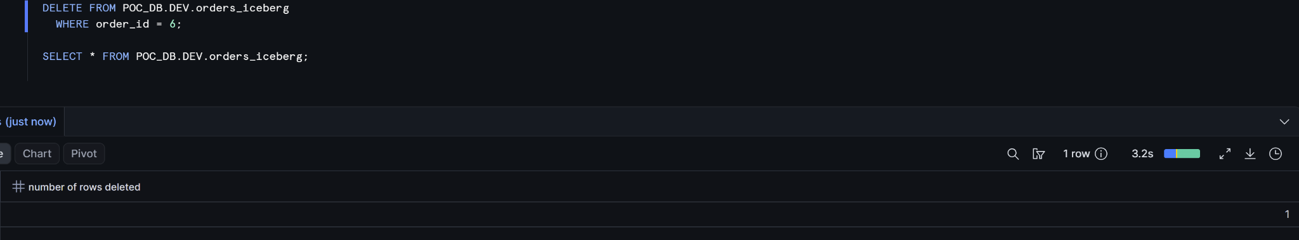

Screenshot Reference :
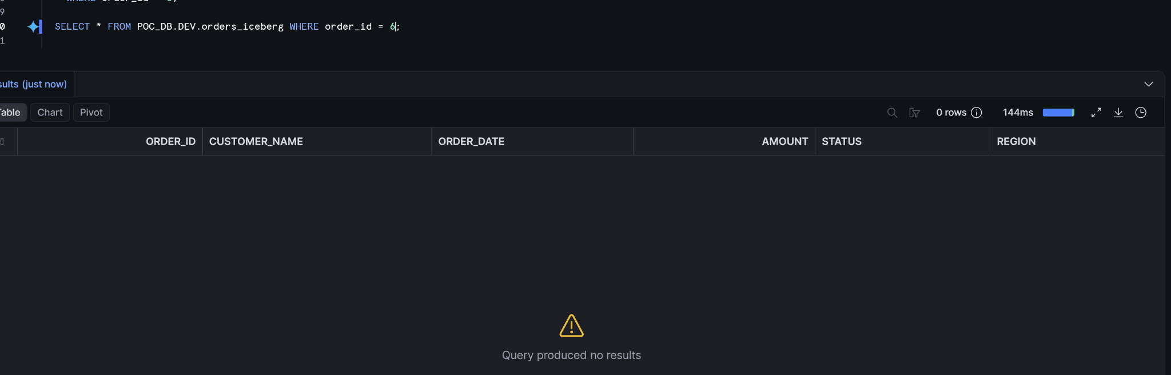
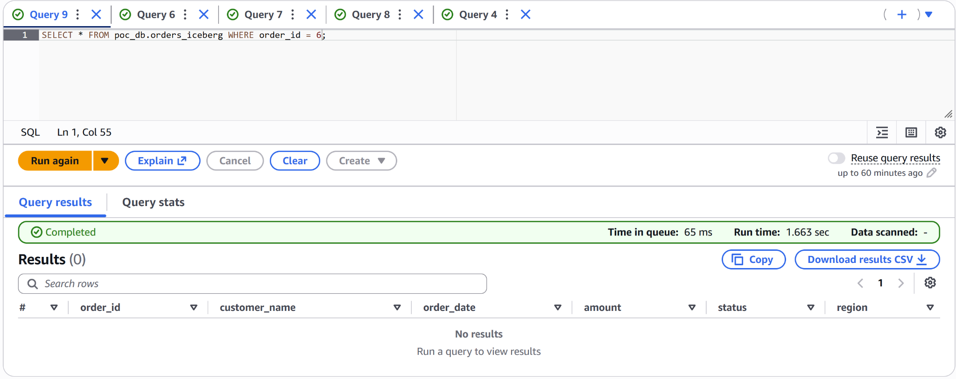

Step 7.3.3: Delete from Athena -> Verify in Snowflake & Databricks
Rows Deleted | 1
Visible in Snowflake? (Y/N + delay) | Yes
Visible in Databricks? (Y/N + delay) | Yes
Command / Config Used:
DELETE FROM poc_db.orders_iceberg WHERE order_id = 8;

Output / Confirmation:
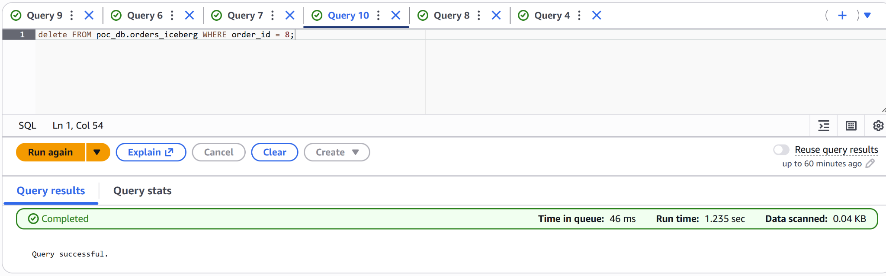

Screenshot Reference :
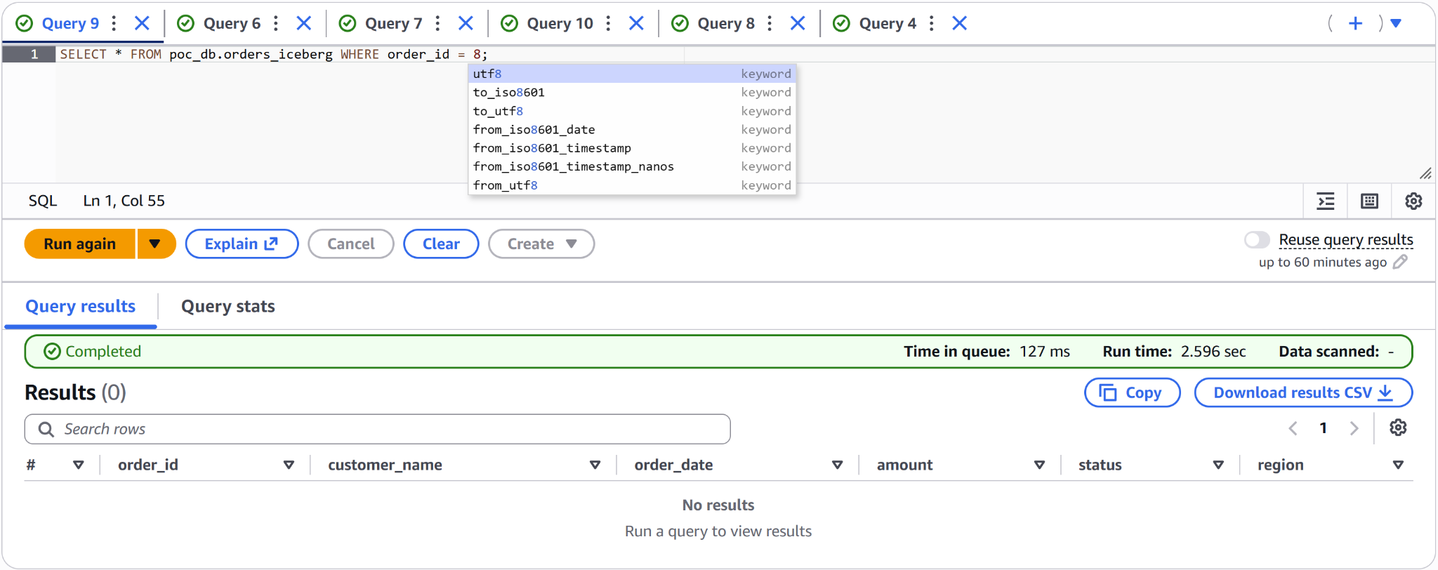
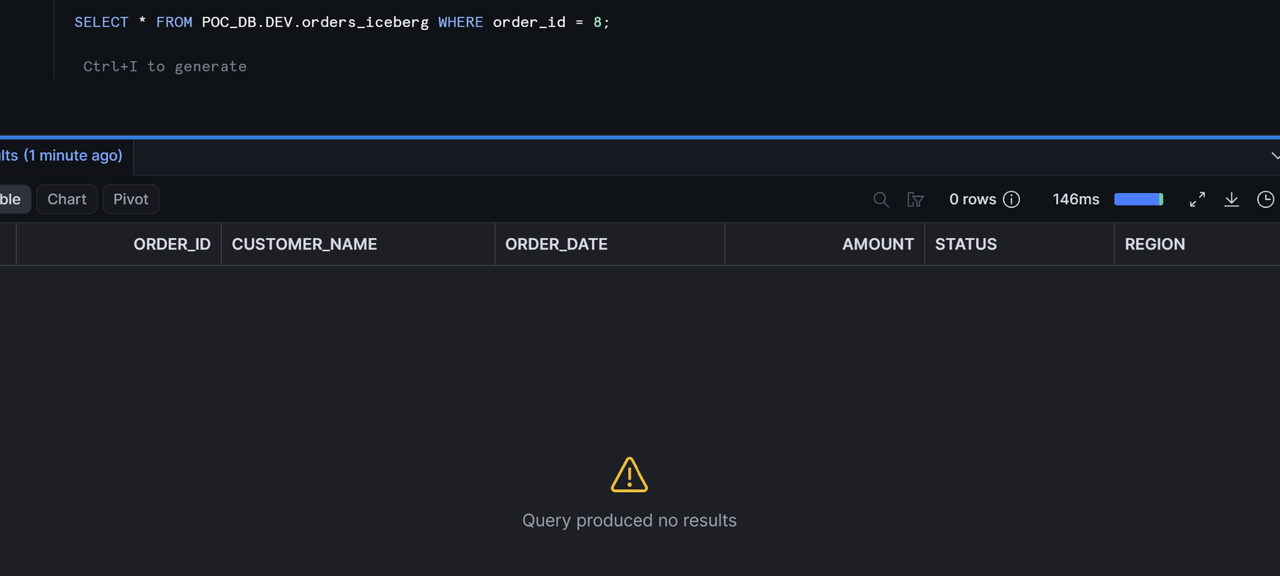

Step 7.4 Additional Checks

Step 7.4.1.1: Schema Evolution Test (Snowflake)
Change Made | Snowflake
Visible in Other Platforms? (Y/N) | Yes Visible in Athena
Command / Config Used:
ALTER ICEBERG TABLE POC_DB.DEV.orders_iceberg DROP COLUMN region;

Output / Confirmation:
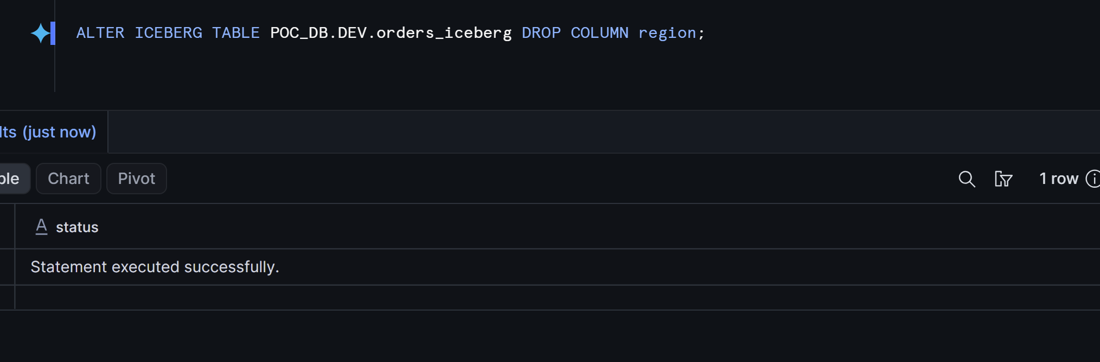

Screenshot Reference (filename):
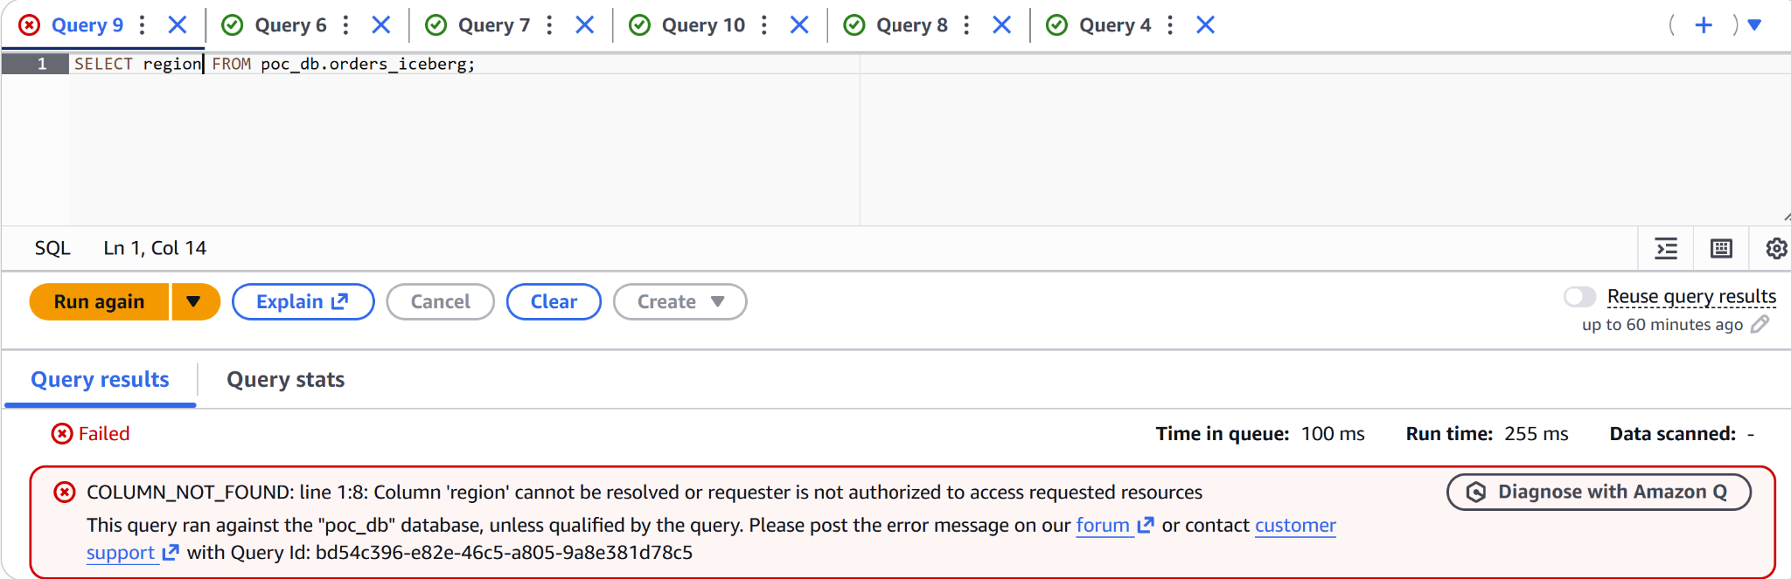

Step 7.4.1.2: Schema Evolution Test (Athena)
Change Made | Athena
Visible in Other Platforms? (Y/N) | Yes, Visible in Snowflake
Command / Config Used:
ALTER TABLE poc_db.orders_iceberg ADD COLUMNS (region string);

Output / Confirmation:
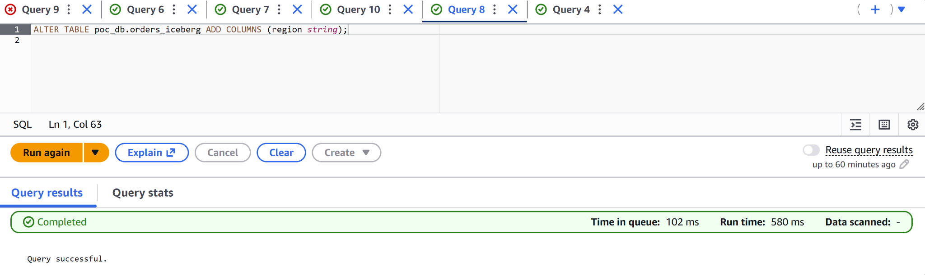

Screenshot Reference (filename):
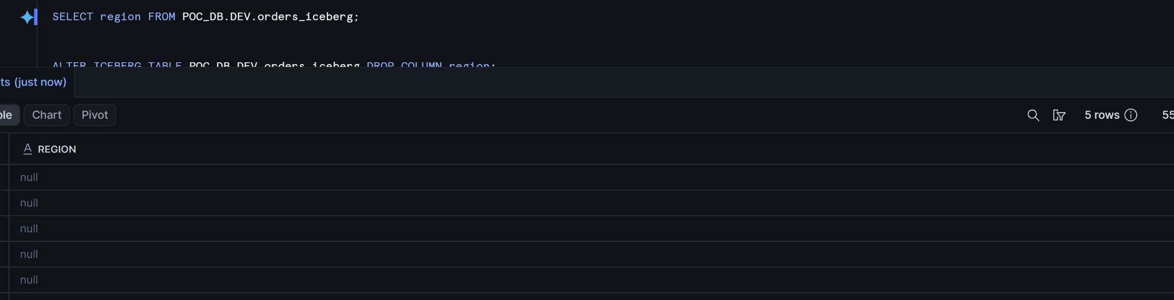

Notes / Issues Encountered:
Schema changes executed in Athena are not automatically reflected in Snowflake in real time; they require a manual refresh of the Snowflake Iceberg table.

Step 7.4.2: Time Travel / Snapshot Query (per platform)
Query Id | 01c6504e-0005-61a9-0001-92ba0009e60e
Result per Platform | Snowflake
Command / Config Used:
SELECT CURRENT_TIMESTAMP() AS before_insert_timestamp;
-- 2026-08-11 00:42:12.584 -0700
INSERT INTO POC_DB.DEV.orders_iceberg VALUES
(100, 'TimeTravel_Test', DATE '2026-08-11', 500.00, 'pending', null);

Output / Confirmation:

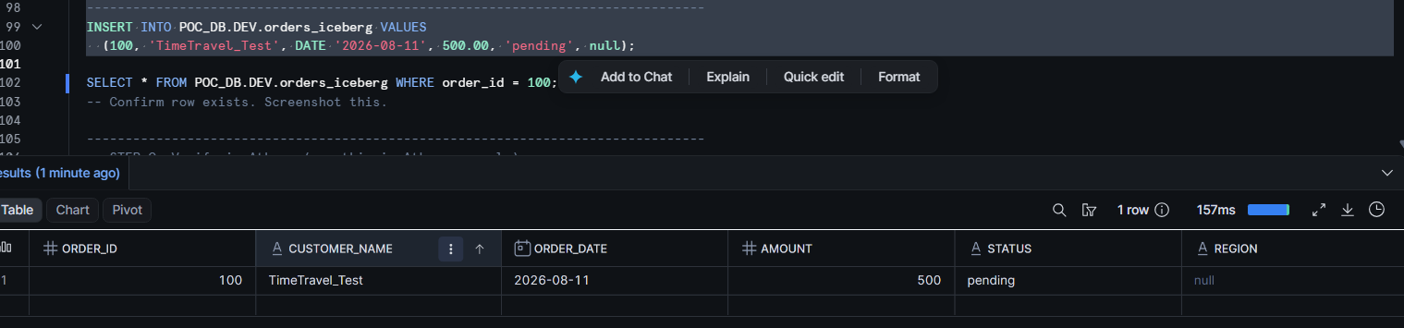
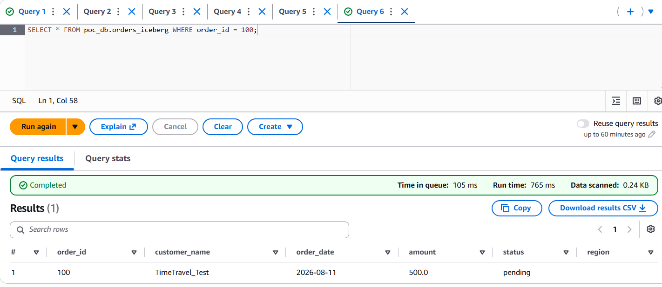
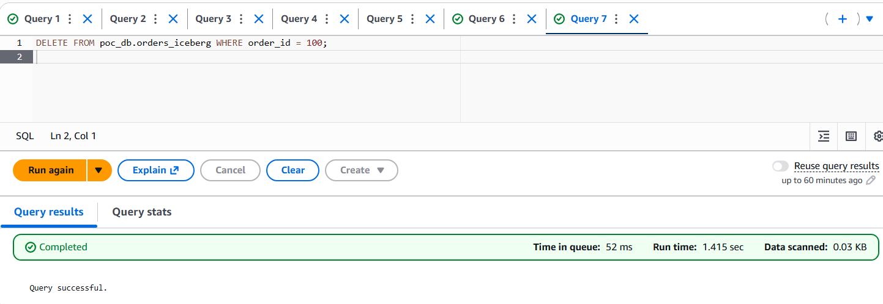
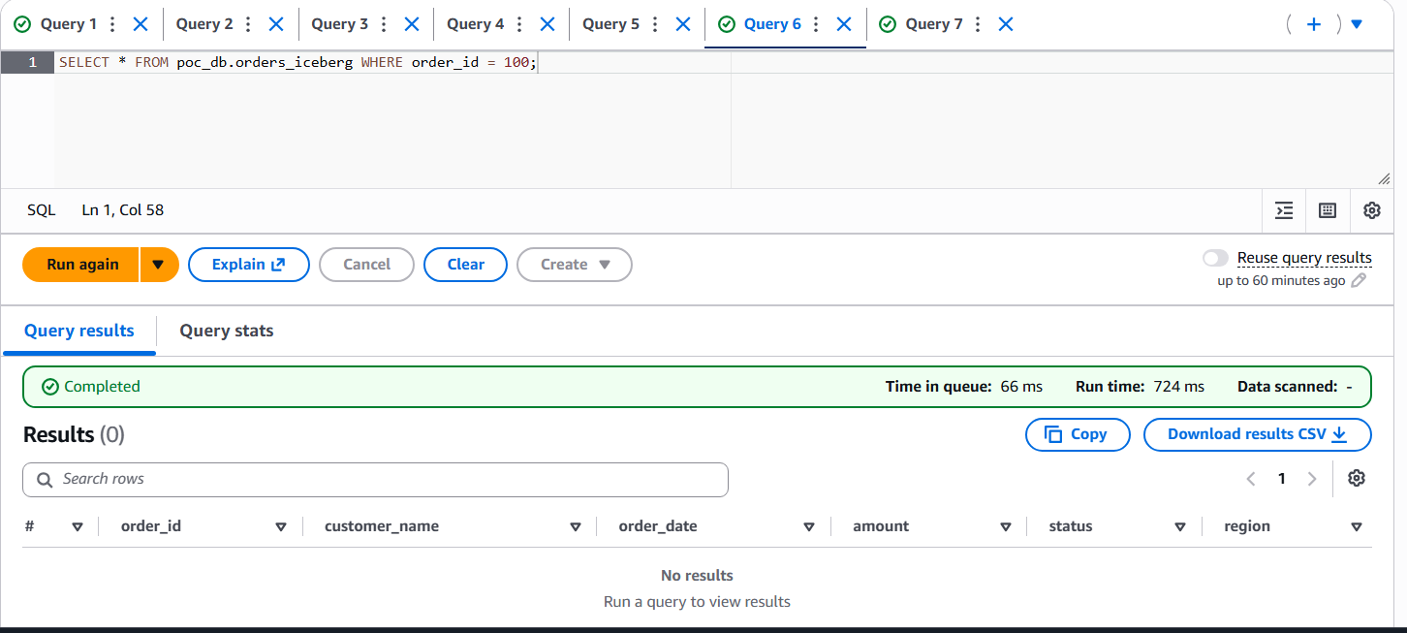

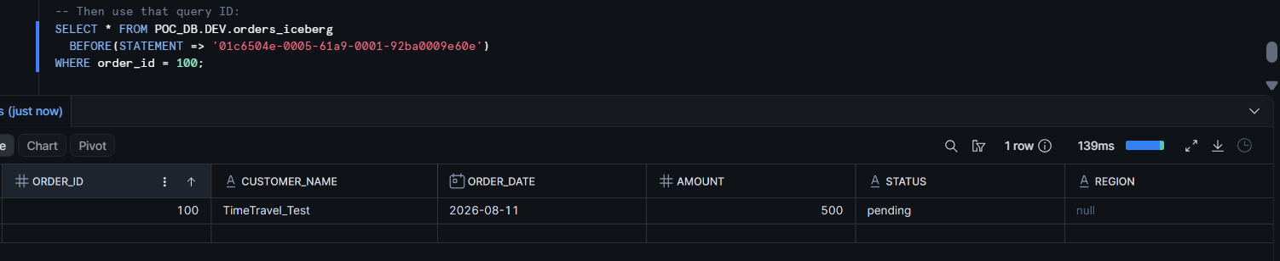
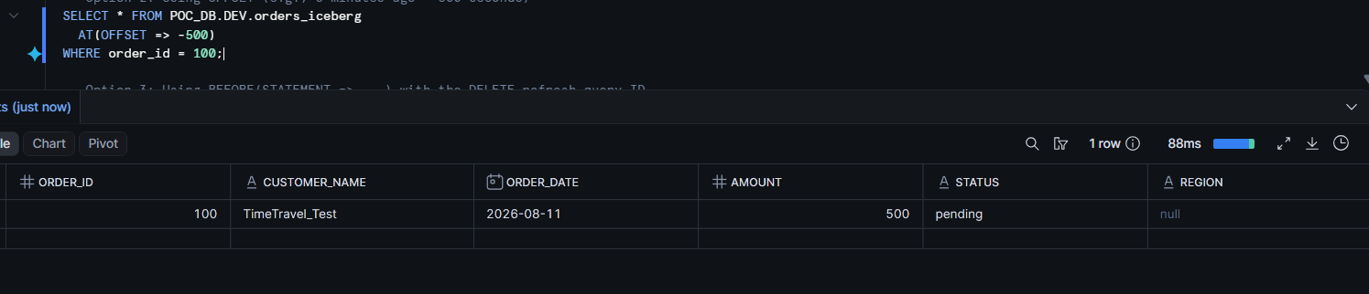

8. Findings & Observations

8.1 Platform Capability Matrix

Capability | Snowflake (Iceberg REST) | Databricks (Cluster Based Catalog) | Athena (Native Glue)
Read | Yes | Yes | Yes
INSERT | Yes | Yes | Yes
UPDATE | Yes | Yes | Yes
DELETE | Yes | Yes | Yes
MERGE | Yes | Yes | Yes
Schema Evolution (ADD/DROP column) | Yes (propagates to Glue) | Yes | Yes
Auto-Refresh (sees other engines' writes) | Yes (~30s polling) | Yes | Yes (instant, reads live snapshot)
Time Travel | Yes | Yes | Yes

8.2 What Worked Seamlessly
Single catalog, zero duplication: A single Iceberg table, created once via Athena and cataloged in AWS Glue, was successfully queried from all three platforms with no data copying or separate load step.
Snowflake full read-write via Iceberg REST: Using CATALOG_SOURCE = ICEBERG_REST (Glue's Iceberg REST endpoint), Snowflake achieved full DML capability — INSERT, UPDATE, DELETE, and schema evolution (DROP COLUMN) all worked and propagated back to Glue. This is a critical distinction from the legacy CATALOG_SOURCE = GLUE integration, which is read-only.
Athena native integration: Zero special configuration beyond the query-result output location. All DML and DDL operations worked with standard SQL.
Cross-platform sync for appends: INSERTs from any platform were visible on the others — Athena and Databricks instantly (they read live S3 metadata); Snowflake within ~30 seconds via auto-refresh polling.
Schema evolution propagation: Column additions (Athena) and column drops (Snowflake) were visible across platforms after metadata refresh, with no data rewrites required — Iceberg's column-ID-based schema tracking works as documented.

8.3 Friction Points & Workarounds
Issue | Platform | Impact | Resolution
IAM trust policy complexity | Snowflake | Multiple distinct external IDs required (one per integration object) — setup is trial-and-error | Consolidated all external IDs into a single trust statement using a StringEquals array
Lake Formation credential vending | Snowflake (REST) | Unable to assume role error blocked all access | Added lakeformation.amazonaws.com as trusted service + registered S3 location with correct role + granted cross-account Lake Formation permissions
Legacy vs. REST integration confusion | Snowflake | CATALOG_SOURCE = GLUE is read-only; documentation doesn't prominently distinguish from REST | Switched to CATALOG_SOURCE = ICEBERG_REST with CATALOG_URI = https://glue.<region>.amazonaws.com/iceberg
V2 delete-file incompatibility | Databricks | Any Iceberg merge-on-read DELETE file (produced by UPDATE/DELETE from Athena or Snowflake) renders the table completely unreadable from Databricks with a Scala assertion failure (DeleteFileWrapper) | No workaround within Databricks trial. Would require compacting the table (rewriting MoR files to CoW) from Athena/Spark, or ensuring all UPDATEs use copy-on-write mode
Serverless-only trial workspace | Databricks | No classic cluster available — could not test Spark-config-based Iceberg access | Pivoted to Unity Catalog Foreign Catalog feature
Self-assuming role requirement | Databricks | UC_IAM_ROLE_NON_SELF_ASSUMING error on catalog creation | Added self-referencing trust statement to IAM role (AWS requirement since June 2023)
Schema refresh not automatic | Snowflake | DDL changes from Athena not visible until refresh | AUTO_REFRESH = TRUE resolves this (~30s delay); or use manual ALTER ICEBERG TABLE ... REFRESH

8.4 Recommendations
- For read-write multi-engine access (Snowflake + Athena): This pattern works well today. Use CATALOG_SOURCE = ICEBERG_REST in Snowflake with AUTO_REFRESH = TRUE. Both engines can INSERT, UPDATE, DELETE, and changes propagate within seconds.
- For including Databricks in the architecture: Limit Databricks to append-only tables, or run Databricks as the sole writer (with others as readers). Alternatively, implement automated Iceberg compaction (via Athena OPTIMIZE or Glue Auto-Compaction) on a schedule to convert delete files before Databricks reads.
- IAM setup: Budget extra time for IAM trust policy configuration. Document all external IDs upfront via DESC EXTERNAL VOLUME and DESC CATALOG INTEGRATION before touching AWS.
- Lake Formation: If you don't need fine-grained column/row-level security, consider disabling Lake Formation governance on the database (use IAM-only mode) to avoid the credential-vending complexity entirely.

8.6 Final Verdict
Question | Answer
Can all three platforms read the same table? | Yes — but Databricks breaks after any V2 delete operation from another engine
Can all three platforms write? | Snowflake + Athena: Yes. Databricks: Read-only (Foreign Catalog limitation)
How fast is cross-platform sync? | Athena/Databricks: instant. Snowflake: ~30 seconds with auto-refresh
Where does it break down? | Databricks V2 delete-file incompatibility; Lake Formation credential vending complexity; IAM multi-principal trust setup
Is this viable for production? | Yes, for Snowflake + Athena as a dual-engine pattern. Adding Databricks requires architectural constraints (append-only or compaction automation)

