A Seminar report on

**SCREENLESS DISPLAY**

submitted in partial fulfilment of the requirement for the award of

the degree of

*Bachelor of Technology in Computer Science and Engineering*

By

**I. MEDISETTI HEMALATHA** (17VV1A0526)

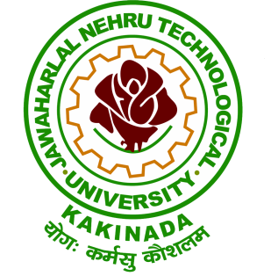

**DEPARTMENT OF COMPUTER SCIENCE AND ENGINEERING**

**JNTUK - UNIVERSITY COLLEGE OF ENGINEERING VIZIANAGARAM**

VIZIANAGARAM-535003,A.P.,INDIA

(2017-2021)

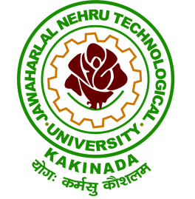

**Department of Computer Science and Engineering**

**JNTUK University College of Engineering Vizianagaram**

VIZIANAGARAM-535003, AP, IN.

**CERTIFICATE**

This is to certify that the seminar report titled “SCREENLESS DISPLAY” is being submitted in partial fulfilment for the award of *Degree of Bachelor of Technology in COMPUTER SCIENCE AND ENGINEERING* from Jawaharlal Nehru Technological University Kakinada - University College of Engineering Vizianagaram is a record of bonafide work carried out by MEDISETTI HEMALATHA bearing roll number:17VV1A0526

|  |  |  |
| --- | --- | --- |
| **Dr. P. Aruna Kumari**  Asst. Professor  Dept. of CSE  Coordinator - Seminar Committee | **Mr. T. Siva Rama Krishna**  Asst. Professor  Dept. of CSE  Senior Member - Seminar Committee | **Dr.A. S. N CHAKRAVARTHY**  Professor and HOD  Dept. of CSE  Chairman - Seminar Committee |

**DECLARATION**

I**,** MEDISETTI HEMALATHA *bearing the Roll No:17VV1A0526* studying in the IV year II semester of Bachelor of Technology in Computer Science and Engineering at JNTUK - University College of Engineering Vizianagaram*,*hereby declare that this seminar work entitled *“SCREENLESS DISPLAY”*which is being submitted by me in partial fulfilment of the requirements for the award of the degree of *B.Tech. in COMPUTER SCIENCE AND ENGINEERING*is an authentic record of me carried out during the academic year 2020-2021.

I further declare that the contents of this report do not include any copyrighted/proprietary material, and I am solely responsible for any such disputes.

MEDISETTI HEMALATHA

17VV1A0526

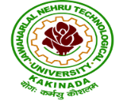

**JAWAHARLAL NEHRU TECHNOLOGICAL UNIVERSITY KAKINADA**

**UNIVERSITY COLLEGE OF ENGINEERING VIZIANAGARAM**

Dwarapudi (post), Vizianagaram Dist-Phone No. 08922-277911.

Website: [www.jntukucev.ac.in](http://www.jntukucev.ac.in)

**INSTITUTE VISION**

To emerge as a premier technical Institution in the field of engineering and research with a focus to produce professionally competent and socially sensitive engineers capable of working in a multidisciplinary global environment.

**INSTITUTE MISSION**

* To provide high quality technical education through a creative balance of academia and Industry by adopting highly effective teaching learning processes
* To promote multidisciplinary research with a global perspective to attain professional excellence
* To establish standards that inculcate ethical and moral values that contribute to growth in the Career and development of society.

**DEPARTMENT OF COMPUTER SCIENCE AND ENGINEERING**

**VISION**

To achieve academic excellence in Computer Science and Engineering by imparting comprehensive knowledge to the students, promoting research activities and professional ethics to outfit the ever changing industrial demands and societal needs.

**MISSION**

* To produce the best quality Computer Science professionals by imparting quality
* teaching and learning process, training and value education. To strengthen links with industry through partnerships and collaborative developmental works.
* To attain self-sustainability and overall development through Research and Consultancy activities.
* To inculcate work ethics and commitment in students for their future endeavours to serve the society.

**PROGRAM OUTCOMES(POS)**

Program Outcomes (POS) form a set of individually assessable outcomes that are the components indicative of the graduate potential to acquire competence to practice at the appropriate level. The POs is exemplars of the attributes expected of a graduate from an institution.

**PO Description:**

PO1:**Engineering Knowledge** Apply the knowledge of mathematics, science, engineering fundamentals, and an engineering specialization to the solution of complex engineering problems.

PO2**:Problem Analysis** Identify, formulate, review research literature, and analyze complex engineering problems reaching substantiated conclusions using first principles of mathematics, natural sciences, and engineering sciences.

PO3 :**Design/development of Solutions** Design solutions for complex engineering problems and design system components or processes that meet the specified needs with appropriate consideration for the public health and safety, and the cultural, societal, and environmental

considerations

PO4: **Conduct Investigations of Complex Problems** Use research-based knowledge and research methods including design of experiments, analysis and interpretation of data, and

synthesis of the information to provide valid conclusions.

PO5: **Modern Tool Usage** Create, select, and apply appropriate techniques, resources, and modern engineering and IT tools including prediction and modelling to complex engineering activities with an understanding of the limitations.

PO6 :**The Engineer and Society** Apply reasoning informed by the contextual knowledge to assess societal, health, safety, legal and cultural issues and the consequent responsibilities relevant to the professional engineering practice.

PO7 :**Environment and Sustainability** Understand the impact of the professional engineering solutions in societal and environmental contexts, and demonstrate the knowledge of, and need for sustainable development.

PO8 :**Ethics** Apply ethical principles and commit to professional ethics and responsibilities and norms of the engineering practice.

PO9: **Individual and Team Work** Function effectively as an individual, and as a member or leader in diverse teams, and in multidisciplinary settings. PO10 :Communication: Communicate effectively on complex engineering activities with the engineering community and with society at large, such as, being able to comprehend and write effective reports and design documentation, make effective presentations, and give and receive clear instructions.

PO11 :**Project Management and Finance** Demonstrate knowledge and understanding of the engineering and management principles and apply these to one's own work, as a member and leader in a team, to manage projects and in multidisciplinary environments.

PO12: **Life-Long Learning** Recognize the need for, and have the preparation and ability to engage in independent and life-long learning in the broadest context of technological change.

**PROGRAM EDUCATIONAL OBJECTIVES (PEOS)**

**PEO 1:** The graduates of the Program will be prepared for their careers in the software industry, public sector or pursue higher studies and continue to develop their professional knowledge.

**PEO 2:** The graduates will acquire capability to apply their knowledge of Computer science and engineering to solve real world problems using latest technologies.

**PEO 3:** The graduates will inculcate in professional attitude, inter-disciplinary approach, ethics and ability to relate computer engineering issues with social awareness.

**PEO 4:** The graduates of Computer Science Engineering will have soft skills to adapt to the diverse global environment through lifelong learning.

**PROGRAM SPECIFIC OUTCOMES (PSOs)**

**PSO 1:**Able to apply the knowledge of programming languages, data structures and algorithms, data science, networks and software engineering principles for software product development

**PSO 2:**Able to analyze and formulate solutions to real world and socially relevant problem solver multidisciplinary domains by using latest technologies.

**PSO3:**Able to be a technically competent employee, researcher, entrepreneur, excel in competitive exams and zest for higher studies.

**ABSTRACT**

**SCREENLESS DISPLAY**

Screen less, as the word suggests clearly means “no screen ”. Therefore, the screenless display can be defined as a display that helps in displaying and even transmitting any information without the help of the screen or Projector.

Screenless display is nothing but a display which can be shot at any place wherever the user wishes to have the screen. It can be at any direction or place such as on the wall or in the open space. It is a system of displaying information/data though an electronic video source without using screen at all.

This seminar provides a concise but all-round concepts about the emerging technology Screenless Display. Then this seminar discusses some current solutions and finally describes future research work about the screenless display technology .

**This project is mapped with following PO’S and PSO’S:**

|  |  |  |  |  |  |  |  |  |  |  |  |
| --- | --- | --- | --- | --- | --- | --- | --- | --- | --- | --- | --- |
| **PO1** | **PO2** | **PO3** | **PO4** | **PO5** | **PO6** | **PO7** | **PO8** | **PO9** | **PO10** | **PO11** | **PO12** |
|  |  |  |  |  |  |  |  |  |  |  |  |

|  |  |  |
| --- | --- | --- |
| **PSO1** | **PSO2** | **PSO3** |
|  |  |  |

**TABLE OF CONTENTS**

1 Introduction . . . . . . . . . . . . . . . . . . . . . . . . . . . . . . . . . . . . . . . . . . . . . . . . . . . . . . . . . . .1

2 Origin of ScreenLess Display 4

3 Needs For ScreenLess Display 5

4 Technologies Used 6

5 Types Of ScreenLess Display 7

5.1 Visual Image 7

5.2 Retinal Projection 10

5.3 Synaptic Interface 12

6 Adavantages and Disadvantages 14

7 Applications 16

8. Enhancements Projects 17

9.Conclusion 19

10.References………………………………………………………………………..20

# 

# **LIST OF FIGURES**

1.1 Screenless Display . . . . . . . . . . . . . . . . . . . . . . . . . . . . . . .2

1.2 Google Glass. . . . . . . . . . . . . . . . . . . . . . . . . . . . . . . . . . . .3

5.1 Types of SLD. . . . . . . . . . . . . . . . . . . . . . . . . . . . . . . . . . . .7

5.1.1 Visual Image Display. . . . . . . . . . . . . . . . . . . . . . . . . . . . .8

5.1.2 Holographic Display. . . . . . . . . . . . . . . . . . . . . . . . . . . . . 8

5.1.3 Heads Up Display. . . . . . . . . . . . . . . . . . . . . . . . . . . . . . . 9

5.1.4 Examples of Visual Image. . . . . . . . . . . . . . . . . . . . . . . . . 10

5.2.1 Block Diagram of Retinal Screenless Display. . . . . . . . . . . .11

5.2.2 Working of Normal Vision. . . . . . . . . . . . . . . . . . . . . . . . . . 11

5.2.3 Retinal Projection. . . . . . . . . . . . . . . . . . . . . . . . . . . . . . . . .12

5.3.1 Synaptic Interface. . . . . . . . . . . . . . . . . . . . . . . . . . . . . . . . .12

# 

# **1.INTRODUCTION**

Screen less, as the word suggests clearly means ‘no screen’. So, Screen less Displays can be defined as a display which helps to display and even transmitting visual information from a video source without the use of a screen .

Advanced technologies are growing faster wherein each technology is renewed with implementation of new one. The current trending display technology most commonly used in gadgets such as tablets, smart phones, etc., is the touch-screen display, which will become outdated in the near future. Screenless display is the advanced display technology, which replaces the [touch screen technology](https://www.elprocus.com/touch-screen-technology-working/) to resolve the problems and to make lives more comfortable. By using this screenless display technology, we can display the images directly on the open space, human retina and also to the human brain.

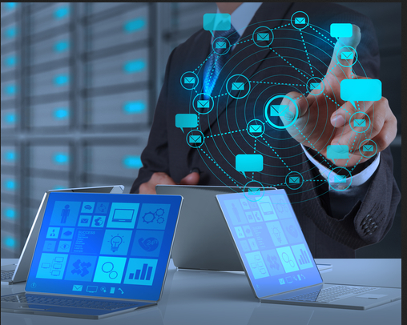

**FIG. 1.1 SCREENLESS DISPLAY**

# **FIRST SCREENLESS DISPLAY**

The first screen-less display that needs mentioning is Google Glass.

Google Glass sits on the face like a pair of glasses, and on one eye it has a block of glass that allows you to see augmepanted reality. Images can be displayed right in front of your eye, as well as text and information about objects and places that are in front of you.

This technology is only in its early stages, but definitely shows that screen-less displays will become a natural form of media consumption in the future.

Augmented reality (AR) is a technology that lets people superimpose digital content (images, sounds, text) over a real-world environment.

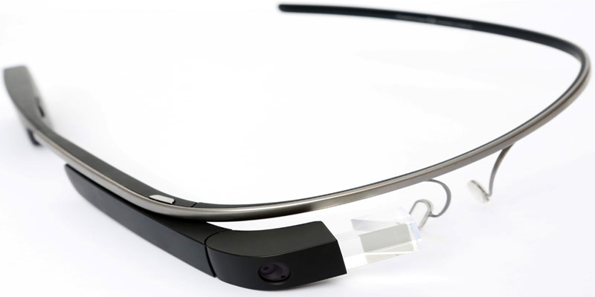

**FIG. 1.2 GOOGLE GLASS**

**2.ORIGIN OF SCREENLESS DISPLAY**

Reto Meier, an “Android Developer Advocate for Google” recently laid out a fairly science-fiction account of where computer (or at least mobile) interfaces are headed. In the spirit of the best futurism, all of his predictions - from Augmented Reality eye glasses to advanced batteries - have parallels in the real world. What follows is a walk-through of the future, expressed in terms of the not quite ready for prime time discoveries coming out of labs today. Working on the average laptop is like working on a desk that’s as big as a sheet of paper. That’s why all our “files” are half an inch high. The key to productivity and immersion is more, bigger screens - hence the proliferation of external monitors, secondary reading devices and even mobile phones with improbably large screens. So-called “Pico” projectors (named for their tiny size) already exist - there’s even an HD version, the Forever Plus, that’s less than an inch on its longest dimension. And there are mobile phones, such as the Samsung Show, which have built-in pico-projectors - so outside of market demand there’s nothing to stop this prediction from coming true.

This field came into progress during the year 2014 by the arrival of products like holographic videos, virtual reality headsets, retinal displays, mobiles for elderly, eye tap etc. At present, we can say that only part of the Screenless Display Technology is brought up which means that more advancement is necessary for a boost in the technology. This problem will surely provide a pathway for screenless display.

# 

# **3 .NEEDS FOR SCREENLESS DISPLAY**

Miniaturization and lack of space are the needs for screenless Display

Miniaturization : the process of making something very small using modern technology:

# Lack of space is one of major problem faced by screen displays. This emerging new display technology will replace this touch screen environment and will solve the problems at higher level, making life more comfortable. Nowadays the technology is changing very rapidly in the existing machines and in the tools in order to solve the problem at the high level. It would be not wrong in saying that the Screenless display technology would be a life-changing concept and also one of the most interesting topics for the research. This technology also solves the problem of the space of display in one .

**4.TECHNOLOGIES USED IN SCREENLESS DISPLAY**

**INTERACTIVE PROJECTORS**

Interactive Projectors are generally ultra-short throw projectors(It virtually eliminates shadow and eye glare....and it also refers to a distance between 0 to 4 ) with projection mapping. The images and words are projected onto a projector screen or whiteboard, much like your standard projectors. Unlike most projectors, however, interactive projection gives you the ability to interact with what you're projecting.

**VISUAL DISPLAY**

Visual Displays are depictions(to show something in a picture ) that convey information by means of elements beyond pure text. Examples include diagrams, maps, and computer interfaces. The common factor in all of these is their reliance on the “visual intelligence” of humans to organize graphically-presented information in a way that makes it easier to understand. The design of an effective visual display is based on general principles involving both the nature of human vision and the nature of the task. The particular medium used—paper, canvas, computer monitor, etc.—is irrelevant.

**3D HOLOGRAM**

A 3D hologram is defined as a 3D projection that exists freely in space and is visible to everyone without the need for 3D glasses. Holography is the next stage of photography and conventional film and its three-dimensionality creates completely new possibilities for use, such as for product presentation

**5.TYPES OF SCRREN LESS DISPLAY**

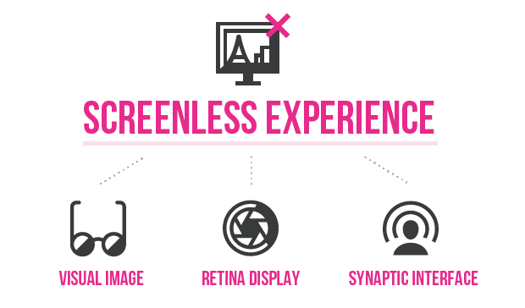

**FIG. 5.1 TYPES OF SLD**

Screenless display technology is divided into three main categories:

* Visual Image Display
* Retinal Display
* Synaptic Interface

The first category, visual image is defined as the things that can be seen by the human eye such as holograms. The second category, retinal display – the name itself- indicates the display of image directly onto the retina. The third category , synaptic reference which means sending information directly to the human brain. Let us look on in detail about these three display types.

### **5.1. Visual Image Display**

The visual image is a type of screenless display, which recognizes any type of image or thing with the help of the human eye.The following are few examples of the visual image display: holographic display, virtual reality goggles, heads up display, etc. The working principle of this display states that the light gets reflected by the intermediate object before reaching the retina or the eye. The intermediate object can be a hologram, [Liquid Crystal Displays (LCD)](https://www.elprocus.com/ever-wondered-lcd-works/)s or even windows.

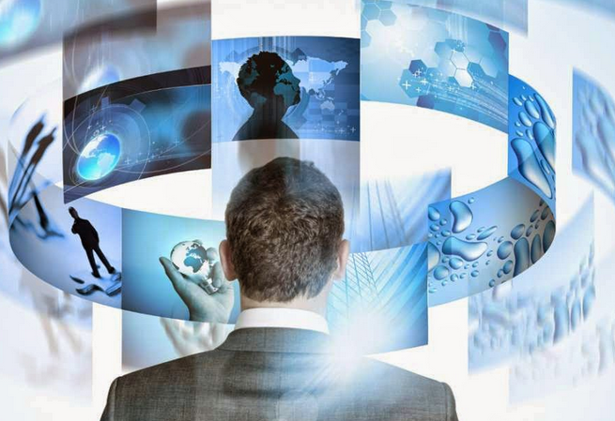

**FIG. 5.1.1 Visual Image Display**

By using the components like Helium Neon Laser, an object, a Lens,a holographic film  and mirror, the **Holographic Displays**display the three dimensional (3D) images. A 3D image will be projected and appears to be floating in the air whenever the laser and object beams overlaps with each other. This display can supply accurate depth cues and high-quality images and videos that can be  viewed by the human eyes without any need of special observation devices. Based on the colors of the laser projector, images are formed in three distinct planes. Holographic displays are commonly used as an alternative to screens.

N 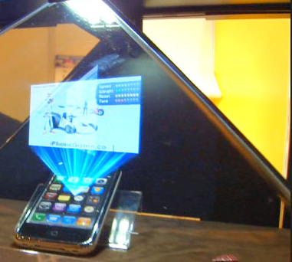

**FIG. 5.1.2 Holographic Display**

**Heads up display** are also named as transparent displays. These displays are applied in different applications such as aeroplanes, computer games and automobiles, etc. Many of the users do not need to look away from their field of view because the device displays the information on a windshield. An orginary heads up display comprises of following components: a projector unit, combiner and a computer. The projector unit projects the image, and the combiner redirects the displayed image by that projected image, and the field of view are seen simultaneously. The screenless computer acts as an interface between the projector and the combiner (data to be displayed).

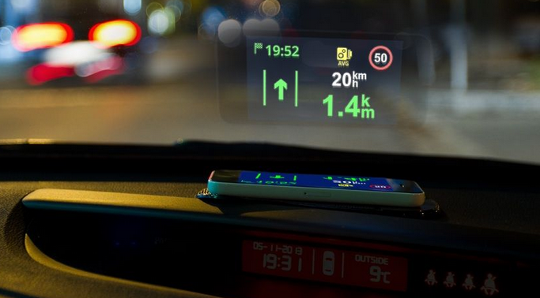

**FIG. 5.1.3 Heads up Display**

The main advantage of visual image displays is creating and manipulating the images up to any size. In this category of displays, multiple bitmaps can be composited together in the object mode and, in the image mode, manipulation takes place. In this [display system](https://www.elprocus.com/2-ways-display-messages-electronically/), Eye files are created which consists of all the images that are loaded. The EYE file creates a ‘Export Project Command’ in the file. These commands in EYE file provide a provision to save any sort of unsaved images in the form of bitmaps into it. A common catalog is created to place the browsed images from ‘Export Editor Command’ in the ‘EYE’ file.

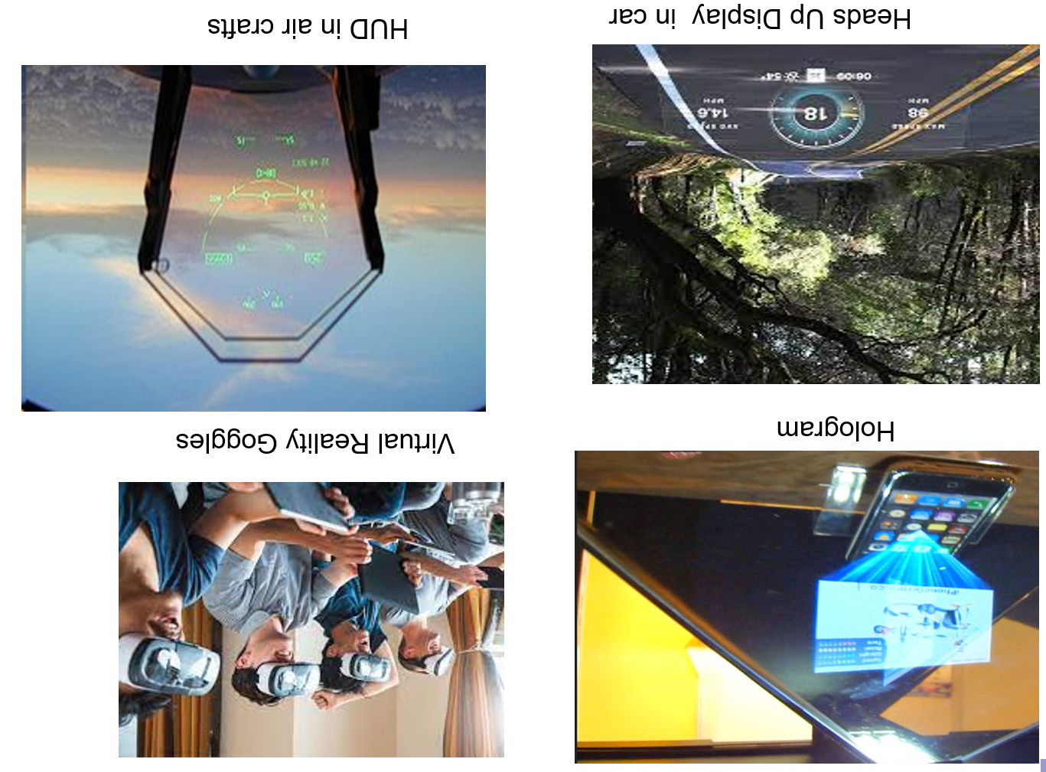

**FIG. 5.1.4 EXAMPLES OF VISUAL IMAGES**

### **5.2. Retinal Display**

The second category of [advancement in display system](https://www.elprocus.com/tft-oeld-advancement-display-technology/), retinal display as the name itself indicates the display of image directly onto the retina. Instead of using some intermediate object for light reflection to project the images, this display directly projects the image onto the retina. The user will  sense that the display is moving freely in the space. Retinal display is commonly known as retinal scan display and retinal projector. This display allows short light emission, coherent light and narrow band colour . Let us know about this display with the help of the following block diagram.

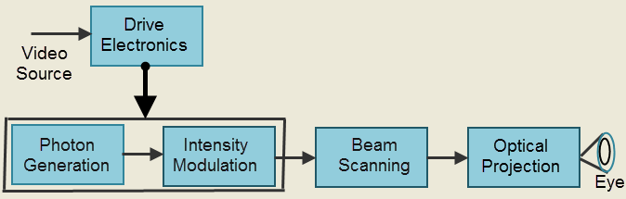

**Fig. 5.2.1 Block Diagram of Retinal Screenless Display**

The block diagram of the virtual retinal display consists of following blocks: photon generation, intensity modulation, beam scanning, optical projection and drive electronics. Photon generation block generates the coherent beam of light; this photon source make use of the laser diodes as coherent source with retina display to give a diffraction onto the retina of the human eye. The light generated from photon source is intensity modulated. The intensity of the light beam gets modulated to match the intensity of the image. The modulated beam gets scanned by the beam scanning. By using this scanning block, the image is placed onto the retina. In this beam scanner, two types of scanning modes takes place: raster mode and vector mode. After the scanning process, optical projection takes place for projecting a spot-like beam onto the retina of the eye. The spot focused on the eye is sketched as an image. A drive electronics placed on the photon generator and intensity modulator is used for synchronization of the scanner, modulator and coming video signal. These displays are made available in the market by using [MEMS technology](https://www.elprocus.com/understanding-fabrication-mems/).

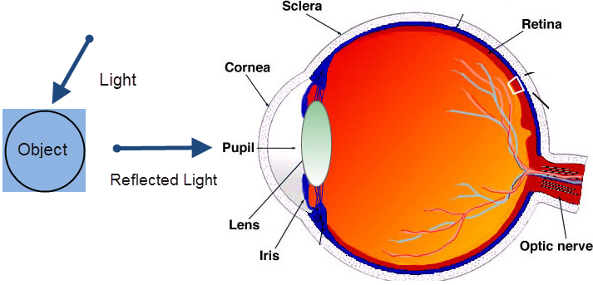

**FIG. 5.2.2 WORKING OF NORMAL VISION**

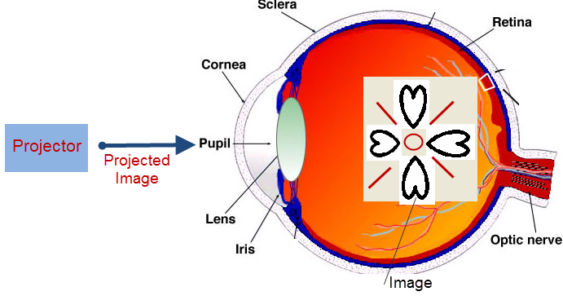

**FIG. 5.2.3 Retinal Projection**

### **5.3. Synaptic Interface**

The third category, synaptic interface means sending information directly to the human brain without using any light. This technology is already tested on humans and most of the companies started using this technology for effective communication, education, business and [security system](https://www.elprocus.com/electronic-security-system/). This technology was successfully developed by sampling the video signals from horse crab eyes through their nerves, and the other video signals are sampled from the electronic cameras into the brains of creatures.

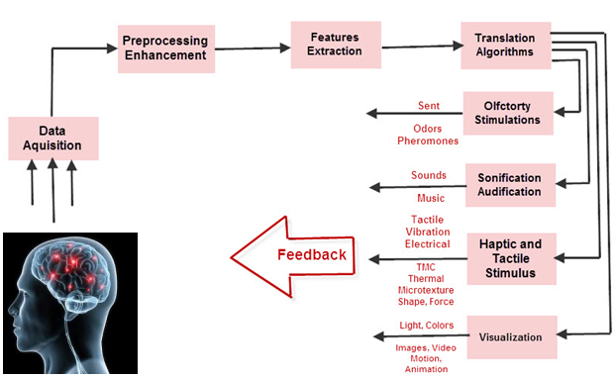

**FIG. 5.3.1 Synaptic Interface**

The brain computer interface allows direct interaction between the human brain and external devices such as computer. This category can also be known by different names such as [human machine interface](https://www.elprocus.com/human-machine-interface-operator-control-and-monitoring-systems/), synthetic telepathy interface, mind machine interface and direct neural interface.

These are the three types of [latest Screenless displays](https://en.wikipedia.org/wiki/Screenless_video) which replace the current use of touch screen technology to fill the lack of space in the screen-based electronic displays.

**Additional Software and Hardware Requirements**

1. To facilitate the interactivity.

2. To optimize the user ’s perceptual and cognitive capabilities.

3. To provide the most healthful visual environment for the user.

4. Responding to a variety of user commands (using voice, hand, foot, or other signal methods).

5. Providing blink cues or blinks responses.6. Modifying output to compensate for changes in user’s physiology or reaction time, etc. The new software and hardware will enable the user and the system to better exploit each other’s capabilities and to function as a fully integrated team.

**6.Advantages and Disadvantages**

**ADVANTAGES**

Low power requirements: Only six diodes are required and a few of a watts to deliver their images to the user’s eyes.

Higher resolution images: The pixels in the images projected by the diodes can be made smaller than is possible with any CRT or flat panel display, so higher resolution can be achieved. With retinal projectors, the only limitation in the resolution of visual images will be the resolving power of the users.

Greater portability: The combination of diodes, lenses, and processing components in a retinal projector system will weigh only a few ounces.

Wider angle of view: Retinal projectors will be able to provide a wider field of view than is possible screens.

More accurate colour: By modulating light sources to vary the intensity of red, green, and blue light, retinal projectors can provide a wider range of colors and more fully saturated colors than any other display technology.

Greater brightness and better contrast: Retinal projectors can provide higher levels of contrast and brightness than any other display system.

Ability to present 3D images: With their capability of presenting high definition image-pairs, retinal projectors can deliver the most highly realistic stereoscopic movies and still pictorial images to their users.

Ability to present far-point images: The human visual system is a far-point system. With today’s desktop and laptop computers users must employ their near-point vision. The excessive use of our near-point vision in using computers, reading, sewing, playing video games, etc., is making myopia a very common impediment. The use of the far-point images that can be provided by retinal projector systems could reduce the incidence ofmyopia and, hence, the growing need for and use of eyeglasses.

Lower costs: The present cost of retinal projector systems is high. Nevertheless, there are no hard-to-overcome manufacturing problems in mass-producing and low-cost components, so inexpensive systems willsoon become available. Environmental and disposal costs of these tiny delivery devices will also be minimal because toxic elements such as lead, phosphorus, arsenic, cadmium, and mercury are not used in their manufacture

**DISADVANTAGES**

The principle disadvantage is that virtual retinal display (VRD) is not yet available in the significant numbers.

The limitation of conventional 3D displays is that the observer has no freedom of head movement or the freedom to increase information about the 3D objects being projected

Prototypes and special experimental models are now being built, but their cost per unit is high.

Many problems related to eyesight can arise as products need close contact with eyes.

**7. APPLICATIONS**

The main use of the screen less displays are used for the development of the mobile phones which are mainly used by the old and blind people. This type of the invention of the screen less displays was first done on the mobile phone named OWASYS 2CC. This model is very useful for the old, blind, and even for the people with less vision power. Hologram projection is a result of a technological innovation that truly helps in touch less holographic interfaces. In fact, hologram projection projects 3D images of so high quality that it feels as if one can touch them. However, holographic projection is still to achieve mass acceptance as until now, conventional holograms, which offer 3D images development of the screen less laptops.

Medical field: By allowing the physician to view a virtual X-Ray of infected areas information that is concerning that patient during surgery. Virtual images produced by VRD could be laid-down with the patient by tracking the view of the physician in relation to the position of the patient.

Manufacturing field: Used in manufacturing environment by viewing virtual blue print that uses C3 images to identify parts placement and operation information.

Transportation system: It can be beneficial in any transportation system by proving the display that can project virtual map of the surrounding area therefore in siding vision of providing reference state train characteristics and craft instrumentation

**8.ENCHANCEMENTS PROJECTS ON SCREENLESS DISPLAY**

For the future development of this emerging new technology, several researches are being conducted and the several renowned IT sector companies and other best labs present in the world are handling over the project of screenless displays. Technology has become perhaps the greatest agent of change in the modern world. While never without risk, positive technological breakthroughs promise innovative solutions to the most pressing global challenges of our time, from resource scarcity to global environmental change. However, a lack of appropriate investment, outdated regulatory frameworks and gaps in public understanding prevent many promising technologies from achieving their potential. This field saw rapid progress in 2013 and appears set for imminent breakthroughs of scalable deployment of screenless display. Various companies have made significant breakthroughs in the field, including virtual reality headsets, bionic contact lenses, the development of mobile phones for the elderly and partially blind people, and hologram-like videos without the need for moving parts or glasses.

Microsoft in 2001 began the work on an idea for an Interactive table that mixes both the physical and the Virtual worlds.

Multi touch is a human computer interaction technique and the hardwire devices that implement it, which allows users to compute without conventional input devices.

CUBIT is being developed for the future use of the multi Touch use of the program.

Development of the enhancement of the micro vision also gives the improved and the futuristic view of the screen less displays. This technology of the micro vision is the very well useful in the Artificial Retinal Display properties.

Japanese scientists have invented the pair of intelligent Glasses that remembers where people last saw their keys, Handbags, iPod, and mobile phones.

Smart Google is developing the compact video camera which films everything the wearer looks at the information what the viewer wants will be directly being seen in through the glasses where there is no screen or projector present.

Several laboratories are working under progress on the electron beam lithography which includes the advanced enhancement of the futuristic screen less display.

Adobe systems are also working out for the development and deployment cross platform of the several applications which are to be viewed without the actual screen.

**PREDICTIONS**

Screenless display technology is likely to affect

Lighting and projection technologies

Software development/design

Lifestyles of the visually impaired

Career opportunities for the visually impaired

**9.** **CONCLUSION**

Reto Meier predicts that 10 years from now we will be able to get transparent LCD patches that will adhere to our eyeglasses and 20 years from now we’ll have contact lenses that project images directly onto our retinas and that we will be able to interface with computers through mind control. The most profound effect will come from the development of the synaptic interface technology. This technology will allow people who are visually impaired to see just as the hearing impaired are able to hear through cochlear implants.

Screenless display technology is the present evolving computer-enhanced technologies. It will surely be the one of the greatest development in the field of technology in the upcoming future. Several patents are still researching on this new technology which can change the whole view of the displays.

# **10.REFERENCES**

[1]Screen-less Head Mounted Projector with Retro tranmissive Optics Ryugo KIJIMA, Jyunya WATANABE

[2]Kiyokawa, K., "A Wide Field-of-view Head Mounted Projective Display using Hyperbolic Half-silvered Mirrors", Procs of ISMAR

[3]Okano, F., Arai, J., "Resolution characteristics of afocal array optics".

[4] SPE Annual Technical Conference and Exhibition, 30 September-3 October 2001, New Orleans, Louisiana

[5]www.technologyreview.com/blog/mimssbits/25623/videos.mitrasites.com/screenless-display.html

[6]Telecoms.cytalk.com/.../why-the-future-of-mobile-isscreenless-touch

[7][Emerging Technology: Screenless Display and their Types (elprocus.com)](https://www.elprocus.com/introduction-to-screenless-displays-and-their-types/).

[8] [Screenless Display | Electronic projects | Mepits](https://www.mepits.com/project/174/Techno-innovations/Screenless-Display).