**COURSE CODE:** CSA1523

**CPOURSE NAME:** CLOUD COMPUTING AND BIG DATA ANALYTICS

**NAME:** D. Hemalatha

**REG NO:** 19231107

EXP 2:

# Create a simple cloud software application for Flight

**Reservation System using any Cloud Service Provider to demonstrate SaaS**

**AIM:** To create a simple cloud software application for Flight Reservation System using any Cloud Service Provider to demonstrate SaaS

# PROCEDURE:

**STEP1: GOTO ZOHO.COM**

STEP 2: LOGIN TO THE ZOHO.COM

STEP 3: SELECT ONE APPLICATION

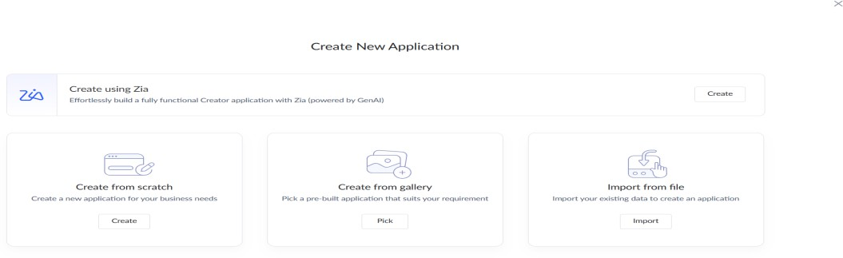

STEP 4: ENTER APPLICATION NAME(“Flight Reservation System)

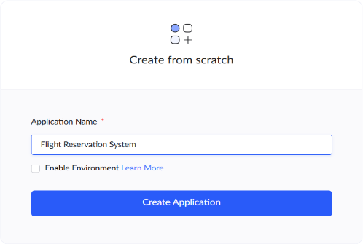

**STEP 5: CREATED NEW APPLICATION**

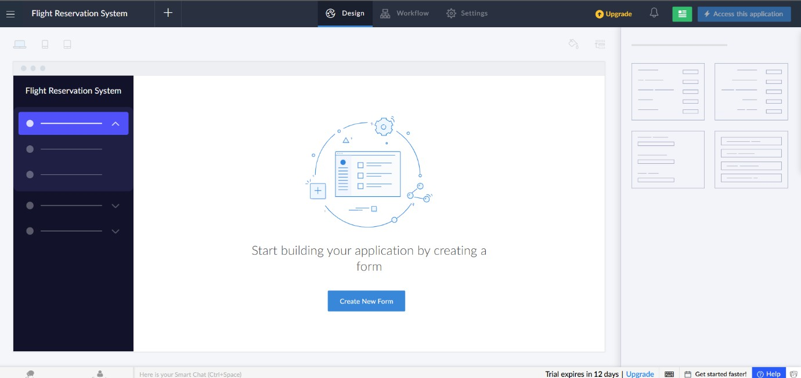

**STEP 6: SELECT ONE FORM**

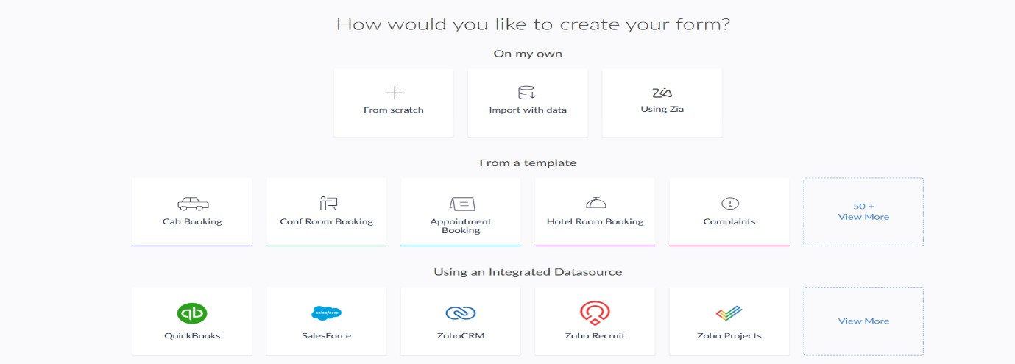

**STEP 7 : CREATE FROM SCRATCH (Flights form)**

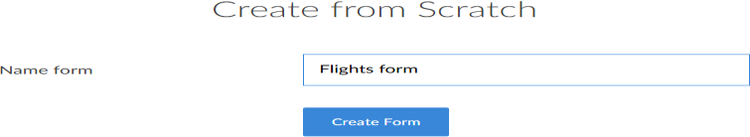

**STEP 8: CREATE FLIGHTS FORM**

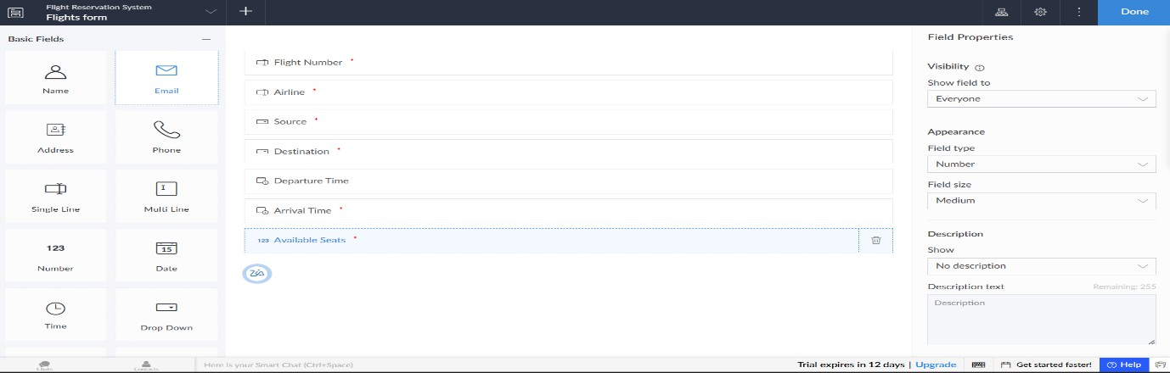

**STEP 9: CREATE PASSENGERS FORM**

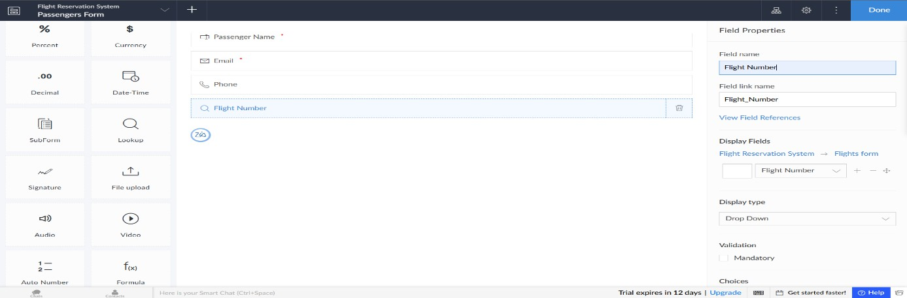

STEP 10 : CRAETE BOOKING FORM

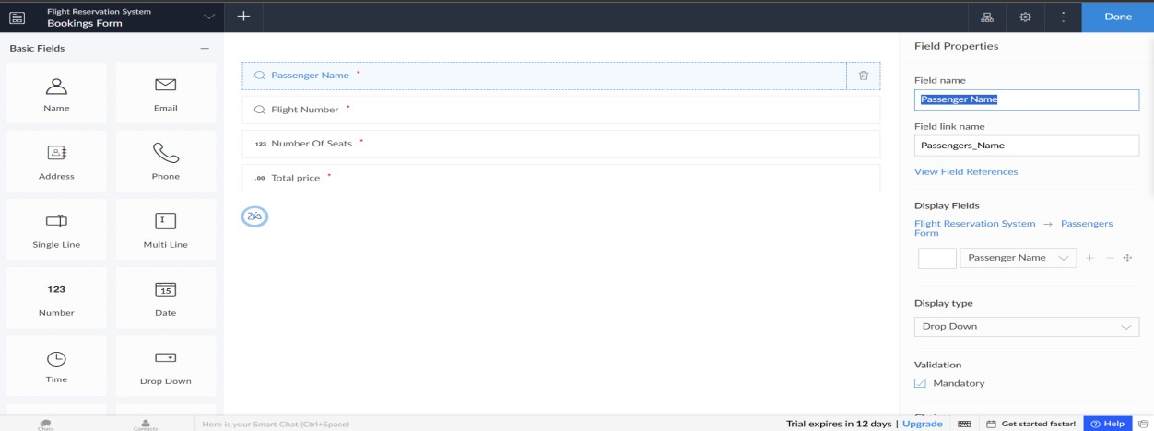

STEP 11: FILL THE FLIGHTS FORM, PASSENGERS FORM, BOOKING FORM

STEP 12:

FLIGHT REPORT

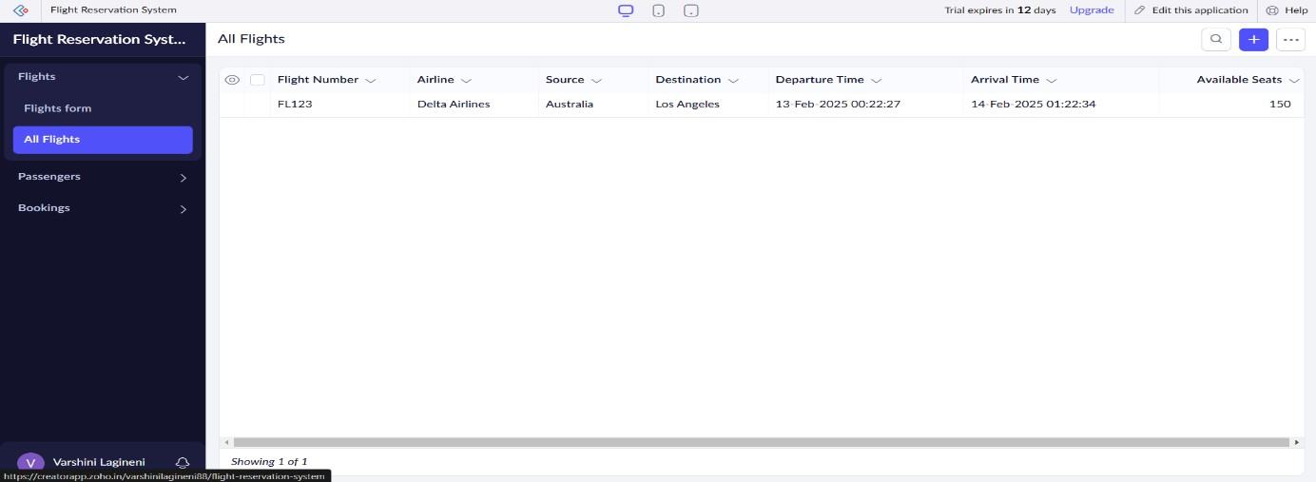

PASSENGERS REPORT

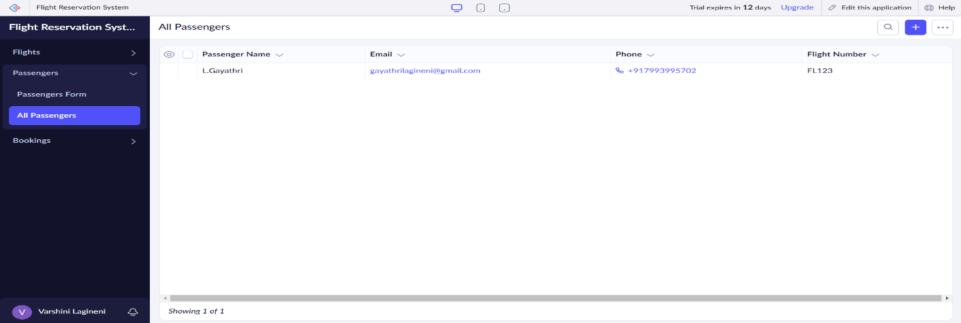

BOOKING REPORT

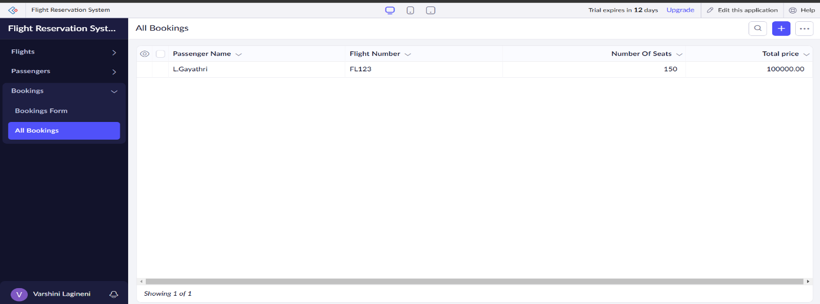

RESULT:

A simple cloud software application for Flight Reservation System using any Cloud Service Provider to demonstrate SaaS has successfully created.