**COURSE CODE:** CSA1523

**CPOURSE NAME:** CLOUD COMPUTING AND BIG DATA ANALYTICS

**NAME:** D. Hemalatha

**REG NO:** 192311107

EXP NO 3:

CREATE A SIMPLE CLOUD SOFTWARE APPLICATION FOR PROPERTY BUYING & RENTAL PROCESS (IN

CHENNAI CITY) USING ANY CLOUD SERVICE PROVIDER TO DEMONSTRATE SAAS.

**AIM:** To Create a simple cloud software application for Property Buying & Rental process (In Chennai city) using any Cloud Service Provider to demonstrate SaaS.

PROCEDURE:

STEP 1: Go to zoho.com.

STEP 2: LOGIN TO THE ZOHO.COM

**STEP 3: SELECT ONE APPLICATION**

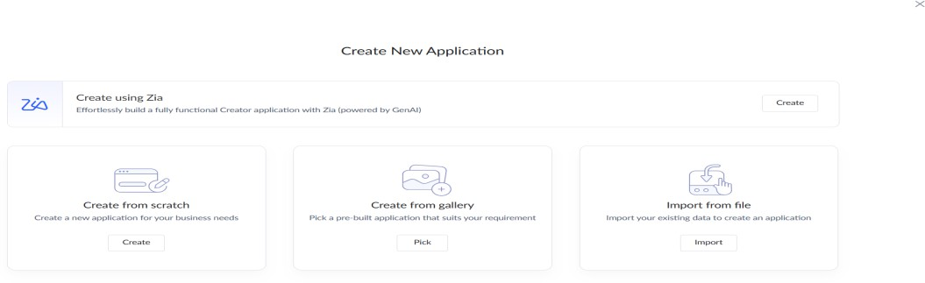

STEP 4: ENTER APPLICATION NAME (“Chennai Property Hub”)

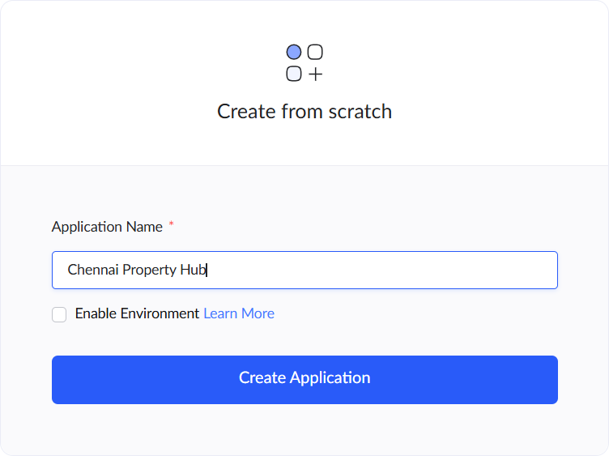

STEP 5: CREATED NEW APPLICATION

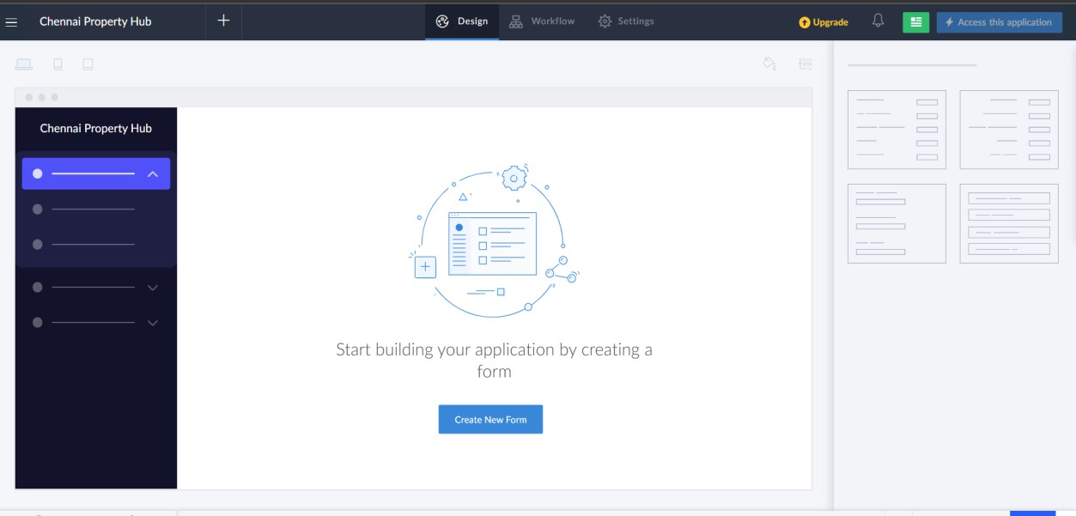

STEP 6: CREATE FROM SCRATCH (Property Listings Form)

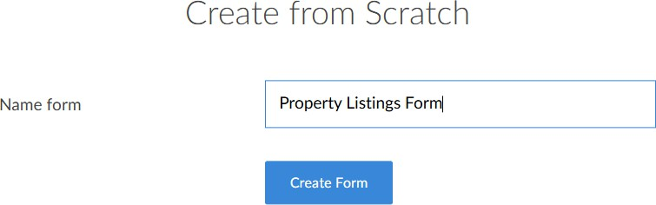

STEP 7: CREATE PROPERTY LISTINGS FORM

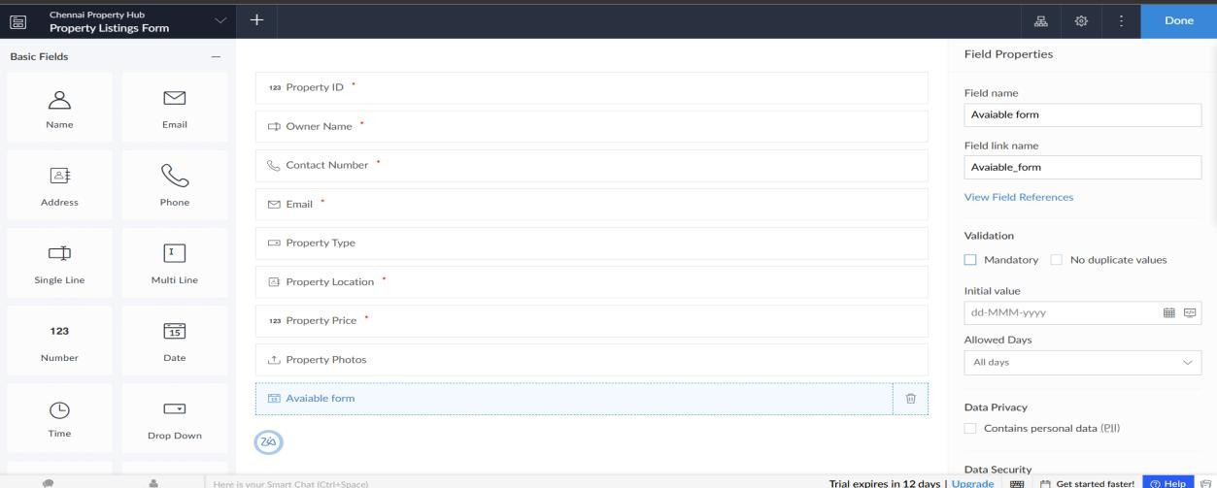

STEP 8: CREATE BUYER/RENTER REQUESTS FORM

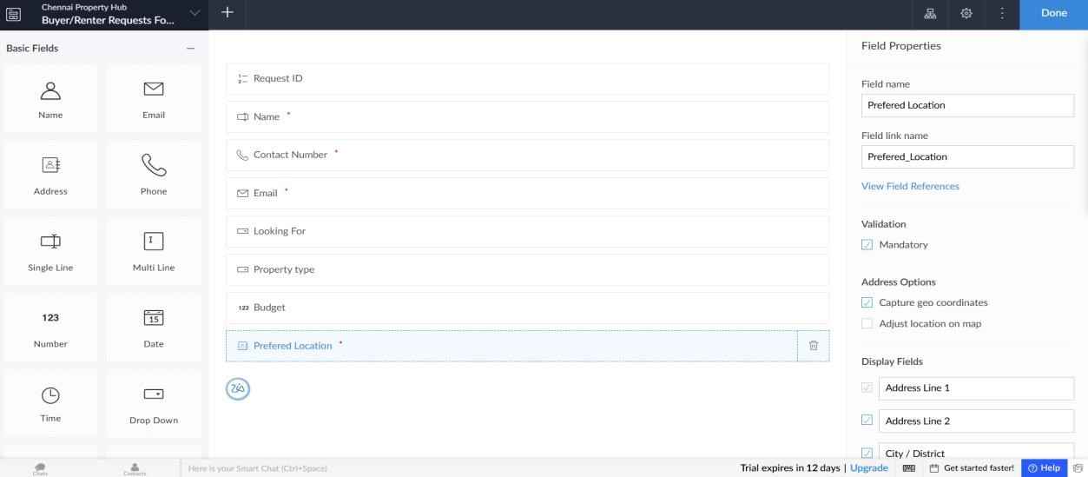

STEP 9: CREATE BOOKINGS FORM

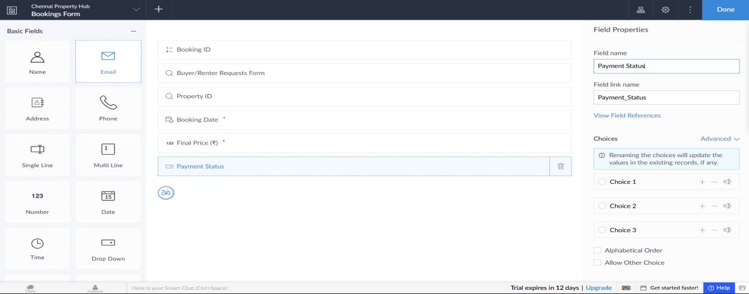

STEP 10: ALL PROPERTY LISTINGS

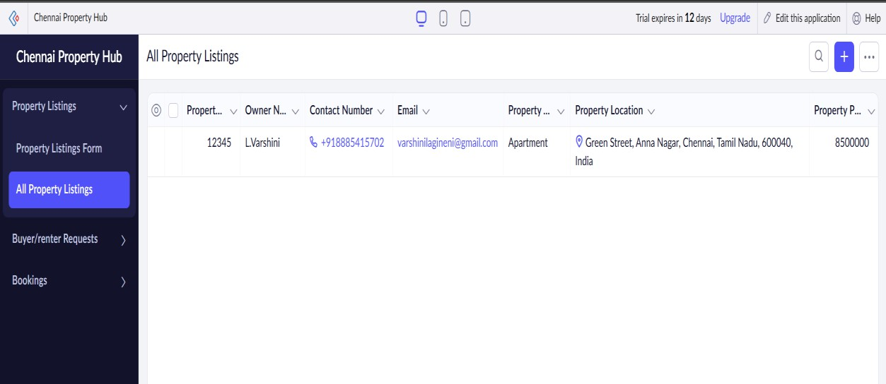

ALL BUYER/RENTER REQUESTS

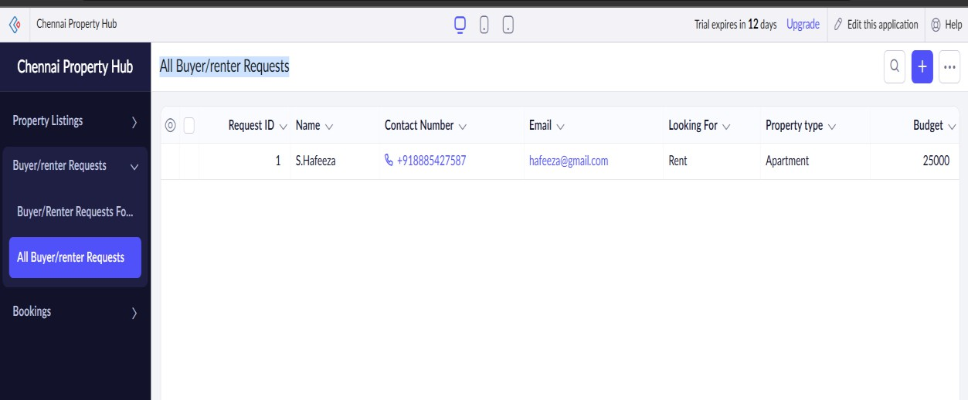

ALL BOOKINGS

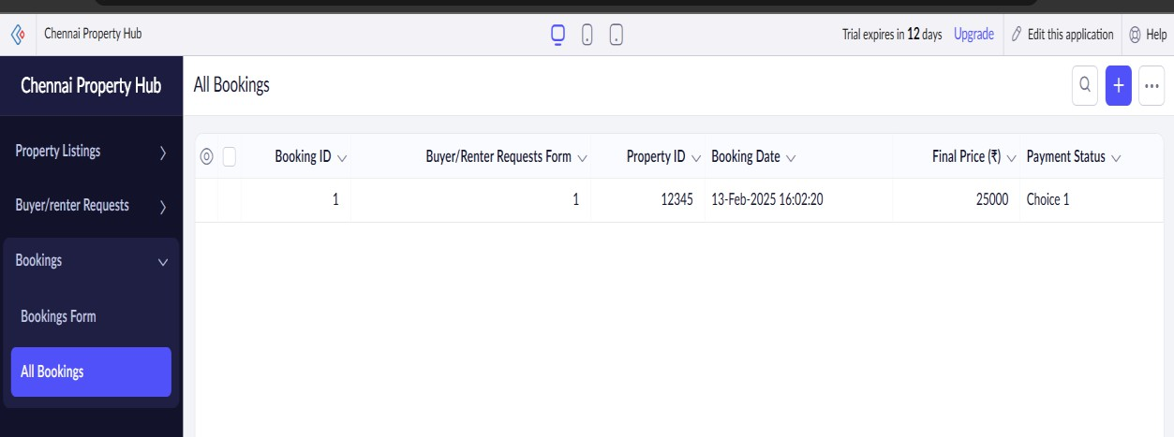

RESULT:

A simple cloud software application for Property Buying & Rental process (In Chennai city) using any Cloud Service Provider to

demonstrate SaaS (Chennai Property Hub) has successfully created