DBMS – SQL QUERY IMPLEMENTATION FOR E-COMMERCE DATABASE
Project Title : Lenskart E-Commerce Order Management System

Objectives
1. Perform SELECT, WHERE, ORDER BY, and DISTINCT queries.
2. Search products based on price,category, and availability.
3. Retrieve customer and product information.
4. Apply filtering conditions.
5. Generate basic business reports.
1. Basic SQL Queries
1.1 SELECT QUERY
The SELECT statement is used to retrieve data from a table.

Display all products
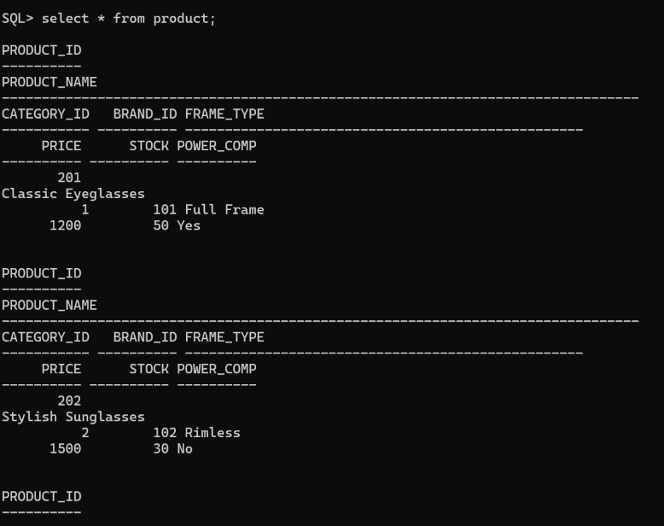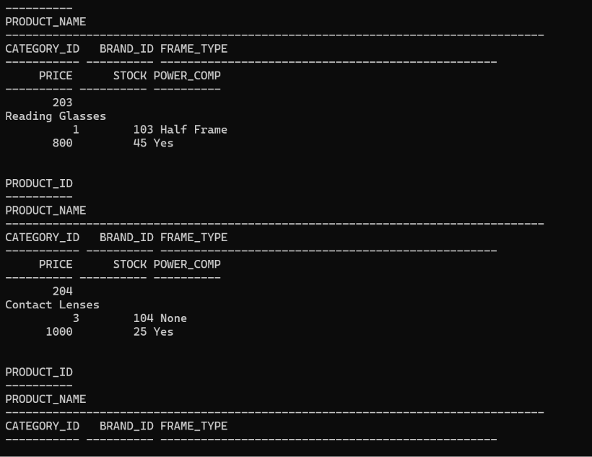
Display selected product data
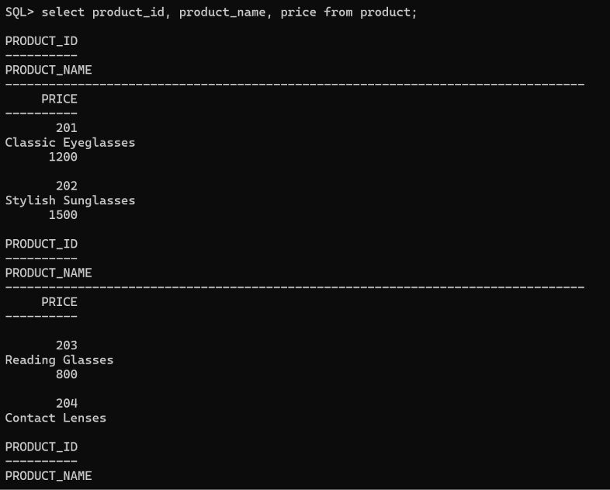
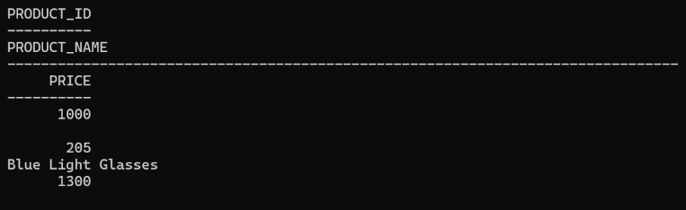

1.2 WHERE Clause
The WHERE clause is used to filter records based on a condition.
Find products with price less than 1000
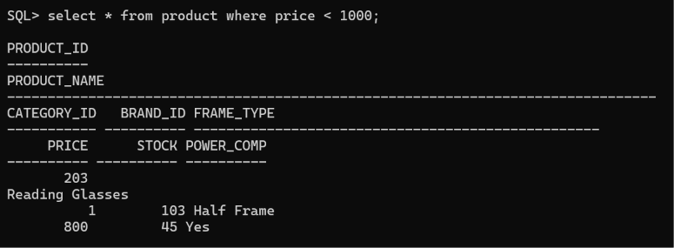

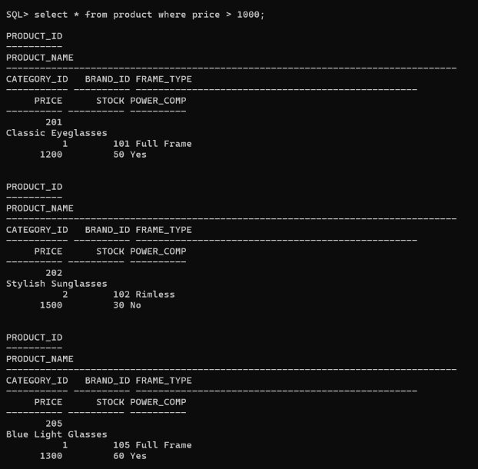
Find products with price greater than 1000

Find products with price greater than 100
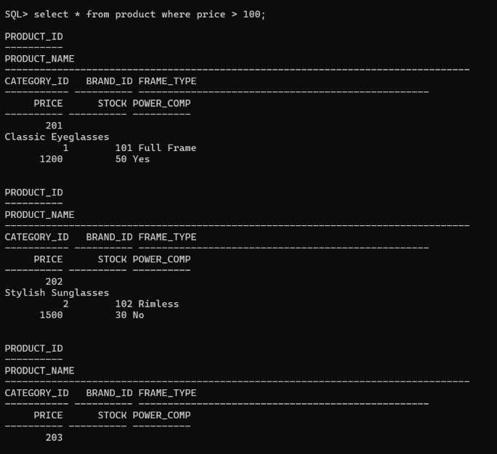

1.3 ORDER BY
The ORDER BY clause is used to sort the query results.
Products from lowest to highest price
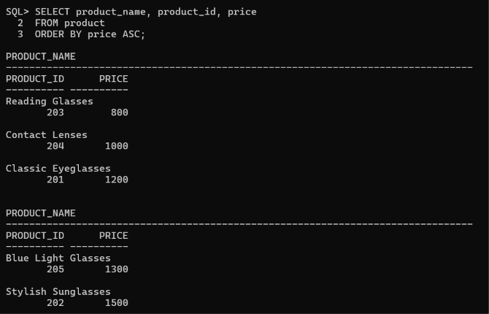

Products from highest to lowest price
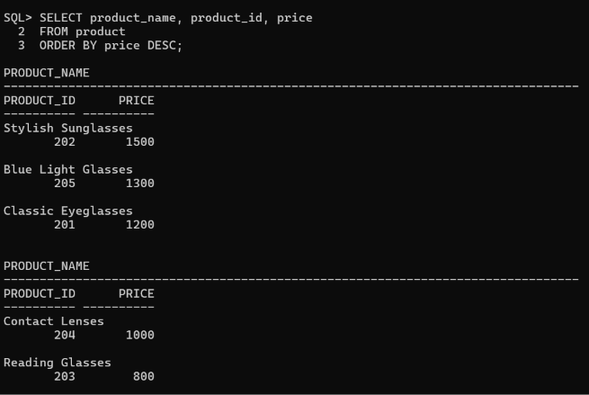
1.4 DISTINCT
The DISTINCT keyword is used to display unique values.
Display unique categories
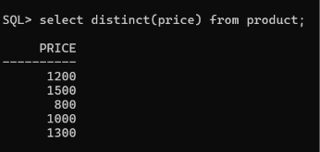
2. Search Products
2.1 Search Products Based on Price
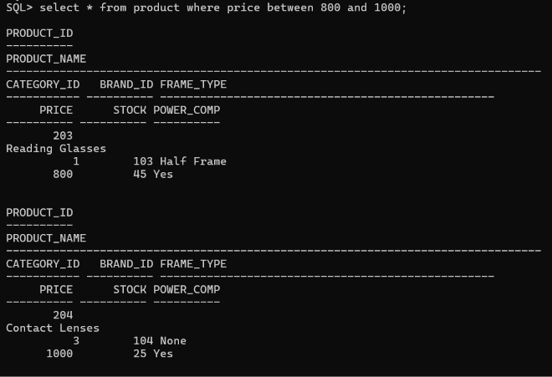
This displays products whose price is between ₹100 and ₹400.
2.2 Search Products Based on Category
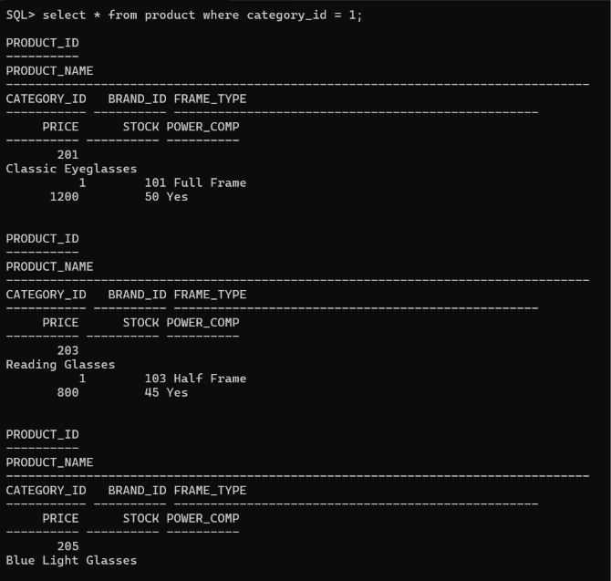
This displays products belonging to category 1.
3. Retrieve Customer Information
Display all customers
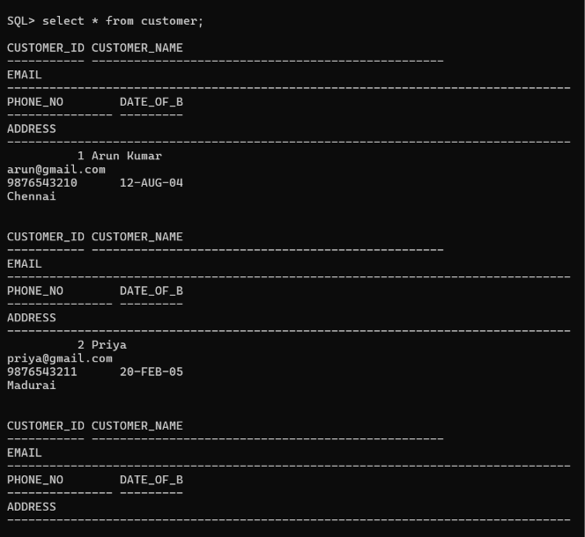
Search for a particular customer
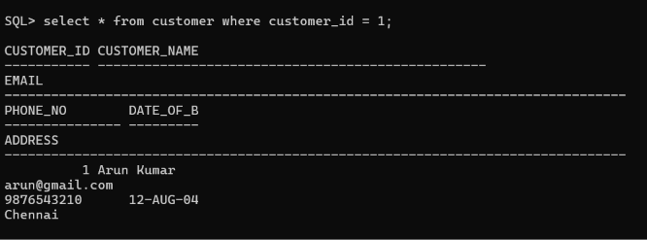
4. Apply Filtering Conditions
Multiple conditions can be combined using AND,OR, and NOT.
4.1 AND Condition
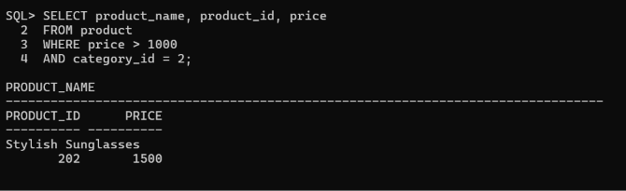
This displays products that satisfy both conditions.
4.2 OR Condition
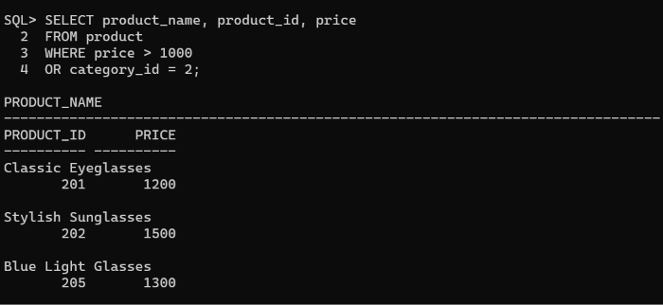
This displays products belonging to either category 101 or 102.
4.3 IN Operator
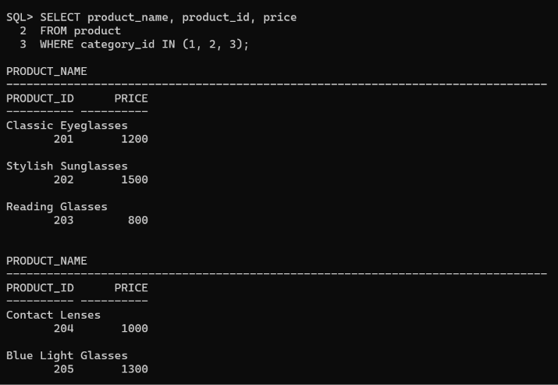
4.4 BETWEEN Operator
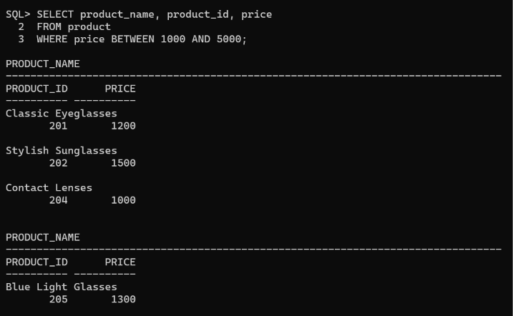
5. Basic Business Reports
5.1 Product Price Report
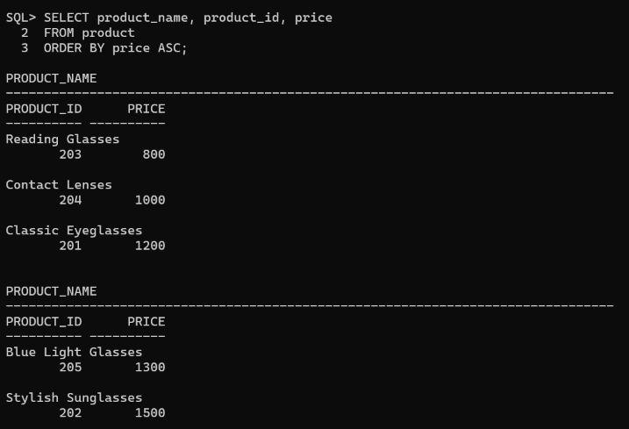
5.2 Customer Order Report
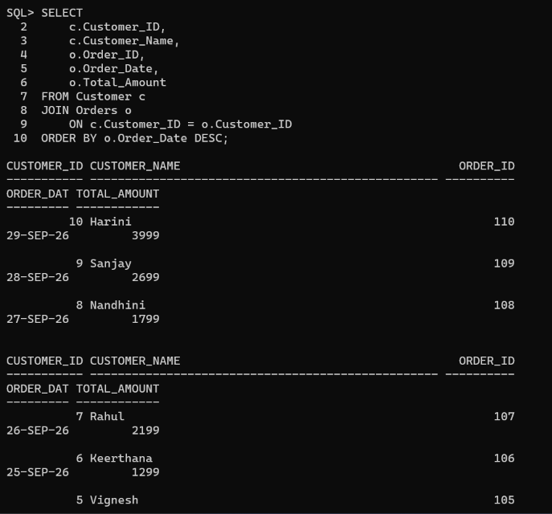
5.3 Product Order Report
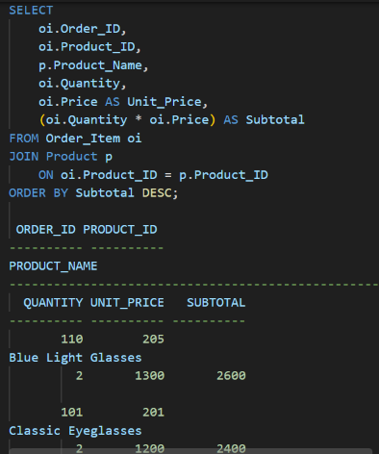
5.4 Customer-wise Total Orders
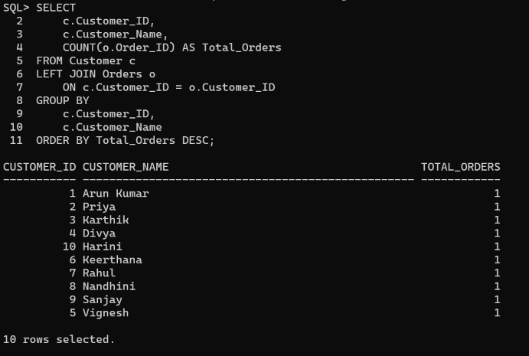
5.5 Customer-wise Total Purchase Amount
