DBMS – PRODUCT REVIEW AND RATING MANAGEMENT SYSTEM
Project Title : Lenskart – E-Commerce Order Management System

Objectives
1. Create Review and Rating tables
2. Store customer feedback and ratings.
3. Retrieve product review details.
4. Calculate average product ratings using aggregate functions.
5. Identify highly rated products.

1. Database Design
1.1 Review Table
Attribute | Key Type
Review_ID | Primary Key
Customer_ID | Foreign Key
Product_ID | Foreign Key
Rating | -
Review_text | -
Review_date | -

1.2 Rating Table
Attribute | Key Type
Rating_ID | Primary Key
Customer_ID | Foreign Key
Product_ID | Foreign Key
Rating | Not Null
Rating_Date | -

2. Table Relationships
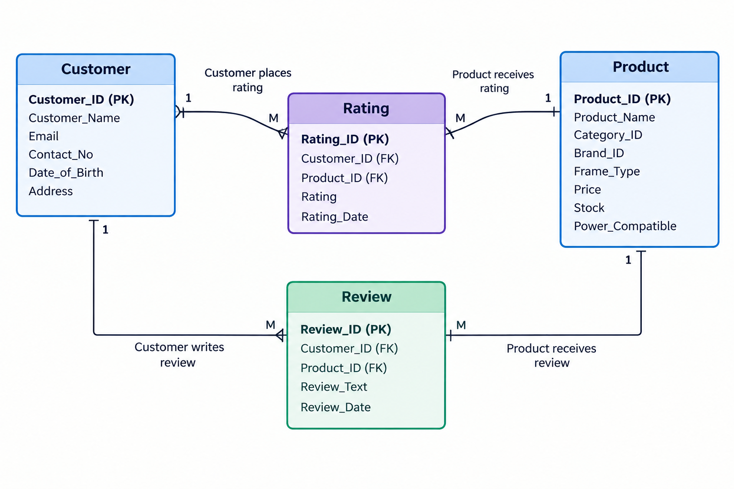

3. Table Creation
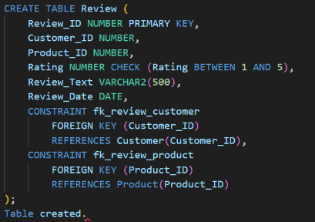
3.1 Create Review Table

3.2 Create Rating Table

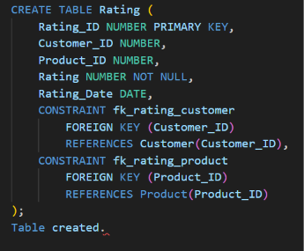

4. Review Data Insertion
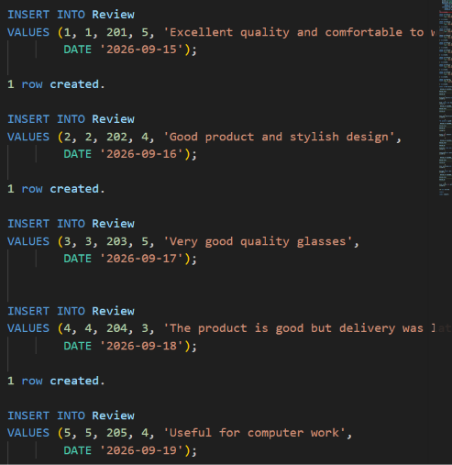

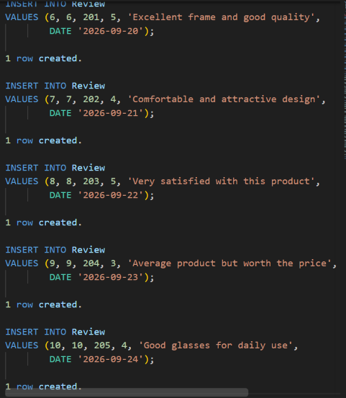

5. Rating Data Insertion
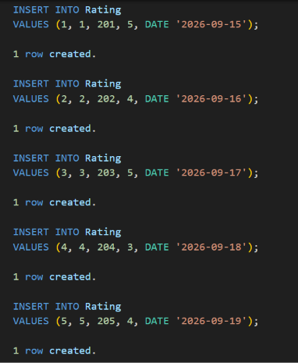

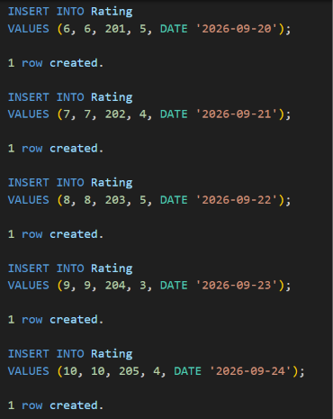

6. Retrieve Product Review Details
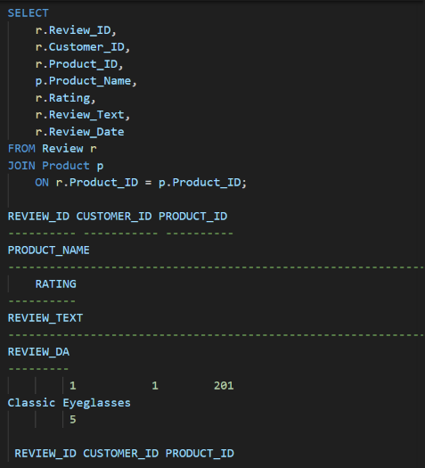

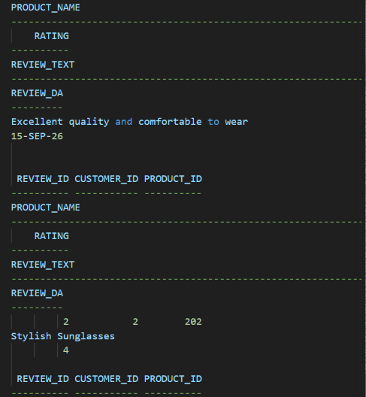

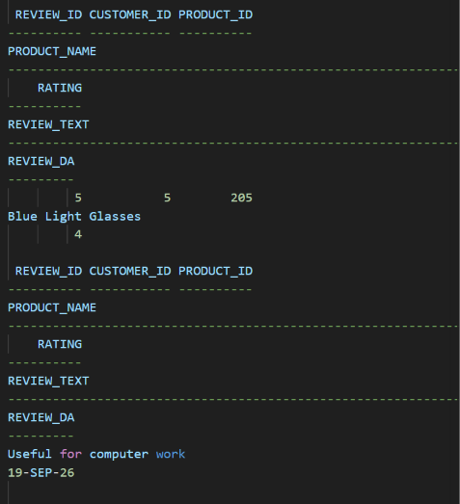

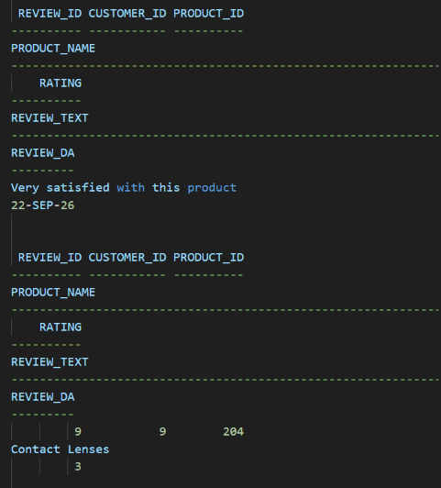

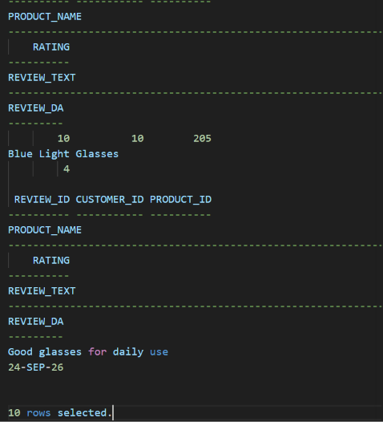

7. Calculate Average Product Ratings
This uses the SUM() aggregate function.

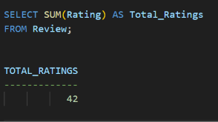

8. Identify Highly Rated Products
Products with an average rating of 4 or above can be displayed using HAVING.

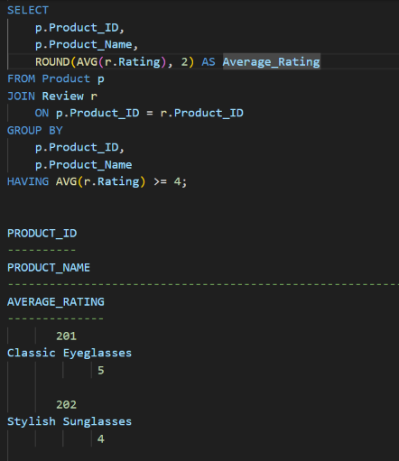

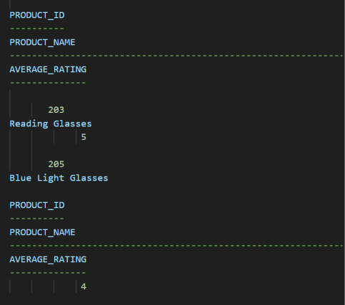

9. Product Rating Report
A combined report can be generated using the Rating and Product tables.
