Project-1-E28093-Deploying-A-Multi-Tier-Website-Using-AWS-EC2-1-1
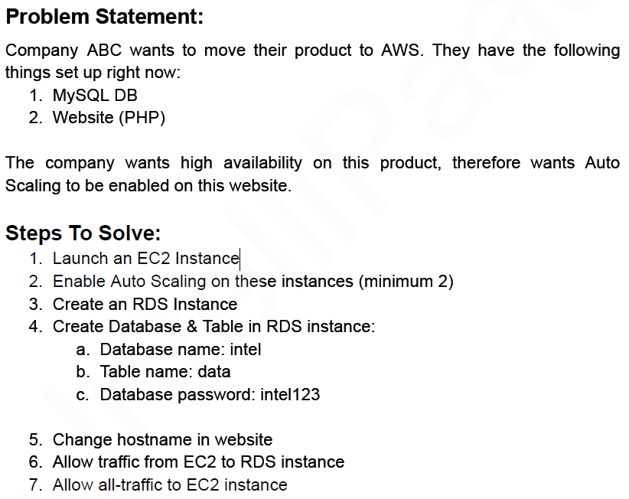

1. Launch an EC2 Instance
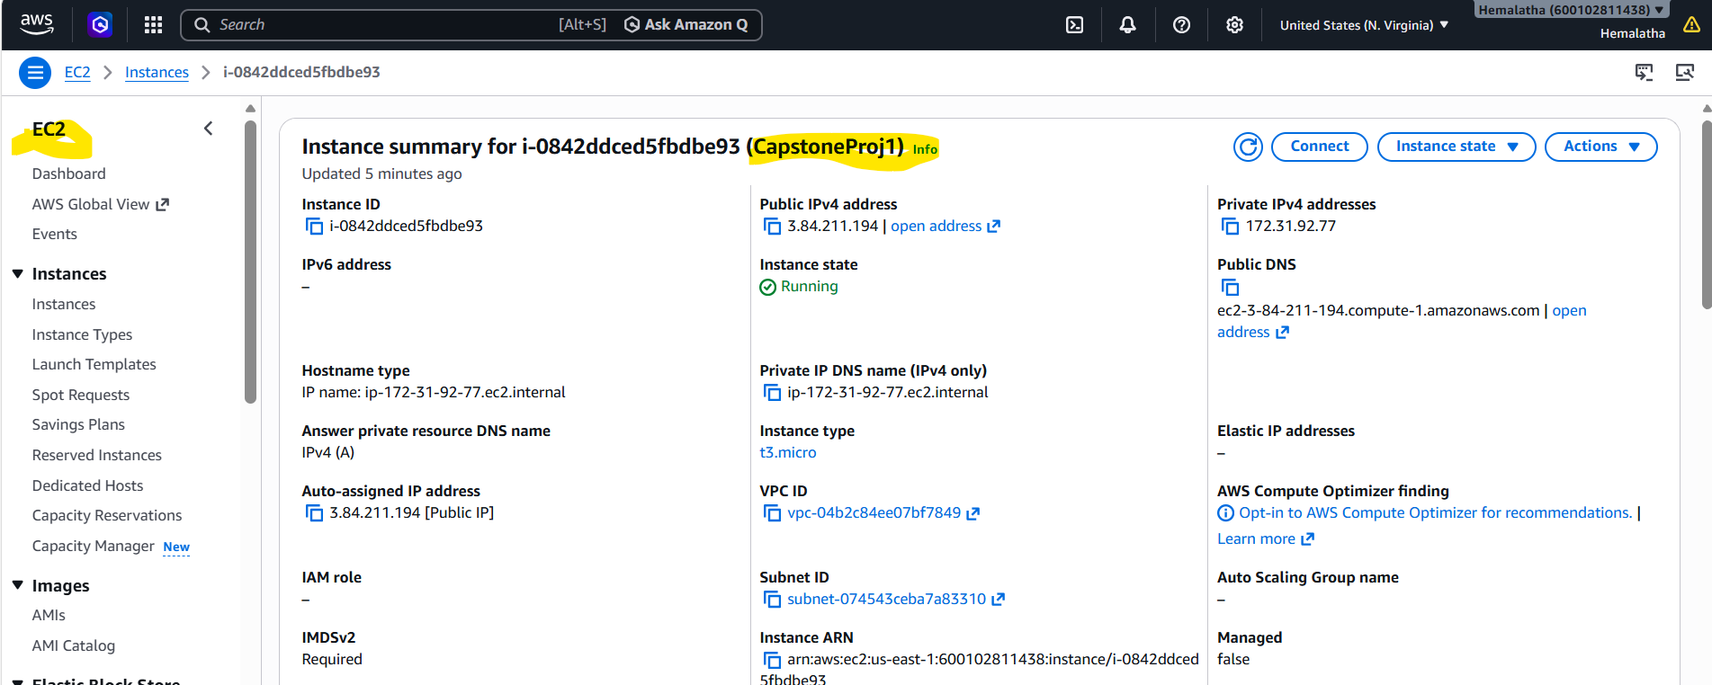

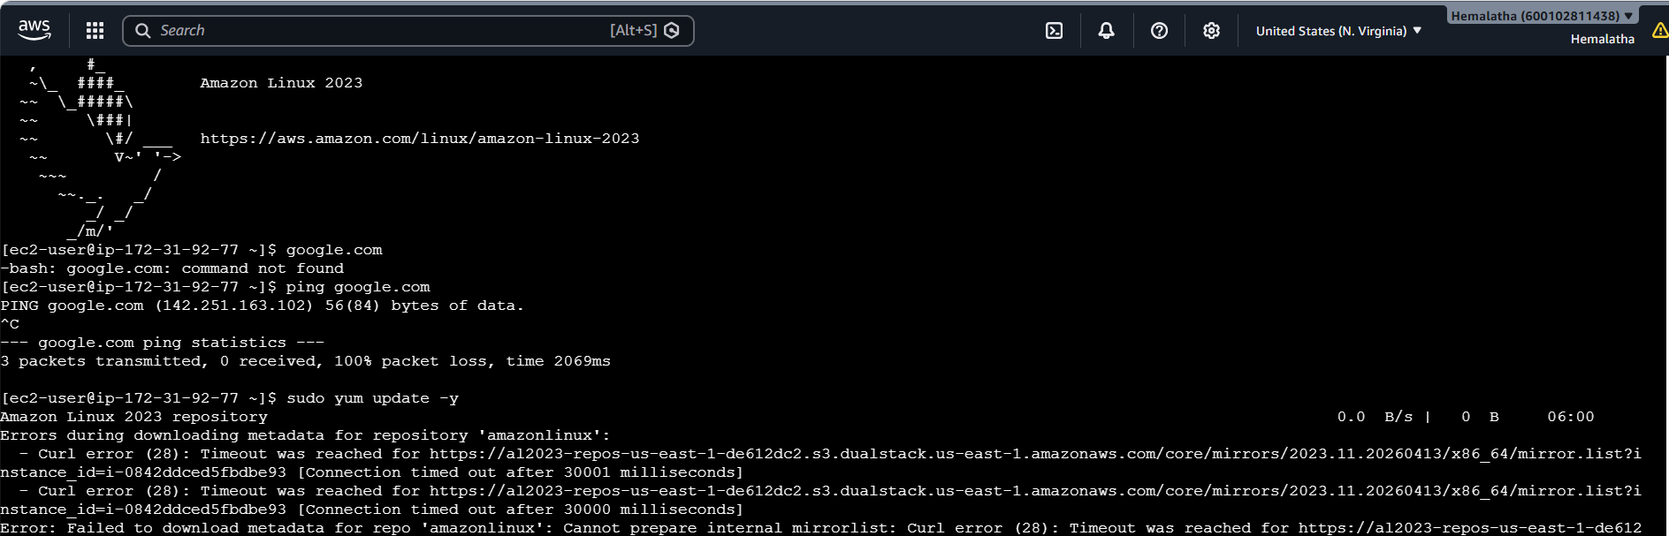
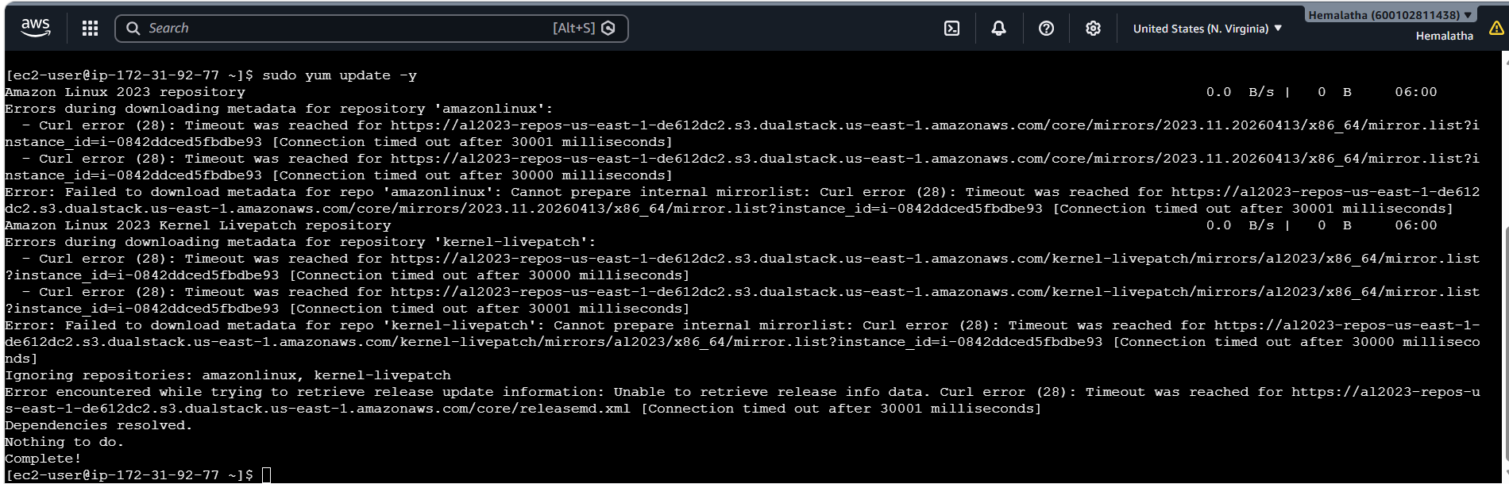
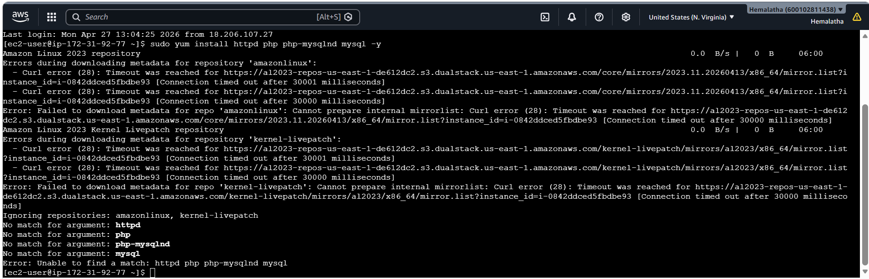
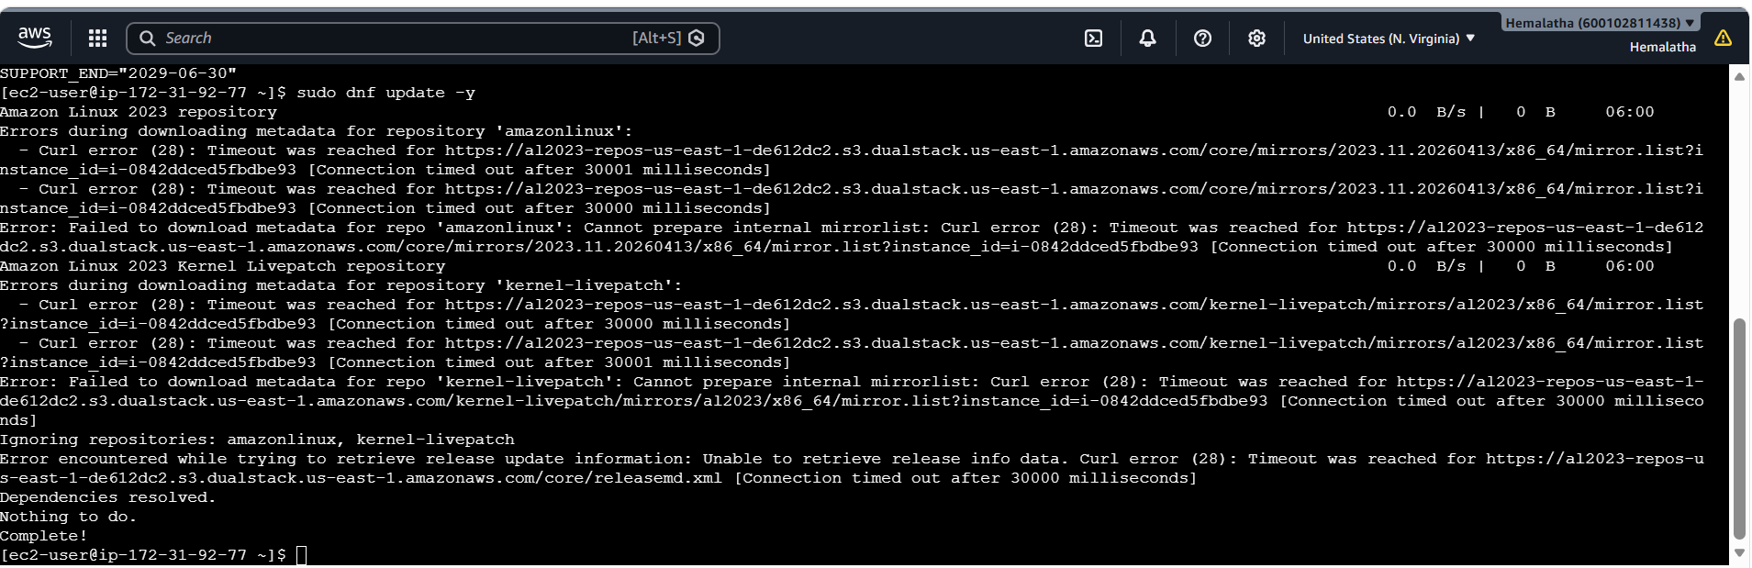
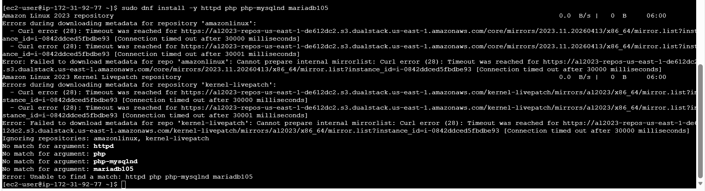

2. Enable Auto Scaling on these instances (minimum 2)
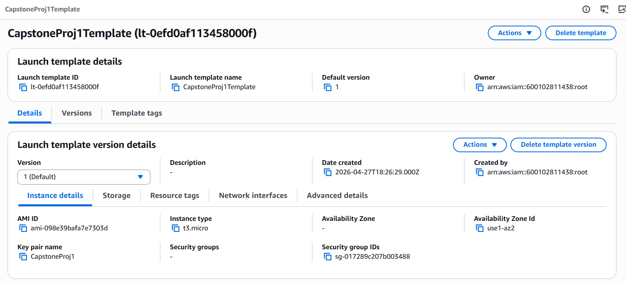

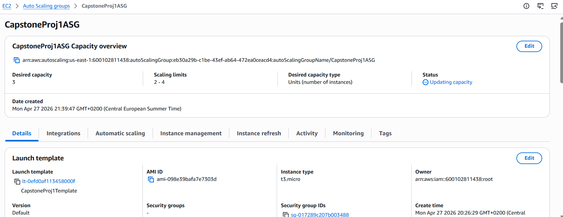

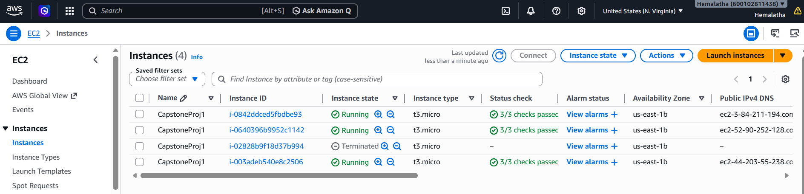

3. Create an RDS Instance
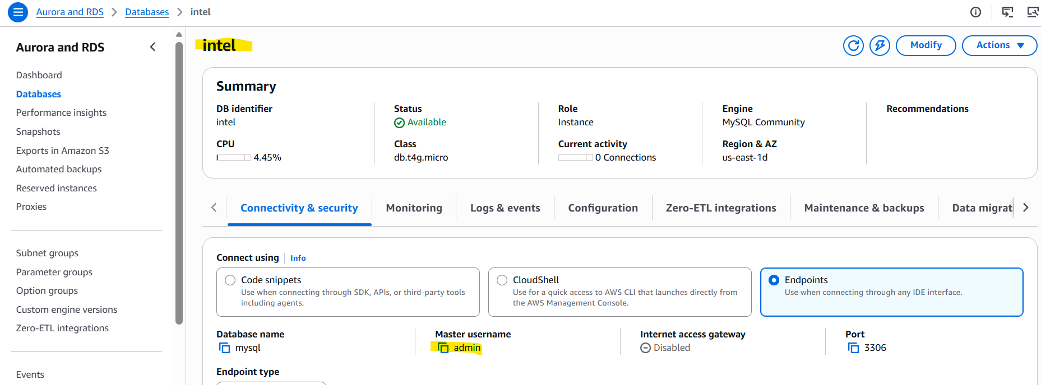

4. Create Database & Table in RDS instance:
a. Database name: intel
b. Table name: data
c. Database password: intel123
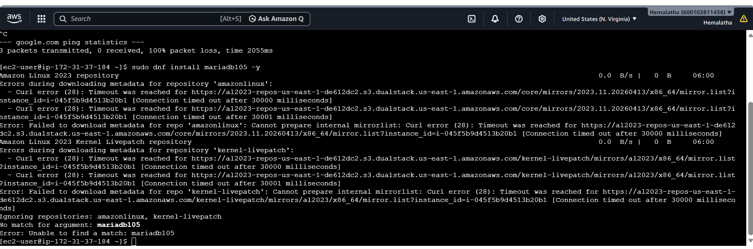

6. Change Hostname in website
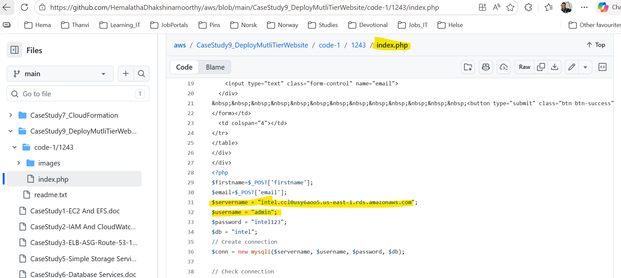

6. Allow traffic from EC2 to RDS instance
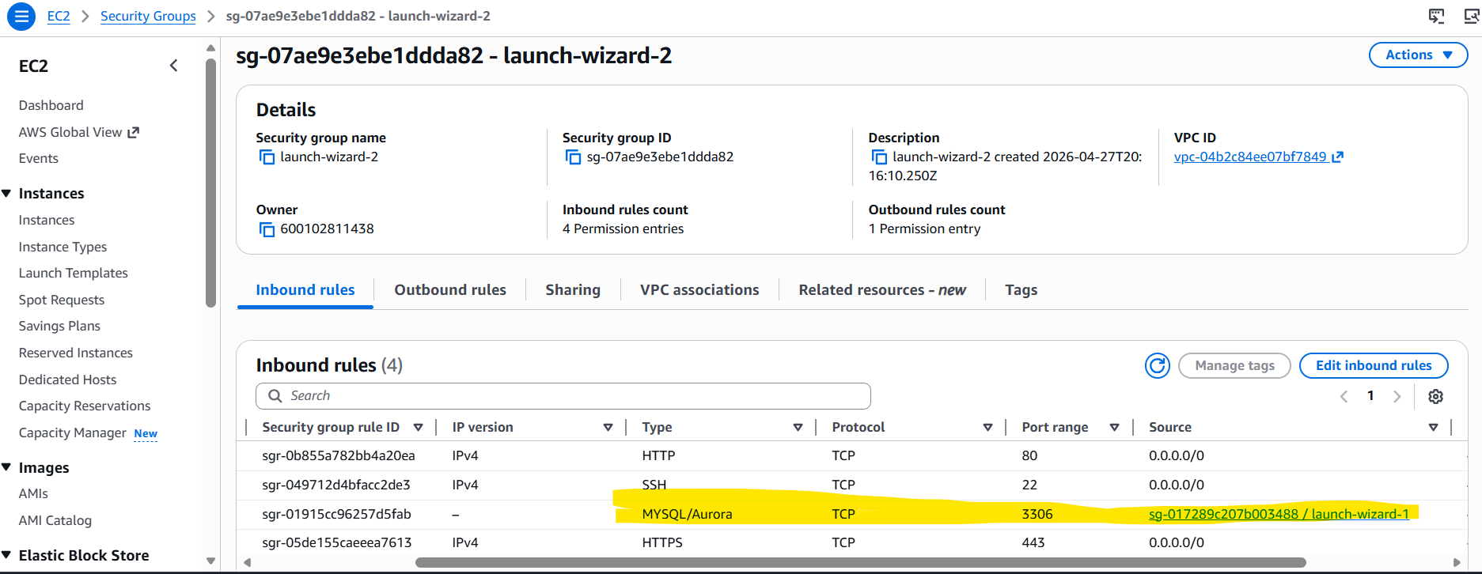

7. Allow all-traffic to EC2 instance
