3_Case-Study-–-ELB-ASG-Route-53-1
Created a launch template
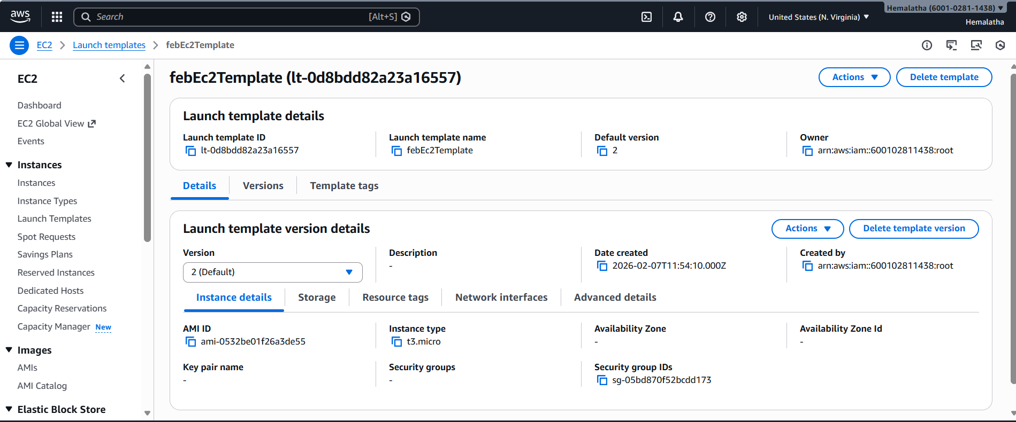

Added user data to launch template
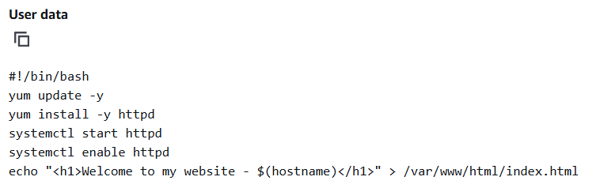

Created Auto Scaling Group
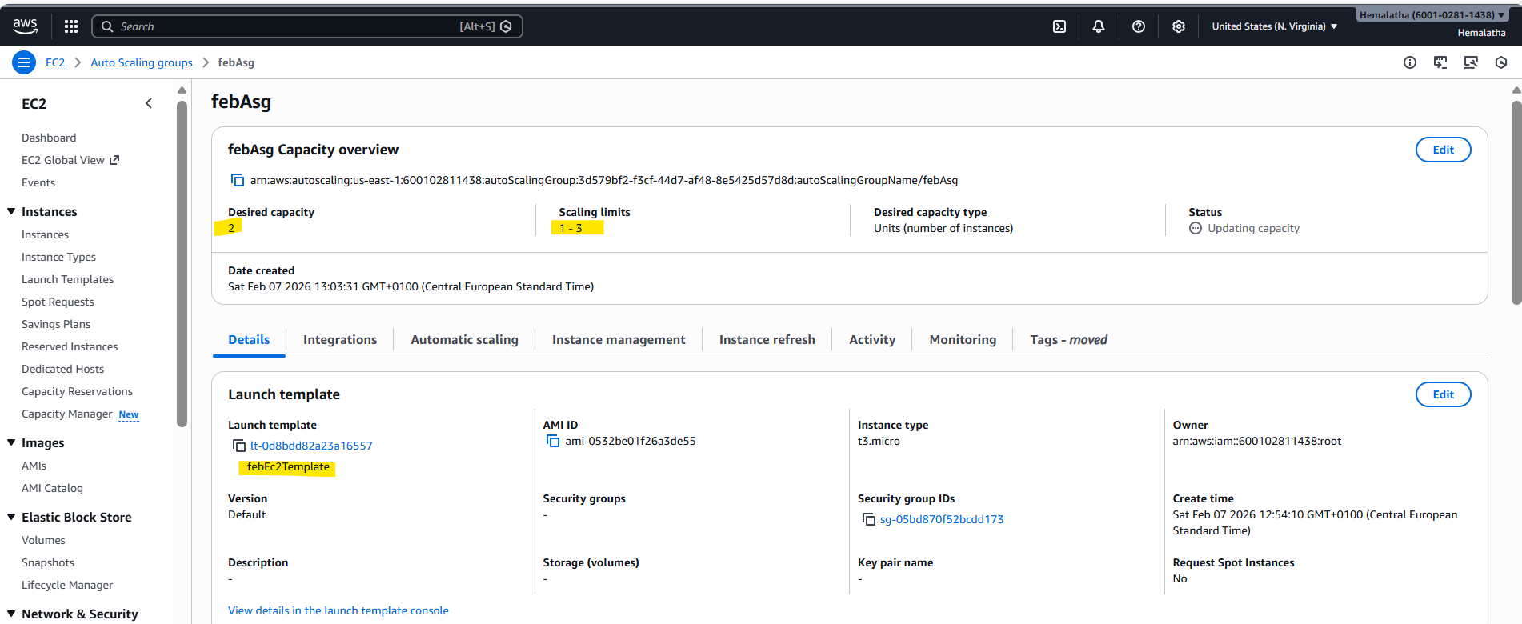

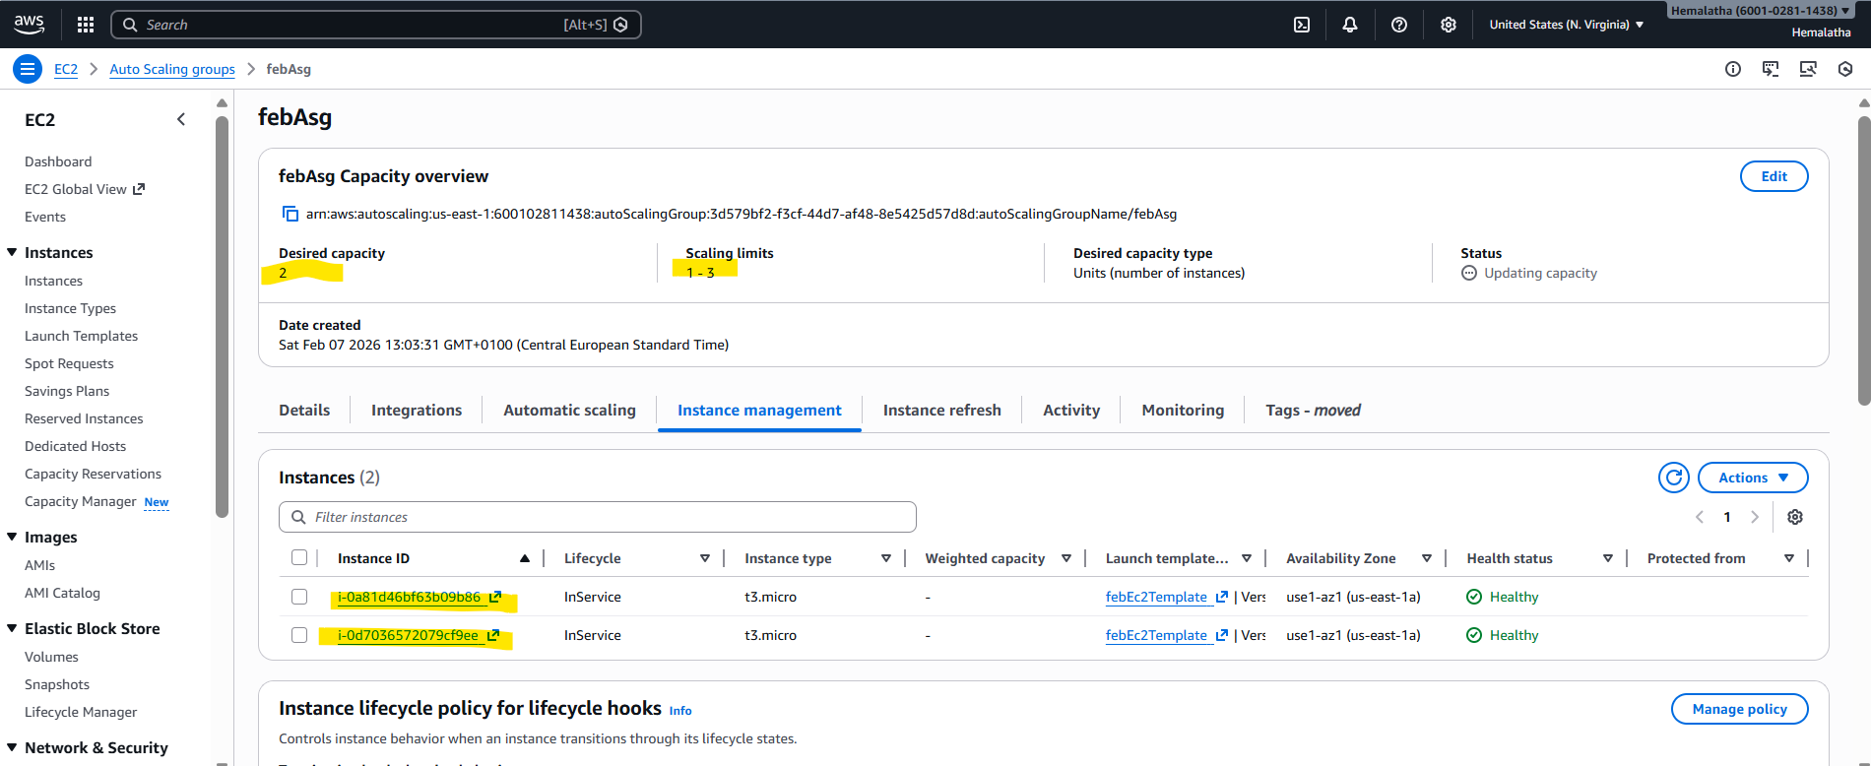

Added simple scaling for scale In and scale Out under Dynamic Scaling policy
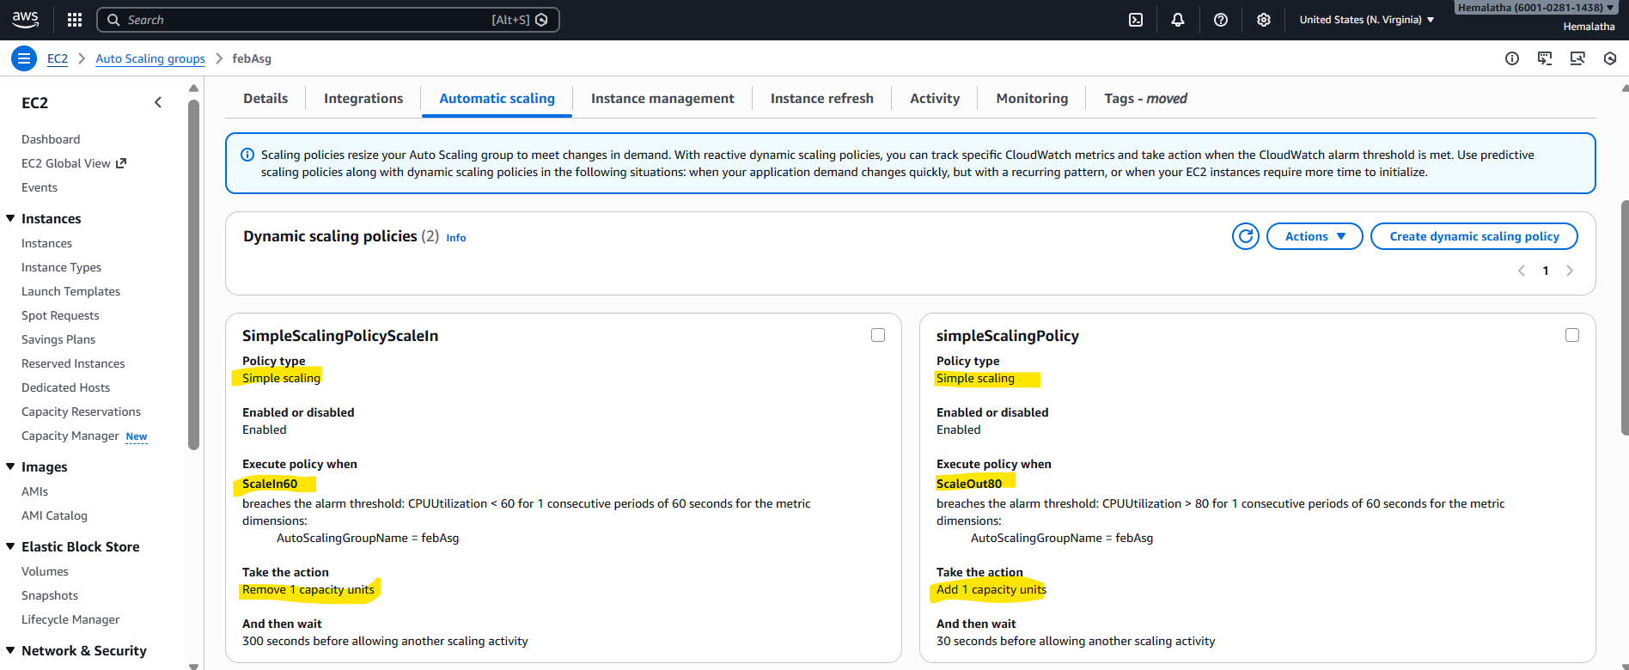

Created Cloutwatch Alarms for ScaleIn and ScaleOut
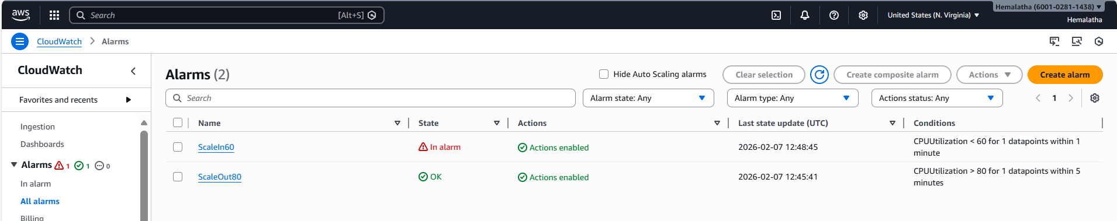

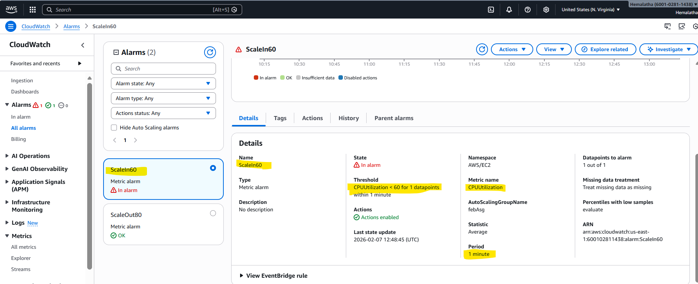
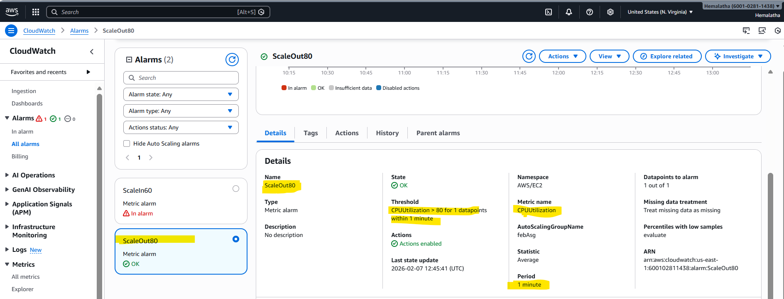

Created Application Load Balancer
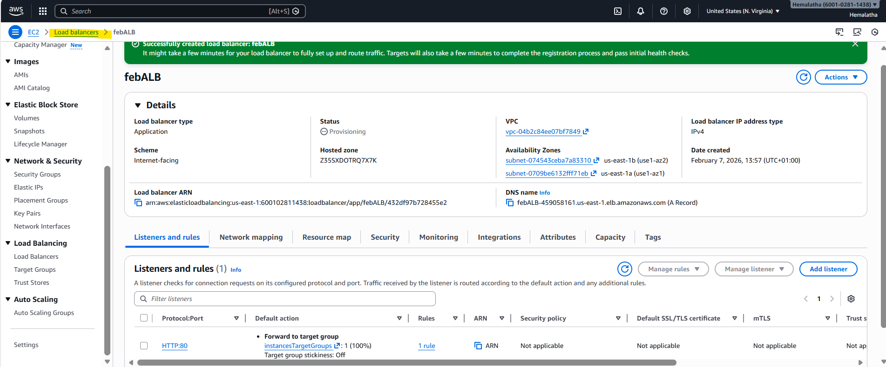

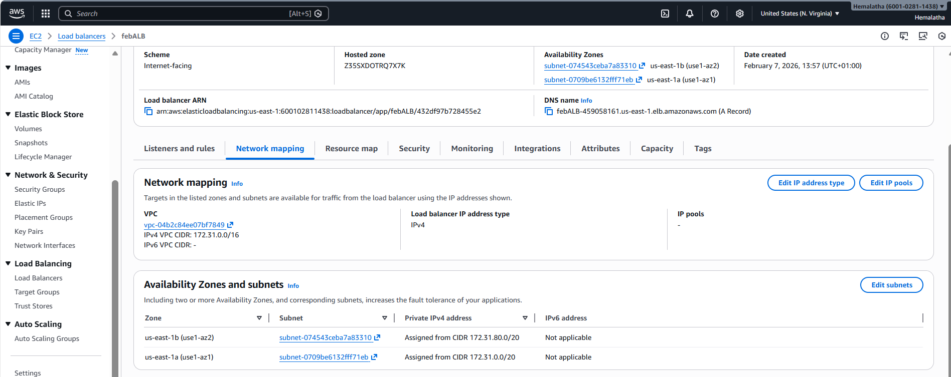

Created Route 53 Hosted Zone and its records
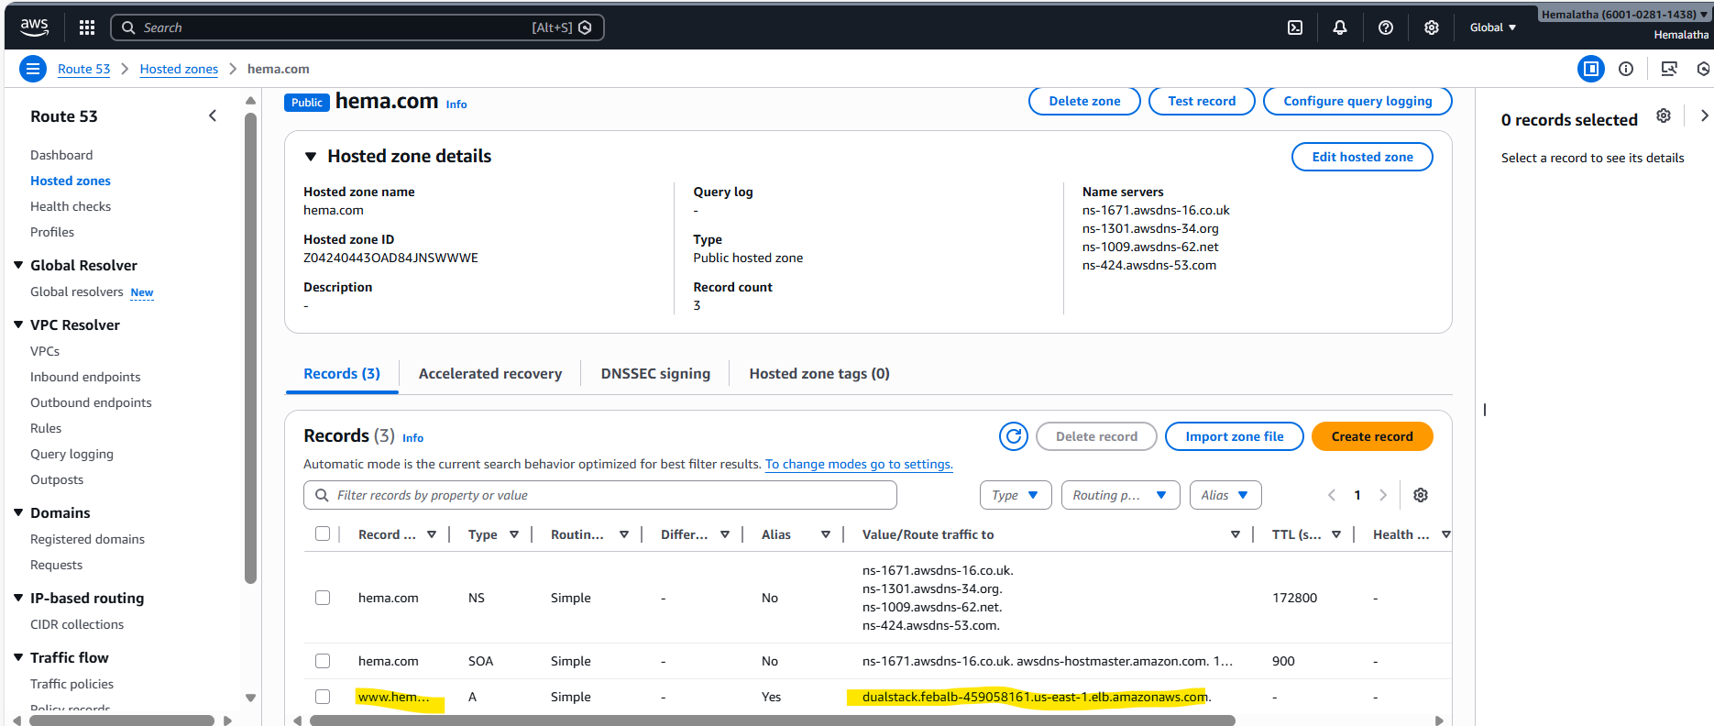

1. Managed the scaling requirements of the company by:
a. Deploying multiple compute resources on the cloud as soon as the load increases and the CPU utilization exceeds 80%
CPU Utilization > 80% : ScaledOut to 3 instance as max capacity is 3
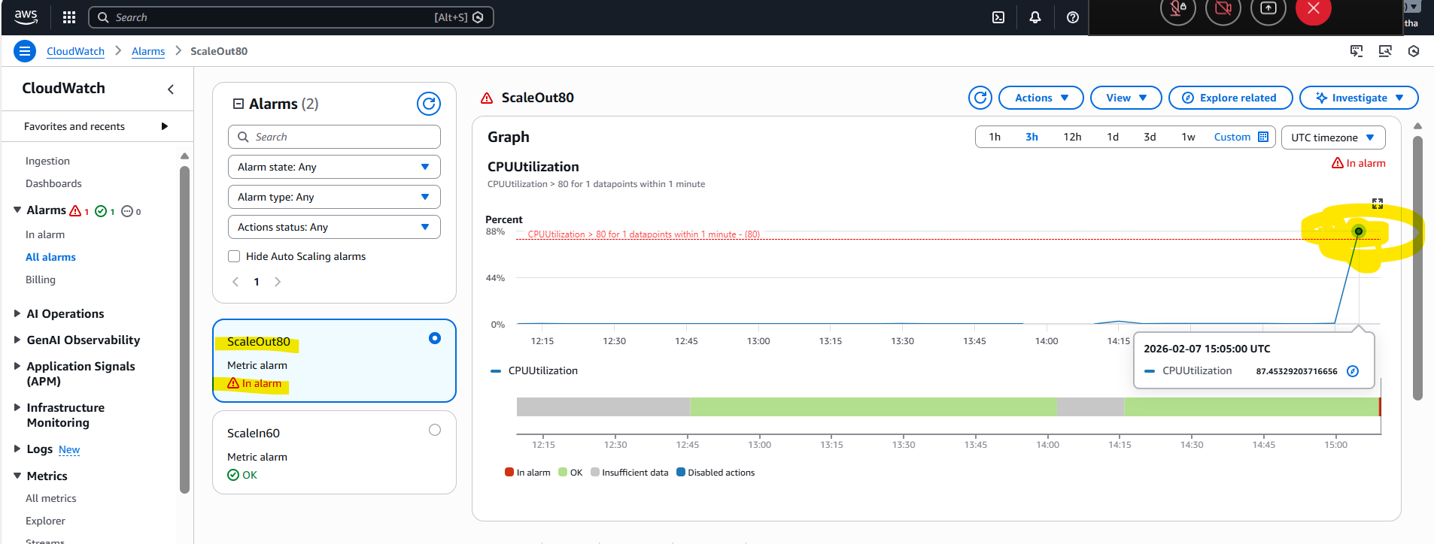

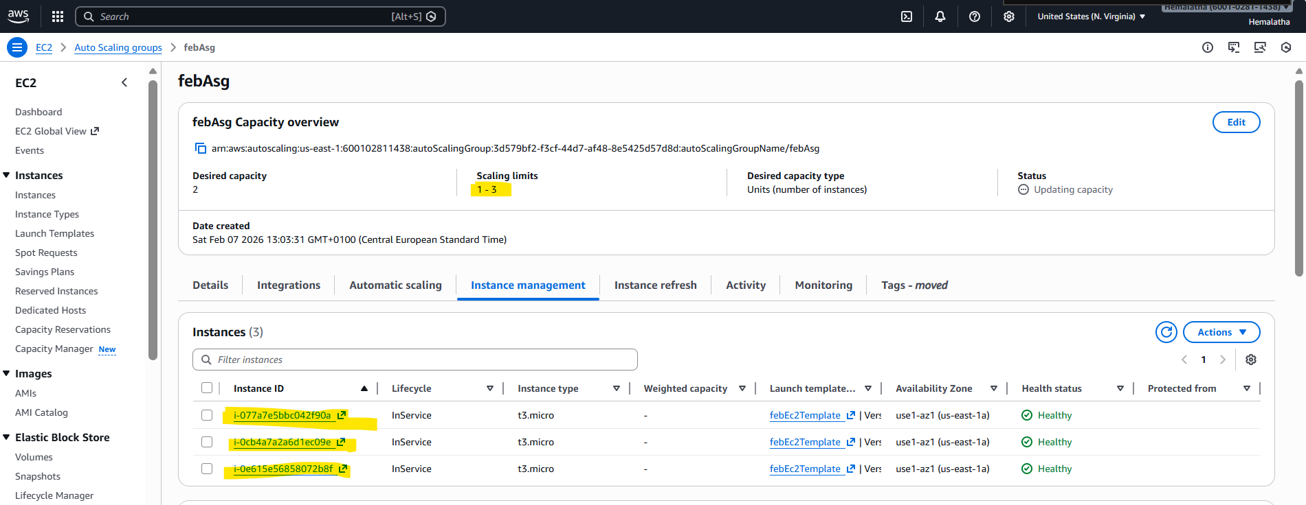

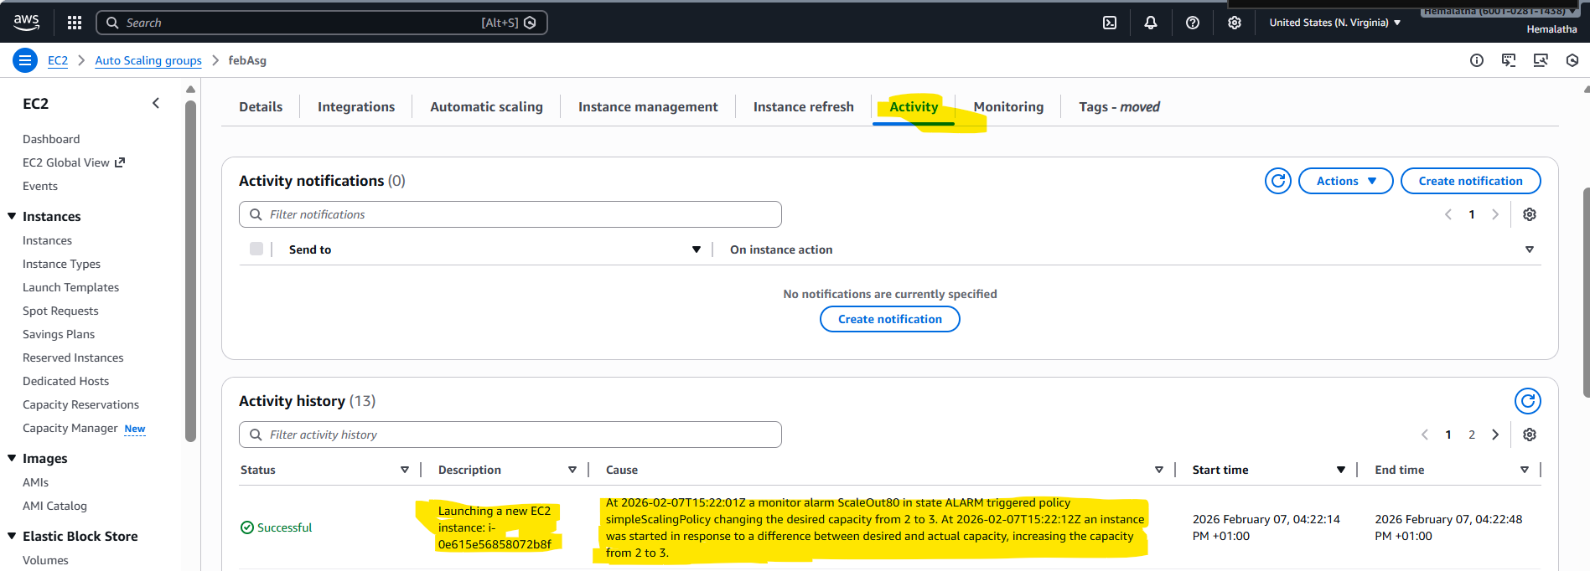

b. Removing the resources when the CPU utilization goes under 60%
CPU Utilization < 60% : ScaledIn to 1 instance as min capacity is 1
