Case Study 1 - Git Assignment
Git Assignment – 1
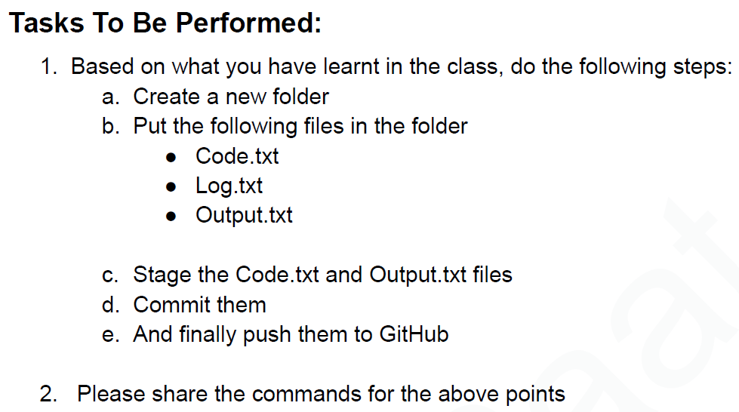
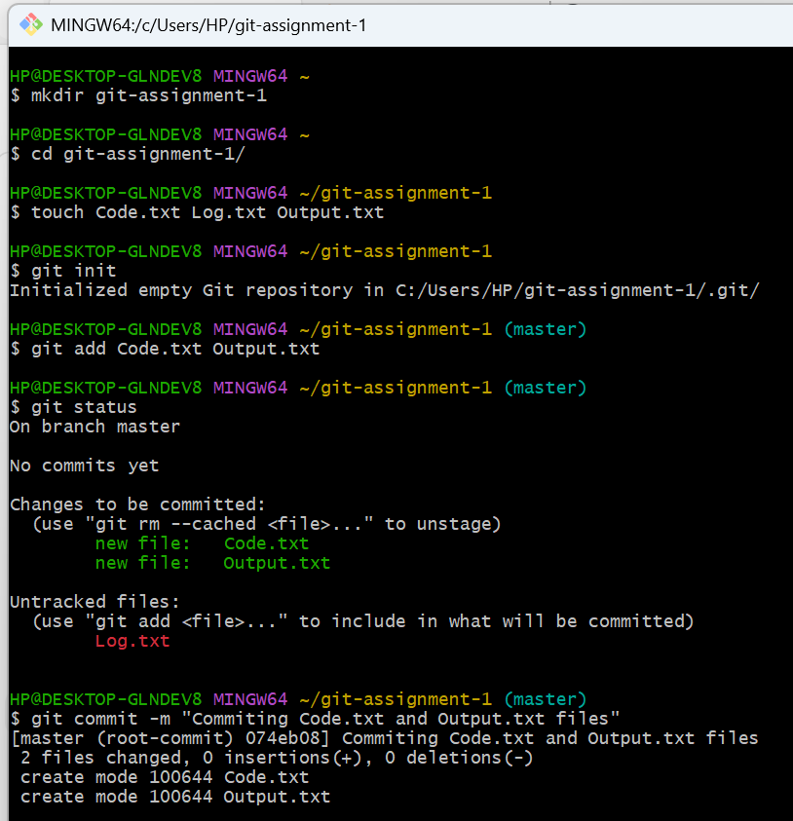

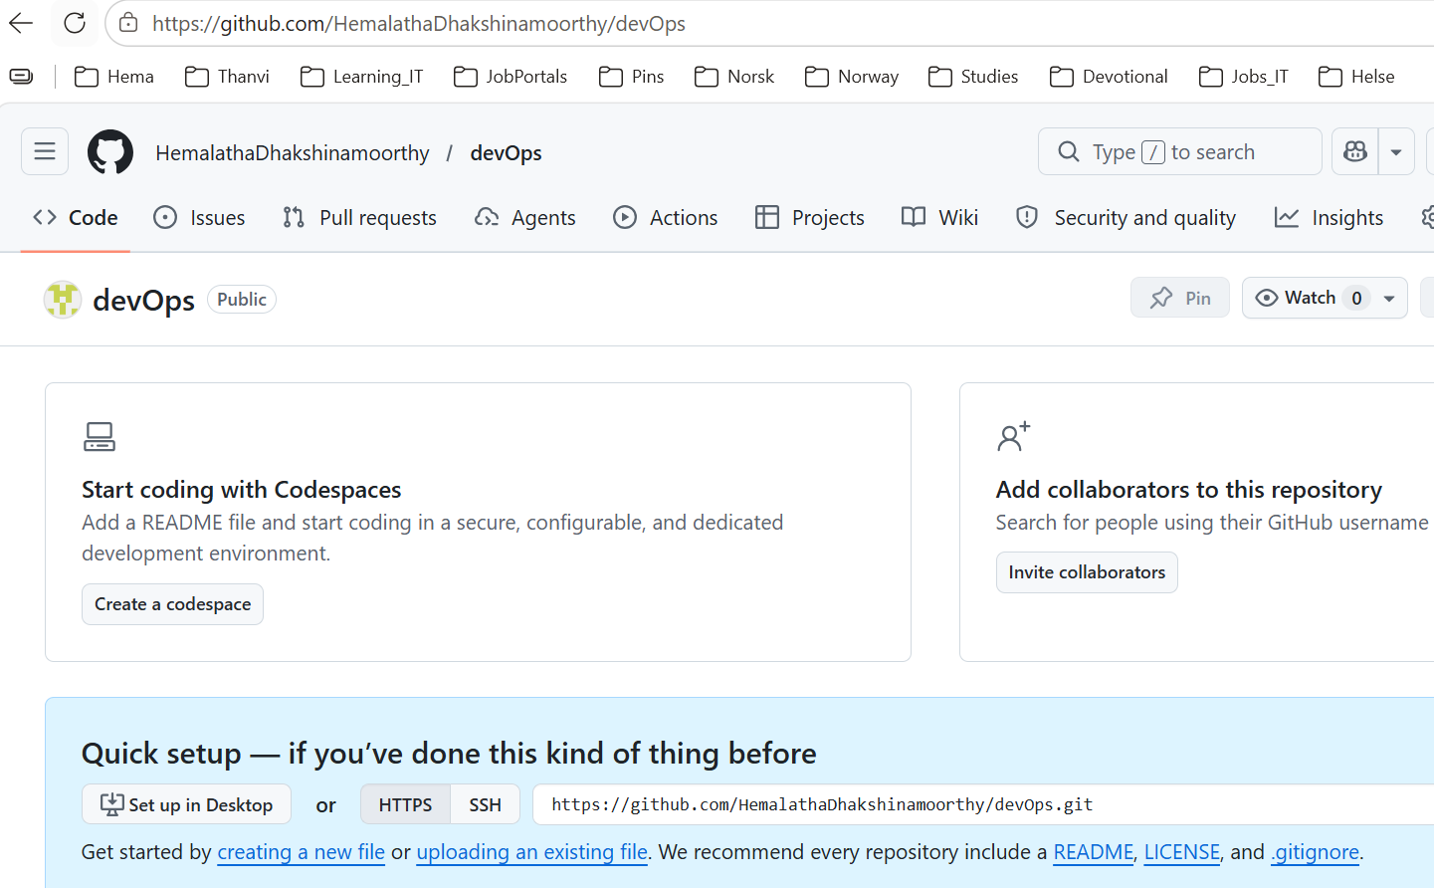
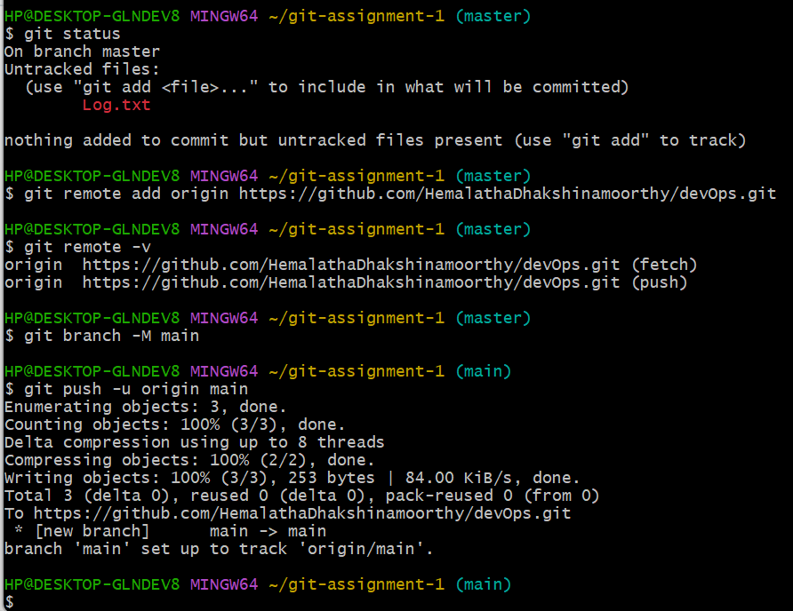
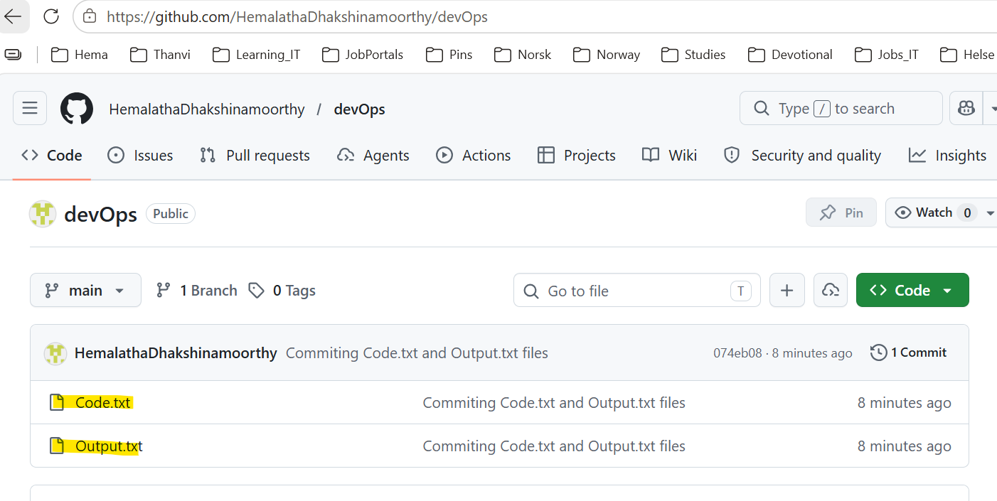

Git Assignment - 2
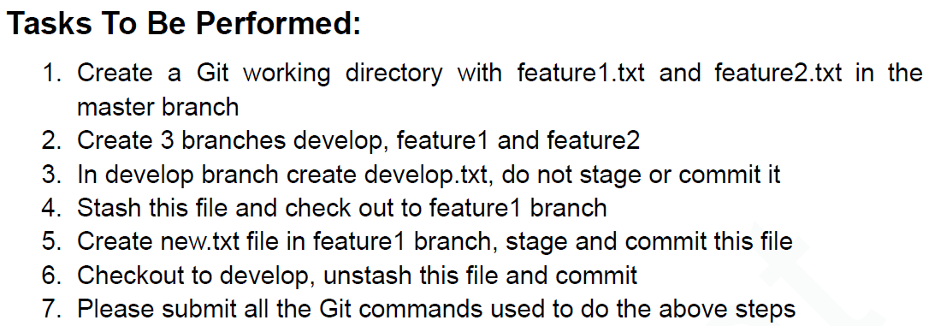
1. Create a Git working directory with feature1.txt & feature2.txt in the master branch
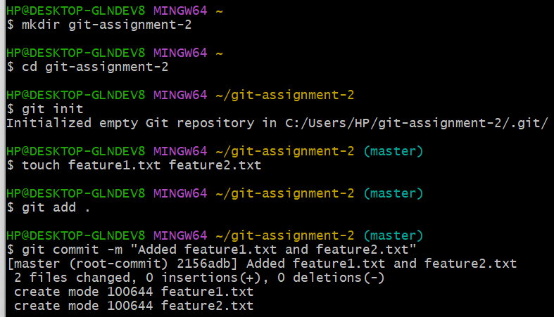
2. Create 3 branches develop, feature1 and feature2
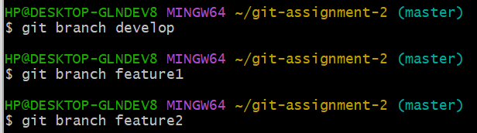
3. In develop branch create develop.txt, do not stage or commit it
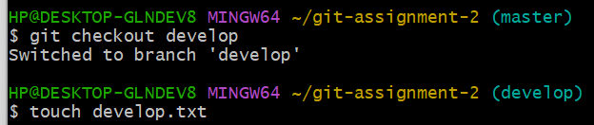
4. Stash this file and check out to feature1 branch
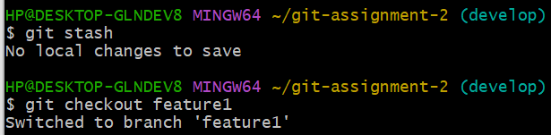
5. Create new.txt file in feature1 branch, stage and commit this file
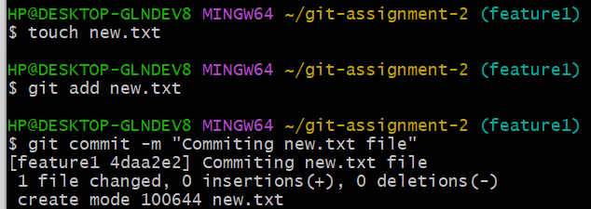
6. Checkout to develop, unstash this file and commit
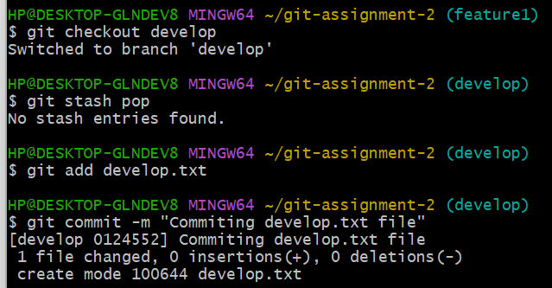

Git Assignment – 3
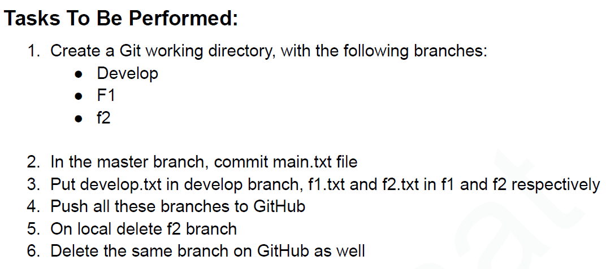

1. Create a Git working directory, with the following branches Develop, F1, f2
2. In the master branch, commit main.txt file

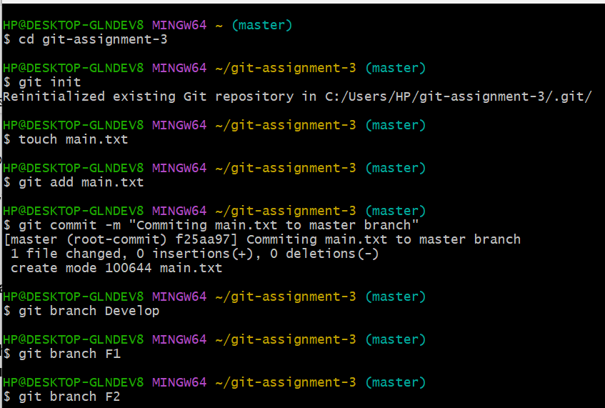

3. Put develop.txt in develop branch, f1.txt and f2.txt in f1 and f2 respectively

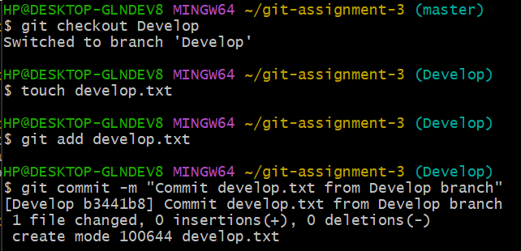

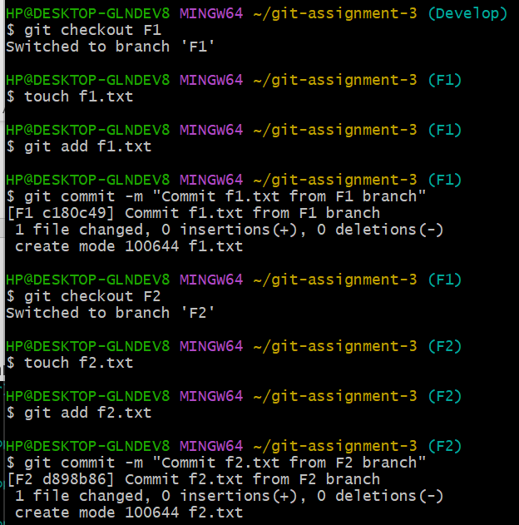

4. Push all these branches to GitHub

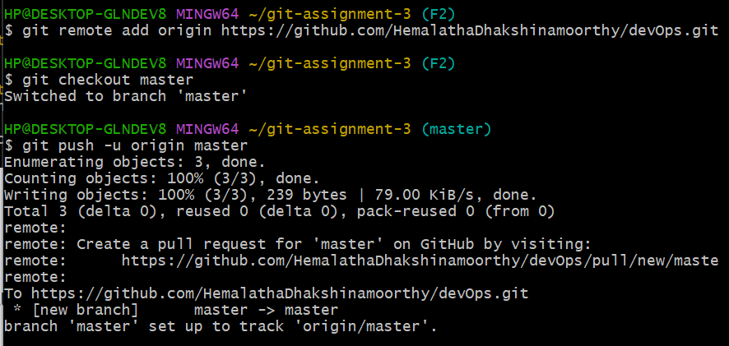

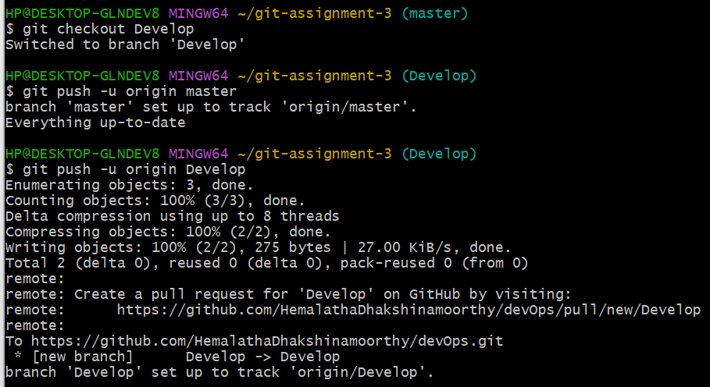

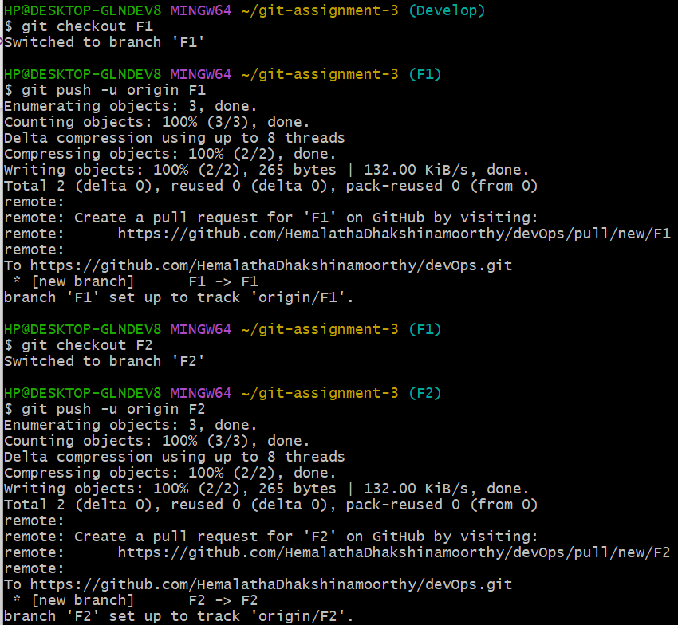

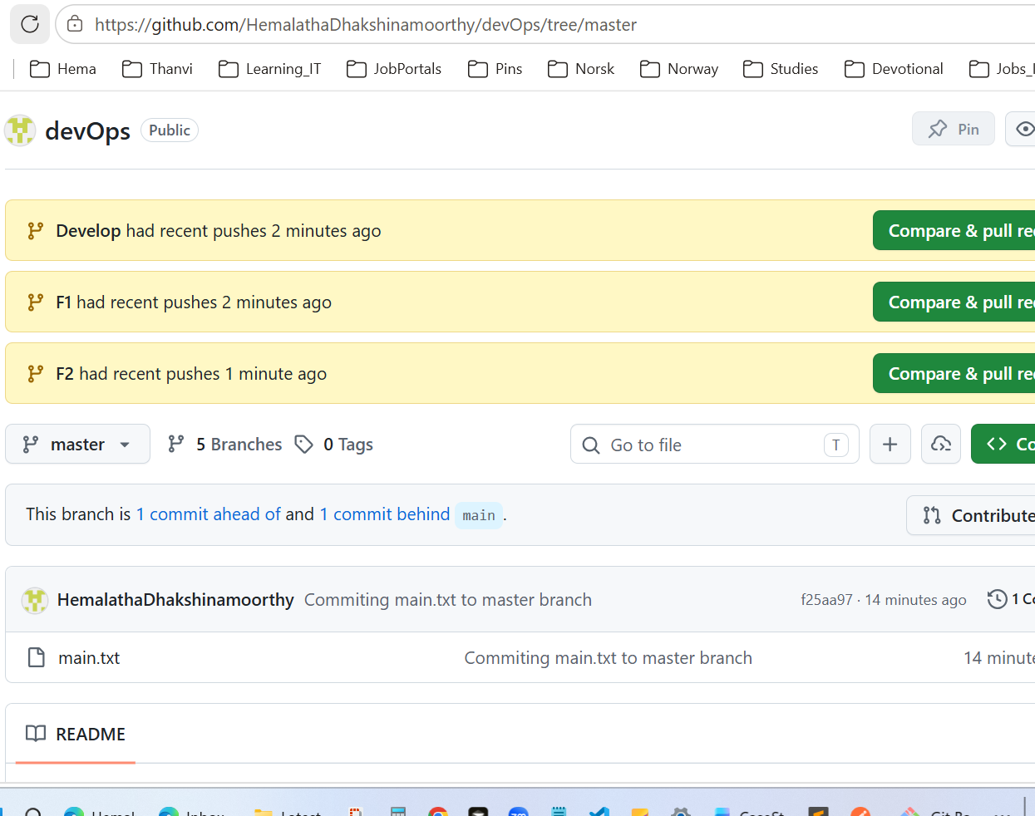

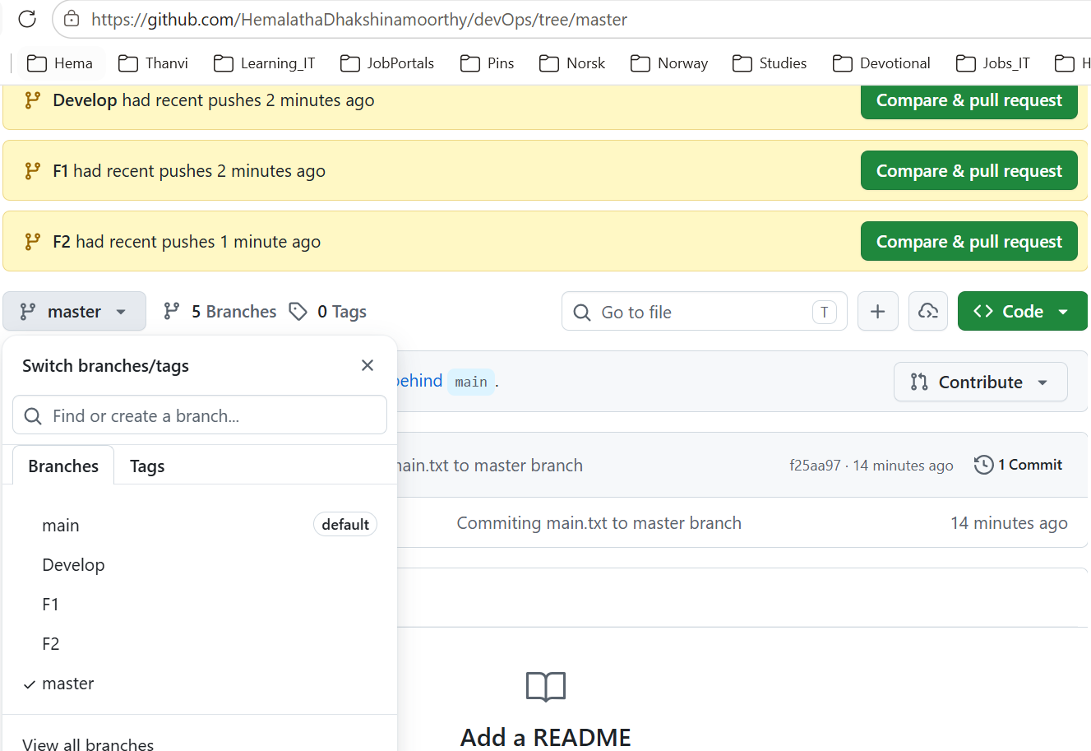
5. On local delete f2 branch

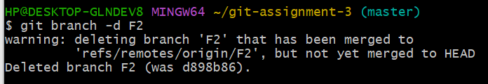

6. Delete the same branch on GitHub as well

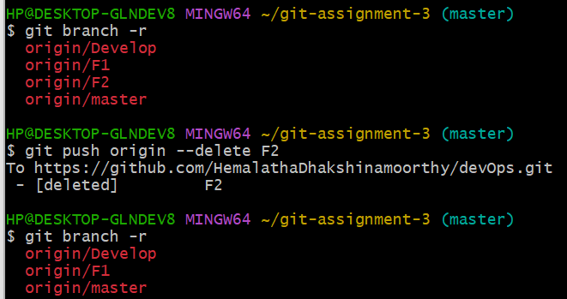

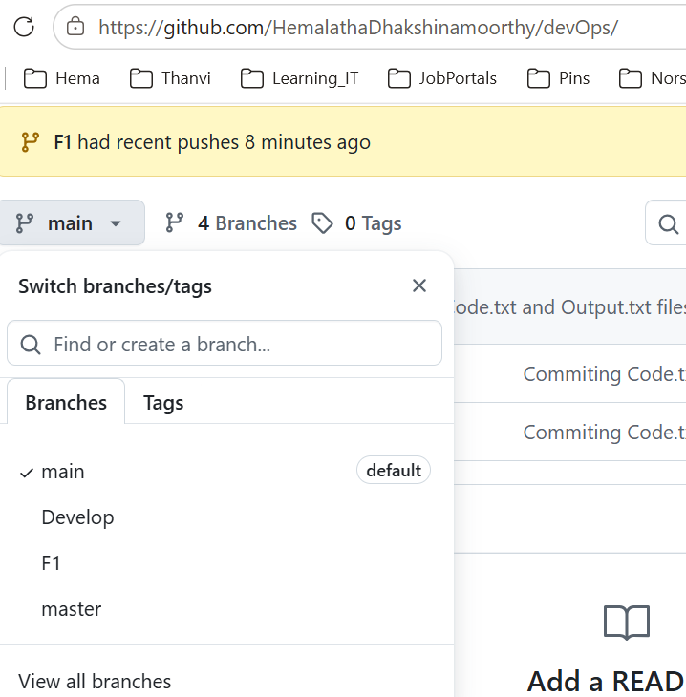
Git Assignment – 4

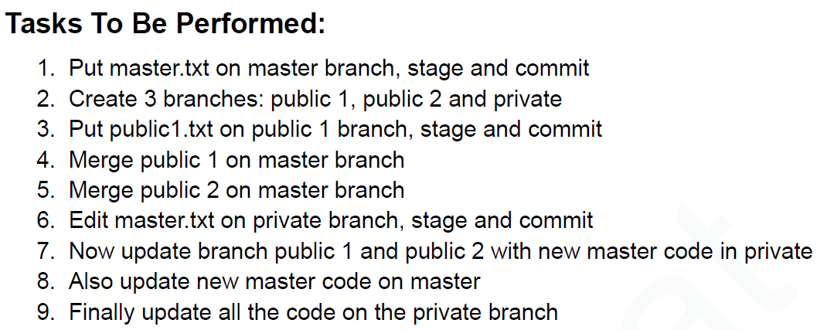

1. Put master.txt on master branch, stage and commit

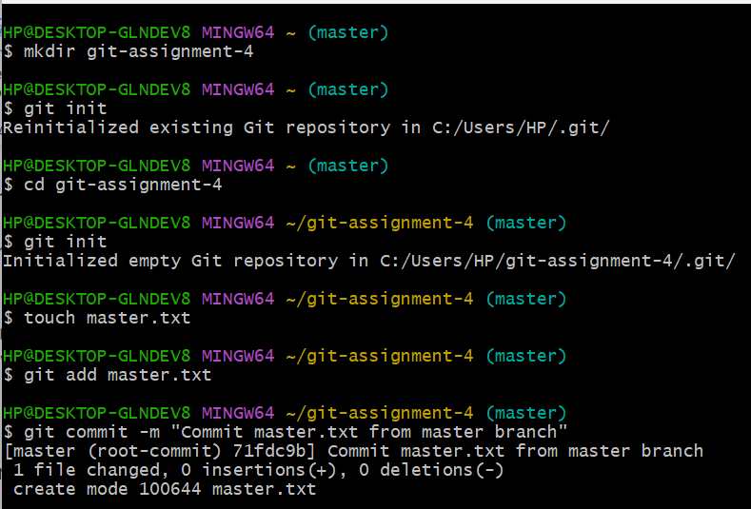

2. Create 3 branches: public 1, public 2 and private

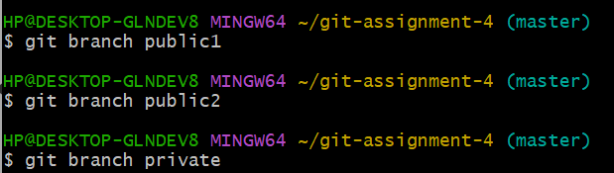
3. Put public1.txt on public 1 branch, stage and commit
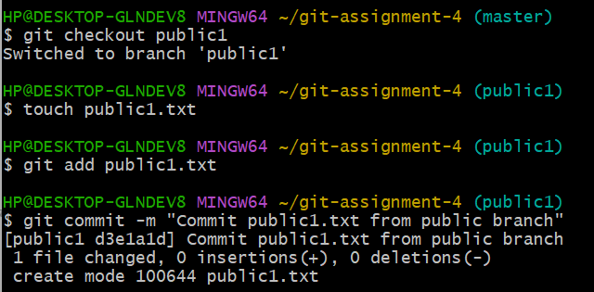

4. Merge public 1 on master branch
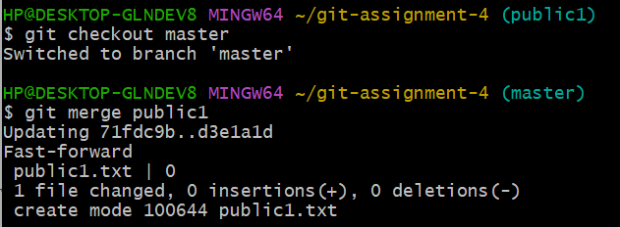

5. Merge public 2 on master branch
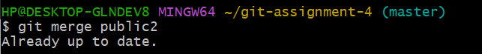

6. Edit master.txt on private branch, stage and commit
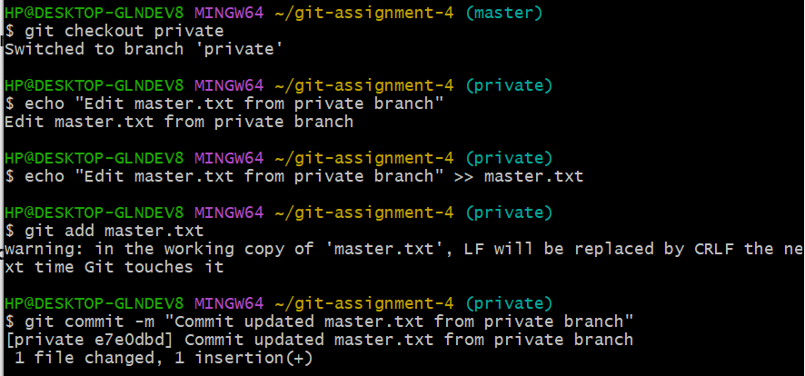

7. Now update branch public 1 and public 2 with new master code in private
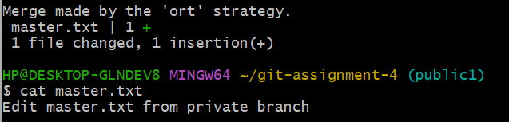

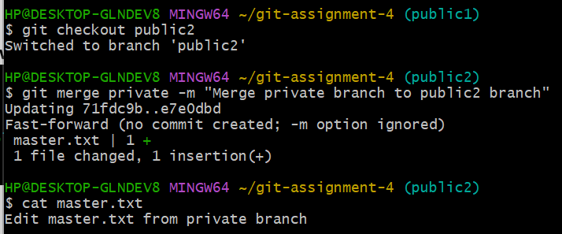

8. Also update new master code on master
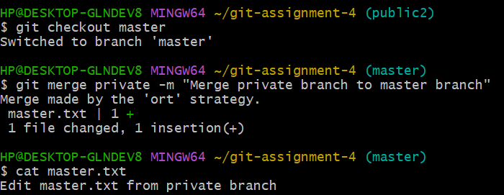

9. Finally update all the code on the private branch

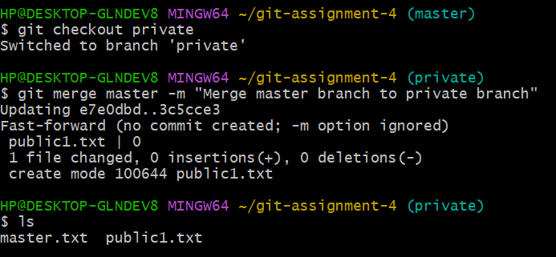

Git Assignment – 5

