SESSION7

ASSIGNMENT3

1.Create a box and whisker plot by class using mtcars dataset.

Solution:

str(mtcars)

View(mtcars)

library(ggplot2)

library(dplyr)

mtcars1 <- mutate(mtcars,

cyl = as.factor(cyl),

disp = as.factor(disp),

vs = as.factor(vs),

am = as.factor(am),

gear = as.factor(gear),

carb = as.factor(carb),

mpg = mpg, hp = hp, drat = drat, qsec=qsec)

str(mtcars1)

# distribution of mpg for each carb

boxplot(mpg~carb, data = mtcars1, col = heat.colors(5))

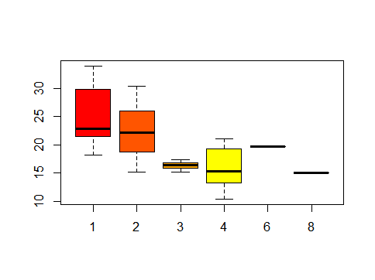

# distribution of mpg for each carb per cyl

ggplot(mtcars1, aes(x=carb, y=mpg, fill = cyl))+ geom_boxplot()

