

See discussions, stats, and author profiles for this publication at: [https://www.researchgate.net/publication/325174206](https://www.researchgate.net/publication/325174206_Drowsiness_Detection_and_Alert_System?enrichId=rgreq-77a985fe6e61bd6fa20a02e9ee46ad71-XXX&enrichSource=Y292ZXJQYWdlOzMyNTE3NDIwNjtBUzo3Nzg0MzIxMzI3MDIyMDlAMTU2MjYwNDA5MTY2Ng%3D%3D&el=1_x_2&_esc=publicationCoverPdf)

[Drowsiness Detection and Alert System](https://www.researchgate.net/publication/325174206_Drowsiness_Detection_and_Alert_System?enrichId=rgreq-77a985fe6e61bd6fa20a02e9ee46ad71-XXX&enrichSource=Y292ZXJQYWdlOzMyNTE3NDIwNjtBUzo3Nzg0MzIxMzI3MDIyMDlAMTU2MjYwNDA5MTY2Ng%3D%3D&el=1_x_3&_esc=publicationCoverPdf)

**Article** · April 2018

DOI: 10.22214/ijraset.2018.4043

CITATIONS

2

READS

27,722

**1 author:**

[Jyotsna Gabhane](https://www.researchgate.net/profile/Jyotsna-Gabhane?enrichId=rgreq-77a985fe6e61bd6fa20a02e9ee46ad71-XXX&enrichSource=Y292ZXJQYWdlOzMyNTE3NDIwNjtBUzo3Nzg0MzIxMzI3MDIyMDlAMTU2MjYwNDA5MTY2Ng%3D%3D&el=1_x_5&_esc=publicationCoverPdf) [Amity University](https://www.researchgate.net/institution/Amity_Business_School?enrichId=rgreq-77a985fe6e61bd6fa20a02e9ee46ad71-XXX&enrichSource=Y292ZXJQYWdlOzMyNTE3NDIwNjtBUzo3Nzg0MzIxMzI3MDIyMDlAMTU2MjYwNDA5MTY2Ng%3D%3D&el=1_x_6&_esc=publicationCoverPdf)

**4** PUBLICATIONS **189** CITATIONS

[SEE PROFILE](https://www.researchgate.net/profile/Jyotsna-Gabhane?enrichId=rgreq-77a985fe6e61bd6fa20a02e9ee46ad71-XXX&enrichSource=Y292ZXJQYWdlOzMyNTE3NDIwNjtBUzo3Nzg0MzIxMzI3MDIyMDlAMTU2MjYwNDA5MTY2Ng%3D%3D&el=1_x_7&_esc=publicationCoverPdf)

**Some of the authors of this publication are also working on these related projects:**

Internet of Things [View project](https://www.researchgate.net/project/Internet-of-Things-223?enrichId=rgreq-77a985fe6e61bd6fa20a02e9ee46ad71-XXX&enrichSource=Y292ZXJQYWdlOzMyNTE3NDIwNjtBUzo3Nzg0MzIxMzI3MDIyMDlAMTU2MjYwNDA5MTY2Ng%3D%3D&el=1_x_9&_esc=publicationCoverPdf)



The Effect of Using Kahoot for Learning ! - A Literature Review [View project](https://www.researchgate.net/project/The-Effect-of-Using-Kahoot-for-Learning-A-Literature-Review?enrichId=rgreq-77a985fe6e61bd6fa20a02e9ee46ad71-XXX&enrichSource=Y292ZXJQYWdlOzMyNTE3NDIwNjtBUzo3Nzg0MzIxMzI3MDIyMDlAMTU2MjYwNDA5MTY2Ng%3D%3D&el=1_x_9&_esc=publicationCoverPdf)

All content following this page was uploaded by [Jyotsna Gabhane](https://www.researchgate.net/profile/Jyotsna-Gabhane?enrichId=rgreq-77a985fe6e61bd6fa20a02e9ee46ad71-XXX&enrichSource=Y292ZXJQYWdlOzMyNTE3NDIwNjtBUzo3Nzg0MzIxMzI3MDIyMDlAMTU2MjYwNDA5MTY2Ng%3D%3D&el=1_x_10&_esc=publicationCoverPdf) on 08 July 2019.

The user has requested enhancement of the downloaded file.

**Drowsiness Detection and Alert System: A Review**

# Jyotsna Gabhane1, Dhanashri Dixit2, Pranali Mankar3, Ruchika Kamble4, Sayantani Gupta5

*1Assistant Professor, 2, 3, 4, 5 Student, Department of Computer Technology, Priyadarshini College of Engineering, Nagpur, India*

***Abstract: Truck drivers, company car drivers and shift workers are the most at risk of falling asleep while driving. Majority of the accidents occur due to the drunkenness of the driver. The burden of which lies on the company owner as they are made liable. It can lead to economic loss. In this presentation we present an adaptive driver and company owner alert system and an application that provides driving behaviour to the company owner.***

## INTRODUCTION

Truck Accidents are most common if the driving is insufficient. The factors causing accidents are: -

1. Speeding: Majorly in highways truck drivers ignore the speed limit. Speed kills and travelling above the speed limit is an easy way to cause accident.
2. Drunk Driving: When the driver is drunk, he loses the ability to focus and function properly, hence it is dangerous when operating a vehicle. This is one of the most contributing factors of accident.
3. Reckless Driving: Improper driving as in speeding up the vehicle or changing lanes too quickly or tailgating and many more can cause reckless driving. Reckless driving is when you’re operating vehicle with deliberate disregard.
4. Night Driving: Driving in daylight can be hazardous, but driving at night nearly doubles the risk of accident. When you can’t see what’s ahead you don’t know what to anticipate as you drive towards it.
5. Driving Under the Influence Of Drug: Drugs, both legal and illegal can impair your ability to fully function as a driver. Mind clearance and control over the body is need else it may cause accident.
6. Drowsy Driving: Driver fatigue isn’t talked about a lot, but how well we can expect anyone to drive when they are having trouble staying awake. Most of the car accidents caused by drowsy driving occur at night.

Here we are concern about the factors which make the truck drivers fall asleep as in Drunk Driving, Night Driving, Driving under the influence of drug and Drowsy Driving.

As the result is same for all the above mentioned factors that is,Eyes become "heavy" and blinking time is higher. Driver tends to keep his eyes closed "at least for a few seconds.

Hence here we create a buzzer and a goggle for an adaptive driver and an application that provides driving behaviour to the company owner. So as to warn the owner and the driver.

*A. Objective Of The Project*

The main objective of our project is to reduce the accident ratio of the truck driver. Major accident occurs because of the driver’s fault the owner compensates, hence to reduce the burden of the owner we are making this project.

## LITERATURE SURVEY

1. *Driver Drowsiness Detection System and Techniques*

According to the experts it has been observed that when the drivers do not take break they tend to run a high risk of becoming drowsy. Study shows that accidents occur due to sleepy drivers in need of a rest, which means that road accidents occurs more due to drowsiness rather than drink-driving. Attention assist can warn of inattentiveness and drowsiness in an extended speed range and notify drivers of their current state of fatigue and the driving time since the last break, offers adjustable sensitivity and, if a warning is emitted, indicates nearby service areas in the COMAND navigation system.

1. *Implementation of the Driver Drowsiness Detection System*

This paper is about making cars more intelligent and interactive which may notify or resist user under unacceptable conditions, they may provide critical information of real time situations to rescue or police or owner himself [2]. Driver fatigue resulting from sleep disorders is an important factor in the increasing number of accidents on today's roads. In this paper, we describe a real-time safety prototype that controls the vehicle speed under driver fatigue [2]. To advance a system to detect fatigue

symptoms in drivers and control the speed of vehicle to avoid accidents is the purpose of such a mode. In this paper, we propose a driver drowsiness detection system in which sensor like eye blink sensor are used for detecting drowsiness of driver

.If the driver is found to have sleep, buzzer will start buzzing and then turns the vehicle ignition off[2] .

1. *Detecting Driver Drowsiness Based on Sensors*

Researchers have attempted to determine driver drowsiness using the following measures: (1) vehicle-based measures; (2) behavioural measures and (3) physiological measures [3]. A detailed review on these measures will provide insight on the present systems, issues associated with them and the enhancements that need to be done to make a robust system [3]. This paper reviews the three measures as to the sensors used and discuss the advantages and limitations of each. The various ways through which drowsiness has been experimentally manipulated is also discussed [3]. It is concluded that by designing a hybrid drowsiness detection system that combines non-intrusive physiological measures with other measures one would accurately determine the drowsiness level of a driver. A number of road accidents might then be avoided if an alert is sent to a driver that is deemed drowsy [3].

1. *Eye Tracking Based Driver Drowsiness Monitoring And Warning System*

This project represents a way of developing an interface to detect driver drowsiness based on continuously monitoring eyes and DIP algorithms [4]. Micro sleeps are the short period of sleeps lasting 2 to 3 seconds, are good indicator of fatigue state. Thus by monitoring continuously the eyes of the driver by using camera one can detect the sleepy state of driver and timely warning is issued. Aim of the project is to develop the hardware which is very advanced product related to driver safety on the roads using controller and image processing [4]. This product detects driver drowsiness and gives warning in form of alarm and it also decreases the speed of vehicle. Along with the drowsiness detection process there is continuous monitoring of the distance done by the Ultrasonic sensor [4]. The ultrasonic sensor detects the obstacle and accordingly warns the driver as well as decreases speed of vehicle [4].

1. *Driver Drowsiness Detection System:*

One of the major cause of traffic accident is Driver‘s drowsiness. It is a serious highway safety problem. If drivers could be warned before they became too drowsy to drive safely, some of these crashes could be prevented. In order to reliably detect the drowsiness, it depends on the presentation of timely warnings of drowsiness [5]. To date, the effectiveness of drowsiness detection methods has been limited by their failure to consider individual differences. Based on the type of data used, drowsiness detection can be conveniently separated into the two categories of intrusive and non-intrusive methods [5]. During the survey, non-intrusive methods detect drowsiness by measuring driving behaviour and sometimes eye features, through which camera based detection system is the best method and so are useful for real world driving situations [5]. This paper presents the review of existed drowsiness detection techniques that will be used in this system like Circular Hough Transform, FCM, Lab Color Space etc [5].

## METHODOLOGY

Each year there are thousands of truck accidents, leading to injuries and fatalities, expensive insurance claims and lengthy traffic jams as wreckage is cleared. When a commercial truck is involved in a serious accident, the driver is usually the spotlight. Usually size and weights of trucks requires the driver to be both highly skilled & focused on controlling these multi-ton behemoths. Due to severity of injuries and property damage commercial truck accidents often produce large claim amounts.

One of the most common fault of the truck driver is their failure in checking blind spots, known in the trucking industries as “no zones”, before turning or changing lanes.

They are on the all four sides of the semi, and many accidents happen when the trucker manoeuvres into the spots without carefully checking for clearance first. They are operating a dangerous vehicle, driving the rig defensively is part of truckers’ “expanded duty” to protect us.

Other truck driver errors are similar to those that anyone can make, such as not paying attention to surrounding, speeding, not knowing routes, exhaustion and driving under the influence of alcohol or drug

This project involves controlling accident and saving driver’s life as well as owner’s problem of compensating every time even if it’s the fault of the driver.

In this project we design goggle/spectacles in which IR sensors and buzzer are fitted. This entire set up is worn by the driver. The setup consist of many more things such as Arduino UNO, GSM SIM 800 module, 2batteries, two ON/OFF buttons each connect with one battery. Now what happens here is first battery is connected with microcontroller and the other one is connected with GSM module. This entire setup works in this way, as soon as the driver wears the goggle IR sensors checks weather the eyes are closed or not, if the eyes are not closed then it again checks for it, this loop continues until the eyes are found closed. AS soon as the eyes are found closed, it again goes for a second check and again if the eyes are found closed then the buzzer is blown and red LED is on and it continues blowing for 1minute and then buzzer and LED will be off. after 1minute. We over here set a condition if the frequency is more than 50 then the driver is not drowsy as soon as it reads frequency less than 50 then the driver is drowsy. On the other hand as soon as the driver is found drowsy the message is sent to the owner via GSM module which reads as “Driver is found drowsy”. The same process keeps repeating.

In short we can say whenever the driver feels drowsy his eyes starts to blink for more than one second, this status is detected by the IR sensor and the buzzer is blown to make the driver conscious and the text message is sent to the owner immediately.

## REQUIREMENTS

1. *Hardware Requirements*
   1. *Arduino UNO SMD:* It is open source microcontroller. The board is equipped with sets of digital and analog input/output (I/O) pins that may be interfaced to various expansion boards (shields) and other circuits. The board features 14 Digital pins and 6 Analog pins.
   2. *HDMI Cable:* HDMI cable is used to connect. That is used to view the GUI of Raspberry Pi.
   3. *Adapter:* Adapter with Input 100-240VAC 50-60Hz and Output 12V- 2Amp is connected to GSM module.
   4. *GSM module:* GSM module is used for text messaging. It is used to read the status of the driver’s blinking eyes.
   5. *Android Mobile:* In this project, android mobile is used for real time monitoring of drowsiness.
   6. *Desktop/Laptop/Tablet:* It is used for coding the program.
   7. *IR[Infra-Red] Transmitter & Receiver LED:* It is fitted across the sides the specs. It is used to read the eye blink status.
   8. *Buzzer:* Buzzer will be blown at driver side when eye lid is closed for more than 1 second.
   9. *Specs:* The driver will wear the specs. In Specs we fitted the IR LED & this whole system will be interfaced with raspberry pi.
2. *Software Requirements*
   1. *Android programming software:* Android application is developed through android programming software to check the status of driver’s drowsiness condition in real time.
   2. *Cross Compiler Arduino 1.5.5v:* It is an open **source** computer hardware and software platform for building digital devices and interactive objects that can sense and control the physical world around them.
   3. *Compiler android studio 1.2v:* It is the official IDE for android development and includes everything you need to built android app.
   4. *Os Windows 7 (32bits min)*

## EXPERIMENTAL RESULTS

Fig: 2 Arduino UNO SMD

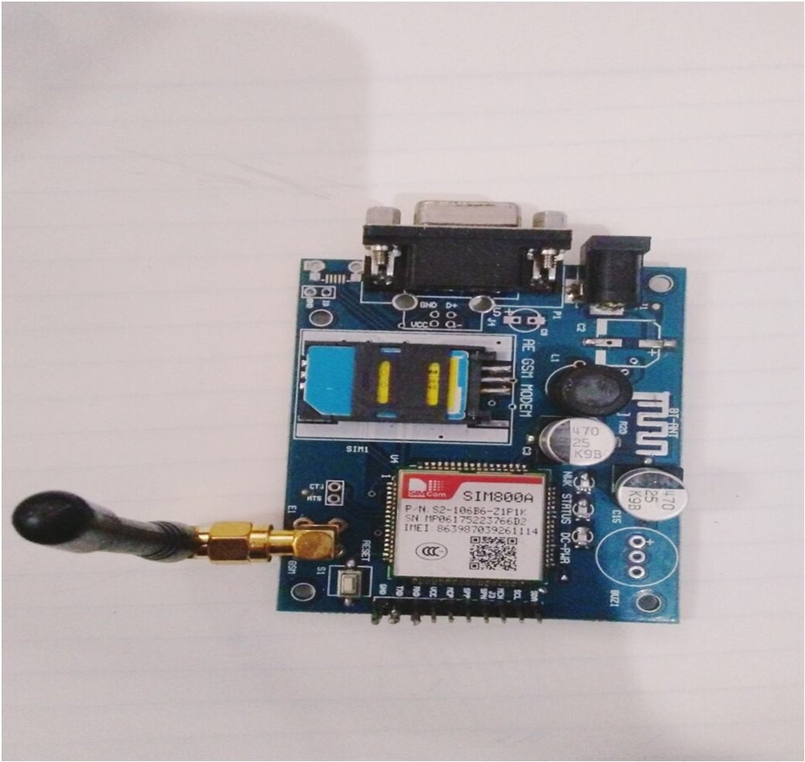

Fig: GSM SIM 800A Modem

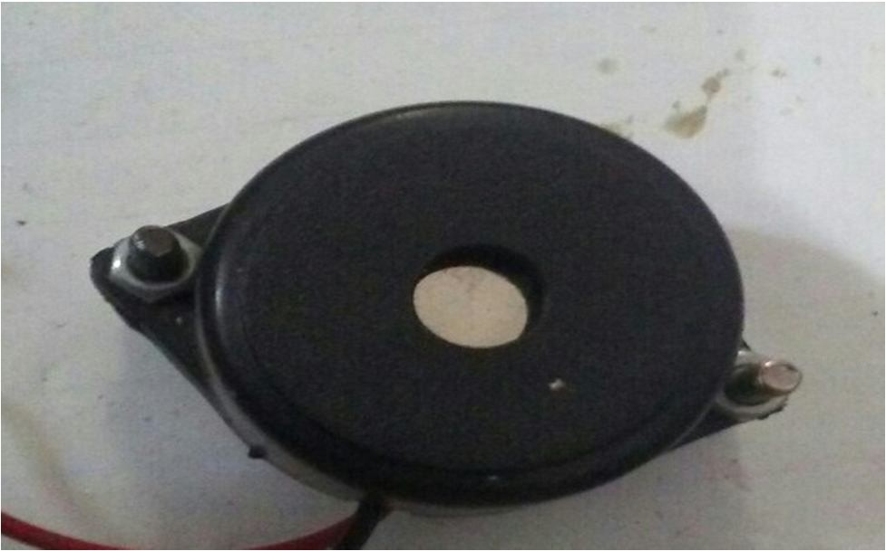

Fig: Buzzer

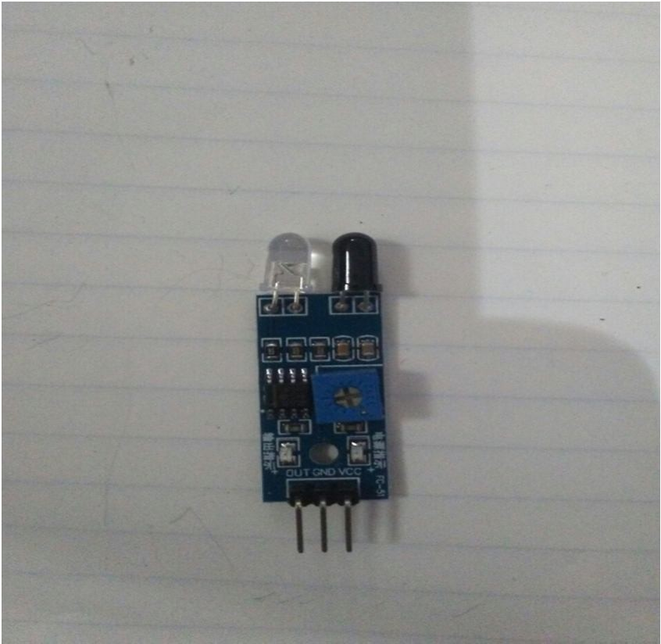

Fig: IR Sensor

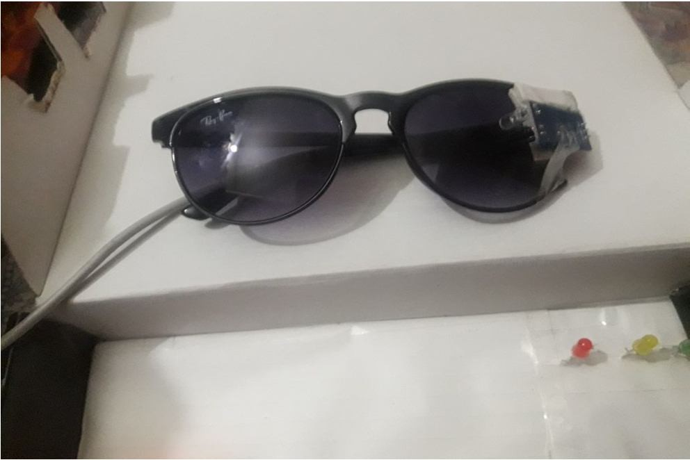

Fig: Goggle

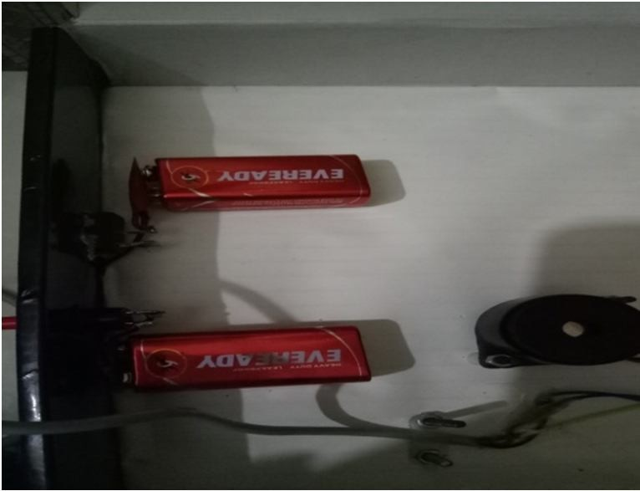

Fig: Battery

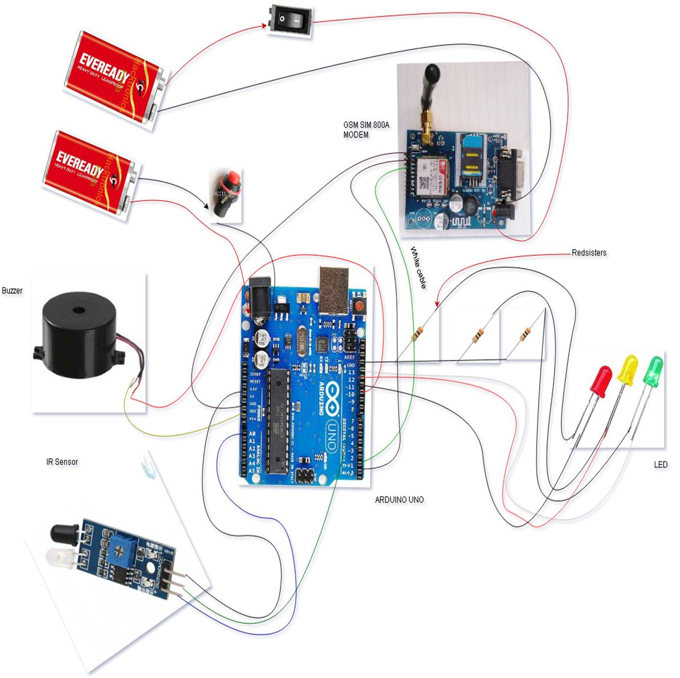

1. 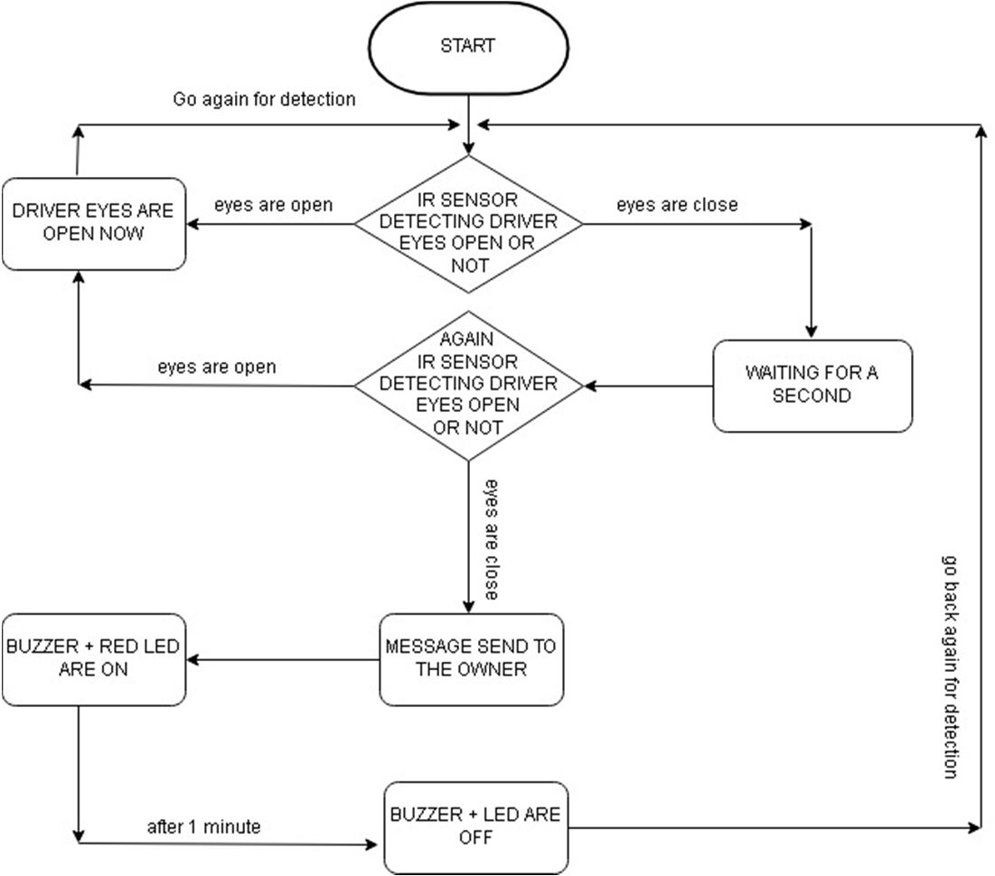*Data Flow Diagram*

©IJRASET (UGC Approved Journal): All Rights are Reserved

241

## CONCLUSION

Purpose of our project is to help solving real life problem in very cost effect way. It alerts the truck driver as well as the owner of the company. Whenever the driver feels drowsy and closes his eyes for more than a second, the buzzer is blown. As a result, it alerts the driver. It also warns the owner of the truck driver by sending him text messages.

As a result the accident ratio decreases. Hence, our project if commercially developed will help in saving the precious life of truck driver & money of the owner.

## REFERENCES

1. Vandna Saini, Rekha Saini “Driver Drowsiness Detection System and Techniques”, IJCSIT, Vol. 5 (3), 2014.
2. K.SRIJAYATHI, M.VEDACHARY “Implementation of the Driver Drowsiness Detection System”, IJSETR, Volume 2, Issue 9, September 2013.
3. Arun Sahayadhas, Kenneth Sundaraj & Murugappan Murugappan “Detecting Driver Drowsiness Based on Sensors”, Sensors, 7 December 2012.
4. Mitharwal Surendra Singh L., Ajgar Bhavana G., Shinde Pooja S., Maske Ashish M. “Eye Tracking Based Driver Drowsiness Monitoring & Warning System”, IJTRA, Volume 3, Issue 3, May-June 2015.
5. Chisty, Jasmeen Gill, “Driver Drowsiness Detection System”, IJCST, Volume 3, Issue 4, Jul-Aug 2015.
6. Ralph Oyini Mbouna, Seong G. Kong, Senior Member, IEEE,(2013),”Visual Analysis of Eye State and Head Pose for Driver Alertness Monitoring
7. Weirwille, W.W. (1994). “Overview of Research on Driver Drowsiness Definition and Driver Drowsiness Detection,” 14th International Technical Conference on Enhanced Safety of Vehicles, pp23-26.
8. Flores, M.; Armingol, J.; de la Escalera, A. Driver drowsiness warning system using visual information for both diurnal and nocturnal illumination conditions.

EURASIP J. Adv. Signal Process. 2010, 2010, 438205. 57

1. “Development of drowsiness detection system” Vehicle Research Laboratory, Nissan Center NISSAN MOTOR Co., Ltd. Hiroshi Ueno Masayuki Kaneda Masataka Tsukino
2. J. Batista, “A drowsiness and point of attention monitoring system for driver vigilance,” in Proc. Intell. Transp. Syst. Conf., 2007, pp. 702–708.

[View publication stats](https://www.researchgate.net/publication/325174206)