**Revenue Optimization & Cohort Analysis**

This investigation addresses urgent revenue instability in an e-commerce platform, focusing on three core objectives.

1. Pinpointing Revenue Leaks
2. Optimize Conversion Funnel
3. Cohort Retention Strategy

Refer problem_statement.docx for detailed insights of the business problem.

Tools Used:

* SQL: - Data Cleaning and Transformation
* Excel: - Trend Analysis.

Key Assumptions:

* Active Users = Users with ≥1 order in month.
* Sept 2021's data isn't artificially inflated by partial-month data (cutoff: 10-Sept).
* Order IDs with no recorded Order Amount represent user carts that were never processed.
* Revenue is counted only when the order is marked as ‘Won’ else it's a lost opportunity.

**Customer Acquisition & Purchase Trends**

**Monthly Customer Acquisitions:**

* New customer acquisitions show steady patterns, with March (1299) and April (1348) being the highest.

|  |  |  |  |  |  |
| --- | --- | --- | --- | --- | --- |
| January | February | March | April | May | June |
| 1224 | 1168 | 1299 | 1348 | 1335 | 1191 |

**Monthly Total & Monthly Average Revenue Per User (MRPU) Trends:**

* Revenue shows a steady increase from January to August, peaking in August at ₹4.8M.
* MRPU increased sharply from ₹769.97 in January to ₹6093.12 in August.
* The peak in July & August suggests either higher spending per user or a change in the customer base.

**Anomalies in Data:**

* August’s ARPU is significantly higher (₹6093.12) than previous months—possibly due to high-value transactions or repeat purchases.
* Additionally, September’s sharp decline (₹2371.47) suggests that this behavior was not sustained, potentially due to promotions, or a temporary influx of high-spending customers.

1. **Identifying Potential Revenue Leaks**

* Despite fluctuations in order volume, the conversion percentage (order placed vs order won) is trending upwards. Indicating improvements in order processing.
* Significant drop in July, possibly due to seasonal factors or marketing changes.
* Gap between cart creation and placed order suggests cart abandonment is a key issue. This could be due to check-out friction or pricing concerns.
* Sales Professionals show a massive drop-off rate of 90.8% from carts created (4,743) to orders placed (436).
* CC Agents created 88 carts but had zero orders placed, meaning a 100% revenue leakage.
* Loan Agents, Investment Agents, and Working Professionals have low cart numbers and poor conversion rates, suggesting low engagement or interest.
* Customer Support professionals also have a relatively higher conversion rate, suggesting they may be more decisive or familiar with the product.
* Small Merchants and BFSI Professionals show better conversion rates from carts to orders compared to others.

1. **Conversion Funnel Optimization**

The transition from orders placed to orders won is relatively stable, with conversion rates above 90% in most cases.

The primary issue is the drop-off before an order is placed, indicating possible friction points like:

* Pricing concerns
* Complex checkout process
* Poor user experience
* Decision fatigue

Actionable Recommendations

* Segment-Based Targeting: Offer profession-specific incentives (e.g., discounts for Insurance Agents and Finance Agents to reduce cart abandonment).
* Re-engagement Strategies: Implement cart abandonment emails, push notifications, and retargeting ads.
* Analyze market spend allocation to investigate post June decline in cart created

1. **Cohort Retention Strategy.**

**Cohort Analysis Matrix – User Activity**

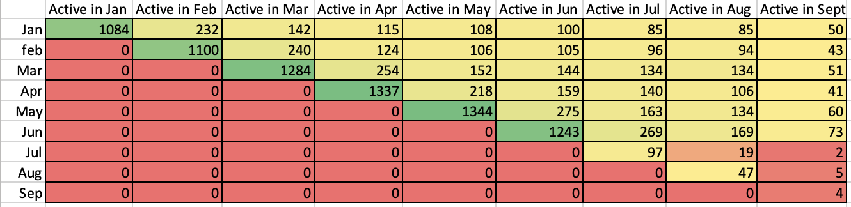

Analyzing user retention across cohorts reveals that while initial engagement is strong, long-term retention declines sharply.

Key Observations:

* The highest retention is observed within the first month of acquisition, but retention rates decline significantly after Month 2.
* March and April Cohorts show higher-than-average retention.
* August’s cohort exhibits unusually low retention, aligning with the revenue decline seen in September. This suggests a temporary influx of high-value customers who did not sustain engagement.

Actionable Recommendations:

* Introduce Customer Loyalty and Reward Programs
* Improve Post-Purchase Engagement by implementing automated follow-up emails and push notifications with personalized recommendations.
* Offer a subscription-based model for frequently purchased products.
* Exclusive membership perks for long-term customers.
* Targeted Retargeting Strategies:
* Identify high-value customer segments and target them with retention-focused marketing efforts.
* Utilize remarketing ads to re-engage customers who haven’t purchased in 60+ days.