**CryptoVerse: A Cryptocurrency dashboard**

**Project Title: CryptoVerse**

**Team Members**:

hemanath r b(**Team Leader**) [Email Id:[babbluhemanath@gmail.com](mailto:e.suriya528@gmail.com?subject=" \o "mailto:e.suriya528@gmail.com?subject=)]

abdul aziz a r [Email Id:[abdulaziznovember2004@gmail.com](mailto:dondinesh1430@gmail.com?subject=" \o "mailto:dondinesh1430@gmail.com?subject=)]

prakash k [Email Id:[prakash2005@gmail.com](mailto:giristark541@gmail.com?subject=" \o "mailto:giristark541@gmail.com?subject=)]

rajesh k [Email Id:[rajesharmy007@gmail.com](mailto:logenathanlogenathan852@gmail.com?subject=" \o "mailto:logenathanlogenathan852@gmail.com?subject=)]

sachin m [Email Id: [sachinmani@gmail.com](mailto:aadhiyuvaa007@gmail.com?subject=" \o "mailto:aadhiyuvaa007@gmail.com?subject=)]

**INTRODUCTION**

A crypto currency dashboard that displays historical price data over the past five years is a powerful tool for investors seeking a comprehensive understanding of market dynamics.This feature-rich interface offers users a detailed historical perspective on the performance of various crypto currencies, enabling insightful analysis and informed decision-making.Through visually intuitive charts and graphs, the dashboard allows for effective comparisons of multiple crypto currencies, aiding in the identification of top performers and overall market trends. Users can customize timeframes for a more granular examination of price movements, facilitating in-depth volatility analysis and risk assessment. This historical data not only supports investors in making data-driven decisions but also assists in recognizing recurring patterns and cycles. Beyond its role in optimizing cryptocurrency portfolios, the dashboard serves as an educational resource, empowering users to grasp the evolving nature of crypto currency markets and the nuanced factors shaping price movements over an extended period.

**DESCRIPTION**

Cryptoverse is a sophisticated cryptocurrency dashboard designed to provide investors with comprehensive insights into market dynamics through detailed historical price data analysis spanning five years. Featuring visually intuitive charts, interactive tools, and seamless navigation, the platform empowers users to identify top-performing assets and make informed investment decisions. With its robust search functionality, users can easily explore a wide range of cryptocurrencies and compare their performance over time. Cryptoverse not only serves as a powerful tool for optimizing investment portfolios but also acts as an educational resource, helping users understand the evolving nature of cryptocurrency.

**FEATURES OF CRYPTOVERSE:**

* Fast and optimized performance using Vite
* Search functionality to find cryptocurrencies quickly
* Display real-time cryptocurrency data (if API integration is used)
* Responsive UI for a seamless user experience
* Interactive charts for price trends

**PRE-REQUISITES**

Here are the key prerequisites for developing a frontend application using React.js:

**NODE.JS AND NPM**

* **Purpose:** Node.js is a powerful JavaScript runtime environment that allows you to run JavaScript code on the local environment. It provides a scalable and efficient platform for building network applications.
* **Install:** Download from [https://nodejs.org/en/download/](https://nodejs.org/en/download/" \t "_blank).
* **Installation Instructions:** Follow the guide at [https://nodejs.org/en/download/package-manager/](https://nodejs.org/en/download/package-manager/" \t "_blank).

**REACT.JS**

* **Purpose:** React.js is a popular JavaScript library for building user interfaces. It enables developers to create interactive and reusable UI components, making it easier to build dynamic and responsive web applications.
* **Setup:**
  + Create a new React app:

npx create-react-app CryptoVerse

Replace fitflex with your preferred project name.

* + Navigate to the project directory:

cd crypto

* + Start the development server:

npm start

* + Environment Variables:
  + Create a .env file to store API keys (if applicable):(VITE\_CRYPTO\_API\_KEY=your\_api\_key\_here)
  + Access the app at [http://localhost:3000](http://localhost:3000" \t "_blank) in your web browser.
* **HTML, CSS, and JavaScript:** Basic knowledge of HTML for creating the structure of your app, CSS for styling, and JavaScript for client-side interactivity is essential.
* **Version Control:** Use Git for version control, enabling collaboration and tracking changes throughout the development process. Platforms like GitHub or Bitbucket can host your repository.
  + **Git:** Download and installation instructions can be found at [https://git-scm.com/downloads](https://git-scm.com/downloads" \t "_blank).
* **Development Environment:** Choose a code editor or Integrated Development Environment (IDE) that suits your preferences, such as Visual Studio Code, Sublime Text, or WebStorm.
  + **Visual Studio Code:** Download from [https://code.visualstudio.com/download](https://code.visualstudio.com/download" \t "_blank).
  + **Sublime Text:** Download from [https://www.sublimetext.com/download](https://www.sublimetext.com/download" \t "_blank).
  + **WebStorm:** Download from [https://www.jetbrains.com/webstorm/download](https://www.jetbrains.com/webstorm/download" \t "_blank).

**INSTALLATION:**

**TO GET THE APPLICATION PROJECT FROM DRIVE**

**Follow these steps:**

* **Get the Code:**
  + Download the code from the drive link (placeholder, to be provided): [https://drive.google.com/drive/folders/17yC9S36xHr5zMsDVsDcT6qYTMBY6GXHw](https://drive.google.com/drive/folders/17yC9S36xHr5zMsDVsDcT6qYTMBY6GXHw" \o "https://drive.google.com/drive/folders/17yC9S36xHr5zMsDVsDcT6qYTMBY6GXHw)
* **Install Dependencies:**
  + Navigate into the cloned repository directory and install libraries:

cd crypto

npm install

* **Start the Development Server:**
  + To start the development server, execute the following command:

npm run dev

* **Access the App:**
  + Open your web browser and navigate to [http://localhost:3000](http://localhost:3000" \t "_blank).
  + You should see the application's homepage, indicating that the installation and setup were successful.

You have successfully installed and set up the application on your local machine. You can now proceed with further customization, development, and testing as needed.

**PROJECT STRUCTURE**

In this project, the files are organized into key directories based on their purpose:

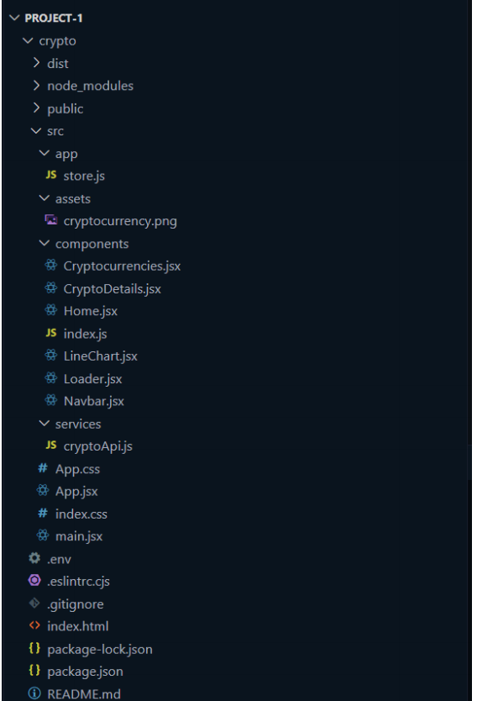

**PROJECT FLOW:**

PROJECT DEMO

* **Demo Link:** [https://drive.google.com/file/d/16H92NdJFyYfr4xc3j\_7nqRyiEv1H-23a/view?usp=drivesdk](https://drive.google.com/file/d/16H92NdJFyYfr4xc3j_7nqRyiEv1H-23a/view?usp=drivesdk" \o "https://drive.google.com/file/d/16H92NdJFyYfr4xc3j_7nqRyiEv1H-23a/view?usp=drivesdk)
* Code link:

**Component documentation** :

**key Components**:

* Cryptocurrencies.jsx - Fetches and displays the list of cryptocurrencies
* CryptoDetails.jsx - Shows detailed cryptocurrency data
* LineChart.jsx - Displays price trends using a chart library

**Reusable Component**s:

* Navbar.jsx - A reusable navigation bar

**State management:**

**Global State:**

* **Redux Toolkit is used for managing cryptocurrency data globally (store.js)**

**Local State:**

* **useState hooks for managing search input and UI states.**

**STYLING:**

**CSS Frameworks/Libraries:**

* **Tailwind CSS or Styled Components for styling.**

**PROJECT EXECUTION**

After completing the code, run the React application using:

npm start

npm run dev

**SCREENSHOTS OF THE APPLICATION**

* It's the UI of the application

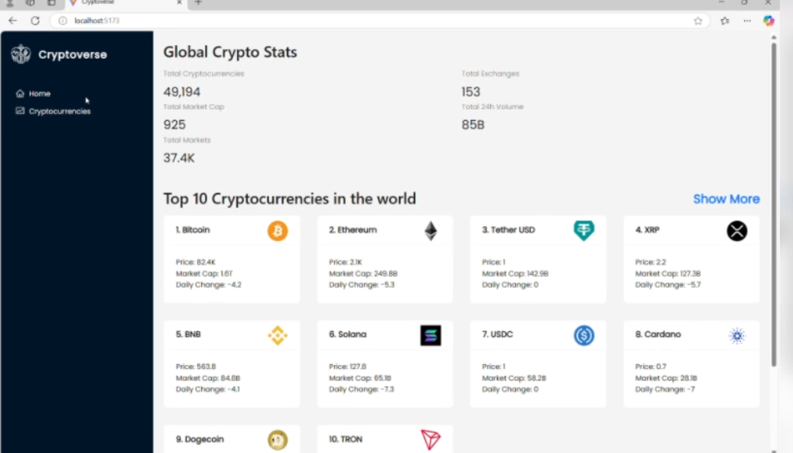

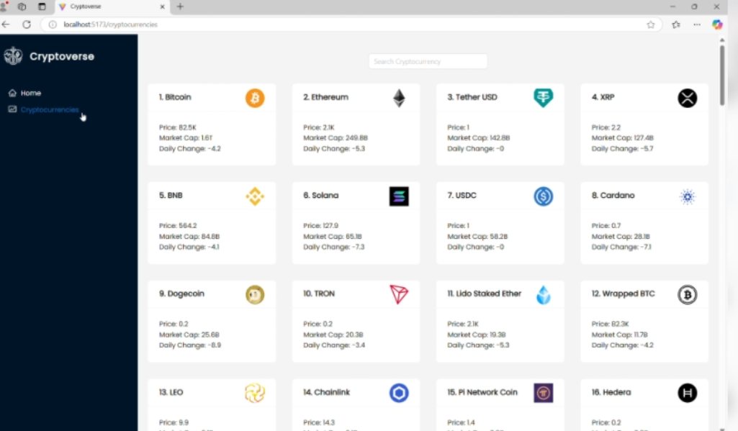

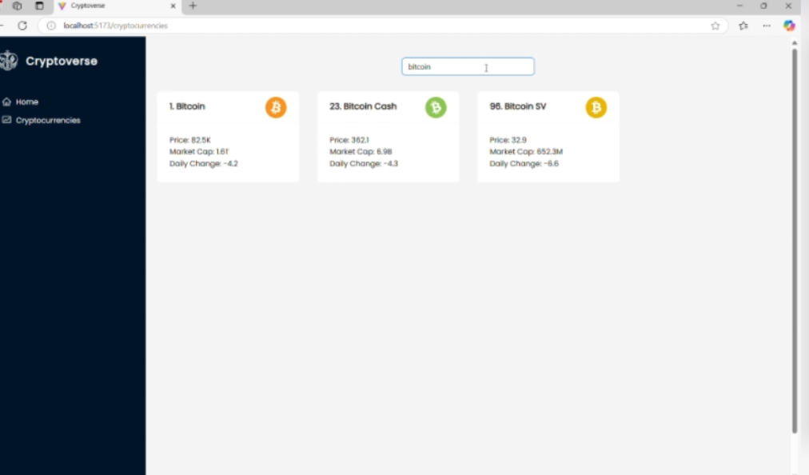

**Known issues:**

* API rate limits may cause issues if using a free tier
* Some UI elements need optimization on smaller screens

**Future enhancements:**

* **Add user authentication for personalized features**
* **Implement real-time price updates using WebSockets**