**LED**

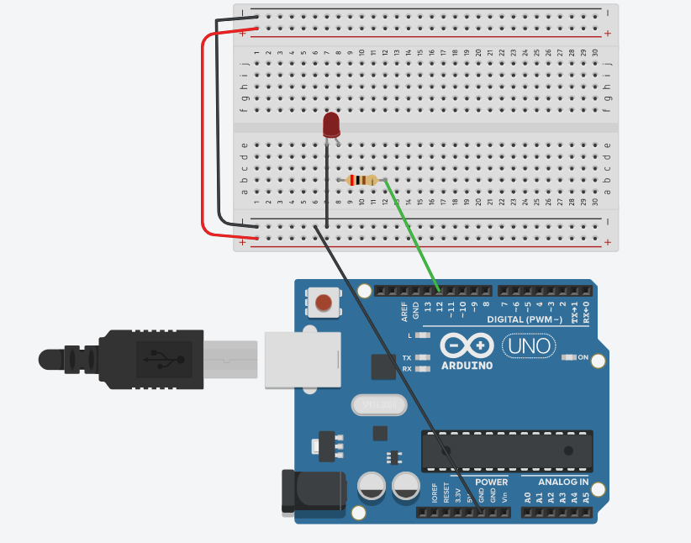

void setup()

{

pinMode(12,OUTPUT);

}

void loop()

{

digitalWrite(12, HIGH);

delay(1000); // Wait for 1000 millisecond(s)

digitalWrite(12, LOW);

delay(1000); // Wait for 1000 millisecond(s)

}

**LED 2**

void setup()

{

pinMode(12,OUTPUT);

pinMode(7,OUTPUT);

}

void loop()

{

digitalWrite(12, HIGH);

digitalWrite(7, LOW);

delay(1000);

digitalWrite(7, HIGH);

digitalWrite(12, LOW);

delay(1000);

}

**LED 6**

void setup()

{

pinMode(12,OUTPUT);

pinMode(10,OUTPUT);

pinMode(8,OUTPUT);

pinMode(3,OUTPUT);

pinMode(2,OUTPUT);

pinMode(1,OUTPUT);

}

void loop()

{

digitalWrite(12, HIGH);

digitalWrite(10, LOW);

digitalWrite(8, LOW);

digitalWrite(3, LOW);

digitalWrite(2, LOW);

digitalWrite(1, LOW);

delay(100);

digitalWrite(10, HIGH);

digitalWrite(12, LOW);

digitalWrite(8, LOW);

digitalWrite(3, LOW);

digitalWrite(2, LOW);

digitalWrite(1, LOW);

delay(100);

digitalWrite(8, HIGH);

digitalWrite(12, LOW);

digitalWrite(10, LOW);

digitalWrite(3, LOW);

digitalWrite(2, LOW);

digitalWrite(1, LOW);

delay(100);

digitalWrite(12, LOW);

digitalWrite(10, LOW);

digitalWrite(8, LOW);

digitalWrite(3, HIGH);

digitalWrite(2, LOW);

digitalWrite(1, LOW);

delay(100);

digitalWrite(12, LOW);

digitalWrite(10, LOW);

digitalWrite(8, LOW);

digitalWrite(3, LOW);

digitalWrite(2, HIGH);

digitalWrite(1, LOW);

delay(100);

digitalWrite(12, LOW);

digitalWrite(10, LOW);

digitalWrite(8, LOW);

digitalWrite(3, LOW);

digitalWrite(2, LOW);

digitalWrite(1, HIGH);

}

**LED 6 Reverse**

**void setup()**

**{**

**pinMode(12,OUTPUT);**

**pinMode(10,OUTPUT);**

**pinMode(8,OUTPUT);**

**pinMode(3,OUTPUT);**

**pinMode(2,OUTPUT);**

**pinMode(1,OUTPUT);**

**}**

**void loop()**

**{**

**delay(100);**

**digitalWrite(12, HIGH);**

**delay(100);**

**digitalWrite(10, HIGH);**

**digitalWrite(12, LOW);**

**delay(100);**

**digitalWrite(8, HIGH);**

**digitalWrite(10, LOW);**

**delay(100);**

**digitalWrite(8, LOW);**

**digitalWrite(3, HIGH);**

**delay(100);**

**digitalWrite(3, LOW);**

**digitalWrite(2, HIGH);**

**delay(100);**

**digitalWrite(2, LOW);**

**digitalWrite(1, HIGH);**

**delay(100);**

**digitalWrite(1,LOW);**

**delay(100);**

**digitalWrite(1, HIGH);**

**delay(100);**

**digitalWrite(2, HIGH);**

**digitalWrite(1, LOW);**

**delay(100);**

**digitalWrite(3, HIGH);**

**digitalWrite(2, LOW);**

**delay(100);**

**digitalWrite(3, LOW);**

**digitalWrite(8, HIGH);**

**delay(100);**

**digitalWrite(8, LOW);**

**digitalWrite(10, HIGH);**

**delay(100);**

**digitalWrite(10, LOW);**

**digitalWrite(12, HIGH);**

**delay(100);**

**digitalWrite(12,LOW);**

**}**

**PUSHBUTTON**

int led =13;

int pushButton =2;

void setup()

{

Serial.begin(9600);

pinMode(pushButton,INPUT);

pinMode(led,OUTPUT);

}

void loop()

{

int buttonState = digitalRead(pushButton);

Serial.println(buttonState);

if(buttonState == HIGH)

{

digitalWrite(led,HIGH);

}

else

{

digitalWrite(led,LOW);

}

delay(1);

}

**PUSHBUTTON LED**

**int LED =13;**

**int pinButton =2;**

**int stateLED =LOW;**

**int stateButton;**

**int previous =LOW;**

**long time =0;**

**long debounce =200;**

**void setup()**

**{**

**pinMode(pinButton,INPUT);**

**pinMode(LED,OUTPUT);**

**}**

**void loop()**

**{**

**stateButton = digitalRead(pinButton);**

**if(stateButton == HIGH && previous == LOW && millis()-time>debounce)**

**{**

**if(stateLED == HIGH)**

**{**

**stateLED =LOW;**

**}**

**else**

**{**

**stateLED =HIGH;**

**}**

**time = millis();**

**}**

**digitalWrite(LED, stateLED);**

**previous == stateButton;**

**}**

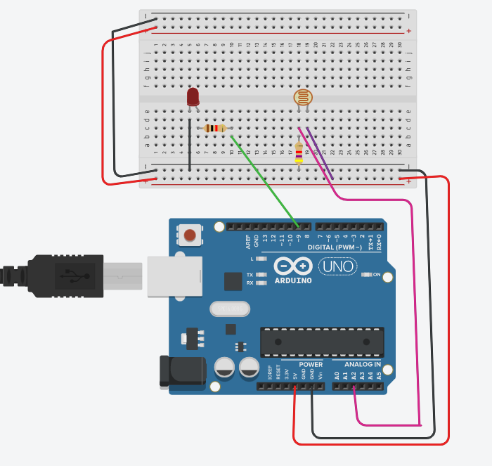

int sensorValue = 0;

void setup()

{

pinMode(A2,INPUT);

Serial.begin(9600);

pinMode(9,OUTPUT);

}

void loop()

{

sensorValue = analogRead(A2);

Serial.println(sensorValue);

if(sensorValue>829)

digitalWrite(9,LOW);

else

digitalWrite(9,HIGH);

}

Photo Resistor 2

int sensorValue = 0;

void setup()

{

pinMode(A2,INPUT);

Serial.begin(9600);

pinMode(9,OUTPUT);

}

void loop()

{

sensorValue = analogRead(A2);

Serial.println(sensorValue);

if(sensorValue>900)

{

digitalWrite(9,LOW);

digitalWrite(6,LOW);

}

else if(sensorValue>852)

{

digitalWrite(9,HIGH);

digitalWrite(6,LOW);

}

else

{

digitalWrite(9,HIGH);

digitalWrite(6,HIGH);

}

}

**Moister Sensor**

int k;

void setup()

{

Serial.begin(9600);

pinMode(A2,INPUT);

pinMode(10,OUTPUT);

pinMode(8,OUTPUT);

pinMode(6,OUTPUT);

}

void loop()

{

k = analogRead(A2);

Serial.println(k);

if(k<=177)

{

digitalWrite(10,HIGH);

digitalWrite(6,HIGH);

digitalWrite(8,LOW);

}

else

{

digitalWrite(8,HIGH);

digitalWrite(10,LOW);

digitalWrite(6,LOW);

}

}

**Moister Sensor using LCD**

#include<LiquidCrystal.h>

const int LM35 = A2;

const int motor = 1;

const int LEDRED = 2;

const int LEDGREEN = 3;

int percentValue =0;

LiquidCrystal lcd(4,5,8,9,10,11);

void setup()

{

Serial.begin(9600);

lcd.begin(16,2);

lcd.print("Automated crop");

lcd.setCursor(0,1);

lcd.print("Givewater");

pinMode(motor,OUTPUT);

pinMode(LEDRED,OUTPUT);

pinMode(LEDGREEN,OUTPUT);

delay(2000);

lcd.clear();

lcd.print("SOILM =");

lcd.setCursor(0,1);

lcd.print("water");

}

void loop()

{

int k = analogRead(A2);

lcd.setCursor(9,0);

lcd.print(k);

lcd.setCursor(10,1);

if(k <177)

{

digitalWrite(10,HIGH);

digitalWrite(6,HIGH);

digitalWrite(8,LOW);

lcd.print("ON ");

}

else

{

digitalWrite(8,HIGH);

digitalWrite(10,LOW);

digitalWrite(6,LOW);

lcd.print("OFF");

}

}

**Temperature Sensor**

#include<LiquidCrystal.h>

LiquidCrystal lcd(4,5,8,9,10,11);

int TMP36 =0;

float temperature =0;

void setup()

{

Serial.begin(9600);

lcd.begin(16,2);

lcd.setCursor(0,0);

lcd.print("TEMPERATURE");

}

void loop()

{

TMP36 = analogRead(A0);

float tension = (TMP36/1024.0) * 5.0;

temperature = (tension - .5) * 100;

lcd.setCursor(1,1);

lcd.print(temperature);

delay(500);

}

Gas Sensor

#include<LiquidCrystal.h>

LiquidCrystal lcd(4,5,8,9,10,11);

int smoke =0;

int r=0;

void setup()

{

pinMode(A4, INPUT);

lcd.begin(16,2);

pinMode(2, OUTPUT);

pinMode(3, OUTPUT);

Serial.begin(9600);

}

void loop()

{

smoke = analogRead(A4);

Serial.println(smoke);

if(smoke <=85)

{

digitalWrite(3,HIGH);

digitalWrite(2,LOW);

lcd.setCursor(0,0);

lcd.print("It's not fire");

}

else

{

digitalWrite(3,LOW);

digitalWrite(2,HIGH);

lcd.setCursor(0,0);

lcd.print("It's fire ");

}

}

**7 Segment LCD**

int a=1;

int b=2;

int c=8;

int d=6;

int e=5;

int f=3;

int g=4;

void setup()

{

pinMode(1,OUTPUT);

pinMode(2,OUTPUT);

pinMode(3,OUTPUT);

pinMode(4,OUTPUT);

pinMode(5,OUTPUT);

pinMode(6,OUTPUT);

pinMode(8,OUTPUT);

}

void loop()

{

digitalWrite(1, HIGH);

digitalWrite(2, HIGH);

digitalWrite(3, HIGH);

digitalWrite(8, HIGH);

digitalWrite(5, HIGH);

digitalWrite(6, HIGH);

digitalWrite(4, LOW);

delay(2000);

digitalWrite(1, LOW);

digitalWrite(2, HIGH);

digitalWrite(3, LOW);

digitalWrite(8, HIGH);

digitalWrite(5, LOW);

digitalWrite(6, LOW);

digitalWrite(4, LOW);

delay(2000);

digitalWrite(1, HIGH);

digitalWrite(2, HIGH);

digitalWrite(3, LOW);

digitalWrite(8, LOW);

digitalWrite(5, HIGH);

digitalWrite(6, HIGH);

digitalWrite(4, HIGH);

delay(2000);

digitalWrite(1, HIGH);

digitalWrite(2, HIGH);

digitalWrite(3, LOW);

digitalWrite(8, HIGH);

digitalWrite(5, LOW);

digitalWrite(6, HIGH);

digitalWrite(4, HIGH);

delay(2000);

digitalWrite(1, LOW);

digitalWrite(2, HIGH);

digitalWrite(3, HIGH);

digitalWrite(8, HIGH);

digitalWrite(5, LOW);

digitalWrite(6, LOW);

digitalWrite(4, HIGH);

delay(2000);

digitalWrite(1, HIGH);

digitalWrite(2, LOW);

digitalWrite(3, HIGH);

digitalWrite(8, HIGH);

digitalWrite(5, LOW);

digitalWrite(6, HIGH);

digitalWrite(4, HIGH);

delay(2000);

digitalWrite(1, LOW);

digitalWrite(2, LOW);

digitalWrite(3, HIGH);

digitalWrite(8, HIGH);

digitalWrite(5, HIGH);

digitalWrite(6, HIGH);

digitalWrite(4, HIGH);

delay(2000);

digitalWrite(1, HIGH);

digitalWrite(2, HIGH);

digitalWrite(3, LOW);

digitalWrite(8, HIGH);

digitalWrite(5, LOW);

digitalWrite(6, LOW);

digitalWrite(4, LOW);

delay(2000);

digitalWrite(1, HIGH);

digitalWrite(2, HIGH);

digitalWrite(3, HIGH);

digitalWrite(8, HIGH);

digitalWrite(5, HIGH);

digitalWrite(6, HIGH);

digitalWrite(4, HIGH);

delay(2000);

digitalWrite(1, HIGH);

digitalWrite(2, HIGH);

digitalWrite(3, HIGH);

digitalWrite(8, HIGH);

digitalWrite(5, LOW);

digitalWrite(6, LOW);

digitalWrite(4, HIGH);

delay(2000);

}

**Token Program**

int a=1;

int b=2;

int c=8;

int d=6;

int e=5;

int f=3;

int g=4;

int buttonpin=10;

int buttonState = 0;

int count =0;

int laststate =0;

void setup()

{

pinMode(1,OUTPUT);

pinMode(2,OUTPUT);

pinMode(3,OUTPUT);

pinMode(4,OUTPUT);

pinMode(5,OUTPUT);

pinMode(6,OUTPUT);

pinMode(8,OUTPUT);

pinMode(buttonpin, INPUT);

}

void loop()

{

buttonState=digitalRead(buttonpin);

if (buttonState != laststate)

{

if(buttonState == HIGH)

count++;

if(count>9)

count=0;

}

laststate = buttonState;

switch(count)

{

case 0:

digitalWrite(1, HIGH);

digitalWrite(2, HIGH);

digitalWrite(3, HIGH);

digitalWrite(8, HIGH);

digitalWrite(5, HIGH);

digitalWrite(6, HIGH);

digitalWrite(4, LOW);

delay(100);

break;

case 1:

digitalWrite(1, LOW);

digitalWrite(2, HIGH);

digitalWrite(3, LOW);

digitalWrite(8, HIGH);

digitalWrite(5, LOW);

digitalWrite(6, LOW);

digitalWrite(4, LOW);

delay(100);

break;

case 2:

digitalWrite(1, HIGH);

digitalWrite(2, HIGH);

digitalWrite(3, LOW);

digitalWrite(8, LOW);

digitalWrite(5, HIGH);

digitalWrite(6, HIGH);

digitalWrite(4, HIGH);

delay(100);

break;

case 3:

digitalWrite(1, HIGH);

digitalWrite(2, HIGH);

digitalWrite(3, LOW);

digitalWrite(8, HIGH);

digitalWrite(5, LOW);

digitalWrite(6, HIGH);

digitalWrite(4, HIGH);

delay(100);

break;

case 4:

digitalWrite(1, LOW);

digitalWrite(2, HIGH);

digitalWrite(3, HIGH);

digitalWrite(8, HIGH);

digitalWrite(5, LOW);

digitalWrite(6, LOW);

digitalWrite(4, HIGH);

delay(100);

break;

case 5:

digitalWrite(1, HIGH);

digitalWrite(2, LOW);

digitalWrite(3, HIGH);

digitalWrite(8, HIGH);

digitalWrite(5, LOW);

digitalWrite(6, HIGH);

digitalWrite(4, HIGH);

delay(100);

break;

case 6:

digitalWrite(1, LOW);

digitalWrite(2, LOW);

digitalWrite(3, HIGH);

digitalWrite(8, HIGH);

digitalWrite(5, HIGH);

digitalWrite(6, HIGH);

digitalWrite(4, HIGH);

delay(100);

break;

case 7:

digitalWrite(1, HIGH);

digitalWrite(2, HIGH);

digitalWrite(3, LOW);

digitalWrite(8, HIGH);

digitalWrite(5, LOW);

digitalWrite(6, LOW);

digitalWrite(4, LOW);

delay(100);

break;

case 8:

digitalWrite(1, HIGH);

digitalWrite(2, HIGH);

digitalWrite(3, HIGH);

digitalWrite(8, HIGH);

digitalWrite(5, HIGH);

digitalWrite(6, HIGH);

digitalWrite(4, HIGH);

delay(100);

break;

case 9:

digitalWrite(1, HIGH);

digitalWrite(2, HIGH);

digitalWrite(3, HIGH);

digitalWrite(8, HIGH);

digitalWrite(5, LOW);

digitalWrite(6, LOW);

digitalWrite(4, HIGH);

delay(100);

break;

}

}