**Smart Parking using IOT SYSTEM**

**Submitted by**

**Name :HEMANATHAN S**

**NM ID : au411521106019**

**Phase-3 Development part 1**

## Project : Smart Parking

## IoT based smart parking system

**OBJECTIVE:**

According to phase-3 guidelines, In this section begin building your project by loading and preprocessing the dataset.

**Introduction to Smart Parking :**

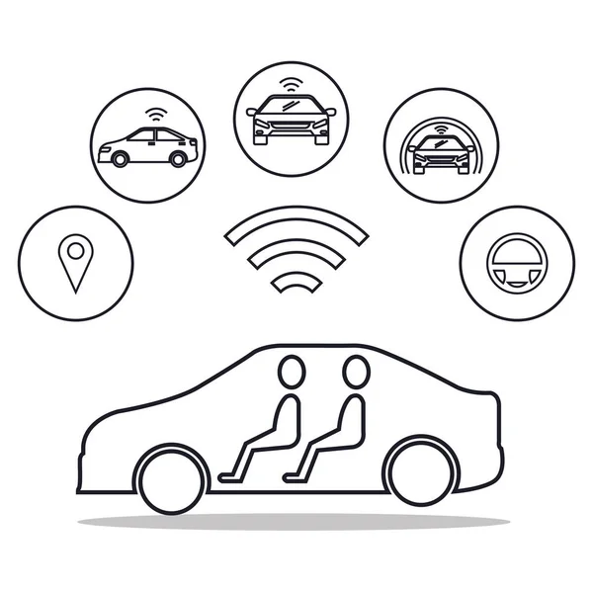

Smart Parking Refers To The Use Of Advanced Technologies And Innovative Solutions To Optimize The Process Of Finding, Reserving And Paying For Parking Spaces. As Urban Areas Continue To Grow, The Demand For Parking Spaces Has Increased Significantly, Leading To Traffic Congestion ,Environmental Pollution And Over All Inefficiency In Urban Transportation Systems. Smart Parking Systems Aim To Address These Challenges By Leveraging Various Technologies To Make Parking Easier, Faster And More Convenient For Both Drivers And Parking Facility Operators.

**Building and development of project:**

**Components required:**

1. **Bread board**

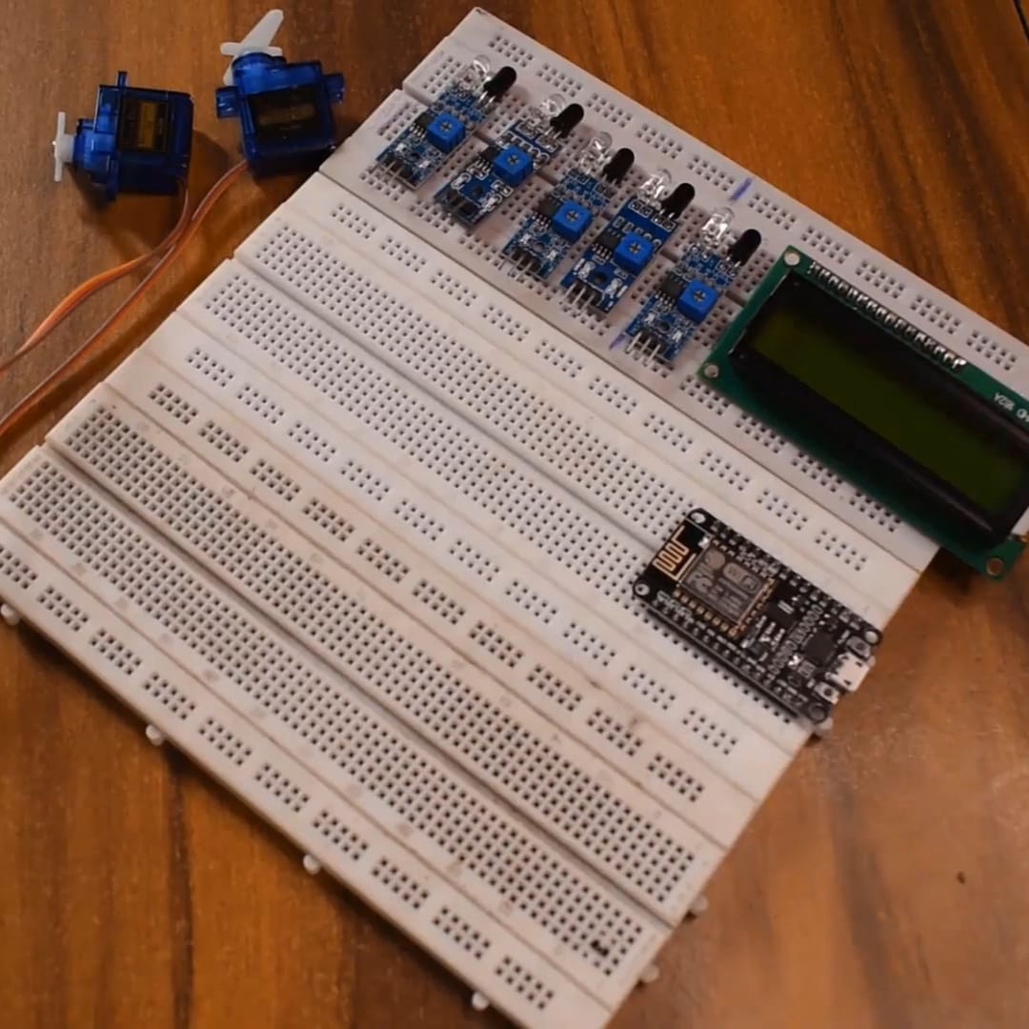

1. **IR sensor**

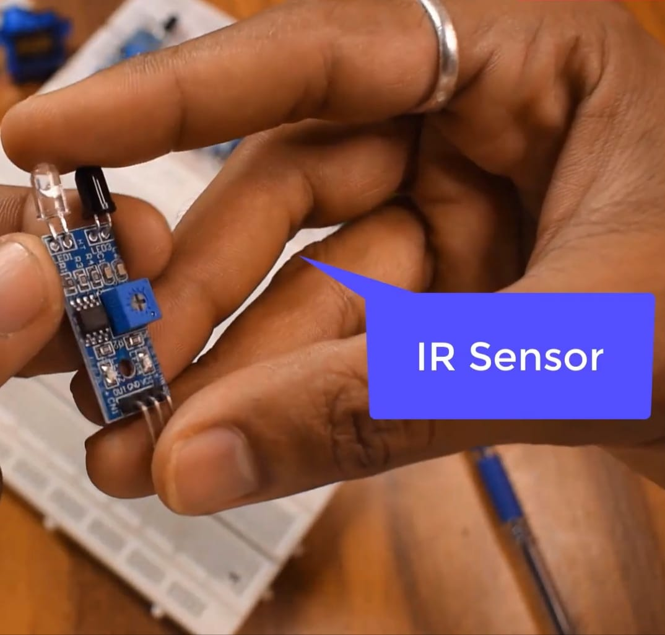

1. **Lcd Display**

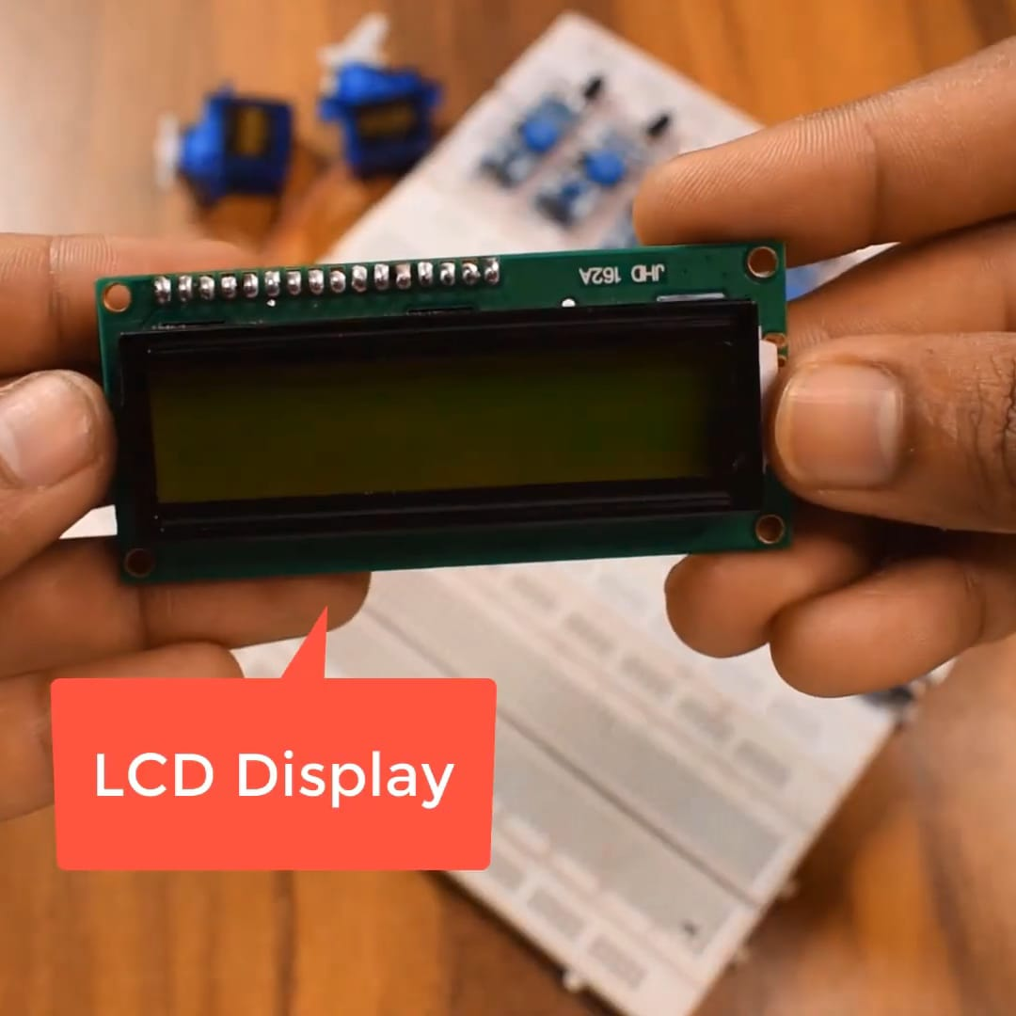

1. **Node MCU**

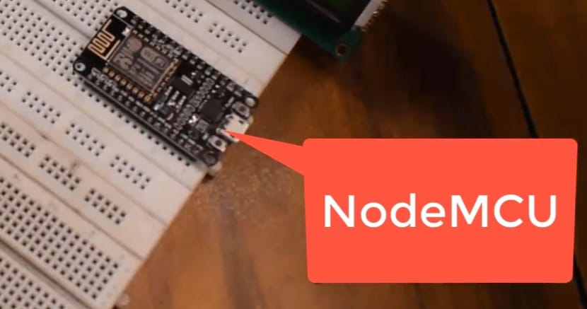

1. **Servo motor**

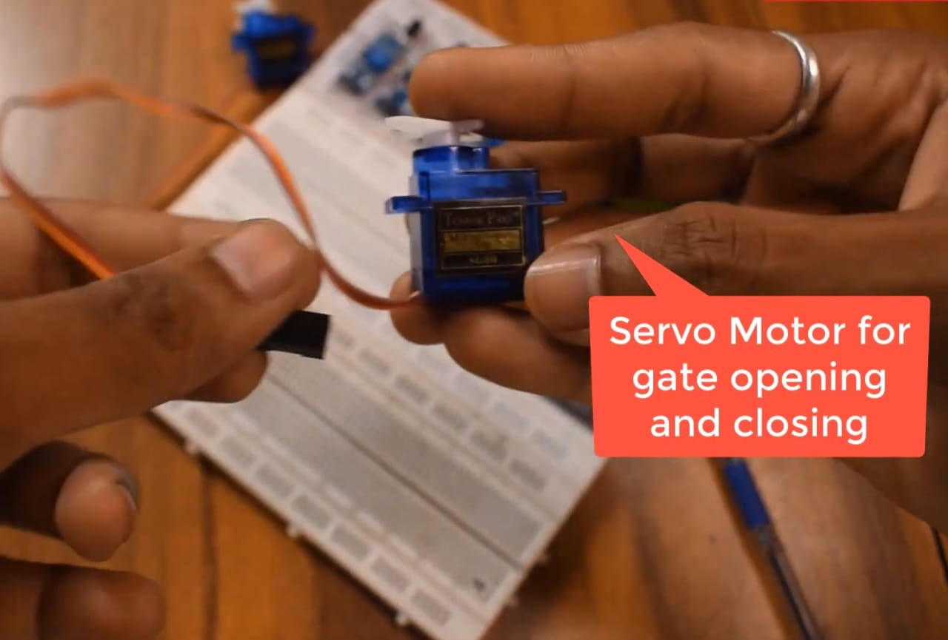

1. **Connecting wires and USB cable**

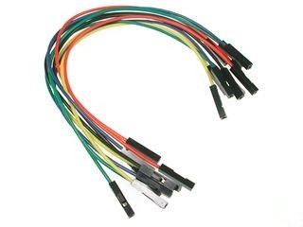

**Placing components on the board:**

**Initial stage**

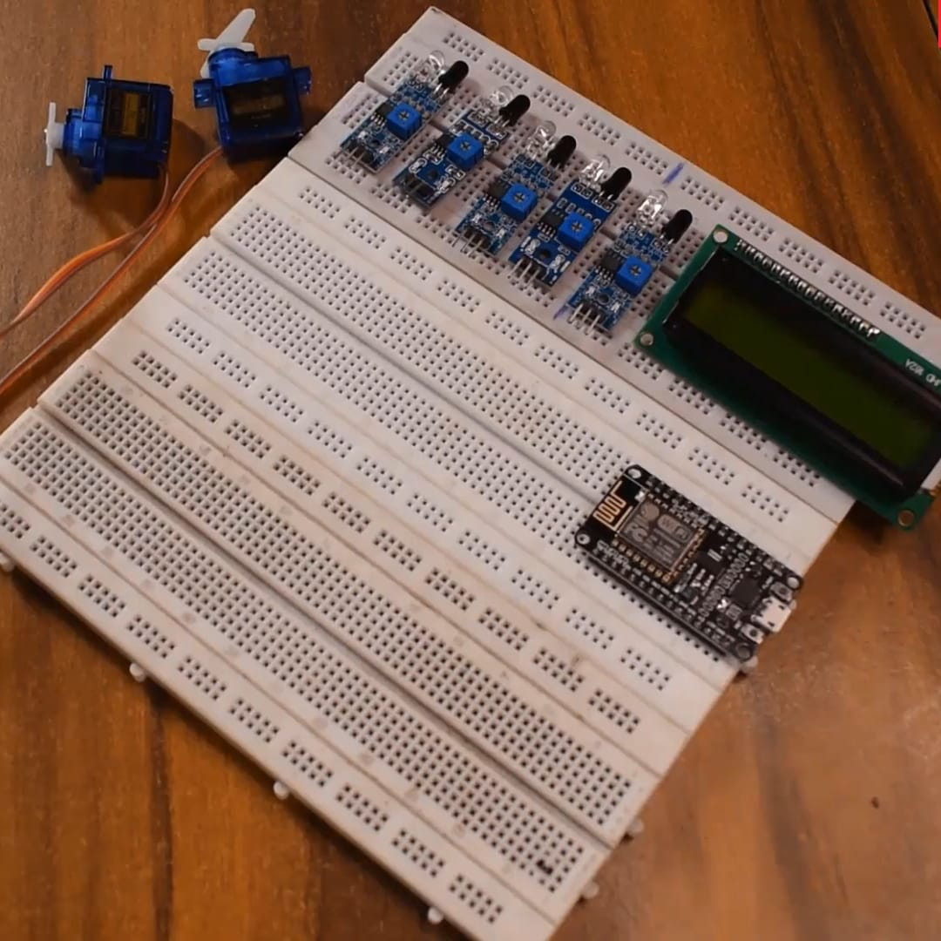

Take all the components for connecting in the bread board to build our project

1. **First , place the Node MCU**

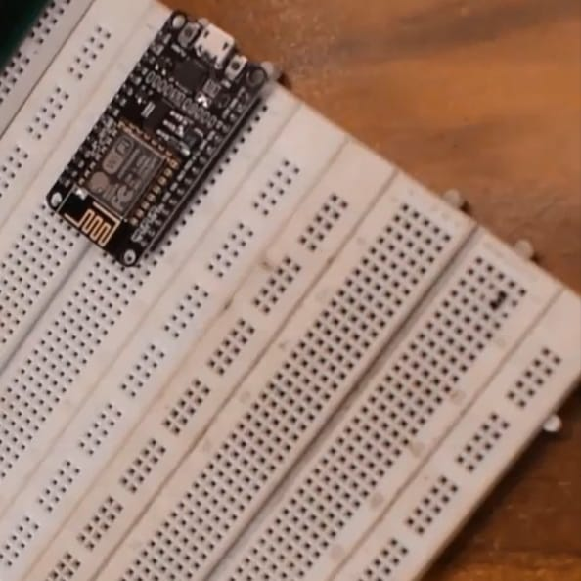

1. **Place the sensors on the board**

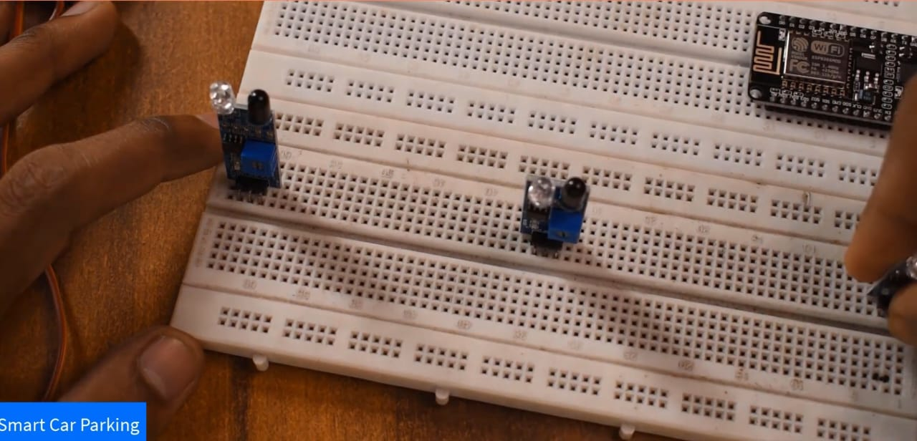

1. **Now ,connect the wires to the corresponding components**

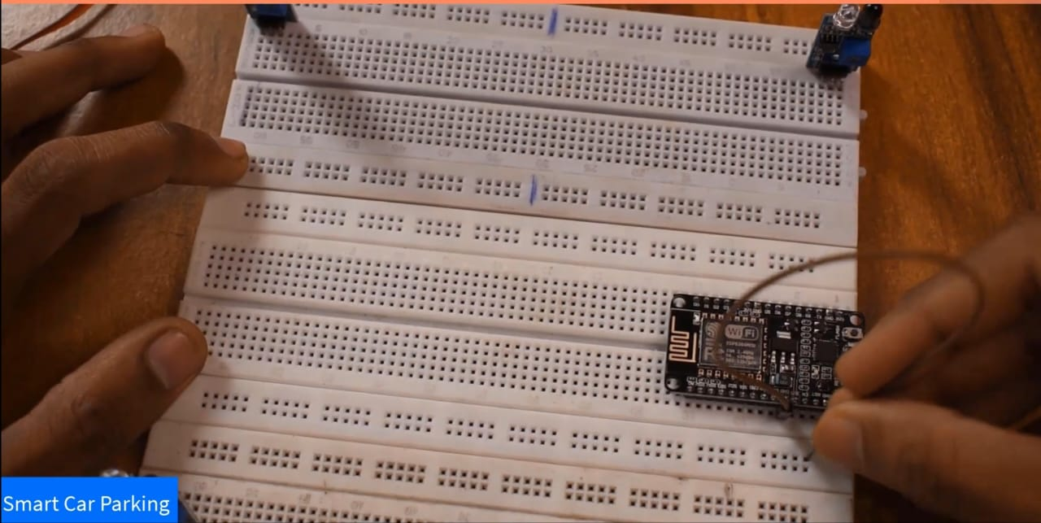

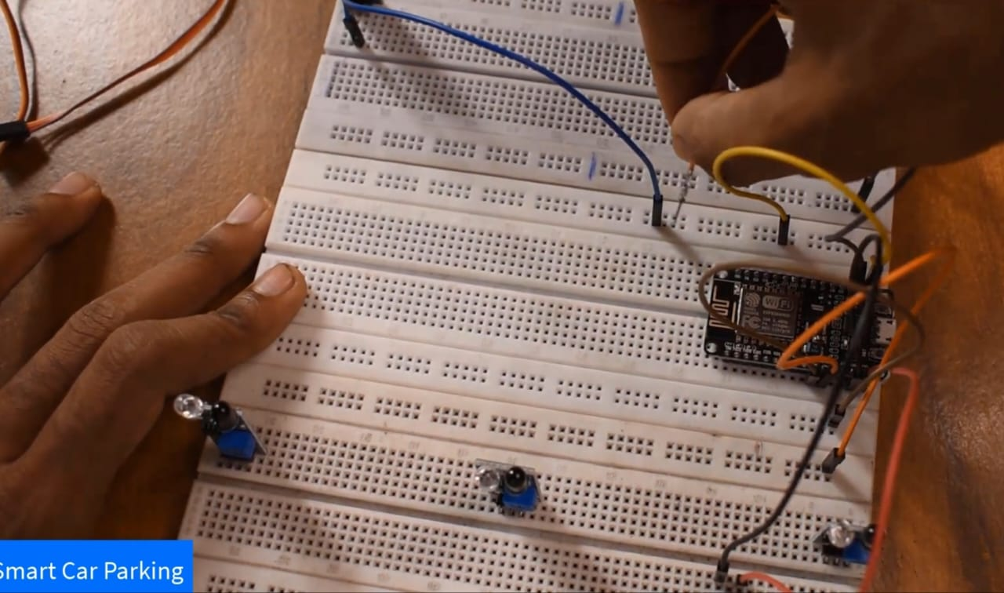

1. **Finally , everything connected successfully**

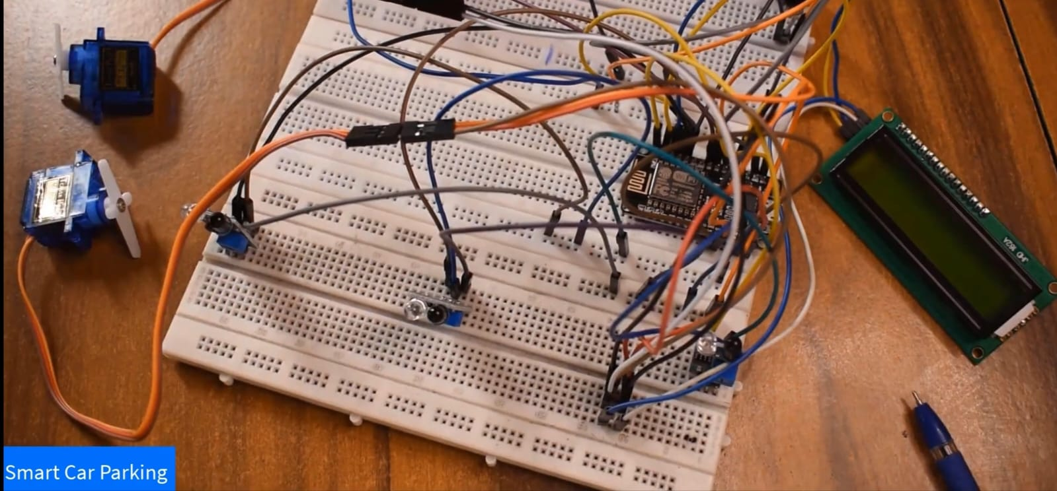

**Connecting NODE MCU to laptop using USB**

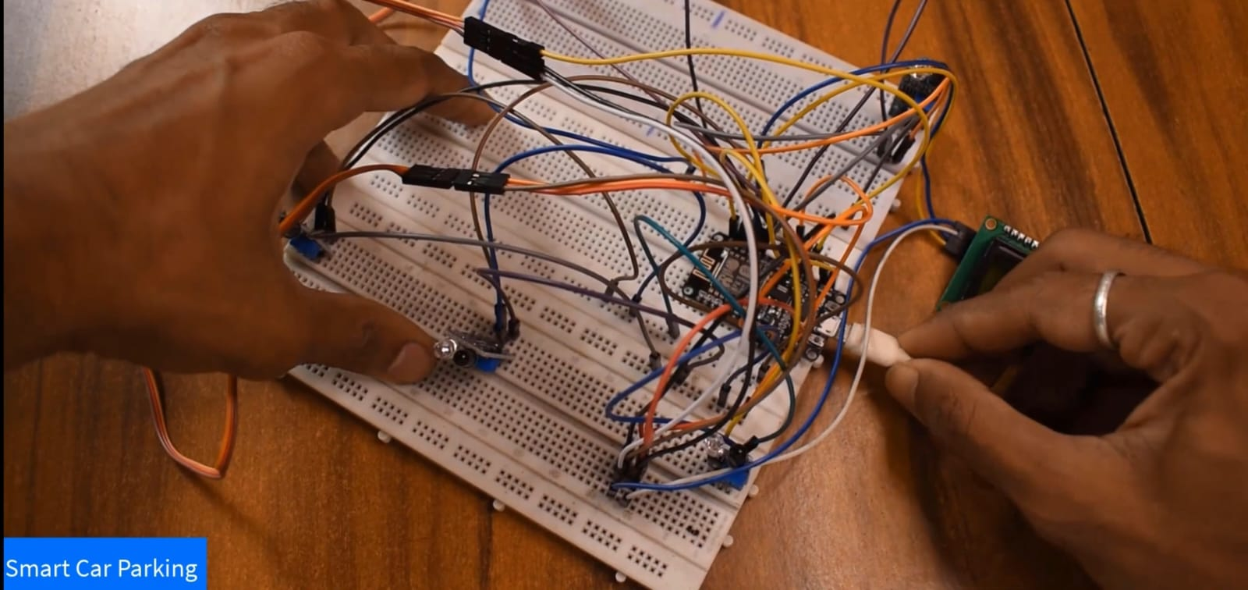

**Now the code is debugged into our Arduino using Arduino ide 1.8.13 software**

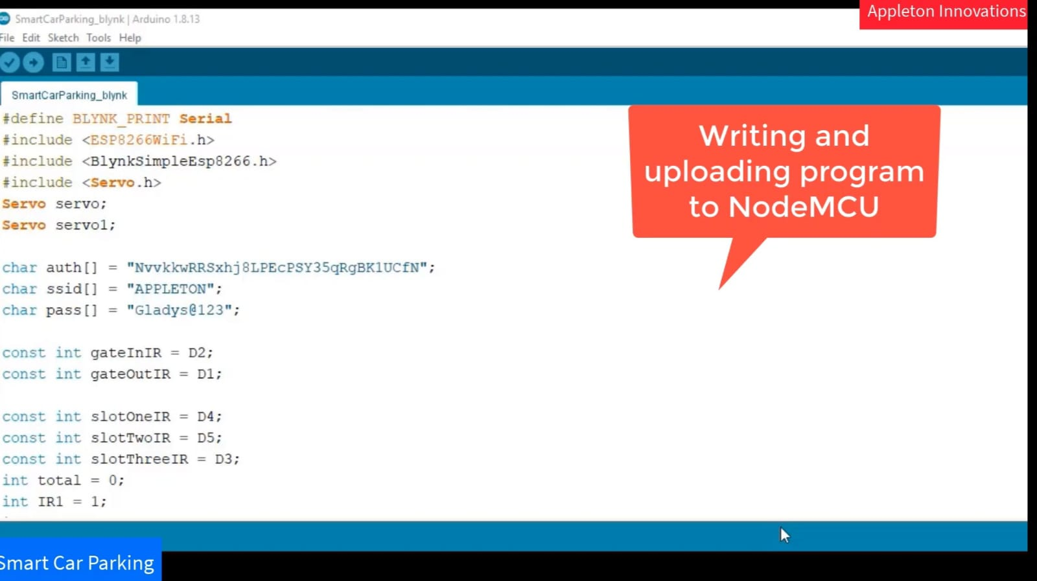

**Coding used …….**

#define BLYNK_PRINT Serial

#include <ESP8266WiFi.h>

#include <BlynkSimpleEsp8266.h>

#include <Servo.h>

Servo servo;

Servo servo1;char auth[] = "NvvkkwRRSxhj8LPECPSY35qRgBK1UCEN";

char ssid[] = "APPLETON";

char pass[] = "Gladys@123";

const int gateInIR = D2;

const int gateOutIR = D1;

const int slotoneIR = D4;

const int slotTwoIR = D5;

const int slotThreeIR = D3;

int total = 0;

int IR1 = 1;

int IR2 = 1;

int IR3 = 1;

BlynkTimer timer:

WidgetLCD lcd (V1);

void setup() {

Serial.begin(9600) I

Blynk.begin (auth, ssid, pass);

pinMode (gateInIR, INPUT);

pinMode (gateOutIR, INPUT);

pinMode(slotoneIR, INPUT);

pinMode (slotTwoIR, INPUT);

pinMode(slotThreeIR, INPUT);

servo.attach (D7);

servol.attach (D8);

timer.setInterval (10000L, carParking);

**FINAL OUTPUT:**

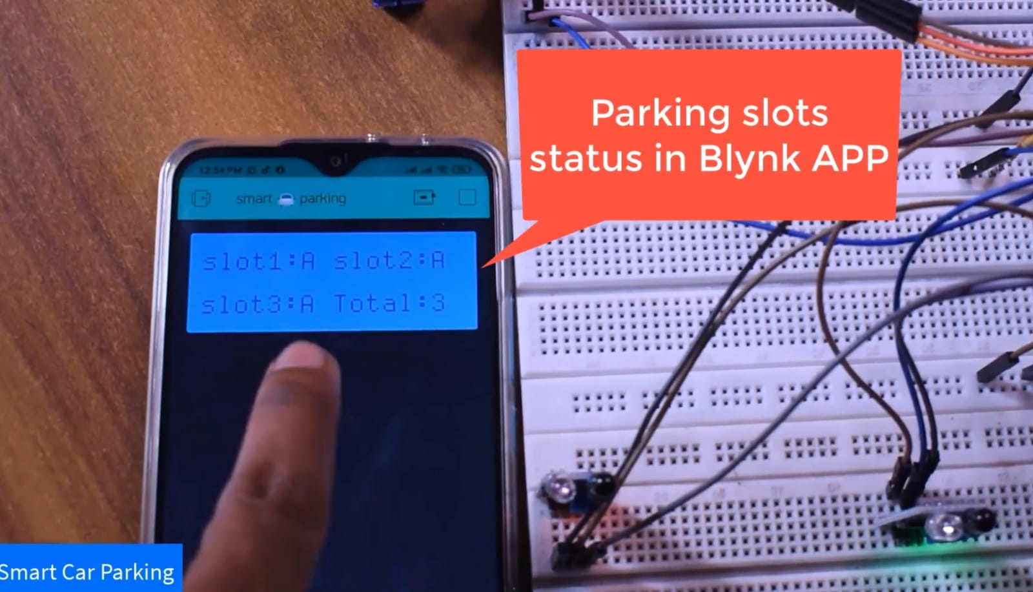

* We made this simple parking system only for 3 cars to be parked.

Here ,initially 3 Slots available which denotes space for parking

A= AVAILABLE

NA=NOT AVAILABLE

Assume each sensor carrying a parking space.

**OUTPUT AFTER SOME TESTING:**

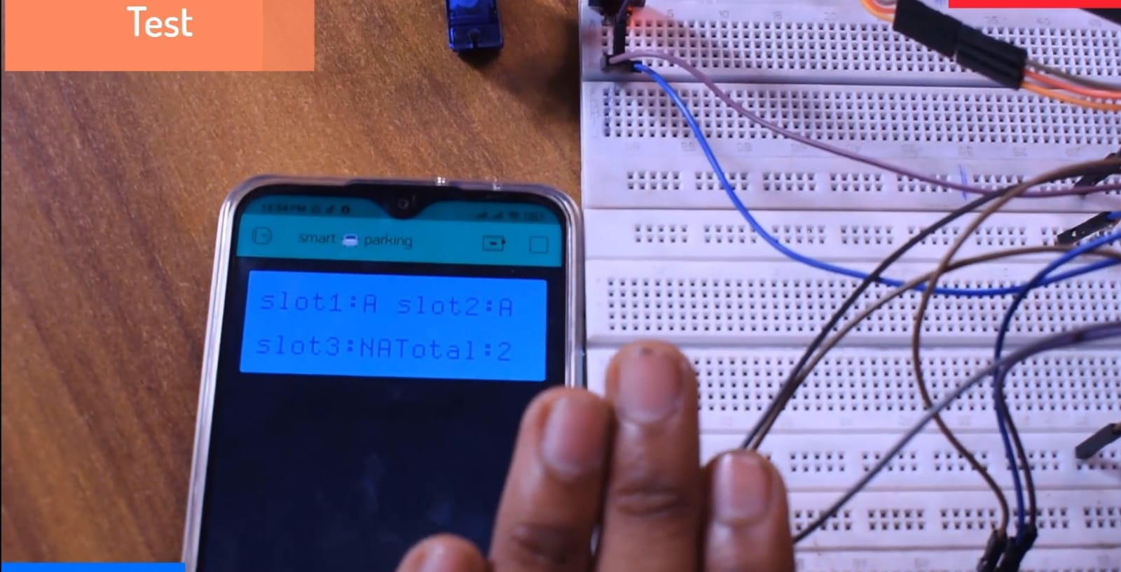

**when the car reaches the sensor 3 which is slot C. Now we got an display**

TOTAL SLOTS AVAILABLE :2

SLOT 3 : NA

**when 2 cars came , Our output will be….**

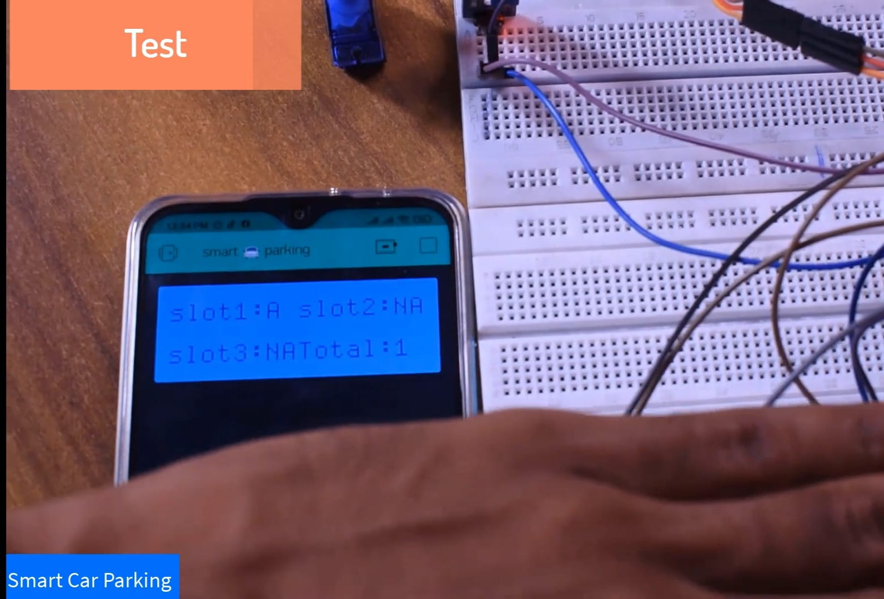

**when 3 cars came , Our output will be….**

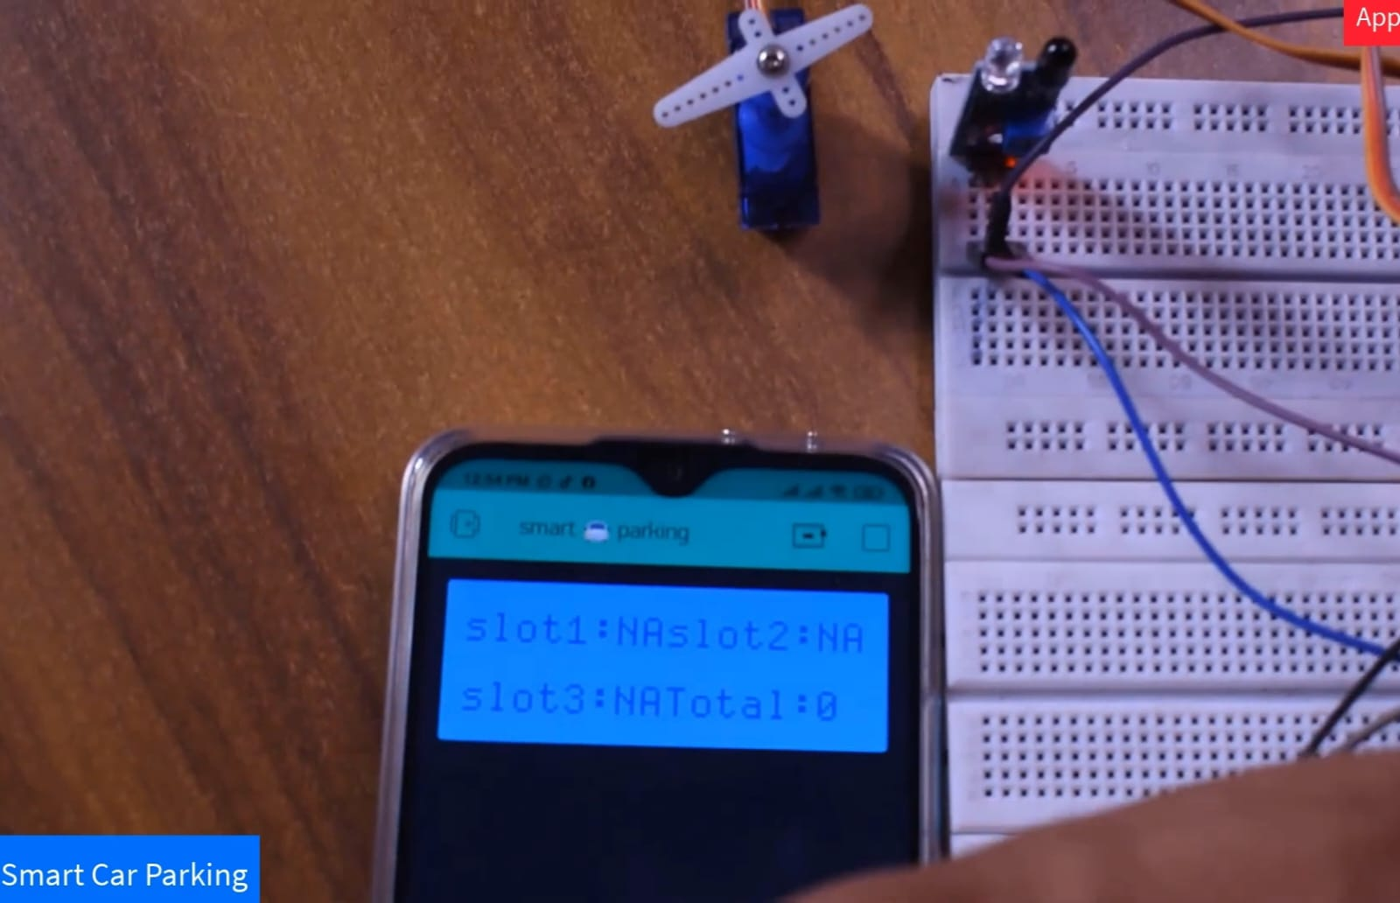

**Conclusion:**

By integrating these modules, the Smart Parking system using IoT offers a comprehensive solution to address the challenges of urban parking, leading to improved efficiency, reduced environmental impact, and enhanced user satisfaction.

Future work:

