**Smart Parking using IOT SYSTEM**

**Submitted by**

**Name : HEMANATHAN S**

**NM ID : au411521106019**

**Phase-4 Development part 2**

## Project : Smart Parking

## IoT based smart parking system

**OBJECTIVE:**

According to phase-4 guidelines, In this section continue building the project by performing different activities like feature engineering, model training, evaluation etc……

**RECAP OF LAST PHASE :**

**kIT:**

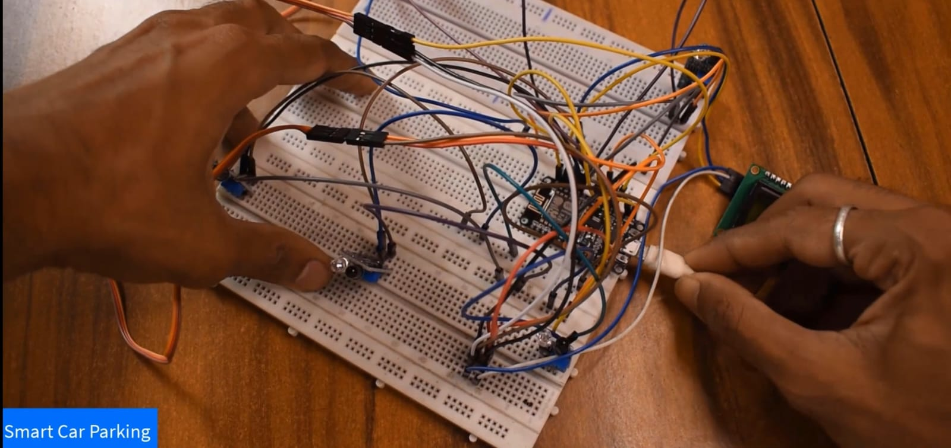

**Mobile app:**

This is our last phase work . In the last phase ,we made our kit for smart parking system by using arduino and we also provided online mobile app authentication.

* **In phase 4 …….**

Now, we are going to develop our project by using feature engineering and we are going to providing real time system of our project.

* **FEATURE ENGINEERING**

Through sensors placed strategically throughout parking lots or garages, the system can detect whether a parking spot is vacant or occupied. This information is then relayed to users in real-time through mobile applications or digital displays, allowing them to quickly locate an available spot.

* **FEATURES OF SMART PARKING SYSTEM :**

One of the main features of smart and automated car parking systems is real-time monitoring. These systems use sensors and cameras to monitor the occupancy of parking spaces in real-time. This allows drivers to quickly find available parking spots without having to circle the parking lot or garage.

* **FEATURES OF IOT BASED CAR PARKING SYSTEM:**

The system detects if parking slots are occupied using IR sensors. Also it uses IR technology to sense if a vehicle has arrived on gate for automated gate opening. The system reads the number of parking slots available and updates data with the cloud server to allow for checking parking slot availability online.

**MAIN OBJECTIVE OF SMART PARKING SYSTEM:**

Smart parking technologies ensure to reduce the number of cars circling around the streets for finding a parking spot. This ultimately smoothens the traffic flow and minimize the search traffic on streets as much as possible.

**Overview of our real time system** **:**

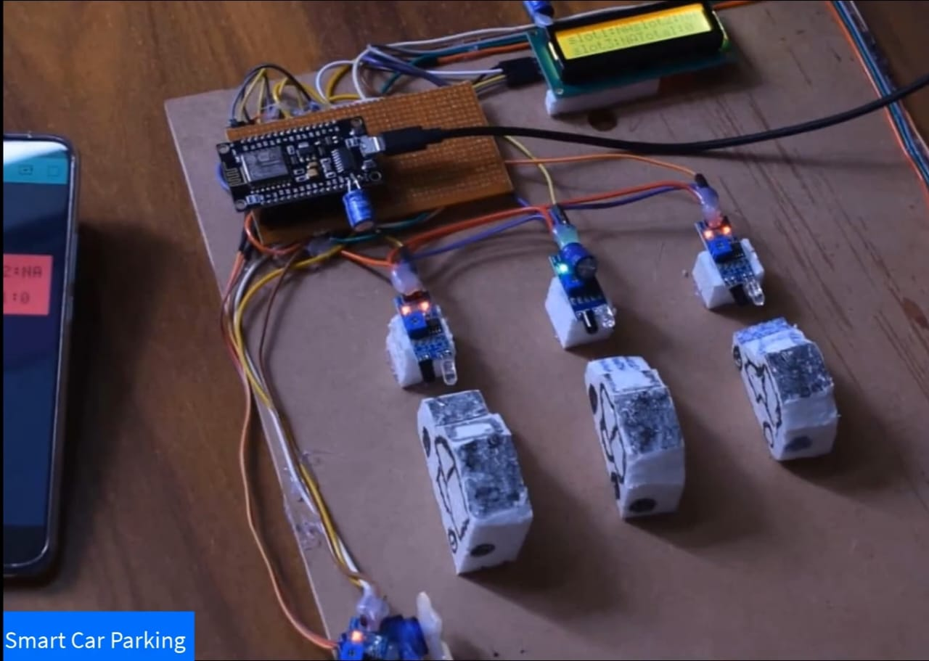

**SPECIFICATIONS :**

* Servo motor is provided for automatic gate opening and closing purpose.

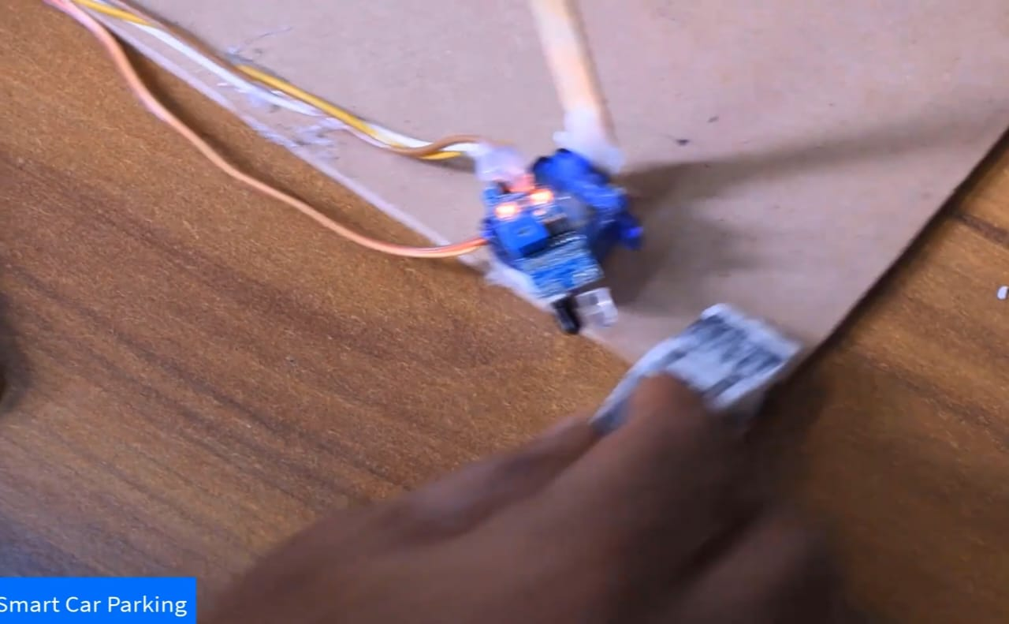

* Sensors are provided for sensing the parking space availability in parking lots and also for sensing cars in gate terminals.

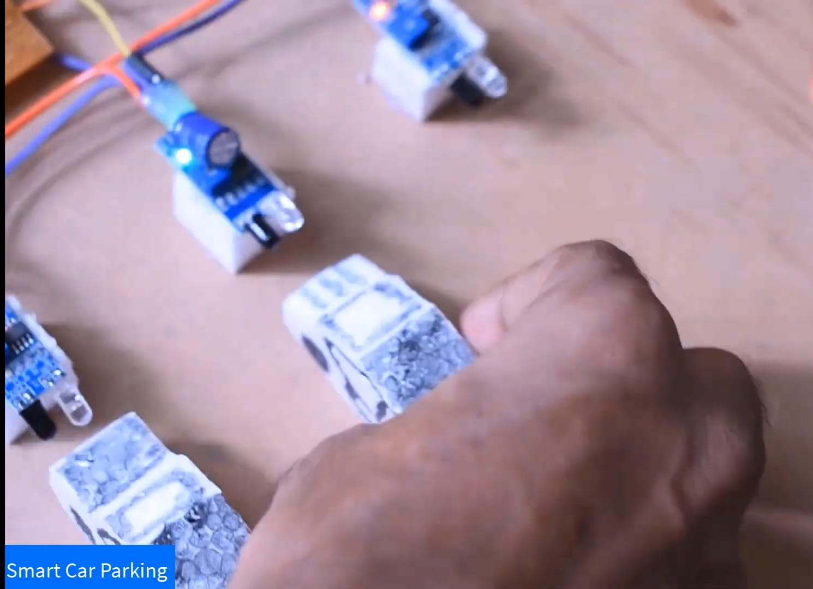

* lcd display is provided for displaying the parking space availability

* Mobile applications are provided for checking the parking space availability from anywhere at anytime.

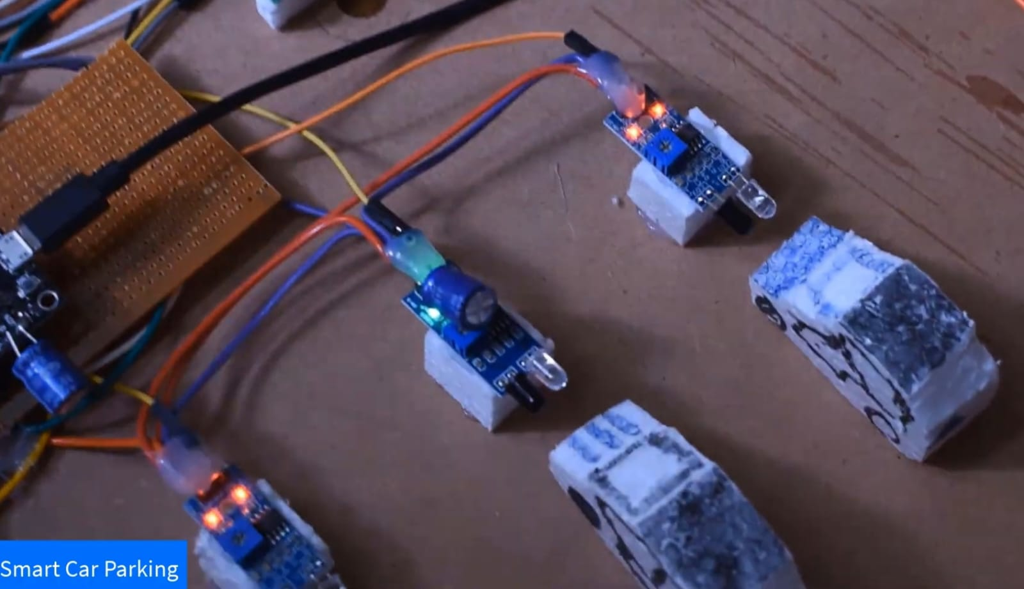

* Screenshot when parking space is full

**Advantages of smart parking system :**

* Optimized parking.
* Reduced traffic.
* Reduced pollution.
* Enhanced User Experience.
* Integrated Payments and POS.
* Increased Safety.
* Real-Time Data and Trend Insight.
* Decreased Management Costs.

**Final project:**

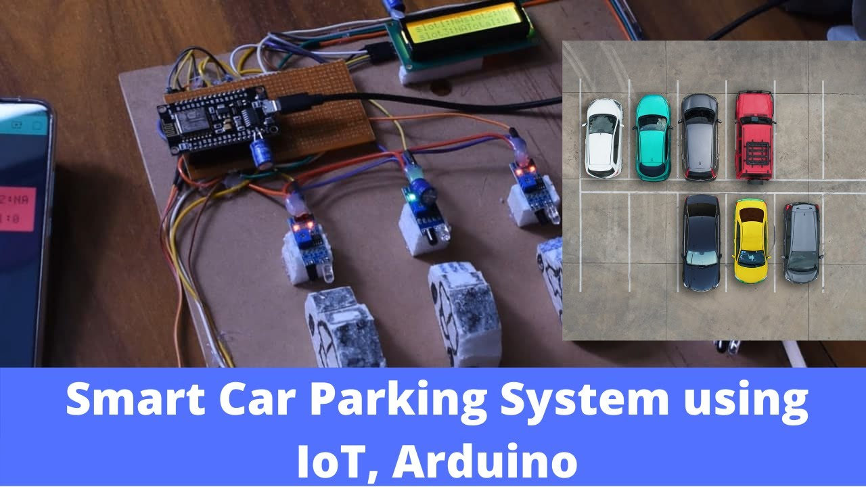

**Conclusion:**

By integrating these modules, the Smart Parking system using IoT offers a comprehensive solution to address the challenges of urban parking, leading to improved efficiency, reduced environmental impact, and enhanced user satisfaction.

**Future scope:**

Using the slot allocation method we can book our own cheapest parking slot.

* THANK YOU