APB_UART Core Verification Plan
Prepared by: Hemang Nagpal

Contents
1. APB_UART Verification Plan 2
1.1 APB_UART Core Features 2
2. APB_UART Block Diagram 3
3. Details of UVM Testbench Integration 4
3.1 apb_uart_tb_top 4
3.2 apb_uart_base_test 5
3.3 apb_uart_top_env 5
3.4 apb_uart_virtual_sequencer 5
3.5 apb_uart_reg_block 5
3.6 apb_uart_scoreboard 5
3.7 apb_uart_env 5
3.8 apb_uart_agent 6
3.9 apb_uart_monitor 6
3.10 apb_uart_driver 6
3.11 apb_uart_sequencer 6
3.12 apb_uart_seq_item 6
4. APB_UART Testcases/sequences 6

1. APB_UART Verification Plan

1.1 APB_UART Core Features
- Compliance with AMBA APB Specification for SoC integration.
- APB slave interface for register access.
- Separate 32×8 Transmit FIFO.
- Separate 32×12 Receive FIFO.
- Programmable FIFO enable/disable mode.
- Integer and Fractional Baud Rate Generator.
- UART transmitter functionality.
- UART receiver functionality.
- Configurable word length (5/6/7/8 bits).
- Configurable parity generation and checking.
- Configurable stop bit generation.
- Break generation support.
- Internal loopback mode.
- TX FIFO interrupt generation.
- RX FIFO interrupt generation.
- Receive timeout interrupt generation.
- Error interrupt generation.
- Interrupt masking and interrupt clearing.
- Error detection:
  - Overrun Error (OE)
  - Framing Error (FE)
  - Parity Error (PE)
  - Break Error (BE)

2. APB_UART Block Diagram

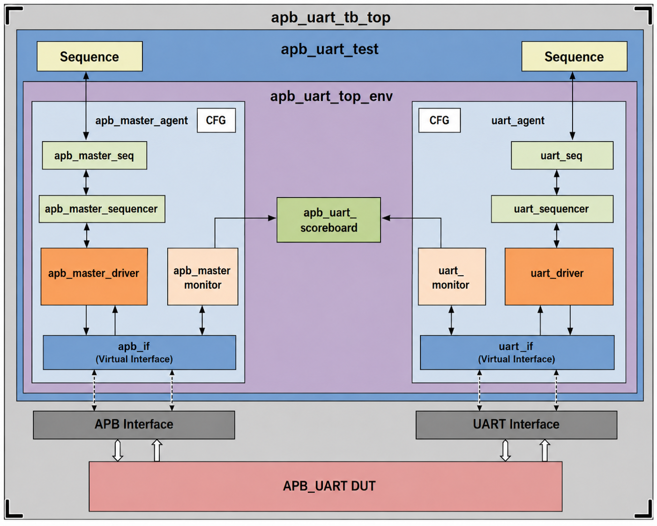

Fig1. Block Diagram

3. Details of UVM Testbench Integration

3.1 apb_uart_tb_top
- Include packages for UVM, APB Master and UART.
- Instantiated interface for APB Master and UART.
- DUT instantiation and its connection with interface.
- Pass interface to the respective VIP.

3.2 apb_uart_base_test
- Instantiate top level environment(apb_uart_top_env) and configuration object.
- Update the configuration field as per testcase requirement.
- Print the uvm_topology().

3.3 apb_uart_top_env
- Instantiation of APB Master VIP env, APB_UART env, Virtual sequencer, reference model, scoreboard, and RAL Model (apb_uart_adapter, apb_uart_reg_block), predictor.
- Passing the configuration to the component below.
- Connection between RAL Model (apb_uart_reg_block, apb_uart_predictor), coverage model, checkers, and reference model.

3.4 apb_uart_virtual_sequencer
- All test case sequences will be executed through the virtual sequencer.
- Installation of the APB Master VIP sequencer, which will be connected to the APB Master VIP driver.
- Installation of the APB_UART sequencer, which will be connected to the APB_UART driver.

3.5 apb_uart_reg_block
- It contains the registers, register fields, and offset information for each register in the APB_UART block.
- The mirror () function will be called for data checking purposes and updates will be reflected in both the DUT and the RAL model.

3.6 apb_uart_scoreboard
- Retrieve the expected data from the APB Master VIP interface and apb_uart_reference_model.
- Capture the actual data from the apb_uart_monitor.
- Perform the data integrity to compare the expected and actual data value.

3.7 apb_uart_env
- The apb_uart_env for the UART includes an instantiation of the apb_uart_agent and configuration object.
- Set the configuration.

3.8 apb_uart_agent
- The apb_uart_agent includes the uart_driver, apb_uart_sequencer, apb_uart_monitor and configuration objects.
- The apb_uart_agent is set to active mode.

3.9 apb_uart_monitor
- Get the values of all registers and UART interface signals and put them into a sequence item.
- Send the sequence item to the scoreboard for data integrity checking.
- Send the same sequence item to the coverage collector for functional coverage sampling.

3.10 apb_uart_driver
- Generate APB_UART transactions based on the sequence item.
- Drive UART transmit and receive stimulus to the DUT.
- Support constrained-random traffic generation for Coverage Driven Verification.

3.11 apb_uart_sequencer
- Controls the execution of APB_UART sequences.
- Supports directed and constrained-random stimulus generation.

3.12 apb_uart_seq_item
- It includes all the register data fields required for both coverage and expected data generation.

4. APB_UART Testcases/sequences
- Refer to the APB_UART_Test_Plan.xlsx for the list of available testcases and sequence details.

