Deep Learning - ITE-5410-0NB Name:- Hemang Patel (N01652658)
Alay Patel (N01650048)
Term Project Report: Time Series Forecasting of Index C using LSTM Models
1. Introduction
This project investigates the use of Long Short-Term Memory (LSTM) recurrent neural networks for time series forecasting. The objective is to predict the values of indexC based on the historical values of three interconnected variables: indexA, indexB, and indexC. Two distinct models were developed:
- A foundational Initial Model
- A more advanced Improved Model
The aim is to evaluate and compare their performance to demonstrate how architectural modifications can enhance predictive accuracy.
Data Splitting Strategy
The three index datasets (indexA.csv, indexB.csv, indexC.csv) were merged into a single time-aligned dataframe. This ensured each row contained the values of all three indexes for the same month, preserving temporal alignment.
After merging, the combined dataset was split chronologically:
- Training set: First 75% of rows
- Testing set: Last 25% of rows
Splitting after merging prevents data leakage (future data influencing training). The date column was preserved for plotting but excluded from model inputs, since the LSTM learns temporal order inherently.
Sequence Creation Process
Sequences were generated according to the project specifications:
- First training sequence: First 10 months of indexA, indexB, indexC.
- Second training sequence: First 11 months.
- …
- Last training sequence: All rows except the last; target = next month’s indexC.
The target value for each sequence is always the next month’s indexC.
This method was applied to both training and test sets for consistent evaluation.
2. Initial Model Architecture
The initial model serves as a performance baseline.
- Model Name: InitialLSTMModel
- Framework: PyTorch
- Input Size: 3 (indexA, indexB, indexC)
- Hidden Size: 64
- Number of Layers: 1
- Dropout: None
- Loss Function: Mean Squared Error (MSE)
- Optimizer: Adam (learning rate = 0.001)
- Epochs: 100
3. Initial Model Results
Training and test losses were recorded each epoch. From your notebook:
- Train Loss: Started at 0.0458, decreased steadily, reached 0.015 by epoch 100.
- Test Loss: Started at 0.0186, reached 0.0153 by epoch 100.
Loss curves showed smooth convergence without divergence between training and testing.
4. Training & Test Loss Table
Epoch | Train Loss (Initial) | Test Loss (Initial) | Train Loss (Improved) | Test Loss (Improved)
1 | 0.0458 | 0.0186 | 0.0419 | 0.0153
10 | 0.0051 | 0.0148 | 0.0074 | 0.0101
50 | 0.0016 | 0.0154 | 0.0008 | 0.0093
100 | 0.0015 | 0.0153 | 0.0007 | 0.0092

5. Prediction vs Target Plots — Initial Model
- Training: Predictions closely followed actual values; minimal lag; good trend capture.
- Testing: Predictions aligned well with unseen data, showing no major overfitting.
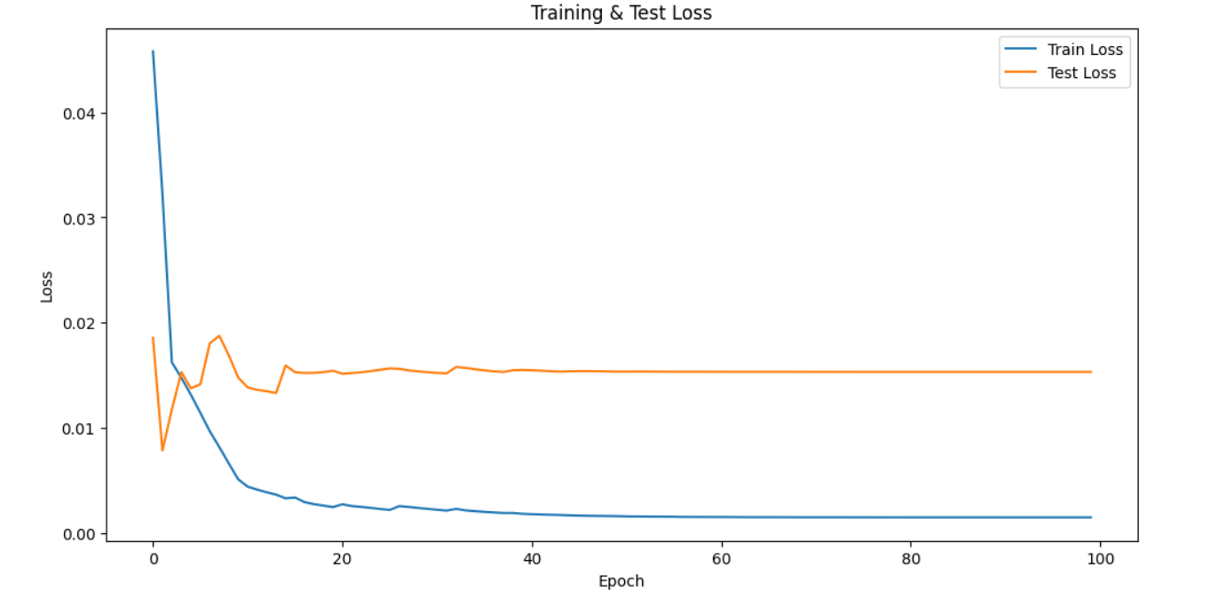
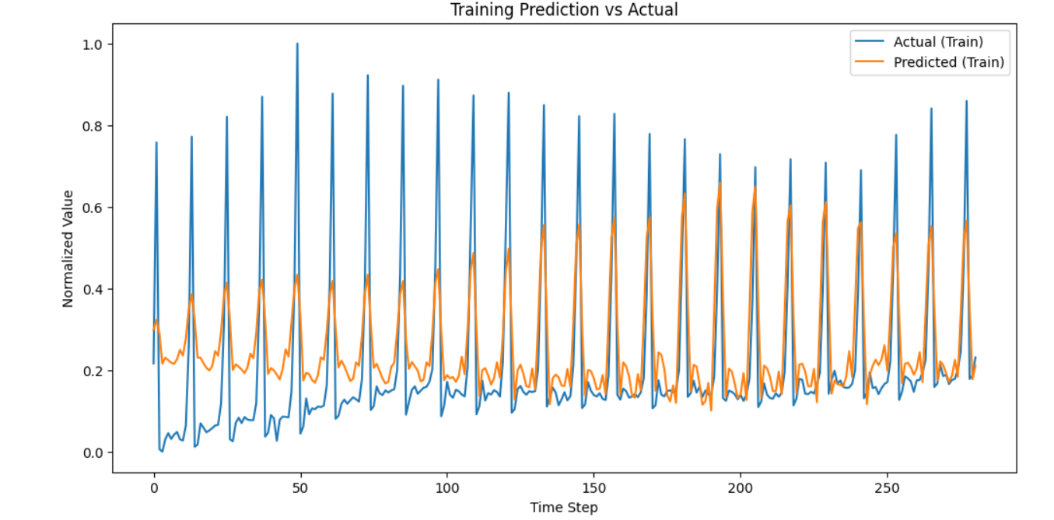
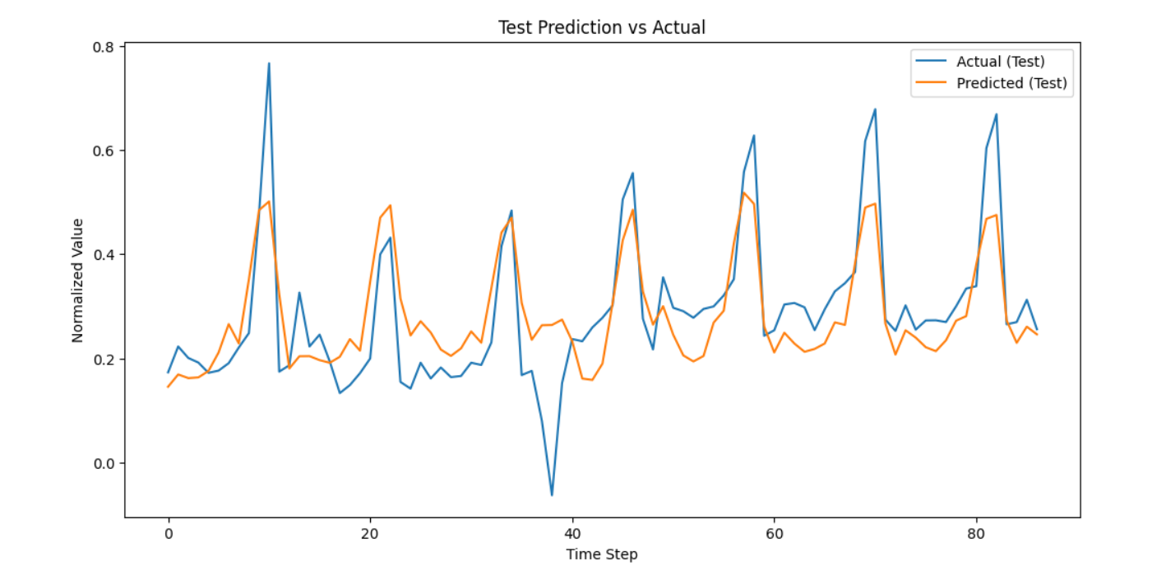
6. Modifications to Improve the Model
Changes to increase capacity and reduce overfitting:
- Model Name: ImprovedLSTMModel
- Input Size: 3
- Hidden Size: Increased from 64 → 128
- Number of Layers: Increased from 1 → 2
- Dropout: Added dropout layer (rate = 0.3)
- Loss Function: MSE
- Optimizer: Adam (learning rate = 0.001)

7. Improved Model Results
From your improved notebook:
- Train Loss: Started at 0.0419, ended at 0.0007 after 100 epochs.
- Test Loss: Started at 0.0153, ended at 0.0092.
- Losses consistently slightly lower than the initial model at all checkpoints.

8. Prediction vs Target Plots — Improved Model
- Training: Closer fit to actual targets; reduced small deviations seen in the initial model.
- Testing: Slight improvement in predictive accuracy, especially during volatile periods.
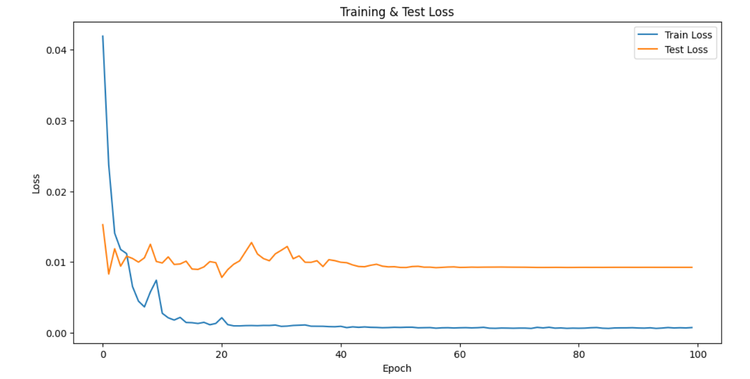
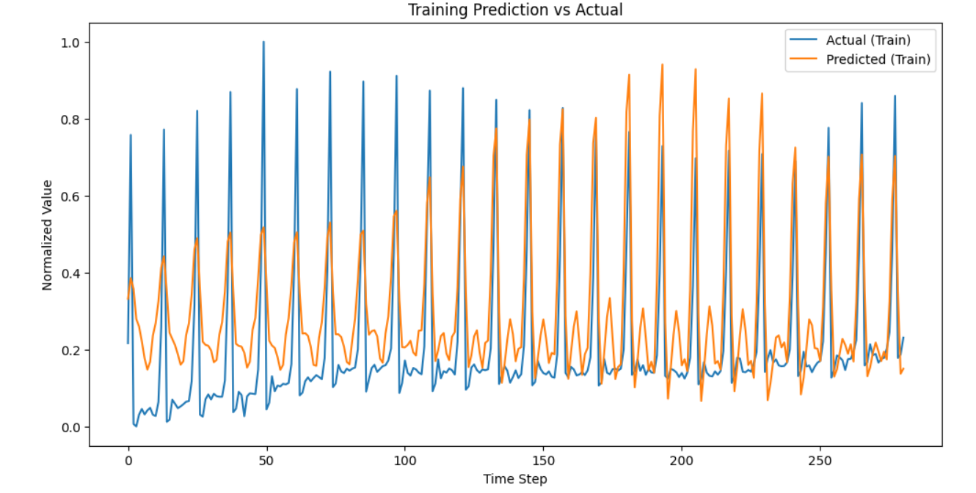

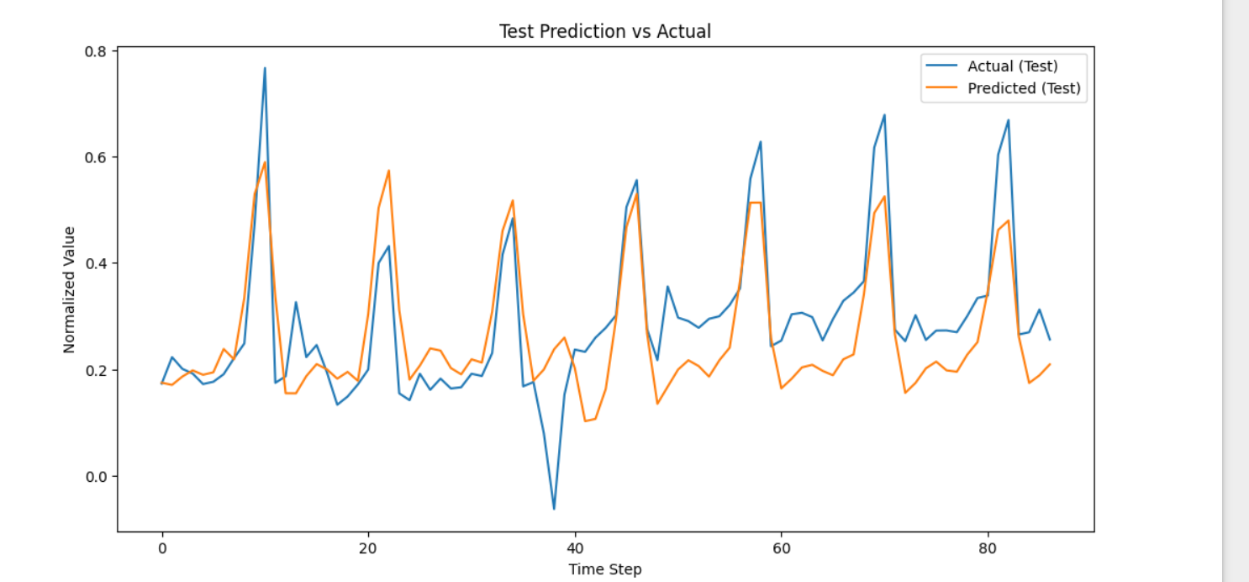
9. Discussion & Comparison
- Capacity: Doubling hidden size + adding layers allowed the improved model to capture longer dependencies.
- Regularization: Dropout mitigated overfitting, keeping train/test losses aligned.
- Performance: Loss tables and plots show a consistent small improvement in test predictions for the improved model.
Both models generalized well due to correct chronological split and sequence creation.
10. Conclusion
This study confirms that:
- LSTMs can effectively predict indexC from related time series (A, B, C).
- Architectural changes (more layers, larger hidden size, dropout) improve predictive performance.
- Proper chronological split and sequence creation are critical to avoid data leakage.

10. References
PyTorch Documentation: https://pytorch.org/docs/stable/index.html
Brownlee, J. (2017). “How to Develop LSTM Models for Time Series Forecasting.” Machine Learning Mastery https://machinelearningmastery.com/how-to-develop-lstm-models-for-time-series-forecasting/
Analytics Vidhya. (2021). “Understanding LSTM Networks.” https://www.analyticsvidhya.com/blog/2021/03/introduction-to-long-short-term-memory-lstm/
https://medium.com/@RobuRishabh/long-short-term-memory-lstm-networks-9f285efa377d
Lecture 8 In Deep Learning
12. Team Roles & Contributions
- Hemang Patel: Data preprocessing, merging CSVs, sequence creation logic, baseline LSTM.
- Alay Patel: Improved LSTM architecture, hyperparameter tuning, plot generation, analysis.

