Walmart Sales Performance Dashboard
Using Microsoft Power BI
Project Report
Submitted by: Hemani Rajesh
Tool used: Microsoft Power BI Desktop

1. Introduction
This project documentation presents a comprehensive operational analysis of retail revenue, volume, and seasonal trends using the Walmart Sales Performance Dashboard. Built within Microsoft Power BI Desktop, the interactive reporting interface enables stakeholders to monitor overall financial health, assess store efficiency, evaluate end-of-year revenue spikes, and analyze macro-environmental impacts on sales performance.

2. Objectives
- Monitor high-level Key Performance Indicators (KPIs) across sales volume, average weekly revenue, and total transaction counts.
- Benchmark individual store locations using store-wise total and average weekly performance comparisons.
- Track historical revenue velocity to pinpoint predictable seasonal demand surges.
- Analyze macro-economic variables (such as fuel price variations) against weekly sales performance.
- Evaluate the overall revenue contribution of holiday periods versus standard non-holiday operating weeks.

3. Dataset Description
The underlying dataset consists of historical store-level sales records spanning from early 2010 to late 2012. Key data fields modeled within the dashboard include:
- Store: Unique numerical identifier for individual retail store locations.
- Date: Weekly transaction timeframe spanning 05-02-2010 to 26-10-2012.
- Weekly_Sales: Aggregated revenue recorded for a given week per store.
- Fuel_Price: Regional cost per gallon of fuel during the corresponding week.
- Holiday_Flag: Binary indicator distinguishing official holiday weeks from standard weeks.

4. Data Preparation
- Data Cleaning & Type Casting: Standardized dates into uniform date data types and formatted monetary fields (Weekly_Sales, Fuel_Price) to decimal numeric values.
- Data Aggregation: Summarized weekly total sales, established store-level averages, and calculated aggregate transaction counts.
- Categorical Mapping: Converted binary Holiday_Flag integers into readable categorical text labels (HOLIDAY and NON-HOLIDAY) for slicer integration.

5. DAX Measures Used
Key measures built in Power BI Desktop to drive the KPI indicators and visual calculations:
- Total Weekly Sales:
Total Weekly Sales = SUM(Sales[Weekly_Sales])
- Average Weekly Sales:
Average Weekly Sales = AVERAGE(Sales[Weekly_Sales])
- Transaction Count:
Transaction Count = COUNT(Sales[Weekly_Sales])
- Holiday Sales Percentage:
Holiday Sales % = DIVIDE(CALCULATE(SUM(Sales[Weekly_Sales]), Sales[Holiday_Flag] = 1), SUM(Sales[Weekly_Sales]))

6. Dashboard Components
- Top Executive KPI Cards: Total Weekly Sales: $6.73bn | Average Weekly Sales: $1.05M | Transaction Count: 6K
- Store Wise Total Weekly Sales: Clustered column chart illustrating total accumulated revenue broken down across store IDs (1 through 45).
- Weekly Sales Trend: Historical line chart displaying temporal fluctuations, highlighting sharp annual revenue spikes.
- Average Weekly Sales by Store: Horizontal bar chart evaluating mean performance per location to isolate top-performing stores.
- Fuel Price vs Weekly Sales: Scatter plot mapping weekly sales density relative to fluctuating fuel prices ($2.00 to $4.00+).
- Holiday vs Non-Holiday Sales: Donut chart detailing revenue volume breakdown: 93.01% (138K share) for non-Holiday weeks vs. 6.99% (10K share) for Holiday weeks.
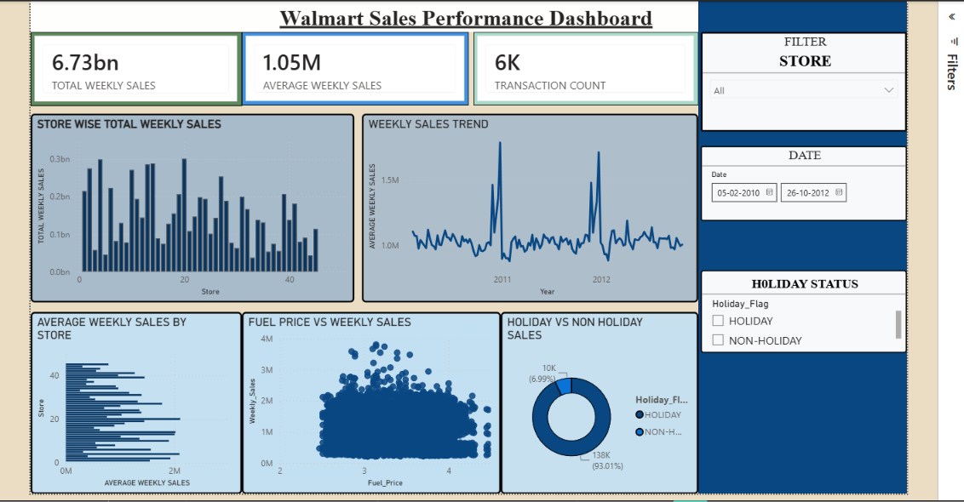

7. Slicers Used
- Store Filter: Dropdown visual filtering data by specific store numbers (default set to All).
- Date Range Slicer: Interactive date boundary slider allowing time-range filtering from 05-02-2010 to 26-10-2012.
- Holiday Status Slicer: Multi-select panel filtering views between HOLIDAY and NON-HOLIDAY flags.
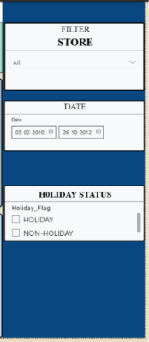

8. Key Findings
- Overall Volume: Cumulative total revenue reached $6.73bn across all stores with a mean weekly output of $1.05M.
- Seasonal Demand Spikes: Revenue trendlines demonstrate prominent surges during Q4 of each year, coinciding with major end-of-year holiday periods (Thanksgiving and Christmas).
- Holiday Revenue Dynamics: Designated holiday weeks account for 6.99% of transaction volume, showing substantial short-term demand intensification given the small number of holiday weeks in a year.
- Fuel Cost Resiliency: Sales density remains tightly clustered between $1M and $3M across varying fuel price points ($2.50–$4.00), showing that consumer spending at Walmart remained resilient to fuel price inflation during this period.

9. Conclusion
The Walmart Sales Performance Dashboard successfully streamlines multi-store operations data into actionable strategic insights. Based on the analysis, supply chain management should focus on stocking and logistics ramp-ups prior to Q4 to accommodate predictable holiday surges. Additionally, performance variances across store IDs indicate an opportunity to optimize inventory distribution based on historical store-level demand profiles.

