Wholesale trading and business accounts analysis
PREPARED BY:
HEMANI RAJESH
E25FA011
B.COM (FINTECH WITH AI)
1. Introduction
The Wholesale Trading & Business Accounts Analysis Power BI dashboard provides a centralized, interactive view of commercial operations, sales performance, product profitability, and customer receivables. By integrating transactional sales, returns, discounting, and payment collection data across two dedicated report pages, the dashboard enables stakeholders to monitor revenue health, evaluate product category performance, and track cash inflows across customer segments and regions.

2. Objectives
- Evaluate Overall Financial Performance: Track top-line net sales, gross profit, gross profit margins, and total invoice volume.
- Analyse Product & Discount Efficiency: Identify top-performing categories, subcategories, and individual SKUs while assessing the impact of discounts on revenue.
- Monitor Accounts Receivable & Collections: Compare total sales against actual payment collections to evaluate cash conversion and payment method preferences.
- Investigate Sales Returns: Quantify return amounts and pinpoint primary root causes (e.g., damaged goods, wrong items) to minimize revenue leakage.
- Segment Customer & Regional Demand: Break down revenue contributions across geographic regions and customer types (Wholesalers, Retailers, Small Businesses, Institutions).

3. Dataset Description
The underlying data model represents a B2B wholesale trading environment structured around sales, product, customer, and financial transactions:

- DIM BRANCH – Average invoice value, branch ID, branch name, City ID, unique customer
- DIM CITY – City ID, City name, State ID
- DIM CUSTOMER – Customer name, Credit terms, City ID, Customer type, Customer ID
- DIM DATE – date key ID, full date, month, month name, quarter, weekday,year
- DIM PRODUCT – Product name, product ID, Subcategory, Category, unit cost
- DIM REGION – Region ID, region name
- DIM SALESPERSON – Branch ID, designation, salesperson ID, salesperson name
- DIM STATE – Region ID, State ID, State name
- Fact Invoice lines – Cost of goods sold, gross profit, invoice id, product id, gross amount, discount amount
- FACT INVOICE – invoice id, invoice amount, invoice date, total invoice, gross sales, customer id
- FACT PAYMENTS – Payment methods, payment amount, Outstanding receivable

4. Data Preparation
To support multi-page reporting and relational filtering across visuals, the dataset underwent standard Power BI ETL (Extract, Transform, Load) preparation:

- Data Modeling: Structured into a star/snowflake schema connecting fact tables (Sales, Returns, Payments) with dimension tables (Customers, Products, Regions, Calendar/Month).
- Data Type Standardization: Formatted currency fields (net_sales, return_amount, payment_amount), integer fields (MONTH 1–12), and categorical text fields (category, region_name, payment_method).
- Data Quality Note (Unmatched Records): Blank values ((Blank)) appear in customer_type, customer_name, and month_name visuals, indicating orphan fact records or missing lookup keys that should be resolved via referential integrity checks in Power Query.

5. DAX Measures Used
The KPI cards and visual aggregations rely on explicit DAX measures to ensure consistent calculations across slicers:

- TOTAL SALES: Sum of net sales across all transactions: SUM(Sales[net_sales]) (Displayed Value: 136M) .
- GROSS PROFIT: Total profit after cost of goods sold: [TOTAL SALES] - SUM(Sales[cost]) (Displayed Value: 26.16M) .
- GROSS PROFIT MARGIN: Ratio of gross profit to total sales: DIVIDE([GROSS PROFIT], [TOTAL SALES], 0) (Displayed Value: 0.19 / 19%.
- TOTAL INVOICE: Count of unique invoices generated: DISTINCTCOUNT(Sales[invoice_id]) (Displayed Value: 2K)
- TOTAL COLLECTION: Total payments received from customers: SUM(Payments[payment_amount]) (Displayed Value: 102.72M)
- TOTAL DISCOUNT: Total discount value granted: SUM(Sales[discount_amount]) (Displayed Value: 5.55M)
- SALES RETURNS: Total monetary value of returned items: SUM(Returns[return_amount]) (Displayed Value: 1.47M)

6. Dashboard Components

Page 1: Wholesale Trading & Business Accounts Analysis (Product & Discount)

Top KPI Banner: Displays five core executive metrics: Total Sales (136M), Gross Profit (26.16M), Gross Profit Margin (0.19), Total Invoice (2K), and Total Collection (102.72M) [cite: 2].
- Sum of Net Sales by Subcategory & Net Sales (Treemap): Visualizes revenue density across product subcategories, highlighting high-volume segments like Mobile Accessories, Socks, Detergent, and Cooking Oil.
- Gross Profit by Product Name (Clustered Bar Chart): Ranks individual SKUs by gross profit contribution, led by Skin Care - 09 (~3.6M) and Paper Products - 12 (~2.8M).
- Total Discount by Category (Clustered Bar Chart): Compares discount allocation across the six major product categories.
- Sum of Net Sales by Category (Clustered Column Chart): Compares top-line revenue generation across product categories.
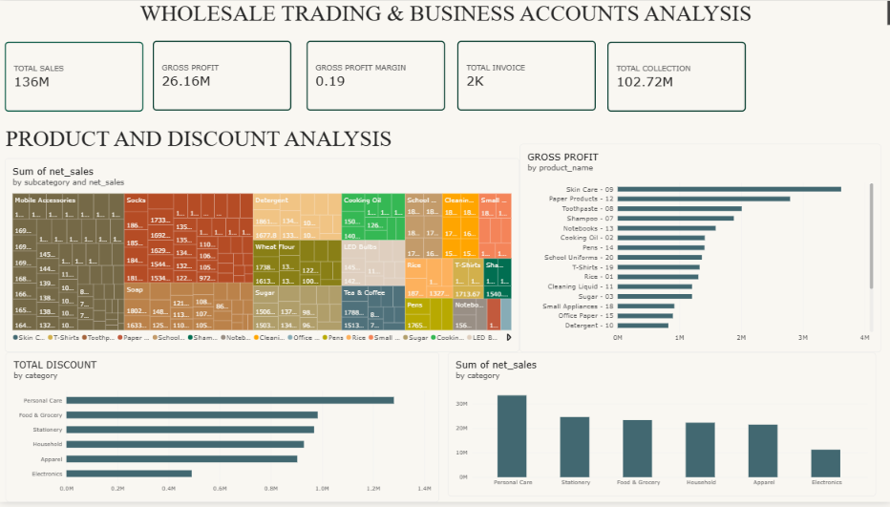

Page 2: Customer and Receivables Analysis
- Top KPI Cards: Highlights Total Invoice (2K), Sales Returns (1.47M), Total Discount (5.55M), and Total Collection (102.72M).
- Total Sales by Customer Type (Clustered Bar Chart): Compares sales across Wholesaler, Small Business, Retailer, Institution, and (Blank) segments.
- Sum of Return Amount by Return Reason (Clustered Column Chart): Categorizes the 1.47M in returns across four primary drivers (Damaged, Wrong Item, Expired, Customer Changed Mind).
- Total Sales by Customer Name (Clustered Bar Chart): Scrollable breakdown of revenue by individual B2B accounts (A1 Distributors 001 through 105).
- Total Collection by Month Name (Line Chart): Tracks monthly cash collection trends across the year.
- Sum of Payment Amount by Payment Method (Donut Chart): Displays the share of the 102.72M collection across UPI, Bank Transfer, Cheque, and Cash
- Total Sales by Region Name (Clustered Column Chart): Compares regional sales volume across West, South, North, and East.

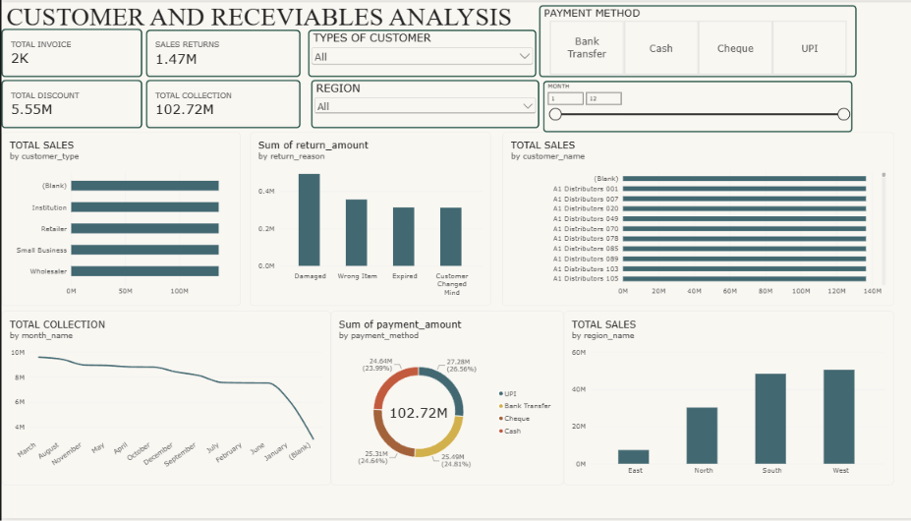

7. Slicers Used
Interactive slicers are positioned at the top of the Customer and Receivables Analysis page to enable dynamic cross-filtering [cite: 1]:

- Types of Customer (Dropdown Slicer): Filters visuals by customer classification (All, Wholesaler, Retailer, Small Business, Institution) [cite: 1].
- Region (Dropdown Slicer): Filters metrics by geographic territory (All, East, North, South, West) [cite: 1].
- Payment Method (Tile / Button Slicer): Allows quick one-click filtering between Bank Transfer, Cash, Cheque, and UPI [cite: 1].
- Month (Numeric Range Slider): Filters data across months 1 through 12 using a continuous slider or direct numeric input boxes [cite: 1].

8. Key Findings
- Receivables & Collection Gap: Out of 136M in total net sales, 102.72M has been collected (~75.5% collection rate), leaving roughly 33.28M in outstanding receivables or uncollected balances [cite: 1, 2].
- Category Revenue & Discount Alignment: Personal Care leads all categories in both net sales (>30M) and total discounts (~1.3M), followed by Stationery and Food & Grocery, while Electronics generates the lowest volume (~11M) and lowest discount spend (~0.48M) [cite: 2].
- Profitability Leaders: Skin Care - 09 (~3.6M) and Paper Products - 12 (~2.8M) are the highest profit-generating products, contributing significantly to the overall 19% gross profit margin [cite: 2].
- Regional Concentration: Sales are heavily concentrated in the West (~50M) and South (~48M) regions, which together account for over 70% of total revenue, whereas the East region lags significantly (<10M) [cite: 1].
- Balanced Payment Adoption: Collections are evenly distributed across all four payment channels—UPI (26.56% / 27.28M), Bank Transfer (24.81% / 25.49M), Cheque (24.64% / 25.31M), and Cash (23.99% / 24.64M) [cite: 1].
- Primary Return Drivers: Product damage (Damaged, ~0.5M) is the single largest contributor to the 1.47M in sales returns, followed by fulfillment errors (Wrong Item, ~0.35M) [cite: 1].
- Data Modeling / Relationship Anomaly: In the Total Sales by Customer Type and Total Sales by Customer Name bar charts, every bar displays an identical value (~136M), and (Blank) appears in customer and month visuals [cite: 1]. This indicates a missing or inactive table relationship between the Sales fact table and the Customer dimension table [cite: 1].

9. Conclusion
The Wholesale Trading & Business Accounts Analysis dashboard successfully consolidates core commercial KPIs, highlighting strong top-line performance in Personal Care and Western/Southern territories alongside a healthy 19% gross margin [cite: 1, 2]. To maximize its operational impact, management should focus on reducing damaged-in-transit returns and accelerating collections on the ~33.28M receivables gap [cite: 1, 2]. Technically, resolving the missing relationship between the Customer dimension and Sales fact table—and sorting the monthly collection line chart chronologically rather than by value—will eliminate duplicate bar lengths and ensure complete analytical accuracy [cite: 1].

