Day-1
An Invoice and Receipt Digitizer is a system that takes paper or image-based invoices/receipts and turns them into clean, searchable digital data.
What it does (in simple terms)
- Takes input like scanned images, photos, or PDFs
- Uses OCR (Optical Character Recognition) to read text
- Extracts key details automatically
- Saves everything in a digital format (database / Excel / JSON)
Data it usually extracts
- Invoice/Receipt number
- Date
- Vendor or shop name
- Item names
- Quantity and price
- Tax (GST/VAT)
- Total amount
- Payment method
How it works (step-by-step)
- Upload invoice or receipt (image/PDF)
- Preprocessing (crop, enhance image, remove noise)
- OCR reads the text from the image
- Data extraction identifies fields (date, total, tax, etc.)
- Validation checks errors or missing values
- Storage saves data into database or file
Technologies commonly used
- OCR: Tesseract, Google Vision OCR, AWS Textract
- Backend: Python (Flask / FastAPI), Node.js
- Frontend: React / HTML / Tailwind
- Database: MySQL, MongoDB
- AI/ML (optional): For layout detection and better accuracy
Where it’s used
- Expense tracking apps
- Accounting systems
- Business finance automation
- College or internship projects
- GST/tax record management
Why it’s useful
- Saves time
- Reduces manual data entry
- Fewer errors
- Easy search and reports

Day-2
Divided into teams
Created a public repository for each team
Created a private repository in github
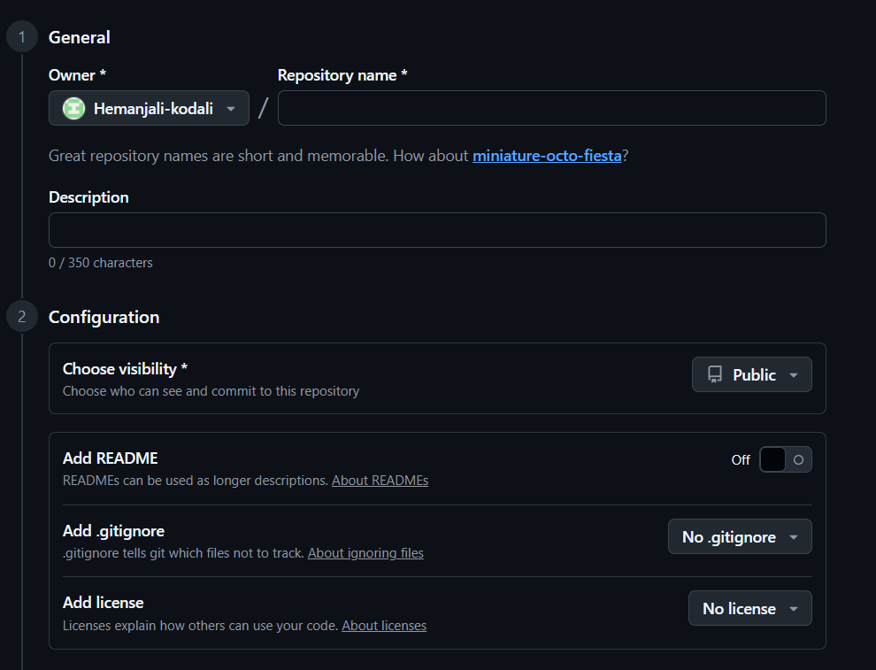
- Enter repository name
- On add README
- In add. gitignore select ‘AL’--Ignore common files that should never be pushed to Git, no matter what language you use.
- In add license select ‘MIT License’-- MIT License is selected because it allows free use, modification, and distribution of the code with minimal restrictions while protecting the author from liability.
Day-3
Git
Git is a version control system. It helps you track code changes, go back to older versions, and work with others without overwriting each other’s work. Everything runs locally, so it’s fast and reliable even without internet.
GitHub
GitHub is a cloud platform that hosts Git repositories. It makes collaboration easy with features like pull requests, issues, code reviews, and project boards. It’s widely used for open-source and team projects.
GitLab
GitLab is also a Git repository hosting platform, but it goes further by bundling DevOps tools in one place. Along with version control, it offers built-in CI/CD pipelines, issue tracking, and deployment tools.
GitLab automates the entire journey from code commit to live deployment, making releases faster, safer, and consistent.
Git commands
git add . – Stages all modified and new files in the current directory.
git add app.py – Stages only the file app.py for commit.
git clone <https_url> – Creates a local copy of a remote repository.
git pull – Fetches and merges the latest changes from the remote repository.
git fetch – Downloads updates from the remote without merging them.
git branch -all – Lists all branches (local and remote).
git branch – Shows only local branches.
git checkout branchname – Switches to an existing branch.
git checkout -b branchname – Creates and switches to a new branch.
git commit -m "message" – Saves staged changes with a commit message.
git push – Uploads local commits to the remote repository.

Python commands
python -m venv name – Creates a virtual environment with the given name.
name/Scripts/activate – Activates the virtual environment (Windows).
pip install -r requirements.txt – Installs all dependencies listed in requirements.txt.
python app.py – Runs the Python application file.
deactivate – Exits the virtual environment and returns to the system Python.

Day-4
SDLC-Step - by - Step process followed to design, develop, test, deploy, and maintaining
SDLC ROLES
1.Functional Consultant or BUSINESS Analyst
Functional Consultant - Focused on the "how"—implementing, configuring, and customizing a specific technology or application
BUSINESS Analyst Primarily focused on the "what" and "why"—eliciting, analyzing, and documenting business requirements.
Functional Specifications Document-Basic requirement from client and how the client is expecting
2. Developer or Programmers-Techy people knows how to fulfil requirements
Prepare tech required document based on Functional Specifications Document
Technical Specifications Document is done
POC-proof of concept-validate if feature is feasible before full scale
Implement the logic in code level
Unit testing-individual components of code tested in isolation to ensure they function correctly
3. Tester or QA TEAM- responsible for ensuring software quality by identifying defects, validating requirements, and ensuring functionality, performance, and security.
Test Script - A test script is a set of instructions used to execute a test case and validate a specific functionality of the software under test.

Test results - capture the outcomes of running the test scripts and cases. This documentation is a critical part of the defect tracking and reporting phases of the Software Testing Life Cycle (STLC).

3 main servers
- Development Server-This is the initial environment where developers build, code, and configure new functionalities. It is used for unit testing, where initial changes are made and basic functionality is verified.
- Quality Server-This is the testing environment, often called the QA or test server, where code or configurations are moved from the development server for rigorous functional, integration, and user acceptance testing (UAT).
- Production Server-This is the final, live environment where the application is hosted for end-users and real, day-to-day transactional data is processed.

4. Administration Team - provides the necessary oversight, resource allocation, and logistical support required to move a project through its phases

5. Product or Project Management
Product Management in SDLC
Focus: Defines the product vision, strategy, and user requirements (the "what").
Project Management in SDLC
Focus: Manages execution, resources, risks, and timelines (the "how" and "when")
Key Differences
Goal: Product Management focuses on delivering value and functionality; Project Management focuses on scope and deadline adherence.

Plan, monitors, control of project

6.Sales and Marketing - Marketing focuses on building brand awareness, researching audience needs, and generating qualified leads through campaigns (ads, content, social media) to create long-term value. Conversely, sales involves direct, personalized interaction—such as calls, meetings, and negotiations—to convert those leads into immediate revenue and close deals.
7. Human Resource- manages personnel allocation, skill development, and team structure to ensure project success.

8. Documentation Team - responsible for creating, maintaining, and managing all project-related documentation, including requirements, design specs, user manuals, and test plans.

9. Support Team - provides essential post-deployment maintenance, troubleshooting, and user assistance, primarily operating during the final "Maintenance" phase.

Waterfall model - a linear, sequential SDLC approach where each phase (requirements, design, implementation, testing, deployment) must be completed before the next begins, emphasizing strict documentation and rigid structure.

Agile Methodologies - Agile Methodologies are iterative, flexible approaches focusing on continuous, incremental delivery, high customer collaboration, and adapting to changes, usually through Sprints.

Agile Roles
1. Product owner - The "voice of the customer" who defines product goals, manages the backlog, and prioritizes work to maximize business value. They are responsible for deciding "what" to build.
2.Scrum Master- A "servant leader" who acts as a facilitator for the Scrum team. They ensure Scrum practices are followed, remove impediments (roadblocks), and help the team improve their processes.
3. Development team - A cross-functional, self-organizing group of 3–9 members (including developers, testers, designers) responsible for delivering a "Done" increment of the product each sprint. They decide "how" to build the product.
Design develop testing deploy - core components of the Software Development Life Cycle (SDLC), which is a structured framework for producing high-quality software

Day-5
An API, or application programming interface, is a set of rules or protocols that enables software applications to communicate with each other to exchange data, features and functionality.
What is Flask?
Flask is a lightweight micro-framework that we can use to build web applications in Python. It doesn’t require setting up any libraries or frameworks and has minimal overhead. You can install Flask on your machine using the following command:
pip install Flask
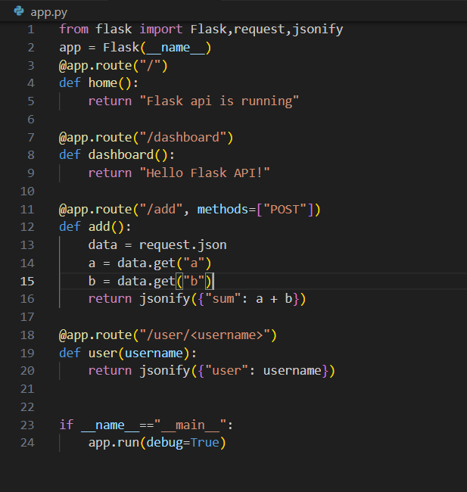
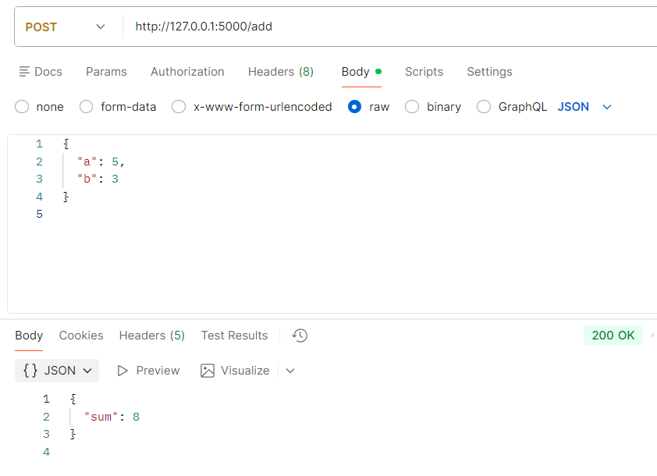

What is FastAPI?
FastAPI is a modern, fast, and high-performance framework for building application programming interfaces (APIs). You can install FastAPI on your system using the following command:
pip install fastapi
Uvicorn is used in FastAPI because FastAPI is ASGI-based and needs an ASGI server to handle async requests efficiently.
Day-6
SQL - Structured Query Language
Used to store, retrieve, update data inside database
MySQL
Postgres
Sqlite
Used in:Website ,Mobile apps

Create a database
1️⃣ Create a database
CREATE DATABASE student_db;

2️⃣ Use the database
USE student_db;

3️⃣ Create a table
CREATE TABLE students (
student_id INT PRIMARY KEY,
name VARCHAR(50),
age INT,
department VARCHAR(50),
email VARCHAR(100)
);

4️⃣ Insert sample data
INSERT INTO students VALUES
(1, 'Hema', 20, 'CSE', 'hema@gmail.com'),
(2, 'Ravi', 21, 'ECE', 'ravi@gmail.com');

5️⃣ View the table
SELECT * FROM students;
For one column
SELECT name
FROM students;
Update data
Update one column for a specific row
UPDATE students
SET email = 'hema123@gmail.com'
WHERE student_id = 1;

Update multiple columns
UPDATE students
SET age = 21,
department = 'AI'
WHERE student_id = 1;

Update all rows (be careful ⚠️)
UPDATE students
SET department = 'CSE';
👉 Always use WHERE unless you really want to update every row.

Delete data
Delete a specific row
DELETE FROM students
WHERE student_id = 1;

Delete based on a condition
DELETE FROM students
WHERE department = 'ECE';

Delete all rows (table stays)
DELETE FROM students;
⚠️ Be careful: without WHERE, everything is deleted.

Delete the entire table
DROP TABLE students;

Delete database
DROP DATABASE student_db;

Parameter | DELETE | DROP | TRUNCATE
Type | DML | DDL | DDL
Purpose | Deletes specific rows based on a condition | Deletes the entire table or database | Deletes all rows but retains table structure
Syntax | DELETE FROM table_name WHERE condition; | DROP TABLE table_name; | TRUNCATE TABLE table_name;

🔹 Comparison Operators
- != or <> → Not equal
SELECT * FROM students WHERE age != 20;

🔹 Logical Operators
- AND → both conditions must be true
age > 18 AND department = 'CSE'
- OR → any one condition true
department = 'CSE' OR department = 'ECE'
- NOT → reverses condition
NOT department = 'CSE'

🔹 ORDER BY
Used to sort data
SELECT * FROM students ORDER BY age ASC;
SELECT * FROM students ORDER BY age DESC;

🔹 GROUP BY
Used to group rows for aggregate functions
SELECT department, COUNT(*)
FROM students
GROUP BY department;

🔹 Aggregate Functions
- MIN() → smallest value
- MAX() → largest value
- AVG() → average
- COUNT() → number of rows
SELECT MIN(age), MAX(age), AVG(age), COUNT(*)
FROM students;

🔹 Patterns (LIKE)
Used with LIKE
Pattern | Meaning | Example match
A% | starts with A | Apple
%a | ends with a | Sathiya
%a% | contains a | Ball
A%e | starts with A, ends with e | Apple
SELECT * FROM students WHERE name LIKE 'A%';

🔹 JOIN Types
INNER JOIN / JOIN
Returns matching rows only
SELECT *
FROM students s
INNER JOIN marks m ON s.student_id = m.student_id;

LEFT JOIN
All rows from left table
SELECT *
FROM students s
LEFT JOIN marks m ON s.student_id = m.student_id;

RIGHT JOIN
All rows from right table
SELECT *
FROM students s
RIGHT JOIN marks m ON s.student_id = m.student_id;

CROSS JOIN
Every row with every row
SELECT * FROM students CROSS JOIN courses;

🔹 Operators
IN
SELECT * FROM students WHERE department IN ('CSE','ECE');

BETWEEN
SELECT * FROM students WHERE age BETWEEN 18 AND 22;

LIKE
SELECT * FROM students WHERE name LIKE '%a%';

IS NULL
SELECT * FROM students WHERE email IS NULL;

🔹 Set Operators
UNION
Removes duplicates
SELECT name FROM students
UNION
SELECT name FROM alumni;

UNION ALL
Keeps duplicates
SELECT name FROM students
UNION ALL
SELECT name FROM alumni;

INTERSECT
Common rows
SELECT name FROM students
INTERSECT
SELECT name FROM alumni;

EXCEPT
Rows in first, not in second
SELECT name FROM students
EXCEPT
SELECT name FROM alumni;

🔹 HAVING
Used with GROUP BY to filter groups
(WHERE cannot use aggregate functions)
SELECT department, COUNT(*)
FROM students
GROUP BY department
HAVING COUNT(*) > 2;

🔹 Summary
Clause | Used On | Used With
WHERE | Rows | Conditions
GROUP BY | Groups | Aggregate functions
HAVING | Groups | Aggregate functions

🔐 JWT (JSON Web Token)
- JWT stands for JSON Web Token
- It is a compact and secure way to send information between two parties
- The information is digitally signed, so it can’t be changed

👥 Client–Server Flow
JWT is mainly used for:
- Authentication
- Authorization
- Stateless APIs

🔄 How JWT Works
- User logs in with username & password
- Server validates the credentials
- Server generates a JWT
- Client stores the token
  - localStorage or cookies
- Client sends token in request header
- Authorization: Bearer <token>
- Server verifies the token
- If valid → access is allowed

📦 Install JWT Library
pip install pyjwt

🧩 Python Example (JWT Creation)
import jwt
import datetime

SECRET_KEY = "mysecretkey"

payload = {
"user_id": 101,
"username": "shakthi",
"exp": datetime.datetime.utcnow() + datetime.timedelta(minutes=30)
}

token = jwt.encode(payload, SECRET_KEY, algorithm="HS256")
print(token)

🔍 Key Points
- payload → data inside the token
- exp → token expiry time
- HS256 → hashing algorithm
- Token is not encrypted, only signed
- Anyone can read it, but cannot modify it

🔐 What is OAuth?
- OAuth is an authorization framework
- Used to give limited access without sharing passwords
- Example: Login with Google / GitHub

🆚 JWT vs OAuth (Quick idea)
- JWT → token format
- OAuth → authorization protocol
- OAuth often uses JWT internally
Day-7
🔐 Hashing (Passwords)
- Never store passwords directly in the database
- Instead, convert the password into a fixed-length, unreadable value
- This is done using a hashing algorithm
- Hashing is one-way → you cannot get the original password back

Example
Original password
Shakthi
Hashed value
3$47&s6J85$#
You store this hash, not the real password.

Why this is secure
- Even if two users use the same password (Shakthi),
the stored values won’t look readable
- Hackers who access the DB only see hashes, not passwords
- During login:
  - User enters password
  - System hashes it again
  - Compares hash with DB value
  - If they match → login success

Important point
Shakthi ≠ 3$47&s6J85$#
They are not the same, and you cannot reverse the hash.

Common hashing algorithms
- SHA-256
- bcrypt (best for passwords)
- Argon2

Day-8
Here’s a clear and simple explanation of all the functions you listed, with small examples.

📂 File I/O Methods (File Handling in Python)
1️⃣ open()
Used to open a file.
f = open("sample.txt", "r") # r = read mode
Modes:
- "r" → Read
- "w" → Write (overwrites file)
- "a" → Append
- "rb" → Read binary

2️⃣ read()
Reads entire file content.
f = open("sample.txt", "r")
content = f.read()
print(content)
f.close()

3️⃣ readline()
Reads one line at a time.
f = open("sample.txt", "r")
print(f.readline())
f.close()

4️⃣ readlines()
Reads all lines and returns a list.
f = open("sample.txt", "r")
lines = f.readlines()
print(lines)
f.close()

5️⃣ write()
Writes data into file.
f = open("sample.txt", "w")
f.write("Hello Python")
f.close()

6️⃣ writelines()
Writes multiple lines from a list.
f = open("sample.txt", "w")
f.writelines(["Line1\n", "Line2\n"])
f.close()

7️⃣ close()
Closes the file.
f.close()
Best practice:
with open("sample.txt", "r") as f:
print(f.read())
(No need to manually close)

🧠 General Purpose Functions
len()
Returns length.
len("Python") # 6

range()
Generates sequence of numbers.
for i in range(5):
print(i)
Output: 0 1 2 3 4

print()
Displays output.
print("Hello")

type()
Returns data type.
type(10) # int

id()
Returns memory address.
x = 10
print(id(x))

uuid
Generates unique ID.
import uuid
print(uuid.uuid4())

sorted()
Returns sorted list.
nums = [3, 1, 2]
print(sorted(nums))
Output: [1, 2, 3]

enumerate()
Adds index to iterable.
word = ["I", "like", "python"]
for i, w in enumerate(word):
print(i, w)

zip()
Combines two lists.
names = ["I"]
marks = [72]
print(list(zip(names, marks)))
Output:
[('I', 72)]

join()
Joins list into string.
word = ["I", "like", "python"]
result = " ".join(word)
print(result)
Output:
I like python

🔄 Conversion Functions
int()
int("3") # 3
float()
float("3.5") # 3.5
str()
str(10) # "10"
list()
list("abc") # ['a', 'b', 'c']
dict()
dict([(1,"a"), (2,"b")])
set()
set([1,2,2,3]) # {1,2,3}
tuple()
tuple([1,2,3]) # (1,2,3)

➕ Mathematical Functions
abs()
Returns positive value.
abs(-12) # 12

sum()
sum([1,2,3]) # 6

min()
min([3,1,5]) # 1

max()
max([3,1,5]) # 5

pow()
pow(2,3) # 8

round()
round(2.7) # 3

🔁 Functional Programming Functions
filter()
Filters elements based on condition.
nums = [1,2,3,4]
even = list(filter(lambda x: x%2==0, nums))
print(even)
Output: [2, 4]

map()
Applies function to all elements.
nums = [1,2,3]
square = list(map(lambda x: x*x, nums))
print(square)
Output: [1, 4, 9]

reduce()
Reduces list to single value.
from functools import reduce
nums = [1,2,3,4]
total = reduce(lambda x,y: x+y, nums)
print(total)
Output: 10

Day-9
🔹 String Methods
1. strip()
Removes spaces from both sides of a string.
text = " shakthi "
print(text.strip())
Output:
shakthi

2. join()
Joins elements of a list using a string.
letters = ["a", "d", "s"]
result = "".join(letters)
print(result)
Output:
ads
If you want space between them:
print(" ".join(letters))

3. replace()
Replaces a word with another word.
text = "I like Java"
print(text.replace("Java", "Python"))
Output:
I like Python

4. startswith()
Checks if string starts with a word. Returns True or False.
text = "Python"
print(text.startswith("Py"))
Output:
True

5. endswith()
Checks if string ends with a word.
text = "Python"
print(text.endswith("on"))
Output:
True

6. find()
Finds position of a word.
text = "I like Python"
print(text.find("like"))
Output:
2

7. isdigit()
Checks if string contains only numbers.
num = "1235"
print(num.isdigit())
Output:
True

8. isalpha()
Checks if string contains only letters.
text = "Hello"
print(text.isalpha())
Output:
True

🔹 Dictionary Methods
1. get()
Gets value of a key.
student = {"Name": "Shakthi", "Age": 20}
print(student.get("Name"))

2. keys()
Returns all keys.
print(student.keys())

3. values()
Returns all values.
print(student.values())

4. items()
Returns key-value pairs.
print(student.items())

5. update()
Updates dictionary.
student.update({"Age": 21})
print(student)

6. pop()
Removes specific key.
student.pop("Age")
print(student)

7. popitem()
Removes last inserted item.
student.popitem()

8. clear()
Removes all items.
student.clear()

🔹 Set Methods
1. add()
Adds element to set.
s = {1, 2}
s.add(3)
print(s)

2. remove()
Removes element (gives error if not found).
s.remove(2)

3. discard()
Removes element (no error if not found).
s.discard(5)

4. pop()
Removes random element.
s.pop()

5. clear()
Removes all elements.
s.clear()

6. union()
Combines two sets.
a = {1, 2}
b = {2, 3}
print(a.union(b))
Output:
{1, 2, 3}

7. intersection()
Common elements.
print(a.intersection(b))
Output:
{2}

8. difference()
Elements in first set but not in second.
print(a.difference(b))
Output:
{1}
Day-10

Day-11 & 12 -1st milestone
Day-13
🔹 Class and Object
A class is a blueprint.
An object is created from a class.
class Student:
def __init__(self, name, age):
self.name = name
self.age = age

s1 = Student("Shakthi", 20)
print(s1.name)

🔹 Built-in Functions for Objects
1. getattr()
Gets value of an attribute.
print(getattr(s1, "name"))

2. setattr()
Sets or changes value of an attribute.
setattr(s1, "age", 21)
print(s1.age)

3. hasattr()
Checks if object has that attribute.
print(hasattr(s1, "name")) # True
print(hasattr(s1, "marks")) # False

4. delattr()
Deletes attribute.
delattr(s1, "age")

5. isinstance()
Checks if object belongs to a class.
print(isinstance(s1, Student)) # True
Example with normal types:
x = 10
print(isinstance(x, int)) # True

6. issubclass()
Checks if one class is subclass of another.
class Person:
pass

class Teacher(Person):
pass

print(issubclass(Teacher, Person)) # True

🔹 Miscellaneous Functions
1. globals()
Returns global variables.
print(globals())

2. locals()
Returns local variables.
def test():
x = 10
print(locals())

test()

3. callable()
Checks if object can be called (like function).
def greet():
print("Hello")

print(callable(greet)) # True
print(callable(10)) # False

4. eval()
Executes a string as Python expression.
x = 5
print(eval("x + 10")) # 15

5. exec()
Executes Python code from string.
code = "a = 10\nb = 20\nprint(a + b)"
exec(code)

🔹 Exception Handling
1. try, except, finally
try:
num = int(input("Enter number: "))
print(10 / num)

except ZeroDivisionError:
print("Cannot divide by zero")

except ValueError:
print("Invalid input")

finally:
print("Done")
- try → risky code
- except → handles error
- finally → always runs

🔹 del() Function
Deletes object or variable.
x = 10
del x

🔹 Garbage Collection (gc library)
Python automatically removes unused objects.
We can manually call garbage collector.
Example using gc
import gc

class Test:
def __del__(self):
print("Object deleted")

obj = Test()

# Delete reference
del obj

# Force garbage collection
gc.collect()
gc.collect() → Forces Python to clean unused memory.

🔹 Assignment 3 – About enumerate()
enumerate() gives index + value together.
Normal way:
names = ["Ram", "Shyam", "Geeta"]

for i in range(len(names)):
print(i, names[i])
Using enumerate() (Better way):
names = ["Ram", "Shyam", "Geeta"]

for index, value in enumerate(names):
print(index, value)
Output:
0 Ram
1 Shyam
2 Geeta
You can also start from another number:
for index, value in enumerate(names, start=1):
print(index, value)

🔹 Small Program Using isinstance() and gc
import gc

class Person:
pass

class Student(Person):
pass

s = Student()

# Check type
if isinstance(s, Student):
print("s is a Student")

if isinstance(s, Person):
print("s is also a Person")

# Delete object
del s

# Force memory cleanup
gc.collect()
print("Garbage collection completed")

Day-14
🔹 AI Models
AI models are programs trained using large amounts of data to perform specific tasks.
Some are built for a single purpose, while some are general-purpose and handle multiple tasks.
They are usually:
- Pre-trained on large datasets
- Fine-tuned for specific use cases

🔹 Types of AI Models
1. Chatbots
Used for conversation, coding help, Q&A, and customer support.
These use LLMs (Large Language Models).
Example: GPT models from OpenAI.

2. Image Generation
Creates images from text prompts.
- Uses deep learning models like diffusion models
- OpenCV is mainly used for image processing (not direct generation), like detecting faces, objects, etc.
Used in:
- Design
- Medical imaging
- Content creation

3. Video Generation
Creates videos using AI.
Combines:
- Image generation
- Motion modeling
- Audio synthesis
Used in animation, AI avatars, content creation.

4. Prediction Models
Used for forecasting future results.
Examples:
- Sales prediction
- Weather prediction
- Stock market analysis
These use machine learning and deep learning algorithms.

🔹 LLM vs NLP
NLP (Natural Language Processing)
It is a technique used to process and analyze text.
Used for:
- Text classification
- Sentiment analysis
- Translation

LLM (Large Language Model)
It is a model, trained on massive data.
- Handles text generation
- Can be multimodal (text + images + code)
So:
- NLP → technique
- LLM → trained model

🔹 Platforms / Companies
1. Google
- Gemini models
- AI services
2. Gemini
- Multimodal model (text + image + code)
3. OpenAI
- GPT models
- AI APIs
4. Groq
- High-speed LLM inference platform
5. Microsoft
- AI integration in products
6. Copilot
- AI assistant in Word, Excel, VS Code
7. Azure OpenAI Service
- Enterprise GPT deployment on Azure

🔹 AI Platforms
- Google AI Studio
- OpenAI Platform
- Groq Platform
These platforms provide:
- API access
- Model selection
- Deployment tools
- Monitoring

🔹 Rate & Token Limit
🔹 Token
A token is a piece of text (word or part of word).
Example:
“ChatGPT is smart” → around 4 tokens.
🔹 Token Limit
Each model has:
- Input token limit
- Output token limit
If limit is exceeded → request fails.

🔹 Rate Limit
Defines:
- How many requests per minute
- How many tokens per minute
Used to prevent overload and misuse.

🔹 Example API Code
response = client.chat.completions.create(
model="gpt-4o-mini",
messages=messages,
temperature=0.7, # Value between 0 and 1
max_tokens=500
)
🔹 temperature (0–1)
- 0 → More accurate, less creative
- 1 → More creative, more variation
🔹 max_tokens
Maximum number of tokens in output response.

🔹 Production Ready or Not?
An AI system is production-ready when:
✔ Proper testing is done
✔ Secure API keys
✔ No security breach
✔ Data encryption used
✔ Access control enabled
✔ Monitoring and logging enabled
If security is weak → data leakage or misuse can happen.

Day-15
🔹 NLP – Definition
NLP (Natural Language Processing) is a branch of AI that helps computers understand, process, and analyze human language (text or speech).
It is used in:
- Chatbots
- Sentiment analysis (positive/negative)
- Translation
- Text classification

🔹 Positive and Negative Sentences
In sentiment analysis, NLP identifies whether a sentence is positive or negative.
Positive Example:
👉 “I love this movie.”
Negative Example:
👉 “This product is very bad.”
The model analyzes words like love (positive) and bad (negative).

🔹 NLTK (Natural Language Toolkit)
NLTK is a popular Python library used for NLP tasks.
Install NLTK
pip install nltk
Import NLTK
import nltk
nltk.download('all')

🔹 7 Main Key Features of NLTK

1️⃣ Tokenization
Splitting text into words or sentences.
Example:
from nltk.tokenize import word_tokenize

text = "NLP is interesting"
tokens = word_tokenize(text)
print(tokens)
Output:
['NLP', 'is', 'interesting']

2️⃣ Stop Word Removal
Stop words are common words like:
this, is, the, and, of
from nltk.corpus import stopwords
from nltk.tokenize import word_tokenize

text = "This is NLP tutorial"
tokens = word_tokenize(text)

filtered = [word for word in tokens if word.lower() not in stopwords.words('english')]
print(filtered)

3️⃣ Stemming
Reduces word to root form (may not be meaningful word).
Example:
- playing → play
- better → bet
from nltk.stem import PorterStemmer

ps = PorterStemmer()
print(ps.stem("playing"))
print(ps.stem("better"))

4️⃣ Lemmatization
Converts word into meaningful base word.
Example:
- better → good
- running → run
from nltk.stem import WordNetLemmatizer

lemmatizer = WordNetLemmatizer()
print(lemmatizer.lemmatize("better", pos='a'))
Lemmatization is more accurate than stemming.

5️⃣ POS (Part of Speech)
Identifies grammatical role of words.
Example:
- NLP → Noun
- is → Verb
- interesting → Adjective
from nltk import pos_tag
from nltk.tokenize import word_tokenize

text = "NLP is interesting"
tokens = word_tokenize(text)
print(pos_tag(tokens))

6️⃣ POS Tagging
Assigns tags like:
- NN → Noun
- VB → Verb
- JJ → Adjective
Already shown above using pos_tag().

7️⃣ NER (Named Entity Recognition)
Identifies names of:
- Person
- Organization
- Location
Example:
- “Ravi works at Google in India”
NER detects:
- Ravi → Person
- Google → Organization
- India → Location
Before using NER:
nltk.download('words')
nltk.download('maxent_ne_chunker')
Example:
from nltk import ne_chunk

sentence = "Ravi works at Google"
tokens = word_tokenize(sentence)
tags = pos_tag(tokens)
print(ne_chunk(tags))

🔹 Text Preprocessing
Text preprocessing means cleaning text before applying NLP.
It includes:
- Lowercasing
- Removing punctuation
- Tokenization
- Stop word removal
- Stemming / Lemmatization
- Removing special characters
Example simple preprocessing:
import string
from nltk.corpus import stopwords
from nltk.tokenize import word_tokenize

text = "NLP is very interesting!!!"
text = text.lower()

tokens = word_tokenize(text)
tokens = [word for word in tokens if word not in string.punctuation]
tokens = [word for word in tokens if word not in stopwords.words('english')]

print(tokens)
Day-16
🔹 Machine Learning (ML)
Machine Learning is a subset of Artificial Intelligence (AI).
It allows computers to learn from data instead of being manually programmed.
In simple words:
👉 The machine studies a dataset and learns patterns from it.

🔹 Three Main Types of Machine Learning
1️⃣ Supervised Learning
Uses labeled data (input + correct output).
🔹 Regression
Used to predict continuous values.
Example:
- House price prediction
- Temperature prediction
🔹 Classification
Used to predict categories.
Example:
- Spam or Not Spam
- Disease: Yes or No

2️⃣ Unsupervised Learning
No labeled output.
Model finds patterns by itself.
🔹 Clustering
Groups similar data together.
Example:
- Customer segmentation
- Market grouping

3️⃣ Reinforcement Learning
Model learns through reward and punishment.
Example:
- Game-playing AI
- Self-driving cars

🔹 Embedding
Embedding converts text (or images) into numbers (vectors).
It helps machines understand meaning.
Example:
- “cat” and “dog” → similar vectors
- “cat” and “car” → different vectors
Used in:
- Search systems
- Chatbots
- Recommendation systems

🔹 Overfitting and Underfitting
🔹 Overfitting
- High accuracy on training data
- Poor performance on test data
- Model learns too much (including noise)
🔹 Underfitting
- Low accuracy on both training and test data
- Model is too simple

🔹 Linear Regression
Used for predicting continuous values.
It fits a straight line:
$$y=mx+c$$
Example:
Predicting salary based on experience.

🔹 Logistic Regression
Used for classification (Yes/No problems).
Output is between 0 and 1 (probability).
Example:
Spam detection
Disease prediction

🔹 Decision Tree
A tree-like model for classification and regression.
- Splits data into branches
- Easy to understand
- Works like decision rules
Example:
If age > 18 → Eligible
Else → Not Eligible

🔹 sklearn vs scikit-learn
Both are the same library.
- Official name → scikit-learn
- Import name → sklearn
Installation:
pip install scikit-learn
Import:
from sklearn.linear_model import LinearRegression

🔹 OCR (Optical Character Recognition)
OCR models convert images of text into machine-readable text.
Used in:
- Reading scanned documents
- Extracting text from images
- Invoice processing

🔹 Popular OCR Models / Libraries
1️⃣ PaddleOCR
- Based on deep learning
- High accuracy
- Multi-language support
2️⃣ pytesseract
- Python wrapper for Tesseract OCR
- Easy to use
3️⃣ DocTR
- Deep learning based OCR
- Good for structured documents
4️⃣ Surya OCR
- Modern OCR tool
- Fast and lightweight
5️⃣ EasyOCR
- Simple Python OCR
- Supports multiple languages
Day-17
✅ Step 1: Create Virtual Environment
Open Command Prompt and go to your project folder:
cd Desktop
mkdir ocr_project
cd ocr_project
Now create virtual environment:
python -m venv venv
Activate it:
👉 Windows:
venv\Scripts\activate
If activated, you’ll see (venv) in front of your terminal line.

✅ Step 2: Install Required Packages
Inside the virtual environment:
pip install pytesseract pillow
Check installation:
pip list
You should see:
- pytesseract
- pillow

⚠️ Step 3: Install Tesseract Engine (Important)
pytesseract is just a wrapper.
You must install the actual Tesseract software.
👉 Download from:
https://github.com/UB-Mannheim/tesseract/wiki
Install it.
After installing, copy the install path.
Usually it is:
C:\Program Files\Tesseract-OCR\tesseract.exe

Add this in your Python code (very important):
import pytesseract
from PIL import Image
pytesseract.pytesseract.tesseract_cmd = r"C:\Program Files\Tesseract-OCR\tesseract.exe"
image_path = r"C:\Users\heman\OneDrive\Pictures\Screenshots\Screenshot 2026-02-12 184429.png"
image = Image.open(image_path)
text = pytesseract.image_to_string(image)
print(text)
⚠️ Also remove extra quotes in image path and use r""

✅ Step 4: Save and Run
Save file as:
app.py
Run:
python app.py

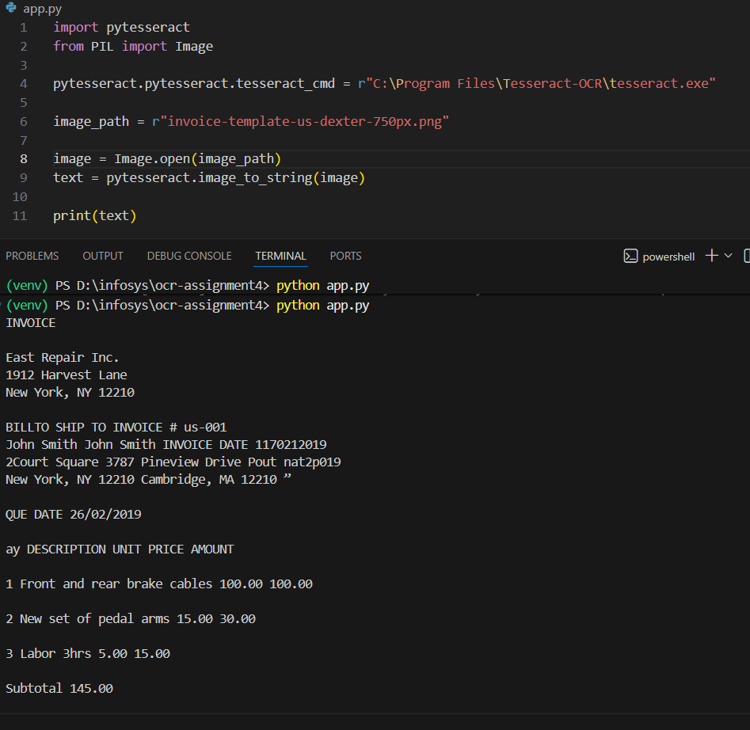

1) Input Layer
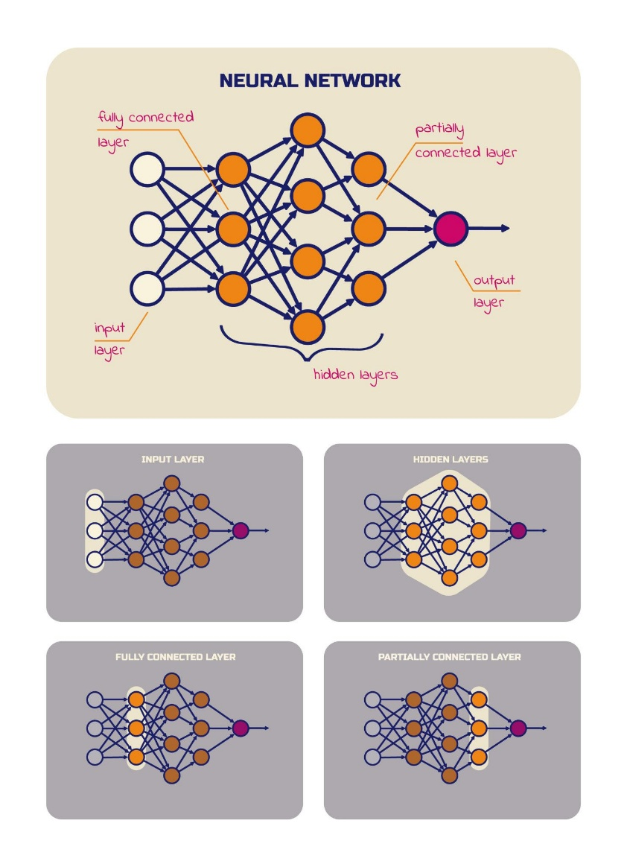
- This is the first layer of a neural network.
- It receives the raw data (features).
- Example:
  - For image → pixel values
  - For student dataset → marks, attendance, age
- It does not perform heavy computation. It just passes values to the next layer.

2) Hidden Layer
- Layers between input and output are called hidden layers.
- They perform calculations using weights, bias, and activation functions.
- These layers learn patterns from the data.
- More hidden layers → Deep Learning model.

3) Output Layer
- Final layer of the network.
- Produces the prediction result.
- Example:
  - Binary classification → 0 or 1
  - Multi-class → Softmax probabilities
  - Regression → Continuous value

4) Forward Pass
- Data moves from input → hidden → output.
- Each neuron calculates:
$$Z=W⋅X+b$$
- Then activation function is applied:
$$A=f(Z)$$
- Final output is generated.
- No learning happens here — just prediction.

5) Loss Calculation
- After prediction, we compare it with the actual value.
- The difference is called loss (error).
Common loss functions:
- Mean Squared Error (MSE) → for regression
- Binary Cross Entropy → for binary classification
- Categorical Cross Entropy → for multi-class
Loss tells us how wrong the model is.

6) Backward Pass (Backpropagation)
- Error is sent backward through the network.
- Gradients (derivatives) are calculated using chain rule.
- We compute:
$$\frac{∂Loss}{∂Weight}$$
- This tells how much each weight contributed to the error.

7) Gradient Descent
- Optimization algorithm used to reduce loss.
- It updates weights in the opposite direction of gradient.
$$W=W-η\frac{∂L}{∂W}$$
Where:
- $η$= learning rate
- Smaller learning rate → slow but stable learning
- Large learning rate → fast but may overshoot
Types:
- Batch Gradient Descent
- Stochastic Gradient Descent (SGD)
- Mini-batch Gradient Descent

8) Parameter Updates
- Parameters = Weights + Biases
- After computing gradients, weights are updated.
- This improves predictions gradually.

9) Iteration
- One forward pass + backward pass for one batch of data.
- If dataset has 1000 samples and batch size = 100
→ 10 iterations per epoch.

10) Epoch
- One complete pass through the entire training dataset.
- If dataset is passed 10 times → 10 epochs.
- More epochs → better learning (but too many → overfitting).

Complete Training Flow
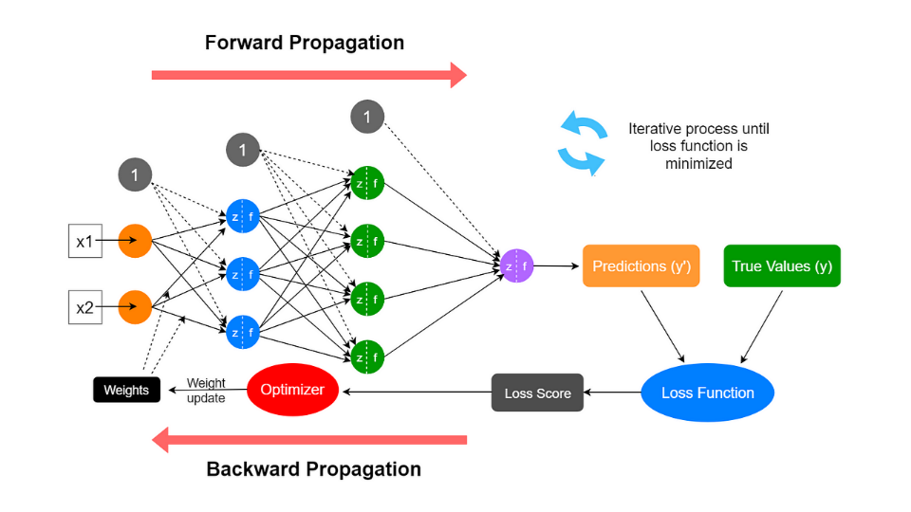

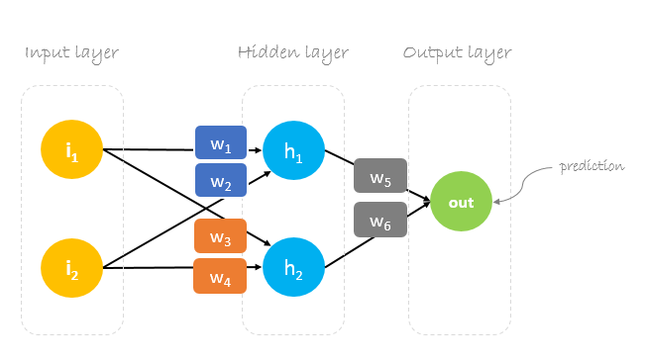
- Input data
- Forward pass
- Calculate loss
- Backward pass
- Update parameters
- Repeat for many iterations
- Complete one epoch
- Repeat epochs until model converges

Key Formula Summary
Forward pass:
$$Z=WX+b$$
Activation:
$$A=f(Z)$$
Loss (example MSE):
$$L=\frac{1}{n}∑(y-\hat{y})^{2}$$
Weight update:
$$W=W-η\frac{∂L}{∂W}$$

