LAB ASSIGNMENT 03
Visualizations and Performance Graphs
Resource Allocation, Activity Scheduling, Huffman Tree and Benchmarks

Student Name | Hemant Mukhiya
Roll Number | 2401201013
Course / Semester | BCA / 5th
Subject | Design and Analysis of Algorithms
Submitted for academic assessment

1. Objective
Create and interpret visual representations for the three greedy algorithms: a Fractional Knapsack allocation chart, an Activity Selection timeline, a Huffman tree, and graphs comparing execution time and peak traced memory.

2. Fractional Knapsack — Resource Allocation
With capacity set to 50, items are processed by descending value-to-weight ratio. Item 1 contributes 10 weight units, Item 2 contributes 20, and Item 3 contributes the remaining 20. The corresponding values are 60, 100, and 80, adding to 240.
plt.figure(figsize=(6, 4))
plt.bar(item_labels, selected_weights)
plt.title("Fractional Knapsack: Selected Weight")
plt.xlabel("Item")
plt.ylabel("Weight selected")
plt.tight_layout()
plt.show()

Code notes
plt.figure() creates the plotting area, plt.bar() draws one column per item, and the axis labels explain what the columns represent. tight_layout() reduces clipping around the chart.
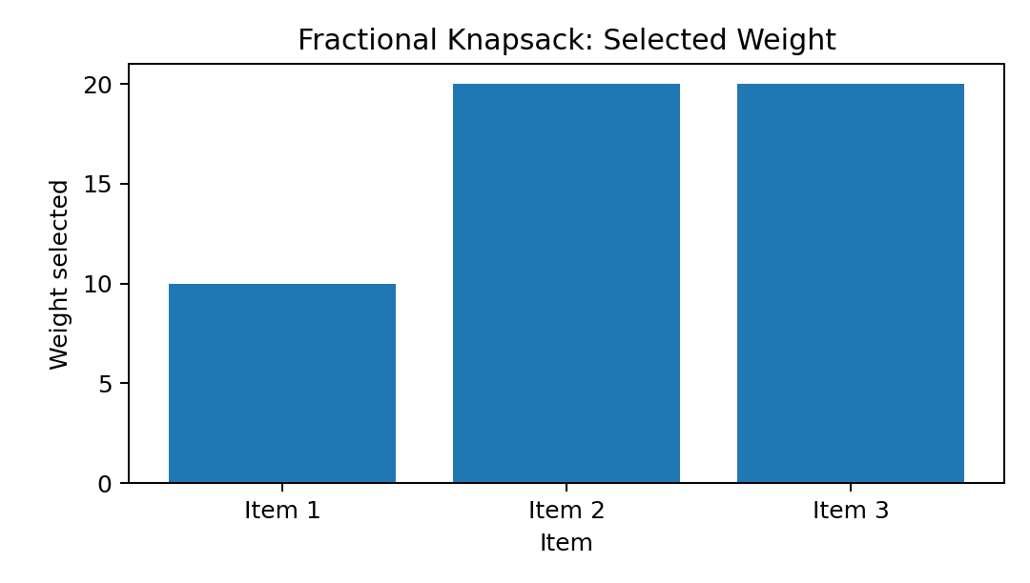
Figure 1. Resource allocation for the capacity-50 example.

3. Activity Selection — Timeline
Each horizontal bar extends from an activity's start to its finish. The chosen intervals are (1, 2), (3, 4), (5, 7), and (8, 9); they do not overlap, so all four can be included.
fig, ax = plt.subplots(figsize=(6, 3.5))
for row, (start, finish) in enumerate(selected_activities):
ax.barh(row, finish - start, left=start, height=0.5)
ax.text((start + finish) / 2, row, f"{start}-{finish}",
ha="center", va="center")
ax.set_yticks(range(len(selected_activities)))
ax.set_yticklabels([f"Activity {i + 1}" for i in range(len(selected_activities))])
ax.set_xlabel("Time")
ax.set_title("Selected Activities Timeline")
ax.grid(axis="x", linestyle="--", alpha=0.4)
plt.tight_layout()
plt.show()

Code notes
barh() draws each interval as a horizontal bar. The left position equals the start time and the width is finish minus start. Labels inside the bars identify each interval.
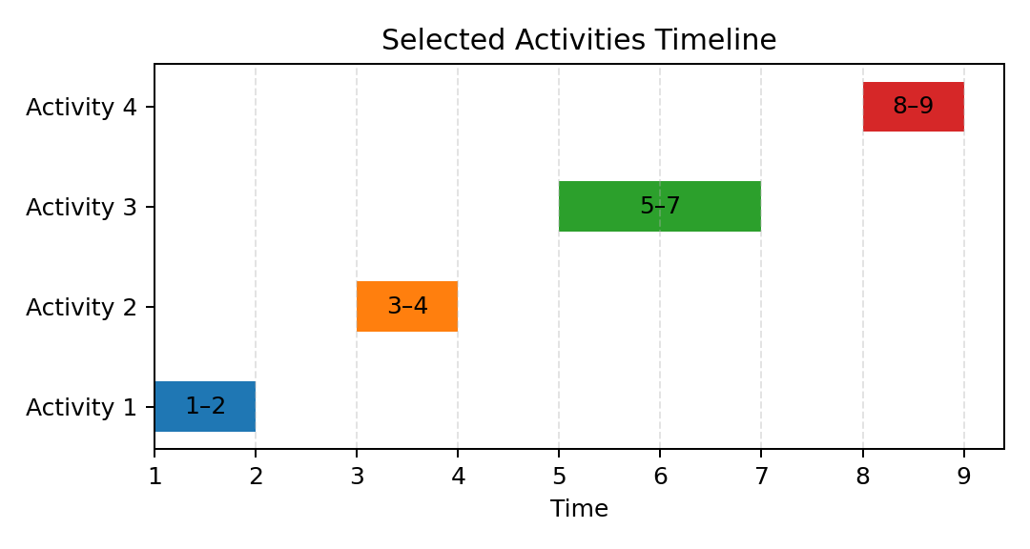
Figure 2. Timeline for the four selected activities.

4. Huffman Tree Representation
The Huffman tree reflects the sequence of merges made by the min-heap. Leaves contain characters and their frequencies, while internal nodes represent combined frequencies. The left and right branches are labelled 0 and 1; a symbol's code is the sequence of labels from root to leaf.
For 'aaabbc', a occurs three times, b twice, and c once. The shown tree assigns a one-bit code to a and two-bit codes to b and c, for 3×1 + 2×2 + 1×2 = 9 bits.
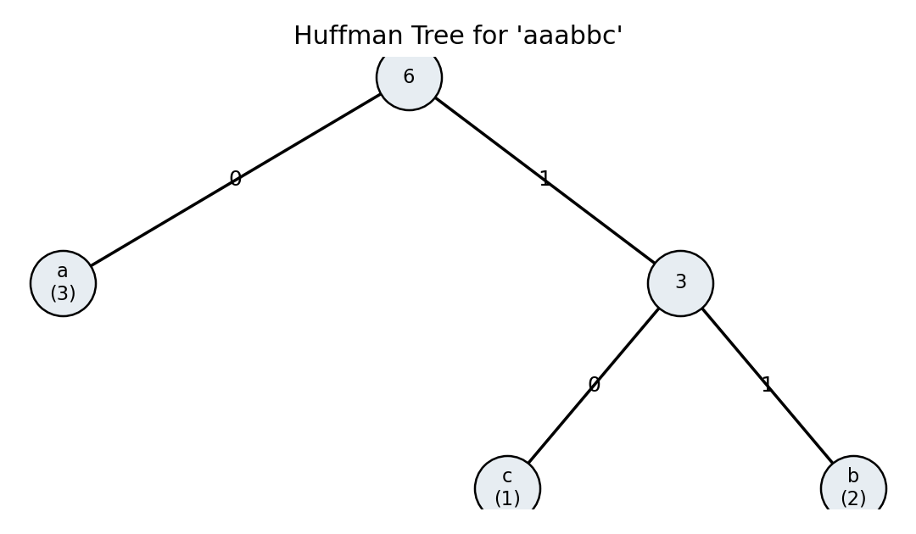
Figure 3. Huffman tree for the text 'aaabbc'.

5. Execution-Time Comparison
The measured execution times were approximately 0.000118 seconds for Fractional Knapsack, 0.000329 seconds for Activity Selection, and 0.000816 seconds for Huffman Compression. Very small runtimes can shift because of system load, timer resolution, and interpreter overhead.
plt.figure(figsize=(6, 4))
plt.bar(performance_df["Algorithm"],
performance_df["Execution Time (seconds)"])
plt.title("Measured Execution Time")
plt.xlabel("Greedy algorithm")
plt.ylabel("Execution time (seconds)")
plt.xticks(rotation=15)
plt.tight_layout()
plt.show()
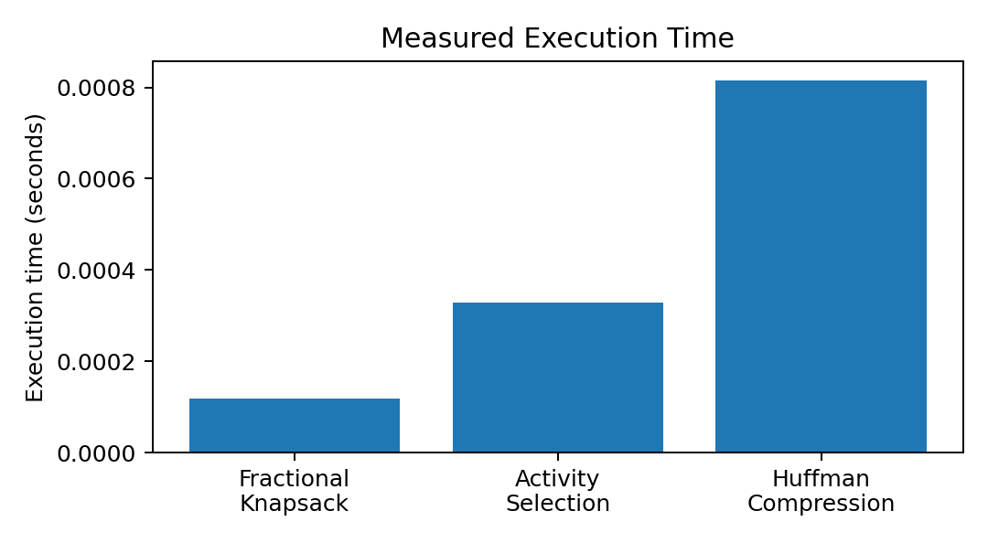
Figure 4. Runtime comparison for the recorded notebook run.

6. Peak Memory Comparison
The reported peak Python-tracked allocations are 0.234375 KB for Fractional Knapsack, 0.226562 KB for Activity Selection, and 9.697266 KB for Huffman Compression. These are allocations traced by tracemalloc, not the total memory consumed by Python or the operating system.
plt.figure(figsize=(6, 4))
plt.bar(performance_df["Algorithm"],
performance_df["Peak Memory (KB)"])
plt.title("Peak Python-Tracked Memory")
plt.xlabel("Greedy algorithm")
plt.ylabel("Peak memory (KB)")
plt.xticks(rotation=15)
plt.tight_layout()
plt.show()
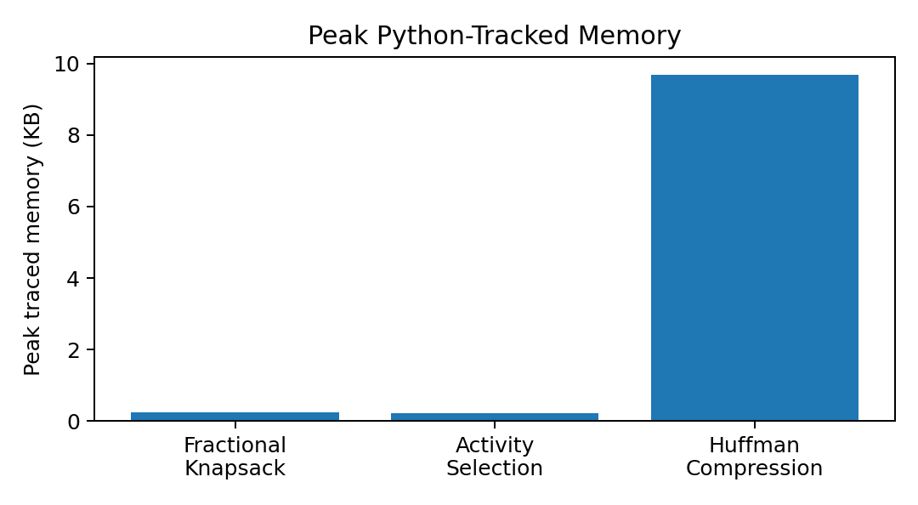
Figure 5. Peak traced memory for each algorithm.

7. Overall Interpretation
The resource chart explains how the knapsack capacity is distributed, the timeline makes schedule compatibility visible, and the Huffman tree demonstrates frequency-driven prefix-code construction. The two performance graphs compare runtime and traced memory for one input set. These visualizations complement the algorithm descriptions and complexity table, but small-input results should not be generalized to larger workloads.

8. Conclusion
The charts make each greedy decision easier to examine: the knapsack plot displays selected weight, the timeline confirms non-overlapping activities, the tree shows Huffman merging, and the benchmark graphs compare measured runtime and memory allocation. Together, they provide a visual companion to the code and complexity analysis.

