LAB ASSIGNMENT 03
Greedy Algorithms
Implementation, Complexity, Performance and Visual Analysis

Student Name | Hemant Mukhiya
Roll Number | 2401201013
Course / Semester | BCA / 5th
Subject | Design and Analysis of Algorithms
Submitted for academic assessment

Abstract
This practical examines three greedy techniques in Python: Fractional Knapsack, Activity Selection, and Huffman Compression Size Generation. The programs use fixed test data and can run in Anaconda Jupyter Notebook without interactive input. The report records the core logic, code, sample outputs, complexity estimates, performance observations, and visual explanations. Timing and memory figures are specific to the supplied run and small inputs.

1. Introduction
A greedy method constructs an answer by repeatedly choosing what appears best at the current step. It is effective when those local choices lead to a suitable global solution. The examples in this lab cover value maximization under a capacity limit, scheduling compatible intervals, and constructing prefix codes.

2. Objectives
• Implement Fractional Knapsack by ranking items according to value per unit weight.
• Choose the largest compatible activity set using finishing-time order.
• Compute Huffman encoded size with a min-heap.
• Record elapsed time and Python-tracked peak memory.
• Compare asymptotic complexity and visualize algorithm behavior.

3. Tools and Environment
Language: Python. Environment: Anaconda Jupyter Notebook. Libraries include matplotlib for plots, pandas for tabular results, time.perf_counter() for timing, tracemalloc for traced allocations, collections.Counter for character frequencies, heapq for heap operations, and itertools.count() for unique tie-breakers.

4. Question 1 — Fractional Knapsack

Problem and greedy strategy
Given item values, weights, and a fixed capacity, the goal is to maximize total value. Because fractions are allowed, compute each item's value-to-weight ratio, process items from the highest ratio downward, and take only the amount that fits.

Implementation
def fractional_knapsack(items, capacity):
ranked_items = sorted(items, key=lambda item: item[0] / item[1],
reverse=True)
value_total = 0.0
for value, weight in ranked_items:
if capacity <= 0:
break
weight_taken = min(weight, capacity)
value_total += weight_taken * (value / weight)
capacity -= weight_taken
return value_total
items = [(60, 10), (100, 20), (120, 30)]
capacity = 50
answer = fractional_knapsack(items, capacity)
print(f"Maximum obtainable value: {answer:.6f}")

How the code works
• Sorting by value / weight places the best value-per-unit-weight items first.
• value_total accumulates the value of each whole or partial item.
• The loop ends once no capacity remains.
• min(weight, capacity) selects the full item when possible, or the remaining capacity otherwise.
• The value contributed by a partial item is proportional to the weight taken.

Test case and result
For items (60, 10), (100, 20), and (120, 30) with capacity 50, the first two items contribute 60 and 100. The remaining 20 units of capacity take two-thirds of the third item and contribute 80. The total is 240.000000.
Complexity: O(n log n) time due to sorting and O(n) auxiliary space for the ranked list.
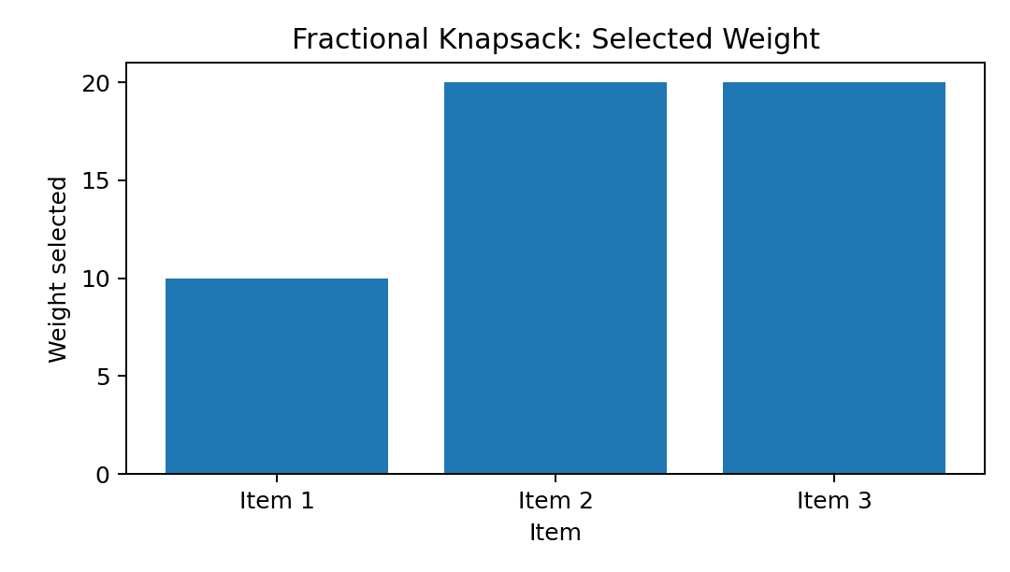
Figure 1. Weight allocated from each item for the capacity-50 example.

5. Question 2 — Activity Selection

Problem and greedy strategy
Given activities with start and finish times, select the largest set that does not overlap. Sort activities by finishing time, using start time as a tie-breaker, then accept an activity if it starts at or after the finish of the last accepted activity.

Implementation
def activity_selection(activities):
ordered = sorted(activities, key=lambda activity: (activity[1], activity[0]))
chosen = []
previous_finish = float("-inf")
for start, finish in ordered:
if start >= previous_finish:
chosen.append((start, finish))
previous_finish = finish
return chosen
activities = [(1, 2), (3, 4), (0, 6), (5, 7), (8, 9), (5, 9)]
chosen = activity_selection(activities)
print("Selected activities:", chosen)
print("Maximum number of activities:", len(chosen))

Explanation and result
• The ordering prioritizes earliest finishing times and resolves ties consistently.
• chosen contains the intervals accepted by the algorithm.
• previous_finish records the end time of the latest selected interval.
• The condition start >= previous_finish allows back-to-back activities.
The selected schedule is (1, 2), (3, 4), (5, 7), and (8, 9), giving a count of four. Time complexity is O(n log n) because of sorting; auxiliary space is O(n).
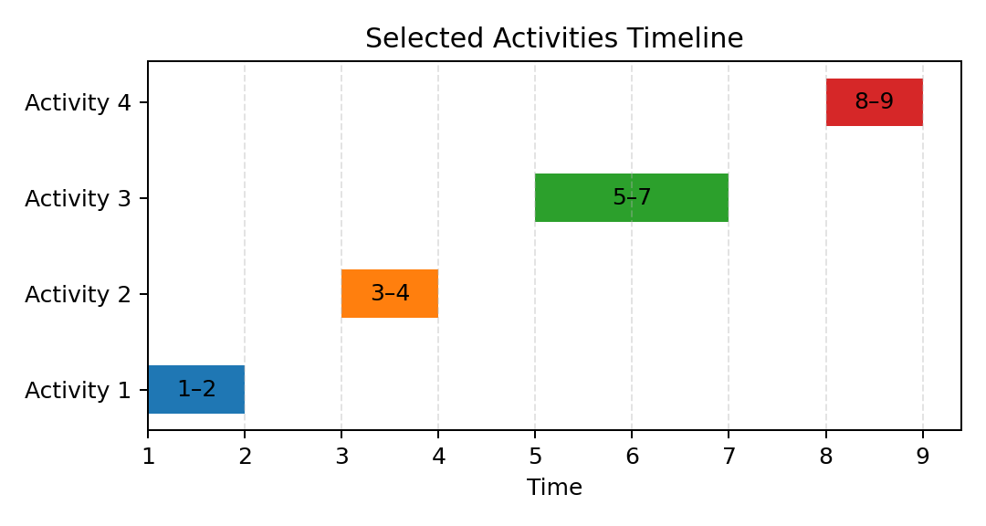
Figure 2. Timeline of the four selected, non-overlapping activities.

6. Question 3 — Huffman Compression Size Generator

Problem and greedy strategy
For an input string, count the frequency of each character and calculate the number of bits in its Huffman encoding. The procedure repeatedly merges the two least-frequent nodes. Each merge contributes its combined frequency to the final weighted path length. For a one-symbol input, this lab uses one bit per character.

Implementation
from collections import Counter
import heapq
import itertools
def huffman_compression_size(text):
if not text:
return 0
frequencies = Counter(text)
sequence = itertools.count()
heap = [(freq, next(sequence), char)
for char, freq in frequencies.items()]
heapq.heapify(heap)
if len(heap) == 1:
return len(text)
bit_total = 0
while len(heap) > 1:
freq_a, _, node_a = heapq.heappop(heap)
freq_b, _, node_b = heapq.heappop(heap)
combined = freq_a + freq_b
bit_total += combined
parent = (node_a, node_b)
heapq.heappush(heap, (combined, next(sequence), parent))
return bit_total
sample = "aaabbc"
print("Input text:", sample)
print("Character frequencies:", dict(Counter(sample)))
print("Total compressed size:", huffman_compression_size(sample), "bits")

Code interpretation
• Counter(text) creates the character-frequency map.
• Each heap entry includes a unique sequence value so ties do not require comparing different node types.
• heapify organizes the entries as a min-heap.
• Every iteration removes the two smallest frequencies, combines them, and adds the combined value to bit_total.
• The merged node is inserted back until one root remains.

Test case and result
For 'aaabbc', the frequencies are a = 3, b = 2, and c = 1. The total encoded size is 9 bits. One optimal code-length assignment gives a one-bit code to a and two-bit codes to b and c: 3×1 + 2×2 + 1×2 = 9.
Let n be the string length and k the number of distinct characters. Frequency counting takes O(n), and heap merges take O(k log k), for O(n + k log k) total time and O(k) auxiliary space.
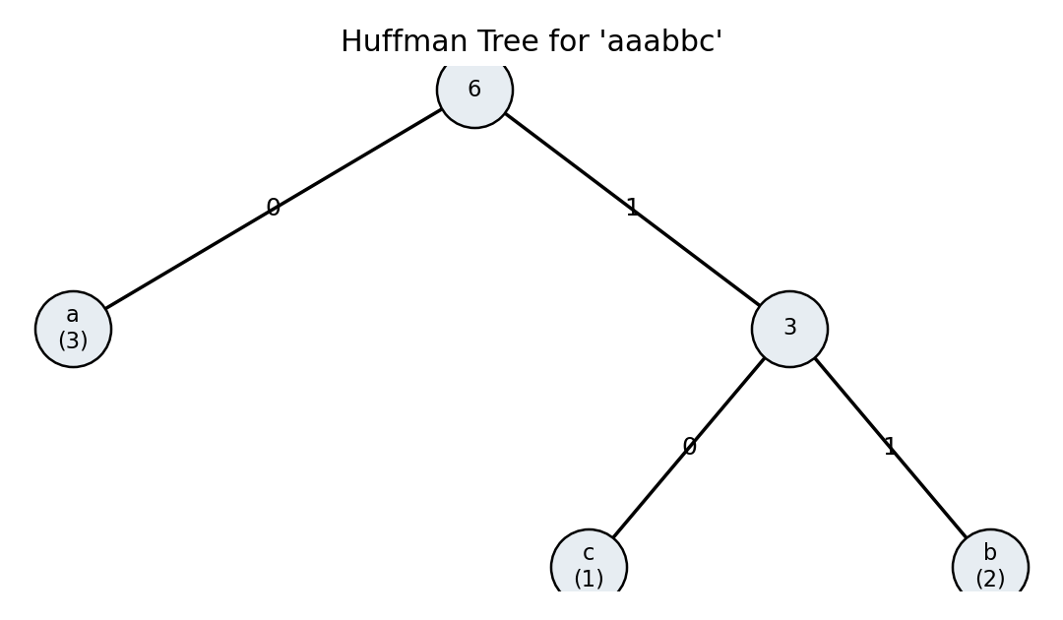
Figure 3. Huffman tree representation; edges are labelled 0 and 1.

7. Performance Analysis
Elapsed time is measured with time.perf_counter(), while tracemalloc reports Python-tracked peak allocation. These figures are transcribed from the provided notebook run and should not be treated as universal benchmarks.
Algorithm | Observed output | Execution time (s) | Peak memory (KB)
Fractional Knapsack | 250.0 | 0.000118 | 0.234375
Activity Selection | [(1, 2), (3, 4), (5, 7), (8, 9)] | 0.000329 | 0.226562
Huffman Compression | 107 | 0.000816 | 9.697266
In this run, Fractional Knapsack has the shortest measured runtime, while Huffman Compression has both the longest runtime and the highest traced peak allocation. The performance cell uses a larger dataset than the small demonstration cases; results may change across machines and repeated runs.
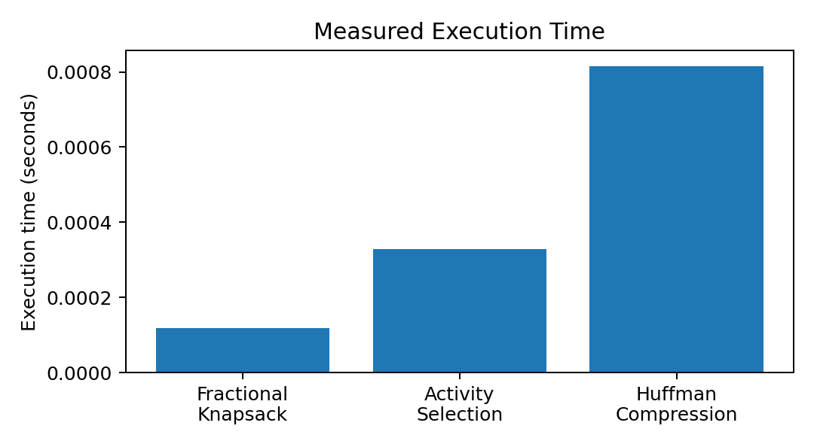
Figure 4. Measured execution-time comparison.
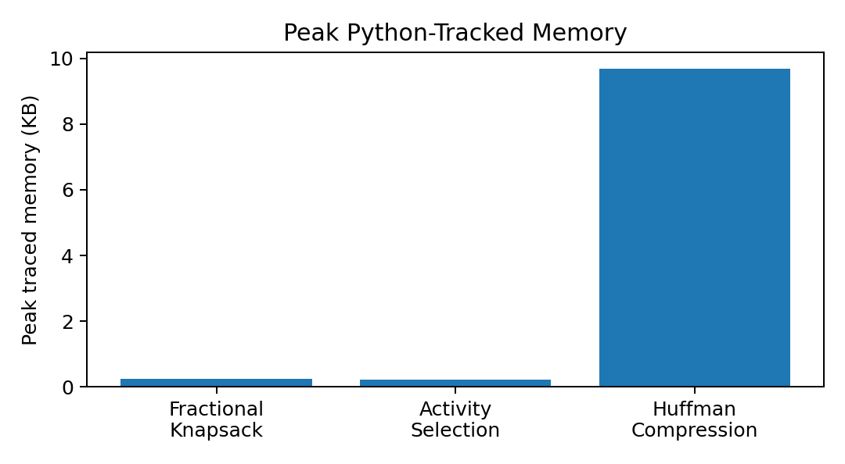
Figure 5. Measured peak Python-tracked memory comparison.

8. Theoretical Complexity Comparison
Algorithm | Best time | Average time | Worst time | Auxiliary space
Fractional Knapsack | O(n log n) | O(n log n) | O(n log n) | O(n)
Activity Selection | O(n log n) | O(n log n) | O(n log n) | O(n)
Huffman Compression | O(n + k log k) | O(n + k log k) | O(n + k log k) | O(k)
For Fractional Knapsack and Activity Selection, sorting determines the stated time bound. For Huffman coding, n is the input text length and k is the number of distinct characters; frequency counting costs O(n), followed by heap merging costing O(k log k).

9. Visualizations and Interpretation

9.1 Resource allocation
For capacity 50, the three items contribute selected weights of 10, 20, and 20. Their values are 60, 100, and 80, giving a total value of 240 for the three-item sample.

9.2 Activity timeline
The horizontal timeline shows the intervals (1, 2), (3, 4), (5, 7), and (8, 9). Their non-overlapping positions illustrate why all four can be scheduled together.

9.3 Character frequency and Huffman tree
Character frequencies determine the merge order. Less frequent symbols tend to sit deeper in the tree and receive longer codes. The displayed tree for 'aaabbc' illustrates a = 3, b = 2, and c = 1.

9.4 Performance graphs
The runtime and memory charts compare a single measured run. Very small runtimes can be affected by timer resolution, system load, and Python overhead. tracemalloc measures traced Python allocations rather than the interpreter's total RAM footprint.

10. Results and Discussion
The demonstrated implementations return a value of 240.000000 for the capacity-50 Fractional Knapsack sample, select four compatible activities, and calculate a 9-bit Huffman size for 'aaabbc'. A separate performance run reports 250.0, the four-activity schedule, and 107 for its larger test data. These outputs correspond to different test inputs and should not be mixed.
Asymptotic complexity describes how resource requirements grow with input size; the measured timing and memory figures describe only one execution. A more robust benchmark would repeat each test and use progressively larger inputs.

11. Conclusion
This lab explored three greedy applications: selecting item fractions by value density, scheduling activities by finish time, and building Huffman codes through repeated low-frequency merges. The recreated charts make resource allocation, interval compatibility, tree structure, runtime, and traced memory easier to inspect. The observed measurements are useful as a snapshot, while complexity analysis provides the broader view of scaling.

